Introduction: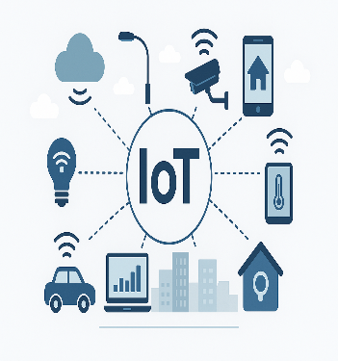

History:
The Internet of Things (Io T) started in the 1990s when everyday devices were first connected to the internet. The term IoT was coined in 1999, and with advances in sensors and networks, it quickly grew into today’s global system of smart, connected devices

Key Finding:
Key points:

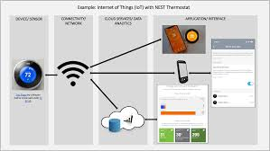

Result:
IoT delivers improved efficiency, smarter infrastructure, and valuable data-driven insights, transforming everyday life and industry operations on a global scale.

Disscussion:

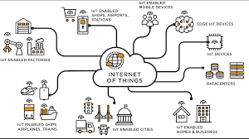

Conclusion:

The Internet of Things) is transforming modern life through smart homes, efficient industries, and intelligent cities. While it offers benefits such as automation

