6.5 Integrate JMeter with Jenkins
This section will guide you to:
- Configure JMeter with Jenkins.

This guide has five subsections, namely:
6.5.1 Install JMeter
6.5.2 Create test cases in Jmeter
6.5.3 Login to Jenkins
6.5.4 Add performance plugin
6.5.5 Create Jenkins job for JMeter

Step 6.5.1: Install JMeter
- Open your Linux terminal and run the below command to check if JDK is installed:
java -version

- Click the following URL to download the latest version of JMeter. You can download the binary or source file of this tool from this location. Click on the ‘Apache-JMeter-5.0.zip’ link to download the binary zip file of JMeter.
http://jmeter.apache.org/download_jmeter.cgi
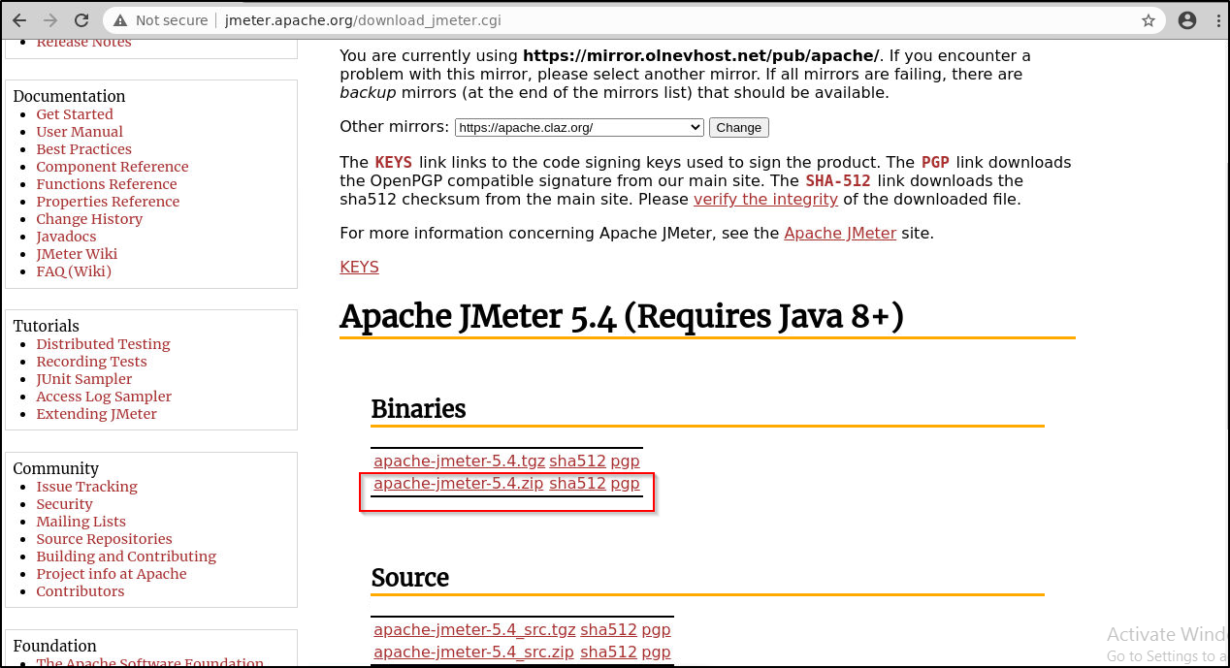
- The file will be downloaded in the Downloads folder. Run the following commands to extract the zip file.
cd Downloads
unzip apache-jmeter-5.4.zip
- Navigate to the bin of the unzipped folder:
cd Downloads/apache-jmeter-5.4/bin
Execute the below command to add the following line in user.properties file.
vi user.properties
Add the below line in the file
jmeter.save.saveservice.output_format=xml
save the file and exit
- Run the below command to run Jmeter:
./jmeter

Step 6.5.2: Create test cases in Jmeter
- Once your jmeter opens up, give the name for the Test Plan as: JmeterJenkinsIntegration and click on the Save icon and select the /home/labuser folder as the location to save.

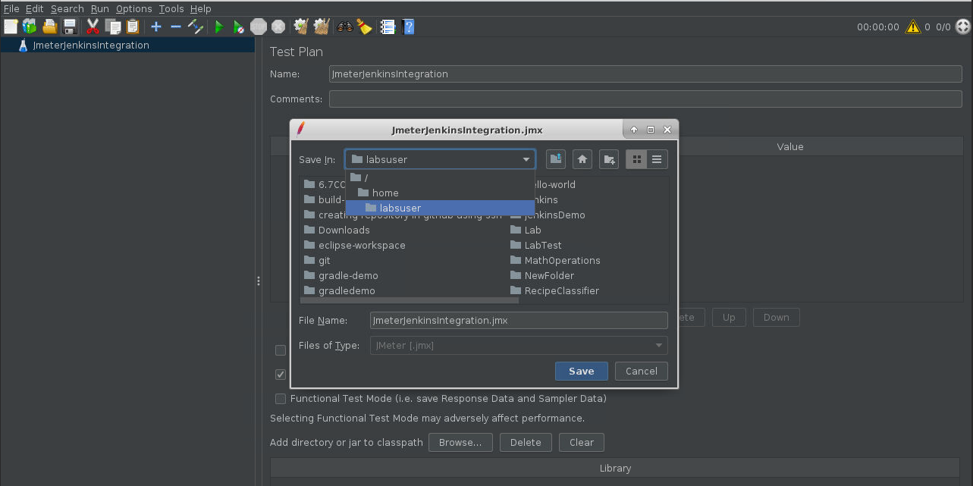

- Right click on JmeterJenkinsIntegration in the left pane and select add thread group as shown below:
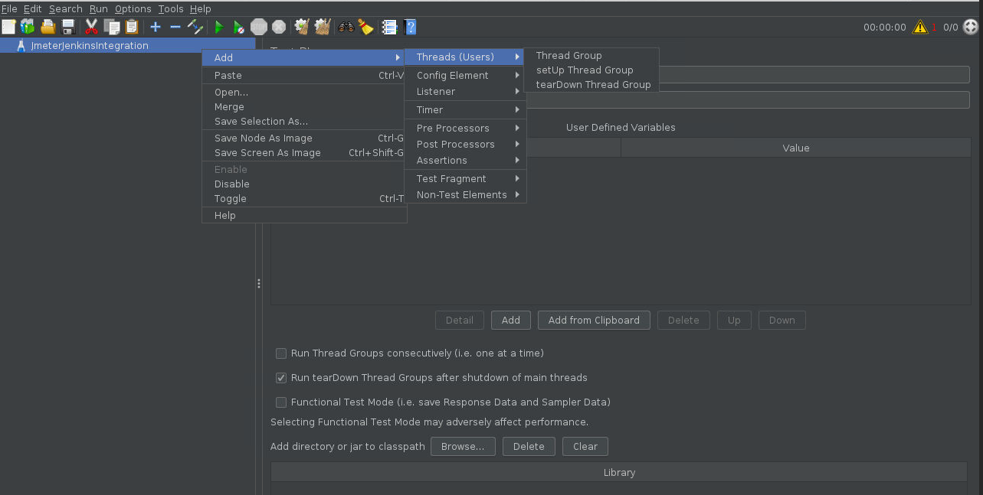
- Name your thread group as User.
- Right click on User -> Add -> Sampler -> HTTP Request.
- Enter the server name or IP : www.merriam-webster.com and Path: /word-of-the-day
- Right click on User -> Add -> Listener-> View Results in Table.

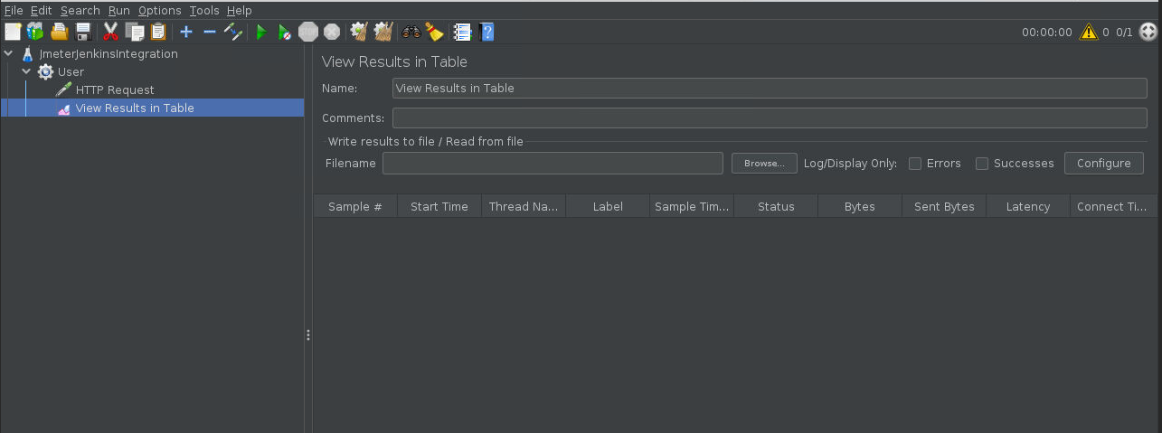
- Click on the run button to run the test.


- You can see the status marked in green once the test run is complete.
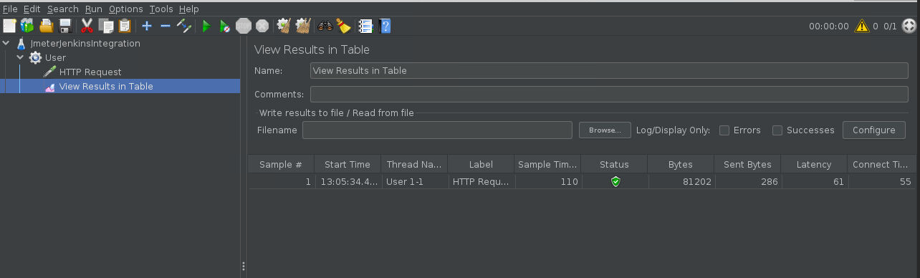
This means that the testcases are ready.
Step 6.5.3: Login to Jenkins
- Open your browser and navigate to localhost:8081
- Provide your username and password and click on Login.
Step 6.5.4: Add performance plugin
- Install the performance plugin via Manage Jenkins -> Manage Plugins.
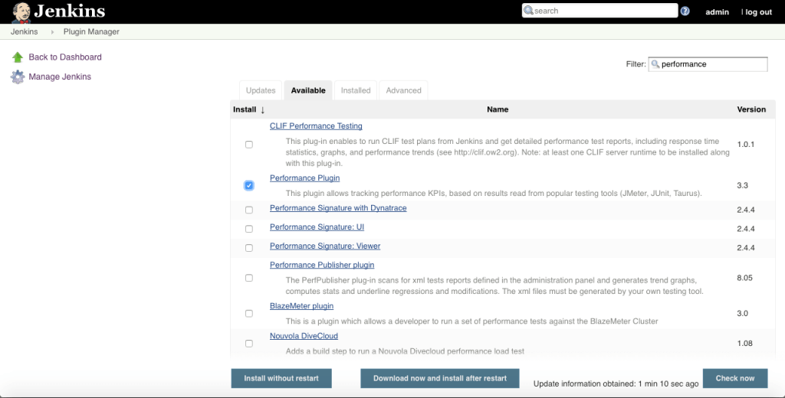

- Click on Install without restart.

Step 6.5.5: Create Jenkins job for JMeter

- Go to Jenkins home page and click on Create New Job, specify a name, select Freestyle Project, and click OK.
- Now you will have to configure the job. In the Build section, select execute from shell and enter the commands given below:

cd /home/labsuser/Downloads/apache-jmeter-5.4/bin/
sh jmeter.sh -Jjmeter.save.saveservice.output_format=xml -n -t /home/labsuser/JmeterJenkinsIntegration.jmx -l /home/labsuser/TestResult1.jtl
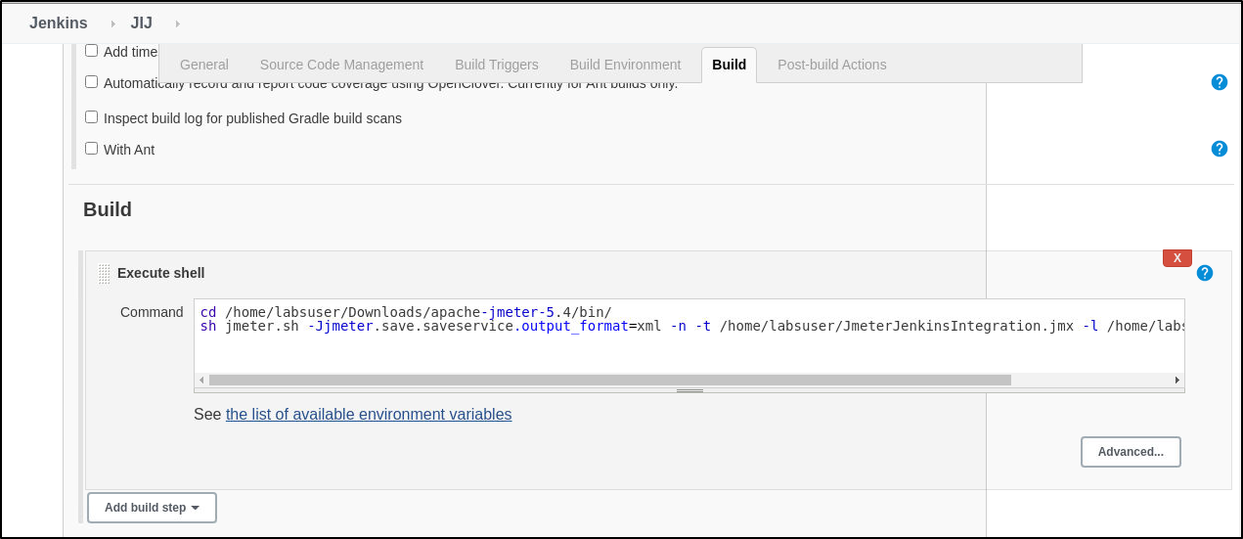

- In the Post build Actions sections, click on add a post build step and select publish performance test result report.
In the source data files textbox enter the path to your test result file. (ie. /home/labsuser/TestResult1.jtl)
Select the evaluation mode as : standard mode
Configure the job as shown in the screenshots.
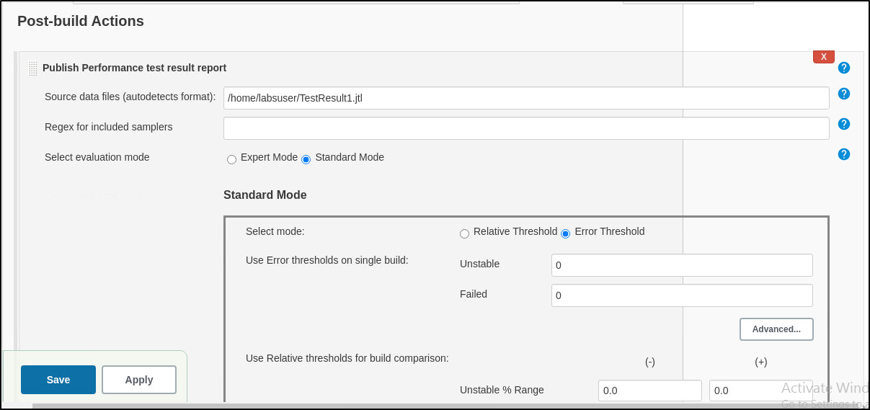

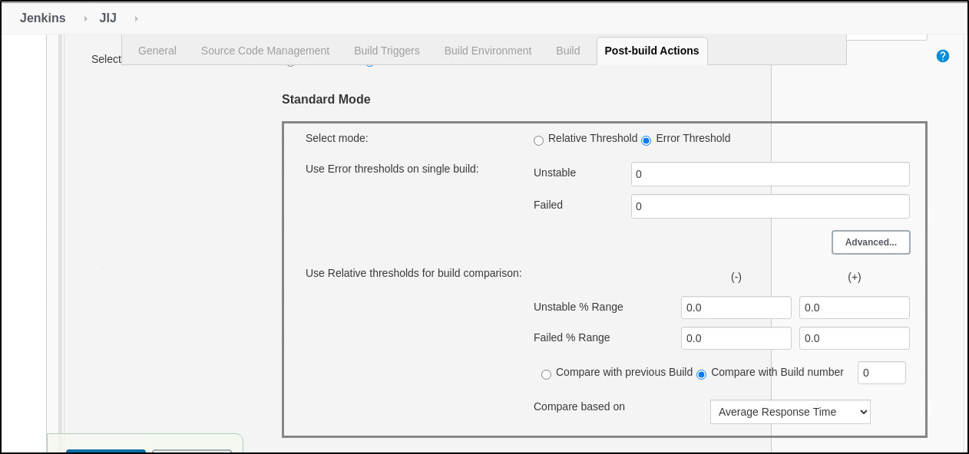
- Build the job and check the performance report in the job page.
