New -->Dynamic Web Project -->Name of the Project

choose web module version 4.0

Finish

**Step 1 :**

Install Tomcat

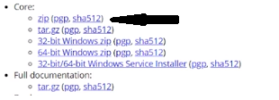

extract at any location

**Step 2 :**

add the server in eclpse

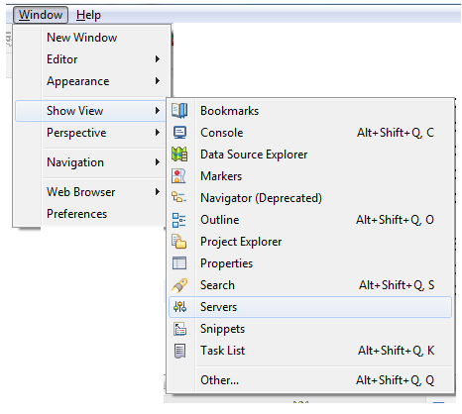

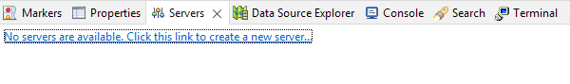

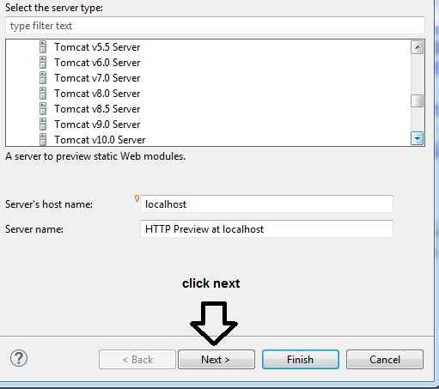

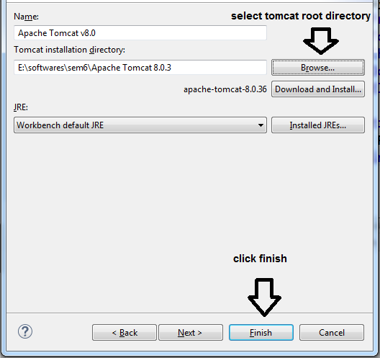

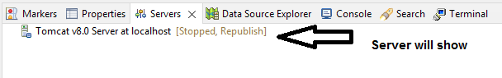

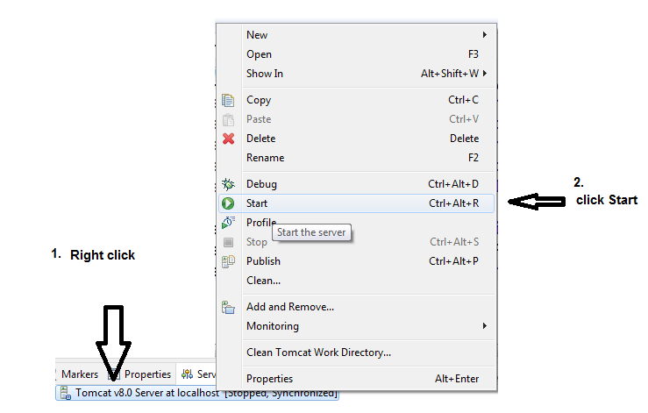

**Step 3: Configuring version of project (JDK & Tomcat are in sync)**

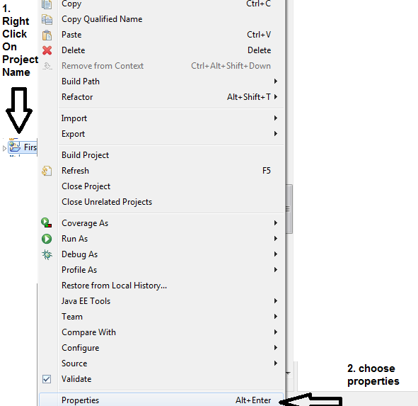

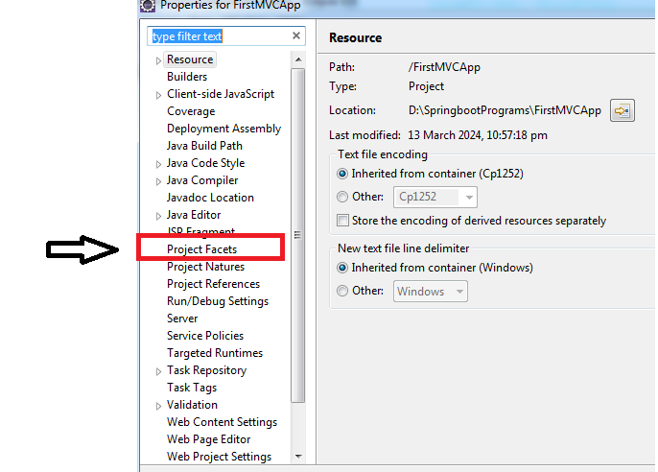

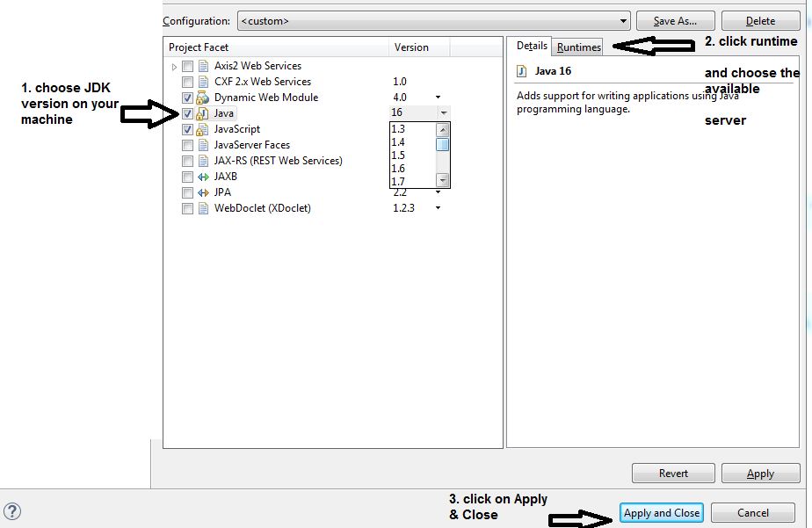

Step 4 : Download the

i)web.xml - routing

ii)spring-mvc-demo.xml - dispatcher servlet

iii)Spring Libs.zip //manual way

https://github.com/uysolanki/Spring5Jars

step 5 : copy paste the files dowloaded in step 4 in the eclipse project

copy the web.xml & spring-mvc-demo.xml files and paste in WEB-INF folder

extract the Spring Libs.zip and paste all the jars in the "lib folder"

step 6 :

a) make a package by the name "com.excelr.controller" in the src/main/java package

b) make a class HelloController in the above package

Step 7 : configure the web.xml

i)Dispatcher Servlet

NOTE the config param file value is the second xml file

open the second file and check the base package @line 15 com.greatlearning

Step 8 : go to the HelloController class

@Controller

**public** **class** HelloController {

@RequestMapping("/hello")

**public** String greet()

{

**return** "virat";

}

}

mutiple end points pointing to the same method

@RequestMapping(value={"/","/hello","/index"})

Step 9 : in WEB-INF make a folder by the name "view"

in the view folder make a jsp file by the return value of the function made in step 8

i.e virat.jsp

<body>

<h1> Hi Virat </h1>

</body>

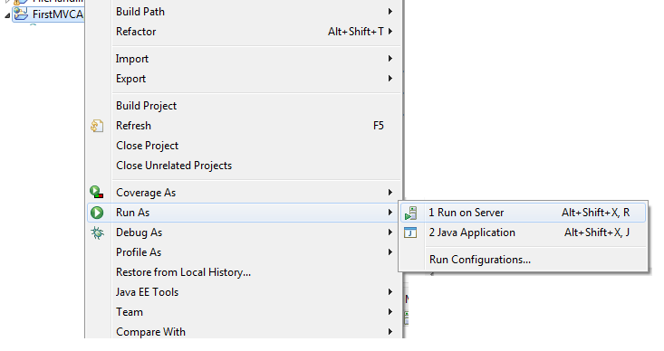

explain view resolver

create few more sample RequestMapping methods & explain

create new Controller class with a sample RequestMapping method & explain and explain

to open in browser

windows

preferences

general

web browser

check the browser apply & close