Here we have some examples of just one keyword entry. For this, use Main_Single.java

1. The word “Shakti” is only available in one of the links.



1. The word “Indian”

1. The Word “Navy”

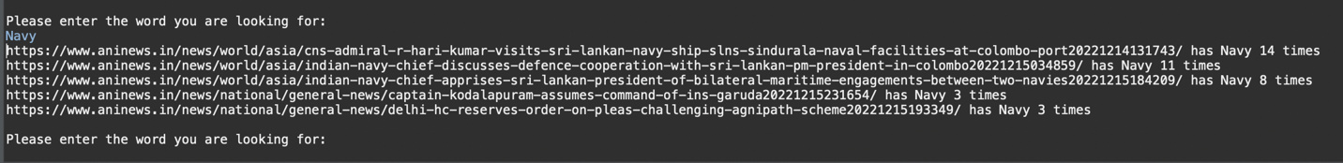

1. Stop Words being eradicated in output results (Stored in stopwords.txt):

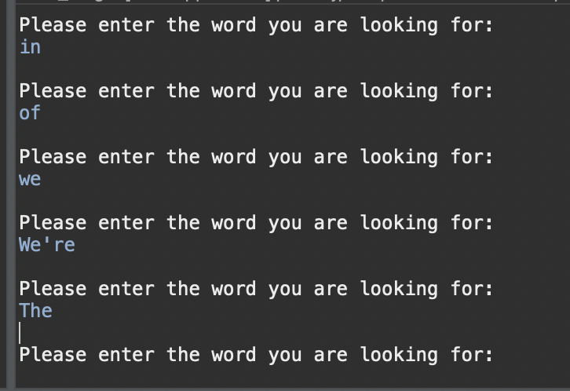

FOR MULTIPLE KEYWORDS

For more than one keywords, we search the pages containing the word by trie and sort them first based on number of keywords out of search query and then in buckets by number of their individual occurrences.

For this use, Main_Multi.java

1. Words: ‘Indian’, ‘Navy’, ‘Action’

1. Words: ‘Indian’, ‘Navy’, ‘Admiral’

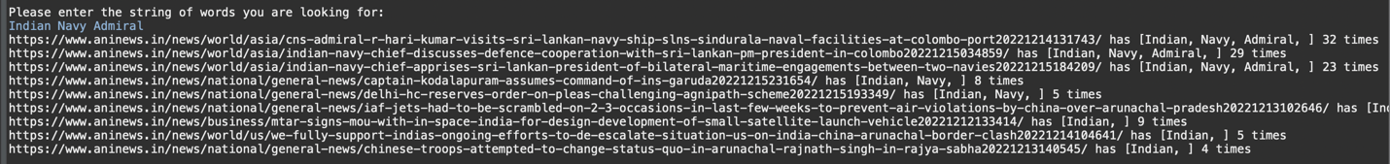

1. Words: ‘Admiral’, ‘in’, ‘Indian’, ‘Navy’

Note: Here, the result is produced same as the 2nd query as in is a stop word and is ignored by the program.

