**Practical File**

**Android Lab Manual(CSPE-35)**



**BACHELOR OF TECHNOLOGY**

**COMPUTER ENGINEERING**

**SUBMITTED TO:                  SUBMITTED BY:**

Ms. Meenakshi Rohin Chhabra

Asst .Proffesor     11710512

C.S.E Department             CO-2

NIT Kurukshetra                      5 th Semester

**Experiment 2 (Layouts & UI Control Components)**

1. Build your first simple Hello world application using android studio.

**Code**

MainActivity.java

package com.example.helloworld;  
  
import android.support.v7.app.AppCompatActivity;  
import android.os.Bundle;  
import android.view.View;  
import android.widget.Button;  
import android.widget.Toast;  
  
public class MainActivity extends AppCompatActivity {  
  
 @Override  
 protected void onCreate(Bundle savedInstanceState) {  
 super.onCreate(savedInstanceState);  
 setContentView(R.layout.*activity_main*);   
 }  
}

activity_main.xml

<?xml version="1.0" encoding="utf-8"?>  
<android.support.constraint.ConstraintLayout xmlns:android="http://schemas.android.com/apk/res/android"  
 xmlns:app="http://schemas.android.com/apk/res-auto"  
 xmlns:tools="http://schemas.android.com/tools"  
 android:layout_width="match_parent"  
 android:layout_height="match_parent"  
 tools:context=".MainActivity">  
  
 <TextView  
 android:layout_width="wrap_content"  
 android:layout_height="wrap_content"  
 android:text="Hello World!"  
 android:textSize="50dp"  
 app:layout_constraintBottom_toBottomOf="parent"  
 app:layout_constraintLeft_toLeftOf="parent"  
 app:layout_constraintRight_toRightOf="parent"  
 app:layout_constraintTop_toTopOf="parent" />  
  
</android.support.constraint.ConstraintLayout>

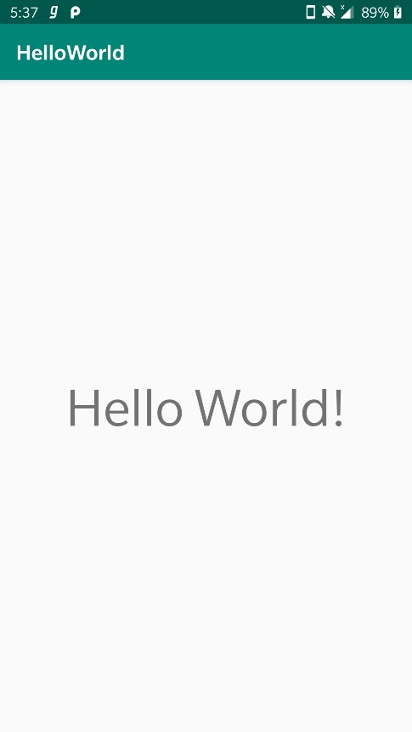**Output**

2. Build Hello world application using Toast in android studio.

**Code**

MainActivity.java

package com.example.helloworld;  
  
import android.support.v7.app.AppCompatActivity;  
import android.os.Bundle;  
import android.view.View;  
import android.widget.Button;  
import android.widget.Toast;  
  
public class MainActivity extends AppCompatActivity {  
  
 Button b1;  
 @Override  
 protected void onCreate(Bundle savedInstanceState) {  
 super.onCreate(savedInstanceState);  
 setContentView(R.layout.*activity_main*);  
 b1=findViewById(R.id.*bt1*);  
 b1.setOnClickListener(new View.OnClickListener() {  
 @Override  
 public void onClick(View v) {  
 Toast.*makeText*(MainActivity.this, "You Clicked Me !!", Toast.*LENGTH_SHORT*).show();  
 }  
 });  
 }  
}

activity_main.xml

<?xml version="1.0" encoding="utf-8"?>  
<LinearLayout xmlns:android="http://schemas.android.com/apk/res/android"  
 xmlns:app="http://schemas.android.com/apk/res-auto"  
 xmlns:tools="http://schemas.android.com/tools"  
 android:layout_width="match_parent"  
 android:layout_height="match_parent"  
 android:orientation="vertical"  
3 tools:context=".MainActivity">  
  
 <TextView  
 android:layout_width="wrap_content"  
 android:layout_height="wrap_content"  
 android:text="Hello World!"  
 android:textSize="50dp"  
 app:layout_constraintBottom_toBottomOf="parent"  
 app:layout_constraintLeft_toLeftOf="parent"  
 app:layout_constraintRight_toRightOf="parent"  
 app:layout_constraintTop_toTopOf="parent" />  
 <Button  
 android:layout_width="wrap_content"  
 android:layout_height="wrap_content"  
 android:text="Click Me!"  
 android:id="@+id/bt1"  
 />  
  
  
</LinearLayout>

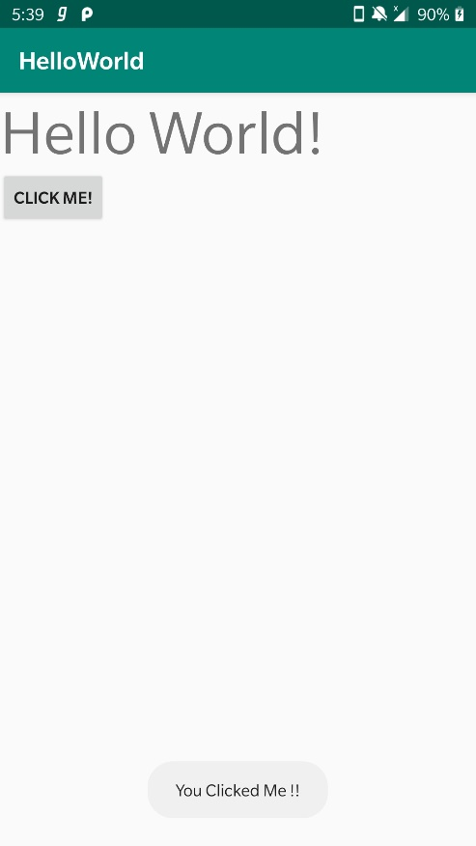**Output**

3. Build an application that contains a TextView with value “Hello world”.

**Code**

MainActivity.java

package com.example.helloworld;  
  
import android.support.v7.app.AppCompatActivity;  
import android.os.Bundle;  
  
public class MainActivity extends AppCompatActivity {  
  
 @Override  
 protected void onCreate(Bundle savedInstanceState) {  
 super.onCreate(savedInstanceState);  
 setContentView(R.layout.*activity_main*);  
 }  
}

activity_main.xml

<?xml version="1.0" encoding="utf-8"?>  
<RelativeLayout xmlns:android="http://schemas.android.com/apk/res/android"  
 xmlns:app="http://schemas.android.com/apk/res-auto"  
 xmlns:tools="http://schemas.android.com/tools"  
 android:layout_width="match_parent"  
 android:layout_height="match_parent"  
 tools:context=".MainActivity">  
  
 <TextView  
 android:layout_width="wrap_content"  
 android:layout_height="wrap_content"  
 android:text="Hello World!"  
 android:textSize="50dp"  
 android:layout_centerHorizontal="true"  
 android:id="@+id/t1"  
 android:layout_margin="50dp"  
 android:background="@color/colorAccent"  
 />  
  
 <TextView  
 android:layout_width="wrap_content"  
 android:layout_height="wrap_content"  
 android:text="Welcome"  
 android:textSize="50dp"  
 android:layout_margin="@dimen/margin_def"  
 android:layout_centerHorizontal="true"  
 android:layout_below="@id/t1"  
 android:background="#E0EF0E"/>  
  
</RelativeLayout>

colors.xml

<?xml version="1.0" encoding="utf-8"?>  
<resources>  
 <color name="colorPrimary">#008577</color>  
 <color name="colorPrimaryDark">#00574B</color>  
 <color name="colorAccent">#D81B60</color>  
</resources>

dimens.xml

<?xml version="1.0" encoding="utf-8"?>  
<resources>  
 <dimen name="margin_def">50dp</dimen>  
</resources>

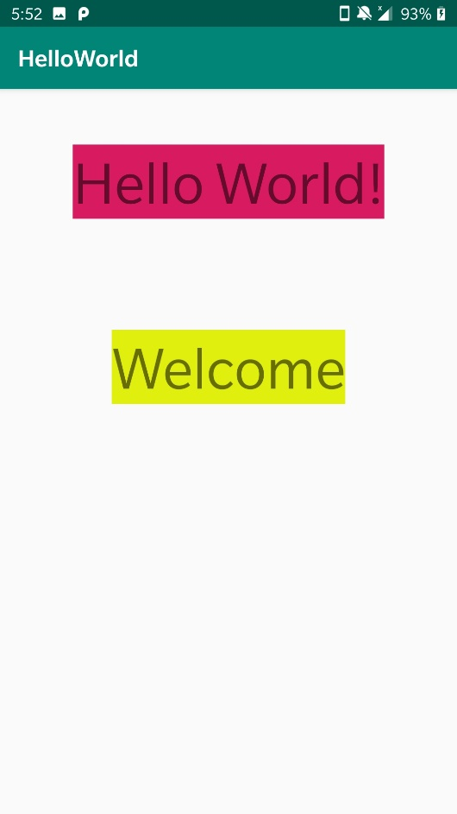**Output**

4. Create your own values in string.xml

**Code**

MainActivity.java

package com.example.helloworld;  
  
import android.support.v7.app.AppCompatActivity;  
import android.os.Bundle;  
import android.view.View;  
import android.widget.Button;  
import android.widget.Toast;  
  
public class MainActivity extends AppCompatActivity {  
  
 @Override  
 protected void onCreate(Bundle savedInstanceState) {  
 super.onCreate(savedInstanceState);  
 setContentView(R.layout.*activity_main*);   
 }  
}

activity_main.xml

<?xml version="1.0" encoding="utf-8"?>  
<RelativeLayout xmlns:android="http://schemas.android.com/apk/res/android"  
 xmlns:app="http://schemas.android.com/apk/res-auto"  
 xmlns:tools="http://schemas.android.com/tools"  
 android:layout_width="match_parent"  
 android:layout_height="match_parent"  
 tools:context=".MainActivity">  
  
 <TextView  
 android:layout_width="wrap_content"  
 android:layout_height="wrap_content"  
 android:text="@string/str1"  
 android:textSize="50dp"  
 android:layout_centerHorizontal="true"  
 android:layout_margin="50dp"  
 />  
</RelativeLayout>

strings.xml

<resources>  
 <string name="app_name">HelloWorld</string>  
 <string name="str1">Welcome to My World</string>  
</resources>

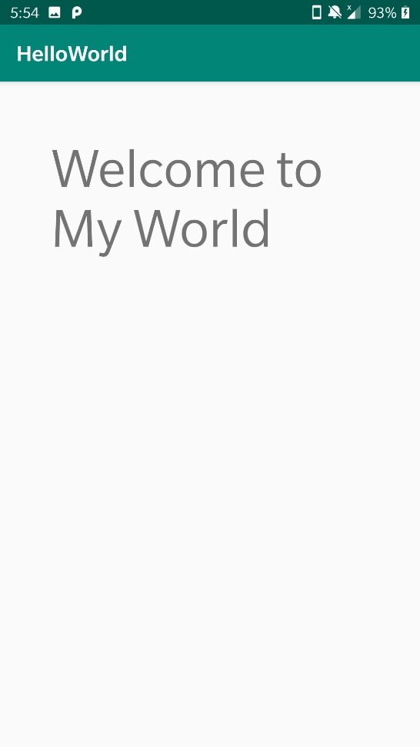**Output**

**Experiment 3 (Layouts & UI Control Components)**

1. Try Linear Layout that contain 4 buttons as UI Components with following attribute properties set –

Layout : android: divider , android : orientation , android: layout_width , android:layout_height

Button : android: layout_width , android:layout_height , android: inputType , android:marginTop , android :text

**Code**

activity_main.xml

<?xml version="1.0" encoding="utf-8"?>  
<LinearLayout xmlns:android="http://schemas.android.com/apk/res/android"  
 xmlns:app="http://schemas.android.com/apk/res-auto"  
 xmlns:tools="http://schemas.android.com/tools"  
 android:layout_width="match_parent"  
 android:layout_height="match_parent"  
 tools:context=".MainActivity"  
 android:orientation="vertical"  
 android:divider="@color/colorAccent">  
  
 <Button  
 android:layout_width="wrap_content"  
 android:layout_height="wrap_content"  
 android:text="Button 1"  
 android:layout_marginTop="50dp"  
 android:layout_gravity="center_horizontal" />  
  
 <Button  
 android:layout_width="wrap_content"  
 android:layout_height="wrap_content"  
 android:text="Button 2"  
 android:layout_marginTop="50dp"  
 android:layout_gravity="center_horizontal"/>  
   
 <Button  
 android:layout_width="wrap_content"  
 android:layout_height="wrap_content"  
 android:text="Button 3"  
 android:layout_marginTop="50dp"  
 android:layout_gravity="center_horizontal"/>  
  
 <Button  
 android:layout_width="wrap_content"  
 android:layout_height="wrap_content"  
 android:text="Button 4"  
 android:layout_marginTop="50dp"  
 android:layout_gravity="center_horizontal"/>  
   
</LinearLayout>

**Output**

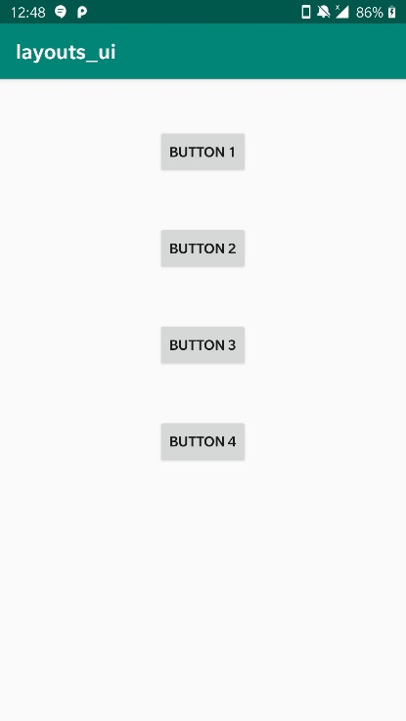

2. Using Relative Layout Design a form that inputs first name , last name , Gender( using radioButton ) and Date of Birth (Using Date Picker ) with following attribute properties set –

Layout : android: layout_alignParentRight , android : layout_alignParentLeft, android: layout_alignParentBottom, android: layout_alignParentTop

RadioButton : android: layout_width , android:layout_height , android: text , android:checked , android :textSize, android :textColor

EditText: android: layout_width , android:layout_height , android: editable , android:text , android:background

**Code**

activity_main.xml

<?xml version="1.0" encoding="utf-8"?>  
<RelativeLayout xmlns:android="http://schemas.android.com/apk/res/android"  
 xmlns:app="http://schemas.android.com/apk/res-auto"  
 xmlns:tools="http://schemas.android.com/tools"  
 android:layout_width="match_parent"  
 android:layout_height="match_parent"  
 tools:context=".MainActivity">  
 <TextView  
 android:layout_width="match_parent"  
 android:layout_height="wrap_content"  
 android:text="First Name"  
 android:id="@+id/textview1"/>  
  
  
  
 <EditText  
 android:layout_width="match_parent"  
 android:layout_height="wrap_content"  
 android:layout_below="@+id/textview1"  
 android:id="@+id/firstname"/>  
  
 <TextView  
 android:layout_width="match_parent"  
 android:layout_height="wrap_content"  
 android:text="Last Name"  
 android:layout_below="@+id/firstname"  
 android:id="@+id/textView2"/>  
  
 <EditText  
 android:layout_width="match_parent"  
 android:layout_height="wrap_content"  
 android:layout_below="@+id/textView2"  
 android:id="@+id/lastname"/>  
  
 <TextView  
 android:layout_width="match_parent"  
 android:layout_height="wrap_content"  
 android:text="Gender"  
 android:layout_below="@id/lastname"  
 android:id="@+id/gender"/>  
  
 <RadioGroup  
 android:layout_width="match_parent"  
 android:layout_height="wrap_content"  
 android:orientation="horizontal"  
 android:layout_below="@+id/gender"  
 android:id="@+id/radio">  
  
 <RadioButton  
 android:layout_width="wrap_content"  
 android:layout_height="wrap_content"  
 android:text="Male"  
 android:id="@+id/male"  
 android:padding="10dp"/>  
  
 <RadioButton  
  
 android:layout_width="wrap_content"  
 android:layout_height="wrap_content"  
 android:text="female"  
 android:id="@+id/female"  
 android:padding="10dp"/>  
 </RadioGroup>  
  
 <Button  
 android:layout_width="wrap_content"  
 android:layout_height="wrap_content"  
 android:text="Date of Birth"  
 android:id="@+id/date"  
 android:layout_below="@+id/radio"  
 android:onClick="setDate"/>  
  
 <TextView  
  
 android:layout_width="wrap_content"  
 android:layout_height="wrap_content"  
 android:id="@+id/dateshow"  
 android:layout_toRightOf="@+id/date"  
 android:text="Date"  
 android:layout_below="@+id/radio"/>  
  
</RelativeLayout>

MainActivity.java

package com.example.layouts_ui;  
import android.support.v7.app.AppCompatActivity;  
import android.app.DatePickerDialog;  
import android.app.Dialog;  
import android.os.Bundle;  
import android.view.View;  
import android.widget.Button;  
import android.widget.DatePicker;  
import android.widget.TextView;  
import android.widget.Toast;  
import java.util.Calendar;  
  
public class MainActivity extends AppCompatActivity {  
   
 private DatePicker datePicker;  
 private Calendar calendar;  
 private TextView dateView;  
 private int year, month, day;  
 @Override  
 protected void onCreate(Bundle savedInstanceState) {  
 super.onCreate(savedInstanceState);  
 setContentView(R.layout.*activity_main*);  
 dateView = (TextView) findViewById(R.id.*dateshow*);  
 calendar = Calendar.*getInstance*();  
 year = calendar.get(Calendar.*YEAR*);  
 month = calendar.get(Calendar.*MONTH*);  
 day = calendar.get(Calendar.*DAY_OF_MONTH*);  
 showDate(year, month + 1, day);  
 }  
 @SuppressWarnings("deprecation")  
 public void setDate(View view) {  
 showDialog(999);  
 }  
   
 @SuppressWarnings("deprecation")  
 @Override  
 protected Dialog onCreateDialog(int id) {  
 // *TODO Auto-generated method stub* if (id == 999) {  
 return new DatePickerDialog(this,myDateListener, year, month, day);  
 }  
 return null;  
 }  
   
 private DatePickerDialog.OnDateSetListener myDateListener = new  
 DatePickerDialog.OnDateSetListener() {  
 @Override  
 public void onDateSet(DatePicker arg0,int arg1, int arg2, int arg3) {  
 showDate(arg1, arg2 + 1, arg3);  
 }  
 };  
   
 private void showDate(int year, int month, int day) {  
 dateView.setText(new StringBuilder().append(day).append("/")  
 .append(month).append("/").append(year));  
 }  
  
}

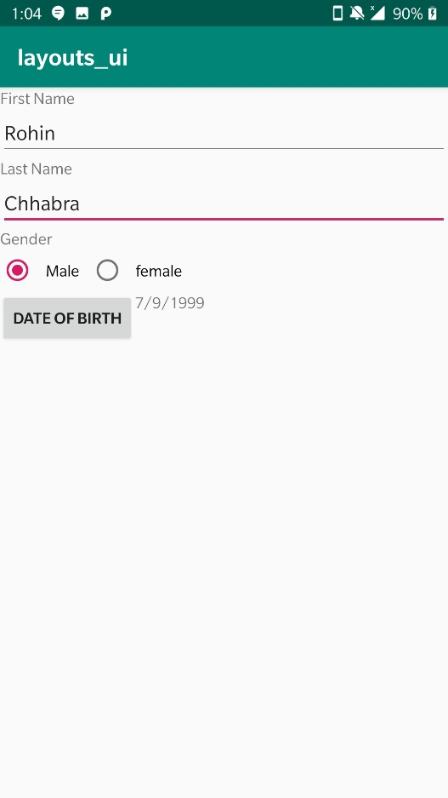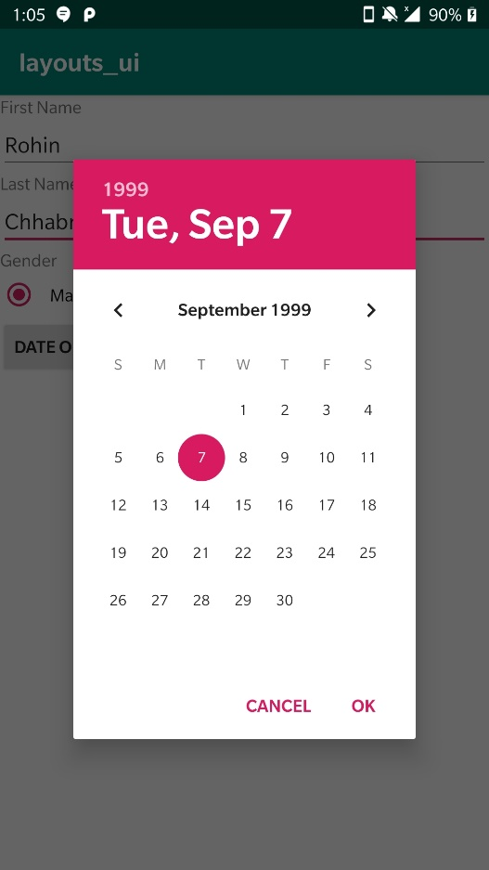**Output**

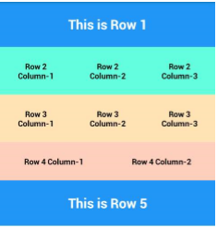3. Try Table Layout and design following using EditText

**Code**

activity_main.xml

<?xml version="1.0" encoding="utf-8"?>  
<TableLayout xmlns:android="http://schemas.android.com/apk/res/android"  
 xmlns:app="http://schemas.android.com/apk/res-auto"  
 xmlns:tools="http://schemas.android.com/tools"  
 android:layout_width="match_parent"  
 android:layout_height="match_parent"  
 tools:context=".MainActivity">  
 <TableRow  
 android:layout_width="match_parent"  
 android:layout_height="match_parent"  
 android:background="#0FE7F6"  
 android:layout_weight="1"  
 android:gravity="center">  
  
 <TextView  
 android:layout_width="match_parent"  
 android:layout_height="wrap_content"  
 android:text="This is Row 1"  
 android:textColor="#FFFF"  
 android:textStyle="bold"  
 android:textSize="50dp"/>  
 </TableRow>  
  
 <TableRow  
 android:layout_width="match_parent"  
 android:layout_height="match_parent"  
 android:background="#0FF6CE"  
 android:layout_weight="1"  
 android:gravity="center">  
  
 <TextView  
 android:layout_width="0dp"  
 android:layout_height="wrap_content"  
 android:text="Row 2\nColumn 1"  
 android:textSize="10dp"  
 android:textStyle="bold"  
 android:gravity="center"  
 android:layout_weight="1"/>  
  
 <TextView  
 android:layout_width="0dp"  
 android:layout_height="wrap_content"  
 android:text="Row 2\nColumn 2"  
 android:textSize="10dp"  
 android:textStyle="bold"  
 android:gravity="center"  
 android:layout_weight="1"/>  
  
 <TextView  
 android:layout_width="0dp"  
 android:layout_height="wrap_content"  
 android:text="Row 2\nColumn 3"  
 android:textSize="10dp"  
 android:gravity="center"  
 android:textStyle="bold"  
 android:layout_weight="1"/>  
 </TableRow>  
  
 <TableRow  
 android:layout_width="match_parent"  
 android:layout_height="match_parent"  
 android:background="#F5E092"  
 android:layout_weight="1"  
 android:gravity="center">  
 <TextView  
 android:layout_width="0dp"  
 android:layout_height="wrap_content"  
 android:text="Row 3\nColumn 1"  
 android:textSize="10dp"  
 android:gravity="center"  
 android:textStyle="bold"  
 android:layout_weight="0.3"/>  
  
 <TextView  
 android:layout_width="0dp"  
 android:layout_height="wrap_content"  
 android:text="Row 3\nColumn 2"  
 android:textSize="10dp"  
 android:gravity="center"  
 android:textStyle="bold"  
 android:layout_weight="0.3"/>  
  
 <TextView  
 android:layout_width="0dp"  
 android:layout_height="wrap_content"  
 android:text="Row 3\nColumn 3"  
 android:textSize="10dp"  
 android:gravity="center"  
 android:textStyle="bold"  
 android:layout_weight="0.3"/>  
 </TableRow>  
  
 <TableRow  
 android:layout_width="match_parent"  
 android:layout_height="match_parent"  
 android:background="#F9B7DA"  
 android:layout_weight="1"  
 android:gravity="center">  
  
 <TextView  
 android:layout_width="0dp"  
 android:layout_height="wrap_content"  
 android:text="Row 4 Column 1"  
 android:textSize="10dp"  
 android:gravity="center"  
 android:textStyle="bold"  
 android:layout_weight="1"/>  
  
 <TextView  
 android:layout_width="0dp"  
 android:layout_height="wrap_content"  
 android:text="Row 4 Column 2"  
 android:textSize="10dp"  
 android:gravity="center"  
 android:textStyle="bold"  
 android:layout_weight="1"/>  
  
 </TableRow>  
  
 <TableRow  
 android:layout_width="match_parent"  
 android:layout_height="match_parent"  
 android:background="#0FE7F6"  
 android:layout_weight="1"  
 android:gravity="center">  
  
 <TextView  
 android:layout_width="wrap_content"  
 android:layout_height="wrap_content"  
 android:text="This is Row 5"  
 android:textColor="#FFFF"  
 android:textStyle="bold"  
 android:textSize="50dp"/>  
 </TableRow>  
  
</TableLayout>

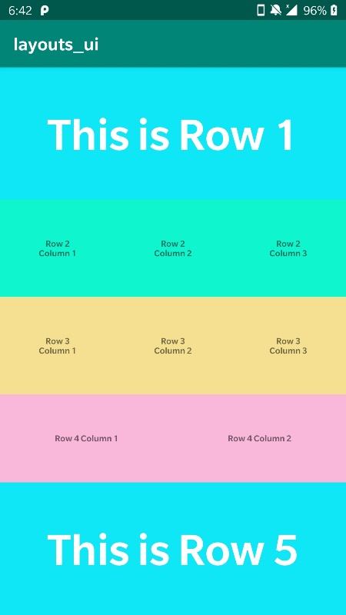**Output**

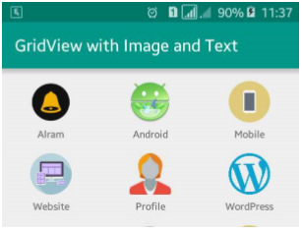4. Design Following using Grid Layout and use ImageView and TextView UI Controls for its designing

**Code**

activity_main.xml

<?xml version="1.0" encoding="utf-8"?>  
<androidx.constraintlayout.widget.ConstraintLayout xmlns:android="http://schemas.android.com/apk/res/android"  
 xmlns:app="http://schemas.android.com/apk/res-auto"  
 xmlns:tools="http://schemas.android.com/tools"  
 android:layout_width="match_parent"  
 android:layout_height="match_parent"  
 tools:context=".MainActivity">  
  
 <TextView  
 android:layout_width="wrap_content"  
 android:layout_height="wrap_content"  
 android:text="Hello World!"  
 app:layout_constraintBottom_toBottomOf="parent"  
 app:layout_constraintLeft_toLeftOf="parent"  
 app:layout_constraintRight_toRightOf="parent"  
 app:layout_constraintTop_toTopOf="parent" />  
  
</androidx.constraintlayout.widget.ConstraintLayout>

**Output**

5. Create a Login page for Online Shopping using any learned Layouts

a. Create TextView for the title

b. Add two EditText for username and password

c. Add Login button

d. Create checkbox

e. Create Radio button

**Code**

activity_main.xml

<?xml version="1.0" encoding="utf-8"?>  
<android.support.constraint.ConstraintLayout xmlns:android="http://schemas.android.com/apk/res/android"  
 xmlns:app="http://schemas.android.com/apk/res-auto"  
 xmlns:tools="http://schemas.android.com/tools"  
 android:layout_width="match_parent"  
 android:layout_height="match_parent"  
 tools:context=".MainActivity">  
  
  
 <TextView  
 android:layout_width="match_parent"  
 android:layout_height="wrap_content"  
 android:id="@+id/title"  
 android:text="Shop Online with us"  
 android:textSize="20sp"  
 android:textStyle="bold"  
 android:background="#E0E"  
 android:gravity="center"  
 android:textColor="#000000"  
 app:layout_constraintLeft_toLeftOf="parent"  
 app:layout_constraintRight_toRightOf="parent"  
 app:layout_constraintTop_toTopOf="parent"  
 android:paddingVertical="10dp"/>  
 <EditText  
 android:layout_width="match_parent"  
 android:layout_height="wrap_content"  
 android:id="@+id/username"  
 android:hint="Username"  
 app:layout_constraintLeft_toLeftOf="parent"  
 app:layout_constraintRight_toRightOf="parent"  
 app:layout_constraintTop_toBottomOf="@+id/title"/>  
 <EditText  
 android:layout_width="match_parent"  
 android:layout_height="wrap_content"  
 android:id="@+id/password"  
 android:inputType="textPassword"  
 android:hint="password"  
 app:layout_constraintTop_toBottomOf="@id/username"  
 app:layout_constraintLeft_toLeftOf="parent"  
 app:layout_constraintRight_toRightOf="parent"/>  
  
 <LinearLayout  
 android:layout_width="match_parent"  
 android:layout_height="wrap_content"  
 android:orientation="vertical"  
 android:id="@+id/radio"  
 app:layout_constraintRight_toRightOf="parent"  
 app:layout_constraintTop_toBottomOf="@id/password"  
 app:layout_constraintLeft_toLeftOf="parent">  
 <TextView  
 android:layout_width="match_parent"  
 android:layout_height="match_parent"  
 android:text="Subscribe to Weekly newsletter"  
 android:textStyle="bold"/>  
 <RadioGroup  
 android:layout_width="match_parent"  
 android:layout_height="wrap_content"  
 app:layout_constraintTop_toBottomOf="@id/password"  
 app:layout_constraintLeft_toLeftOf="parent"  
 app:layout_constraintRight_toRightOf="parent"  
 android:orientation="horizontal">  
  
 <RadioButton  
 android:layout_width="wrap_content"  
 android:layout_height="wrap_content"  
 android:text="Yes"/>  
 <RadioButton  
 android:layout_width="wrap_content"  
 android:layout_height="wrap_content"  
 android:text="No"/>  
  
 </RadioGroup>  
 </LinearLayout>  
  
  
 <CheckBox  
 android:layout_width="wrap_content"  
 android:layout_height="wrap_content"  
 android:text="I agree to the terms and conditions"  
 android:id="@+id/terms"  
 app:layout_constraintTop_toBottomOf="@+id/radio"  
 app:layout_constraintLeft_toLeftOf="parent"  
 app:layout_constraintBottom_toTopOf=""/>  
  
 <Button  
 android:layout_width="wrap_content"  
 android:layout_height="wrap_content"  
 android:id="@+id/login"  
 android:text="Login"  
 android:textColor="#000000"  
 android:background="#E0E"  
 app:layout_constraintTop_toBottomOf="@id/terms"  
 app:layout_constraintBottom_toBottomOf="parent"  
 app:layout_constraintLeft_toLeftOf="parent"  
 app:layout_constraintRight_toRightOf="parent"/>  
  
</android.support.constraint.ConstraintLayout>

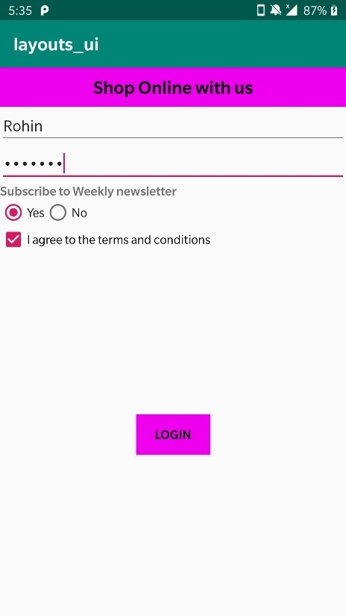**Output**

**Experiment 4 (Activity LifeCycle)**

1. Create an application to show the lifecycle of an activity

2. Include the following functions: -

a. onCreate

b. onStart

c. onResume

d. onPause

e. OnStop

f. OnRestart

g. OnDestroy

3. Use Toast and logcat to show when each function gets called

**Code**

MainActivity.java

package com.example.myapplication;  
  
import android.support.v7.app.AppCompatActivity;  
import android.os.Bundle;  
import android.util.Log;  
import android.widget.Toast;  
  
public class MainActivity extends AppCompatActivity {  
  
 @Override  
 protected void onCreate(Bundle savedInstanceState) {  
 super.onCreate(savedInstanceState);  
 setContentView(R.layout.activity_main);  
 Log.d("lifecycle","onCreate invoked");  
 Toast.makeText(getApplicationContext(),"On Create Method Called",Toast.LENGTH_LONG).show();  
 }  
 @Override  
 protected void onStart() {  
 super.onStart();  
 Log.d("lifecycle","onStart invoked");  
 }  
 @Override  
 protected void onResume() {  
 super.onResume();  
 Log.d("lifecycle","onResume invoked");  
 }  
 @Override  
 protected void onPause() {  
 super.onPause();  
 Log.d("lifecycle","onPause invoked");  
 }  
 @Override  
 protected void onStop() {  
 super.onStop();  
 //Toast.makeText(getApplicationContext(),"On Stop Method Called",Toast.LENGTH_LONG).show();  
 Log.d("lifecycle","onStop invoked");  
 }  
 @Override  
 protected void onRestart() {  
 super.onRestart();  
 Log.d("lifecycle","onRestart invoked");  
 }  
 @Override  
 protected void onDestroy() {  
 super.onDestroy();  
 Log.d("lifecycle","onDestroy invoked");  
 }  
}

activity_main.xml

<?xml version="1.0" encoding="utf-8"?>  
<android.support.constraint.ConstraintLayout xmlns:android="http://schemas.android.com/apk/res/android"  
 xmlns:app="http://schemas.android.com/apk/res-auto"  
 xmlns:tools="http://schemas.android.com/tools"  
 android:layout_width="match_parent"  
 android:layout_height="match_parent"  
 tools:context=".MainActivity">  
  
 <TextView  
 android:layout_width="wrap_content"  
 android:layout_height="wrap_content"  
 android:text="Hello World!"  
 app:layout_constraintBottom_toBottomOf="parent"  
 app:layout_constraintLeft_toLeftOf="parent"  
 app:layout_constraintRight_toRightOf="parent"  
 app:layout_constraintTop_toTopOf="parent" />  
  
</android.support.constraint.ConstraintLayout>

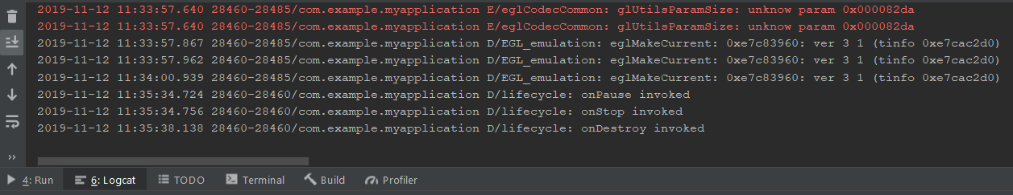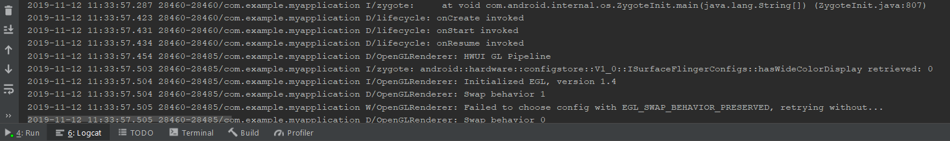**Output**

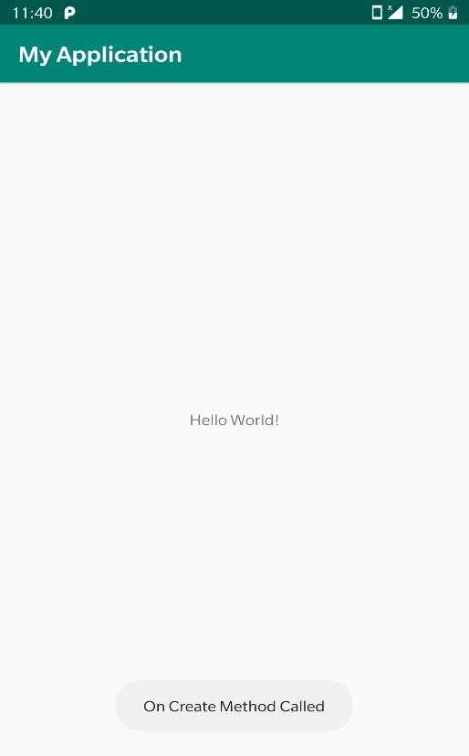

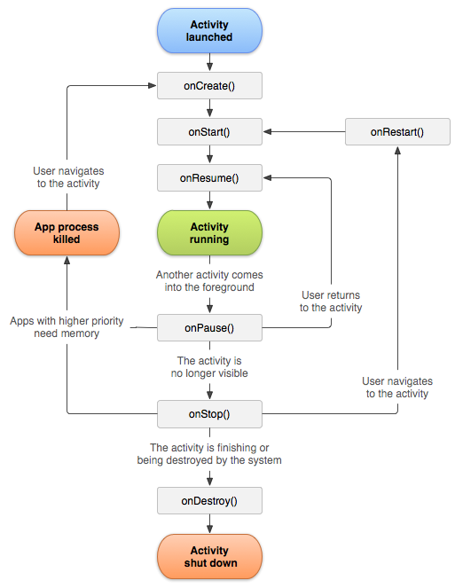

**Experiment 5 (Event Creation)**

1. Create a calculator App with buttons for each operation

**Code**

MainActivity.java

package com.example.calculator;  
  
import android.support.v7.app.AppCompatActivity;  
import android.os.Bundle;  
import android.view.View;  
import android.widget.Button;  
import android.widget.TextView;  
  
import com.example.calculator.R;  
  
public class MainActivity extends AppCompatActivity {  
  
 TextView displayTextView;  
 Button one_btn,two_btn,three_btn,four_btn,five_btn,six_btn,seven_btn,eight_btn,nine_btn,equal_btn,dot_btn,zero_btn,add_btn,sub_btn,divide_btn,mul_btn;  
 Button clear_btn;  
 double result=0;  
 @Override  
 protected void onCreate(Bundle savedInstanceState) {  
 super.onCreate(savedInstanceState);  
 setContentView(R.layout.*activity_main*);  
 displayTextView=(TextView)findViewById(R.id.*display_result_textview*);  
 one_btn=(Button)findViewById(R.id.*button1*);  
 two_btn=(Button)findViewById(R.id.*button2*);  
 three_btn=(Button)findViewById(R.id.*button3*);  
 four_btn=(Button)findViewById(R.id.*button4*);  
 five_btn=(Button)findViewById(R.id.*button5*);  
 six_btn=(Button)findViewById(R.id.*button6*);  
 seven_btn=(Button)findViewById(R.id.*button7*);  
 eight_btn=(Button)findViewById(R.id.*button8*);  
 nine_btn=(Button)findViewById(R.id.*button9*);  
 zero_btn=(Button)findViewById(R.id.*button0*);  
 add_btn=(Button)findViewById(R.id.*add_btn*);  
 divide_btn=(Button)findViewById(R.id.*divide_btn*);  
 sub_btn=(Button)findViewById(R.id.*sub_btn*);  
 mul_btn=(Button)findViewById(R.id.*multiply_btn*);  
 clear_btn=(Button)findViewById(R.id.*clear_btn*);  
 equal_btn=(Button)findViewById(R.id.*equal_btn*);  
 dot_btn=(Button)findViewById(R.id.*dot_btn*);  
  
 equal_btn.setOnClickListener(new View.OnClickListener() {  
 @Override  
 public void onClick(View v) {  
 String displayText=displayTextView.getText().toString();  
  
 String first="",second="";  
 int i=0;  
 while(displayText.charAt(i)!='+' && displayText.charAt(i)!='-' && displayText.charAt(i)!='*' && displayText.charAt(i)!='/'){  
 first+=displayText.charAt(i);  
 i++;  
 }  
 char c=displayText.charAt(i);  
 i++;  
 while(i<displayText.length()){  
 second+=displayText.charAt(i);  
 i++;  
 }  
 double val1=Double.*parseDouble*(first);  
 double val2=Double.*parseDouble*(second);  
 if(c=='+'){  
 result+=(val1+val2);  
 }else if(c=='-'){  
 result+=(val1-val2);  
 }else if(c=='*'){  
 result+=(val1*val2);  
 }else if(c=='/'){  
 result+=(val1/val2);  
 }  
 displayTextView.setText(Double.*toString*(result));  
 }  
 });  
 clear_btn.setOnClickListener(new View.OnClickListener() {  
 @Override  
 public void onClick(View v) {  
 displayTextView.setText("");  
 result=0;  
 }  
 });  
 }  
  
 public void writeInDisplay(View view){  
 switch (view.getId()){  
 case R.id.*button0*:  
 if(displayTextView.getText().equals("0")){  
 displayTextView.setText("0");  
 }else  
 displayTextView.setText(displayTextView.getText().toString()+"0");  
 break;  
 case R.id.*button1*:  
 if(displayTextView.getText().equals("0")){  
 displayTextView.setText("1");  
 }else  
 displayTextView.setText(displayTextView.getText().toString()+"1");  
 break;  
 case R.id.*button2*:  
 if(displayTextView.getText().equals("0")){  
 displayTextView.setText("2");  
 }else  
 displayTextView.setText(displayTextView.getText().toString()+"2");  
 break;  
 case R.id.*button3*:  
 if(displayTextView.getText().equals("0")){  
 displayTextView.setText("3");  
 }else  
 displayTextView.setText(displayTextView.getText().toString()+"3");  
 break;  
 case R.id.*button4*:  
 if(displayTextView.getText().equals("0")){  
 displayTextView.setText("4");  
 }else  
 displayTextView.setText(displayTextView.getText().toString()+"4");  
 break;  
 case R.id.*button5*:  
 if(displayTextView.getText().equals("0")){  
 displayTextView.setText("5");  
 }else  
 displayTextView.setText(displayTextView.getText().toString()+"5");  
 break;  
 case R.id.*button6*:  
 if(displayTextView.getText().equals("0")){  
 displayTextView.setText("6");  
 }else  
 displayTextView.setText(displayTextView.getText().toString()+"6");  
 break;  
 case R.id.*button7*:  
 if(displayTextView.getText().equals("0")){  
 displayTextView.setText("7");  
 }else  
 displayTextView.setText(displayTextView.getText().toString()+"7");  
 break;  
 case R.id.*button8*:  
 if(displayTextView.getText().equals("0")){  
 displayTextView.setText("8");  
 }else  
 displayTextView.setText(displayTextView.getText().toString()+"8");  
 break;  
 case R.id.*button9*:  
 if(displayTextView.getText().equals("0")){  
 displayTextView.setText("9");  
 }else  
 displayTextView.setText(displayTextView.getText().toString()+"9");  
 break;  
 case R.id.*dot_btn*:  
 displayTextView.setText(displayTextView.getText().toString()+".");  
 break;  
 case R.id.*add_btn*:  
 displayTextView.setText(displayTextView.getText().toString()+"+");  
 break;  
 case R.id.*sub_btn*:  
 displayTextView.setText(displayTextView.getText().toString()+"-");  
 break;  
 case R.id.*multiply_btn*:  
 displayTextView.setText(displayTextView.getText().toString()+"*");  
 break;  
 case R.id.*divide_btn*:  
 displayTextView.setText(displayTextView.getText().toString()+"/");  
 break;  
 }  
 }  
}

activity_main.xml

<?xml version="1.0" encoding="utf-8"?>  
<RelativeLayout xmlns:android="http://schemas.android.com/apk/res/android"  
 xmlns:app="http://schemas.android.com/apk/res-auto"  
 xmlns:tools="http://schemas.android.com/tools"  
 android:layout_width="match_parent"  
 android:layout_height="match_parent"  
 tools:context=".MainActivity">  
  
  
 <TextView  
 android:id="@+id/display_result_textview"  
 android:layout_width="match_parent"  
 android:layout_height="126dp"  
 android:text="0"  
 android:textSize="18sp"  
 android:padding="5dp"/>  
 <GridLayout  
 android:id="@+id/grid_layout"  
 android:layout_below="@id/display_result_textview"  
 android:layout_width="match_parent"  
 android:layout_height="wrap_content"  
 android:rowCount="4"  
 android:columnCount="4">  
  
 <Button  
 android:id="@+id/button7"  
 android:layout_width="wrap_content"  
 android:layout_height="wrap_content"  
 android:onClick="writeInDisplay"  
 android:text="7" />  
  
 <Button  
 android:id="@+id/button8"  
 android:layout_width="wrap_content"  
 android:layout_height="wrap_content"  
 android:onClick="writeInDisplay"  
 android:text="8" />  
  
 <Button  
 android:id="@+id/button9"  
 android:layout_width="wrap_content"  
 android:layout_height="wrap_content"  
 android:onClick="writeInDisplay"  
 android:text="9" />  
  
 <Button  
 android:id="@+id/divide_btn"  
 android:layout_width="wrap_content"  
 android:layout_height="wrap_content"  
 android:onClick="writeInDisplay"  
 android:text="/" />  
  
 <Button  
 android:id="@+id/button4"  
 android:layout_width="wrap_content"  
 android:layout_height="wrap_content"  
 android:onClick="writeInDisplay"  
 android:text="4" />  
  
 <Button  
 android:id="@+id/button5"  
 android:layout_width="wrap_content"  
 android:layout_height="wrap_content"  
 android:onClick="writeInDisplay"  
 android:text="5" />  
  
 <Button  
 android:id="@+id/button6"  
 android:layout_width="wrap_content"  
 android:layout_height="wrap_content"  
 android:onClick="writeInDisplay"  
 android:text="6" />  
  
 <Button  
 android:id="@+id/multiply_btn"  
 android:layout_width="wrap_content"  
 android:layout_height="wrap_content"  
 android:onClick="writeInDisplay"  
 android:text="*" />  
 <Button  
 android:id="@+id/button1"  
 android:layout_width="wrap_content"  
 android:layout_height="wrap_content"  
 android:onClick="writeInDisplay"  
 android:text="1" />  
  
 <Button  
 android:id="@+id/button2"  
 android:layout_width="wrap_content"  
 android:layout_height="wrap_content"  
 android:onClick="writeInDisplay"  
 android:text="2" />  
  
 <Button  
 android:id="@+id/button3"  
 android:layout_width="wrap_content"  
 android:layout_height="wrap_content"  
 android:onClick="writeInDisplay"  
 android:text="3" />  
  
 <Button  
 android:id="@+id/sub_btn"  
 android:layout_width="wrap_content"  
 android:layout_height="wrap_content"  
 android:onClick="writeInDisplay"  
 android:text="-" />  
 <Button  
 android:id="@+id/button0"  
 android:layout_width="wrap_content"  
 android:layout_height="wrap_content"  
 android:onClick="writeInDisplay"  
 android:text="0" />  
  
 <Button  
 android:id="@+id/dot_btn"  
 android:layout_width="wrap_content"  
 android:layout_height="wrap_content"  
 android:onClick="writeInDisplay"  
 android:text="." />  
  
 <Button  
 android:id="@+id/equal_btn"  
 android:layout_width="wrap_content"  
 android:layout_height="wrap_content"  
 android:text="=" />  
  
 <Button  
 android:id="@+id/add_btn"  
 android:layout_width="wrap_content"  
 android:layout_height="wrap_content"  
 android:onClick="writeInDisplay"  
 android:text="+" />  
  
 </GridLayout>  
  
 <Button  
 android:layout_below="@+id/grid_layout"  
 android:id="@+id/clear_btn"  
 android:layout_width="match_parent"  
 android:layout_height="wrap_content"  
 android:text="Clear"/>  
</RelativeLayout>

**Output**

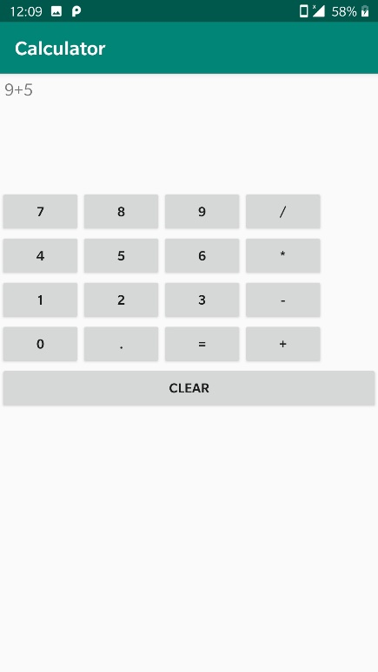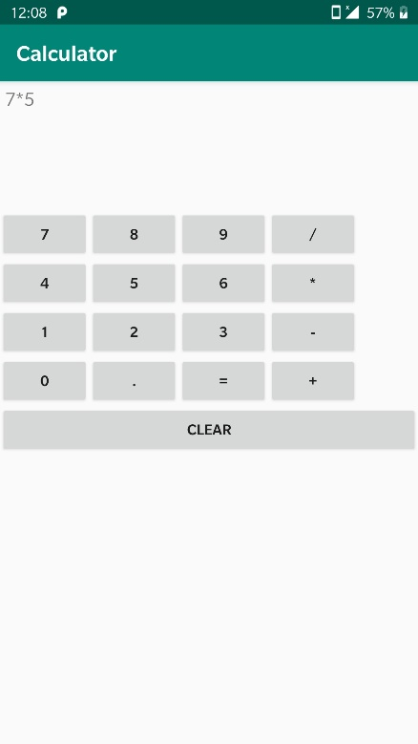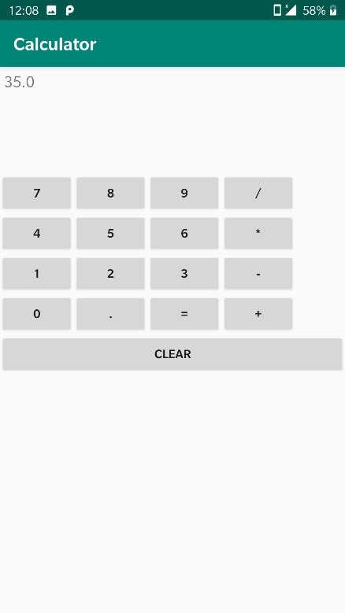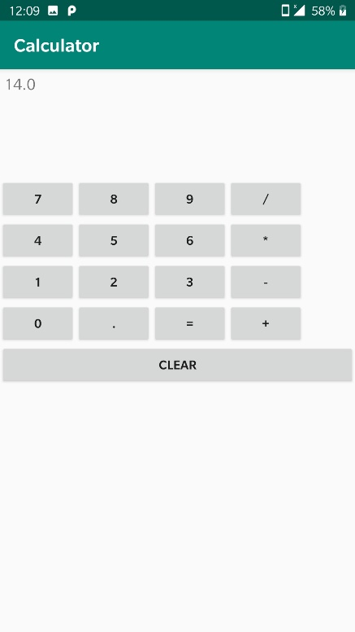

2. Create an Tailor App that will take in various paramters like : Name, PhoneNo , Address, Height( in metres) ( EditText ) Gender ( RadioButton Group ) Size (L/XL/XXL ) ( using Spinner)

**Code**

MainActivity.java

package com.example.tailorapp;  
  
import android.support.v7.app.AppCompatActivity;  
import android.os.Bundle;  
import android.os.Bundle;  
import android.view.View;  
import android.widget.EditText;  
import android.widget.RadioButton;  
import android.widget.Spinner;  
import android.widget.TextView;  
  
public class MainActivity extends AppCompatActivity {  
   
 Spinner spinner;  
 EditText height;  
 RadioButton male;  
 RadioButton female;  
 Boolean gender;  
 EditText name, ph, address;  
 String _name,_address,phone,size;  
 Double _height;  
 protected void onCreate(Bundle savedInstanceState) {  
 super.onCreate(savedInstanceState);  
 setContentView(R.layout.*activity_main*);  
 spinner = findViewById(R.id.*size*);  
 height = findViewById(R.id.*height*);  
 male = findViewById(R.id.*male*);  
 female = findViewById(R.id.*female*);  
 name = findViewById(R.id.*name*);  
 ph = findViewById(R.id.*ph*);  
 address = findViewById(R.id.*address*);  
 }  
 public void onRadioClick(View view)  
 {  
 if(male.isChecked())  
 gender = true;  
 if(female.isChecked())  
 gender = false;  
 }  
 public void onClick(View view){  
 _name = name.getText().toString();  
 _height = Double.*parseDouble*(height.getText().toString());  
 _address = address.getText().toString();  
 phone = ph.getText().toString();  
 size = spinner.getSelectedItem().toString();  
 Double price = calculatePrice();  
 TextView ans = findViewById(R.id.*price*);  
 ans.setText(price.toString());  
 }  
 public double calculatePrice()  
 {  
 if(gender)  
 {  
 if(size.equals("L"))  
 return _height*300;  
 else if(size.equals("XL"))  
 return _height*400;  
 else if(size.equals("XXL"))  
 return _height*500  
 }  
 else  
 {  
 if(size.equals("L"))  
 return _height*500;  
 else if(size.equals("XL"))  
 return _height*700;  
 else if(size.equals("XXL"))  
 return _height*900;  
 }  
 return -1;  
 }  
}

activity_main.xml

<?xml version="1.0" encoding="utf-8"?>  
<LinearLayout xmlns:android="http://schemas.android.com/apk/res/android"  
 xmlns:app="http://schemas.android.com/apk/res-auto"  
 xmlns:tools="http://schemas.android.com/tools"  
 android:layout_width="match_parent"  
 android:layout_height="match_parent"  
 tools:context=".MainActivity"  
 android:orientation="vertical"  
 android:layout_marginTop="20dp">  
  
 <TextView  
 android:layout_width="match_parent"  
 android:layout_height="wrap_content"  
 android:text="Name"/>  
 <EditText  
 android:layout_width="match_parent"  
 android:layout_height="wrap_content"  
 android:hint="Name"  
 android:id="@+id/name"/>  
  
 <TextView  
 android:layout_width="match_parent"  
 android:layout_height="wrap_content"  
 android:text="Contact Number"/>  
  
 <EditText  
 android:layout_width="match_parent"  
 android:layout_height="wrap_content"  
 android:hint="Phone Number"  
 android:inputType="phone"  
 android:id="@+id/ph"/>  
 <TextView  
 android:layout_width="match_parent"  
 android:layout_height="wrap_content"  
 android:text="Address"/>  
 <EditText  
 android:layout_width="match_parent"  
 android:layout_height="wrap_content"  
 android:hint="Address"  
 android:id="@+id/address"/>  
 <TextView  
 android:layout_width="match_parent"  
 android:layout_height="wrap_content"  
 android:text="Height"/>  
 <LinearLayout  
 android:layout_width="match_parent"  
 android:layout_height="wrap_content"  
 android:orientation="horizontal">  
  
 <EditText  
 android:layout_width="wrap_content"  
 android:layout_height="wrap_content"  
 android:id="@+id/height"  
 android:hint="height"/>  
  
 <TextView  
 android:layout_width="wrap_content"  
 android:layout_height="wrap_content"  
 android:text="metres" />  
 </LinearLayout>  
  
 <RadioGroup  
 android:layout_width="wrap_content"  
 android:layout_height="wrap_content"  
 android:orientation="horizontal">  
  
 <RadioButton  
 android:layout_width="match_parent"  
 android:layout_height="wrap_content"  
 android:text="Male"  
 android:id="@+id/male"  
 android:textSize="16sp"  
 android:onClick="onRadioClick"/>  
  
 <RadioButton  
 android:layout_width="wrap_content"  
 android:layout_height="match_parent"  
 android:text="Female"  
 android:id="@+id/female"  
 android:textSize="16sp"  
 android:onClick="onRadioClick"/>  
 </RadioGroup>  
  
 <Spinner  
 android:layout_width="match_parent"  
 android:layout_height="wrap_content"  
 android:id="@+id/size"  
 android:entries="@array/sizes"/>  
  
 <Button  
 android:layout_width="wrap_content"  
 android:layout_height="wrap_content"  
 android:id="@+id/submit"  
 android:text="Submit"  
 android:layout_gravity="center_horizontal"  
 android:onClick="onClick"/>  
  
 <TextView  
  
 android:layout_width="match_parent"  
 android:layout_height="wrap_content"  
 android:id="@+id/price"/>  
  
</LinearLayout>

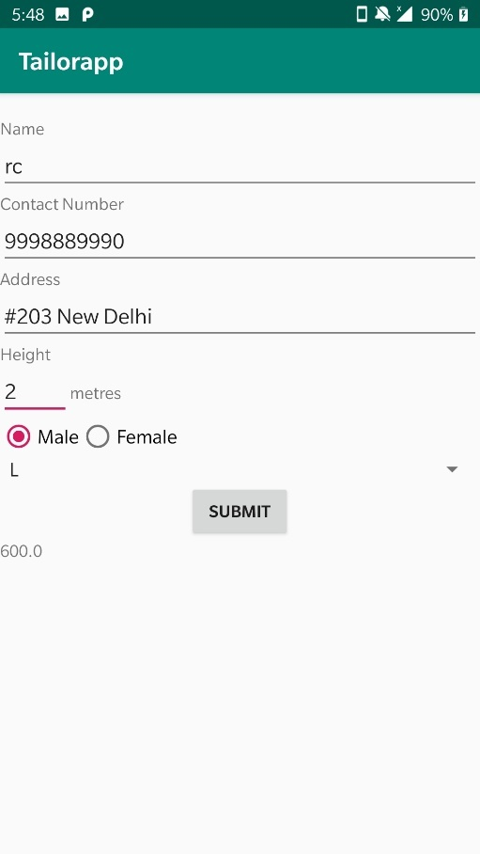**Output**

3. Dice Roller : On Button click Application will display any random number between 1 to 6

**Code**

MainActivity.java

package com.example.dice_roller;  
  
import android.support.v7.app.AppCompatActivity;  
import android.os.Bundle;  
import android.util.Log;  
import android.view.View;  
import android.widget.Button;  
import android.widget.ImageView;  
  
import java.util.Random;  
  
public class MainActivity extends AppCompatActivity {  
  
  
 private ImageView imgView01, imgView02;  
 private Button rollButton;  
 private Random randomDiceGenrater = new Random();  
  
 @Override  
 protected void onCreate(Bundle savedInstanceState) {  
 super.onCreate(savedInstanceState);  
 setContentView(R.layout.*activity_main*);  
  
 imgView01 = findViewById(R.id.*imageView01*);  
  
 rollButton = findViewById(R.id.*button*);  
 rollButton.setOnClickListener(new View.OnClickListener() {  
 @Override  
 public void onClick(View v) {  
 diceRoller(imgView01);  
 }  
 });  
 }  
  
 private void diceRoller(ImageView imgView)  
 {  
 int rdg = randomDiceGenrater.nextInt(6) + 1;  
  
 Log.*d*("Checking", "" + rdg);  
 switch (rdg)  
 {  
 case 1:  
 imgView.setImageResource(R.drawable.*dice01*);  
 break;  
 case 2:  
 imgView.setImageResource(R.drawable.*dice02*);  
 break;  
 case 3:  
 imgView.setImageResource(R.drawable.*dice03*);  
 break;  
 case 4:  
 imgView.setImageResource(R.drawable.*dice04*);  
 break;  
 case 5:  
 imgView.setImageResource(R.drawable.*dice05*);  
 break;  
 case 6:  
 imgView.setImageResource(R.drawable.*dice06*);  
 break;  
  
 }  
 }  
}

activity_main.xml

<?xml version="1.0" encoding="utf-8"?>  
<android.support.constraint.ConstraintLayout xmlns:android="http://schemas.android.com/apk/res/android"  
 xmlns:app="http://schemas.android.com/apk/res-auto"  
 xmlns:tools="http://schemas.android.com/tools"  
 android:layout_width="match_parent"  
 android:layout_height="match_parent"  
 android:scrollbars="vertical"  
 tools:context=".MainActivity">  
  
 <LinearLayout  
 android:id="@+id/linearLayout"  
 android:layout_width="wrap_content"  
 android:layout_height="wrap_content"  
 android:layout_margin="8dp"  
 android:layout_marginStart="8dp"  
 android:layout_marginTop="16dp"  
 android:layout_marginEnd="8dp"  
 android:orientation="horizontal"  
 app:layout_constraintEnd_toEndOf="parent"  
 app:layout_constraintStart_toStartOf="parent"  
 app:layout_constraintTop_toTopOf="parent">  
  
 <ImageView  
 android:id="@+id/imageView01"  
 android:layout_width="match_parent"  
 android:layout_height="match_parent"  
 android:layout_weight="1"  
 android:contentDescription="Dice Number 1"  
 android:src="@drawable/dice01" />  
  
 </LinearLayout>  
  
 <Button  
 android:id="@+id/button"  
 android:layout_width="wrap_content"  
 android:layout_height="wrap_content"  
 android:layout_marginStart="8dp"  
 android:layout_marginTop="56dp"  
 android:layout_marginEnd="8dp"  
 android:background="@color/colorPrimaryDark"  
 android:elevation="8dp"  
 android:padding="8dp"  
 android:text="Roll The Dice"  
 android:textColor="@android:color/white"  
 android:textSize="24sp"  
 app:layout_constraintEnd_toEndOf="parent"  
 app:layout_constraintStart_toStartOf="parent"  
 app:layout_constraintTop_toBottomOf="@+id/linearLayout" />  
  
</android.support.constraint.ConstraintLayout>

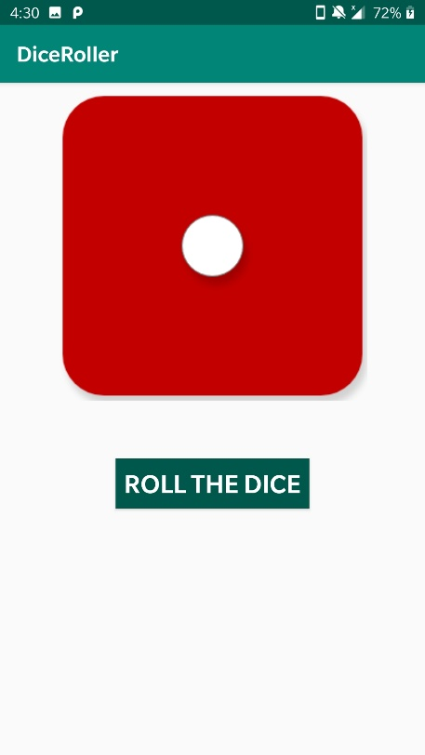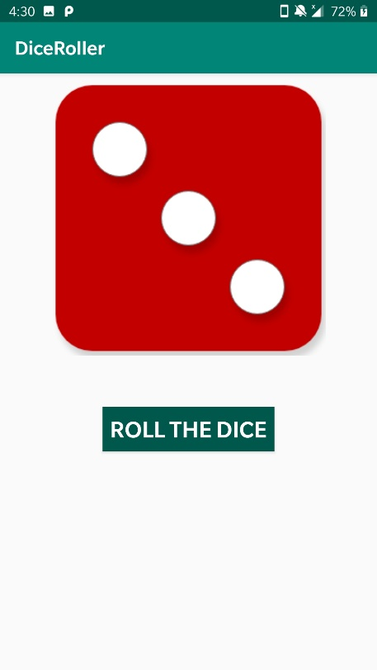**Output**

**Experiment 6 (ListView)**

1. Create an application that lists the states of India using ListView

**Code**

MainActivity.java

package com.example.listview;  
  
import android.support.v7.app.AppCompatActivity;  
import android.os.Bundle;  
  
public class MainActivity extends AppCompatActivity {  
  
  
 @Override  
 protected void onCreate(Bundle savedInstanceState) {  
 super.onCreate(savedInstanceState);  
 setContentView(R.layout.*activity_main*);  
 }  
}

activity_main.xml

<?xml version="1.0" encoding="utf-8"?>  
<RelativeLayout xmlns:android="http://schemas.android.com/apk/res/android"  
 xmlns:app="http://schemas.android.com/apk/res-auto"  
 xmlns:tools="http://schemas.android.com/tools"  
 android:layout_width="match_parent"  
 android:layout_height="match_parent"  
 tools:context=".MainActivity">  
  
 <ListView  
 android:entries="@array/india_states"  
 android:layout_width="match_parent"  
 android:layout_height="match_parent"  
 />  
</RelativeLayout>

strings.xml

<resources>  
 <string name="app_name">ListView  
 </string>  
 <string-array name="india_states">  
 <item>Andaman and Nicobar Islands</item>  
 <item>Andhra Pradesh</item>  
 <item>Arunachal Pradesh</item>  
 <item>Assam</item>  
 <item>Bihar</item>  
 <item>Chandigarh</item>  
 <item>Chhattisgarh</item>  
 <item>Dadra and Nagar Haveli</item>  
 <item>Daman and Diu</item>  
 <item>Delhi</item>  
 <item>Goa</item>  
 <item>Gujarat</item>  
 <item>Haryana</item>  
 <item>Himachal Pradesh</item>  
 <item>Jammu and Kashmir</item>  
 <item>Jharkhand</item>  
 <item>Karnataka</item>  
 <item>Kerala</item>  
 <item>Lakshadweep</item>  
 <item>Madhya Pradesh</item>  
 <item>Maharashtra</item>  
 <item>Manipur</item>  
 <item>Meghalaya</item>  
 <item>Mizoram</item>  
 <item>Nagaland</item>  
 <item>Orissa</item>  
 <item>Pondicherry</item>  
 <item>Punjab</item>  
 <item>Rajasthan</item>  
 <item>Sikkim</item>  
 <item>Tamil Nadu</item>  
 <item>Telangana</item>  
 <item>Tripura</item>  
 <item>Uttaranchal</item>  
 <item>Uttar Pradesh</item>  
 <item>West Bengal</item>  
 </string-array>  
</resources>

**Output**

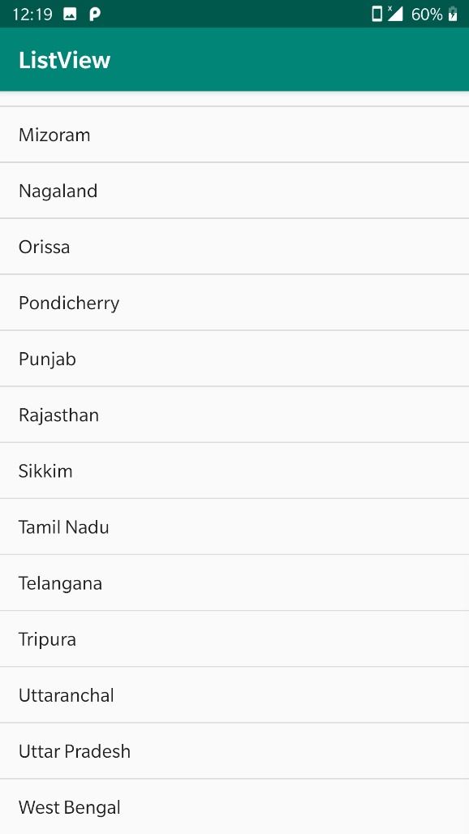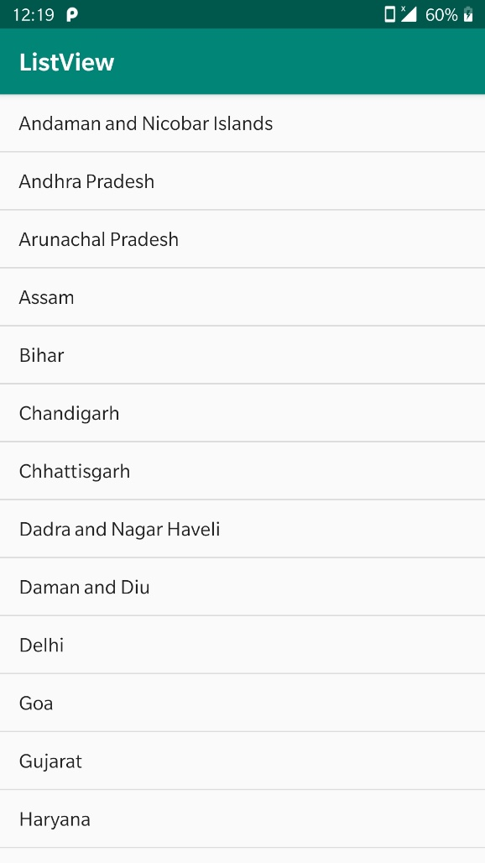

2. Create an application that lists the various android Versions till date .

**Code**

MainActivity.java

package com.example.listview;  
  
import android.support.v7.app.AppCompatActivity;  
import android.os.Bundle;  
  
public class MainActivity extends AppCompatActivity {  
  
  
 @Override  
 protected void onCreate(Bundle savedInstanceState) {  
 super.onCreate(savedInstanceState);  
 setContentView(R.layout.*activity_main*);  
 }  
}

activity_main.xml

<?xml version="1.0" encoding="utf-8"?>  
<RelativeLayout xmlns:android="http://schemas.android.com/apk/res/android"  
 xmlns:app="http://schemas.android.com/apk/res-auto"  
 xmlns:tools="http://schemas.android.com/tools"  
 android:layout_width="match_parent"  
 android:layout_height="match_parent"  
 tools:context=".MainActivity">  
  
 <ListView  
 android:entries="@array/india_states"  
 android:layout_width="match_parent"  
 android:layout_height="match_parent"  
 />  
</RelativeLayout>

strings.xml

<resources>  
 <string name="app_name">ListView  
 </string>  
 <string-array name="india_states">  
 <item>Android 1.5: Android Cupcake</item>  
 <item>Android 1.6: Android Donut</item>  
 <item>Android 2.0: Android Eclair</item>  
 <item>Android 2.2: Android Froyo</item>  
 <item>Android 2.3: Android Gingerbread</item>  
 <item>Android 3.0: Android Honeycomb</item>  
 <item>Android 4.0: Android Ice Cream Sandwich</item>  
 <item>Android 4.1: Android Jelly Bean</item>  
 <item>Android 4.4: Android KitKat</item>  
 <item>Android 5.0: Android Lollipop</item>  
 <item>Android 6.0: Android Marshmallow</item>  
 <item>Android 7.0: Android Nougat</item>  
 <item>Android 8.0: Android Oreo</item>  
 <item>Android 9.0: Android Pie</item>  
 </string-array>  
</resources>

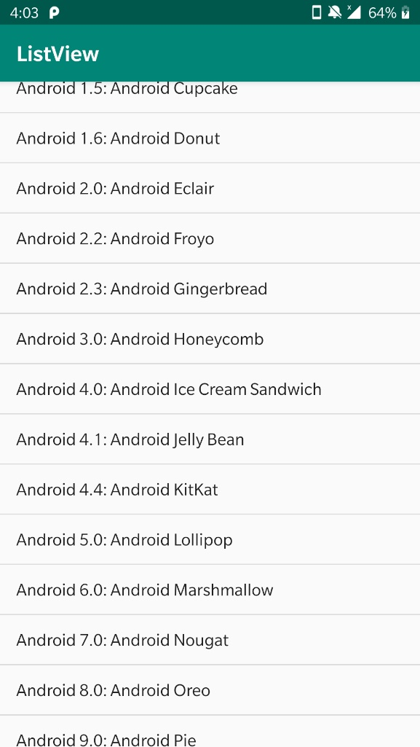**Output**

3. Design a Custom ListView.

**Code**

MainActivity.java

package com.example.customlistview;  
  
import android.support.v7.app.AppCompatActivity;  
import android.os.Bundle;  
import android.widget.ListView;  
  
import java.util.ArrayList;  
import java.util.List;  
  
public class MainActivity extends AppCompatActivity {  
 private List<Person> personList;  
 private PersonAdapter personAdapter;  
  
 @Override  
 protected void onCreate(Bundle savedInstanceState) {  
 super.onCreate(savedInstanceState);  
 setContentView(R.layout.*activity_main*);  
  
 personList = new ArrayList<>();  
 personList.add(new Person("Mark", "21"));  
 personList.add(new Person("John", "22"));  
 personList.add(new Person("Oliver", "28"));  
 personList.add(new Person("Tom", "27"));  
 personList.add(new Person("Francis", "30"));  
  
 personAdapter = new PersonAdapter(this, 0, personList);  
  
 ListView listView = (ListView) findViewById(R.id.*names_list_view*);  
 listView.setAdapter(personAdapter);  
 }  
}

activity_main.xml

<?xml version="1.0" encoding="utf-8"?>  
<RelativeLayout xmlns:android="http://schemas.android.com/apk/res/android"  
 xmlns:tools="http://schemas.android.com/tools"  
 android:id="@+id/activity_main"  
 android:layout_width="match_parent"  
 android:layout_height="match_parent"  
 tools:context=".MainActivity">  
  
 <ListView  
 android:id="@+id/names_list_view"  
 android:layout_width="match_parent"  
 android:layout_height="match_parent"  
 android:layout_centerVertical="true"  
 android:layout_centerHorizontal="true" />  
</RelativeLayout>

Person.java

package com.example.customlistview;  
  
public class Person {  
 private String name;  
 private String age;  
  
 public Person(String name, String age) {  
 this.name = name;  
 this.age = age;  
 }  
  
 public String getName() {  
 return name;  
 }  
  
 public String getAge() {  
 return age;  
 }  
}

PersonAdapter.java

package com.example.customlistview;  
  
import android.content.Context;  
import android.support.annotation.NonNull;  
import android.view.LayoutInflater;  
import android.view.View;  
import android.view.ViewGroup;  
import android.widget.ArrayAdapter;  
import android.widget.TextView;  
  
import java.util.List;  
  
public class PersonAdapter extends ArrayAdapter<Person>{  
 private static final String *TAG* = PersonAdapter.class.getSimpleName();  
  
 List<Person> personList;  
  
 public PersonAdapter(Context context, int resource, List<Person> objects) {  
 super(context, resource, objects);  
  
 personList = objects;  
 }  
  
 @NonNull  
 @Override  
 public View getView(int position, View convertView, ViewGroup parent) {  
 View listItemView = convertView;  
 Person currentPerson = personList.get(position);  
  
 if(listItemView == null){  
 listItemView = LayoutInflater.*from*(getContext()).inflate(R.layout.*person_list_item*, parent, false);  
 }  
  
 TextView nameTextView = (TextView) listItemView.findViewById(R.id.*name_text_view*);  
 nameTextView.setText(currentPerson.getName());  
  
 TextView ageTextView = (TextView) listItemView.findViewById(R.id.*age_text_view*);  
 ageTextView.setText(currentPerson.getAge());  
  
  
 return listItemView;  
 }  
}

person_list_item.xml

<?xml version="1.0" encoding="utf-8"?>  
<LinearLayout xmlns:android="http://schemas.android.com/apk/res/android"  
 xmlns:tools="http://schemas.android.com/tools"  
 android:layout_width="match_parent"  
 android:layout_height="60dp"  
 xmlns:app="http://schemas.android.com/apk/res-auto"  
 android:orientation="vertical"  
 android:id="@+id/text_container">  
  
  
  
 <TextView  
 android:layout_width="match_parent"  
 android:layout_height="0dp"  
 android:layout_weight="1"  
 android:id="@+id/name_text_view"  
 android:gravity="bottom"  
 android:textSize="18sp"  
 android:textStyle="normal|bold"  
 android:paddingLeft="10dp"  
 android:paddingRight="10dp"  
 android:paddingStart="10dp"  
 android:paddingEnd="10dp"  
 tools:text="Placeholder Name"  
 />  
  
 <TextView  
 android:layout_width="match_parent"  
 android:layout_height="0dp"  
 android:layout_weight="1"  
 android:id="@+id/age_text_view"  
 android:gravity="top"  
 android:textSize="18sp"  
 android:paddingLeft="10dp"  
 android:paddingRight="10dp"  
 android:paddingStart="10dp"  
 android:paddingEnd="10dp"  
 tools:text="Placeholder Age"  
 />  
  
  
</LinearLayout>

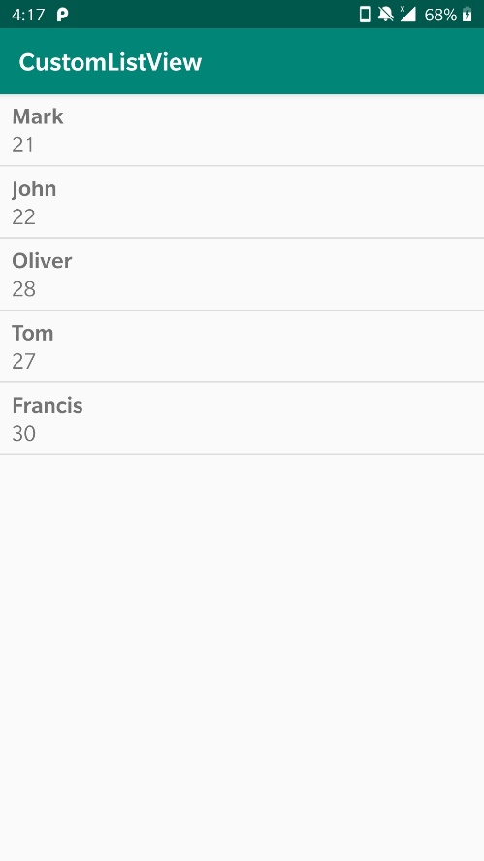**Output**

4. Design a ListView that will display each country name and its currency along with the flags

**Code**

MainActivity.java

package com.example.listview2;  
  
import android.support.v7.app.AppCompatActivity;  
import android.os.Bundle;  
import android.widget.ListView;  
  
  
public class MainActivity extends AppCompatActivity {  
  
 ListView simpleList;  
 String countryList[] = {"India", "China", "australia", "Portugal", "America", "NewZealand"};  
 int flags[] = {R.drawable.india, R.drawable.china, R.drawable.australia, R.drawable.portugal, R.drawable.america, R.drawable.newzealand};  
  
 @Override  
 protected void onCreate(Bundle savedInstanceState) {  
 super.onCreate(savedInstanceState);  
 setContentView(R.layout.activity_main);  
 simpleList = (ListView) findViewById(R.id.simpleListView);  
 CustomAdapter customAdapter = new CustomAdapter(getApplicationContext(), countryList, flags);  
 simpleList.setAdapter(customAdapter);  
 }  
}

activity_main.xml

<?xml version="1.0" encoding="utf-8"?>  
<LinearLayout xmlns:android="http://schemas.android.com/apk/res/android"  
 android:layout_width="match_parent"  
 android:layout_height="match_parent"  
 android:orientation="vertical">  
  
 <ListView  
 android:id="@+id/simpleListView"  
 android:layout_width="fill_parent"  
 android:layout_height="wrap_content"  
 android:divider="@color/material_blue_grey_800"  
 android:dividerHeight="1dp"  
 android:footerDividersEnabled="false" />  
</LinearLayout>

CustomAdapter.java

package com.example.listview2;  
  
import android.content.Context;  
import android.media.Image;  
import android.view.LayoutInflater;  
import android.view.View;  
import android.view.ViewGroup;  
import android.widget.BaseAdapter;  
import android.widget.ImageView;  
import android.widget.TextView;  
  
import com.example.listview2.R;  
  
import java.util.zip.Inflater;  
  
public class CustomAdapter extends BaseAdapter {  
 Context context;  
 String countryList[];  
 int flags[];  
 LayoutInflater inflter;  
  
 public CustomAdapter(Context applicationContext, String[] countryList, int[] flags) {  
 this.context = context;  
 this.countryList = countryList;  
 this.flags = flags;  
 inflter = (LayoutInflater.*from*(applicationContext));  
 }  
  
 @Override  
 public int getCount() {  
 return countryList.length;  
 }  
  
 @Override  
 public Object getItem(int i) {  
 return null;  
 }  
  
 @Override  
 public long getItemId(int i) {  
 return 0;  
 }  
  
 @Override  
 public View getView(int i, View view, ViewGroup viewGroup) {  
 view = inflter.inflate(R.layout.*activity_listview*, null);  
 TextView country = (TextView) view.findViewById(R.id.*textView*);  
 ImageView icon = (ImageView) view.findViewById(R.id.*icon*);  
 country.setText(countryList[i]);  
 icon.setImageResource(flags[i]);  
 return view;  
 }  
}

Listview.java

package com.example.listview2;  
  
import android.support.v7.app.AppCompatActivity;  
import android.os.Bundle;  
  
public class Listview extends AppCompatActivity {  
  
 @Override  
 protected void onCreate(Bundle savedInstanceState) {  
 super.onCreate(savedInstanceState);  
 setContentView(R.layout.*activity_listview*);  
 }  
}

activity_listview.xml

<?xml version="1.0" encoding="utf-8"?>  
<LinearLayout xmlns:android="http://schemas.android.com/apk/res/android"  
 android:layout_width="match_parent"  
 android:layout_height="match_parent"  
 android:orientation="horizontal">  
  
 <ImageView  
 android:id="@+id/icon"  
 android:layout_width="50dp"  
 android:layout_height="50dp"  
 android:src="@drawable/ic_launcher_background" />  
  
 <TextView  
 android:id="@+id/textView"  
 android:layout_width="fill_parent"  
 android:layout_height="wrap_content"  
 android:layout_gravity="center"  
 android:padding="15dp"  
 android:textColor="#000000" />  
</LinearLayout>

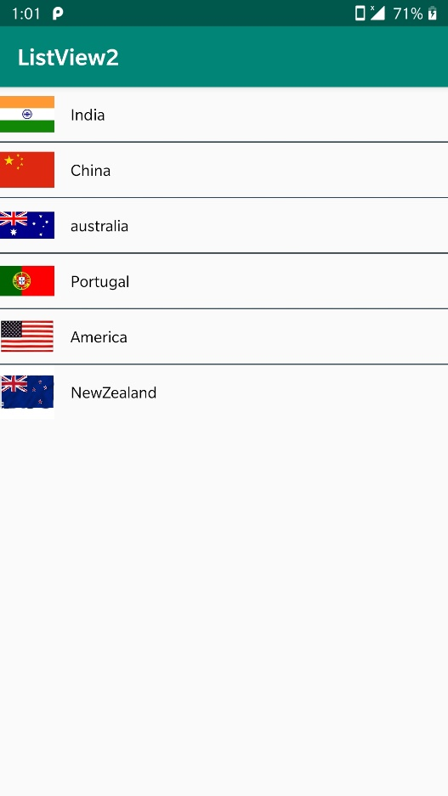**Output**

**Experiment 7 (Fragments)**

1. Create an application that uses fragments inside an activity

**Code**

MainActivity.java

package com.example.practice;  
  
import android.content.Intent;  
import android.support.v4.app.Fragment;  
import android.support.v4.app.FragmentManager;  
import android.support.v4.app.FragmentTransaction;  
import android.support.v7.app.AppCompatActivity;  
import android.os.Bundle;  
import android.view.View;  
import android.widget.Button;  
import android.widget.EditText;  
import android.widget.Toast;  
  
  
public class MainActivity extends AppCompatActivity implements View.OnLongClickListener{  
  
 Button b1,b2,b3,b4;  
 EditText edt;  
 Fragment fragment;  
 @Override  
 protected void onCreate(Bundle savedInstanceState) {  
 super.onCreate(savedInstanceState);  
 setContentView(R.layout.*activity_main*);  
  
 }  
  
 @Override  
 public boolean onLongClick(View v)  
 {  
 Toast.*makeText*(getApplicationContext(),"This is Button 1",Toast.*LENGTH_SHORT*).show();  
 return false;  
 }  
 public void onClick(View v)  
 {  
 Toast.*makeText*(getApplicationContext(),"This is Button 3",Toast.*LENGTH_SHORT*).show();  
 }  
 public void changeFragment(View v){  
 if(v.getId()==R.id.*b5*)  
 {  
 fragment= new one();  
 FragmentManager fm = getSupportFragmentManager();  
 FragmentTransaction ft =fm.beginTransaction();  
 ft.replace(R.id.*fg*,fragment);  
 ft.commit();  
 }  
 else if(v.getId()==R.id.*b6*)  
 {  
 fragment = new two();  
 FragmentManager fm = getSupportFragmentManager();  
 FragmentTransaction ft =fm.beginTransaction();  
 ft.replace(R.id.*fg*,fragment);  
 ft.commit();  
 }  
 }  
}

activity_main.xml

<?xml version="1.0" encoding="utf-8"?>  
<LinearLayout xmlns:android="http://schemas.android.com/apk/res/android"  
 xmlns:app="http://schemas.android.com/apk/res-auto"  
 xmlns:tools="http://schemas.android.com/tools"  
 android:layout_width="match_parent"  
 android:layout_height="match_parent"  
 tools:context=".MainActivity"  
 android:orientation="vertical">  
  
 <Button  
 android:layout_width="wrap_content"  
 android:layout_height="wrap_content"  
 android:id="@+id/b5"  
 android:text="Button 5"  
 android:onClick="changeFragment"/>  
 <Button  
 android:layout_width="wrap_content"  
 android:layout_height="wrap_content"  
 android:id="@+id/b6"  
 android:text="Button 6"  
 android:onClick="changeFragment"/>  
  
 <fragment  
 android:name="com.example.practice.two"  
 android:layout_width="match_parent"  
 android:layout_height="match_parent"  
 android:id="@+id/fg"/>  
</LinearLayout>

One.java

package com.example.practice;  
  
import android.content.Context;  
import android.net.Uri;  
import android.os.Bundle;  
import android.support.v4.app.Fragment;  
import android.view.LayoutInflater;  
import android.view.View;  
import android.view.ViewGroup;  
  
  
public class one extends Fragment {  
  
 @Override  
 public View onCreateView(LayoutInflater inflater, ViewGroup container,Bundle savedInstanceState) {  
 // Inflate the layout for this fragment  
 return inflater.inflate(R.layout.*fragment_one*, container, false);  
 }  
}

fragment_one.xml

<?xml version="1.0" encoding="utf-8"?>  
<FrameLayout xmlns:android="http://schemas.android.com/apk/res/android"  
 xmlns:tools="http://schemas.android.com/tools"  
 android:layout_width="match_parent"  
 android:layout_height="match_parent"  
 android:background="#12efef"  
 tools:context=".one">  
  
 <!-- *TODO: Update blank fragment layout* -->  
 <TextView  
 android:layout_width="match_parent"  
 android:layout_height="match_parent"  
 android:text="Fragment 1" />  
  
</FrameLayout>

Two.java

package com.example.practice;  
  
import android.content.Context;  
import android.net.Uri;  
import android.os.Bundle;  
import android.support.v4.app.Fragment;  
import android.view.LayoutInflater;  
import android.view.View;  
import android.view.ViewGroup;  
  
public class two extends Fragment {  
  
 @Override  
 public View onCreateView(LayoutInflater inflater, ViewGroup container, Bundle savedInstanceState) {  
 // Inflate the layout for this fragment  
 return inflater.inflate(R.layout.*fragment_two*, container, false);  
 }  
}

fragment_two.xml

<?xml version="1.0" encoding="utf-8"?>  
<FrameLayout xmlns:android="http://schemas.android.com/apk/res/android"  
 xmlns:tools="http://schemas.android.com/tools"  
 android:layout_width="match_parent"  
 android:layout_height="match_parent"  
 android:background="#f0f349"  
 tools:context=".two">  
  
 <!-- *TODO: Update blank fragment layout* -->  
 <TextView  
 android:layout_width="match_parent"  
 android:layout_height="match_parent"  
 android:text="Fragment 2" />  
  
</FrameLayout>

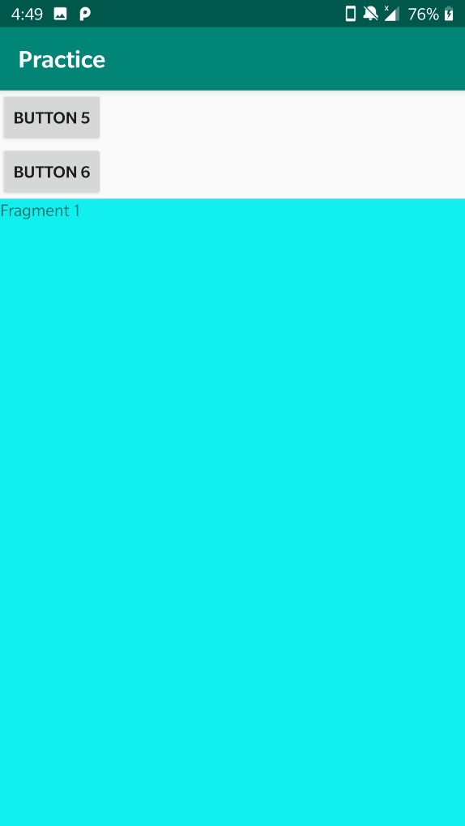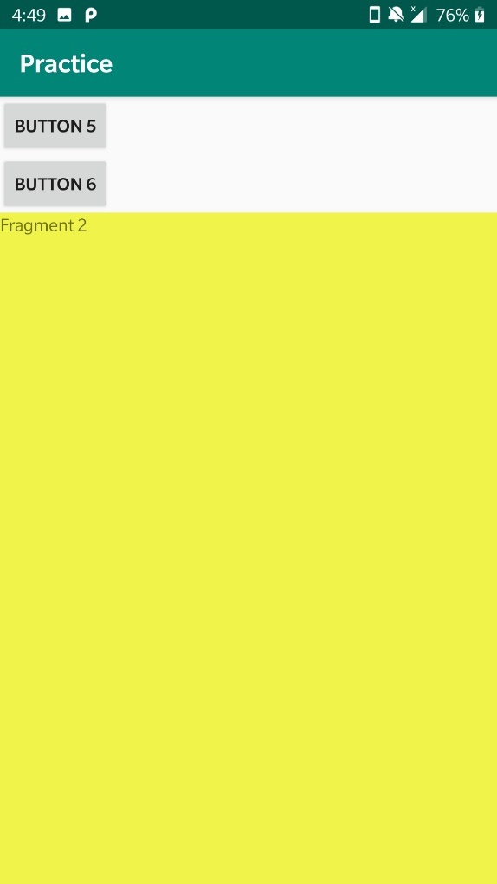**Output**

2. Create a tabbed activity and create 4 sliding tabs, using:

a. Viewpager widget, and

b. SectionsPagerAdapter

**Code**

MainActivity.java

package com.example.tabbed;  
  
import android.app.Fragment;  
import android.app.FragmentManager;  
import android.os.Bundle;  
import androidx.appcompat.app.AppCompatActivity;  
import androidx.appcompat.widget.Toolbar;  
import androidx.fragment.app.FragmentPagerAdapter;  
import androidx.viewpager.widget.ViewPager;  
import com.example.tabbed.Page1Fragment;  
import com.example.tabbed.Page2Fragment;  
import com.example.tabbed.Page3Fragment;  
import com.example.tabbed.R;  
import com.google.android.material.tabs.TabLayout;  
import com.example.R;  
public class MainActivity extends AppCompatActivity {  
 private final String LOG_TAG = MainActivity.class.getSimpleName();  
 // Titles of the individual pages (displayed in tabs)  
 private final String[] PAGE_TITLES = new String[] {  
 "Page 1",  
 "Page 2",  
 "Page 3",  
 "Page 4"  
 };  
 // The fragments that are used as the individual pages  
 private final Fragment[] PAGES = new Fragment[] {  
 new Page1Fragment(),  
 new Page2Fragment(),  
 new Page3Fragment(),  
 new Page4Fragment()  
 };  
 // The ViewPager is responsible for sliding pages (fragments) in and out upon user input  
 private ViewPager mViewPager;  
 @Override  
 protected void onCreate(Bundle savedInstanceState) {  
 super.onCreate(savedInstanceState);  
 setContentView(R.layout.activity_main);  
 // Set the Toolbar as the activity's app bar (instead of the default ActionBar)  
 Toolbar toolbar = (Toolbar) findViewById(R.id.toolbar);  
 setSupportActionBar(toolbar);  
 // Connect the ViewPager to our custom PagerAdapter. The PagerAdapter supplies the pages  
 // (fragments) to the ViewPager, which the ViewPager needs to display.  
 mViewPager = (ViewPager) findViewById(R.id.viewpager);  
 mViewPager.setAdapter(new MyPagerAdapter(getFragmentManager()));  
 // Connect the tabs with the ViewPager (the setupWithViewPager method does this for us in  
 // both directions, i.e. when a new tab is selected, the ViewPager switches to this page,  
 // and when the ViewPager switches to a new page, the corresponding tab is selected)  
 TabLayout tabLayout = (TabLayout) findViewById(R.id.tab_layout);  
 tabLayout.setupWithViewPager(mViewPager);  
 }  
 /* PagerAdapter for supplying the ViewPager with the pages (fragments) to display. */  
 public class MyPagerAdapter extends FragmentPagerAdapter {  
 public MyPagerAdapter(FragmentManager fragmentManager) {  
 super(fragmentManager);  
 }  
 @Override  
 public Fragment getItem(int position) {  
 return PAGES[position];  
 }  
 @Override  
 public int getCount() {  
 return PAGES.length;  
 }  
 @Override  
 public CharSequence getPageTitle(int position) {  
 return PAGE_TITLES[position];  
 }  
 }  
}

Page1Fragment.java

package com.example.tabbed;  
import android.app.Fragment;  
import android.os.Bundle;  
import android.view.LayoutInflater;  
import android.view.View;  
import android.view.ViewGroup;  
import org.weibeld.example.R;  
/* Fragment used as page 1 */  
public class Page1Fragment extends Fragment {  
 @Override  
 public View onCreateView(LayoutInflater inflater, ViewGroup container, Bundle savedInstanceState) {  
 View rootView = inflater.inflate(R.layout.fragment_page1, container, false);  
 return rootView;  
 }  
}

Page2Fragment.java

package com.example.tabbed;  
import android.app.Fragment;  
import android.os.Bundle;  
import android.view.LayoutInflater;  
import android.view.View;  
import android.view.ViewGroup;  
import org.weibeld.example.R;  
/* Fragment used as page 1 */  
public class Page1Fragment extends Fragment {  
 @Override  
 public View onCreateView(LayoutInflater inflater, ViewGroup container, Bundle savedInstanceState) {  
 View rootView = inflater.inflate(R.layout.fragment_page2, container, false);  
 return rootView;  
 }  
}

Page3Fragment.java

package com.example.tabbed;  
import android.app.Fragment;  
import android.os.Bundle;  
import android.view.LayoutInflater;  
import android.view.View;  
import android.view.ViewGroup;  
import org.weibeld.example.R;  
/* Fragment used as page 1 */  
public class Page1Fragment extends Fragment {  
 @Override  
 public View onCreateView(LayoutInflater inflater, ViewGroup container, Bundle savedInstanceState) {  
 View rootView = inflater.inflate(R.layout.fragment_page3, container, false);  
 return rootView;  
 }  
}

Page4Fragment.java

package com.example.tabbed;  
import android.app.Fragment;  
import android.os.Bundle;  
import android.view.LayoutInflater;  
import android.view.View;  
import android.view.ViewGroup;  
import org.weibeld.example.R;  
/* Fragment used as page 1 */  
public class Page1Fragment extends Fragment {  
 @Override  
 public View onCreateView(LayoutInflater inflater, ViewGroup container, Bundle savedInstanceState) {  
 View rootView = inflater.inflate(R.layout.fragment_page4, container, false);  
 return rootView;  
 }  
}

activity_main.xml

<?xml version="1.0" encoding="utf-8"?>  
<LinearLayout  
 xmlns:android="http://schemas.android.com/apk/res/android"  
 xmlns:tools="http://schemas.android.com/tools"  
 android:id="@+id/activity_main"  
 android:layout_width="match_parent"  
 android:layout_height="match_parent"  
 android:orientation="vertical"  
 tools:context="org.weibeld.example.tabs.MainActivity">  
<android.support.v7.widget.Toolbar  
 android:id="@+id/toolbar"  
 android:layout_width="match_parent"  
 android:layout_height="wrap_content"  
 android:minHeight="?attr/actionBarSize"  
 android:background="?attr/colorPrimary"  
 />  
<android.support.design.widget.TabLayout  
 android:id="@+id/tab_layout"  
 android:layout_height="wrap_content"  
 android:layout_width="match_parent"  
 android:background="?attr/colorPrimary"  
 />  
<android.support.v4.view.ViewPager  
 xmlns:android="http://schemas.android.com/apk/res/android"  
 android:id="@+id/viewpager"  
 android:layout_width="match_parent"  
 android:layout_height="match_parent"  
 />  
</LinearLayout>

Fragment_page1.xml

<?xml version="1.0" encoding="utf-8"?>  
<FrameLayout  
 xmlns:android="http://schemas.android.com/apk/res/android"  
 android:layout_width="match_parent"  
 android:layout_height="match_parent"  
 android:background="@color/pageColor1">  
<TextView  
 android:layout_width="wrap_content"  
 android:layout_height="wrap_content"  
 android:layout_gravity="center"  
 android:text="This is page 1"  
 />  
</FrameLayout>

Fragment_page2.xml

<?xml version="1.0" encoding="utf-8"?>  
<FrameLayout  
 xmlns:android="http://schemas.android.com/apk/res/android"  
 android:layout_width="match_parent"  
 android:layout_height="match_parent"  
 android:background="@color/pageColor1">  
<TextView  
 android:layout_width="wrap_content"  
 android:layout_height="wrap_content"  
 android:layout_gravity="center"  
 android:text="This is page 2"  
 />  
</FrameLayout>

Fragment_page3.xml

<?xml version="1.0" encoding="utf-8"?>  
<FrameLayout  
 xmlns:android="http://schemas.android.com/apk/res/android"  
 android:layout_width="match_parent"  
 android:layout_height="match_parent"  
 android:background="@color/pageColor1">  
<TextView  
 android:layout_width="wrap_content"  
 android:layout_height="wrap_content"  
 android:layout_gravity="center"  
 android:text="This is page 3"  
 />  
</FrameLayout>

Fragment_page4.xml

<?xml version="1.0" encoding="utf-8"?>  
<FrameLayout  
 xmlns:android="http://schemas.android.com/apk/res/android"  
 android:layout_width="match_parent"  
 android:layout_height="match_parent"  
 android:background="@color/pageColor1">  
<TextView  
 android:layout_width="wrap_content"  
 android:layout_height="wrap_content"  
 android:layout_gravity="center"  
 android:text="This is page 4"  
 />  
</FrameLayout>

**Output**

**Experiment 8 (Activities and Intents)**

1. Create an application with 2 activities and study about <intent-filter> in Manifest File and alternatively make each activity main and launcher one by one at a time.

**Code**

MainActivity.java

package com.example.intents;  
import android.content.Intent;  
import android.net.Uri;  
import android.support.v7.app.AppCompatActivity;  
import android.os.Bundle;  
import android.view.View;  
import android.widget.Button;  
  
public class MainActivity extends AppCompatActivity {  
 Button explicit_btn, implicit_btn;  
  
 @Override  
 protected void onCreate(Bundle savedInstanceState) {  
 super.onCreate(savedInstanceState);  
 setContentView(R.layout.*activity_main*);  
 explicit_btn = (Button)findViewById(R.id.*explicit_Intent*);  
 implicit_btn = (Button) findViewById(R.id.*implicit_Intent*);  
 //implement Onclick event for Explicit Intent  
 explicit_btn.setOnClickListener(new View.OnClickListener() {  
 @Override  
 public void onClick(View v) {  
 Intent intent = new Intent(getBaseContext(), SecondActivity.class);  
 startActivity(intent);  
 }  
 });  
 //implement onClick event for Implicit Intent  
 implicit_btn.setOnClickListener(new View.OnClickListener() {  
 @Override  
 public void onClick(View v) {  
 Intent intent = new Intent(Intent.*ACTION_VIEW*);  
 intent.setData(Uri.*parse*("https://www.abhiandroid.com"));  
 startActivity(intent);  
 }  
 });  
 }  
}

SecondActivity.java

package com.example.intents;  
import android.support.v7.app.AppCompatActivity;  
import android.os.Bundle;  
import android.widget.Toast;  
  
public class SecondActivity extends AppCompatActivity {  
 @Override  
 protected void onCreate(Bundle savedInstanceState) {  
 super.onCreate(savedInstanceState);  
 setContentView(R.layout.*activity_second*);  
 Toast.*makeText*(getApplicationContext(), "We are moved to second Activity",Toast.*LENGTH_LONG*).show();  
 }  
}

activity_main.xml

<RelativeLayout xmlns:android="http://schemas.android.com/apk/res/android"  
 xmlns:tools="http://schemas.android.com/tools" android:layout_width="match_parent"  
 android:layout_height="match_parent"  
 tools:context=".MainActivity">  
 <TextView  
 android:layout_width="wrap_content"  
 android:layout_height="wrap_content"  
 android:textAppearance="?android:attr/textAppearanceMedium"  
 android:text="If you click on Explicit example we will navigate to second activity within App and if you click on Implicit example AbhiAndroid Homepage will open in Browser"  
 android:id="@+id/textView2"  
 android:clickable="false"  
 android:layout_alignParentTop="true"  
 android:layout_alignParentStart="true"  
 android:layout_marginTop="42dp"  
 android:background="#3e7d02"  
 android:textColor="#ffffff" />  
 <Button  
 android:layout_width="wrap_content"  
 android:layout_height="wrap_content"  
 android:text="Explicit Intent Example"  
 android:id="@+id/explicit_Intent"  
 android:layout_alignParentTop="true"  
 android:layout_centerHorizontal="true"  
 android:layout_marginTop="147dp" />  
  
 <Button  
 android:layout_width="wrap_content"  
 android:layout_height="wrap_content"  
 android:text="Implicit Intent Example"  
 android:id="@+id/implicit_Intent"  
 android:layout_centerVertical="true"  
 android:layout_centerHorizontal="true" />  
</RelativeLayout>

activity_second.xml

<?xml version="1.0" encoding="utf-8"?>  
  
<RelativeLayout xmlns:android="http://schemas.android.com/apk/res/android"  
 xmlns:tools="http://schemas.android.com/tools" android:layout_width="match_parent"  
 android:layout_height="match_parent"  
 android:background="#CCEEAA"  
 tools:context=".SecondActivity">  
 <TextView  
 android:layout_width="wrap_content"  
 android:layout_height="wrap_content"  
 android:textAppearance="?android:attr/textAppearanceLarge"  
 android:text="This is Second Activity"  
 android:id="@+id/textView"  
 android:layout_centerVertical="true"  
 android:layout_centerHorizontal="true" />  
</RelativeLayout>

AndroidManifest.xml

<?xml version="1.0" encoding="utf-8"?>  
<manifest xmlns:android="http://schemas.android.com/apk/res/android"  
 package="com.example.intents">  
  
 <application  
 android:allowBackup="true"  
 android:icon="@mipmap/ic_launcher"  
 android:label="@string/app_name"  
 android:roundIcon="@mipmap/ic_launcher_round"  
 android:supportsRtl="true"  
 android:theme="@style/AppTheme">  
 <activity android:name=".SecondActivity"></activity>  
 <activity android:name=".MainActivity">  
 <intent-filter>  
 <action android:name="android.intent.action.MAIN" />  
  
 <category android:name="android.intent.category.LAUNCHER" />  
 </intent-filter>  
 </activity>  
 </application>  
  
</manifest>

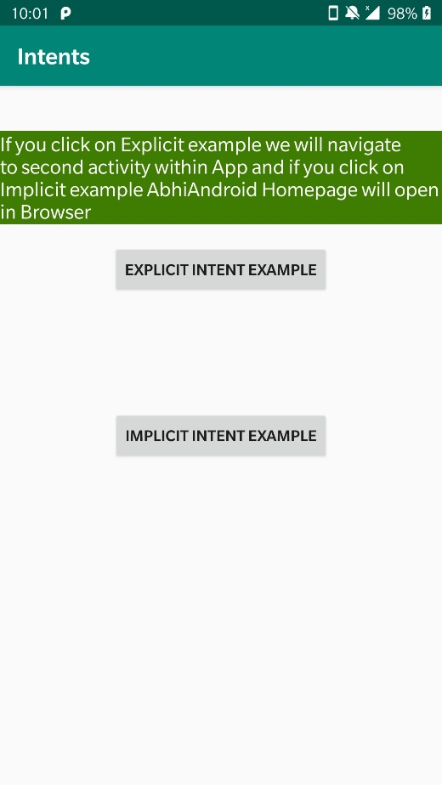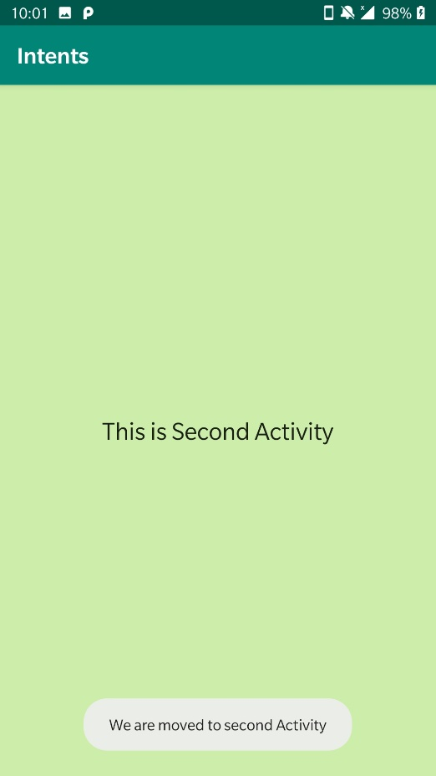**Output**

2. Use a Button to make intent and move between various activities.

**Code**

MainActivity.java

package com.example.intents;  
import android.support.v7.app.AppCompatActivity;  
import android.content.Intent;  
import android.os.Bundle;  
import android.view.View;  
import android.widget.Button;  
public class MainActivity extends AppCompatActivity {  
 Button b1;  
 @Override  
 protected void onCreate(Bundle savedInstanceState) {  
 super.onCreate(savedInstanceState);  
 setContentView(R.layout.*activity_main*);  
 b1=findViewById(R.id.*btn1*);  
 fun1();  
 }  
 public void fun1(){  
 b1.setOnClickListener(new View.OnClickListener() {  
 @Override  
 public void onClick(View view) {  
 Intent i=new Intent("activity1main");  
 i.putExtra("Message","Hello Mam");  
 startActivity(i);  
 }  
 });  
 }  
}

SecondActivity.java

package com.example.intents;  
import android.support.v7.app.AppCompatActivity;  
import android.content.Intent;  
import android.os.Bundle;  
import android.widget.TextView;  
public class SecondActivity extends AppCompatActivity {  
 public static final String *str*="Message";  
 TextView txt;  
 @Override  
 public void onCreate(Bundle savedInstanceState) {  
 super.onCreate(savedInstanceState);  
 setContentView(R.layout.*activity_second*);  
 Intent i=getIntent();  
 txt=findViewById(R.id.*txt1*);  
 txt.setText(i.getStringExtra(*str*));  
 }  
}

activity_main.xml

<?xml version="1.0" encoding="utf-8"?>  
<LinearLayout xmlns:android="http://schemas.android.com/apk/res/android"  
 xmlns:app="http://schemas.android.com/apk/res-auto"  
 xmlns:tools="http://schemas.android.com/tools"  
 android:layout_width="match_parent"  
 android:layout_height="match_parent"  
 tools:context=".MainActivity">  
 <Button  
 android:layout_width="wrap_content"  
 android:layout_height="wrap_content"  
 android:layout_gravity="center"  
 android:text="touch me"  
 android:id="@+id/btn1"/>  
</LinearLayout>

activity_second.xml

<?xml version="1.0" encoding="utf-8"?>  
<LinearLayout xmlns:android="http://schemas.android.com/apk/res/android"  
 android:layout_width="match_parent"  
 android:layout_height="match_parent"  
 android:background="@color/colorAccent"  
 android:orientation="vertical">  
  
 <TextView  
 android:layout_width="wrap_content"  
 android:layout_height="wrap_content"  
 android:layout_gravity="center"  
 android:text="Hello"  
 android:id="@+id/txt1"/>  
</LinearLayout>

AndroidManifest.xml

<?xml version="1.0" encoding="utf-8"?>  
<manifest xmlns:android="http://schemas.android.com/apk/res/android"  
 package="com.example.intents">  
  
 <application  
 android:allowBackup="true"  
 android:icon="@mipmap/ic_launcher"  
 android:label="@string/app_name"  
 android:roundIcon="@mipmap/ic_launcher_round"  
 android:supportsRtl="true"  
 android:theme="@style/AppTheme">  
 <activity android:name=".SecondActivity">  
 <intent-filter>  
 <action android:name="activity1main" />  
 <category android:name="android.intent.category.DEFAULT" />  
 </intent-filter>  
 </activity>  
 <activity android:name=".MainActivity">  
 <intent-filter>  
 <action android:name="android.intent.action.MAIN" />  
  
 <category android:name="android.intent.category.LAUNCHER" />  
 </intent-filter>  
 </activity>  
 </application>  
  
</manifest>

**Output**

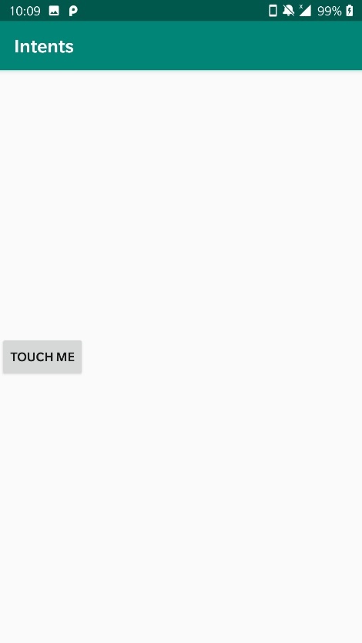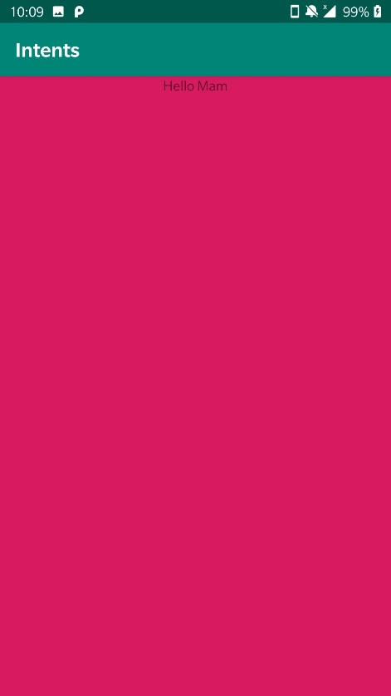

3. Design a Login Page that forwards user to new activity using intent on successful login

**Code**

MainActivity.java

package com.example.intents;  
  
import android.support.v7.app.AppCompatActivity;  
  
import android.content.Intent;  
import android.os.Bundle;  
import android.view.View;  
import android.widget.Button;  
import android.widget.EditText;  
import android.widget.Toast;  
public class MainActivity extends AppCompatActivity {  
  
 EditText et1,et2;  
 Button b1;  
 @Override  
 protected void onCreate(Bundle savedInstanceState) {  
 super.onCreate(savedInstanceState);  
 setContentView(R.layout.*activity_main*);  
 b1=findViewById(R.id.*bt1*);  
 et1=findViewById(R.id.*et1*);  
   
 b1.setOnClickListener(new View.OnClickListener() {  
 @Override  
 public void onClick(View view) {  
 String Name = et1.getText().toString();  
 String pass = et2.getText().toString();  
  
 if(Name.equals("") || pass.equals(""))  
 {  
 Toast.*makeText*(MainActivity.this, "Enter Complete Details", Toast.*LENGTH_SHORT*).show();  
 }  
 else  
 {  
 Intent intent = new Intent(MainActivity.this,SecondActivity.class);  
 startActivity(intent);  
 finish();  
 }  
 }  
 });  
  
 }  
  
  
}

SecondActivity.java

package com.example.intents;  
  
import android.support.v7.app.AppCompatActivity;  
import android.os.Bundle;  
public class SecondActivity extends AppCompatActivity {  
  
 @Override  
 protected void onCreate(Bundle savedInstanceState) {  
 super.onCreate(savedInstanceState);  
 setContentView(R.layout.*activity_second*);  
 }  
}

Activity_main.xml

<?xml version="1.0" encoding="utf-8"?>  
<LinearLayout xmlns:android="http://schemas.android.com/apk/res/android"  
 xmlns:app="http://schemas.android.com/apk/res-auto"  
 xmlns:tools="http://schemas.android.com/tools"  
 android:layout_width="match_parent"  
 android:layout_height="match_parent"  
 android:orientation="vertical"  
 android:layout_margin="20dp"  
 tools:context=".MainActivity">  
  
 <EditText  
 android:layout_width="match_parent"  
 android:layout_height="wrap_content"  
 android:hint="Name"  
 android:layout_margin="10dp"  
 android:id="@+id/et1"/>  
 <EditText  
 android:layout_width="match_parent"  
 android:layout_height="wrap_content"  
 android:hint="Password"  
 android:inputType="textPassword"  
 android:layout_margin="10dp"  
 android:id="@+id/et2"/>  
 <Button  
 android:layout_width="wrap_content"  
 android:layout_height="wrap_content"  
 android:text="Push Me"  
 android:layout_margin="10dp"  
 android:layout_gravity="center"  
 android:id="@+id/bt1"/>  
  
</LinearLayout>

Activity_second.xml

<?xml version="1.0" encoding="utf-8"?>  
<LinearLayout xmlns:android="http://schemas.android.com/apk/res/android"  
 xmlns:app="http://schemas.android.com/apk/res-auto"  
 xmlns:tools="http://schemas.android.com/tools"  
 android:layout_width="match_parent"  
 android:layout_height="match_parent"  
 android:orientation="vertical"  
 android:layout_margin="20dp"  
 tools:context=".MainActivity">  
  
 <TextView  
 android:layout_width="match_parent"  
 android:layout_height="wrap_content"  
 android:text="Succesfully logged in"  
 android:id="@+id/et1"/>  
  
  
</LinearLayout>

**Output**

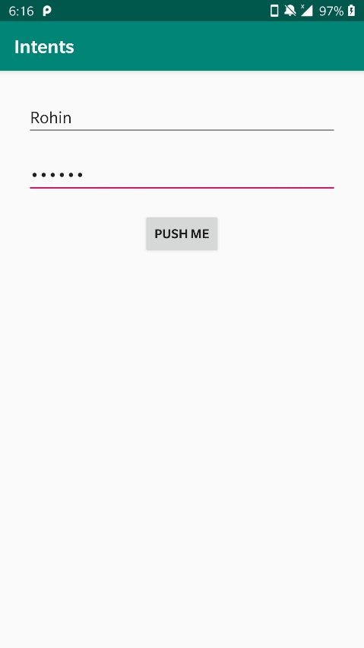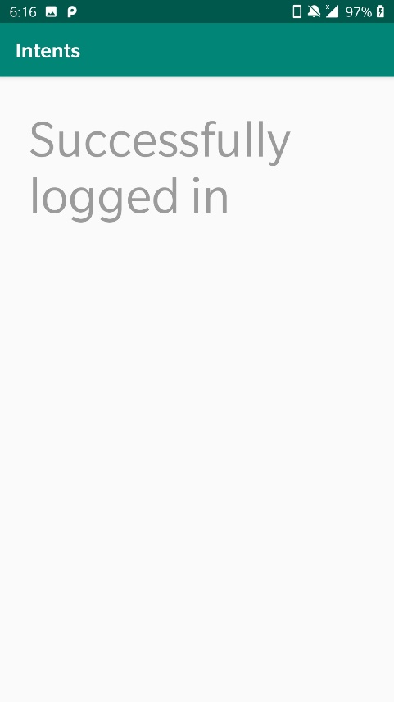

4. Design a 2 Activity long registration form such that on ‘ next Page Button ‘ activity 1 proceeds to next Page of form only if all the fields in current form are filled

**Code**

MainActivity.java

package com.example.intents;  
  
import android.support.v7.app.AppCompatActivity;  
  
import android.content.Intent;  
import android.os.Bundle;  
import android.view.View;  
import android.widget.Button;  
import android.widget.EditText;  
import android.widget.Toast;  
public class MainActivity extends AppCompatActivity {  
  
 EditText et1,et2,et3,et4;  
 Button b1;  
 @Override  
 protected void onCreate(Bundle savedInstanceState) {  
 super.onCreate(savedInstanceState);  
 setContentView(R.layout.*activity_main*);  
 b1=findViewById(R.id.*bt1*);  
 et1=findViewById(R.id.*et1*);  
 et2=findViewById(R.id.*et2*);  
 et3=findViewById(R.id.*et3*);  
 et4=findViewById(R.id.*et4*);  
  
  
  
 b1.setOnClickListener(new View.OnClickListener() {  
 @Override  
 public void onClick(View view) {  
 String firstName = et1.getText().toString();  
 String lastName = et2.getText().toString();  
 String age = et3.getText().toString();  
 String rollNo = et4.getText().toString();  
  
 if(firstName.equals("") || lastName.equals("") || age.equals("") || rollNo.equals(""))  
 {  
 Toast.*makeText*(MainActivity.this, "Enter Complete Details", Toast.*LENGTH_SHORT*).show();  
 }  
 else  
 {  
 Intent intent = new Intent(MainActivity.this,SecondActivity.class);  
 startActivity(intent);  
 finish();  
 }  
 }  
 });  
  
 }  
  
  
}

SecondActivity.java

package com.example.intents;  
  
import android.content.Intent;  
import android.support.v7.app.AppCompatActivity;  
import android.os.Bundle;  
import android.view.View;  
import android.widget.Button;  
import android.widget.EditText;  
import android.widget.Toast;  
public class SecondActivity extends AppCompatActivity {  
  
 EditText et1,et2;  
 Button b1;  
  
 @Override  
 protected void onCreate(Bundle savedInstanceState) {  
 super.onCreate(savedInstanceState);  
 setContentView(R.layout.*activity_second*);  
 b1=findViewById(R.id.*bt1*);  
 et1=findViewById(R.id.*et1*);  
 et2=findViewById(R.id.*et2*);  
  
 b1.setOnClickListener(new View.OnClickListener() {  
 @Override  
 public void onClick(View view) {  
 String pass = et1.getText().toString();  
 String repass = et2.getText().toString();  
  
 if(pass.equals("") || repass.equals(""))  
 {  
 Toast.*makeText*(SecondActivity.this, "Enter Complete Details", Toast.*LENGTH_SHORT*).show();  
 }  
 else  
 {  
 Toast.*makeText*(SecondActivity.this, "Successfully Registered", Toast.*LENGTH_SHORT*).show();  
 }  
 }  
 });  
  
 }  
}

Activity_main.xml

<?xml version="1.0" encoding="utf-8"?>  
<LinearLayout xmlns:android="http://schemas.android.com/apk/res/android"  
 xmlns:app="http://schemas.android.com/apk/res-auto"  
 xmlns:tools="http://schemas.android.com/tools"  
 android:layout_width="match_parent"  
 android:layout_height="match_parent"  
 android:orientation="vertical"  
 android:layout_margin="20dp"  
 tools:context=".MainActivity">  
  
 <EditText  
 android:layout_width="match_parent"  
 android:layout_height="wrap_content"  
 android:hint="First Name"  
 android:layout_margin="10dp"  
 android:id="@+id/et1"/>  
 <EditText  
 android:layout_width="match_parent"  
 android:layout_height="wrap_content"  
 android:hint="Last Name"  
 android:layout_margin="10dp"  
 android:id="@+id/et2"/>  
 <EditText  
 android:layout_width="match_parent"  
 android:layout_height="wrap_content"  
 android:hint="Age"  
 android:layout_margin="10dp"  
 android:id="@+id/et3"/>  
 <EditText  
 android:layout_width="match_parent"  
 android:layout_height="wrap_content"  
 android:hint="Roll Number"  
 android:layout_margin="10dp"  
 android:id="@+id/et4"/>  
 <Button  
 android:layout_width="wrap_content"  
 android:layout_height="wrap_content"  
 android:text="Next"  
 android:layout_margin="10dp"  
 android:layout_gravity="center"  
 android:id="@+id/bt1"/>  
  
</LinearLayout>

Activity_second.xml

<?xml version="1.0" encoding="utf-8"?>  
<LinearLayout xmlns:android="http://schemas.android.com/apk/res/android"  
 xmlns:app="http://schemas.android.com/apk/res-auto"  
 xmlns:tools="http://schemas.android.com/tools"  
 android:layout_width="match_parent"  
 android:layout_height="match_parent"  
 android:orientation="vertical"  
 android:layout_margin="20dp"  
 tools:context=".SecondActivity">  
  
 <TextView  
 android:layout_width="match_parent"  
 android:layout_height="wrap_content"  
 android:hint="Set Password"  
 android:textSize="30dp"  
 android:textStyle="bold"/>  
 <EditText  
 android:layout_width="match_parent"  
 android:layout_height="wrap_content"  
 android:hint="Enter Password"  
 android:inputType="textPassword"  
 android:id="@+id/et2"/>  
  
 <EditText  
 android:layout_width="match_parent"  
 android:layout_height="wrap_content"  
 android:hint="Re-Enter Password"  
 android:inputType="textPassword"  
 android:id="@+id/et1"/>  
  
 <Button  
 android:layout_width="wrap_content"  
 android:layout_height="wrap_content"  
 android:text="Finsih"  
 android:layout_margin="10dp"  
 android:layout_gravity="center"  
 android:id="@+id/bt1"/>  
  
</LinearLayout>

**Output**

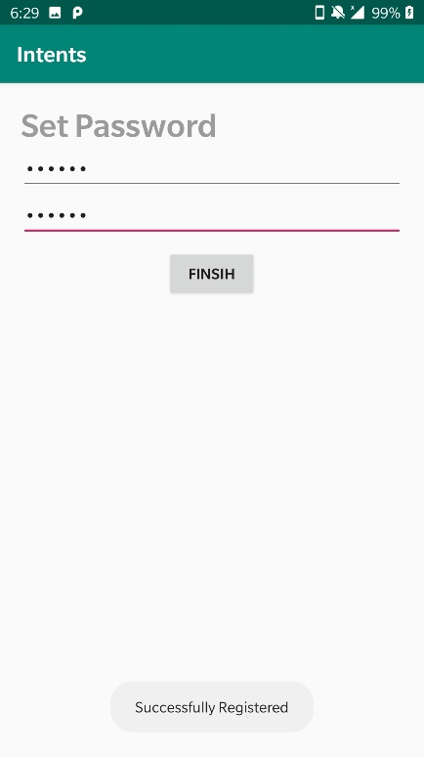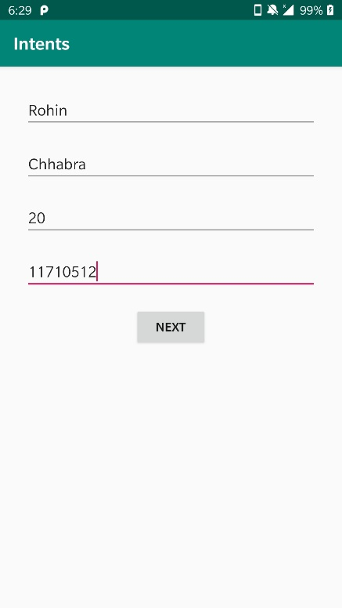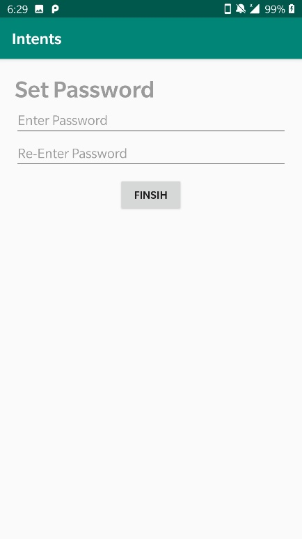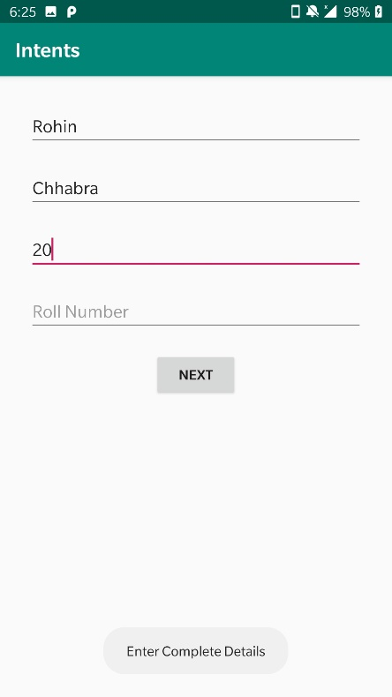

5. Design a App named Loopy that basically has 4 activities in a way that the intents form a loop

**Code**

MainActivity.java

package com.example.intents;  
  
import android.support.v7.app.AppCompatActivity;  
import android.content.Intent;  
import android.os.Bundle;  
import android.view.View;  
import android.widget.Button;  
public class MainActivity extends AppCompatActivity {  
  
 Button bt;  
 @Override  
 protected void onCreate(Bundle savedInstanceState) {  
 super.onCreate(savedInstanceState);  
 setContentView(R.layout.*activity_main*);  
 bt=findViewById(R.id.*bt*);  
 bt.setOnClickListener(new View.OnClickListener() {  
 @Override  
 public void onClick(View v) {  
 Intent intent =new Intent(MainActivity.this,SecondActivity.class);  
 startActivity(intent);  
 finish();  
 }  
 });  
  
 }  
  
  
}

SecondActivity.java

package com.example.intents;  
  
import android.content.Intent;  
import android.support.v7.app.AppCompatActivity;  
import android.os.Bundle;  
import android.view.View;  
import android.widget.Button;  
public class SecondActivity extends AppCompatActivity {  
  
 Button bt;  
 @Override  
 protected void onCreate(Bundle savedInstanceState) {  
 super.onCreate(savedInstanceState);  
 setContentView(R.layout.*activity_second*);  
 bt=findViewById(R.id.*bt*);  
 bt.setOnClickListener(new View.OnClickListener() {  
 @Override  
 public void onClick(View v) {  
 Intent intent =new Intent(SecondActivity.this,ThirdActivity.class);  
 startActivity(intent);  
 finish();  
 }  
 });  
 }  
}

ThirdActivity.java

package com.example.intents;  
import android.content.Intent;  
import android.support.v7.app.AppCompatActivity;  
import android.os.Bundle;  
import android.view.View;  
import android.widget.Button;  
public class ThirdActivity extends AppCompatActivity {  
 Button bt;  
 @Override  
 protected void onCreate(Bundle savedInstanceState) {  
 super.onCreate(savedInstanceState);  
 setContentView(R.layout.*activity_third*);  
 bt=findViewById(R.id.*bt*);  
 bt.setOnClickListener(new View.OnClickListener() {  
 @Override  
 public void onClick(View v) {  
 Intent intent =new Intent(ThirdActivity.this,FourthActivity.class);  
 startActivity(intent);  
 finish();  
 }  
 });  
 }  
}

FourthActivity.java

package com.example.intents;  
import android.content.Intent;  
import android.support.v7.app.AppCompatActivity;  
import android.os.Bundle;  
import android.view.View;  
import android.widget.Button;  
public class FourthActivity extends AppCompatActivity {  
 Button bt;  
 @Override  
 protected void onCreate(Bundle savedInstanceState) {  
 super.onCreate(savedInstanceState);  
 setContentView(R.layout.*activity_fourth*);  
 bt=findViewById(R.id.*bt*);  
 bt.setOnClickListener(new View.OnClickListener() {  
 @Override  
 public void onClick(View v) {  
 Intent intent =new Intent(FourthActivity.this,MainActivity.class);  
 startActivity(intent);  
 finish();  
 }  
 });  
 }  
}

Activity_main.xml

<?xml version="1.0" encoding="utf-8"?>  
<LinearLayout xmlns:android="http://schemas.android.com/apk/res/android"  
 android:layout_width="match_parent"  
 android:layout_height="match_parent"  
 android:background="#ABADE0"  
 android:orientation="vertical">  
 <Button  
 android:id="@+id/bt"  
 android:layout_width="wrap_content"  
 android:layout_height="wrap_content"  
 android:layout_marginTop="50dp"  
 android:layout_gravity="center"  
 android:text="Intent 1" />  
  
</LinearLayout>

Activity_second.xml

<?xml version="1.0" encoding="utf-8"?>  
<LinearLayout xmlns:android="http://schemas.android.com/apk/res/android"  
 android:layout_width="match_parent"  
 android:layout_height="match_parent"  
 android:background="#C0D2"  
 android:orientation="vertical">  
 <Button  
 android:id="@+id/bt"  
 android:layout_width="wrap_content"  
 android:layout_height="wrap_content"  
 android:layout_marginTop="50dp"  
 android:layout_gravity="center"  
 android:text="Intent 2" />  
  
</LinearLayout>

Activity_third.xml

<?xml version="1.0" encoding="utf-8"?>  
<LinearLayout xmlns:android="http://schemas.android.com/apk/res/android"  
 android:layout_width="match_parent"  
 android:layout_height="match_parent"  
 android:background="@android:color/holo_orange_light"  
 android:orientation="vertical">  
 <Button  
 android:id="@+id/bt"  
 android:layout_width="wrap_content"  
 android:layout_height="wrap_content"  
 android:layout_marginTop="50dp"  
 android:layout_gravity="center"  
 android:text="Intent 3" />  
  
</LinearLayout>

Activity_fourth.xml

<?xml version="1.0" encoding="utf-8"?>  
<LinearLayout xmlns:android="http://schemas.android.com/apk/res/android"  
 android:layout_width="match_parent"  
 android:layout_height="match_parent"  
 android:background="#4D50D1"  
 android:orientation="vertical">  
 <Button  
 android:id="@+id/bt"  
 android:layout_width="wrap_content"  
 android:layout_height="wrap_content"  
 android:layout_marginTop="50dp"  
 android:layout_gravity="center"  
 android:text="Intent 4" />  
  
</LinearLayout>

**Output**

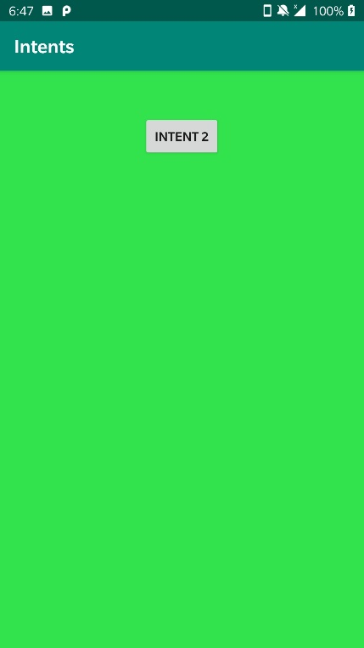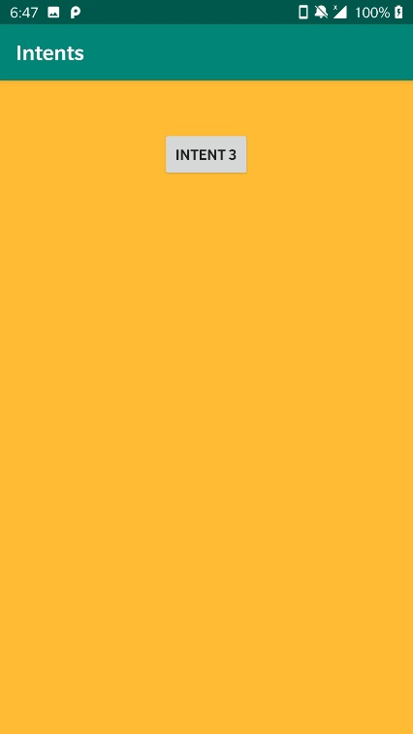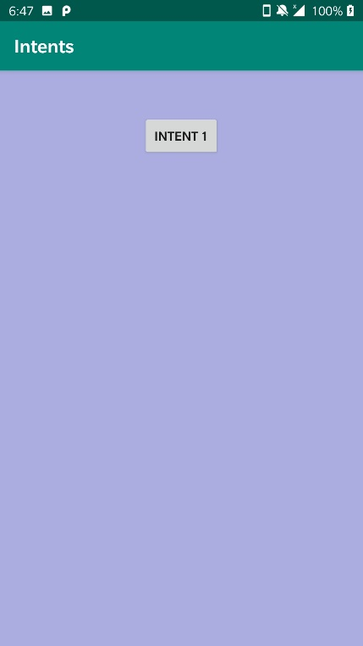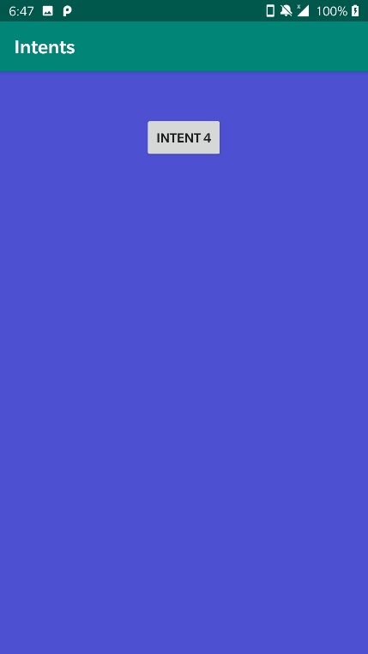

6. Pass Key Values in Intent in above ques and retrieve it in second activity (Forward Parsing)

**Code**

MainActivity.java

package com.example.loppy;  
import androidx.appcompat.app.AppCompatActivity;  
import android.content.Intent;  
import android.os.Bundle;  
import android.view.View;  
import android.widget.Button;  
public class MainActivity extends AppCompatActivity {  
 Button bt1;  
 @Override  
 protected void onCreate(Bundle savedInstanceState) {  
 super.onCreate(savedInstanceState);  
 setContentView(R.layout.activity_main);  
 bt1 = findViewById(R.id.bt1);  
 click1();  
 }  
 public void click1(){  
 bt1.setOnClickListener(new View.OnClickListener() {  
 @Override  
 public void onClick(View view) {  
 Intent i = new Intent(MainActivity.this,Activity2.class);  
 i.putExtra("key","abc");  
 startActivity(i);  
 }  
 });  
 }  
}

activity_main.xml

**<?xml version="1.0" encoding="utf-8"?>**

**<LinearLayout xmlns:android="http://schemas.android.com/apk/res/android"**

**xmlns:app="http://schemas.android.com/apk/res-auto"**

**xmlns:tools="http://schemas.android.com/tools"**

**android:layout_width="match_parent"**

**android:layout_height="match_parent"**

**android:background="@android:color/holo_blue_bright"**

**android:orientation="vertical"**

**tools:context=".MainActivity">**

**<Button**

**android:id="@+id/bt1"**

**android:layout_width="wrap_content"**

**android:layout_height="wrap_content"**

**android:layout_gravity="center"**

**android:text="intent 1" />**

**</LinearLayout>**

Activity2.java

**package com.example.loppy;**

**import android.os.Bundle;**

**import android.widget.EditText;**

**import androidx.annotation.Nullable;**

**import androidx.appcompat.app.AppCompatActivity;**

**public class Activity2 extends AppCompatActivity {**

**EditText edt;**

**@Override**

**protected void onCreate(@Nullable Bundle savedInstanceState) {**

**super.onCreate(savedInstanceState);**

**setContentView(R.layout.activity2_layout);**

**edt=findViewById(R.id.edt);**

**Bundle bundle=getIntent().getExtras();**

**edt.setText(bundle.getString("key"));**

**}**

**}**

Activity2_layout.xml

**<?xml version="1.0" encoding="utf-8"?>**

**<LinearLayout xmlns:android="http://schemas.android.com/apk/res/android"**

**android:layout_width="match_parent"**

**android:layout_height="match_parent"**

**android:background="@android:color/holo_green_dark"**

**android:orientation="vertical">**

**<EditText**

**android:layout_width="wrap_content"**

**android:layout_height="wrap_content"**

**android:hint="hello"**

**android:layout_gravity="center"**

**android:textSize="60dp"**

**android:id="@+id/edt"/></LinearLayout>**

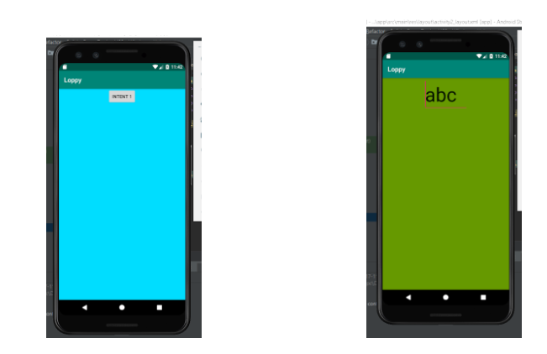**Output**

**Experiment 9 (Data Storage)**

1. Use shared Preferences to store and retrieve key value pairs stored in Shared Preferences

**Code**

MainActivity.java

package com.example.sharedpreference;  
  
import android.content.Intent;  
import android.content.SharedPreferences;  
import android.support.v7.app.AppCompatActivity;  
import android.os.Bundle;  
import android.view.View;  
import android.widget.Button;  
import android.widget.EditText;  
import android.widget.Toast;  
  
public class MainActivity extends AppCompatActivity {  
  
 EditText et1,et2;  
 Button bt1,bt2;  
 @Override  
 protected void onCreate(Bundle savedInstanceState) {  
 super.onCreate(savedInstanceState);  
 setContentView(R.layout.*activity_main*);  
  
 et1=findViewById(R.id.*et1*);  
 et2=findViewById(R.id.*et2*);  
 bt1=findViewById(R.id.*bt1*);  
 bt2=findViewById(R.id.*bt2*);  
  
 bt2.setOnClickListener(new View.OnClickListener() {  
 @Override  
 public void onClick(View v) {  
 Intent intent = new Intent(MainActivity.this,SecondActivity.class);  
 startActivity(intent);  
 finish();  
 }  
 });  
 bt1.setOnClickListener(new View.OnClickListener() {  
 @Override  
 public void onClick(View v) {  
 SharedPreferences sp = getSharedPreferences("MyData",*MODE_PRIVATE*);  
 SharedPreferences.Editor ed = sp.edit();  
 ed.putString("Name",et1.getText().toString());  
 ed.putString("Password",et2.getText().toString());  
 ed.commit();  
 Toast.*makeText*(MainActivity.this, "Data Saved", Toast.*LENGTH_SHORT*).show();  
 }  
 });  
 }  
}

activity_main.xml

<?xml version="1.0" encoding="utf-8"?>  
<LinearLayout xmlns:android="http://schemas.android.com/apk/res/android"  
 xmlns:app="http://schemas.android.com/apk/res-auto"  
 xmlns:tools="http://schemas.android.com/tools"  
 android:layout_width="match_parent"  
 android:layout_height="match_parent"  
 android:orientation="vertical"  
 android:layout_margin="20dp"  
 tools:context=".MainActivity">  
  
 <EditText  
 android:layout_width="match_parent"  
 android:layout_height="wrap_content"  
 android:hint="Name"  
 android:layout_margin="10dp"  
 android:id="@+id/et1"/>  
 <EditText  
 android:layout_width="match_parent"  
 android:layout_height="wrap_content"  
 android:hint="Password"  
 android:inputType="textPassword"  
 android:layout_margin="10dp"  
 android:id="@+id/et2"/>  
 <Button  
 android:layout_width="wrap_content"  
 android:layout_height="wrap_content"  
 android:text="Save"  
 android:layout_margin="10dp"  
 android:layout_gravity="center"  
 android:id="@+id/bt1"/>  
 <Button  
 android:layout_width="wrap_content"  
 android:layout_height="wrap_content"  
 android:text="Next"  
 android:layout_margin="10dp"  
 android:layout_gravity="center"  
 android:id="@+id/bt2"/>  
  
  
</LinearLayout>

SecondActivity.java

package com.example.sharedpreference;  
  
import android.content.Intent;  
import android.content.SharedPreferences;  
import android.support.v7.app.AppCompatActivity;  
import android.os.Bundle;  
import android.view.View;  
import android.widget.Button;  
import android.widget.TextView;  
import android.widget.Toast;  
  
public class SecondActivity extends AppCompatActivity {  
  
 TextView et1,et2;  
 Button bt1,bt2;  
 @Override  
 protected void onCreate(Bundle savedInstanceState) {  
 super.onCreate(savedInstanceState);  
 setContentView(R.layout.*activity_second*);  
  
 et1=findViewById(R.id.*et1*);  
 et2=findViewById(R.id.*et2*);  
 bt1=findViewById(R.id.*bt1*);  
 bt2=findViewById(R.id.*bt2*);  
  
 bt1.setOnClickListener(new View.OnClickListener() {  
 @Override  
 public void onClick(View v) {  
 SharedPreferences sp =getSharedPreferences("MyData",*MODE_PRIVATE*);  
 String name= sp.getString("Name","");  
 String password= sp.getString("Password","");  
  
 if(name.equals("") || password.equals(""))  
 {  
 Toast.*makeText*(SecondActivity.this, "Data not found", Toast.*LENGTH_SHORT*).show();  
 }  
 else  
 {  
 et1.setText(name);  
 et2.setText(password);  
 Toast.*makeText*(SecondActivity.this, "Data displayed", Toast.*LENGTH_SHORT*).show();  
 }  
 }  
  
 });  
  
 bt2.setOnClickListener(new View.OnClickListener() {  
 @Override  
 public void onClick(View v) {  
 Intent intent = new Intent(SecondActivity.this,MainActivity.class);  
 startActivity(intent);  
 finish();  
 }  
 });  
  
 }  
}

activity_second.xml

<?xml version="1.0" encoding="utf-8"?>  
<LinearLayout xmlns:android="http://schemas.android.com/apk/res/android"  
 xmlns:app="http://schemas.android.com/apk/res-auto"  
 xmlns:tools="http://schemas.android.com/tools"  
 android:layout_width="match_parent"  
 android:layout_height="match_parent"  
 android:orientation="vertical"  
 android:layout_margin="20dp"  
 tools:context=".SecondActivity">  
  
 <TextView  
 android:layout_width="match_parent"  
 android:layout_height="50dp"  
 android:text="Name"  
 android:layout_margin="10dp"  
 android:textSize="30dp"  
 android:id="@+id/et1"/>  
 <TextView  
 android:layout_width="match_parent"  
 android:layout_height="50dp"  
 android:text="Password"  
 android:textSize="30dp"  
 android:layout_margin="10dp"  
 android:id="@+id/et2"/>  
 <Button  
 android:layout_width="wrap_content"  
 android:layout_height="wrap_content"  
 android:text="Show"  
 android:layout_margin="10dp"  
 android:layout_gravity="center"  
 android:id="@+id/bt1"/>  
 <Button  
 android:layout_width="wrap_content"  
 android:layout_height="wrap_content"  
 android:text="Previous"  
 android:layout_margin="10dp"  
 android:layout_gravity="center"  
 android:id="@+id/bt2"/>  
  
  
</LinearLayout>

**Output**

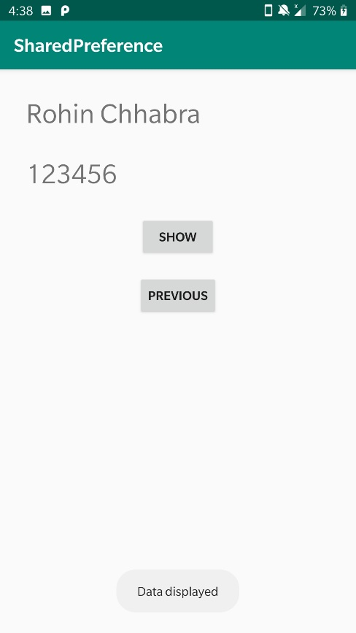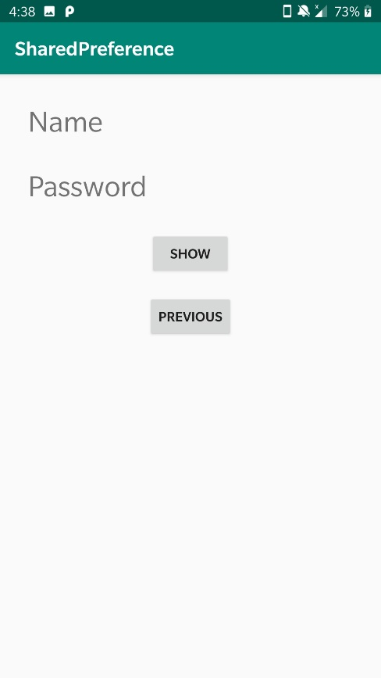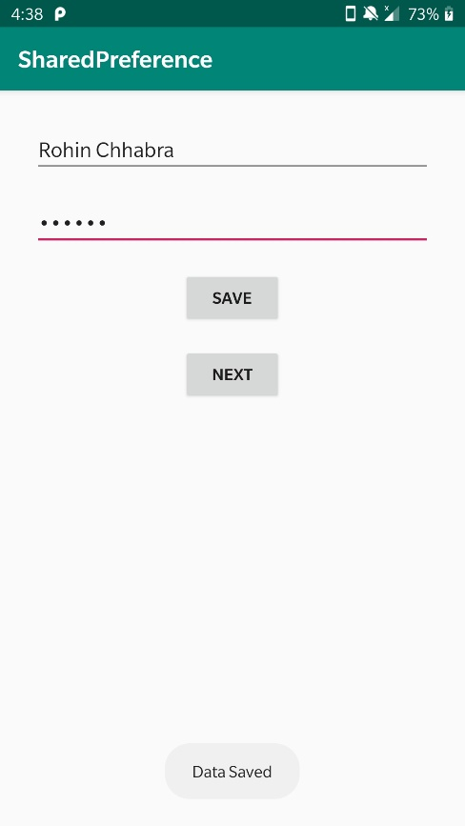

2. Use Content Provider and store data in SQLite.

**Code**

MainActivity.java

package com.example.programmingknowledge.sqliteapp;

import android.app.AlertDialog;

import android.database.Cursor;

import android.support.v7.app.ActionBarActivity;

import android.os.Bundle;

import android.view.Menu;

import android.view.MenuItem;

import android.view.View;

import android.widget.Button;

import android.widget.EditText;

import android.widget.Toast;

public class MainActivity extends ActionBarActivity {

DatabaseHelper myDb;

EditText editName,editSurname,editMarks ,editTextId;

Button btnAddData;

Button btnviewAll;

Button btnDelete;

Button btnviewUpdate;

@Override

protected void onCreate(Bundle savedInstanceState) {

super.onCreate(savedInstanceState);

setContentView(R.layout.activity_main);

myDb = new DatabaseHelper(this);

editName = (EditText)findViewById(R.id.editText_name);

editSurname = (EditText)findViewById(R.id.editText_surname);

editMarks = (EditText)findViewById(R.id.editText_Marks);

editTextId = (EditText)findViewById(R.id.editText_id);

btnAddData = (Button)findViewById(R.id.button_add);

btnviewAll = (Button)findViewById(R.id.button_viewAll);

btnviewUpdate= (Button)findViewById(R.id.button_update);

btnDelete= (Button)findViewById(R.id.button_delete);

AddData();

viewAll();

UpdateData();

DeleteData();

}

public void DeleteData() {

btnDelete.setOnClickListener(

new View.OnClickListener() {

@Override

public void onClick(View v) {

Integer deletedRows = myDb.deleteData(editTextId.getText().toString());

if(deletedRows > 0)

Toast.makeText(MainActivity.this,"Data Deleted",Toast.LENGTH_LONG).show();

else

Toast.makeText(MainActivity.this,"Data not Deleted",Toast.LENGTH_LONG).show();

}

}

);

}

public void UpdateData() {

btnviewUpdate.setOnClickListener(

new View.OnClickListener() {

@Override

public void onClick(View v) {

boolean isUpdate = myDb.updateData(editTextId.getText().toString(),

editName.getText().toString(),

editSurname.getText().toString(),editMarks.getText().toString());

if(isUpdate == true)

Toast.makeText(MainActivity.this,"Data Update",Toast.LENGTH_LONG).show();

else

Toast.makeText(MainActivity.this,"Data not Updated",Toast.LENGTH_LONG).show();

}

}

);

}

public void AddData() {

btnAddData.setOnClickListener(

new View.OnClickListener() {

@Override

public void onClick(View v) {

boolean isInserted = myDb.insertData(editName.getText().toString(),

editSurname.getText().toString(),

editMarks.getText().toString() );

if(isInserted == true)

Toast.makeText(MainActivity.this,"Data Inserted",Toast.LENGTH_LONG).show();

else

Toast.makeText(MainActivity.this,"Data not Inserted",Toast.LENGTH_LONG).show();

}

}

);

}

public void viewAll() {

btnviewAll.setOnClickListener(

new View.OnClickListener() {

@Override

public void onClick(View v) {

Cursor res = myDb.getAllData();

if(res.getCount() == 0) {

// show message

showMessage("Error","Nothing found");

return;

}

StringBuffer buffer = new StringBuffer();

while (res.moveToNext()) {

buffer.append("Id :"+ res.getString(0)+"\n");

buffer.append("Name :"+ res.getString(1)+"\n");

buffer.append("Surname :"+ res.getString(2)+"\n");

buffer.append("Marks :"+ res.getString(3)+"\n\n");

}

// Show all data

showMessage("Data",buffer.toString());

}

}

);

}

public void showMessage(String title,String Message){

AlertDialog.Builder builder = new AlertDialog.Builder(this);

builder.setCancelable(true);

builder.setTitle(title);

builder.setMessage(Message);

builder.show();

}

@Override

public boolean onCreateOptionsMenu(Menu menu) {

// Inflate the menu; this adds items to the action bar if it is present.

getMenuInflater().inflate(R.menu.menu_main, menu);

return true;

}

@Override

public boolean onOptionsItemSelected(MenuItem item) {

// Handle action bar item clicks here. The action bar will

// automatically handle clicks on the Home/Up button, so long

// as you specify a parent activity in AndroidManifest.xml.

int id = item.getItemId();

//noinspection SimplifiableIfStatement

if (id == R.id.action_settings) {

return true;

}

return super.onOptionsItemSelected(item);

}

}

DatabaseHelper.java

package com.example.programmingknowledge.sqliteapp;

import android.content.ContentValues;

import android.content.Context;

import android.database.Cursor;

import android.database.sqlite.SQLiteDatabase;

import android.database.sqlite.SQLiteOpenHelper;

/**

* Created by ProgrammingKnowledge on 4/3/2015.

*/

public class DatabaseHelper extends SQLiteOpenHelper {

public static final String DATABASE_NAME = "Student.db";

public static final String TABLE_NAME = "student_table";

public static final String COL_1 = "ID";

public static final String COL_2 = "NAME";

public static final String COL_3 = "SURNAME";

public static final String COL_4 = "MARKS";

public DatabaseHelper(Context context) {

super(context, DATABASE_NAME, null, 1);

}

@Override

public void onCreate(SQLiteDatabase db) {

db.execSQL("create table " + TABLE_NAME +" (ID INTEGER PRIMARY KEY AUTOINCREMENT,NAME TEXT,SURNAME TEXT,MARKS INTEGER)");

}

@Override

public void onUpgrade(SQLiteDatabase db, int oldVersion, int newVersion) {

db.execSQL("DROP TABLE IF EXISTS "+TABLE_NAME);

onCreate(db);

}

public boolean insertData(String name,String surname,String marks) {

SQLiteDatabase db = this.getWritableDatabase();

ContentValues contentValues = new ContentValues();

contentValues.put(COL_2,name);

contentValues.put(COL_3,surname);

contentValues.put(COL_4,marks);

long result = db.insert(TABLE_NAME,null ,contentValues);

if(result == -1)

return false;

else

return true;

}

public Cursor getAllData() {

SQLiteDatabase db = this.getWritableDatabase();

Cursor res = db.rawQuery("select * from "+TABLE_NAME,null);

return res;

}

public boolean updateData(String id,String name,String surname,String marks) {

SQLiteDatabase db = this.getWritableDatabase();

ContentValues contentValues = new ContentValues();

contentValues.put(COL_1,id);

contentValues.put(COL_2,name);

contentValues.put(COL_3,surname);

contentValues.put(COL_4,marks);

db.update(TABLE_NAME, contentValues, "ID = ?",new String[] { id });

return true;

}

public Integer deleteData (String id) {

SQLiteDatabase db = this.getWritableDatabase();

return db.delete(TABLE_NAME, "ID = ?",new String[] {id});

}

}

activity_main.xml

<RelativeLayout xmlns:android="http://schemas.android.com/apk/res/android"

xmlns:tools="http://schemas.android.com/tools" android:layout_width="match_parent"

android:layout_height="match_parent" android:paddingLeft="@dimen/activity_horizontal_margin"

android:paddingRight="@dimen/activity_horizontal_margin"

android:paddingTop="@dimen/activity_vertical_margin"

android:paddingBottom="@dimen/activity_vertical_margin" tools:context=".MainActivity">

<TextView

android:layout_width="wrap_content"

android:layout_height="wrap_content"

android:textAppearance="?android:attr/textAppearanceLarge"

android:text="Name"

android:id="@+id/textView"

android:layout_alignParentTop="true"

android:layout_alignParentLeft="true"

android:layout_alignParentStart="true" />

<TextView

android:layout_width="wrap_content"

android:layout_height="wrap_content"

android:textAppearance="?android:attr/textAppearanceLarge"

android:text="Surname"

android:id="@+id/textView2"

android:layout_below="@+id/editText_name"

android:layout_alignParentLeft="true"

android:layout_alignParentStart="true" />

<TextView

android:layout_width="wrap_content"

android:layout_height="wrap_content"

android:textAppearance="?android:attr/textAppearanceLarge"

android:text="Marks"

android:id="@+id/textView3"

android:layout_below="@+id/editText_surname"

android:layout_alignParentLeft="true"

android:layout_alignParentStart="true" />

<EditText

android:layout_width="match_parent"

android:layout_height="wrap_content"

android:id="@+id/editText_name"

android:layout_alignTop="@+id/textView"

android:layout_toRightOf="@+id/textView"

android:layout_toEndOf="@+id/textView" />

<EditText

android:layout_width="match_parent"

android:layout_height="wrap_content"

android:id="@+id/editText_surname"

android:layout_alignTop="@+id/textView2"

android:layout_toRightOf="@+id/textView2"

android:layout_toEndOf="@+id/textView2" />

<EditText

android:layout_width="match_parent"

android:layout_height="wrap_content"

android:id="@+id/editText_Marks"

android:layout_below="@+id/editText_surname"

android:layout_toRightOf="@+id/textView3"

android:layout_toEndOf="@+id/textView3" />

<Button

android:layout_width="wrap_content"

android:layout_height="wrap_content"

android:text="Add Data"

android:id="@+id/button_add"

android:layout_below="@+id/editText_Marks"

android:layout_alignParentLeft="true"

android:layout_alignParentStart="true"

android:layout_marginTop="76dp" />

<Button

android:layout_width="wrap_content"

android:layout_height="wrap_content"

android:text="View All"

android:id="@+id/button_viewAll"

android:layout_above="@+id/button_update"

android:layout_centerHorizontal="true" />

<Button

android:layout_width="wrap_content"

android:layout_height="wrap_content"

android:text="Update"

android:id="@+id/button_update"

android:layout_below="@+id/button_add"

android:layout_alignParentLeft="true"

android:layout_alignParentStart="true" />

<Button

android:layout_width="wrap_content"

android:layout_height="wrap_content"

android:text="Delete"

android:id="@+id/button_delete"

android:layout_centerVertical="true"

android:layout_below="@+id/button_viewAll"

android:layout_alignLeft="@+id/button_viewAll"

android:layout_alignStart="@+id/button_viewAll" />

<TextView

android:layout_width="wrap_content"

android:layout_height="wrap_content"

android:textAppearance="?android:attr/textAppearanceLarge"

android:text="id"

android:id="@+id/textView_id"

android:layout_below="@+id/editText_Marks"

android:layout_alignParentLeft="true"

android:layout_alignParentStart="true" />

<EditText

android:layout_width="match_parent"

android:layout_height="wrap_content"

android:id="@+id/editText_id"

android:layout_alignTop="@+id/textView_id"

android:layout_toRightOf="@+id/textView3"

android:layout_toEndOf="@+id/textView3" />

</RelativeLayout>

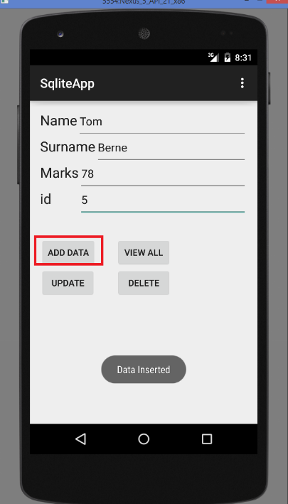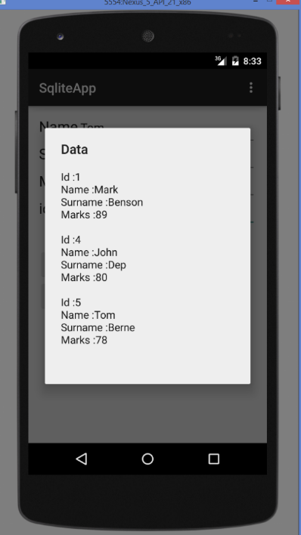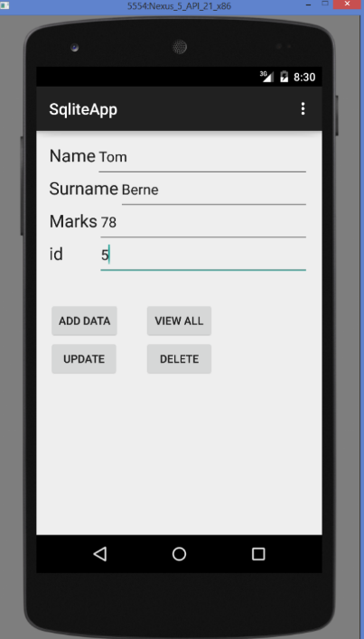**Output**

**Project – JusTalk**

**About**

JusTalk is a messaging app which helps users to communicate with other users. User can view all his chats and can also view the list of all other users registered with the app. It also enables user to add Profile picture. Users can smoothly send and receive messages with an additional feature of whether the message is delivered and seen by the receiver. Each user is associated with a status of online or offine and accordingly it is displayed with the help of green indicator alongside profile picture in the list of chats of the user. Proper authentication is provided and if in case user forgets his/her password then they can reset password with the help of forgot password feature in which a mail is send to the user’s email id which enables the user to change its password.

**Technologies Used**

* Android Studio
* Firebase Authentication
* Firebase Realtime Database

**Features of Android Studio used :**

* Fragments
* Circular Image View
* Recycler View
* Card View
* Intents
* TabLayout
* Custom App Bar
* User Models
* Custom Adapters etc.

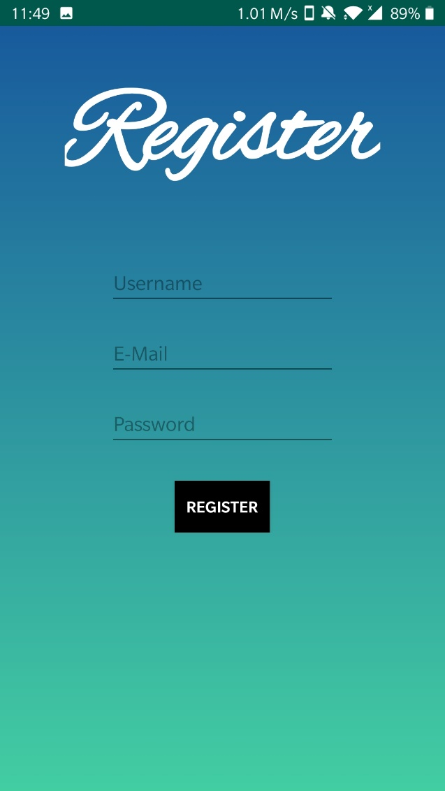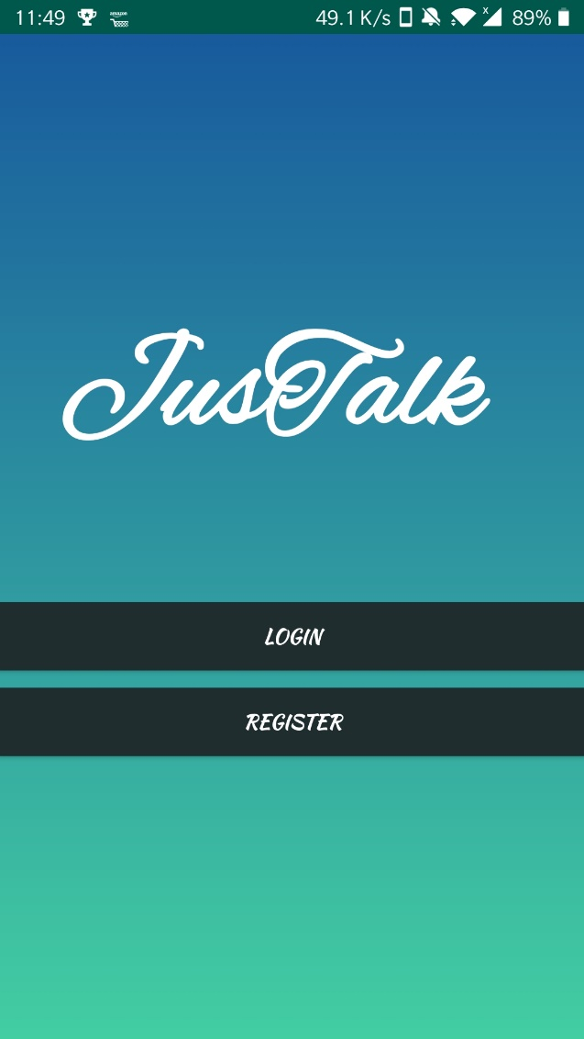**App**

