//TABLE CREATION AND DATA LOAD

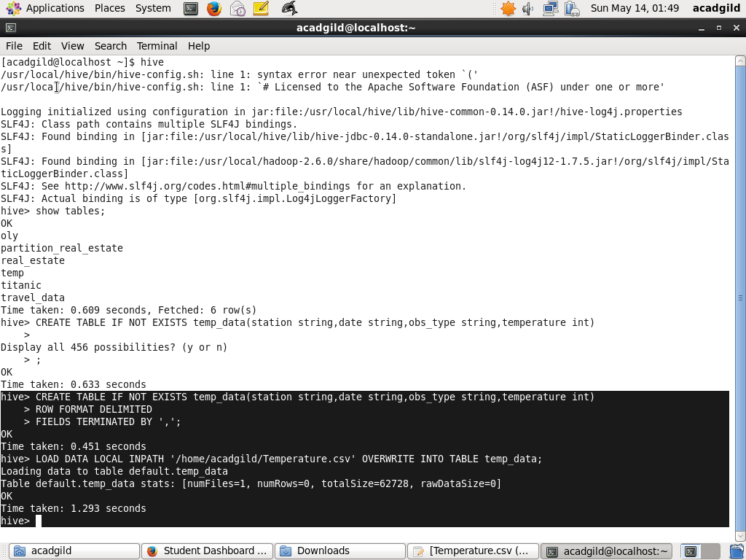

- Minimum temperature observed in a given weather station in a particular year.

//QUERY EXECUTION

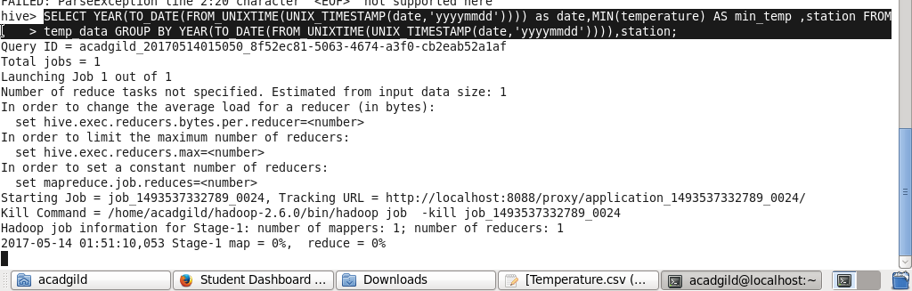

//RESULT

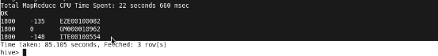

- Maximum temperature observed in a given weather station in a particular year.

//QUERY EXECUTION

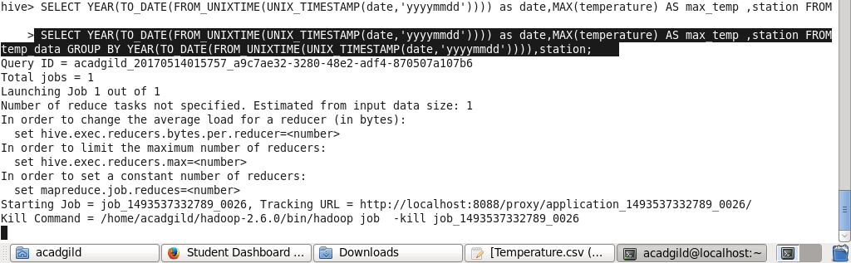

//RESULT

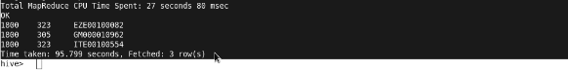

- Maximum temperature observed in a given weather station in a particular year.

//QUERY EXECUTION
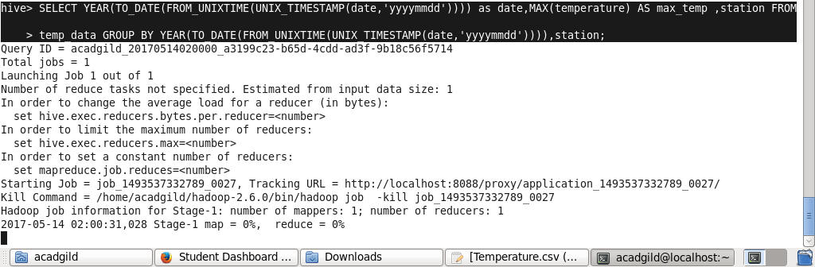

//RESULT

