1. IMPORT FROM MYSQL TO HDFS

//CREATING A DB IN MYSQL

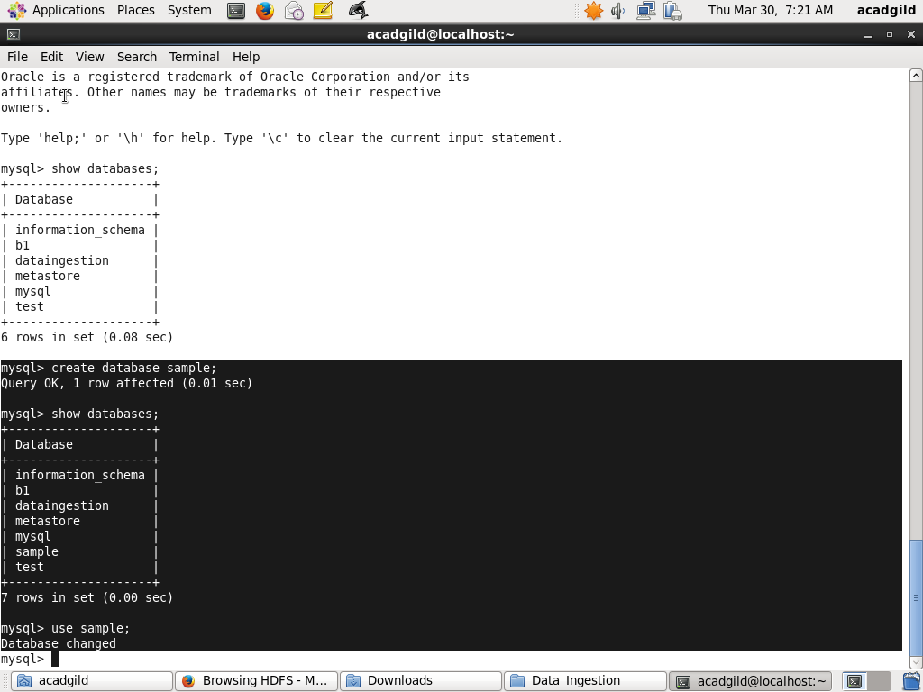

//CREATING THE TABLE EMP

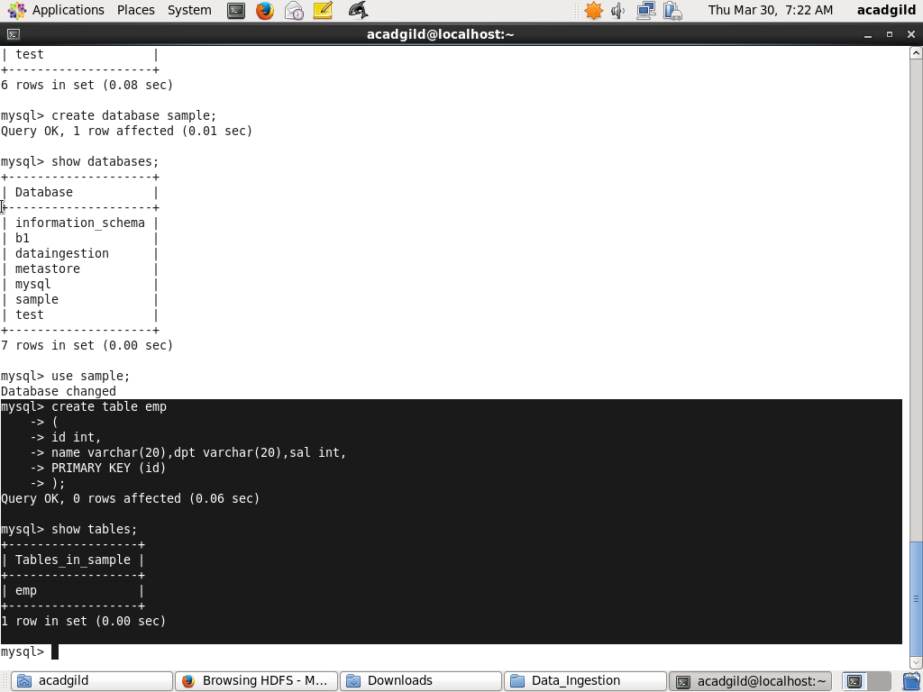

//INSERTING 10 VALUES

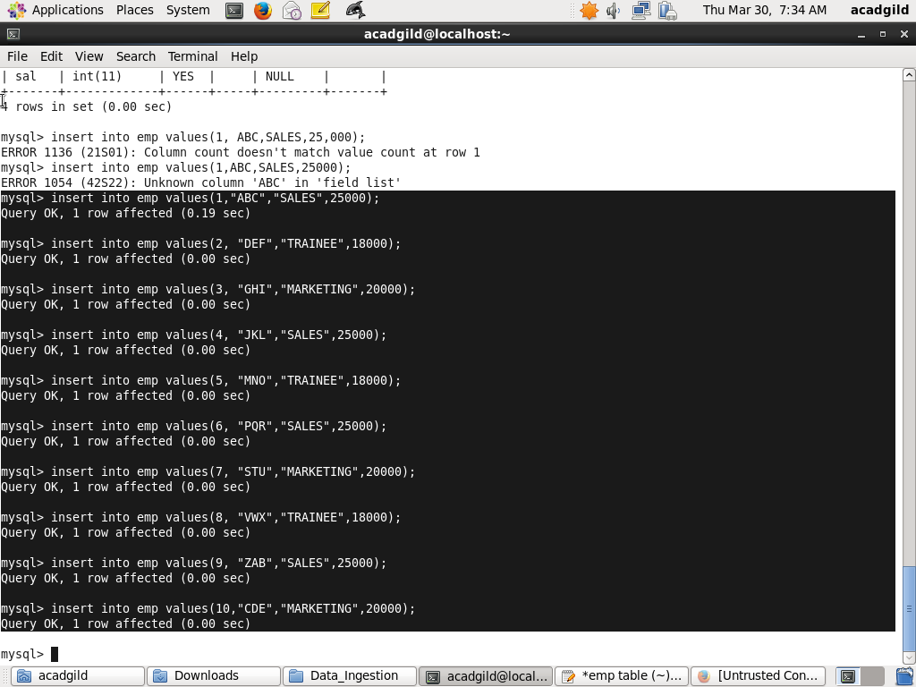

//DATA IN EMP

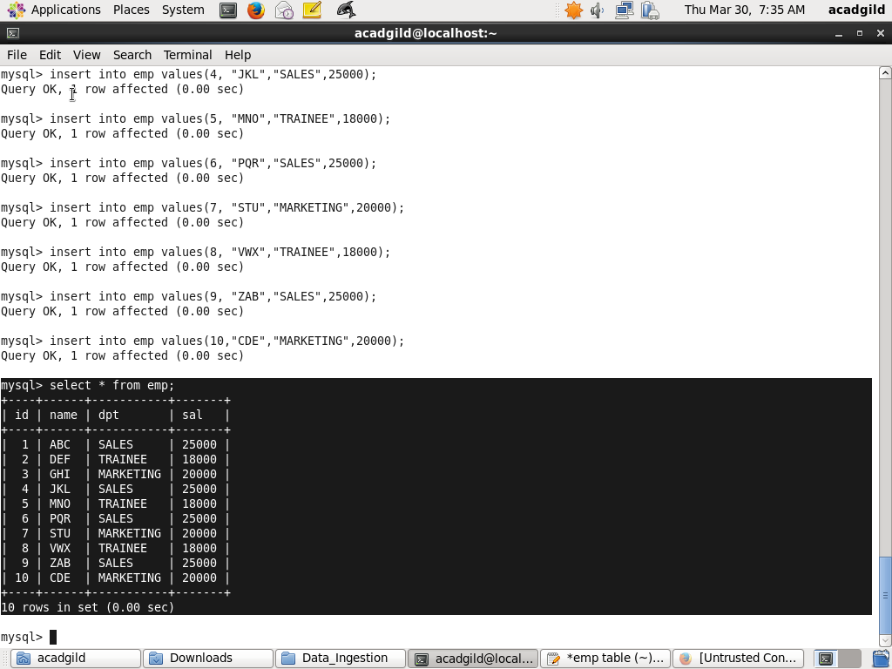

//RUNNING THE SQOOP IMPORT

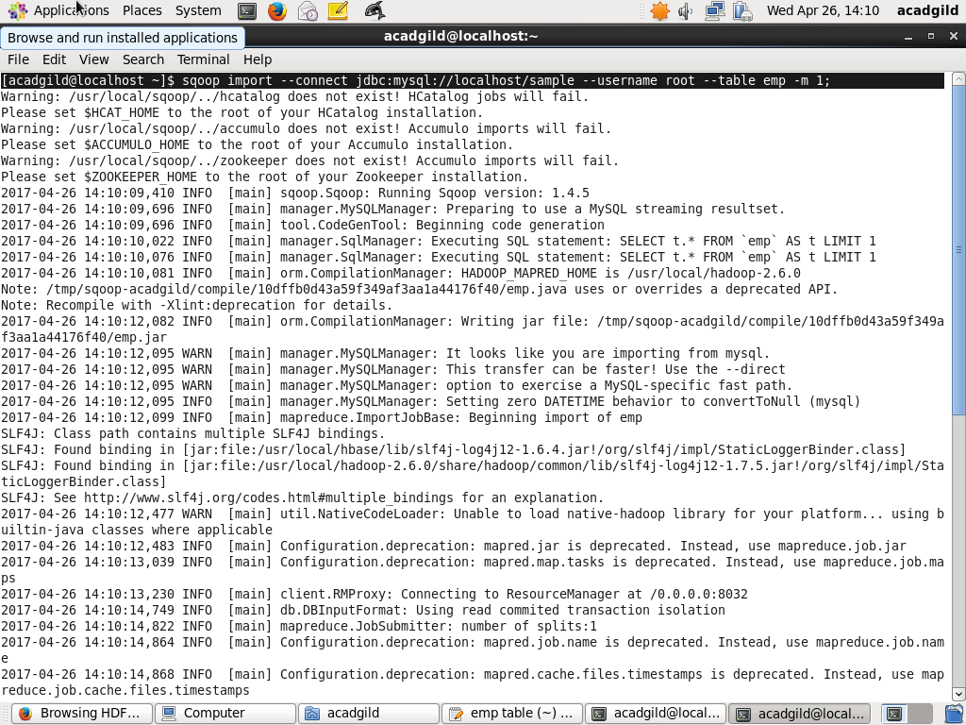

//DATA STORED ON HDFS

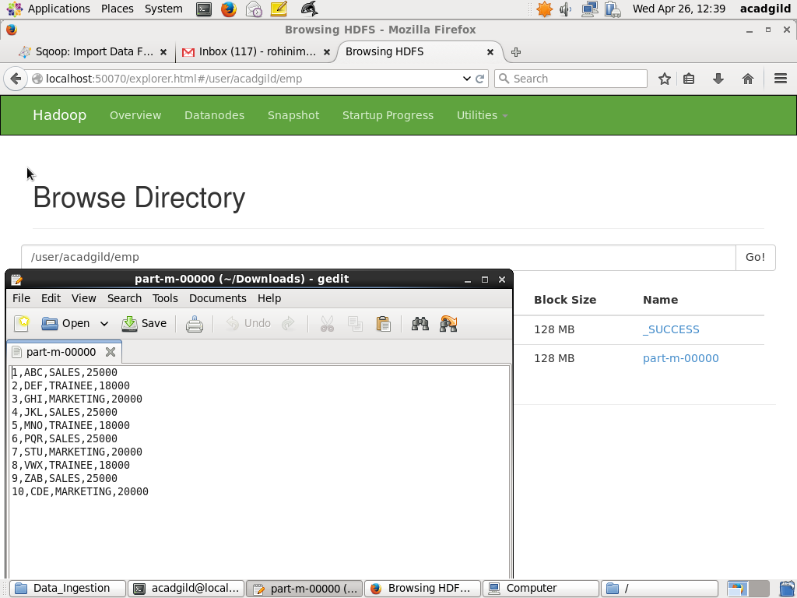

1. IMPORT INTO HIVE

//HIVE IMPORT USING SQOOP

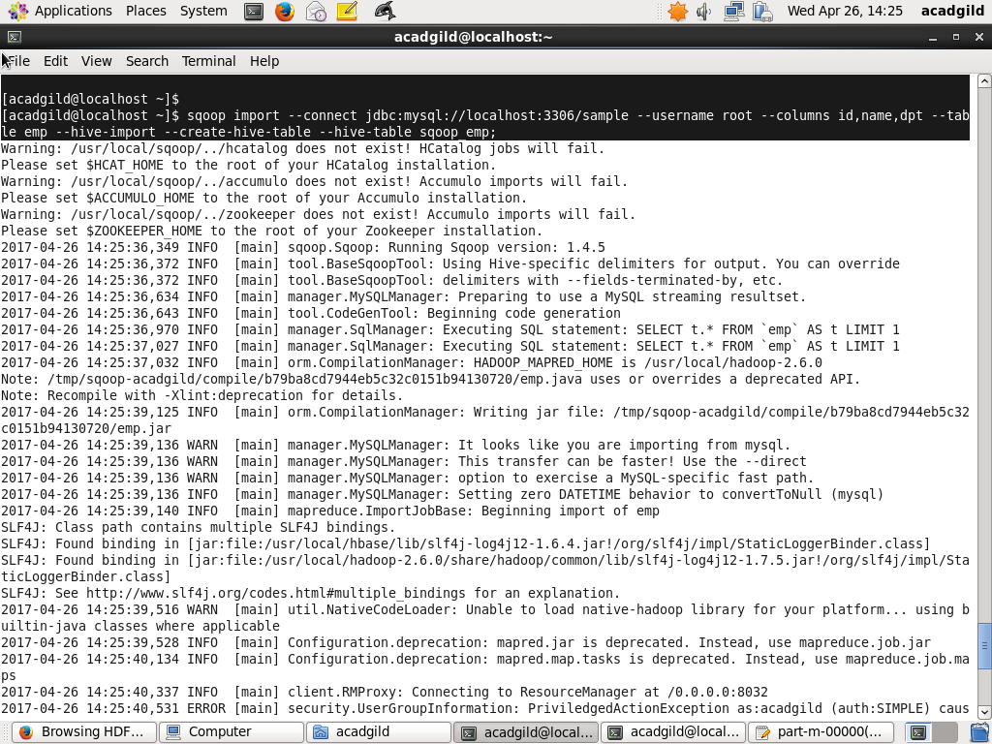

//DATA STORED ON HDFS

