//TV.JAVA CODE SCREENSHOT

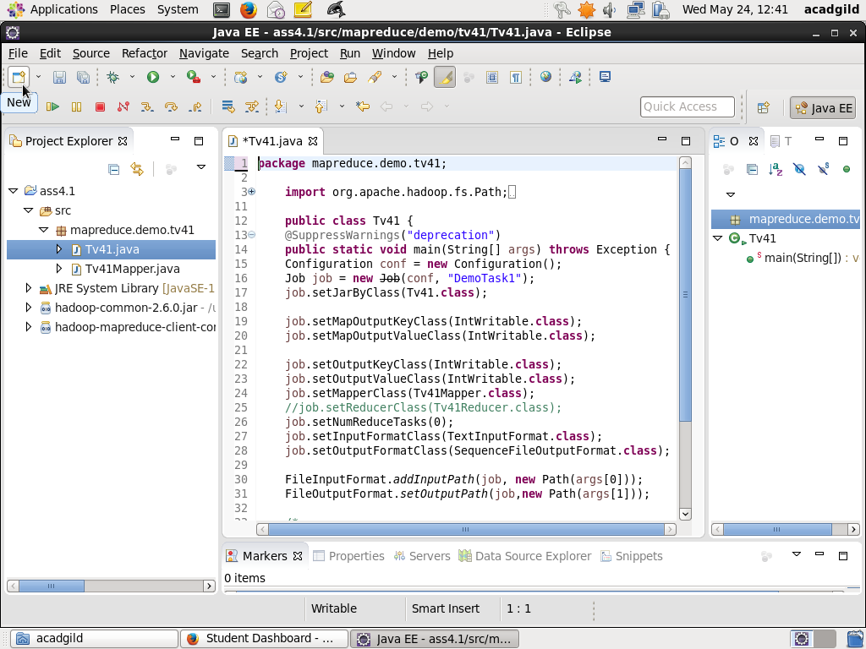

//TVMAPPER.JAVA CODE SCREENSHOT

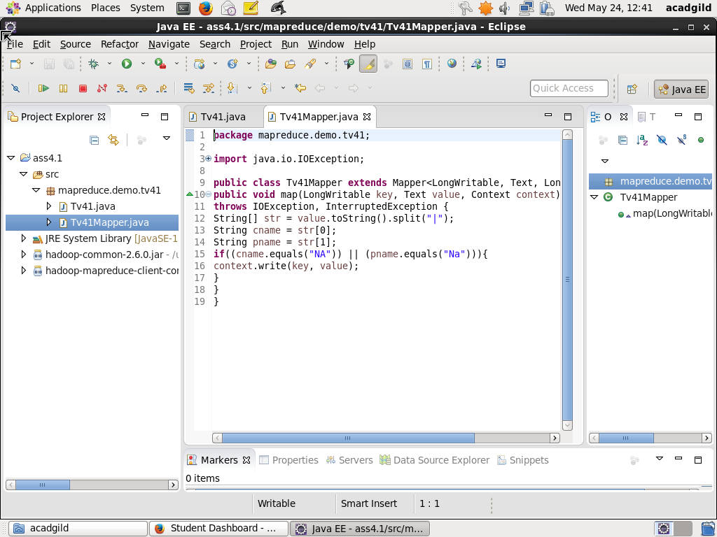

//JAR FILE

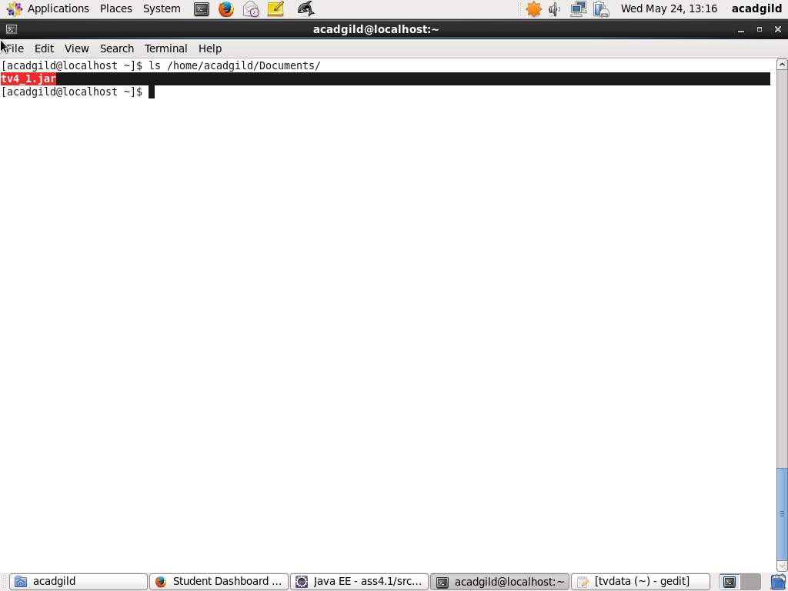

//EXECUTION OF THE JAR

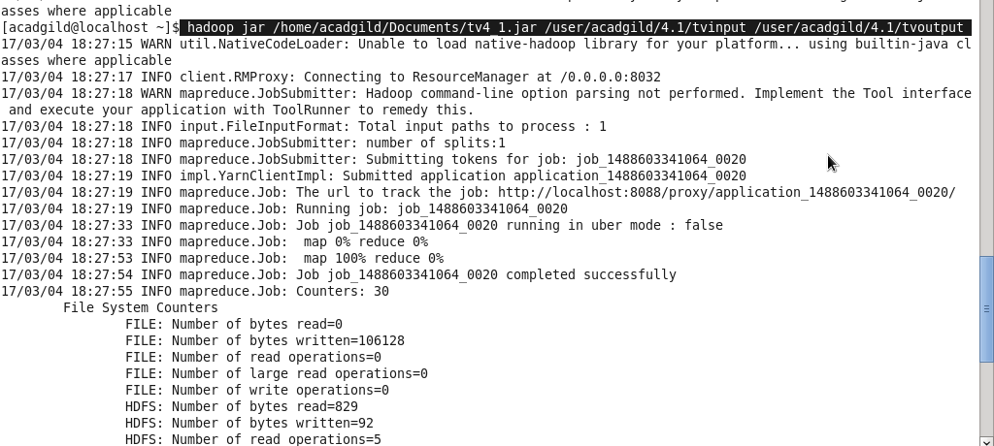

//OUTPUT FILE

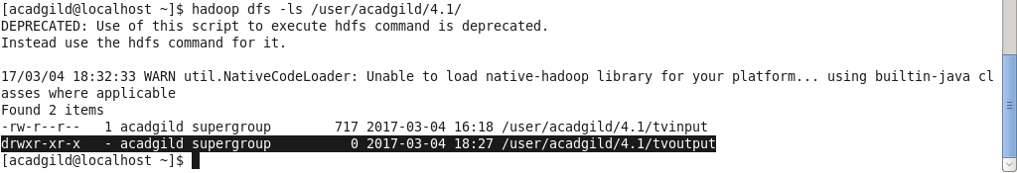

//CODE

Tv41.java
package mapreduce.demo.tv41;

import org.apache.hadoop.fs.Path;
import org.apache.hadoop.conf.*;
import org.apache.hadoop.mapreduce.Job;
Import org.apache.hadoop.mapreduce.lib.input.FileInputFormat;
Import org.apache.hadoop.mapreduce.lib.input.TextInputFormat;
import org.apache.hadoop.mapreduce.lib.output.FileOutputFormat;
Import org.apache.hadoop.mapreduce.lib.output.SequenceFileOutputFormat;
import org.apache.hadoop.io.IntWritable;

public class Tv41 {
@SuppressWarnings("deprecation")
public static void main(String[] args) throws Exception {
Configuration conf = new Configuration();
Job job = new Job(conf, "DemoTask1");
job.setJarByClass(Tv41.class);

job.setMapOutputKeyClass(IntWritable.class);
job.setMapOutputValueClass(IntWritable.class);

job.setOutputKeyClass(IntWritable.class);
job.setOutputValueClass(IntWritable.class);
job.setMapperClass(Tv41Mapper.class);
job.setNumReduceTasks(0);
job.setInputFormatClass(TextInputFormat.class);
job.setOutputFormatClass(SequenceFileOutputFormat.class);

FileInputFormat.addInputPath(job, new Path(args[0]));
FileOutputFormat.setOutputPath(job,new Path(args[1]));

/*
Path out=new Path(args[1]);
out.getFileSystem(conf).delete(out);
*/

job.waitForCompletion(true);
}
}

Tv41Mapper.java

package mapreduce.demo.tv41;

import java.io.IOException;

import org.apache.hadoop.io.LongWritable;
import org.apache.hadoop.io.Text;
import org.apache.hadoop.mapreduce.*;

public class Tv41Mapper extends Mapper<LongWritable, Text, LongWritable, Text> {
public void map(LongWritable key, Text value, Context context)
throws IOException, InterruptedException {
String[] str = value.toString().split("|");
String cname = str[0];
String pname = str[1];
if((cname.equals("NA")) || (pname.equals("Na"))){
context.write(key, value);
}
}
}

