//Assign.java code

import java.io.IOException;

import org.apache.hadoop.conf.Configuration;
import org.apache.hadoop.fs.Path;
import org.apache.hadoop.io.IntWritable;
import org.apache.hadoop.io.Text;
import org.apache.hadoop.mapreduce.Job;
import org.apache.hadoop.mapreduce.lib.input.FileInputFormat;
import org.apache.hadoop.mapreduce.lib.input.TextInputFormat;
import org.apache.hadoop.mapreduce.lib.output.FileOutputFormat;
import org.apache.hadoop.mapreduce.lib.output.TextOutputFormat;

public class Assign {

public static void main(String[] args) throws IllegalArgumentException, IOException, ClassNotFoundException, InterruptedException {
// TODO Auto-generated method stub
Configuration conf = new Configuration();
Job job = new Job(conf, "Demo");
job.setJarByClass(Assign.class);

job.setMapOutputKeyClass(Text.class);
job.setMapOutputValueClass(IntWritable.class);
job.setMapperClass(AssignMapper.class);

job.setPartitionerClass(AssignPartitioner.class);

job.setNumReduceTasks(3);//setting the number of reducers
job.setReducerClass(AssignReducer.class);
job.setOutputKeyClass(Text.class);
job.setOutputValueClass(IntWritable.class);

job.setInputFormatClass(TextInputFormat.class);
job.setOutputFormatClass(TextOutputFormat.class);

FileInputFormat.addInputPath(job, new Path(args[0]));
FileOutputFormat.setOutputPath(job, new Path(args[1]));

job.waitForCompletion(true);

}

}

//AssignMapper.java code

import java.io.IOException;
import java.util.regex.Pattern;

import org.apache.hadoop.io.IntWritable;
import org.apache.hadoop.io.LongWritable;
import org.apache.hadoop.io.Text;
import org.apache.hadoop.mapreduce.Mapper;

public class AssignMapper extends Mapper<LongWritable, Text, Text, IntWritable> {
public void map(LongWritable Key, Text Value, Context context) throws IOException, InterruptedException {
String[] data = Value.toString().split(",");
IntWritable one=new IntWritable(1);
Text t=new Text(data[0]);
context.write(t, one);
}
}

//AssignPartitioner.java code

import org.apache.hadoop.io.IntWritable;
import org.apache.hadoop.io.Text;
import org.apache.hadoop.mapreduce.Partitioner;

public class AssignPartitioner extends Partitioner<Text, IntWritable> {

@Override
public int getPartition(Text key, IntWritable value, int arg2) {

int k = key.toString().length();
if (k==5)
{
return 0;
}
else if (k==6)
{
return 1;
}
else
{
return 2;
}

}

}

//AssignReducer.java code

import java.io.IOException;

import org.apache.hadoop.io.IntWritable;
import org.apache.hadoop.io.Text;
import org.apache.hadoop.mapreduce.Reducer;

public class AssignReducer extends Reducer<Text, IntWritable, Text, IntWritable>
{
private IntWritable tot = new IntWritable();
private int minValue = Integer.MIN_VALUE;

@Override
public void reduce(Text key, Iterable<IntWritable> values,Context context) throws IOException, InterruptedException
{
int count = 0;
for ( IntWritable value : values )
{ if(value.get()>minValue){
count+=value.get();
}
}
tot.set(count);
context.write(key, tot);
}
}

//EXECUTION OF THE JAR WITHTHE INPUT FILE “WC.TXT” AND THE OUTPUT FILE ”OUTPUT5.4”
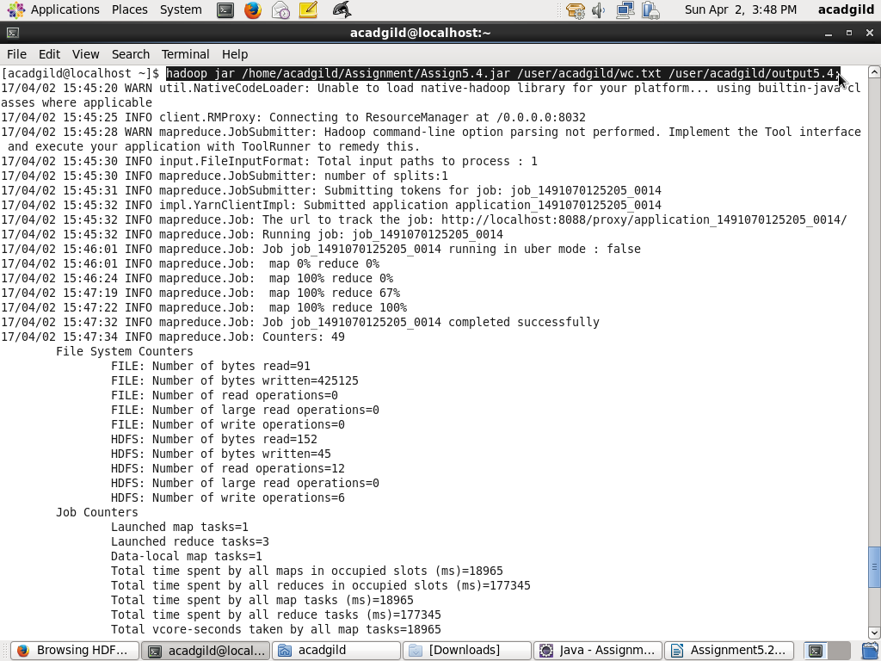

//OUTPUT DIRECTORY

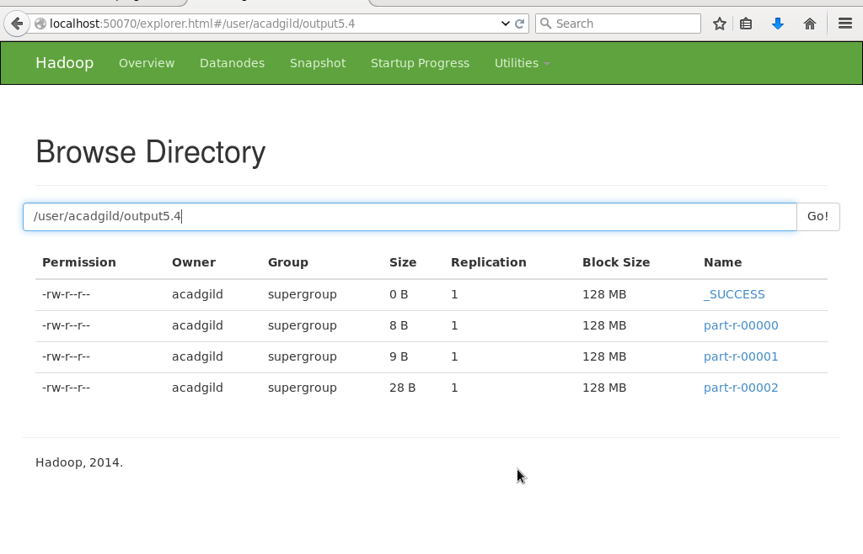

//RESULT

