1.Find the top five kinds of GoogleKnowlege_Occupation people who were guests in the show, in a particular time period. Take the time period as 1/11/99 to 6/11/99 i.e., 6 months

//load data

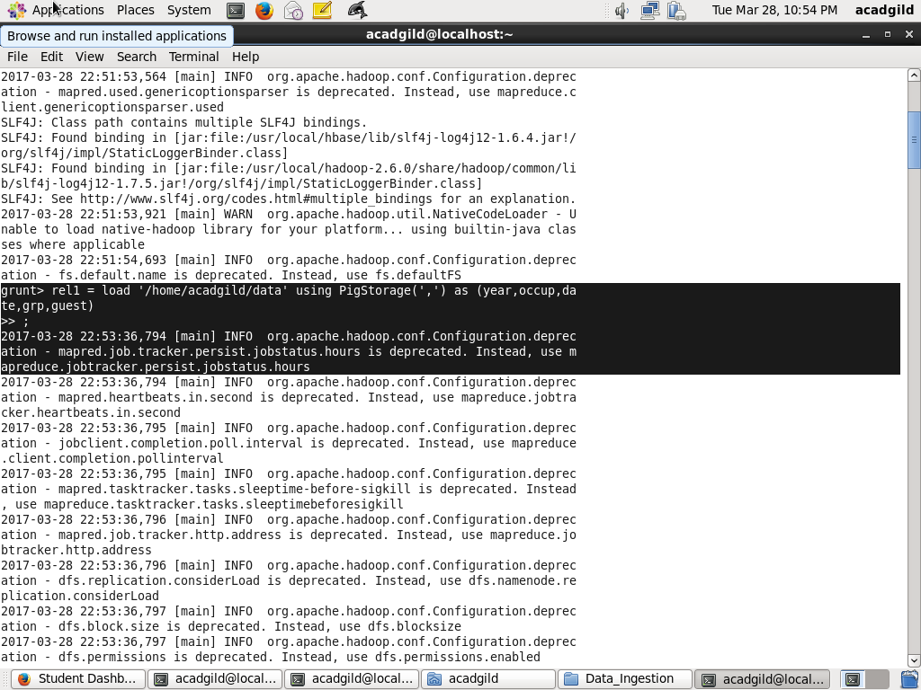

//generate the occupation and date

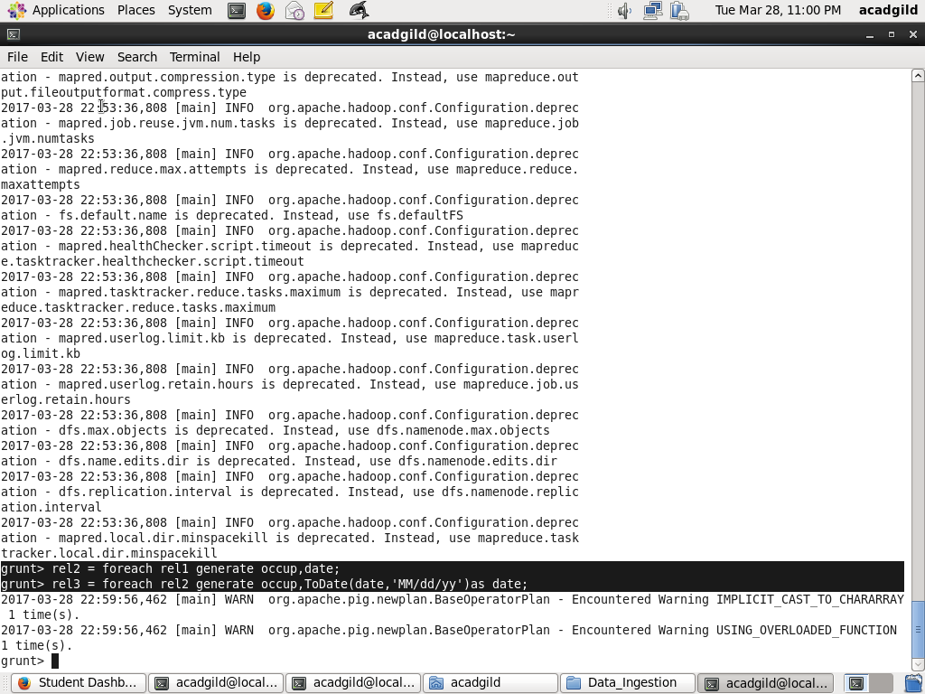

//filter operation

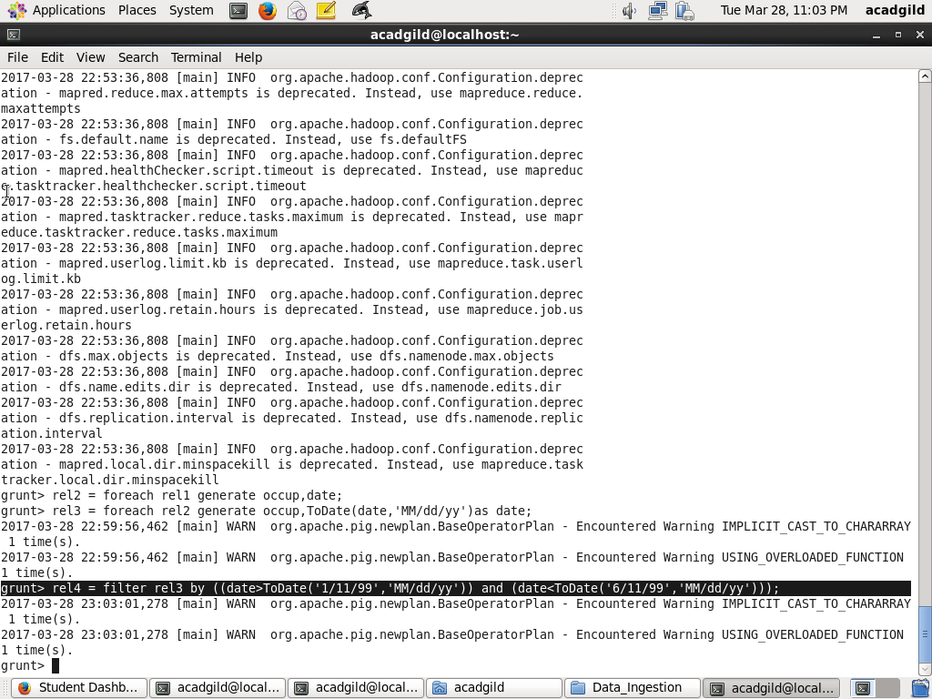

//group operation

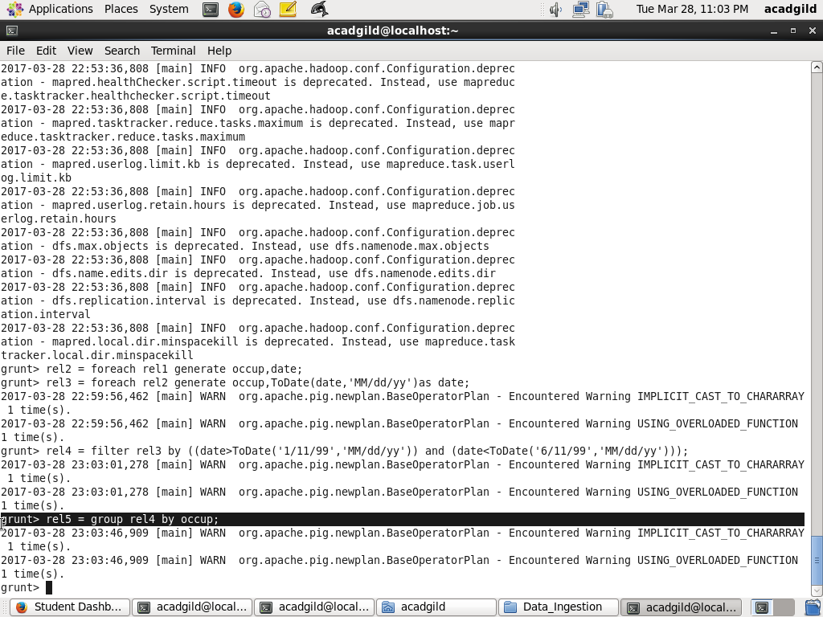

//count operation

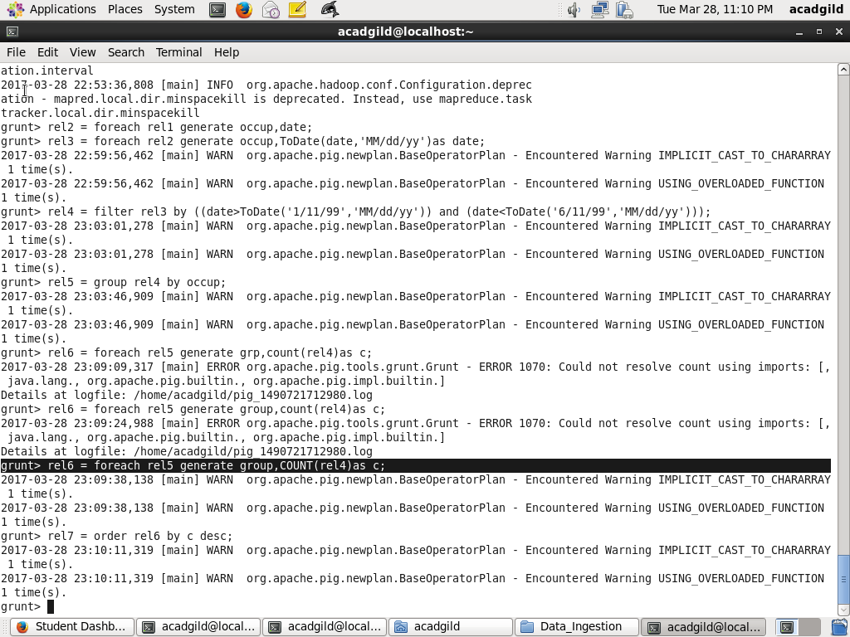

//ordering

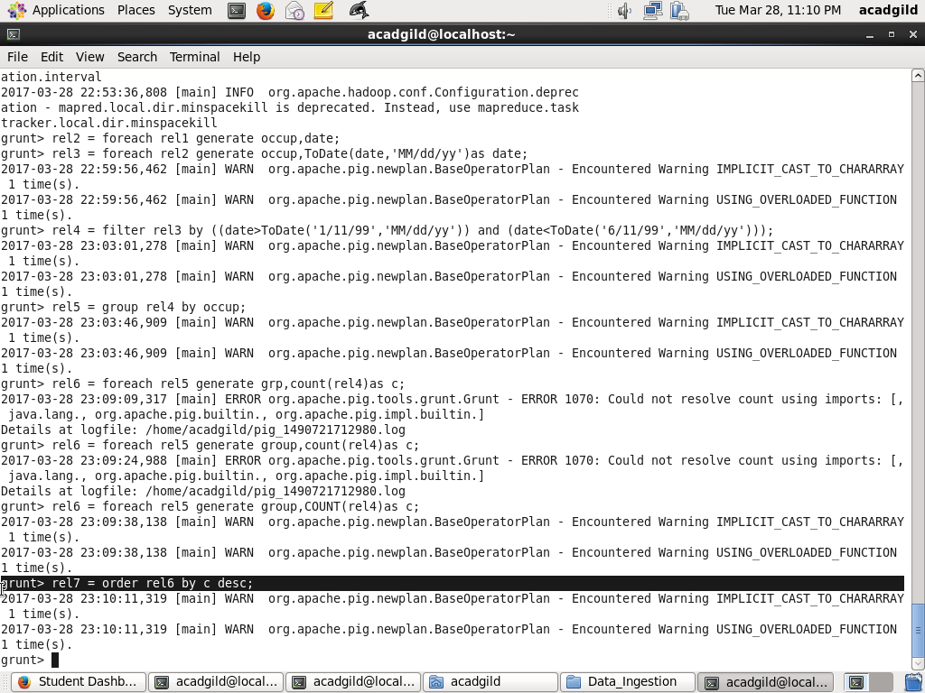

//limit to first 5

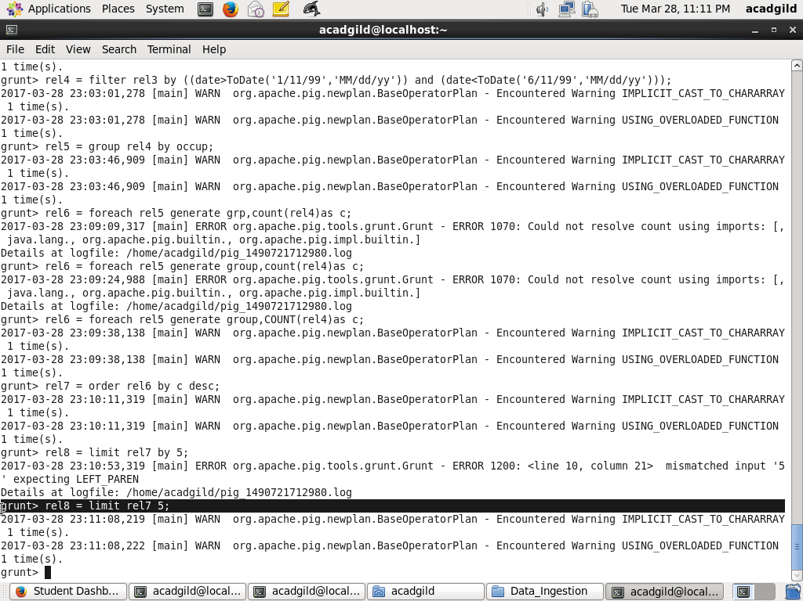

//result

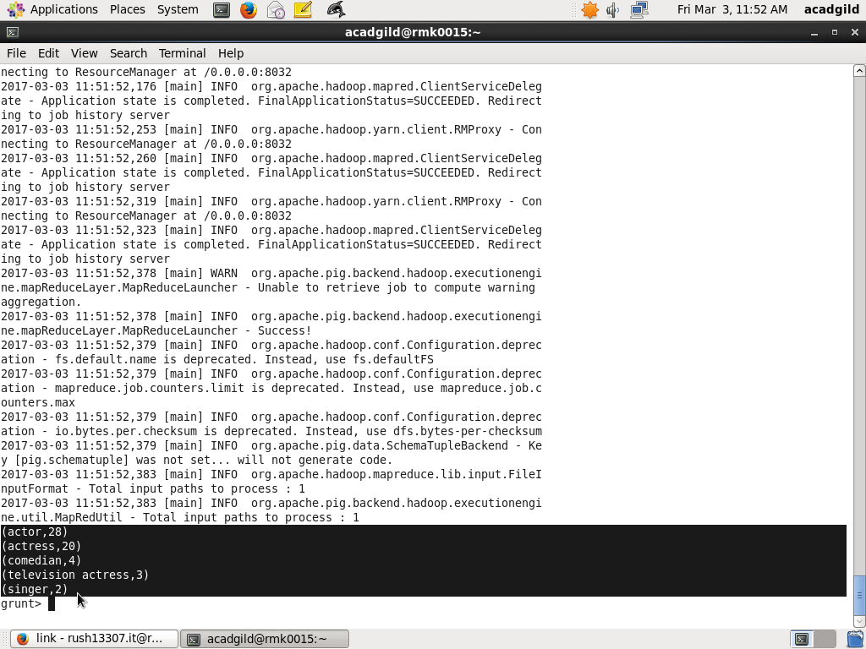

- Find the number of Google Knowledge occupation types in each group, who have been guests on the show.

//load data

//operations on the data

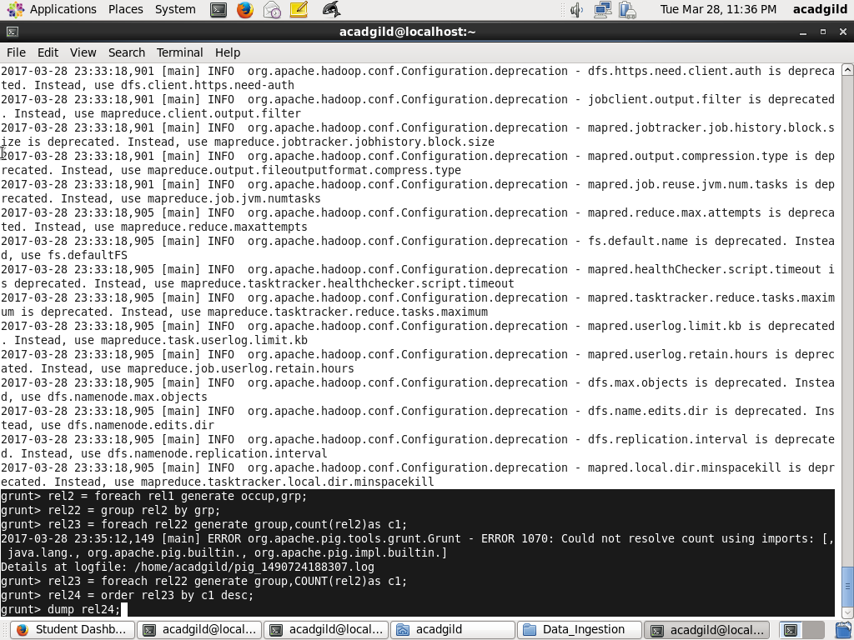

//generation of count,order and dump

//result

