//DATA LOAD - EMP DETAILS

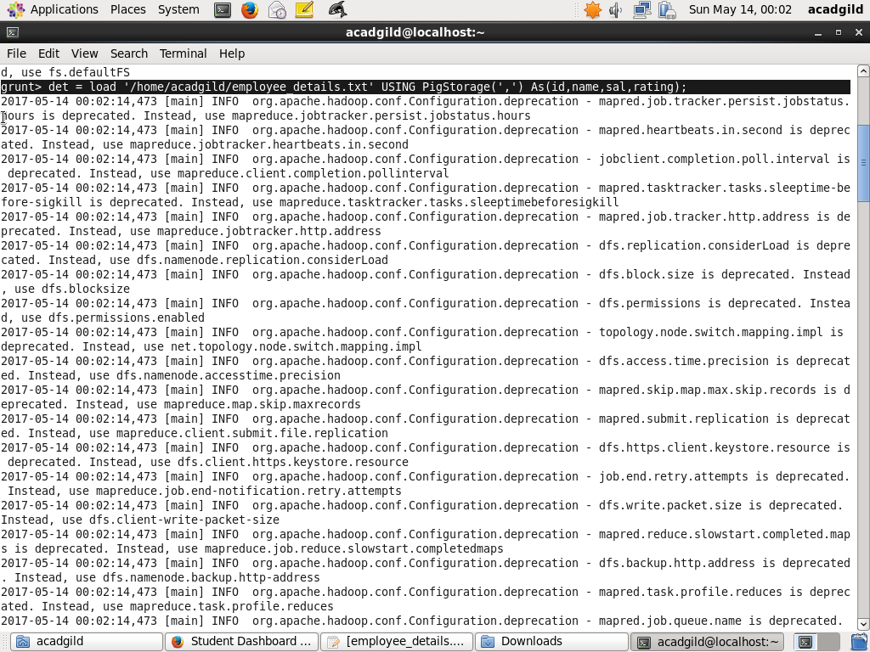

//DATA LOAD - EMP EXPENSES

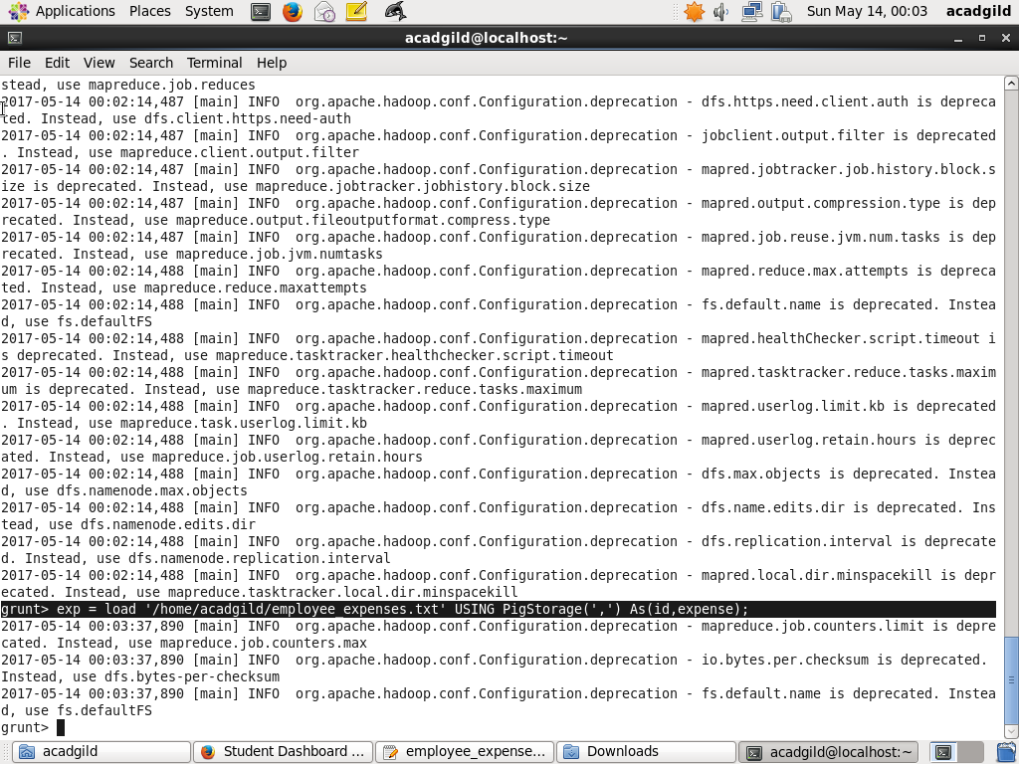

(a) Top 5 employees (employee id
and employee name) with highest rating.

//QUERY EXECUTION

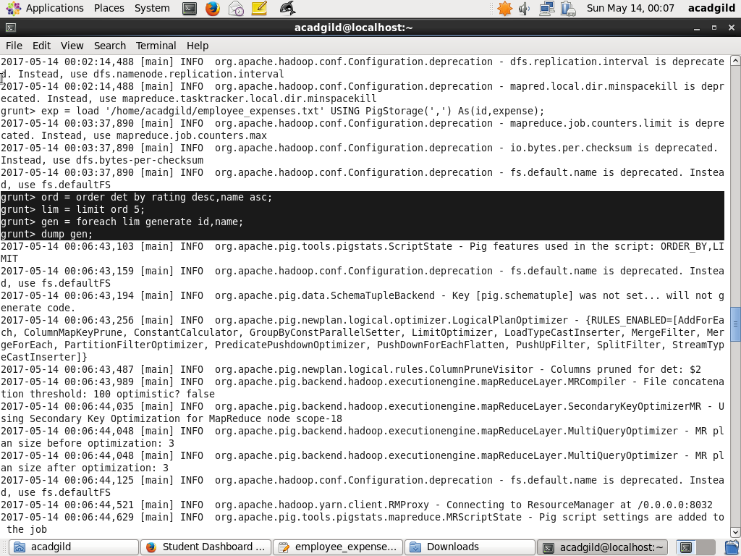

//RESULT

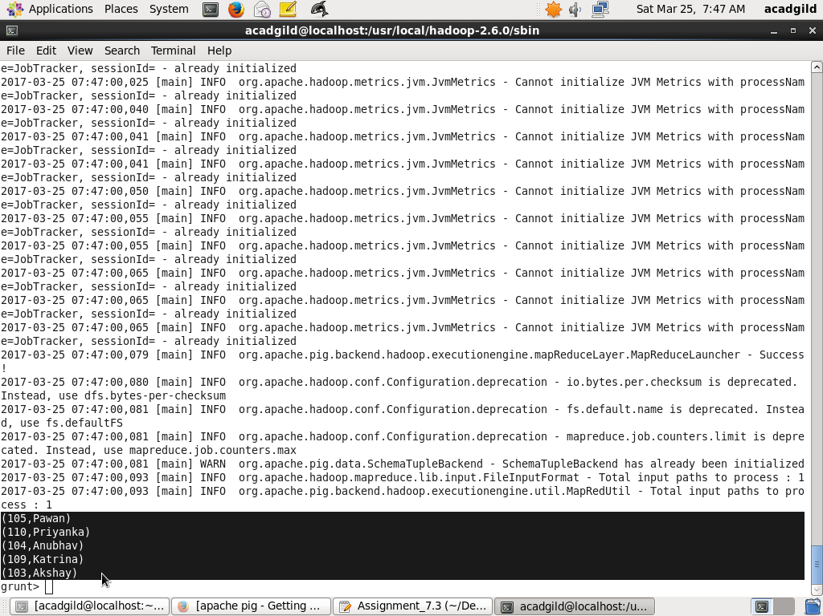

(b) Top 3 employees (employee id and employee name) with highest salary, whose employee id
is an odd number.

//QUERY EXECUTION

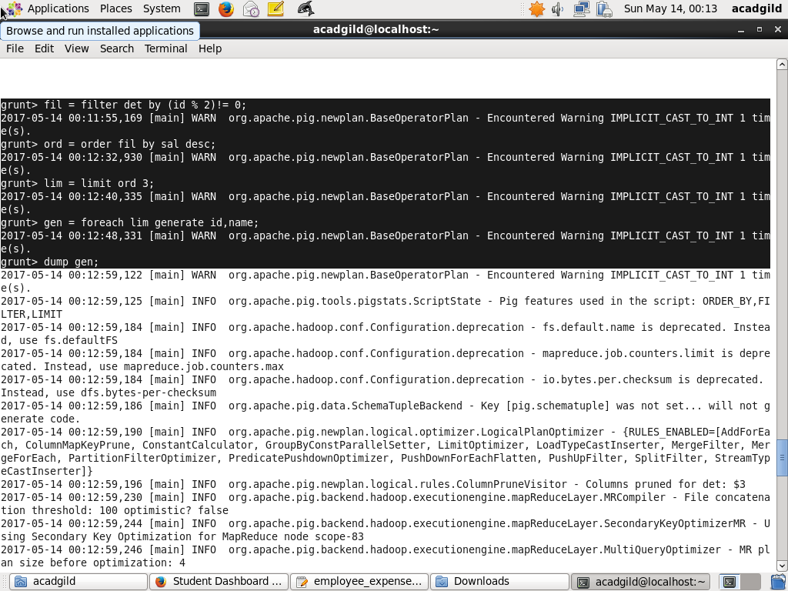

//RESULT

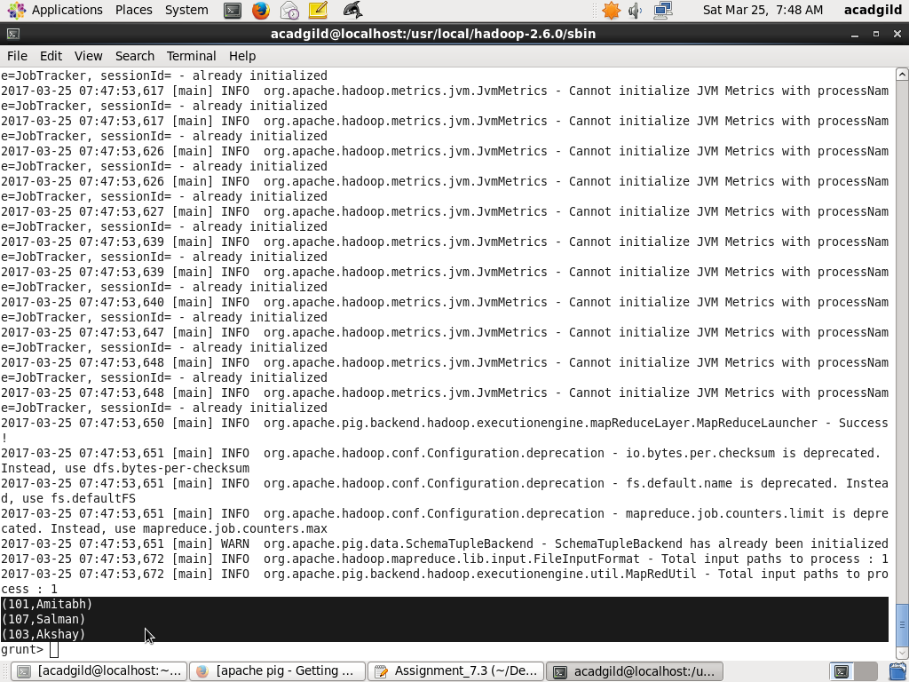

(c) Employee (employee id and employee name) with maximum expense

//QUERY EXECUTION

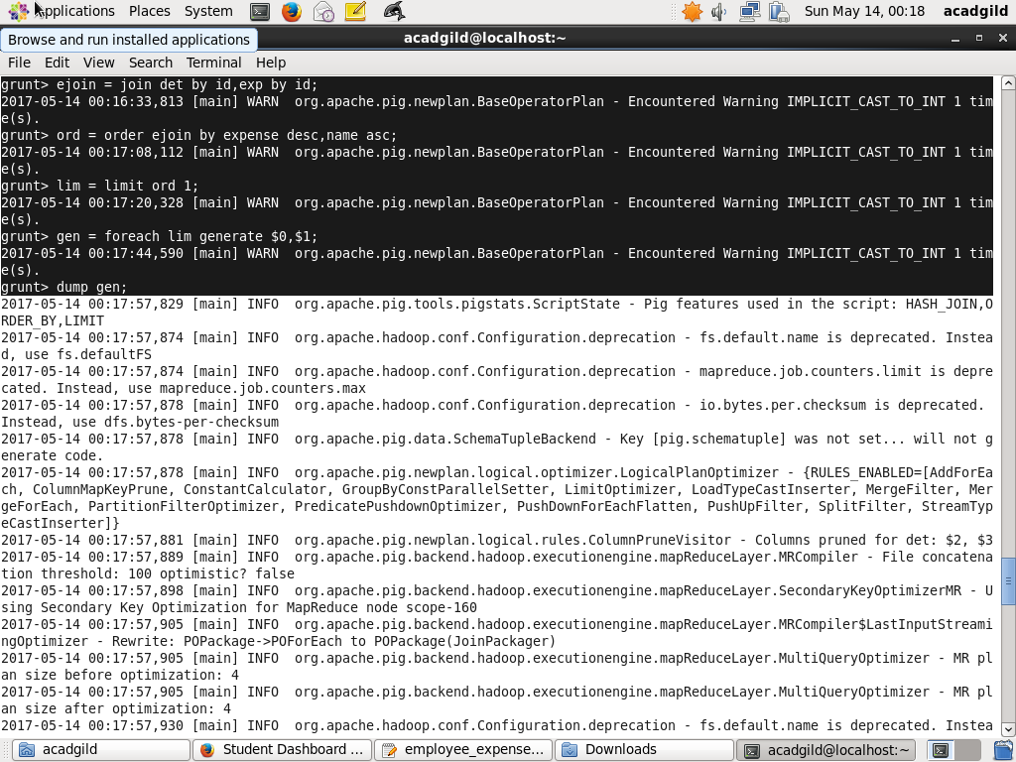

//RESULT

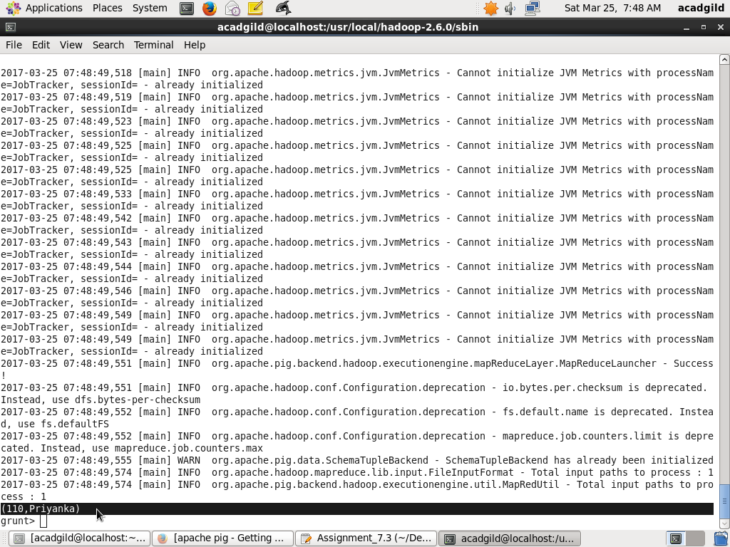

(d) List of employees (employee id and employee name) having entries in employee_expenses
file.

//QUERY EXECUTION
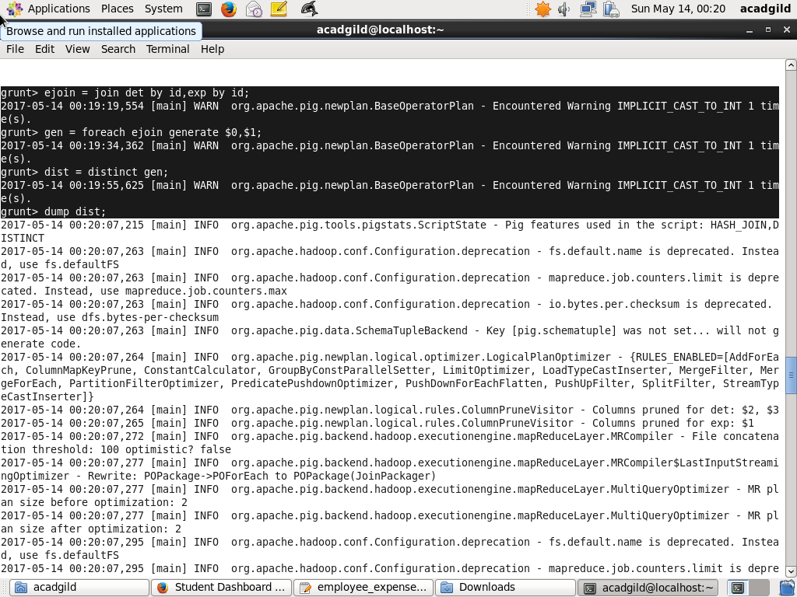

//RESULT

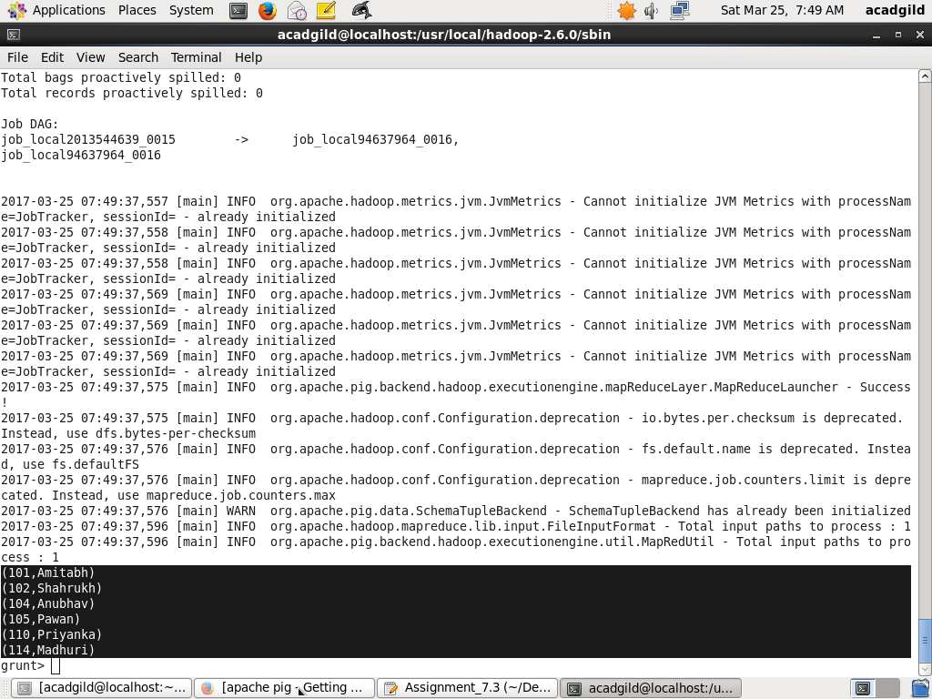

(e) List of employees (employee id and employee name) having no entry in employee_expenses
file.

//QUERY EXECUTION

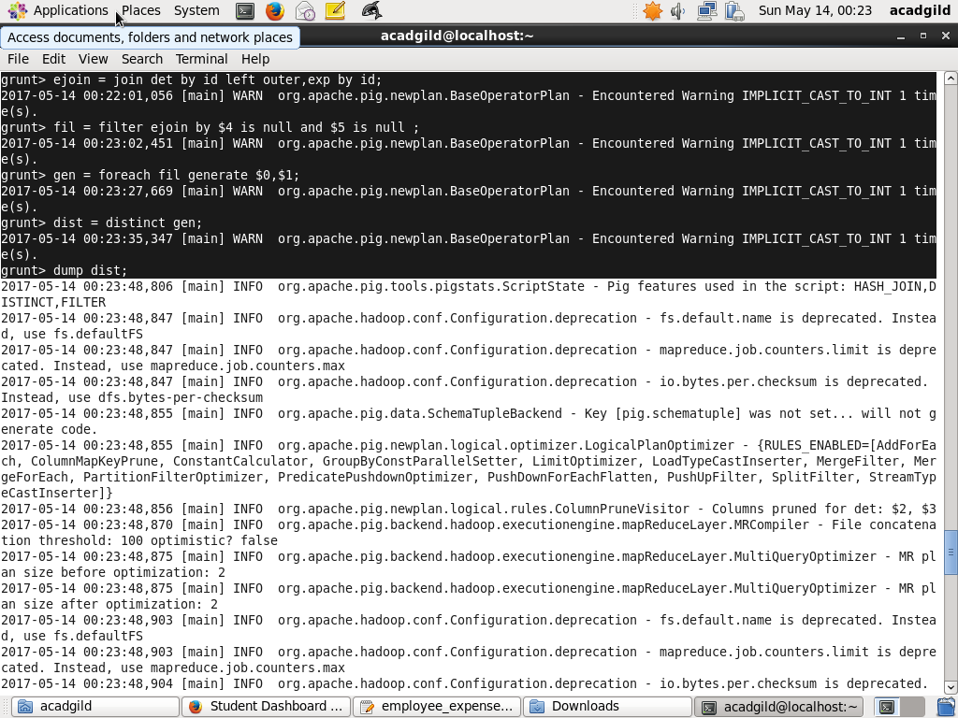

//RESULT

