Parsing XML files using pig

//DATA LOAD

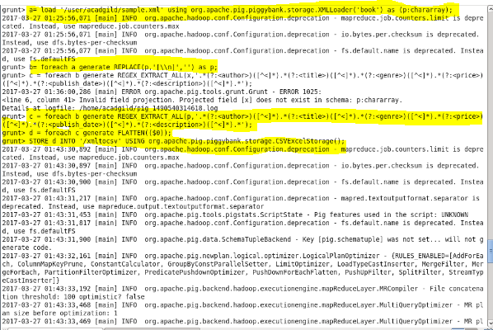

//REPLACE FUNCTION



//REGEX FUNCTION



//FLATTEN AND STORE FUNCTION

