Create a flume agent that streams data from Twitter and stores it in the HDFS c luster.

//download and include the snapshot.jar
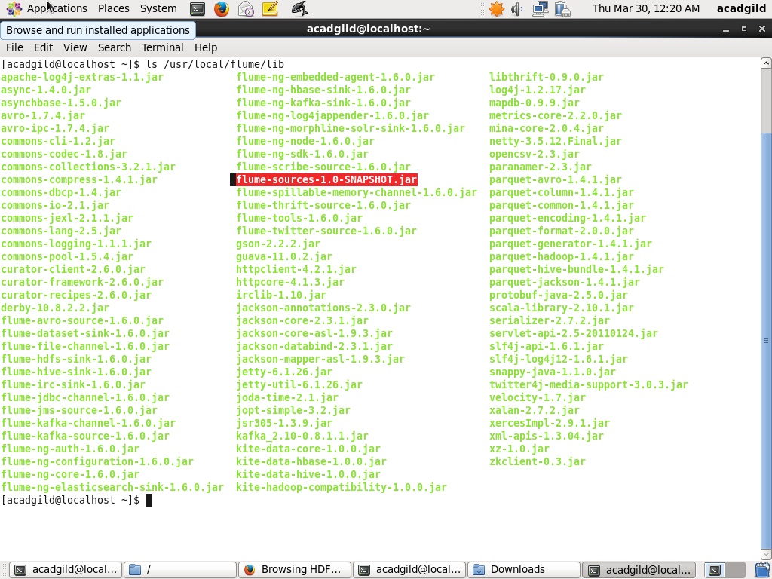

//set flume class path
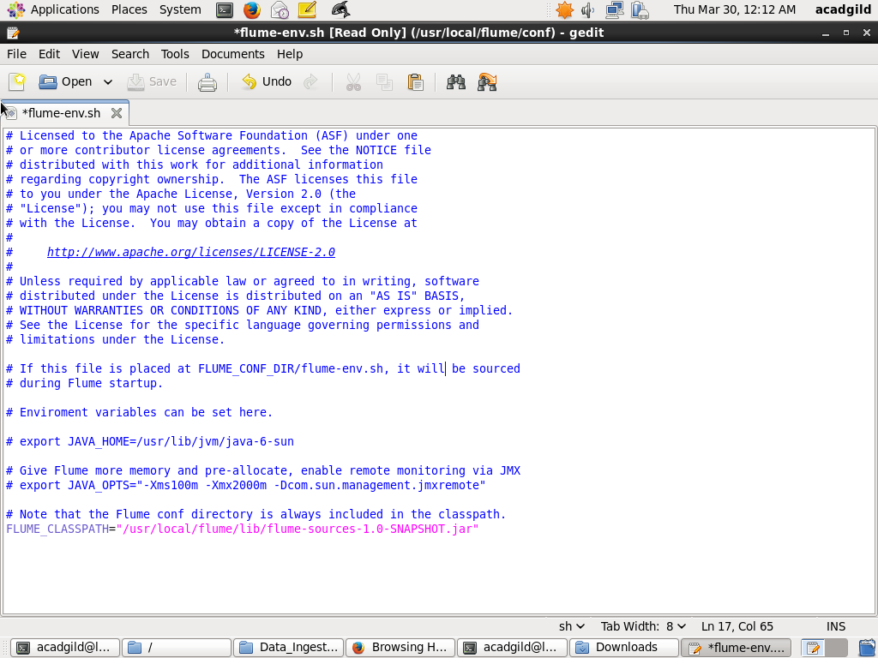
//EDITING THE .conf FILE WITH OUR CREDENTIALS
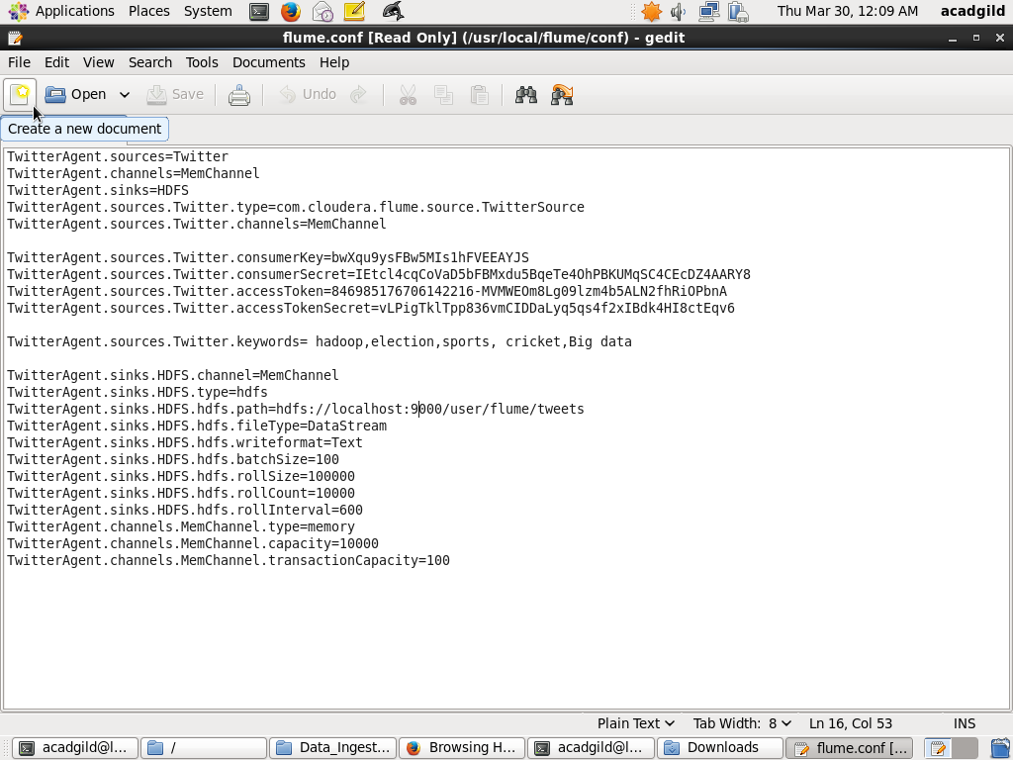

//CHANGING THE PERMISSIONS
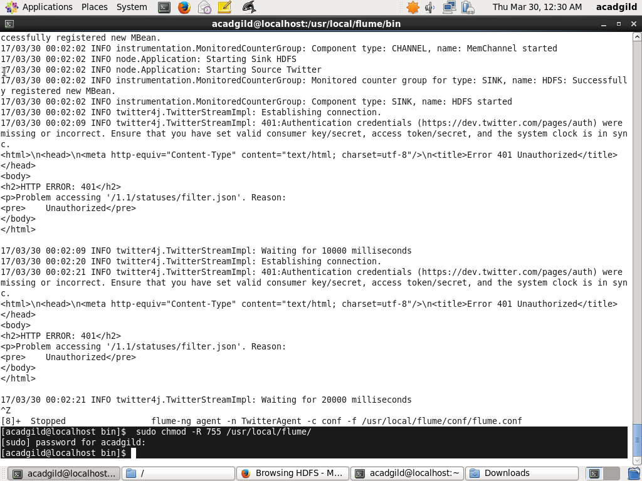

//FETCHING THE DATA FROM TWITTER
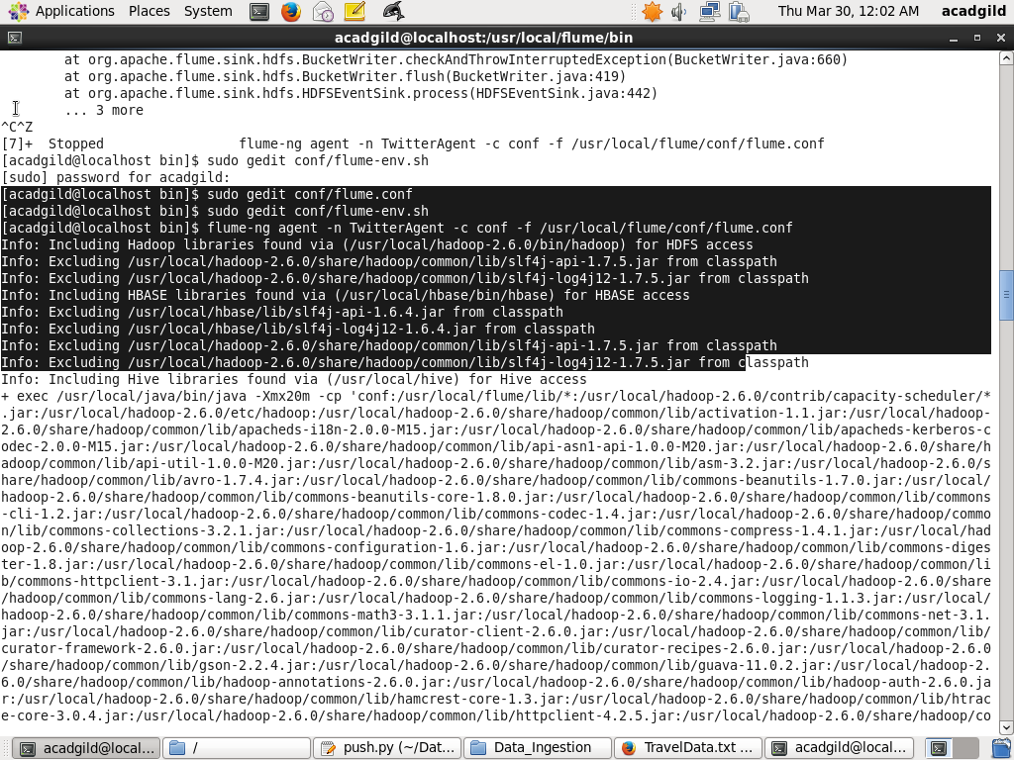
//RESULTANT DIRECTORY CREATED IN HDFS
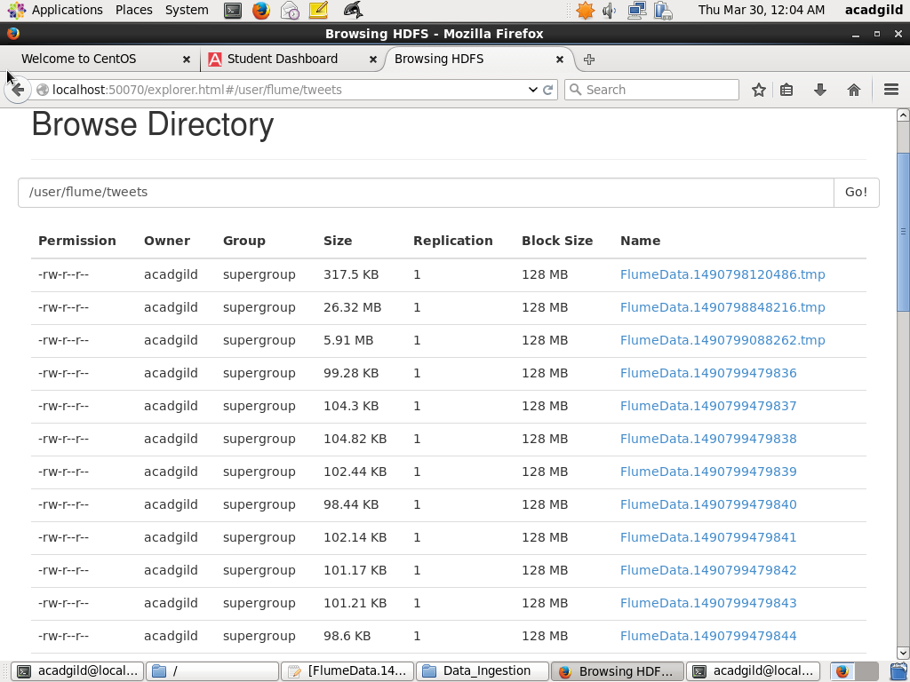

//THE STREAMING DATA INSIDE THE .tmp FILE
