//DATA LOAD

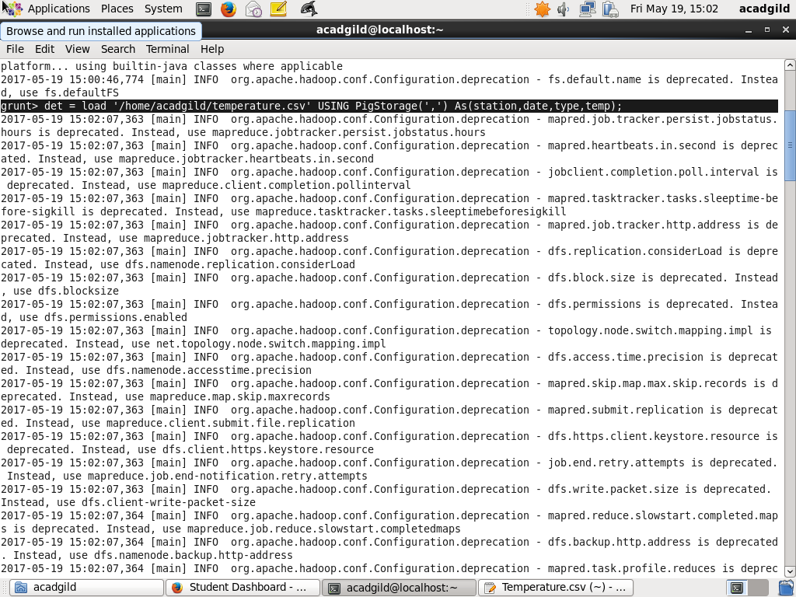

1. Write a pig script to find the minimum temperature observed in a given weather station in a particular year

//FILTER OPERATION

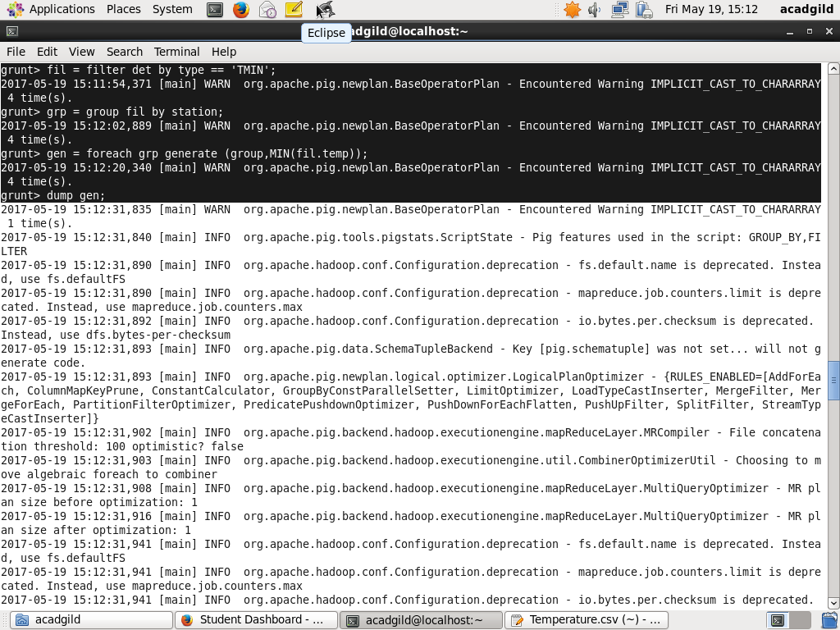

//GROUP OPERATION



//MIN TEMPERATURE



1. Write a pig script to find the maximum temperature observed in a given weather station in a particular year.

//FILTER OPERATION

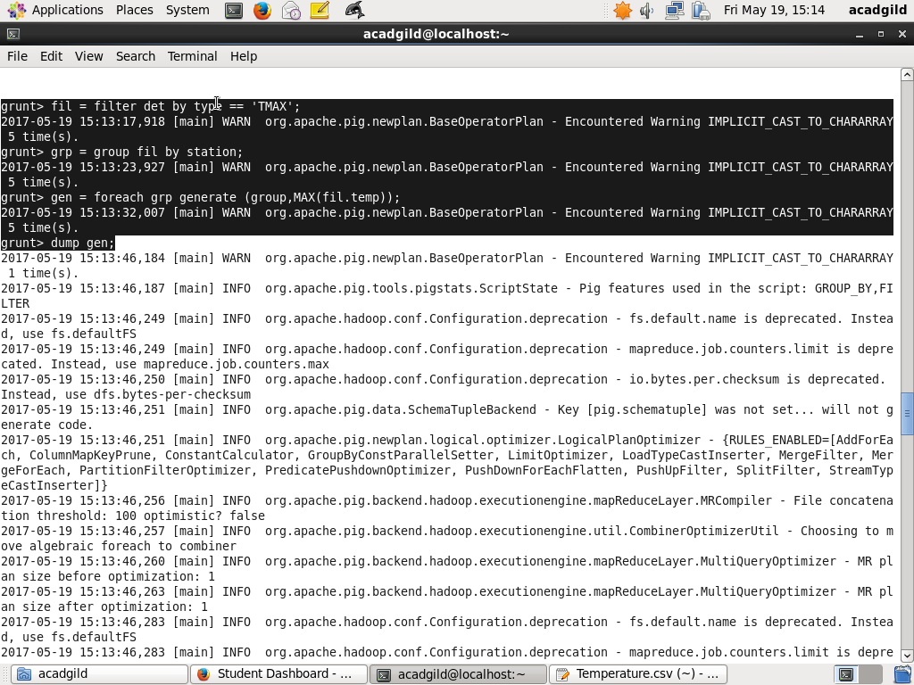

//GROUP OPERATION



//MAX TEMPERATURE



1. Write a pig script to find the number of readings given by each weather station according to the dataset.

//GROUP OPERATION

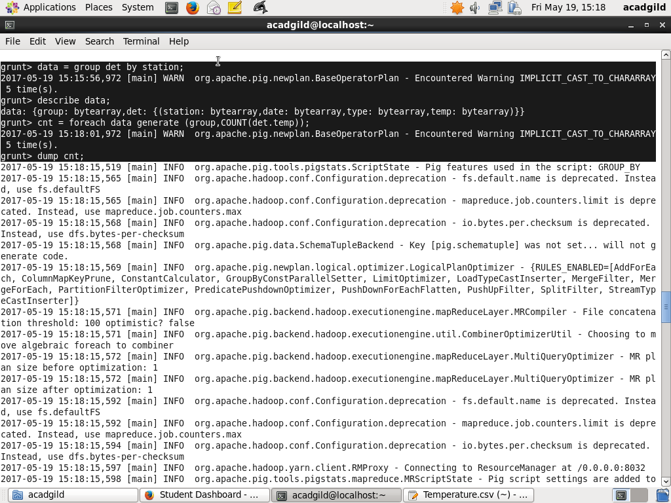

//COUNT OPERATION

