Create a database named 'custom'. Create a table named temperature_data inside custom database with the following fields (delimited by comma - ‘,’ ) : 1. date (mm-dd-yyyy) format 2. zip code 3. Temperature

// database creation

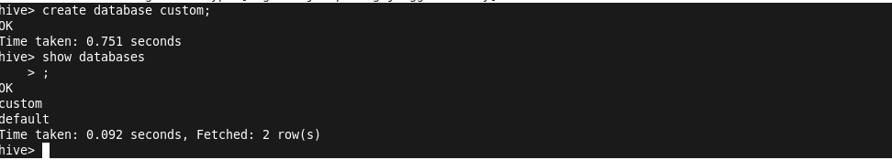

//use a database to insert the table



//table creation

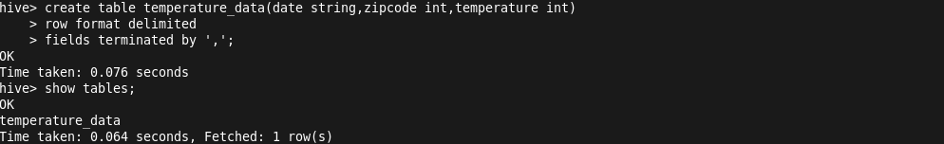

//load the data into the table



//display the data

