1.Write a pig script find the average age of male and female persons died in the titanic tragedy

//LOADING THE FILE TITANIC DATA INTO A RELATION PIG

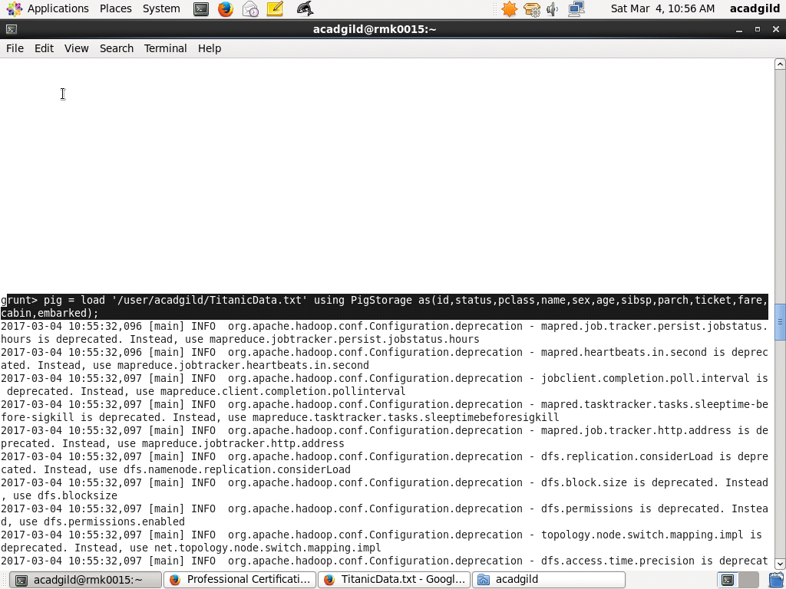

//FILTER THE RECORDS OF PEOPLE DEAD

//COLLECT THE RECORDS OF MALE AND FEMALE BY GROUPING THEM BY SEX

//GENERATE THE AVERAGE AND DUMP

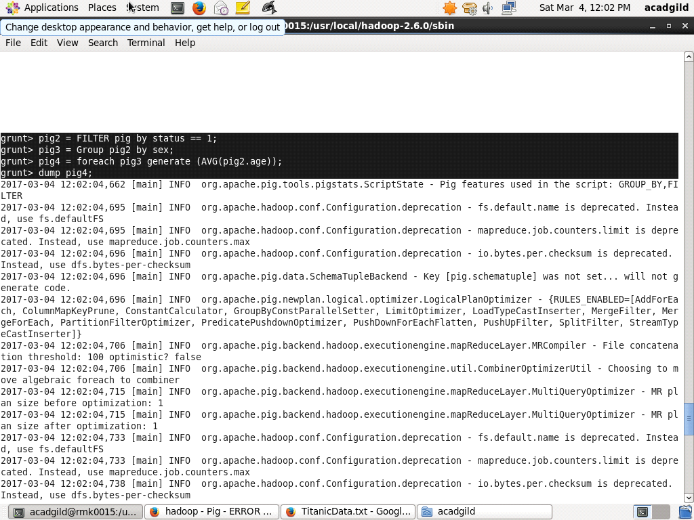

//RESULT OF DUMP WITH MALE AVERAGE AND FEMALE AVERAGE:

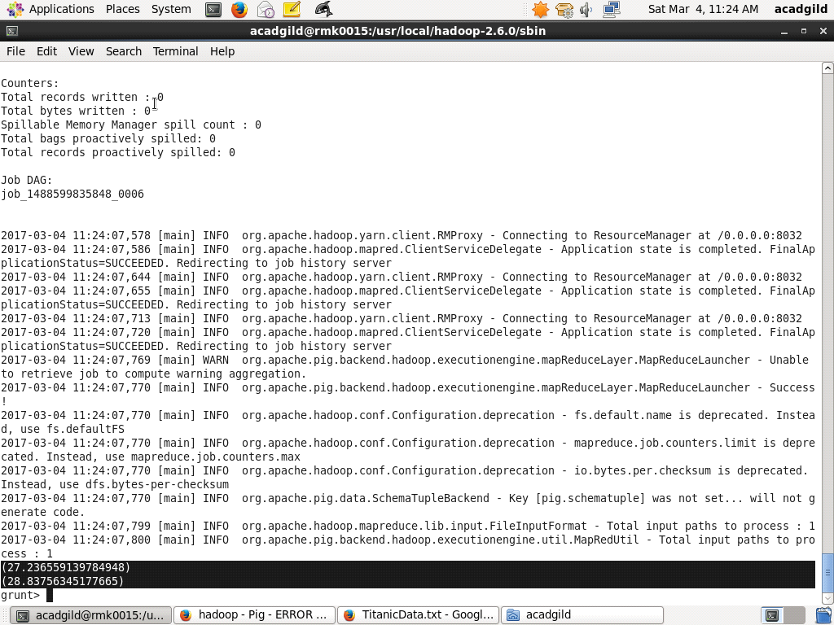

//stored result

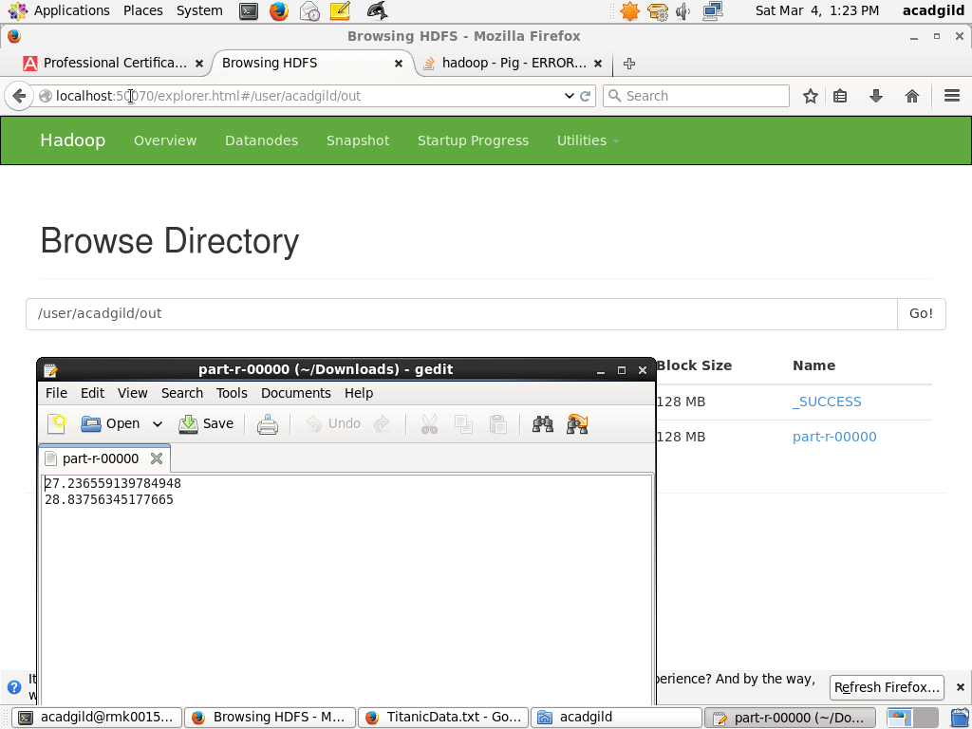

2.Write a pig script to find the number of people died and survived in each class

//FOR PEOPLE WHO ARE DEAD

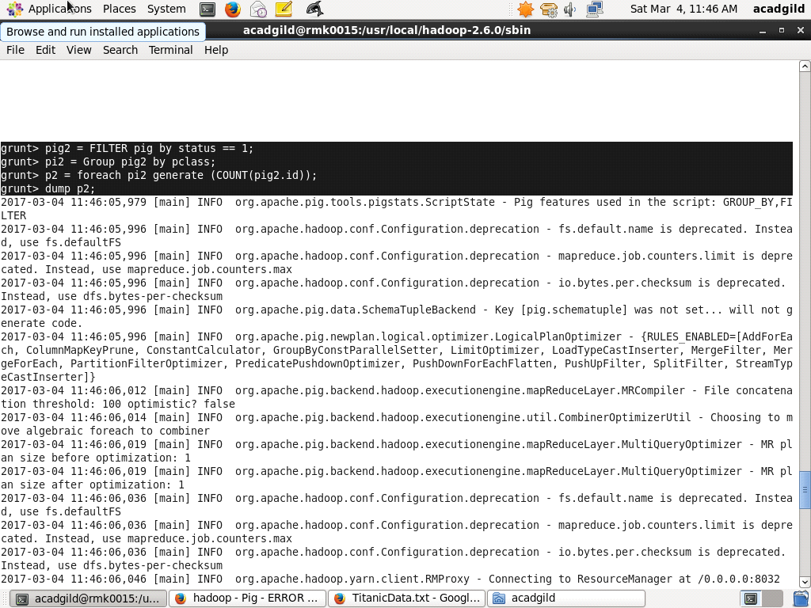

//RESULT OF PEOPLE DEAD COUNT

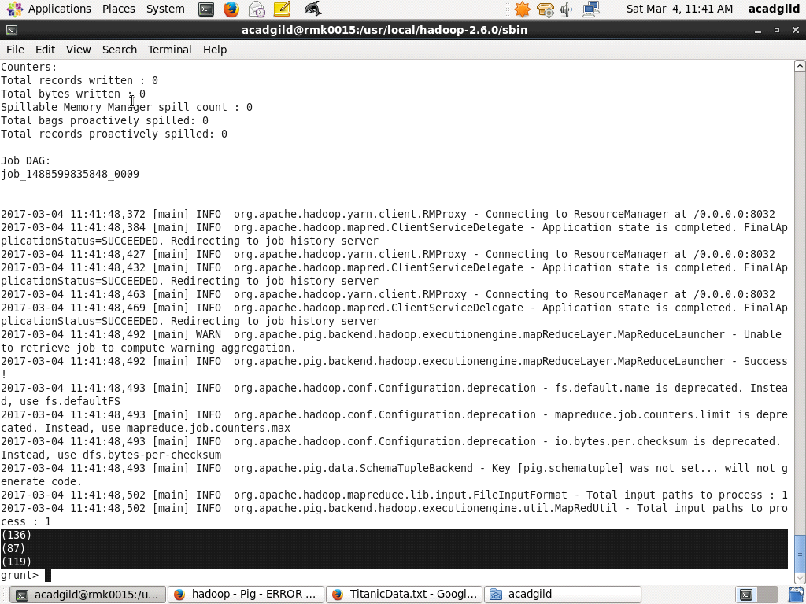

//FOR PEOPLE WHO ARE SURVIVED

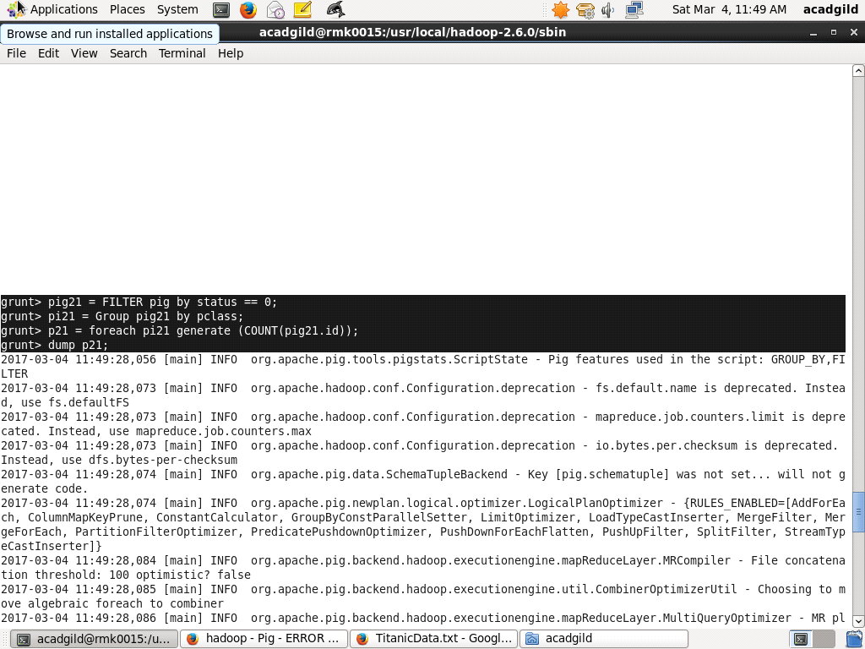

//RESULTANT COUNT OF PEOPLE SURVIVED

