URL : https://medium.com/@reach2arunprakash/www-guvi-io-zen-d395deec1373
1. // Declare four variables without assigning values and print them in console
let a,b,c,d;
console.log(a,b,c,d)
//---------------------------------------------------------------
//How to get value of the variable myvar as output
var myvar= 1;
console.log(myvar);
//----------------------------------------------------------------
// Declare variables to store your first name, last name, marital status//country and age in multiple lines
let fname = "Rohini"
let lname = "Murugesan"
let Marital_Status = "Unmarried"
let country = "India"
let Age = "24"
//Declare variables to store your first name, last name, marital status, //country and age in a single line
let fname1 = "Rohini",lname1 = "Murugesan", Marital_Status1 = "Unmarried", country1 = "India", Age1 = "24";
//Declare variables and assign string, boolean, undefined and null data types
let str = "String"
let Bool = true
let und
let null_var = null
/* 6. Convert the string to integer
parseInt()
Number()
Plus sign(+) */
let str1 = "5";
console.log(str1)
console.log(parseInt(str1))
console.log(Number(str1))
console.log(+str1)
//Write 6 statement which provide truthy & falsey values.
// Truthy
console.log('false')
console.log('0')
console.log([])
console.log({})
console.log('7')
console.log('cab')
//Falsy
console.log(false)
console.log(0)
console.log('')
console.log(null)
console.log(undefined)
console.log(NaN)
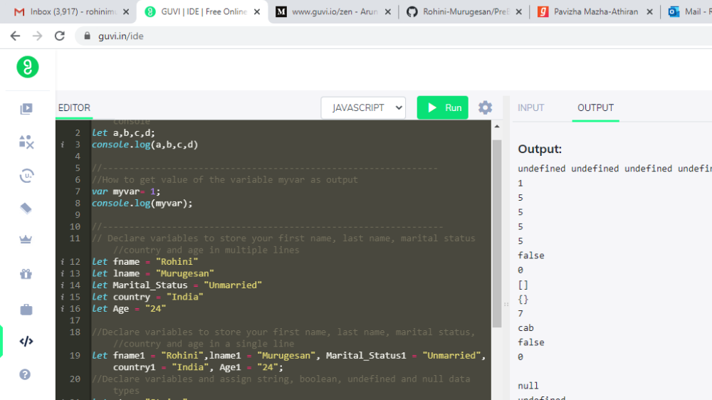

Simple Programs todo for Operators
1.Square of a number

var N = userInput[0];
var square = N * N;
console.log(square);
2.Swapping 2 numbers

let a = 1;
let b = 2;
let temp;

temp = a;
a = b;
b = temp;
console.log(a);
console.log(b);

3.Addition of 3 numbers
const readline = require('readline');
const inp = readline.createInterface({
input: process.stdin
});
const userInput = [];
inp.on("line", (data) => {
userInput.push(data);
});
inp.on("close", () => {
var a = +userInput[0];
var b = + userInput[1];
var c = +userInput[2];
console.log(a+b+c)

});

4.Celsius to Fahrenheit conversion

const readline = require('readline');
const inp = readline.createInterface({
input: process.stdin
});
const userInput = [];
inp.on("line", (data) => {
userInput.push(data);
});
inp.on("close", () => {
var a = +userInput[0];
console.log(Math.round((a*1.8+32)*100)/100)
});

5.Meter to miles
const readline = require('readline');
const inp = readline.createInterface({
input: process.stdin
});
const userInput = [];
inp.on("line", (data) => {
userInput.push(data);
});
inp.on("close", () => {

var M = userInput[0];
var m = M / 1609;
console.log(m);

});

6.Pounds to kg
const readline = require('readline');
const inp = readline.createInterface({
input: process.stdin
});
const userInput = [];
inp.on("line", (data) => {
userInput.push(data);
});
inp.on("close", () => {

var p = userInput[0];
var kg = p / 2.205;
console.log(kg);

});

7.Calculate Batting Average

const readline = require('readline');
const inp = readline.createInterface({
input: process.stdin
});
const userInput = [];
inp.on("line", (data) => {
userInput.push(data);
});
inp.on("close", () => {

var runs = userInput[0];
var timesOut = userInput[1];
var BA =runs / timesOut;
console.log(BA);

});

8.Calculate five test scores and print their average

const readline = require('readline');
const inp = readline.createInterface({
input: process.stdin
});
const userInput = [];
inp.on("line", (data) => {
userInput.push(data);
});
inp.on("close", () => {

var a = +userInput[0];
var b = +userInput[1];
var c = +userInput[2];
var d = +userInput[3];
var e = +userInput[4];
var Average = (a + b + c + d + e)/5;
console.log(Average);

});

9.Power of any number x ^ y.

const readline = require('readline');
const inp = readline.createInterface({
input: process.stdin
});
const userInput = [];
inp.on("line", (data) => {
userInput.push(data);
});
inp.on("close", () => {

var x = +userInput[0];
var y = +userInput[1];
var power = Math.pow(x,y);
console.log(power);

});

10.Calculate Simple Interest
const readline = require('readline');
const inp = readline.createInterface({
input: process.stdin
});
const userInput = [];
inp.on("line", (data) => {
userInput.push(data);
});
inp.on("close", () => {

var P = +userInput[0];
var N = +userInput[1];
var R = +userInput[2];
var SI = (P * N*R)/100;
console.log(SI);

});

11.Calculate area of an equilateral triangle

const readline = require('readline');
const inp = readline.createInterface({
input: process.stdin
});
const userInput = [];
inp.on("line", (data) => {
userInput.push(data);
});
inp.on("close", () => {
var a = +userInput[0];
var Area = (Math.pow(3,1/2)* a * a)/4
//var Area = (Math.sqrt(3)* a * a)/4
console.log(Math.round(Area*100)/100)
});

12.Area Of Isosceles Triangle
const readline = require('readline');
const inp = readline.createInterface({
input: process.stdin
});
const userInput = [];
inp.on("line", (data) => {
userInput.push(data);
});
inp.on("close", () => {
var b = userInput[0];
var h = userInput[1];
var Area = (b * h)/2;
console.log(Area);
});

13.Volume Of Sphere
const readline = require('readline');
const inp = readline.createInterface({
input: process.stdin
});
const userInput = [];
inp.on("line", (data) => {
userInput.push(data);
});
inp.on("close", () => {
var r = userInput[0];
var vol = 4/3 * (3.14 * r * r);
console.log(vol.toFixed (02));
});

14.Volume Of Prism
const readline = require('readline');
const inp = readline.createInterface({
input: process.stdin
});
const userInput = [];
inp.on("line", (data) => {
userInput.push(data);
});
inp.on("close", () => {
var l = userInput[0];
var b = userInput[1];
var h = userInput[2];
var vol = (l * b * h)/2;
console.log(vol.toFixed (02));
});

15.Find area of a triangle.
const readline = require('readline');
const inp = readline.createInterface({
input: process.stdin
});
const userInput = [];
inp.on("line", (data) => {
userInput.push(data);
});
inp.on("close", () => {
var h = userInput[0];
var b = userInput[1];
var Area = 1/2 * (b * h);
console.log(Area);
});

16.Give the Actual cost and Sold cost, Calculate Discount Of Product

const readline = require('readline');
const inp = readline.createInterface({
input: process.stdin
});
const userInput = [];
inp.on("line", (data) => {
userInput.push(data);
});
inp.on("close", () => {
var CP = userInput[0];
var SP = userInput[1];
var discount = CP - SP;
console.log(discount);
});

17.Given their radius of a circle and find its diameter, circumference and area.
const readline = require('readline');
const inp = readline.createInterface({
input: process.stdin
});
const userInput = [];
inp.on("line", (data) => {
userInput.push(data);
});
inp.on("close", () => {
var r = userInput[0];
var d = 2 * r;
var c = 2 * 3.14 * r;
console.log(d);
console.log(c);
});

18.Given two numbers and perform all arithmetic operations.
const readline = require('readline');
const inp = readline.createInterface({
input: process.stdin
});
const userInput = [];
inp.on("line", (data) => {
userInput.push(data);
});
inp.on("close", () => {
var a = +userInput[0];
var b = +userInput[1];

console.log(a + b);
console.log(a - b);
console.log(a * b);
console.log(a / b);
});

19.Display the asterisk pattern as shown below(No loop needed):
console.log("*****");
console.log("*****");
console.log("*****");
console.log("*****");
console.log("*****");

20.Program To Calculate CGPA
const readline = require('readline');
const inp = readline.createInterface({
input: process.stdin
});
const userInput = [];
inp.on("line", (data) => {
userInput.push(data);
});
inp.on("close", () => {
var a = +userInput[0];
var b = +userInput[1];
var avg = +userInput[2];
var GPA = a + b;
var CGPA = (a + b)/avg;
console.log(CGPA);

});

Task 3: Simple Programs todo for Condition , Looping and Arrays
1.
const readline = require('readline');
const inp = readline.createInterface({
input: process.stdin
});
const userInput = [];
inp.on("line", (data) => {
userInput.push(data);
});
inp.on("close", () => {
for(let i=1;i<=8;i++){
let out = ""
for (let j=1;j<i;j++){
out += "*"
}
console.log(out)
}
});

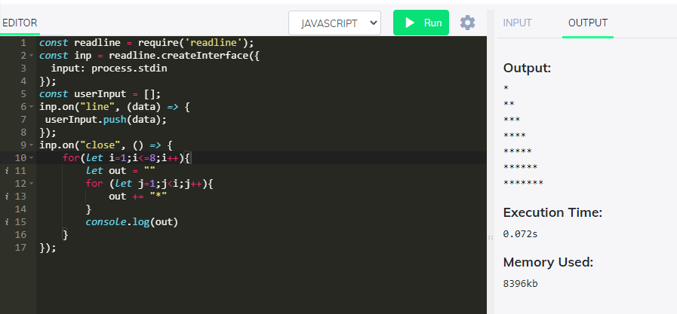

- Iterate through the string array and print it contents
const readline = require('readline');
const inp = readline.createInterface({
input: process.stdin
});
const userInput = [];
inp.on("line", (data) => {
userInput.push(data);
});
inp.on("close", () => {
var strArray= ["<option>Jazz</option>",
"<option>Blues</option>",
"<option>New Age</option>",
"<option>Classical</option>",
"<option>Opera</option>"]
for (var i=0;i<strArray.length;i++){
console.log(strArray[i])
}
});

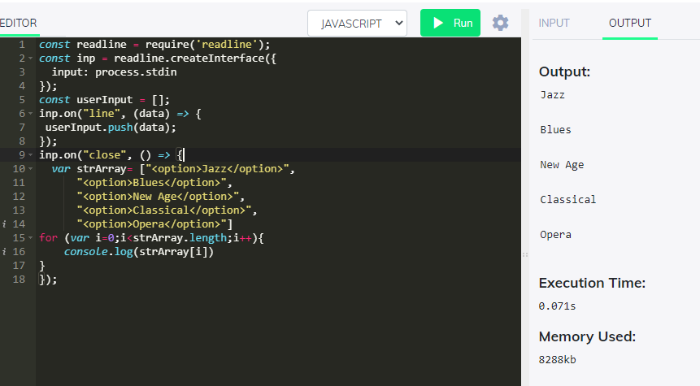

var myarray=[11,22,33,44,55]
write a code to count the elements in the array . Don’t use length property
const readline = require('readline');
const inp = readline.createInterface({
input: process.stdin
});
const userInput = [];
inp.on("line", (data) => {
userInput.push(data);
});
inp.on("close", () => {
var myarray=[11,22,33,44,55]
count = 0;
for(var i in myarray){
count++;
}
console.log(count)
});

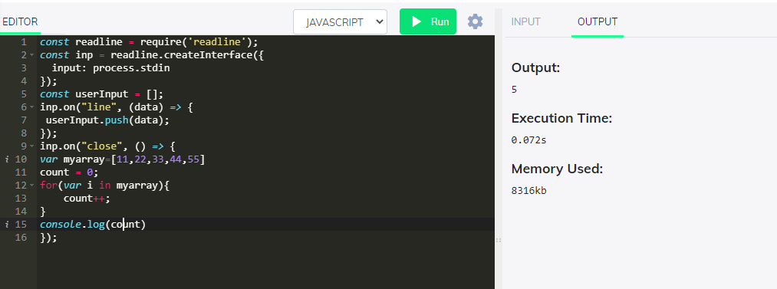

Foods Array

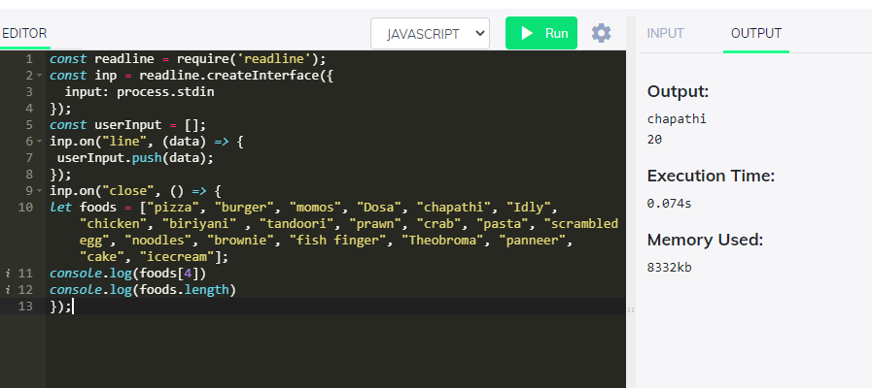

Friends
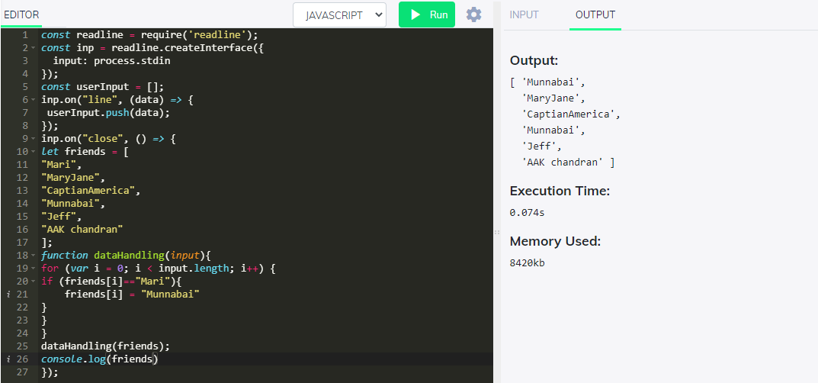

Print till Captain America <3

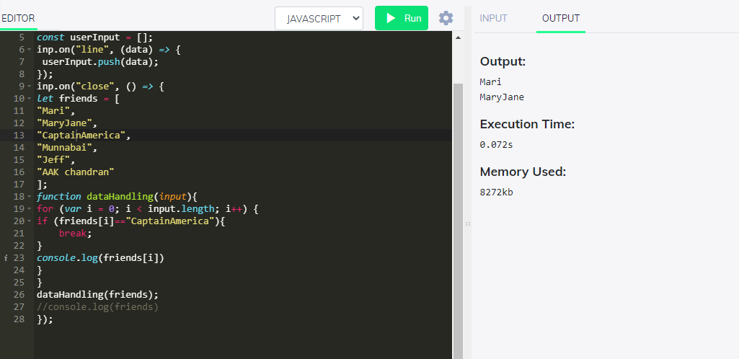

Find friend
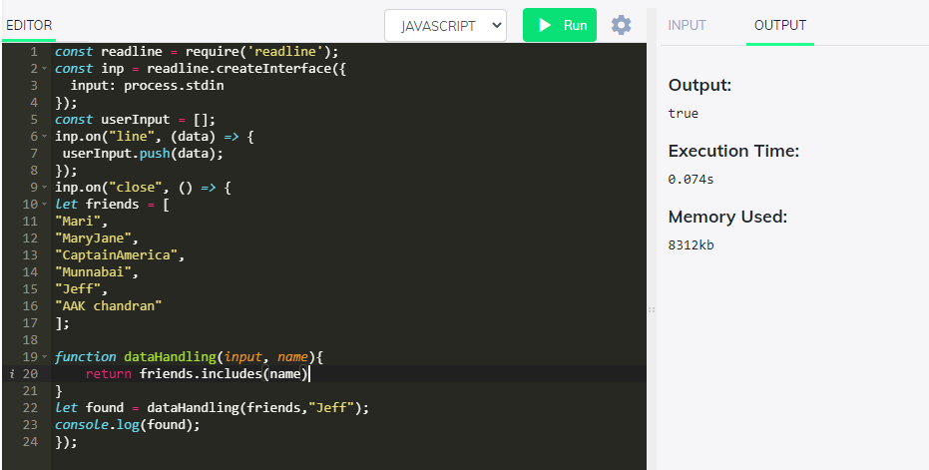

We have two lists of friends below. Use array methods to combine them into one alphabetically-sorted list.

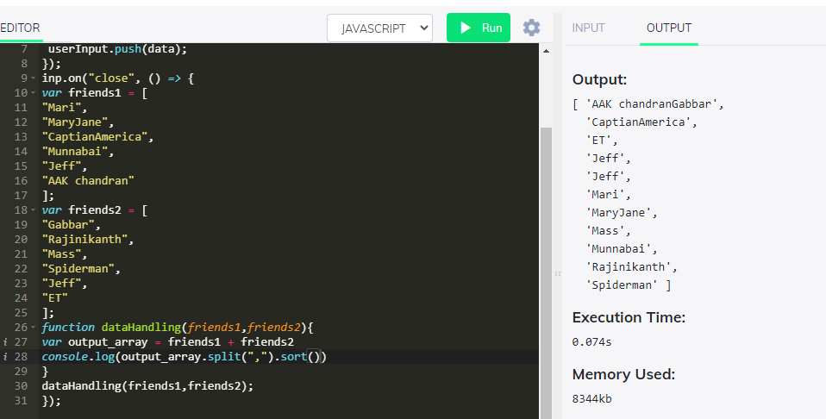

var friends1 = [
"Mari",
"MaryJane",
"CaptianAmerica",
"Munnabai",
"Jeff",
"AAK chandran"
];
var friends2 = [
"Gabbar",
"Rajinikanth",
"Mass",
"Spiderman",
"Jeff",
"ET"
];
function dataHandling(friends1,friends2){
var output = (friends1+friends2).split(",").sort()
console.log(output)
return output
}
output = dataHandling(friends1,friends2);

//1. Get the first item, the middle item and the last item of the array
console.log(output[0],output[Math.floor(output.length/2)],output.slice(-1)[0])
//2. Add your name to the end of the friends array, and add another name to beginning.
output.push("Rohini Murugesan")
output.unshift("Vidhya")
console.log(output)
let a_arr = []
let len = 0
let M_start = []
let max_val = output[0].length
let max_frnd = output[0]
let min_val = output[0].length
let min_frnd = output[0]

//3. Add Mr or Ms to the names in the friends array.

for(var i =0;i<output.length;i++){
if(output[i].includes("a")){
a_arr.push(output[i])
}
if(output[i][0]=="M"){
M_start.push(output[i])
}
if(max_val<output[i].length){
max_val = output[i].length
max_frnd = output[i]
}
if(min_val>output[i].length){
min_val = output[i].length
min_frnd = output[i]
}
len += output[i].length
console.log("Ms/Mr."+output[i])
}

//4. Concat all the names the friends array and return as comma “,” seperated string.
console.log(output.join(","))

//5. Find the friends names who has letter ‘a’ and return the list.
console.log(a_arr)
//6. Find the avg length of all the friends names. Get the individual length of the names and do the avg.
console.log(len/output.length)
//7. Find the names and return the list starting with letter M.
console.log(M_start)
//8. Find the name with max characters and return the name.
console.log("Max length",max_val,"Max len Friend",max_frnd)
//9. Find the name with min characters and return the name.
console.log("Min length",min_val,"Min len Friend",min_frnd)

OUTPUT:

Output:
[ 'AAK chandranGabbar',
'CaptianAmerica',
'ET',
'Jeff',
'Jeff',
'Mari',
'MaryJane',
'Mass',
'Munnabai',
'Rajinikanth',
'Spiderman' ]
AAK chandranGabbar Mari Spiderman
[ 'Vidhya',
'AAK chandranGabbar',
'CaptianAmerica',
'ET',
'Jeff',
'Jeff',
'Mari',
'MaryJane',
'Mass',
'Munnabai',
'Rajinikanth',
'Spiderman',
'Rohini Murugesan' ]
Ms/Mr.Vidhya
Ms/Mr.AAK chandranGabbar
Ms/Mr.CaptianAmerica
Ms/Mr.ET
Ms/Mr.Jeff
Ms/Mr.Jeff
Ms/Mr.Mari
Ms/Mr.MaryJane
Ms/Mr.Mass
Ms/Mr.Munnabai
Ms/Mr.Rajinikanth
Ms/Mr.Spiderman
Ms/Mr.Rohini Murugesan
Vidhya,AAK chandranGabbar,CaptianAmerica,ET,Jeff,Jeff,Mari,MaryJane,Mass,Munnabai,Rajinikanth,Spiderman,Rohini Murugesan
[ 'Vidhya',
'AAK chandranGabbar',
'CaptianAmerica',
'Mari',
'MaryJane',
'Mass',
'Munnabai',
'Rajinikanth',
'Spiderman',
'Rohini Murugesan' ]
8.307692307692308
[ 'Mari', 'MaryJane', 'Mass', 'Munnabai' ]
Max length 18 Max len Friend AAK chandranGabbar
Min length 2 Min len Friend ET

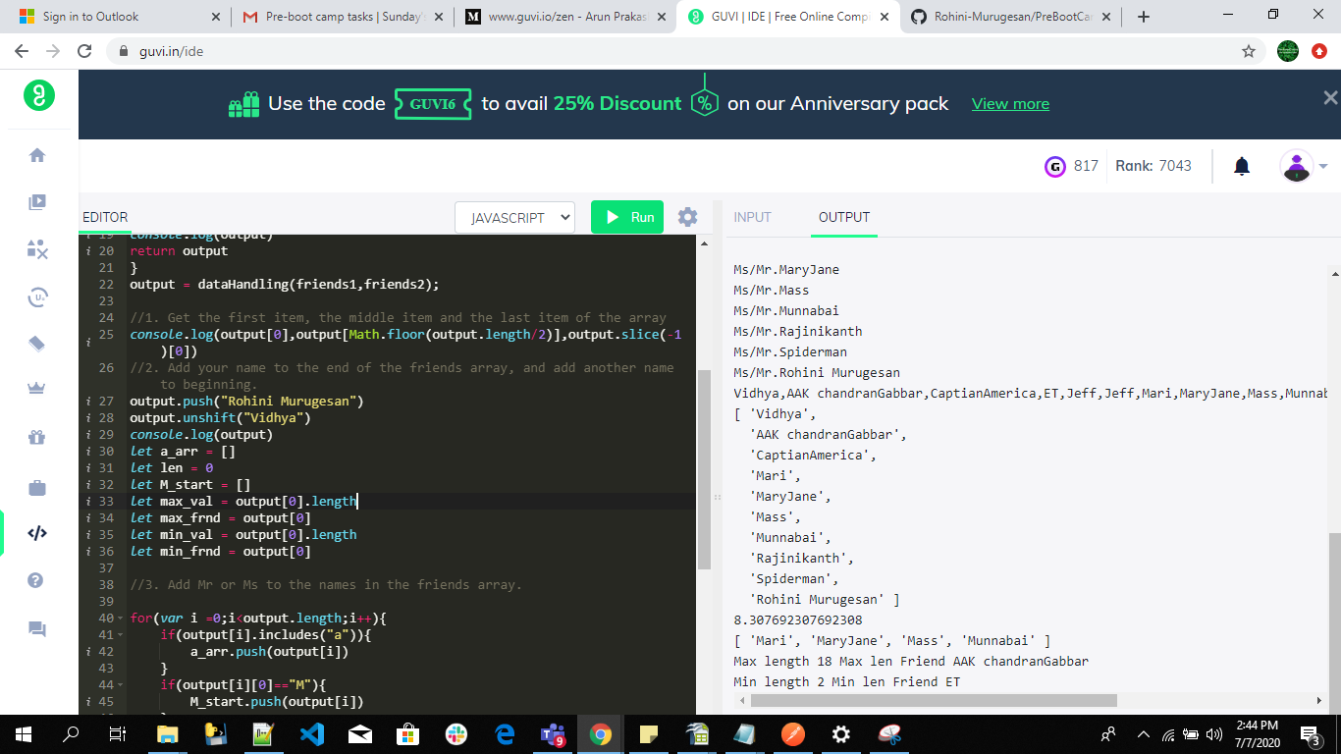

What is the output

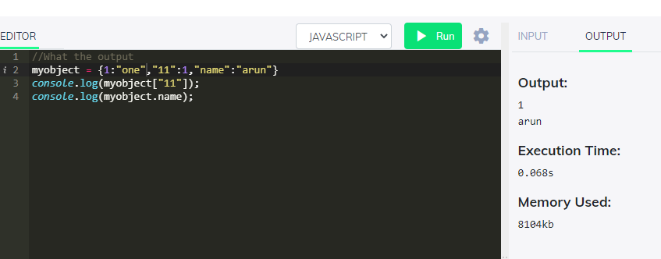

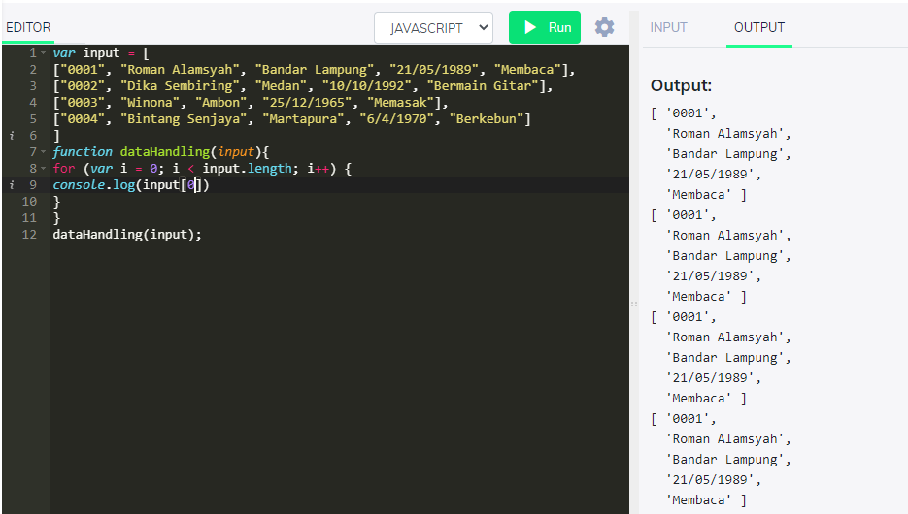

Add a new key value pair to myobject
key : ten
value : ten
