https://docs.google.com/document/d/1AB04kg6FD9UuJgfW3P9Ml_Ol9tFCNJRVT2mx4jPKK3U/edit

Class 0: Class Calculator

Code:
class calculator{
constructor(num1,num2){
this.num1 = num1
this.num2 = num2
}
add(){
console.log("Sum is ",this.num1+this.num2)
return this.num1+this.num2
}
sub(){
console.log("Difference is ",this.num1-this.num2)
return this.num1-this.num2
}
mul(){
console.log("Product is ",this.num1*this.num2)
return this.num1*this.num2
}
div(){
console.log("Quotient is ",this.num1/this.num2)
return this.num1/this.num2
}
}
let calcobj = new calculator(10,8)
let add_val = calcobj.add()
let sub_val = calcobj.sub()
let mul_val = calcobj.mul()
let div_val = calcobj.div()

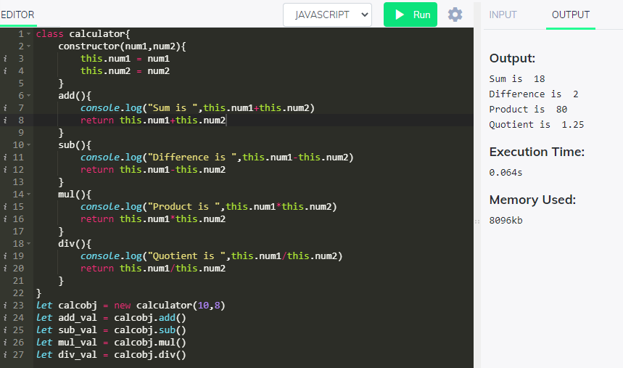

Class 1: Class Movie

Code:
class Movie{
constructor(Title,Studio,Rating="PG"){
this.Title = Title
this.Studio = Studio
this.Rating = Rating
}
getPG(Arr){
let filtered_val = Arr.filter((val)=>val.Rating==="PG")
console.log(filtered_val)
return filtered_val
}
}
let obj1 = new Movie("Casino Royale_1","Eon Productions_1","PG13")
let obj2 = new Movie("Casino Royale_2","Eon Productions_2")
let obj3 = new Movie("Casino Royale_3","Eon Productions_3")
let obj4 = new Movie("Casino Royale_4","Eon Productions_4","PG13")
let obj5 = new Movie("Casino Royale_5","Eon Productions_5")
let obj6 = new Movie("Casino Royale_6","Eon Productions_6","PG13")
let filval = obj1.getPG([obj1,obj2,obj3,obj4,obj5,obj6])

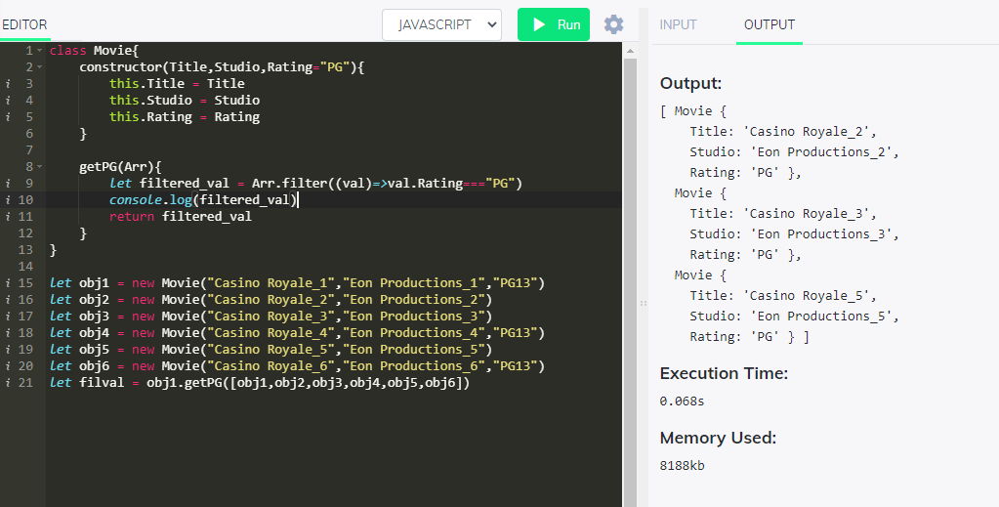

Class 3: Class Circle
Code:
class Circle{
constructor(radius,color){
this.radius = radius
this.color = color
if(this.radius===undefined && this.color===undefined){
console.log("Radius & Color not defined")
}else if(this.color===undefined){
console.log("Color is not defined")
}else if(this.radius===undefined){
console.log("Radius is not defined")
}else{
console.log("Both Defined")
}
}
getRadius(){
console.log(this.radius)
return this.radius
}
getColor(){
console.log(this.color)
return this.color
}
setRadius(Rad){
if(Rad !== undefined){
this.radius = Rad
}
}
setColor(Color){
if(Color !== undefined){
this.color = Color
}
}
getArea(){
console.log(Math.pow(this.radius,2) * 3.14)
return Math.pow(this.radius,2) * 3.14
}
}
let obj = new Circle()
let radius = obj.getRadius()
obj.setRadius(4)
obj.setColor("Red")
let after_rad = obj.getRadius()
obj.getArea()
// constructor
let obj1 = new Circle()
let obj2 = new Circle(4)
let obj3 = new Circle(3,4)
let obj4 = new Circle(undefined,4)

Output
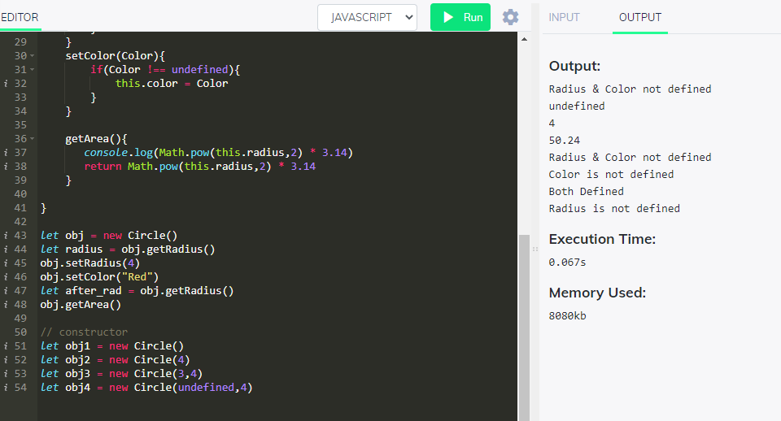

class 4: TV class

class TV_Class{
constructor(brand,price,inches,onoff){
this.reset = function (){
this.brand = brand
this.volume = 50
this.channel = 1
this.price = price
this.inches = inches
this.onoff = onoff
}
this.reset()
}
change_volume(action,value){
if(action==="increase"){
if(value<=100){
this.volume = value
}else{
console.log("Increase cannot be performed. Volume already above range 0 to 100")
}
}else{
if(value>=0){
this.volume = value
}else{
console.log("Volume decrease cannot be performed. Volume cannot be less than 0")
}
}
}
set_Channel(channel){
if(channel>50){
this.channel = 50
console.log("Channel cannot be more than 50")
}else{
this.channel = channel
}
}
reset_TV(){
this.reset()
console.log("Reset done")
}
getStatus(){
console.log(this.brand+" at channel "+this.channel+", volume "+this.volume)
}
}
var obj1 = new TV_Class("Panasonic","10000","40","on")
obj1.getStatus()
obj1.set_Channel(20)
obj1.getStatus()
obj1.reset_TV()
obj1.getStatus()
class LED_TV extends TV_Class{
constructor(){
super();
console.log("**** Fron LED_TV ****")
this.screen_thickness = 4;//inches
this.energyusage = "91.5 watts";
this.lifespan = 4;//yrs
this.refresh_rate = 60;//hz
//console.log("Hey")
}
viewingAngle(){
console.log("viewingAngle function")
}
backlight(){
console.log("backlight function")
}
displayDetails(){
console.log(this.screen_thickness,this.energyusage,this.lifespan,this.refresh_rate)
}
}
var obj2 = new LED_TV()
obj2.viewingAngle()
obj2.displayDetails()
class Plasma_TV extends TV_Class{
constructor(){
super();
console.log("**** Fron Plasma_TV ****")
this.screen_thickness = 3;//inches
this.energyusage = "90.5 watts";
this.lifespan = 3;//yrs
this.refresh_rate = 70;//hz
//console.log("Hey")
}
viewingAngle(){
console.log("viewingAngle function")
}
backlight(){
console.log("backlight function")
}
displayDetails(){
console.log(this.screen_thickness,this.energyusage,this.lifespan,this.refresh_rate)
}
}
var obj3 = new Plasma_TV()
obj3.viewingAngle()
obj3.displayDetails()

Output:
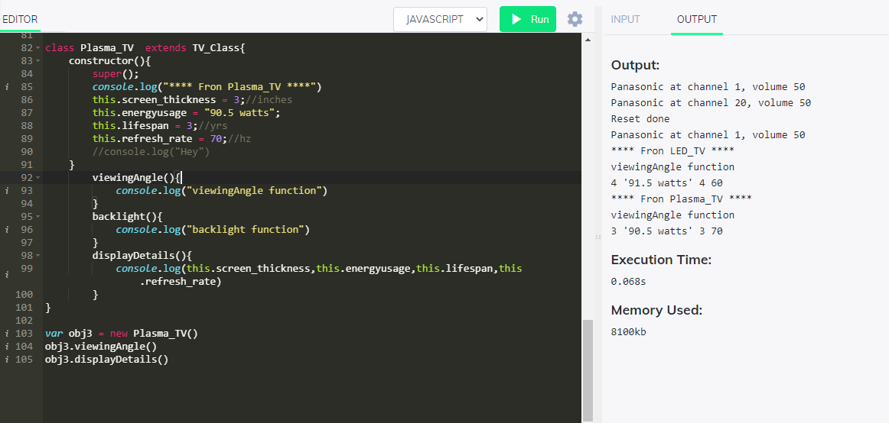

Class 5: BANK – Only Skeleton

class Bank{
constructor(){
this.code = "code"
this.adddress = "address"
this.Account = []
this.ATM;
}
manages(){
}
maintains(){
}
}
class Customer{
constructor(){
this.name = "name"
this.age = "age"
this.addr = "addr"
this.dob = "dob"
this.Account = [] //length 2
}
setAccount(AccObj){
if(this.Account.length<=2){
this.Account.push(AccObj)
}
}
verifyPwd(){
}

withdraw(ATMObj){

}
}
class Account{
constructor(){
this.number = ""
this.balance = "bal"
}
deposit(){
}
withdraw(){
}
createTransaction(){
}
}
class ATM{
constructor(){
this.location =""
this.managedby = ""
this.Customer = CustObj
}
}
class ATM_Transactions{
constructor(){
this.transactionid = ""
this.date = ""
this.type = ""
this.amount = ""
this.postbal = ""
}
modifies(){
}
}
class current_acc extends Account{
constructor(){
this.acc_no = ""
this.balance = ""}
withdraw(){
}
}
class savings_acc extends Account{
constructor(){
this.acc_no = ""
this.balance = ""
}
}

