What is the difference between window, screen, and document in Javascript?

Window:
- The window object represents an open window in a browser.
- Window is the main JavaScript object root, aka the global object in a browser.
- It is also treated as the root of the DOM
- If a document contain frames (<iframe> tags), the browser creates one window object for the HTML document, and one additional window object for each frame.
- Can be accessed as window
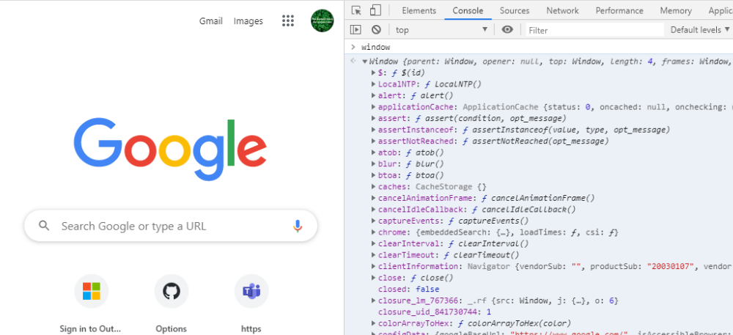
Screen
window.screen or screen is a small information object about physical screen dimensions.

PropertyDescriptionavailHeightReturns the height of the screen (excluding the Windows Taskbar)availWidthReturns the width of the screen (excluding the Windows Taskbar)
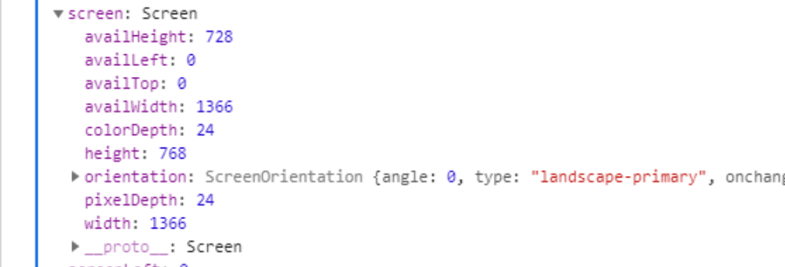

Document
When an HTML document is loaded into a web browser, it becomes a document object
The document object is the root node of the HTML document.
window.document or document is the main object of the potentially visible (or better: rendered) DOM

