1. Problem:
Write a function called “addFive”.
Given a number, “addFive” returns 5 added to that number.

Code:
let num = 10;
function addFive(num) {
return num+5;
}
let result = addFive(num)
let result1 = addFive(0);
let result2 = addFive(-5);

console.log(result,result1,result2)

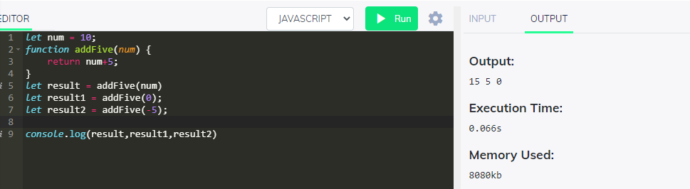

- Write a function called “getOpposite”.
Given a number, return its opposite

Code:

function getOpposite(num) {
if(num<0 && num%1===0){return Math.abs(num)}
else if(num>0 && num%1===0){return 0-num}
else if(num===0){return 0}
else{return -1}
}
var result = getOpposite(5);
var result1 = getOpposite(0);
var result2 = getOpposite(-5);
var result3 = getOpposite("5a");
var result4 = getOpposite(5.5);

console.log(result,result1,result2,result3,result4)

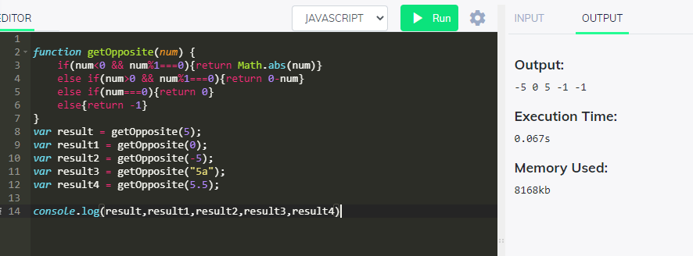

3. Problem:
Fill in your code that takes an number minutes and converts it to seconds.
Code:
var min = 5;
function toSeconds(min) {
console.log(min*60)
return min*60;
}
let result = toSeconds(5)
toSeconds(3)
toSeconds(2)

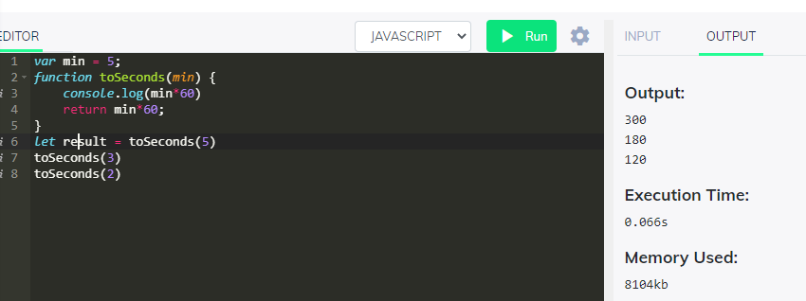

- Problem
Create a function that takes a string and returns it as an integer.
Code:
var mystr = "5";
function toInteger(mystr) {
return +mystr
}
var myint = toInteger(mystr)
console.log(myint,typeof(myint))

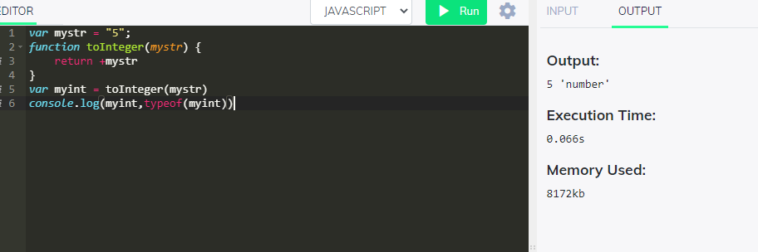

5. Problem
Create a function that takes a number as an argument, increments the number by +1 and returns the result.

Code:
var myint = 0;
function nextNumber(myint) {
return myint+=1
}
var myNextint = nextNumber(myint)
console.log(myNextint)

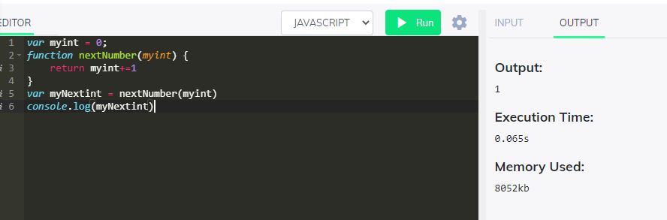

6. Problem
Create a function that takes an array and returns the first element.
Code:
var arr = [1, 2, 3];
function getFirstElement(arr) {
return arr[0]
}
var data = getFirstElement(arr)
console.log(data)

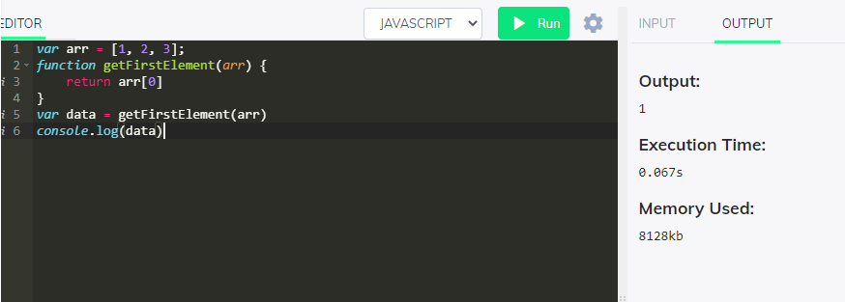

7. Problem
Convert Hours into Seconds
Write a function that converts hours into seconds.

Code:
var hr = 2;
function hourToSeconds(arr) {
return hr * 60 * 60
}
var sec = hourToSeconds(hr)
console.log(sec)

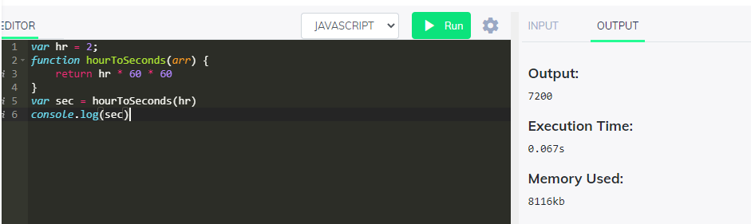

- Find the Perimeter of a Rectangle
Create a function that takes height and width and finds the perimeter of a rectangle.
Code:

function findPerimeter(num1,num2) {
return 2*(num1+num2)

}
var peri = findPerimeter(6,7)
console.log(peri)

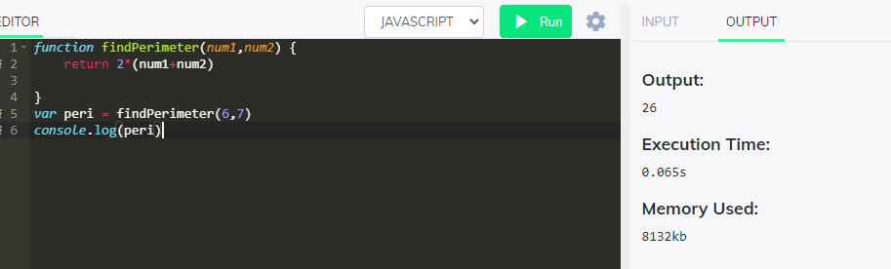
9.
Less Than 100?
Given two numbers, return true if the sum of both numbers is less than 100. Otherwise return false.

Code:
function lessThan100(num1,num2) {
return true ? (num1+num2<100) : false

}
var res = lessThan100(22,15)
console.log(res)

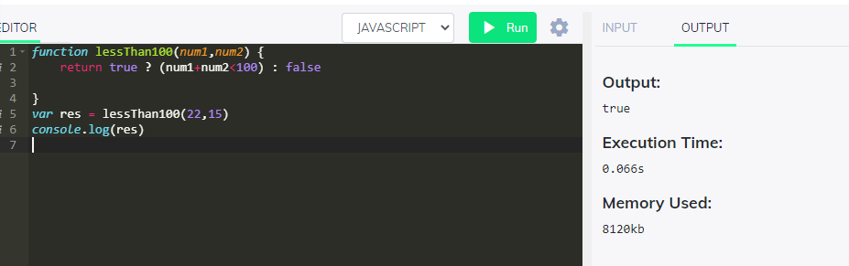
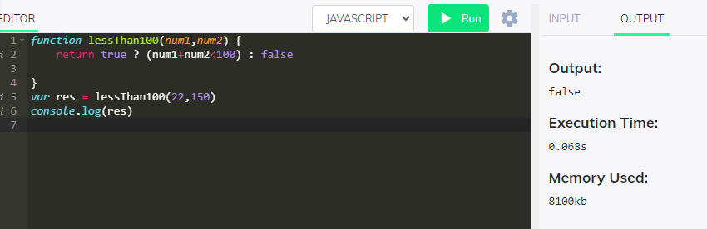

- There is a single operator in JavaScript, capable of providing the remainder of a division operation. Two numbers are passed as parameters. The first parameter divided by the second parameter will have a remainder, possibly zero. Return that value.
Code:
function remainder(num1,num2) {
return num1%num2
}
var res = remainder(1,3)
console.log(res)
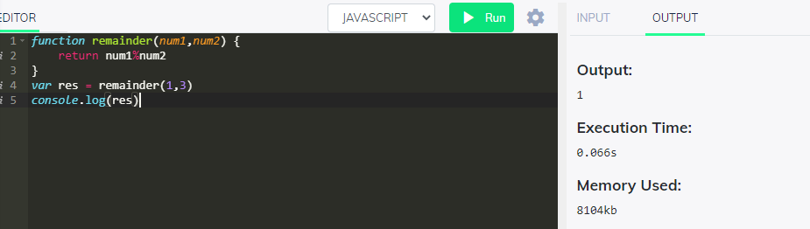

11. Old macdonald had a farm:
MacDonald is asking you to tell him how many legs can be counted among all his animals. The farmer breeds three species:
turkey = 2 legs
horse = 4 legs
pigs = 4 legs
The farmer has counted his animals and he gives you a subtotal for each species. You have to implement a function that returns the total number of legs of all the animals.

Code:
function CountAnimals(tur,horse,pigs) {

return tur*2 + horse*4 + pigs*4
}
var legs = CountAnimals(2,3,5)
console.log(legs)

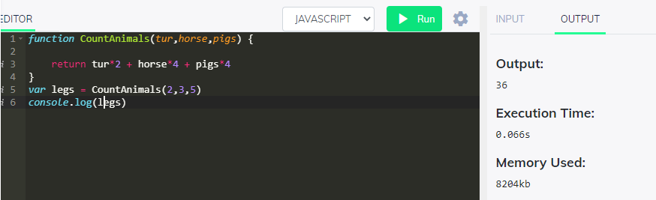

11.Frames Per Second
Create a function that returns the number of frames shown in a given number of minutes for a certain FPS.

Code:
function frames(num1,num2) {

return num1*num2*60
}
var fps = frames(10,25)
console.log(fps)

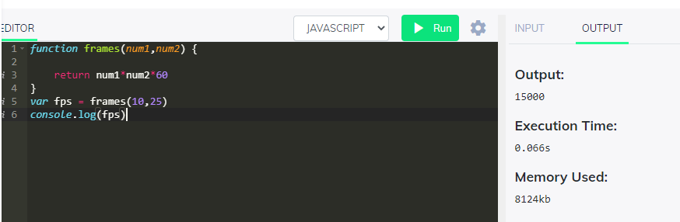

- Check if an Integer is Divisible By Five
Create a function that returns true if an integer is evenly divisible by 5, and false otherwise.
Code:
function divisibleByFive(num1) {
return true ? (Math.abs(num1)%5 === 0) : false

}
var divisible = divisibleByFive(-55)
console.log(divisible)

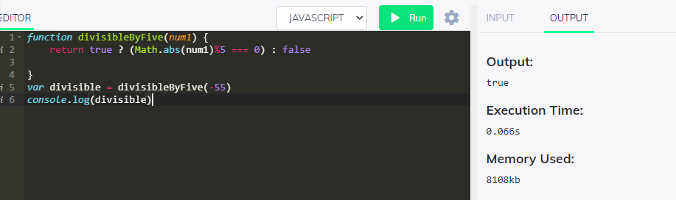

14.
Problem:
Write a function called “isEven”.
Given a number, “isEven” returns whether it is even.
Code:
function isEven(num){
return true? (num%2===0):false
}
var even = isEven(5)
console.log(even)

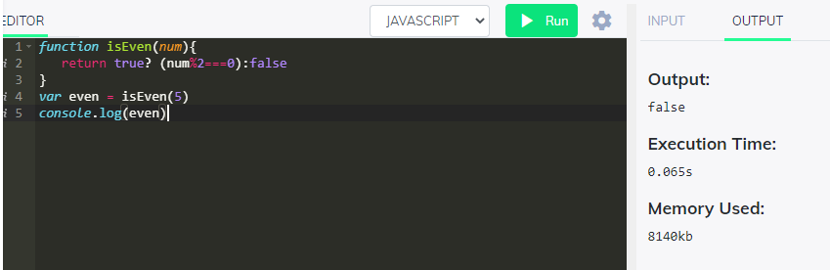

- Write a function called “areBothOdd”.
Given 2 numbers, “areBothOdd” returns whether or not both of the given numbers are odd.
Code:
function arebothodd(num1,num2){
return true? (num1%2!==0 && num2%2!==0):false
}
var result = arebothodd(5,9)
console.log(result)

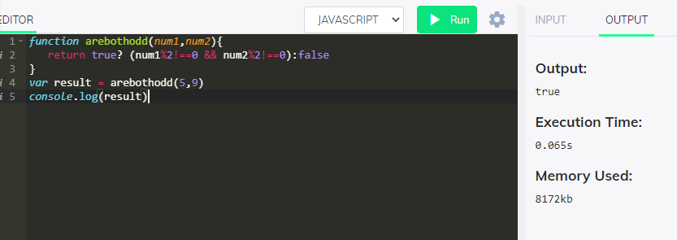

16.
Problem:
Write a function called “getFullName”.
Given a first and a last name, “getFullName” returns a single string with the given first and last names separated by a single space.

Code:
function getFullName(firstName, lastName){
let a = ""
if(firstName!==undefined && firstName!==""){a+= firstName}
if(firstName!==""){a+=" "}
if(lastName!==undefined ){a+=lastName}
console.log(a)
}

getFullName("GUVI", "GEEK");
getFullName("GUVI", );
getFullName("", "GEEK");
getFullName("", "");

