Cross-region replication in S3

Cross-Region Replication (CRR): AWS S3 allows you to replicate objects from one S3 bucket to another in a different AWS region. This feature provides benefits such as reduced latency, compliance, security, disaster recovery, and regional efficiency.

Follow the below steps for set the CRR:

**Step1**: creating 2 buckets in different regions

**Step2**: Enable the versioning **Step3:** cross region replication **Step1: Creating s3 buckets**

* Open AWS console and cental region
* Go to s3 service
* Click on create bucket
* Give name tag as Prathibha-bucket1
* Click on create bucket
* Follow the steps as shown in the below slides

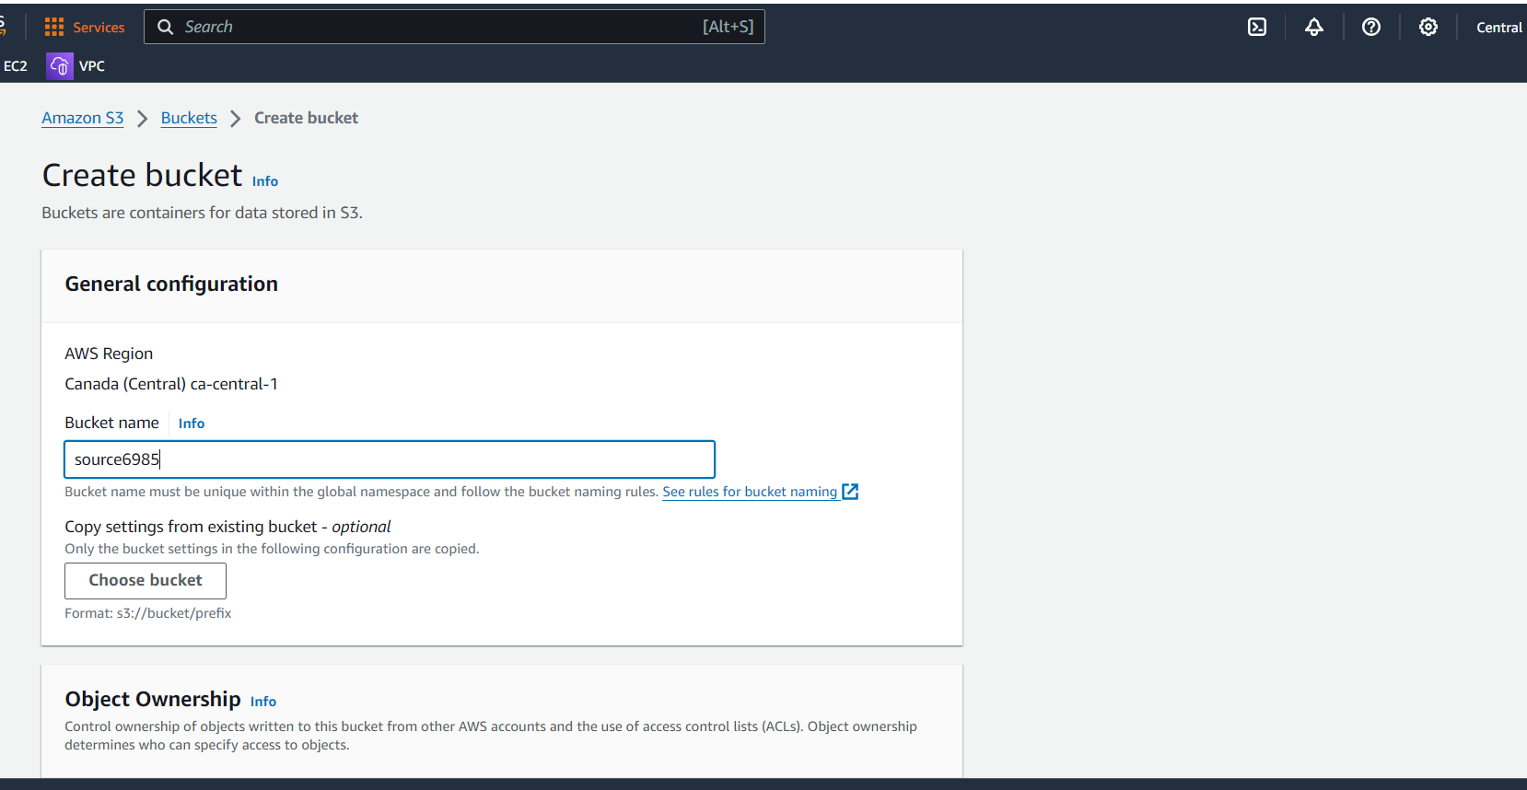

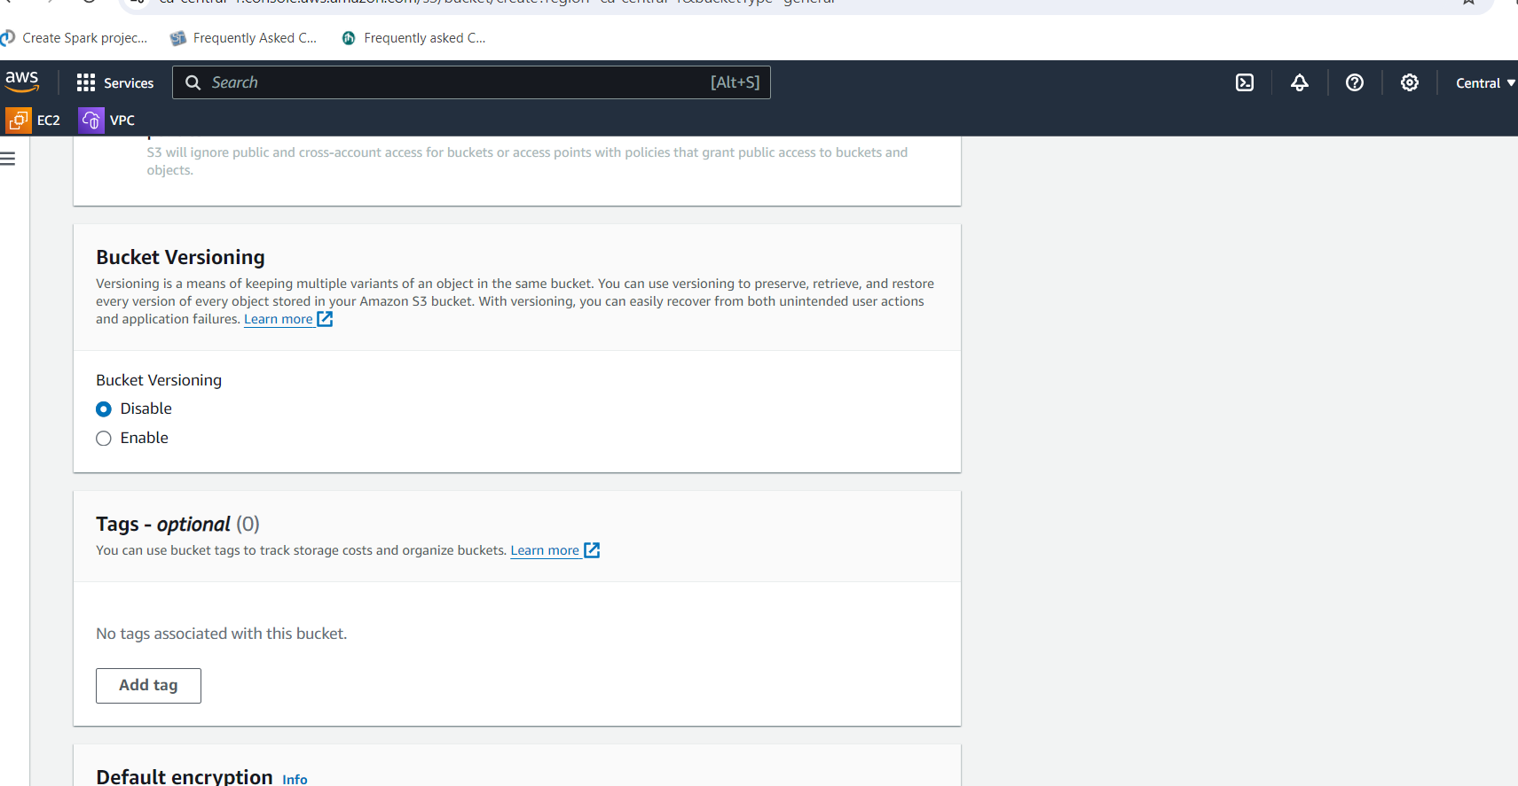

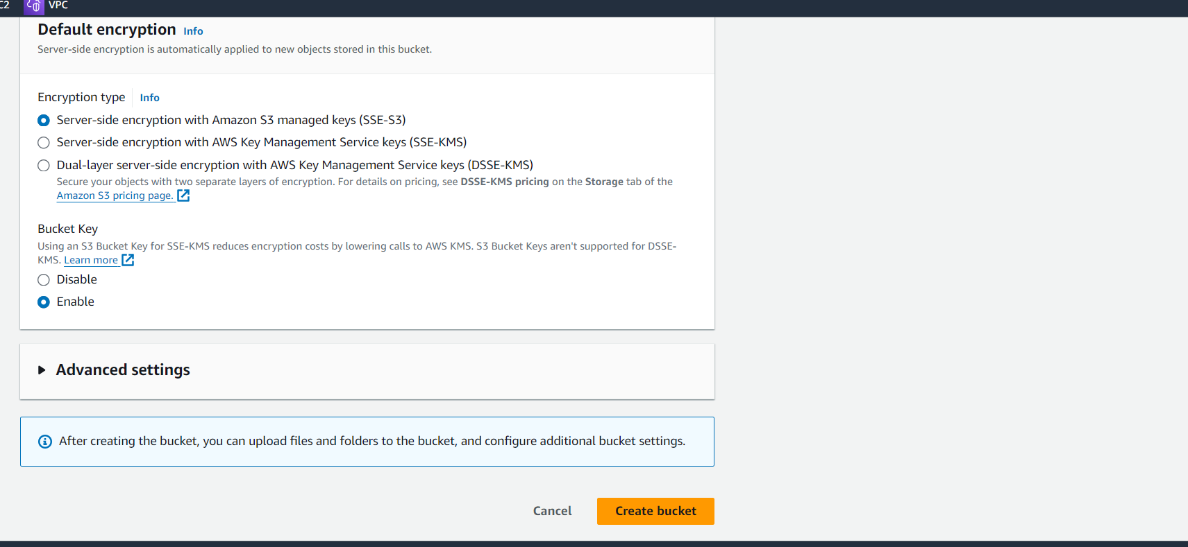

* Once created bucket in central and go to virginia region
* Go to s3 bucket and click on create bucket
* Give name as Prathibha-bucket2
* Remaining field leave it as default and click on create bucket

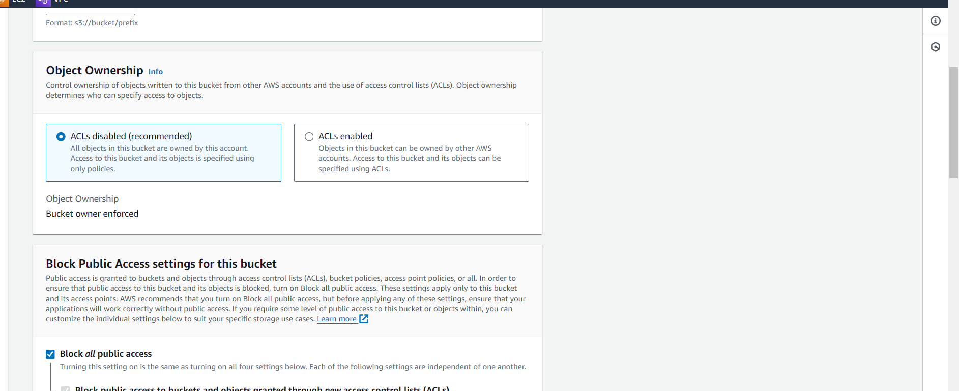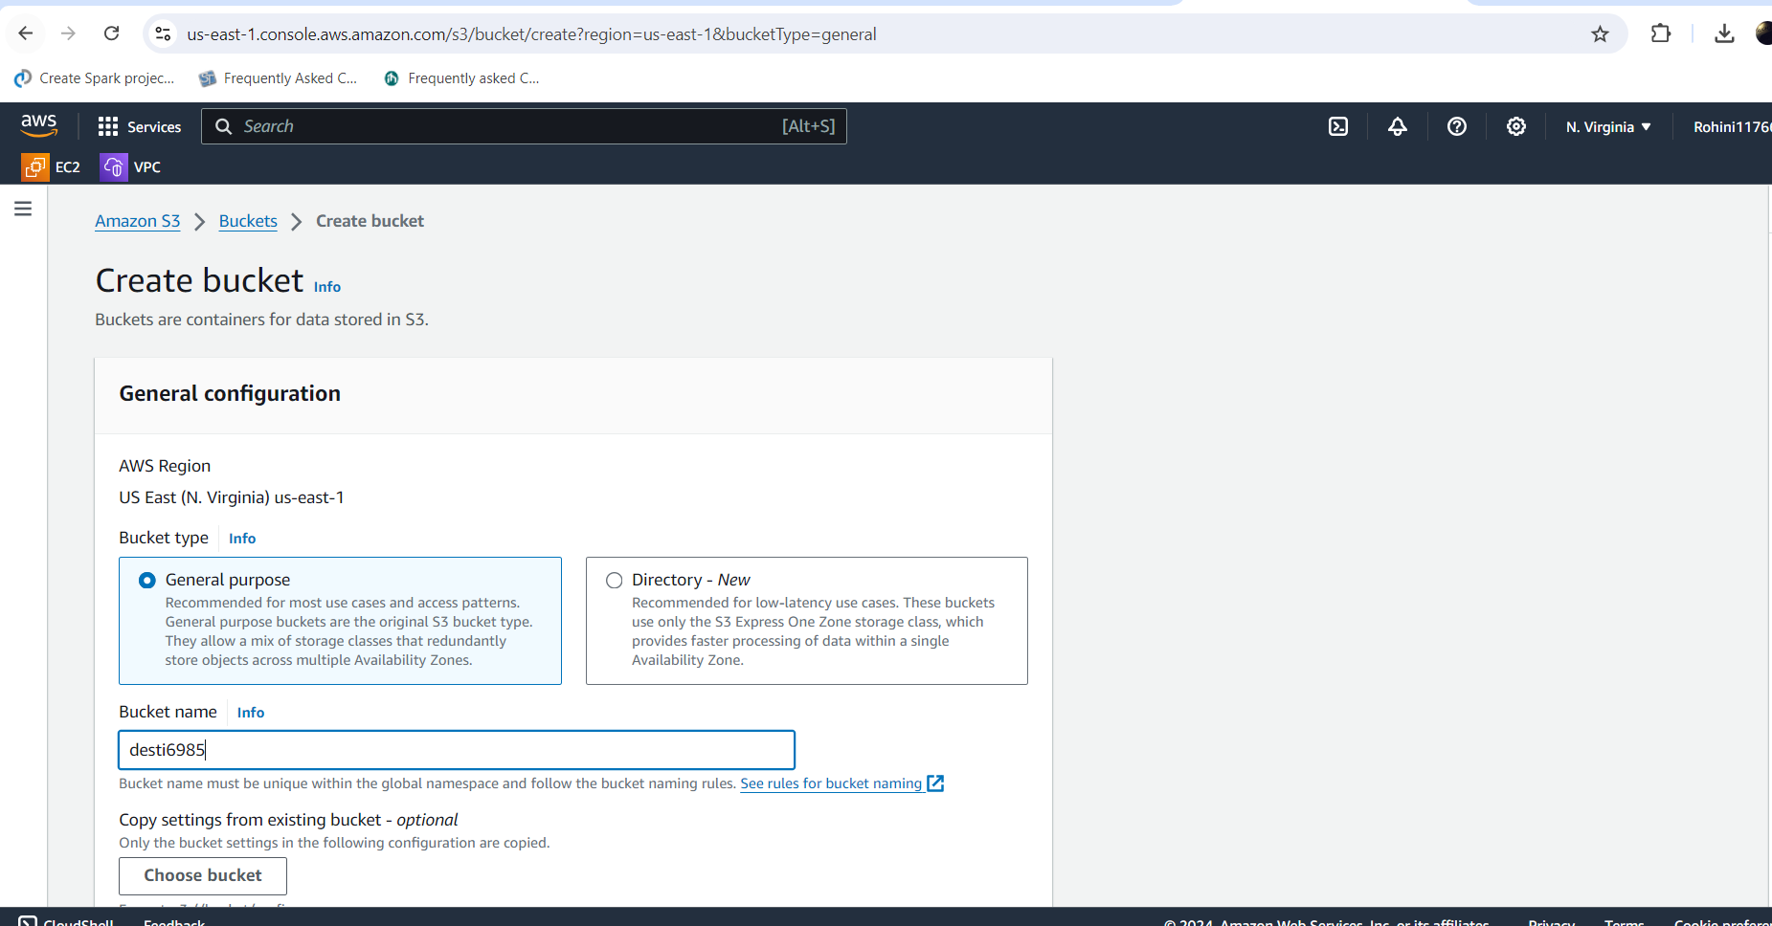

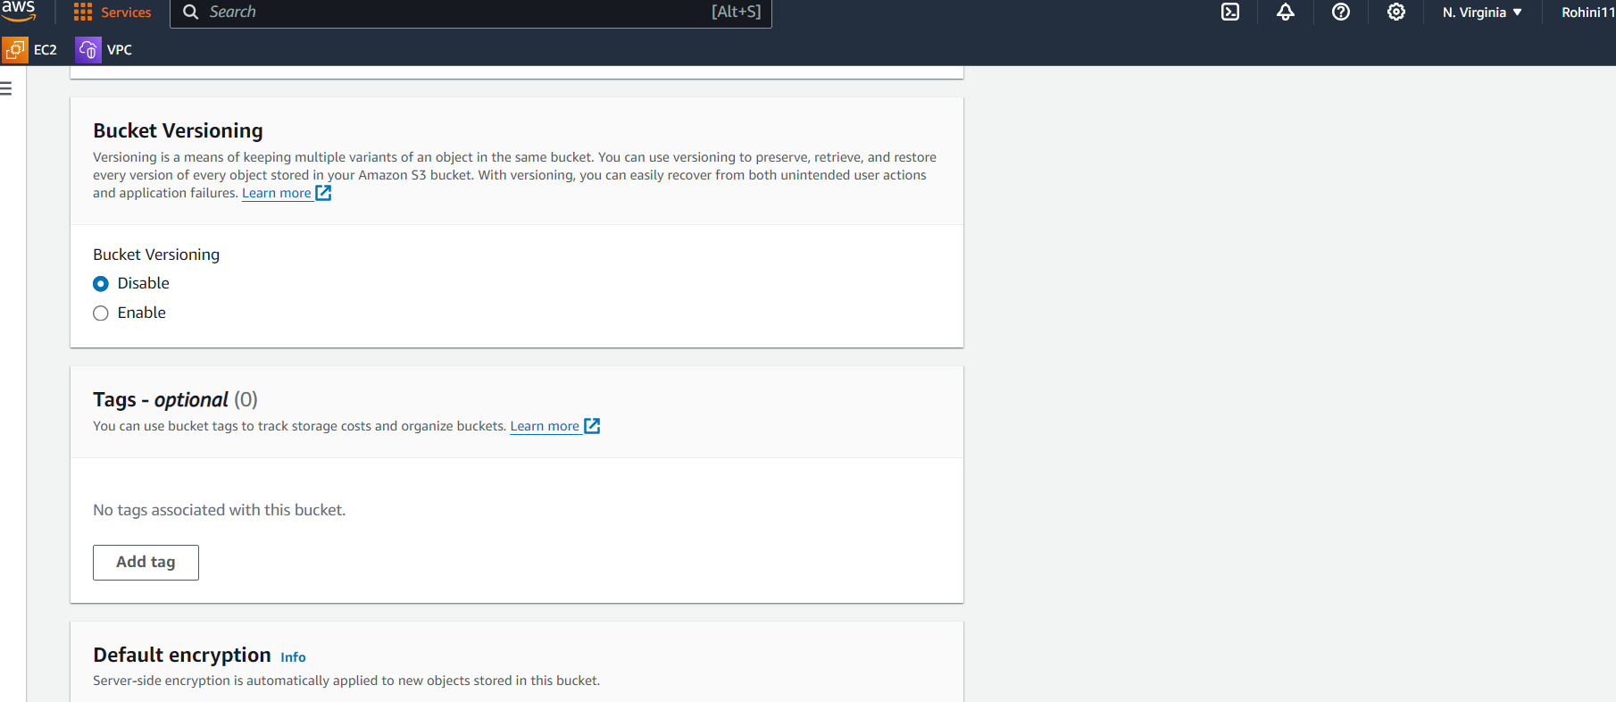

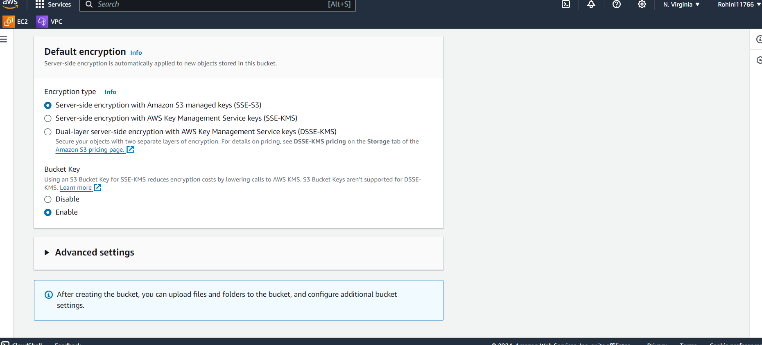

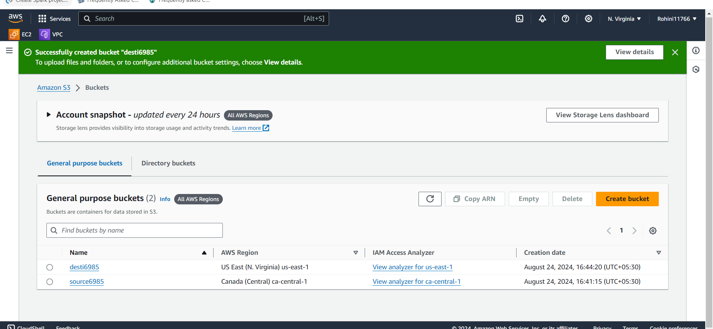

# Step2: Enable the versioning

* Open source6985 and click on properties
* Go to bucket versioning and click on edit
* Enable the versioning and click on save changes
* Likewise need to enable versioning in desti6985 and save as shown in below slides

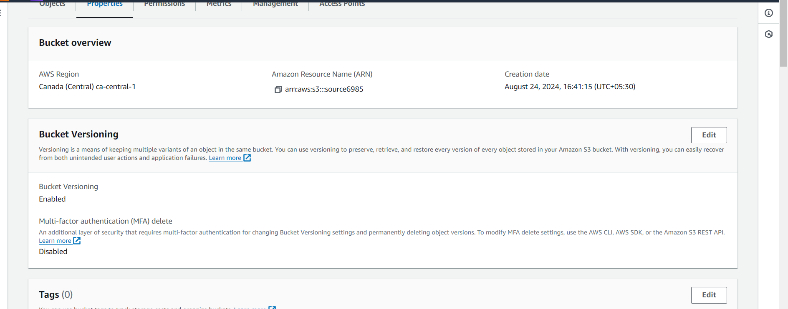

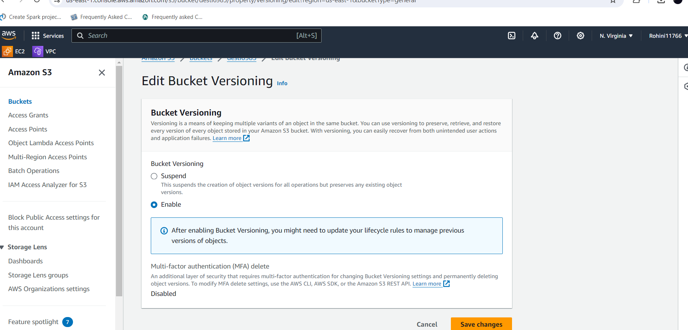

**Step-3: Cross region replication (CRR):**

* Go to the first bucket which is created in N.virginia region
* Open Prathibha-bucket1 and click on management
* Go to cross region replication and click on replication rule
* Give name tag as bucket12-replication
* Click on apply to all objects in the bucket in source bucket field
* Select bucket name in destination field
* Click on replication time control (RTC) in Additional replication options field
* Remaining fields should be default and click on save
* The following will showcase the cross-region replication

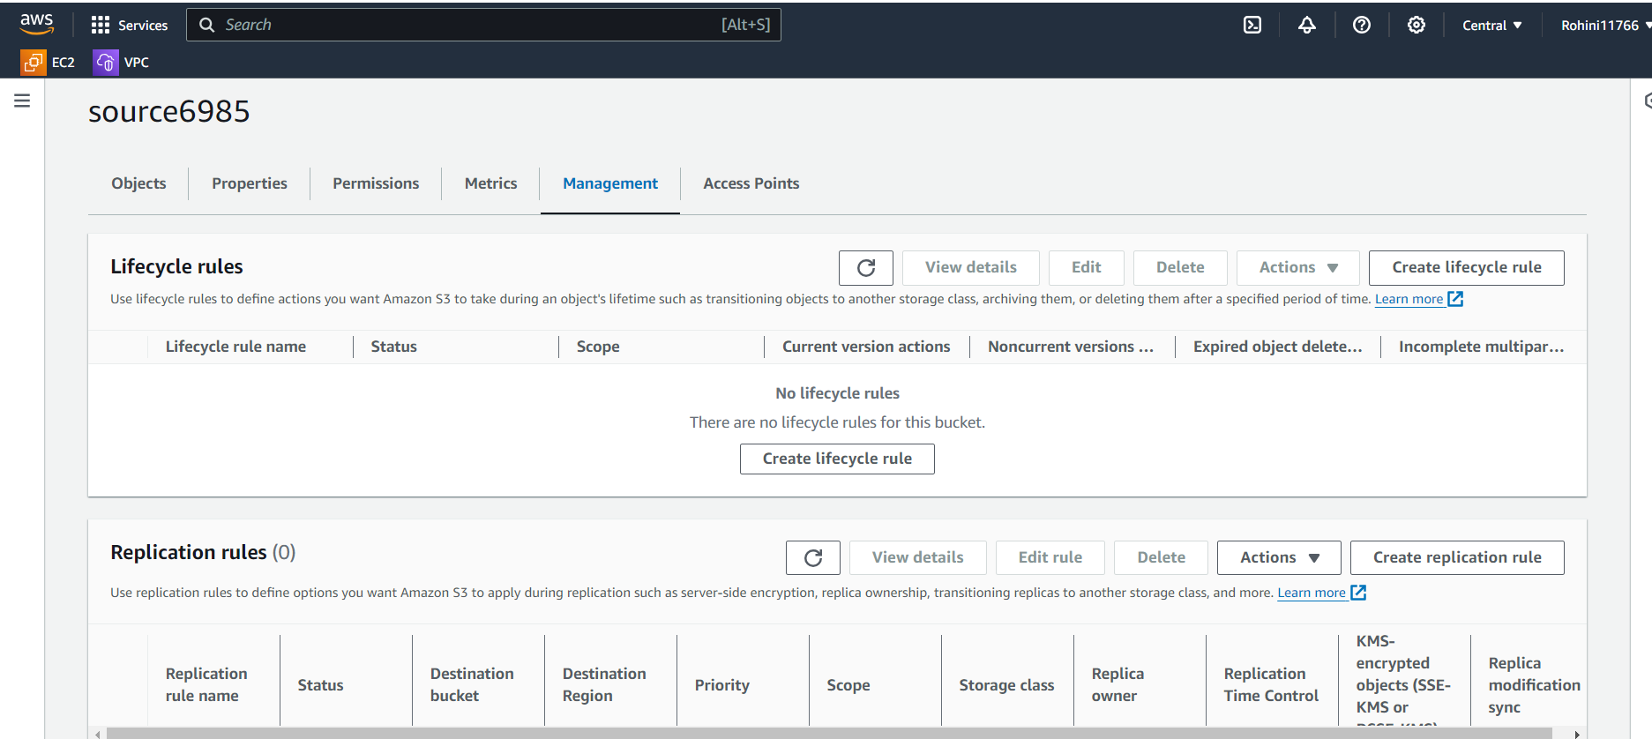

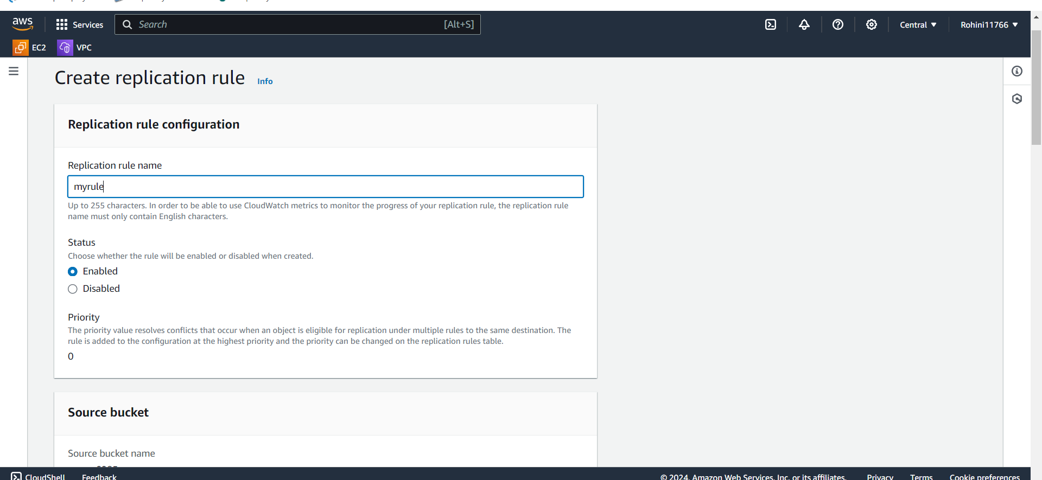

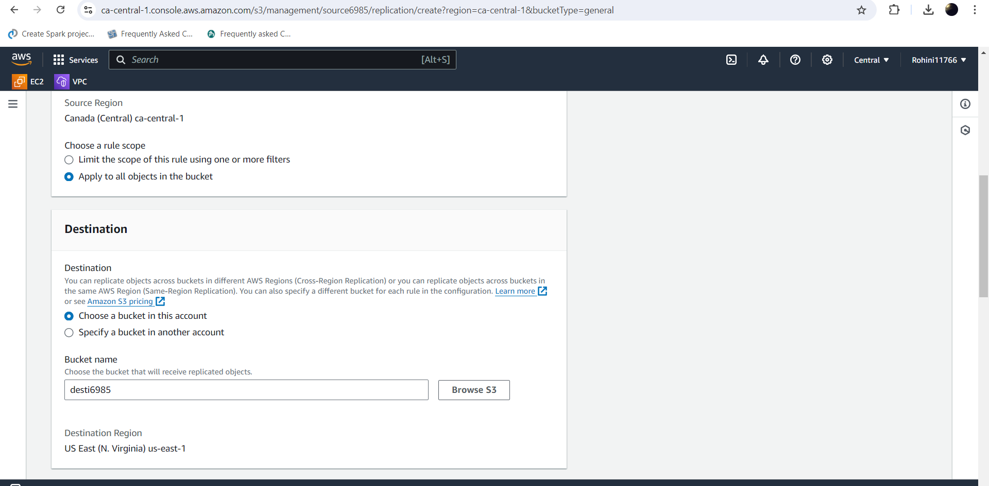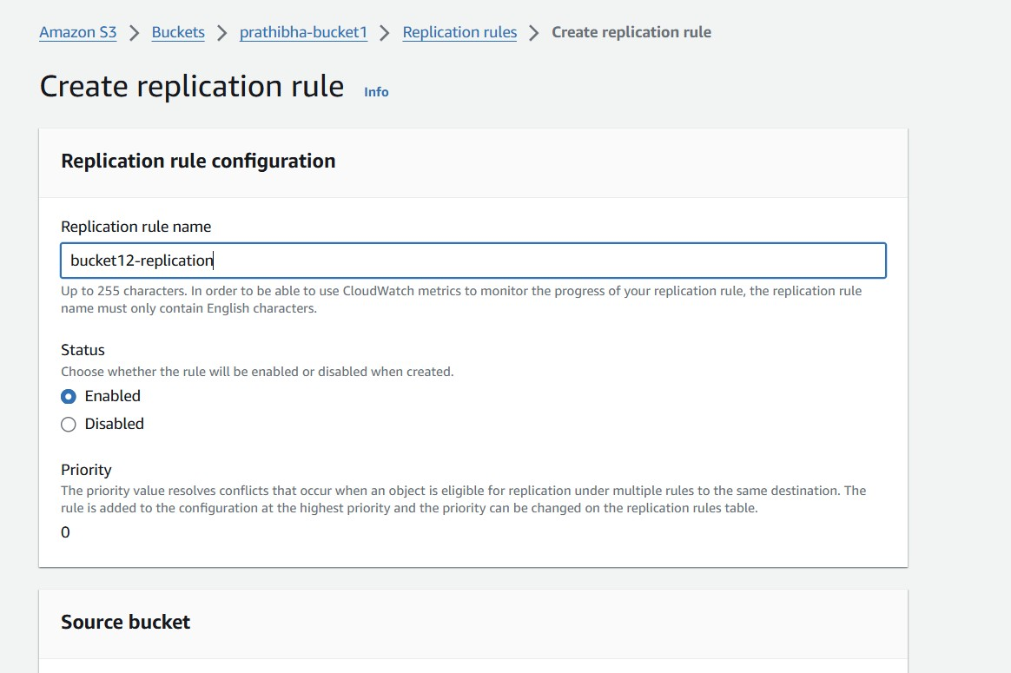

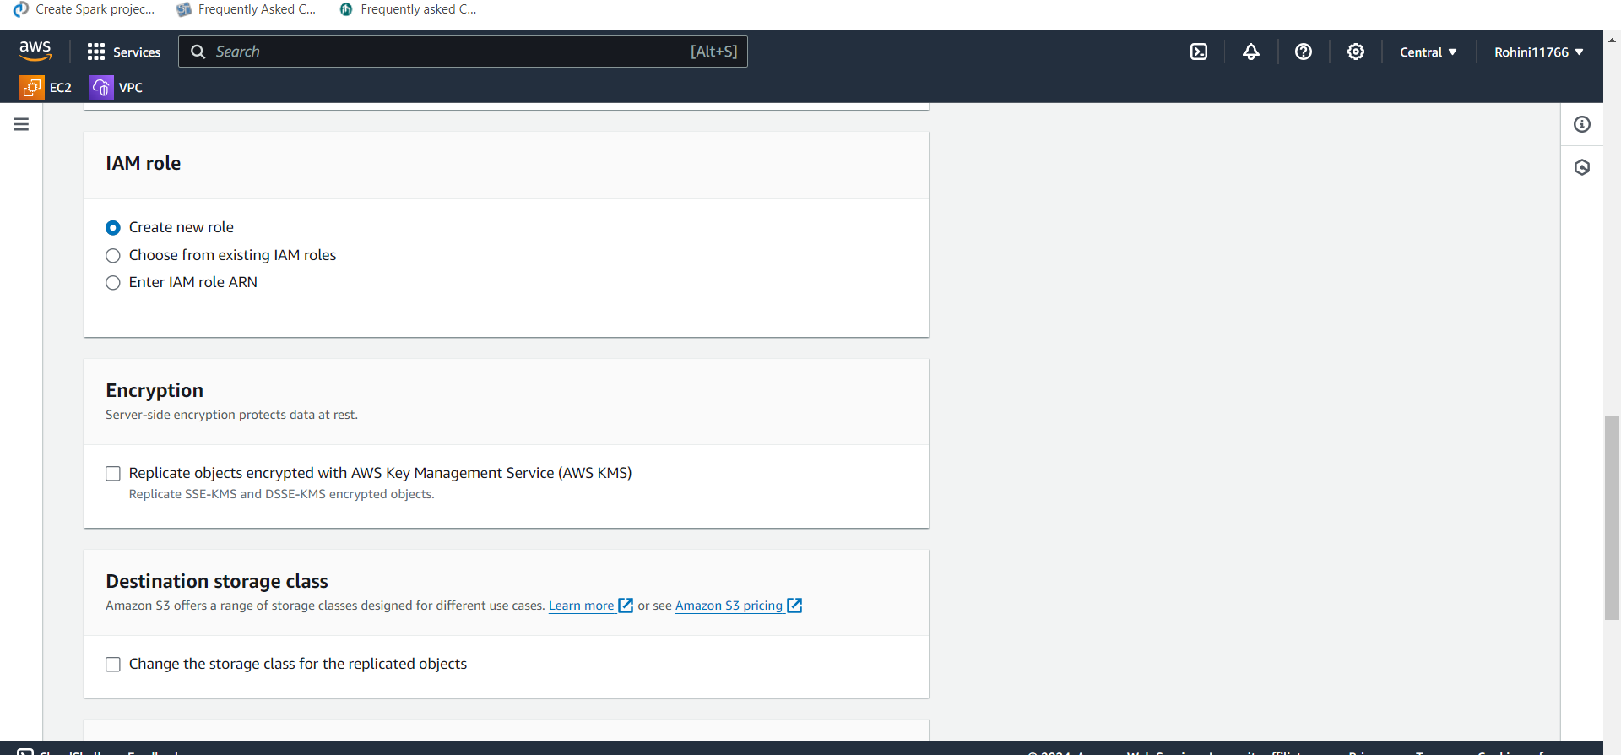

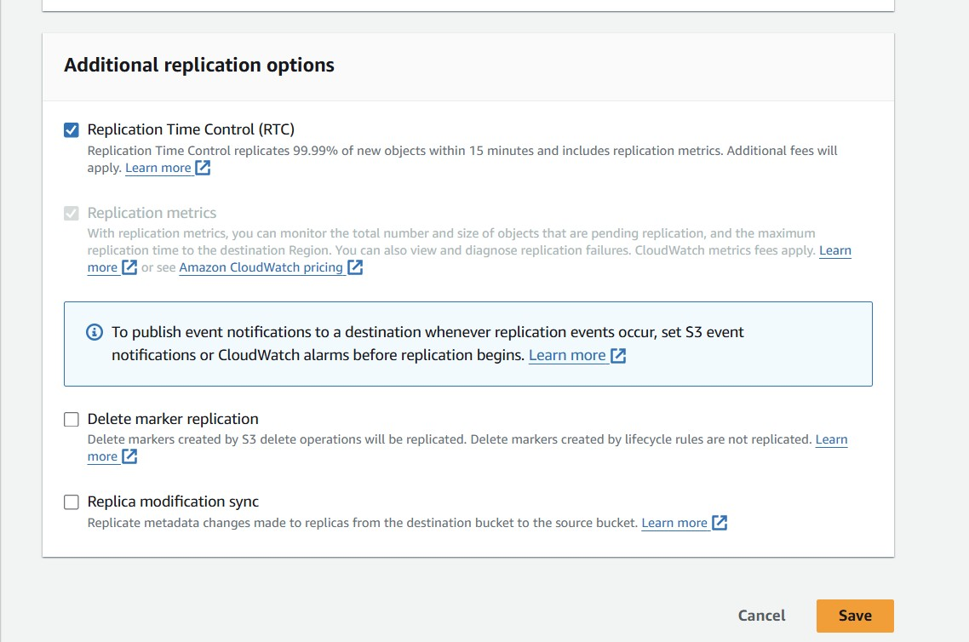 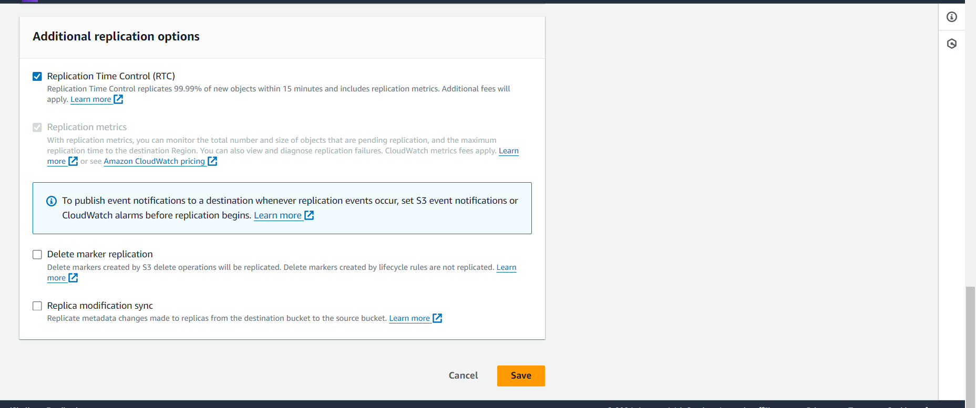

* Once created the cross-region replication upload a file or folder in bucket one which is created in central as shown in below slides.

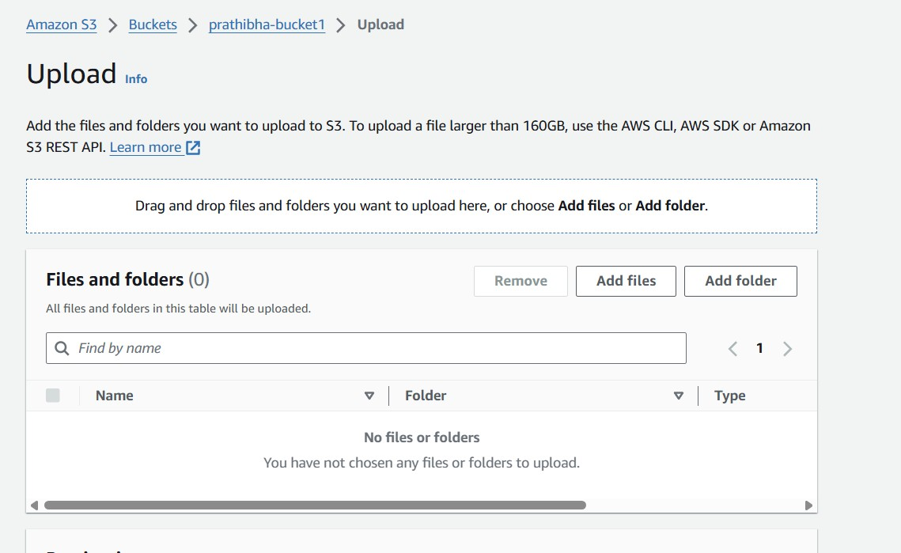

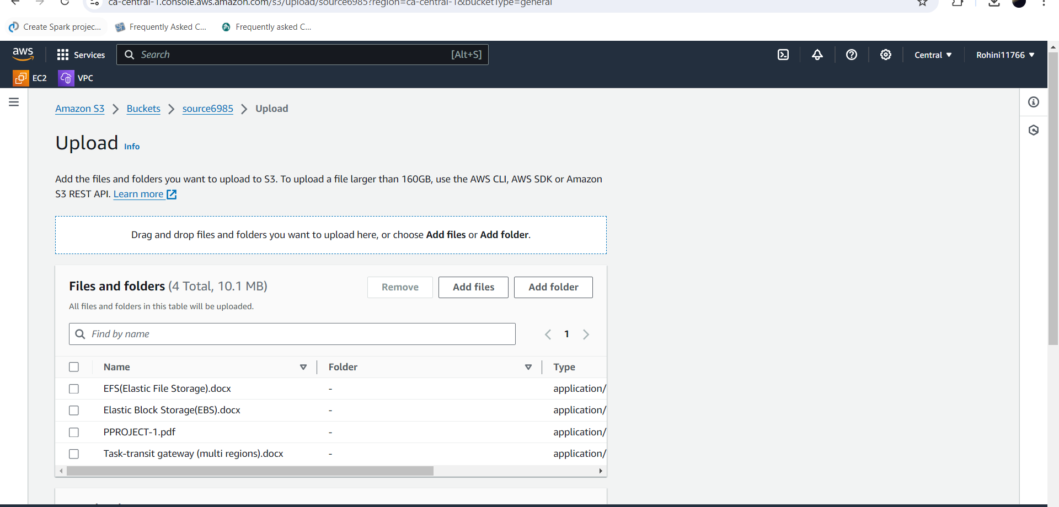

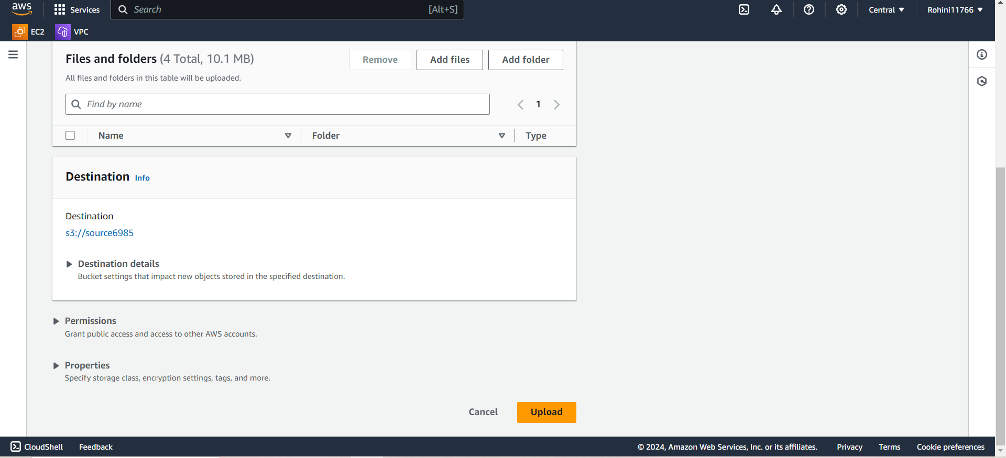

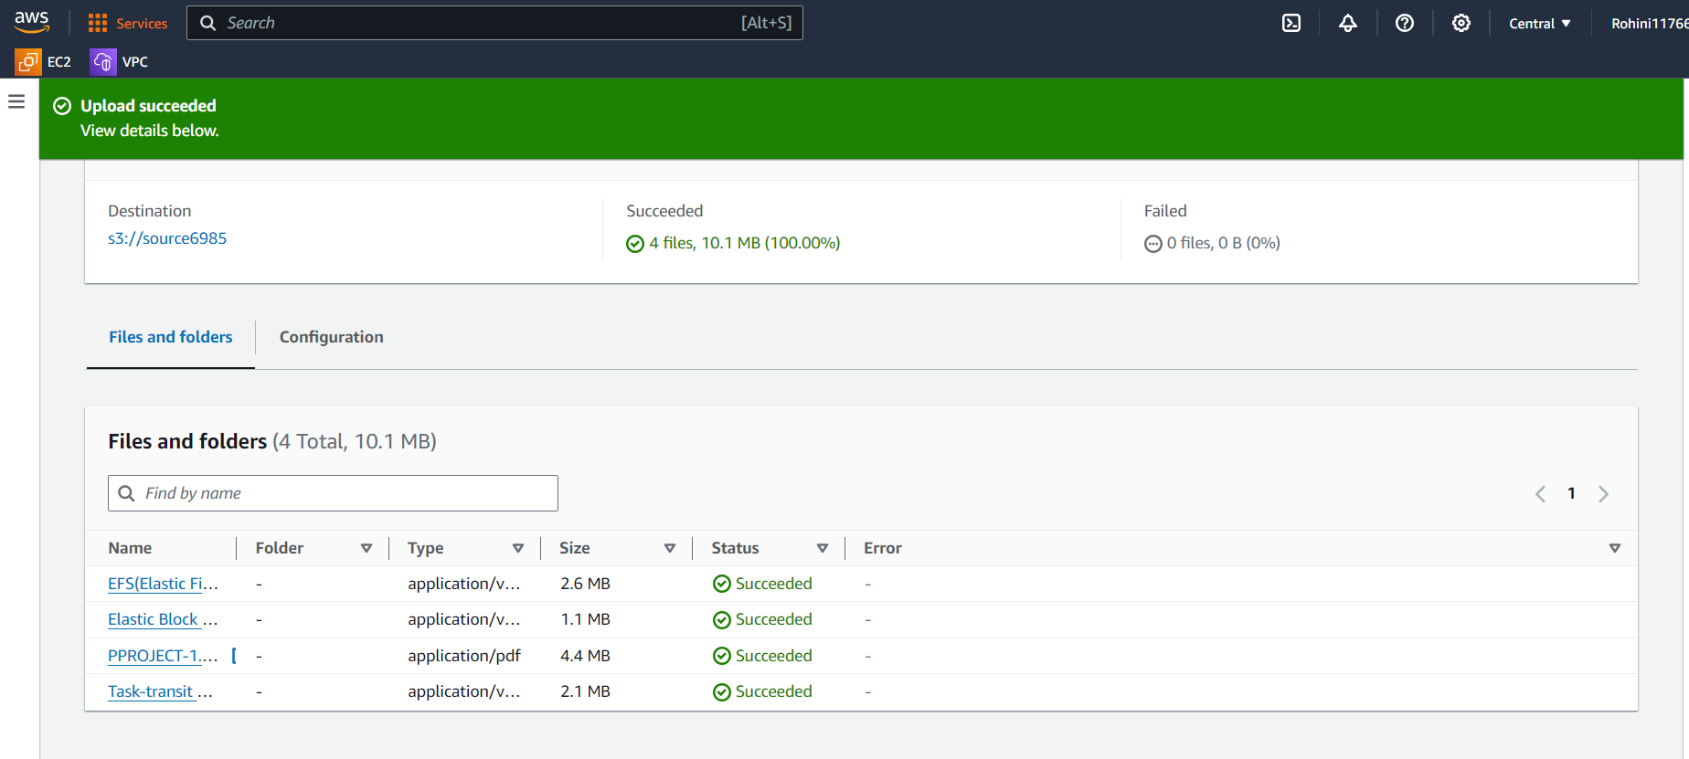

* We uploaded file in source6985 and it was replicated in desti6985 because of we enable the cross- region replication
* It was shown in below slide

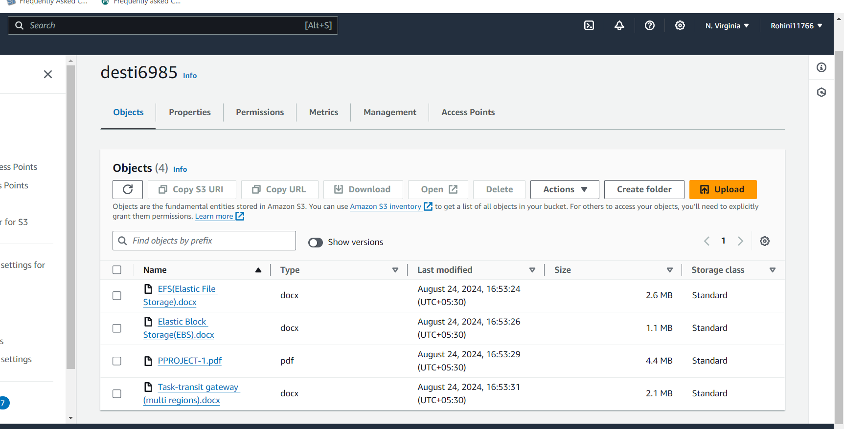

# Conclusion:

cross-region replication in AWS is a powerful strategy for enhancing the availability,

durability, and resilience of critical data across geographically dispersed locations. By replicating data to multiple AWS regions, organizations can ensure high levels of redundancy and disaster recovery capabilities, effectively mitigating the risk of data loss due to regional failures or outages