Simple Notification service (SNS)

Amazon Simple Notification Service (Amazon SNS) is a managed service that provides message delivery from publishers to subscribers (also known as *producers* and *consumers*).

Publishers communicate asynchronously with subscribers by sending messages to a *topic*, which is a logical access point and communication channel.

# Step1: Create an instance

* Login to the AWS console
* Open seoul region and click on instances
* Click on launch instance
* Given name tag as instance-a
* Select amazon Linux in application and OS image field
* Select the key pair and launch instance as shown in below slides

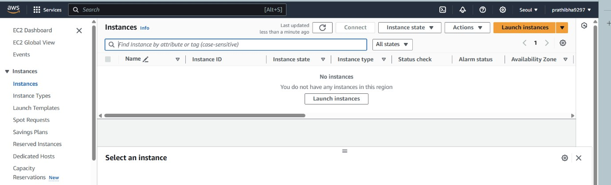

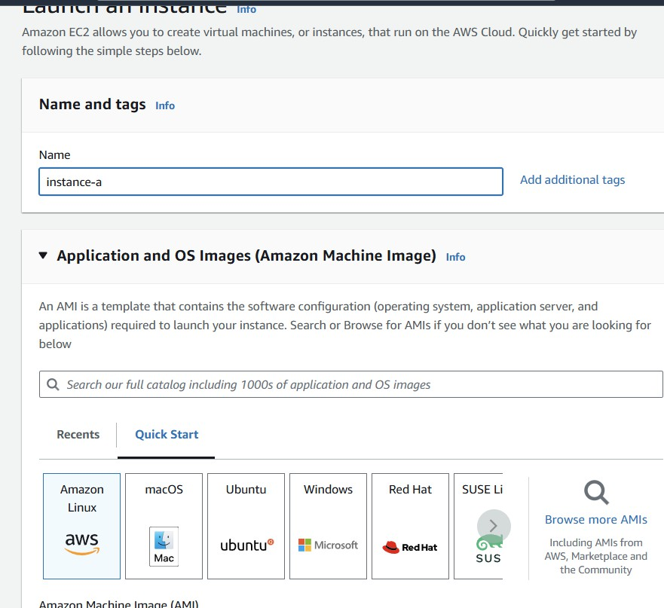

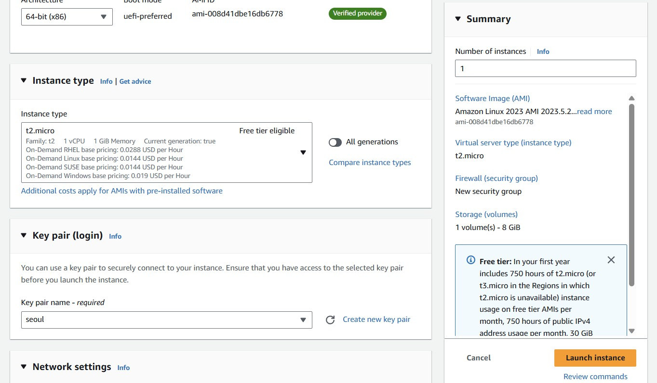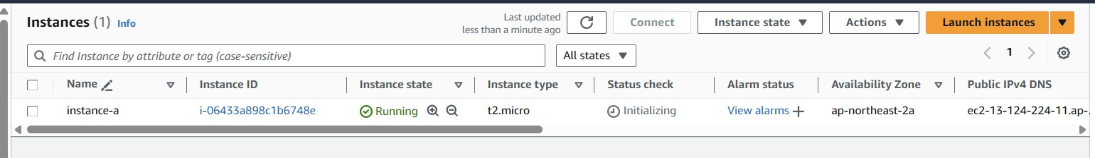

* Once instance state change to running click on connect and then you will get connection to the amazon Linux server.
* Change to root user using sudo -i
* For updating the server yum update -y
* For installing the stress =>yum install stress -y

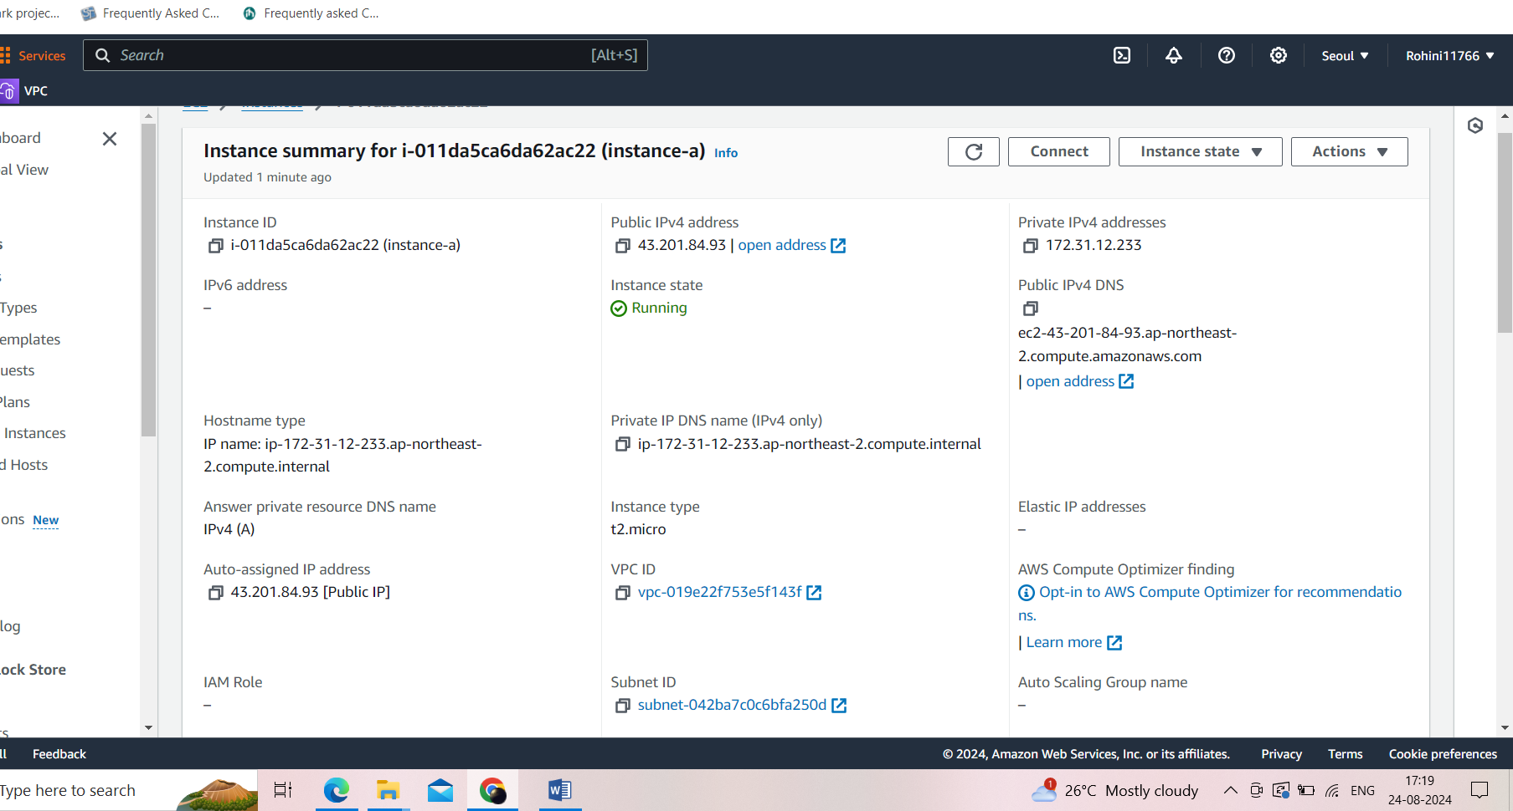

# Step2: Creating Simple Notification Service (SNS) topic

* Open SNS and click one create topic
* Type should be standard
* Give name tag as sns-a
* And then click on create topic

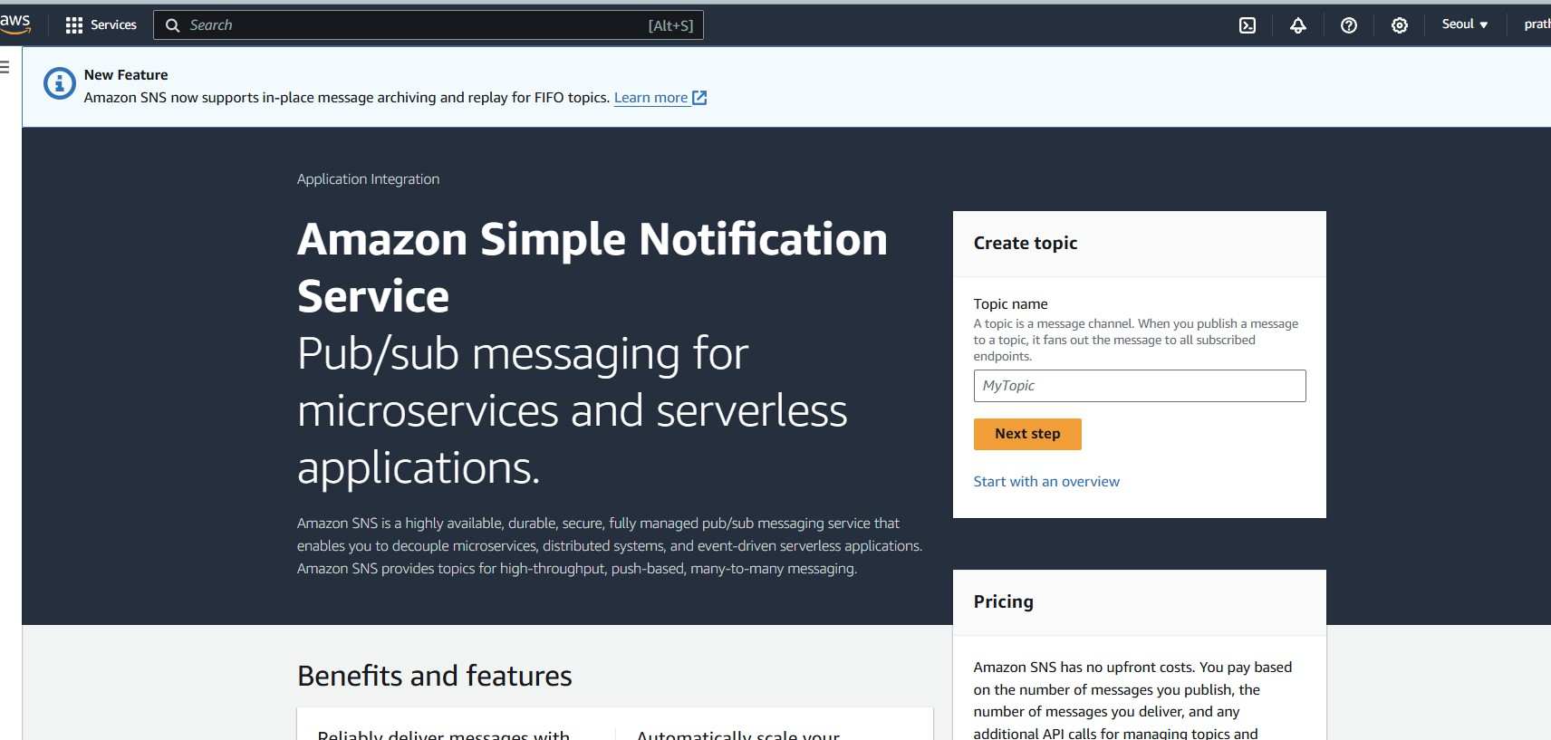

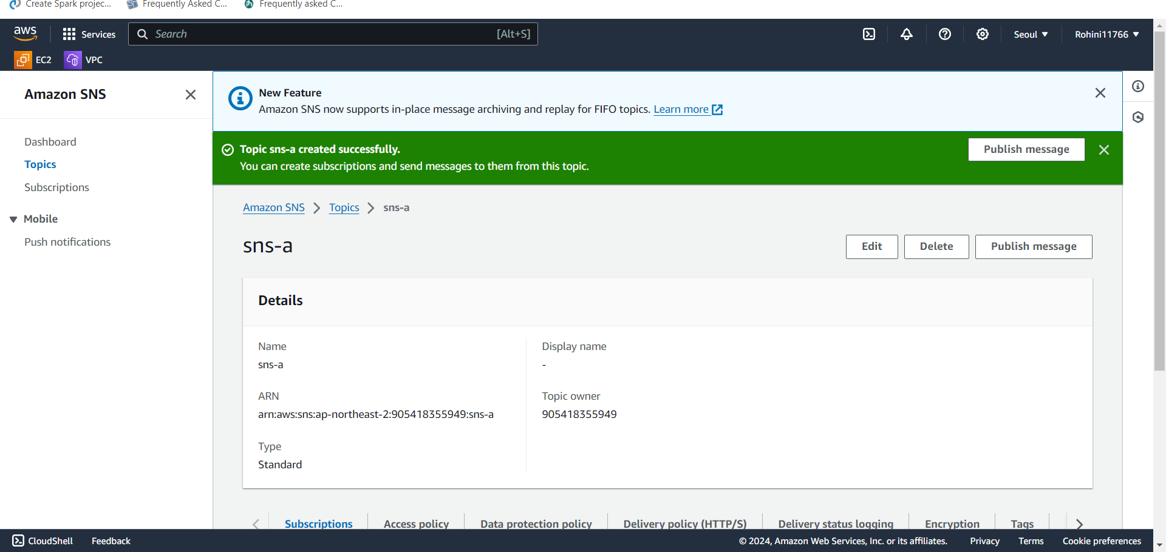

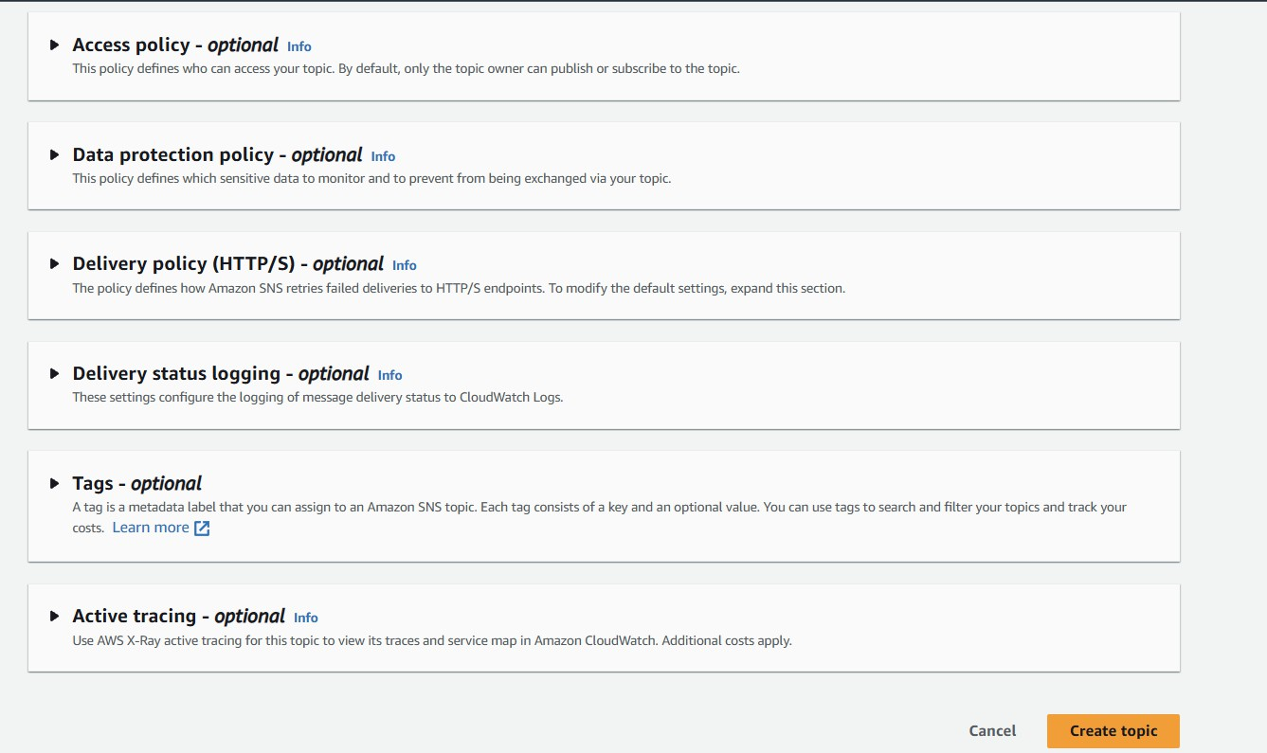

# Step3: Subscription

* Open subscriptions in Amazon SNS
* Click on create subscription
* Select SNS topic ARN
* Protocol should be Email
* Enter the email address in the Endpoint field
* Click on create subscription
* Once created the subscription confirmation mail will come to the particular mail address u mentioned in subscription
* Click on confirm subscription in email
* The following slides will showcase the subscription process

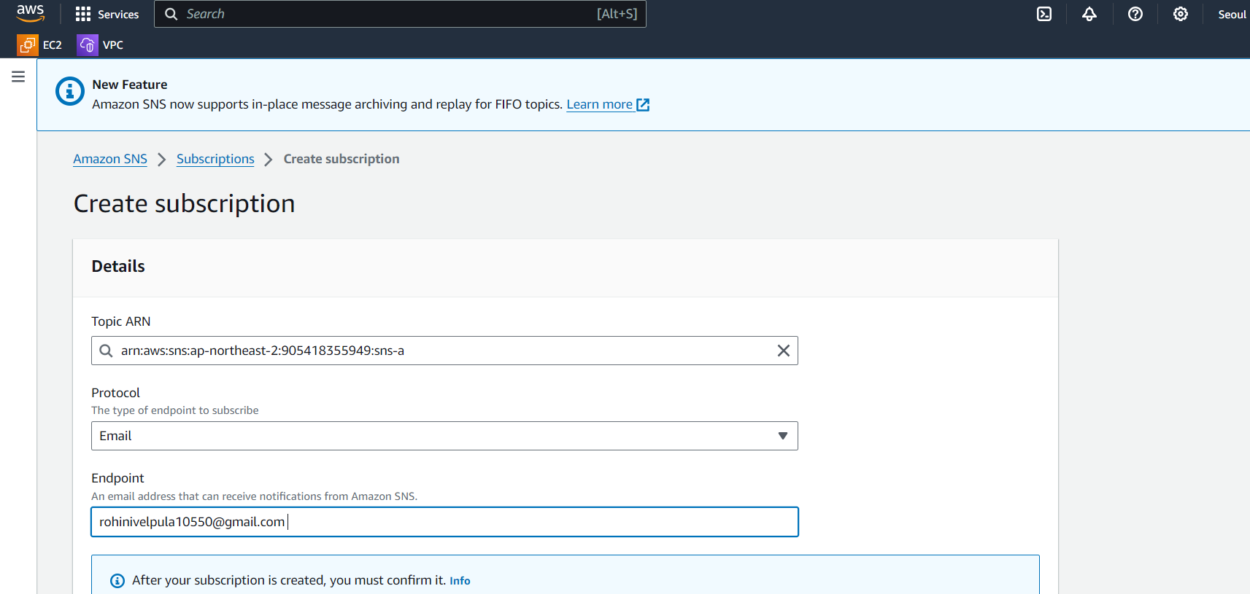

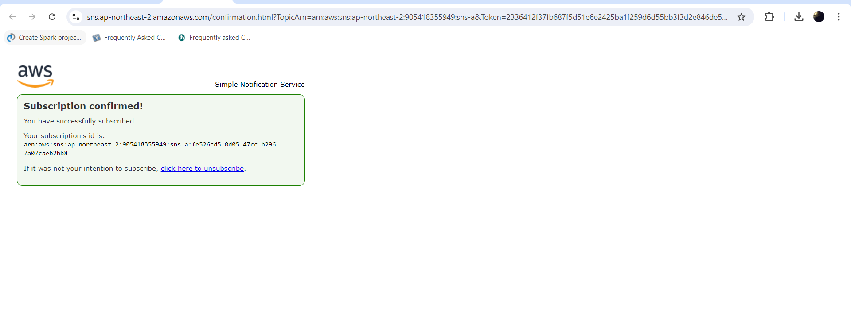

# Step4: Creating alarm in CloudWatch

* Open the CloudWatch service and go to in alarm
* Click on create alarm
* Click on select metric
* Click on Select per instance metrics and select the CPU utilization for instance-a and click on select metric
* In conditions field select threshold type should be static and threshold value should be greater than or equal to 50
* Give name tag as sns-a-notification and click on create alarm as shown in below slides

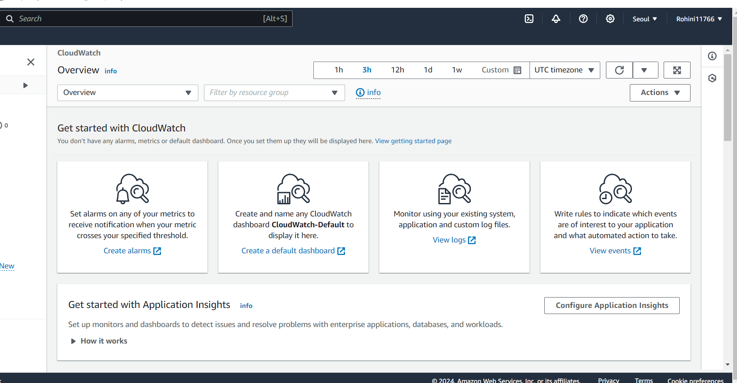

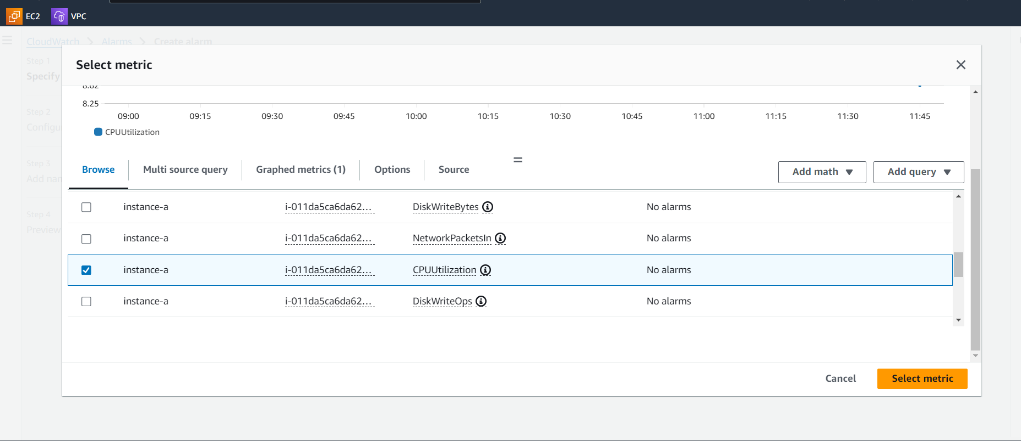

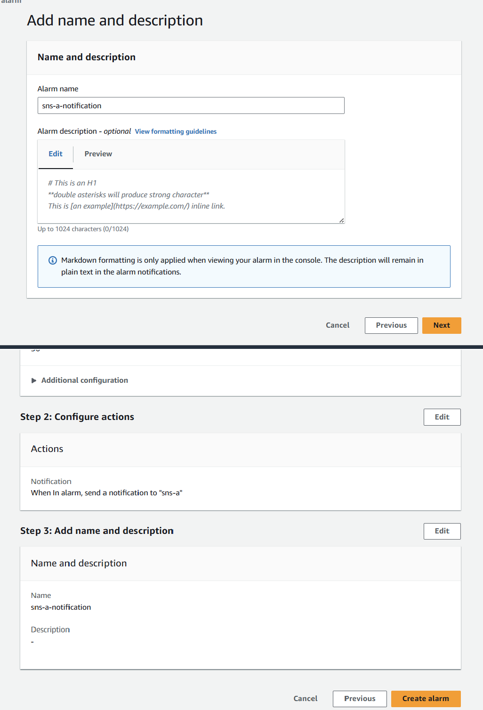

# Step5: Enable the detailed monitoring for instance-a

* Once alarm cleared go to instance-a and click on monitoring
* Click on managed detailed monitoring and click on enable and then hit on confirm

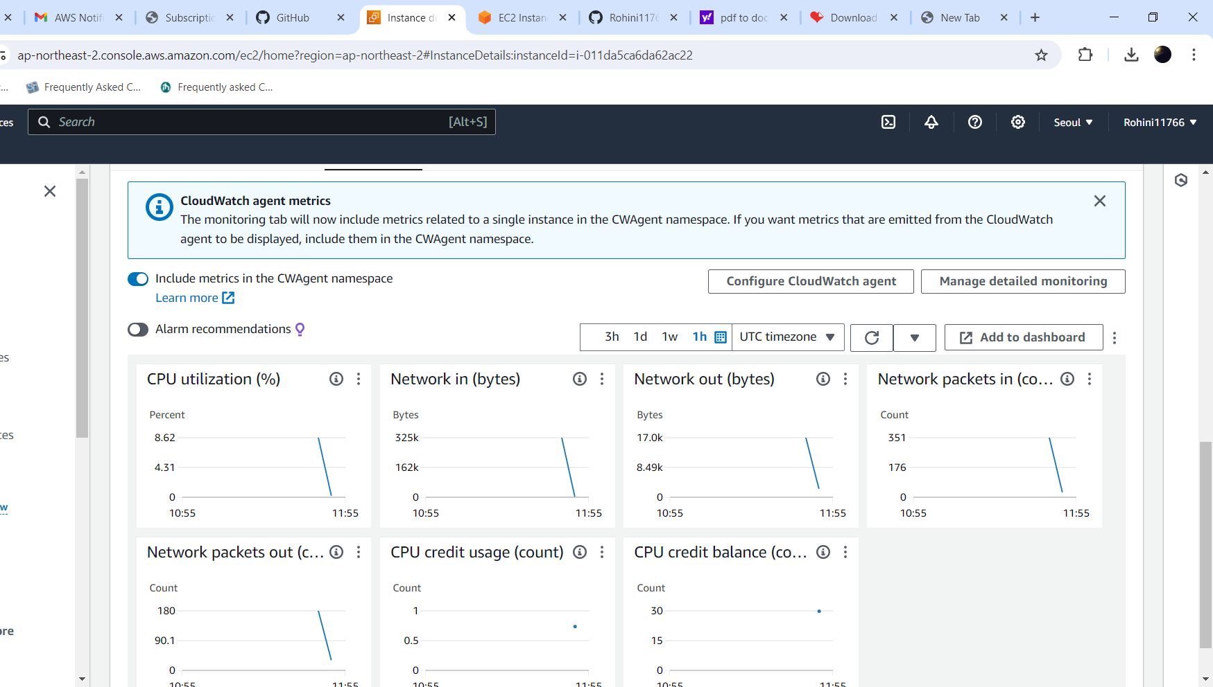

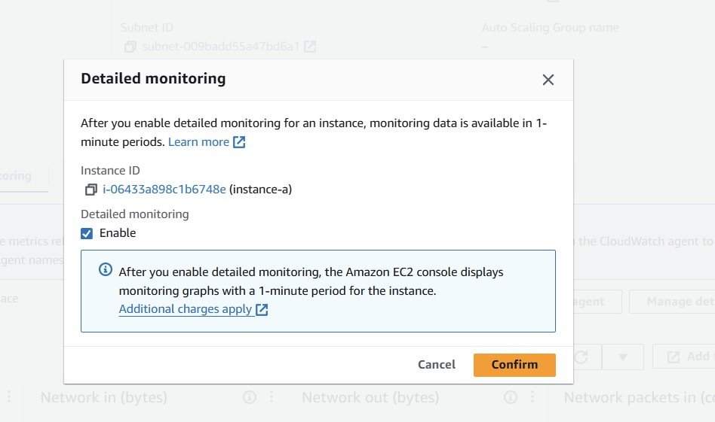

* Go to AWS Linux server and give stress command => stress –cpu 10 -v –timeout 400s
* Once given stress to the instance-a the CPU utilization should be more than 50 percentage
* Then we will get notification to the email as shown in below slides.

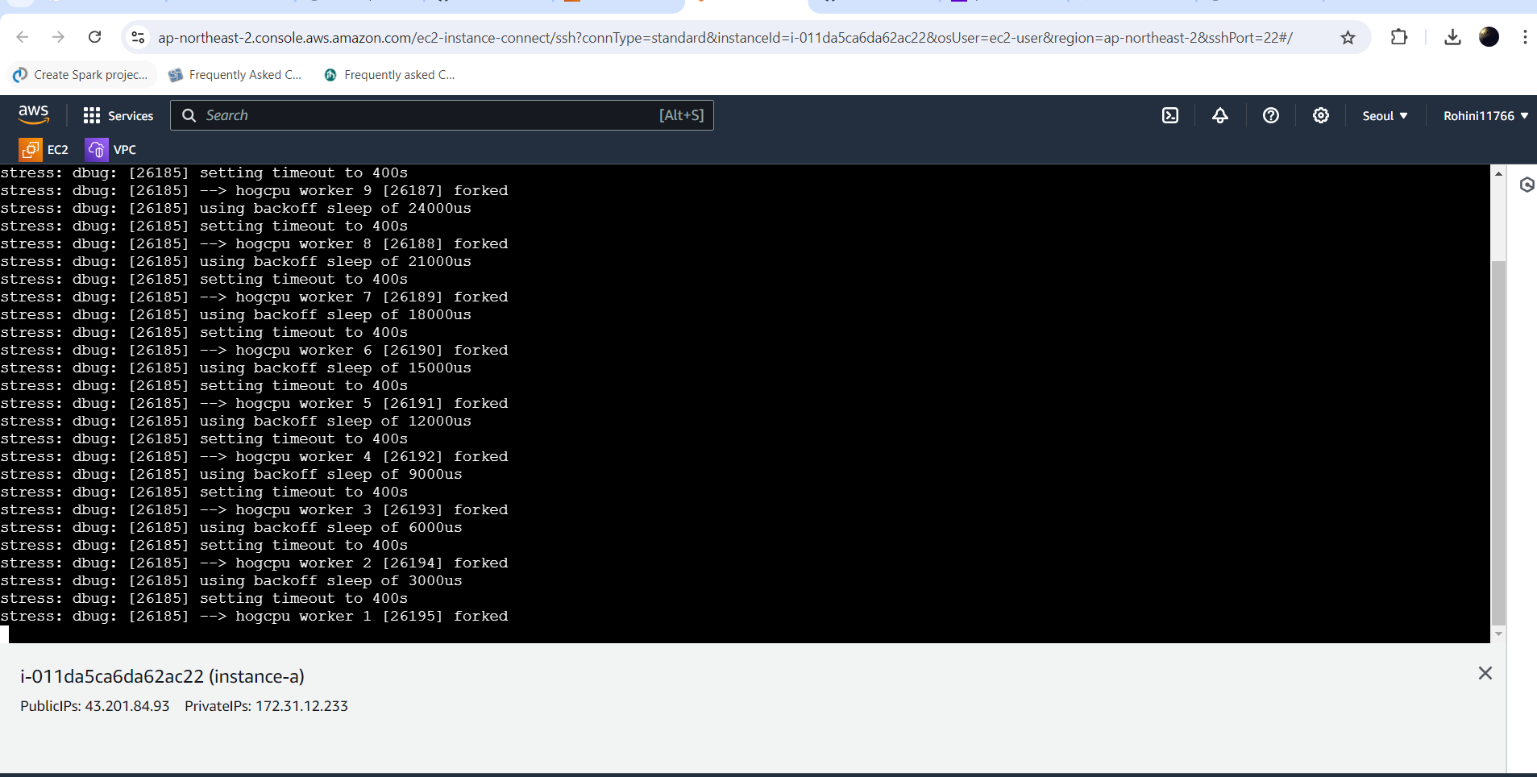

**Output:**

