Case Study Report



**Tech Saksham**

Data Analytics with Power BI

**“ANALYSIS OF COMMERICAL**

**ELECTRICAL CONSUMPTION IN INDIAN STATES”**

**“**THIRUVALLUVAR COLLEGE

PAPANASAM**”**

|  |  |
| --- | --- |
| **NM ID** | **NAME** |
| **0460111BA14C07E8614461E8782BF848** | **S. Rohini** |

|  |  |
| --- | --- |
|  |  |
|  | Trainer Name |
|  | Master Trainer |

**ABSTRACT**

This study presents a comprehensive analysis of electricity consumption patterns, focusing on understanding the key factors influencing consumption trends. Through meticulous data collection and analysis, various aspects such as seasonal variations, demographic influences, technological advancements, and policy implications are examined. The study employs both quantitative and qualitative methodologies to provide a nuanced understanding of electricity consumption dynamics. Additionally, the research explores the impact of emerging trends such as renewable energy integration and smart grid technologies on consumption patterns. The findings contribute valuable insights for policymakers, energy providers, and consumers to make informed decisions aimed at promoting sustainable electricity usage and enhancing energy efficiency.

Top of Form

**INDEX**

|  |  |  |
| --- | --- | --- |
| **Sr. No.** | **Table of Contents** | **Page No.** |
| 1 | Chapter 1: Introduction | 4 |
| 2 | Chapter 2: Services and Tools Required | 6 |
| 3 | Chapter 3: Project Architecture | 7 |
| 4 | Chapter 4: Modeling and Result | 9 |
| 5 | Conclusion | 18 |
| 6 | Future Scope | 19 |
| 7 | References | 20 |
| 8 | Links | 21 |

**CHAPTER 1**

**INTRODUCTION**

* 1. **Problem Statement**

The current electrical consumption in India is a significant concern due to its impact on energy sustainability, economic stability, and environmental health. Despite efforts to increase generation capacity and promote renewable energy sources, the demand for electricity continues to outpace supply in many regions. This presents several challenges, including:*Energy Security:* With an increasing population and industrialization, ensuring a reliable and secure energy supply is crucial for sustaining economic growth and meeting the needs of the populace.

Environmental Sustainability: The reliance on fossil fuels for electricity generation contributes to air and water pollution, as well as greenhouse gas emissions, exacerbating climate change and impacting public health.

Infrastructure Strain: Insufficient infrastructure and distribution networks lead to transmission losses, inefficiencies, and power outages, hindering economic development and quality of life for citizens

Affordability and Accessibility: High electricity costs and disparities in access to electricity between urban and rural areas pose socio-economic challenges, limiting opportunities for economic development and social equity.

* 1. **Proposed Solution**

The proposed solution is to develop a Power BI dashboard that can analyze and visualize real-time customer data. Obtain data on commercial electricity consumption in Indian states from reliable sources such as government databases, energy regulatory authorities, or utility companies. Ensure that the data is structured and includes relevant parameters such as consumption levels, time periods, and geographical details. Utilize forecasting techniques in Power BI to predict future trends in commercial electricity consumption for Indian states. Apply time series analysis methods such as exponential smoothing or ARIMA modeling to forecast consumption levels based on historical data. Visualize the forecasted values alongside actual consumption data to assess the accuracy of the predictions.

**Feature Data Sources and Analysis Tools**:

**Data Availability:**

* Consider the availability and reliability of data sources, including utility billing records, smart meter data, census data, and surveys .Analysis Tools: Utilize analytical tools and techniques such as regression analysis, time series analysis, and machine learning algorithms to identify patterns, forecast future consumption, and evaluate the effectiveness of intervention

**Seasonal Variations.**

* Heating and Cooling: In regions with distinct seasons, electrical consumption often peaks during extreme temperatures due to heating or cooling needs.
* Lighting: Daylight hours affect the use of lighting, with longer nights leading to increased electrical consumption for artificial lighting.

**Time of Day Patterns**:

* Peak Hours: Identify peak hours when electricity demand is highest, typically during early mornings and evenings when people are at home and using application
  + Off-Peak Hours: Evaluate off-peak hours when electricity demand is lower, potentially due to reduced commercial and industrial activity.
  1. **Advantages**

1. **Data Collection**: Obtain data on commercial electricity consumption in Indian states from reliable sources such as government databases, energy regulatory authorities, or utility companies. Ensure that the data is structured and includes relevant parameters such as consumption levels, time periods, and geographical details.
2. **Data Preparation**: Clean and process the data to ensure accuracy and consistency. This may involve handling missing values, removing duplicates, and formatting the data for analysis. Additionally, merge the consumption data with other relevant datasets such as demographic information or economic indicators if available.
3. **Data Modelling**: Design a data model in Power BI that represents the relationships between different entities such as states, electricity consumption, and time periods. Create measures and calculated columns to aggregate and analysis the data effectively. Consider using hierarchies and filters to enable interactive exploration of the data.
4. **Visualization**: Create visualizations in Power BI to visualize the commercial electricity consumption trends across Indian states.
   1. **Scope**

The scope of this project extends to all banking institutions that aim to leverage data for decision-making and customer engagement. The project can be further extended to incorporate more data sources and advanced analytics techniques, such as machine learning and artificial intelligence, to provide more sophisticated insights into customer behavior. The project also has the potential to be adapted for other sectors, such as retail, healthcare, and telecommunications, where understanding customer behavior is crucial. Furthermore, the project contributes to the broader goal of digital transformation in the banking sector, promoting efficiency, innovation, and customer-centricity.

**CHAPTER 2**

**SERVICES AND TOOLS REQUIRED**

**2.1 Services Used**

* **Data Collection and Storage Services**: Banks need to collect and store customer data in real-time. This could be achieved through services like Azure Data Factory, Azure Event Hubs, or AWS Kinesis for real-time data collection, and Azure SQL Database or AWS RDS for data storage.
* **Data Processing Services**: Services like Azure Stream Analytics or AWS Kinesis Data Analytics can be used to process the real-time data.
* **Healthcare Sector**:
  + Hospitals and Clinics: Healthcare facilities consume electricity for lighting, HVAC systems, medical equipment, and critical infrastructure to provide patient care.
* **Education Sector:**
  + Schools and Universities: Educational institutions consume electricity for lighting, HVAC systems, classroom equipment, and administrative operations.
* **Machine Learning Services**: Azure Machine Learning or AWS SageMaker can be used to build predictive models based on historical data.

**2.2 Tools and Software used**

**Tools**:

* **Power BI**: The main tool for this project is Power BI, which will be used to create interactive dashboards for real-time data visualization.
* **Power Query**: This is a data connection technology that enables you to discover, connect, combine, and refine data across a wide variety of sources.

**Software Requirements**:

* **Power BI Desktop**: This is a Windows application that you can use to create reports and publish them to Power BI.
* **Power BI Service**: This is an online Sas (Software as a Service) service that you use to publish reports, create new dashboards, and share insights.
* **Power BI Mobile**: This is a mobile application that you can use to access your reports and dashboards on the go.

**CHAPTER 3**

**PROJECT ARCHITECTURE**

**3.1 Architecture**

**USER FRONTEND BACKEND**

|  |  |  |
| --- | --- | --- |
|  | **HTML 5** | **NODEJS 14.0**  **Database** |

Here’s a high-level architecture for the project:

1. **Data Collection**: Real-time customer data is collected from various sources like bank transactions, customer interactions, etc. This could be achieved using services like Azure Event Hubs or AWS Kinesis.
2. **Data Storage**: The collected data is stored in a database for processing. Azure SQL Database or AWS RDS can be used for this purpose.
3. **Data Processing**: The stored data is processed in real-time using services like Azure Stream Analytics or AWS Kinesis Data Analytics.
4. **Machine Learning**: Predictive models are built based on processed data using Azure Machine Learning or AWS Sage Maker. These models can help in predicting customer behavior, detecting fraud, etc.
5. **Data Visualization**: The processed data and the results from the predictive models are visualized in real-time using Power BI. Power BI allows you to create interactive dashboards that can provide valuable insights into the data.
6. **Data Access**: The dashboards created in Power BI can be accessed through Power BI Desktop, Power BI Service (online), and Power BI Mobile.

This architecture provides a comprehensive solution for real-time analysis of bank customers. However, it’s important to note that the specific architecture may vary depending on the bank’s existing infrastructure, specific requirements, and budget. It’s also important to ensure that all tools and services comply with relevant data privacy and security regulations.

**CHAPTER 4**

**MODELING AND RESULT**

**Manage relationship**

The “1 data” file will be used as the main connector as it contain most key identifier (Column) which can be used to relates the 4 data files together . The “long data” file is use to link the client profile geographically with “Dates” .

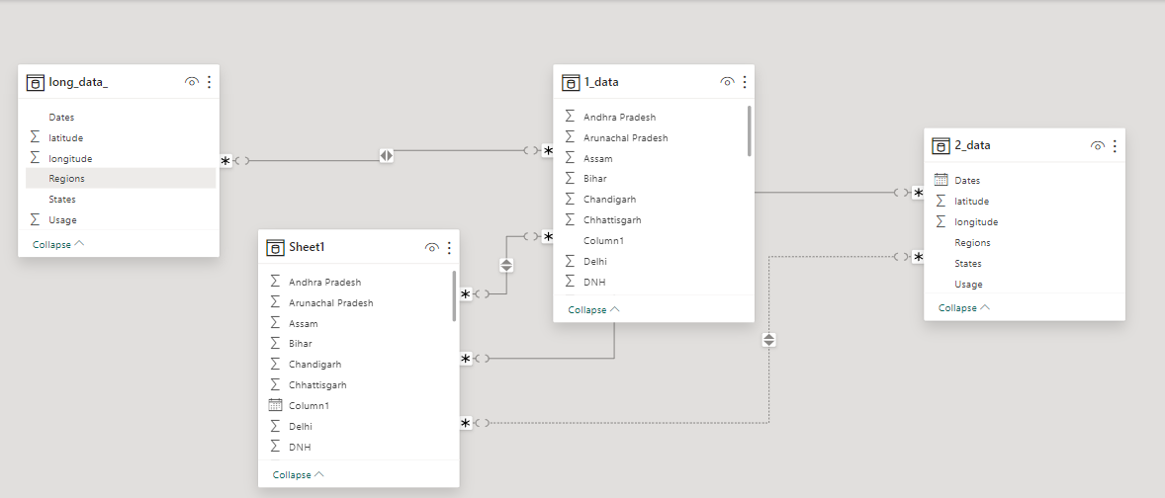

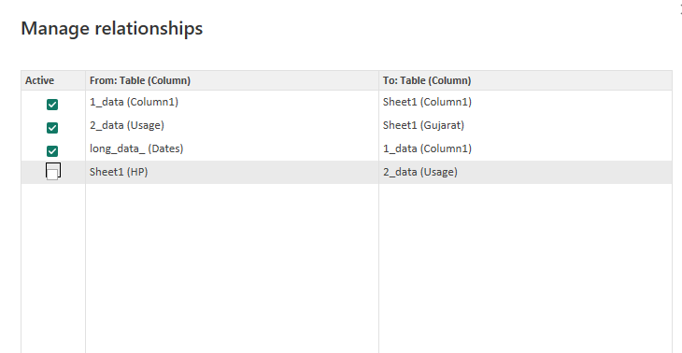

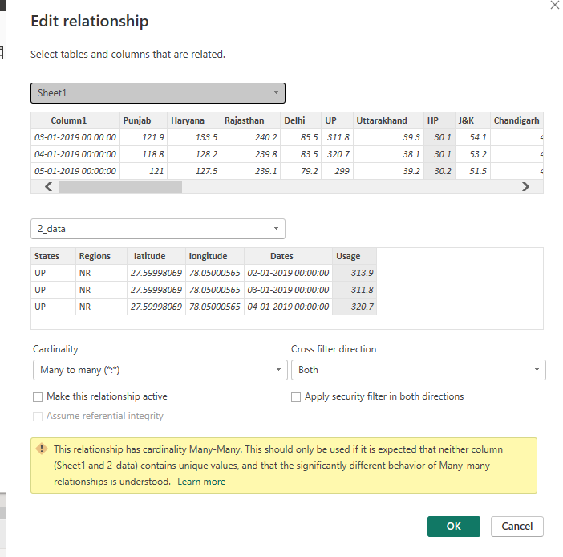

**Modeling for Data and Consumption Data**

Notice that the Dates and usage of the consumption of electricity are there in the dataset by not sorted’ so by using the ascending command it is been sorted in ascending order

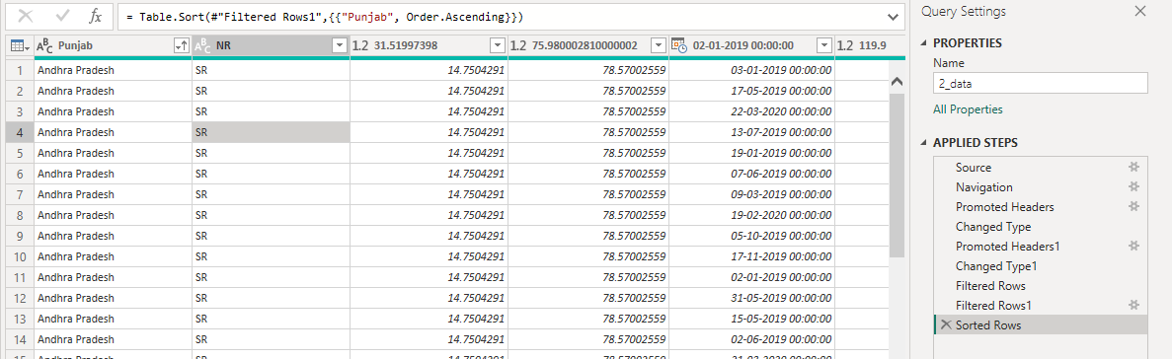

The states are sorted ascending order to find the highest consumption state and the usage it,.

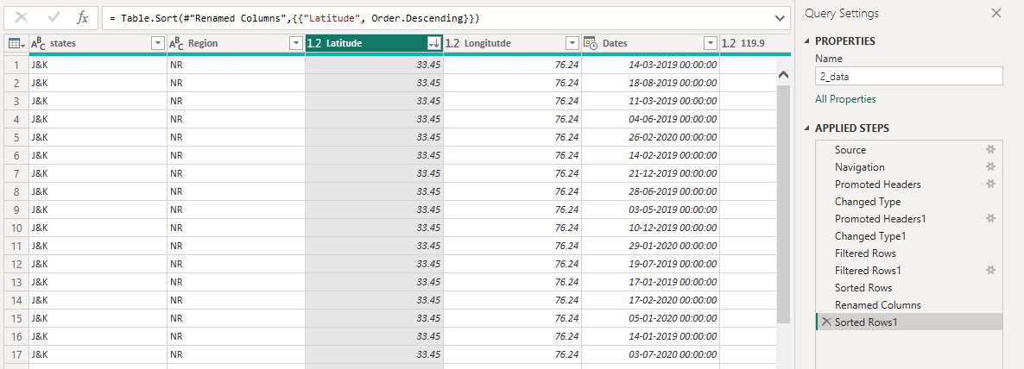

**Replacing values**

Set some fields to English for easy understanding, we replace values to English with the Power Query Editor.

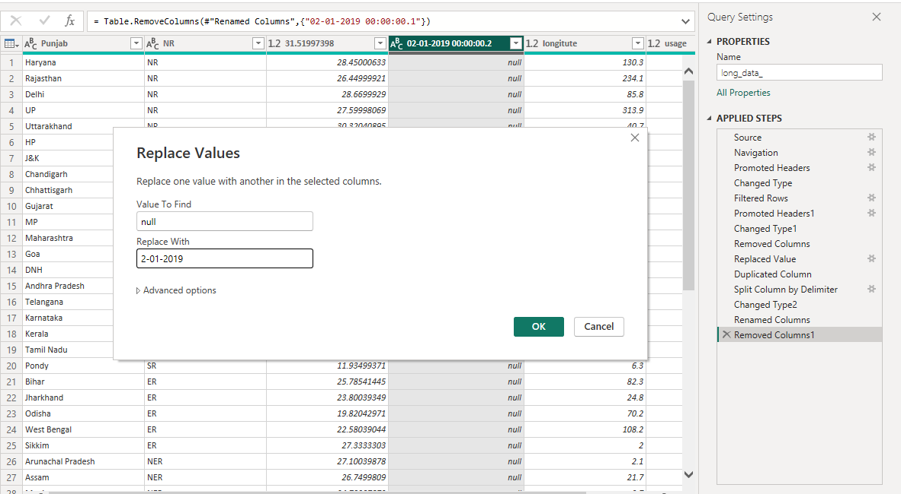

Changing the order of Region name at Power Query

Duplicate the “district /region” then split column using space as delimiter.

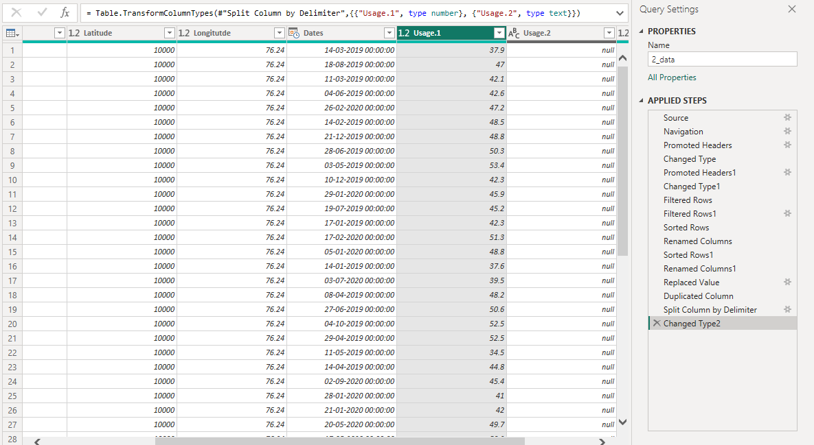

**Group of region usage**

**As the States from 0 to 30, we shall group them into different state range**

**For easier profiting, we will group the states with the values of median.**

**Group By**

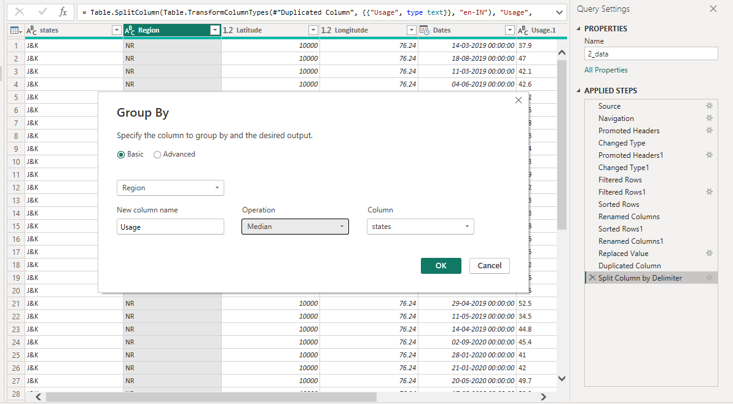

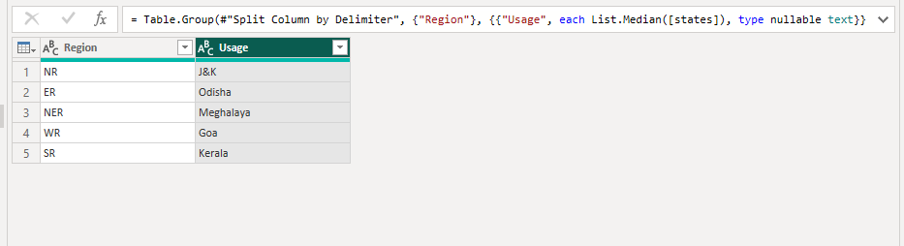

**Credit Rating and Loan Status**

As the Loan status uses A, B, C, D which are not reader friendly. We can add a column to represent what it stands for, we also simplify the classification of those with late or default on payment as bad credit, refer to the table below for details on the new columns added.

Values of such as “account Id” have also been set as Text.

And District name have been categorized as place to be use for the map to show the sum of the inhabitants in each region.

**Dashboard**

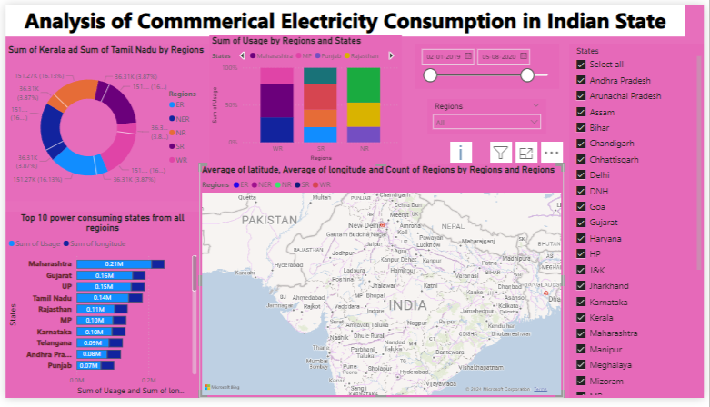

**CONCLUSION**

The project “Analysis of Commercial Electricity Consumption in Indian States ” using Power BI has successfully demonstrated the potential of data analytics in the banking sector. In conclusion, commercial electricity consumption in Indian states is influenced by a complex interplay of factors including economic development, infrastructure, policy interventions, technological advancements, and urbanization trends. Sustainable management of commercial electricity consumption requires a holistic approach involving stakeholder collaboration, policy coherence, and targeted interventions to promote energy efficiency and environmental stewardship while supporting economic growth and development.

Top of Form

**FUTURE SCOPE**

The future scope of this project is vast. With the advent of advanced analytics and machine learning, Power BI can be leveraged to predict future trends based on historical data. these Developing advanced energy modelling tools and techniques to forecast future commercial electricity consumption scenarios under different socioeconomic, technological, and policy scenarios, enabling policymakers, utilities, and businesses to make informed decisions and plan for future energy needs. **Demand-Side Management** Exploring demand-side management strategies and initiatives to optimize commercial electricity consumption, including demand response programs, energy efficiency measures, load-shifting strategies, and smart grid technologies, to mitigate peak demand, enhance grid reliability, and reduce energy costs. **Renewable Energy Integration** Assessing the potential for integrating renewable energy sources, such as solar photo volatile, wind power, and biomass, into commercial electricity consumption patterns, including rooftop solar installations, renewable energy procurement strategies, and grid integration challenges. **Data Analytics and Artificial Intelligence** Leveraging advanced data analytics and machine learning algorithms to analysis large-scale commercial electricity consumption datasets, identify consumption patterns, anomalies, and opportunities for optimization, and develop predictive models for forecasting future consumption trends.

**REFERENCES**

<https://www.google.com/search?q=analysis+of+commerical+electricity+consumption+in+indian+states&rlz=1C1CHBD_en-GBIN1081IN1081&oq=&gs_lcrp=EgZjaHJvbWUqCQgCEEUYOxjCAzIJCAAQRRg7GMIDMgkIARBFGDsYwgMyCQgCEEUYOxjCAzIJCAMQRRg7GMIDMgkIBBBFGDsYwgMyCQgFEEUYOxjCAzIRCAYQABgDGEIYjwEYtAIY6gIyEQgHEAAYAxhCGI8BGLQCGOoC0gEJMjM0OWowajE1qAIIsAIB&sourceid=chrome&ie=UTF-8>

**LINK**

<https://github.com/athis2004/Analysis-of-commercial-electricity-consumption-in-indian-states>