Laptop Request Catalog Item
Table of Contents
1. INTRODUCTION 3
1.1Project Overview 3
1.2 Purpose 3
2. IDEATION PHASE 3
2.1 Problem Statement 3
2.2 Empathy Map Canvas 4
2.3 Brainstorming 5
3. REQUIREMENT ANALYSIS 6
3.1 Customer Journey map 6
3.2 Solution Requirement 6
3.3 Data Flow Diagram 7
3.4 Technology Stack 9
4. PROJECT DESIGN 11
4.1 Problem Solution Fit 11
4.2 Proposed Solution 12
4.3 Solution Architecture 12
5. PROJECT PLANNING & SCHEDULING 13
5.1 Project Planning 13
6. FUNCTIONAL AND PERFORMANCE TESTING 13
6.1 Performance Testing 13
7. RESULTS 14
7.1 Output Screenshots 14
8. ADVANTAGES & DISADVANTAGES 17
9. CONCLUSION 17
10. FUTURE SCOPE 18

1. INTRODUCTION

1.1Project Overview

The Laptop Request Catalog Item project in ServiceNow involves creating a user-friendly and automated form that allows employees to request laptops through the organization’s ServiceNow platform. This item streamlines the hardware request process, ensuring faster approvals, accurate tracking, and better inventory management.

1.2 Purpose
The primary goal of this project is to simplify and digitalize the laptop requisition process. By implementing this catalog item, the organization can improve service delivery, reduce manual intervention, and ensure a transparent, traceable workflow for IT hardware provisioning.

2. IDEATION PHASE

2.1 Problem Statement
Date | 10 February 2026
Team ID | LTVIP2026TMIDS70012
Project Name | laptop request catalog item
Maximum Marks | 2 Marks

Employees face delays and inefficiencies when requesting laptops through manual or email-based systems. Lack of standardized processes leads to confusion, approval delays, and inventory mismanagement. There is a need for a centralized and automated solution to manage laptop requests effectively.

2.2 Empathy Map Canvas

Date | 10 February 2026
Team ID | LTVIP2026TMIDS70012
Project Name | laptop request catalog item
Maximum Marks | 4 Marks

Section Description
Think & Feel Captures the user's internal thoughts, worries, aspirations, and priorities.
Hear Reflects what the user hears from friends, colleagues, influencers, or media.
See Describes the user's environment, what they observe, and what competitors offer.
Say & Do Outlines the user's behavior, public attitude, and how they interact with others.
Pain Identifies fears, frustrations, and obstacles the user faces.
Gain Highlights the user's goals, needs, and what success looks like to them.

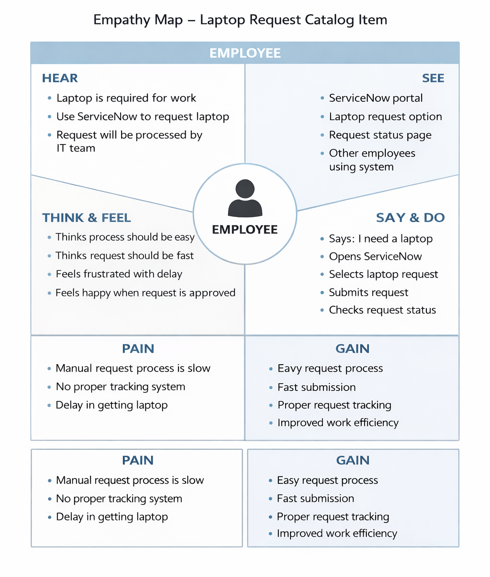

2.3 Brainstorming
Date | 10 February 2026
Team ID | LTVIP2026TMIDS70012
Project Name | laptop request catalog item
Maximum Marks | 4 Marks

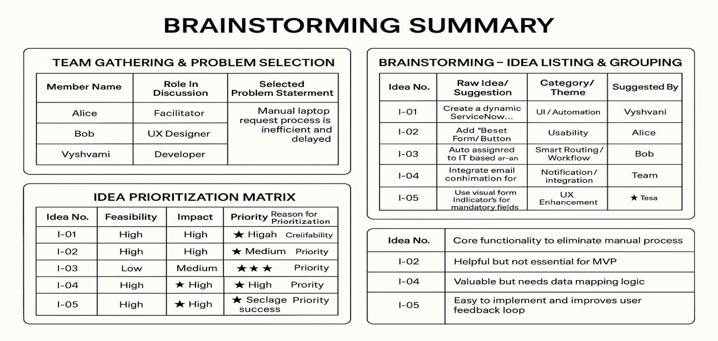

3. REQUIREMENT ANALYSIS

3.1 Customer Journey map
This visualizes the end-to-end experience of an employee requesting a laptop:
Awareness: Employee realizes the need for a laptop.
Access: Logs into the ServiceNow portal and navigates to the Hardware Catalog.
Interaction: Fills out the dynamic Laptop Request form (selects model, RAM, processor, accessories).
Approval: Request is routed to the manager for approval.
Fulfillment: Upon approval, a task is assigned to the Hardware team.
Closure: Laptop is delivered and the request is marked complete.
Pain Points Addressed: Manual delays, lack of clarity, and inconsistent data entry.

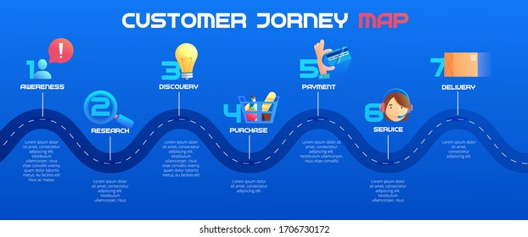

3.2 Solution Requirement

Date | 11 February 2026
Team ID | LTVIP2026TMIDS70012
Project Name | laptop request catalog item
Maximum Marks | 4 Marks
Functional Requirements:
Following are the functional requirements of the proposed solution.
FR Functional Requirement
Sub Requirement (Story / Sub-Task)
No. (Epic)
- Registration through Form <br> - Registration via Gmail <br> -
FR-1 User Registration
Registration via LinkedIn
FR-2 User Confirmation - Confirmation via Email <br> - Confirmation via OTP

Non-functional Requirements:
Following are the non-functional requirements of the proposed solution.
NFR Non-Functional No. Requirement
Description
NFR-1 Usability

The system should have an intuitive and user-friendly interface.
NFR-2 | Security | Implement secure login, data encryption, and access controls.
NFR-3 | Reliability | The application should operate without failures or data loss.
NFR-4 | Performance | System should process requests and responses within 2 seconds.
NFR-5 | Availability | The application should be accessible 99.9% of the time.
NFR-6 | Scalability | The solution should support increasing users and request volumes efficiently.

3.3 Data Flow Diagram
Date | 11 February 2026
Team ID | LTVIP2026TMIDS70012
Project Name | laptop request catalog item
Maximum Marks | 4 Marks
Level 1 DFD might include:
External Entities: Employee (requestor), Manager, Hardware Team.
Processes:
- Submit Laptop Request
- Approve Request
- Fulfill Request
Data Stores: Request Table, User Table, Approval Logs
Data Flows: Request details, approval status, task assignment, fulfillment status
This diagram shows how data moves from the user to the system and back, ensuring transparency and traceability.
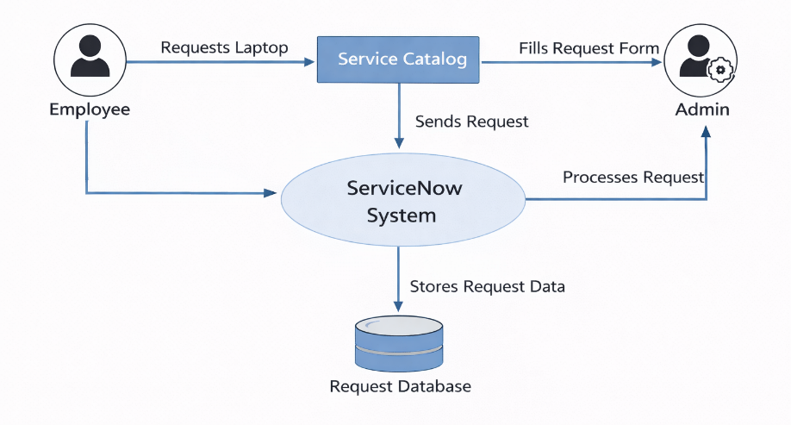

User Stories Related to Data Flow (DFD Perspective)

User Stories
Use the below template to list all the user stories for the product.
User Type | Functional Requirement (Epic) | User Story Number | User Story / Task | Acceptance criteria | Priority | Release
Employee | Laptop Request | USN-1 | As an employee, I want to request a laptop through ServiceNow | Request created successfully | High | Sprint-1
Employee | Select Specification | USN-2 | As an employee, I want to select laptop specifications | Specifications selected | High | Sprint-1
Employee | Submit Request | USN-3 | As an employee, I want to submit request | Request submitted | High | Sprint-1
Employee | Track request | USN-4 | As an employee, I want to track request status | Status displayed | Medium | Sprint-1
Admin | Manage Request | USN-5 | As an admin, I want to manage requests | Admin can view requests | Medium | Sprint-1

3.4 Technology Stack
Date | 11 February 2026
Team ID | LTVIP2026TMIDS70012
Project Name | laptop request catalog item
Maximum Marks | 4 Marks

Table-1: Components & Technologies

S.No Component Description Technology
Web-based interface where users HTML, CSS, JavaScript, ServiceNow
- User Interface
request laptops and view status Catalog UI, GlideForm APIs
Dynamic form logic, field visibility,
- Application Logic-1 ServiceNow Client Scripts, UI Policies
validations
ServiceNow Flow Designer, Approval
- Application Logic-2 Workflow automation and approvals
Rules, Script Actions
ServiceNow Business Rules, Catalog
- Application Logic-3 Request routing and task assignment
Task Workflows
ServiceNow Tables (sc_req_item,
- Database Stores request data, user profiles, tasks sc_task, sys_user)
Native cloud data storage provided by
- Cloud Database ServiceNow (built on MySQL backend)
platform
Attachments like ID proof or approval ServiceNow Attachments API,
- File Storage
docs Encrypted file storage
- External API-1 Email notifications integration SMTP / Outlook API
9 External API-2 | Optional future integration (e.g., asset  REST APIs / MID Server scripts  validation via vendor APIs)
Machine Learning  10  Model | Optional future enhancement (e.g., Not currently used, possible integration predictive asset assignment) via AI Search
Infrastructure  11  (Server/Cloud) | Cloud-based deployment of Hosted on ServiceNow Cloud (SaaS); ServiceNow platform no local setup needed

Table-2: Application Characteristics

S.No Characteristics Description Technology / Notes
Open-Source Scripted APIs and web standards used in ECMAScript, Bootstrap (within
1
Frameworks UI logic ServiceNow components)
Security Role-based access, data encryption, audit ACLs, SHA-256 Hashing, RBAC,
2
Implementations logging ServiceNow Security Policies
Scalable Modular service catalog structure, 3-tier architecture using ServiceNow
3
Architecture reusable workflows platform layers
Platform maintained on enterprise-grade 99.9% uptime via ServiceNow SaaS
- Availability
infrastructure with clustering and failover
Caching used in workflows, indexed GlideRecord optimizations,
- Performance database queries, asynchronous tasks ServiceNow Performance Analytics

4. PROJECT DESIGN

4.1 Problem Solution Fit
Date | 13 February 2026
Team ID | LTVIP2026TMIDS70012
Project Name | laptop request catalog item
Maximum Marks | 4 Marks

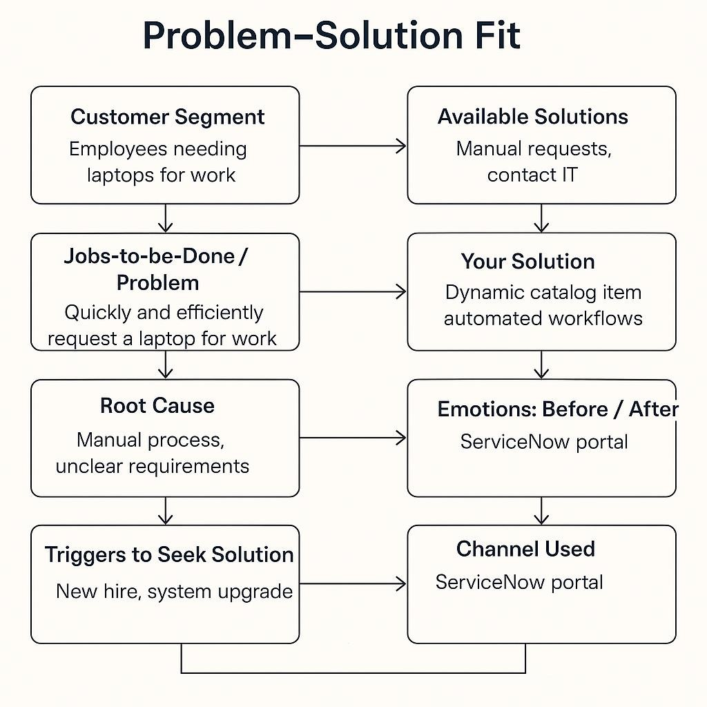
Section | Insight
Customer Segment (CS) | Defines your target users – for example, employees needing laptops for work.
Customer Constraints (CC) | Barriers like lack of time, unfamiliar forms, or manual delays.
Available Solutions (AS) | Existing manual request methods or contacting IT directly.
Jobs-to-be-Done / Problems  (J&P) | The core need: quickly and efficiently request a laptop for work.
Root Cause (RC) | Manual process, unclear requirements, lack of self-service tools.
Customer Behavior (BE) | Users ask peers or IT manually; unaware of digital request options.
Triggers (TR) | New hire onboarding, system upgrades, or broken devices.
A dynamic ServiceNow catalog item with automated workflows and form
Your Solution (SL) validation.
Channels (CH) ServiceNow portal, internal emails, onboarding documentation.
Emotions: Before / After (EM) Before: Frustrated, delayed. <br>After: Confident, satisfied, empowered.

4.2 Proposed Solution
S.No. Parameter Description
Employees currently face delays and inconsistencies due to the manual

1 Problem Statement
laptop request process, lacking dynamic guidance, validation, and tracking.
Design and deploy a dynamic ServiceNow Catalog Item for Laptop Idea / Solution
- Requests with conditional fields, validation rules, workflow automation,
Description and audit trail.
Integrates dynamic form logic, real-time validation, reset functionality,
- Novelty / Uniqueness approval workflows, and task automation — all within a single self-service portal.
Social Impact / Reduces manual workload, minimizes errors, and improves turnaround
4
Customer Satisfaction time, leading to higher employee satisfaction and streamlined IT operations.
5 Business Model As an internal organizational tool, the model supports operational
 | (Revenue Model) | efficiency. Optionally, the solution can be packaged as a module for enterprise clients.
6 | Scalability of the Solution | The catalog item can be extended to include other hardware or software requests, additional workflows, and integrations with asset management systems.

4.3 Solution Architecture
Date | 13 February 2026
Team ID | LTVIP2026TMIDS70012
Project Name | laptop request catalog item
Maximum Marks | 4 Marks

Aspect | Description
Objective | Bridge the gap between business needs (e.g., laptop requests) and technical implementation using ServiceNow.
Key Goals | Identify the best-fit tech solution, define system behavior, outline development phases, and provide implementation specs.
Core  Components | - User Interface: ServiceNow Catalog Item<br>- Business Logic: Client Scripts, UI Policies, Flow Designer<br>- Data Layer: ServiceNow Tables (sc_req_item, sc_task)<br>- Integration: Email Notifications, Approval Workflows<br>- Governance: Audit Logs, Update Sets
Stakeholders | Employees, Managers, IT Fulfillment Team, Admins
Development 1. Requirement Gathering<br>2. Catalog Item Design<br>3. Workflow Automation<br>4. Phases Testing & Deployment
Delivery Specs Defined via update sets, version control, and role-based access policies

5. PROJECT PLANNING & SCHEDULING

5.1 Project Planning
Element | Description
Project Scope | Develop a ServiceNow Catalog Item for laptop requests with dynamic fields, approval workflows, and audit tracking.
Project Goals | - Streamline laptop request process<br>- Improve user experience<br>- Ensure governance and traceability
Stakeholders | Employees, Managers, IT Fulfillment Team, ServiceNow Admins
Project Phases | 1. Requirement Gathering<br>2. Design & Prototyping<br>3. Development<br>4.  Testing<br>5. Deployment<br>6. Feedback & Optimization
Deliverables | - Dynamic Catalog Item<br>- Approval Workflow<br>- Task Assignment Logic<br>- Audit Logs<br>- User Documentation
Element | Description
Tools &  Technologies | ServiceNow, Flow Designer, Client Scripts, UI Policies, Update Sets
Team Roles | - Developer: Form logic, scripting<br>- Admin: Workflow & access control<br>- QA:  Testing & validation<br>- Project Lead: Coordination & reporting
Timeline | Estimated 4–6 weeks (adjustable based on sprint planning and feedback loops)

6. FUNCTIONAL AND PERFORMANCE TESTING

6.1 Performance Testing
Date | 18 February 2026
Team ID | LTVIP2026TMIDS70012
Project Name | laptop request catalog item
Maximum Marks | 4 Marks

Test Type Purpose
Load Testing Assess system behavior under normal and peak user loads.
Stress Testing Determine system limits by pushing beyond expected load.
Spike Testing Evaluate how the system handles sudden surges in traffic.
Soak Testing Check for memory leaks or degradation over extended usage periods.
Performance Metrics

Metric Description
Response Time Time taken to load the catalog form or submit a request.
Throughput Number of requests processed per second/minute.
Error Rate Percentage of failed requests under load.
Resource Usage CPU, memory, and database utilization during test cycles.
Tools & Environment

Component Details
Test Tool JMeter or LoadRunner (for simulating user load)
Monitoring Tools ServiceNow Performance Analytics, built-in logs
Test Environment Pre-production ServiceNow instance with production-like configuration
Test Data Simulated user accounts, request payloads, and approval workflows

7. RESULTS

7.1 Output Screenshots
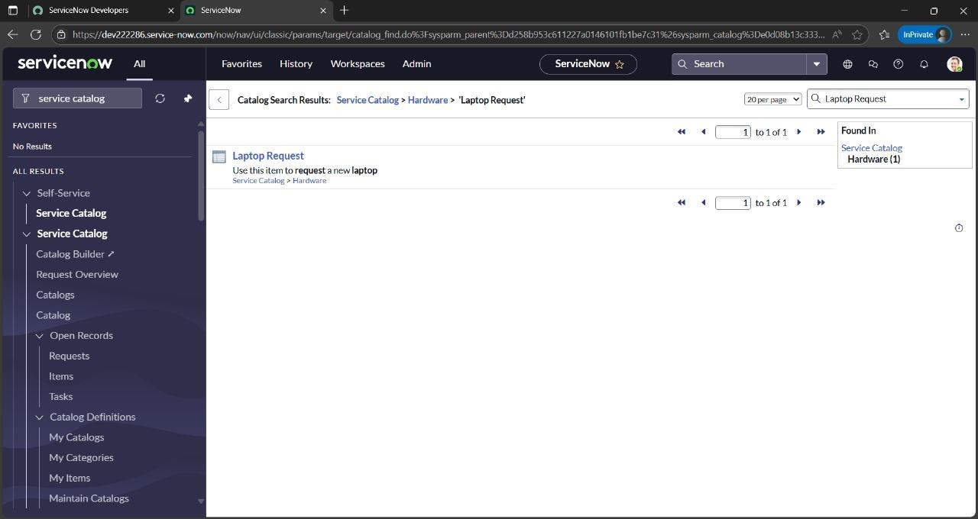

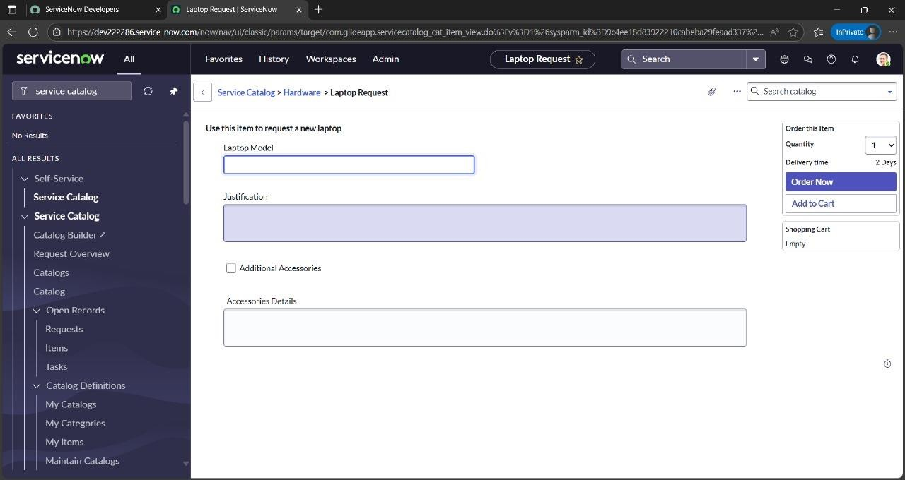

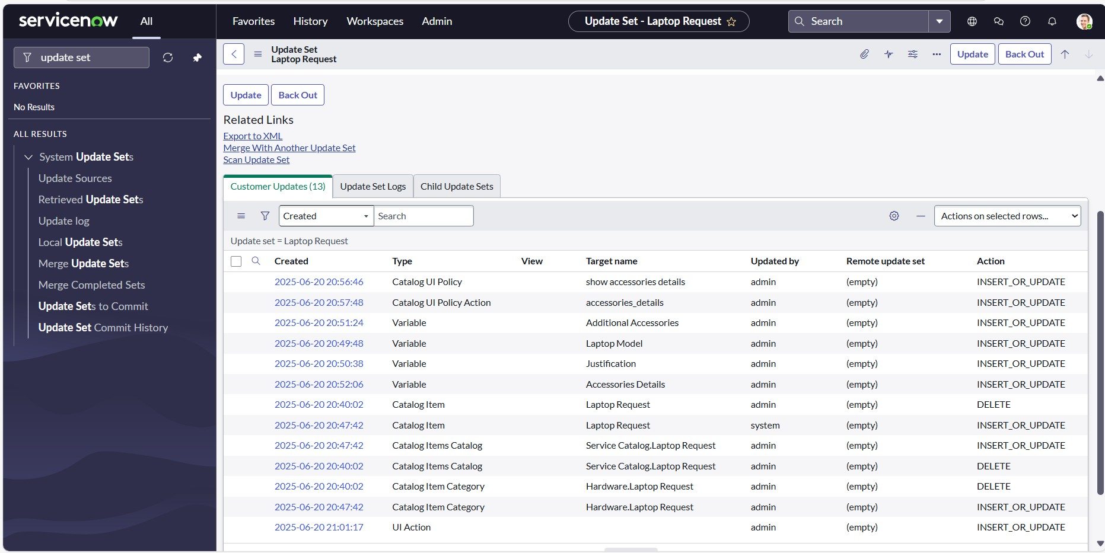

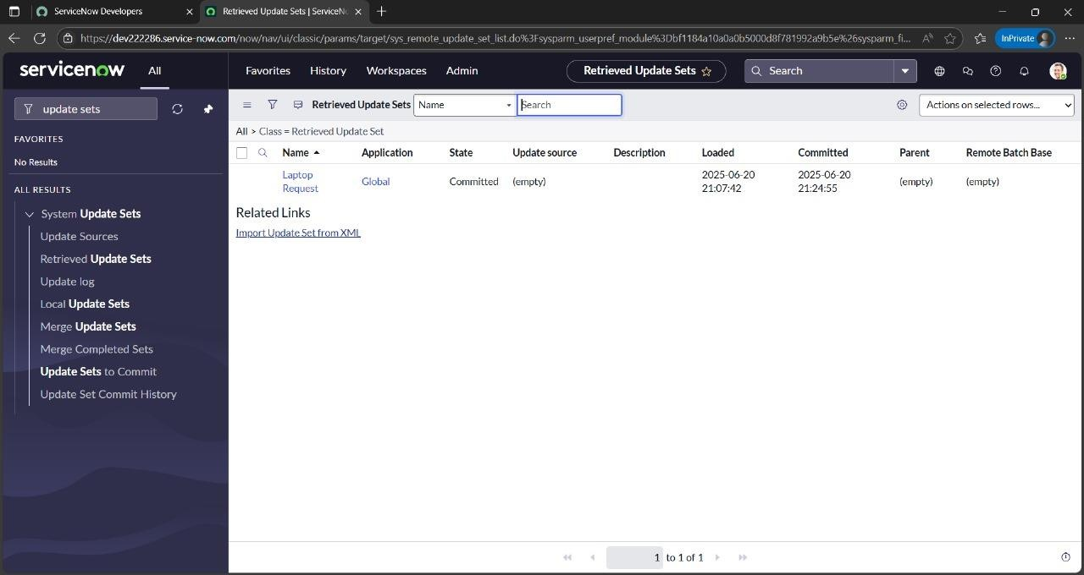

8. ADVANTAGES & DISADVANTAGES

Advantages:

Simplified Request Process: A catalog item for a laptop streamlines the request process, making it easy for users to request a laptop without needing to specify all the details manually.

Standardization: It ensures a consistent approach to laptop requests, making it easier to manage and fulfill them.

Centralized Management: Catalog items are typically managed within a service catalog, which provides a centralized platform for managing requests, approvals, and fulfillment.

Improved User Experience: A well-designed catalog item provides a user-friendly interface for requesting laptops, increasing user satisfaction.

Cost Reduction: By standardizing the process and potentially offering pre-configured options, catalog items can help reduce costs associated with laptop procurement.

Disadvantages:

Limited Customization: Catalog items may not accommodate every specific need or configuration that a user might require.

Potential for Over- or Under-Specification: Users might select a laptop that doesn't perfectly match their needs, leading to either over-specified hardware or inadequate performance.

Dependency on Workflow: The fulfillment of a catalog item relies on the defined workflow, which may not always be flexible enough to handle unique situations.

Requires Maintenance: Catalog items need to be maintained and updated to reflect changes in laptop models, specifications, or pricing.

9. CONCLUSION
The proposed solution transforms a traditionally manual and error-prone process into an intelligent, userfriendly workflow using ServiceNow. By combining dynamic forms, automated approvals, role-based access, and backend tracking, it not only streamlines laptop provisioning but also improves stakeholder satisfaction. The project demonstrates how thoughtful digital transformation can enhance internal IT services while aligning with governance and usability goals.

10. FUTURE SCOPE
- Multi-Device Support: Extend the catalog to include mobile phones, monitors, or accessories.
- Asset Inventory Integration: Auto-check availability and assign pre-registered asset tags.
- Analytics Dashboard: Generate real-time reports on request trends and SLA metrics.
- AI Recommendations: Suggest devices based on user role or department history.
- Multi-language Support: Enhance accessibility for a diverse global workforce.
- Self-Help Chatbot: Guide users through the request process via a conversational assistant (could even use NLP concepts you're exploring!).

