When change in R1,job-1 get trigger
By using webhook

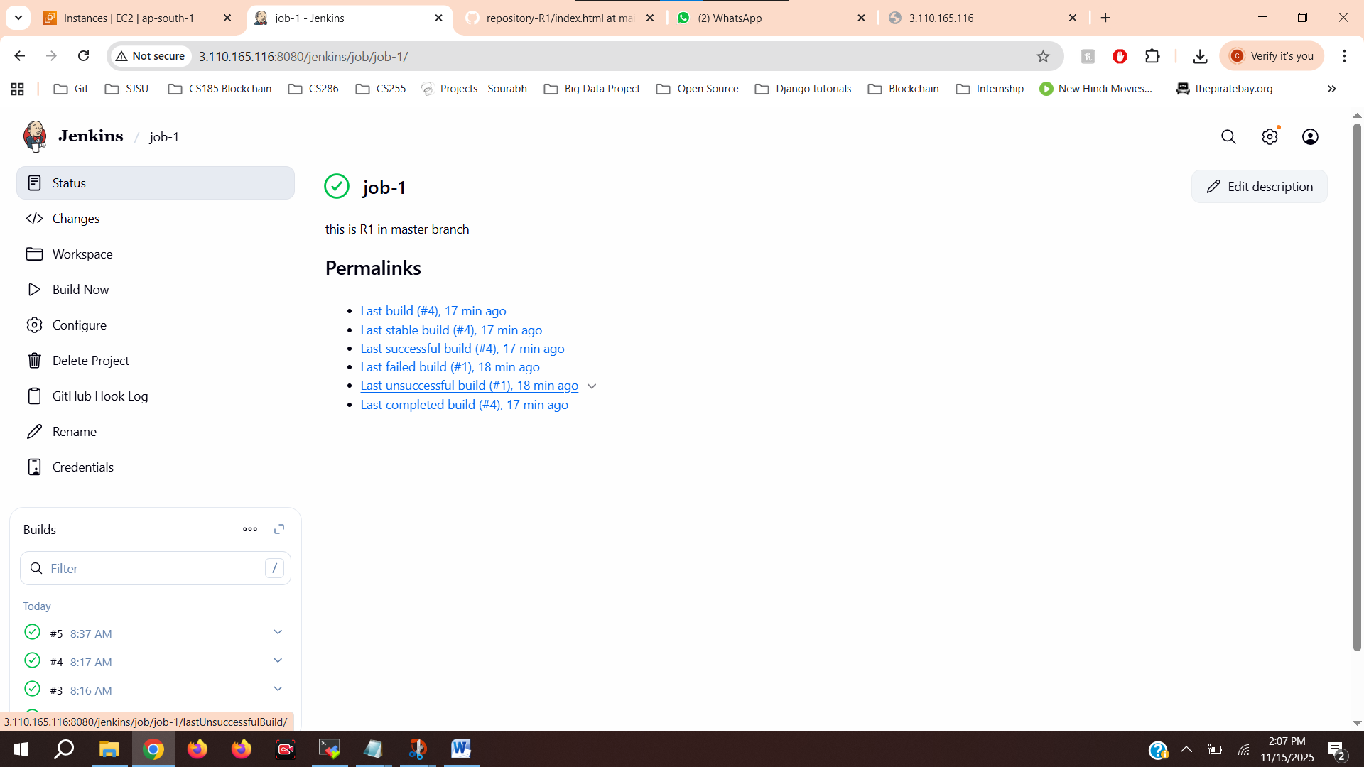
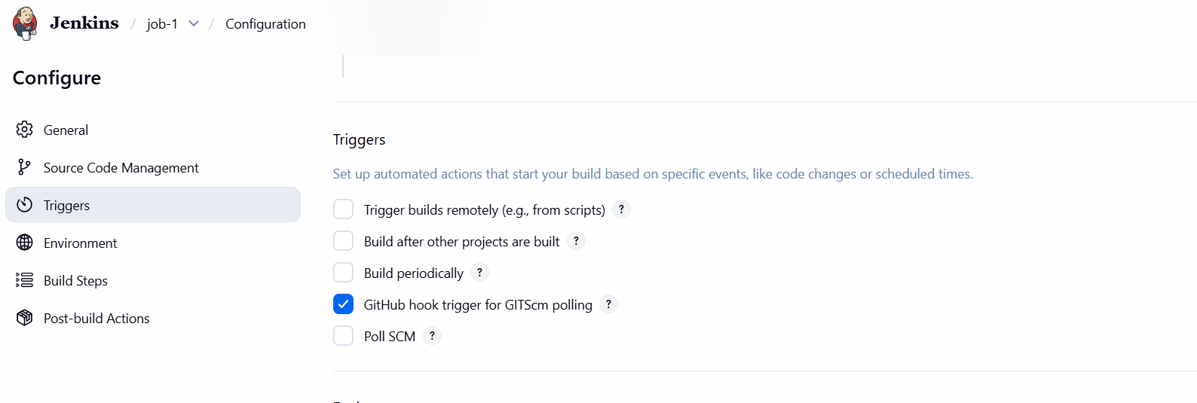
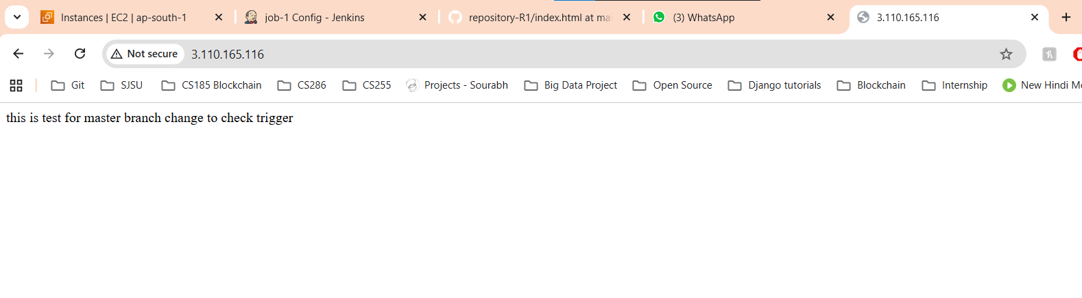

For job-2
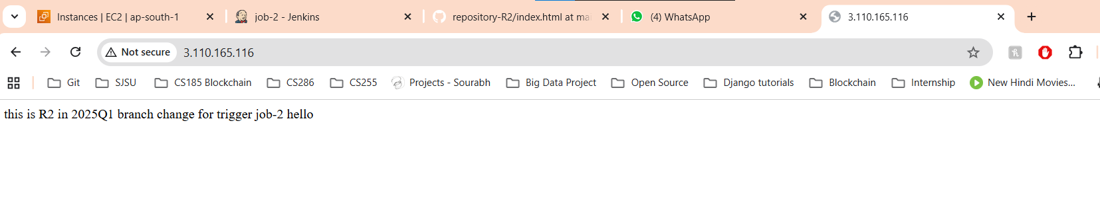
For job-3
