**ABSTRACT**

IoT Based Onion Preservation System

Vinay Sidawadkar1,Rohini Ahire2, Dipak Gavhale3,Shankaranand Lohare4,Dr.P.P.Vast5

vsidawadkar86[@gmail.com1](mailto:@gmail.com1), [rohiahire43@gmail.com2](mailto:rohiahire43@gmail.com2), dipakgavhale95[@gmail.com](mailto:@gmail.com)3,[splohareelx@gmail.com](mailto:splohareelx@gmail.com)4, ppvast[@aissmscoe.com](mailto:rritkarkar@aissmscoe.com)5.

Electronics & telecommunication Department, All India Shri Shivaji Memorial Society's College Of Engineering Pune, 411001, India.

***India ranks second in onion production in the world. Onion is extremely important not only as a vegetable but also as a foreign exchange earner amongst other fruits and vegetables. But due to the continuous change in Indian climate onions can rot or decay. Therefore onions should be preserved by maintaining the temperature given by the NOA (National Onion Association). Under the ambient condition the onions are stored at temperature 0-4℃ with humidity (60-70%). So the idea has come up to preserve onion.***

***In this project we have designed onion preservation system, which preserves an onion in a prescribed manner. In this system temperature, humidity sensors have been used to monitor a temperature and humidity respectively. Using Peltier module air inside the tank is cooled and warmed to maintain the standard temperature range. By using IoT, making the proposed system smart and efficient, user will get notification of the system anywhere in the world. Also user will get recent onion market trends.***

***Keywords – Thermo-electric Module (TEM), National Onion Association (NOA), Onion preservation, Coefficient Of Performance(COP)***

**INTRODUCTION**

Losses in stored onion in Maharashtra is higher because of onion bulbs are having higher water content. It is estimated that out of the total production of 41 lakh tones of onion, 40 to 50 % valued at more than Rs.600crore are lost due to desiccation, decay and sprouting in storage. This results in raise in their price to the four to five times. India produces all three varieties of onion viz. red, yellow and white. The production as well as market value of this potential vegetable is increasing day by day. This states that onion desiccation, rotting, rooting, decay & sprouting in onion storage sheds should be avoided**. Onion is extremely important vegetable crop not only for internal consumption but also as highest foreign exchange earner among the fruits and vegetables**. Onion farmers trying to increase the production year after year. However onion price have been highly volatile and more recently the price have been sluggish. This has resulted in Maharashtra State Agriculture Marketing Board seeking price support.

1. **THERMOELECTRIC MODULE**

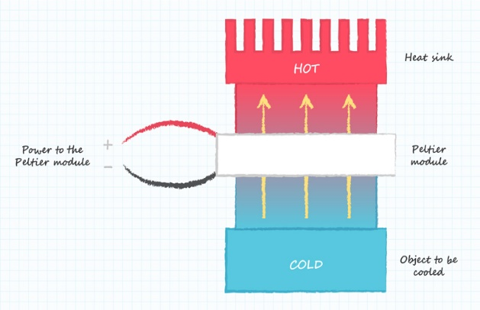

Thermoelectric module consists of tiles generally known as Peltier tiles. These tiles having P-Type and N-type semiconductor arrays. Thermoelectric module works on principle of **“Peltier Effect”.** When voltage is applied is to terminals of the peltier module, one side gets hot but at the same time another side gets cooled. If we reverse the polarity of power supply hot side becomes cold and vice versa.

**III. LITERATURE SURVEY**

The post-harvest onion storage methodology is designed and implemented to reduce its degradation [1] An onion harvesting detection is done using arduino, LM35 temperature sensor, humidity sensor, gas sensor and GSM module. The objectives of this quality of onion using arduino is to sense the ammonia gas, temperature, humidity help of LM35 temperature sensor, gas sensor MQ 137, and send SMS alerts to mobile numbers stored inside the arduino program if onion quality is selected using GSM.

This paper introduces an advance system that will help user to control such parameters affecting positive feedback against different onion losses [2]. Shed net is used here because it improves the thermal behaviour significantly decreasing the inside temperature.

The system works on the principle of sensing emitted gases by onions and attempting to control them within desired parameter range of temperature and so humidity and also gives online record observation facility.

In this novel methodology, a system is introduced which is IoT based food monitoring system [3]. In this system sensors related to food safety like Co2, humidity and nitrogen sensing elements used. And IoT plays and important role as it gives the alert to user at remote location.

**Development of Flow Chart**

The flow chart which we develop is very simple which is shown in Fig.

Sense the Temperature (Temp)

If temp<2

temp1<2

Yes

Turn ON the heater, OFF chiller

No

No

If Temp>4

temp1<2

Yes



Turn ON chiller, OFF heater

1. **METHODOLOGY**

In this paper, the quality and quantity of onion is maintained by using thermoelectric cooling system and monitored using and IoT. The Wi-Fi module is used to send monitored data to user at any remote location. Temperature controlling is the most challenging part of the system as external environment impacts on inner tank temperature. An entire system can be divided into two parts.

***1. Maintaining the temperature inside the tank***

Maintaining the temperature is one of the major tasks. Thermoelectric cooling system which is based on peltier effect is used to decrease the temperature inside the tank. As power supply is given to the thermoelectric cooling module, one side of the peltier starts to become cold. The exhaust fan attached to the cooling module, blows cooling air from thermoelectric module to inside the tank. The temperature decreases exponentially. As temperature lies in between 0-4℃, cooling module is turned OFF.As soon as temperature increases again cooling module is turned ON. If for any reason temperature goes below the prescribed range, heating module is turned ON.

**2. *Monitoring* & Logging the sensed data on Google cloud and send it to the user.**

Parameters like temperature and humidity are monitored using LM35 and DHT11 sensor respectively. The monitored data is logged on google cloud. This data can also send to the user. IoT plays an important role here. The quantity of onion is also updated to the user. So user get to know how much onion is in the store.

**V. SYSTEM DESIGN**

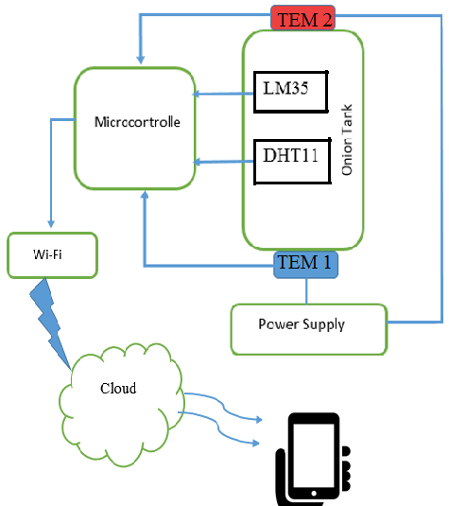

**1. TEM (Thermo-Electric cooling module)**

As the name suggests, thermal effects can be achieved using electricity. Thermo-electric modules consists of two or more p and n type semiconductor blocks sandwiched between two plane ceramic substrate. The p-type and n-type are connected in series electrically while connected parallel thermally. When DC voltage is applied to it, heat from one side is transferred from one side to another side. Hence one side is cooled and other becomes hot.

**2. LM35**

For monitoring the temperature LM35 temperature sensor is used. The main advantage of LM35 sensor is output voltage is more than traditional thermocouple. Because of this no external signal conditioning circuitry required. And accuracy is more.

**3. DHT11**

DHT11 is humidity sensor having range of 20%-90% and it has also measures temperature with the range of 0°-50°C.

**4. ATMega328p**

In this system Atmega328p microcontroller is used to maintain the temperature inside the onion storage tank. Basically it is 8-bit low power microcontroller. The main feature is inbuilt ADC. This feature make this microcontroller suitable for this application.

**5. ESP32 Wi-Fi module**

It is an integrated SoC (System-on-Chip) used to connect the device to the world. It is wireless transreceiver. It also supports WPA/WPA2 security mode. Even we can connect sensors directly to it. It supports Bluetooth. It gives wireless connectivity to the devices so it can connect and communicate with other system.

**6. Power Supply**

The Thermoelectric module required constant DC voltage so thermal effect can be achieved. Here linear power supply is designed for 12V 2A.SMPS is good option as power supply because heat is less generated through it.

**V.SIMULATION**

For simulating the temperature controlling part, **PROTEUS IDE** is used. As shown in the images temperature controlling setup is done. For cooling module, symbolic motor is shown, while foe heating module Lamp is shown. Keypad is provided to set the desired temperature. Here LM35 temperature sensor is acting as input to the microcontroller. For testing purpose Arduino UNO is used. OLED display is used. Lamp and motor acts as heating and cooling module respectively.

**A. CASE I**

Referring fig.V.1set temperature i.e. **“Temp Ref.”** is 2°C now current temperature i.e. **“Temp”** sensed by temperature sensor is 15.1°C.So for getting the desired temperature cooling fan is turn ON i.e. cooling module. After current temperature reaches to the set temperature, cooling module is turned OFF.

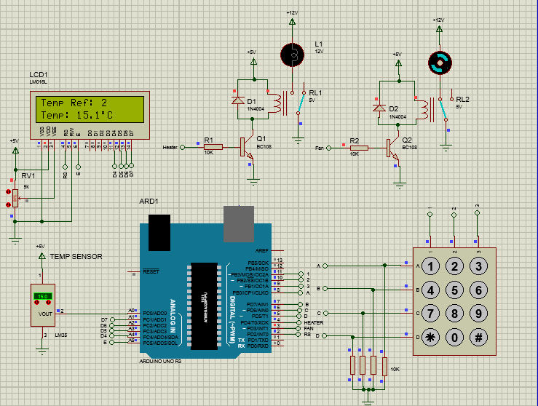**Fig. V.1**

**B. CASE II**

Here Set temperature is kept constant. But current temperature is below the set temperature. By Referring fig.V.2 we can see that Lamp is turned ON i.e. heating module. At the same time cooling module turned OFF.

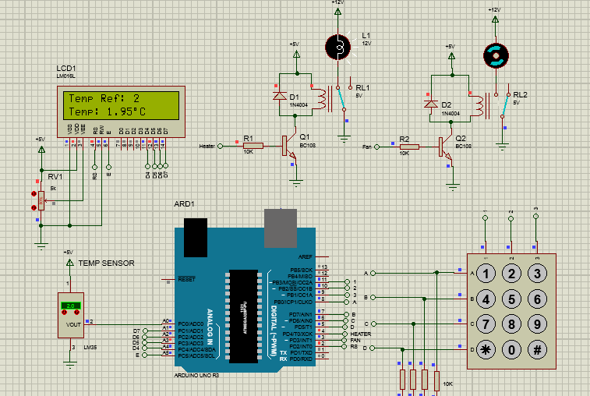

**Fig.V.2**

**VI. CONCLUSION**

To preserve the onion Thermoelectric cooling system has been introduced. This system can control the temperature inside the cell required for the onion preservation by using Peltier tiles. According to quantity of onion this system can be easily modified and implemented. By using Google assistance user will get updates regarding system condition and also current rates of onion.

**REFERENCES**

**[1]** Mokshi Vyas1, Rutuja Gore-Post harvesting Onion Storage Methodology Using IOT **“IJARCCE** Vol. 8, Issue 5, May 2019

**[2]**An Intelligent IoT-Based Food Quality Monitoring Approach Using Low-Cost Sensors Alexandra Popa

**[3]** S. A. Pawar **,** Cost Effective Long-Time Preservation and reporting of Onion Rotting and Onion Decay with Online Feedback .published in **International Journal of Advanced Research in Electrical, Electronics and Instrumentation Engineering Vol. 6, Issue 1, January 2017**

**[4]** D. Jude Hemanth (Department of ECE, Karunya Institute of Technology and Sciences, Coimbatore, Tamil Nadu 641014, India An Intelligent IoT-Based Food Quality Monitoring Approach Using Low-Cost Sensors Publish in **Symmetry**

**[5]** Nandini K.K., Muralidhara, “peltier based cabinet cooling system using heat pipe and liquid based heat sink”.