1. INTRODUCTION
Stored onion decays at higher rate because of onion bulbs are having higher water content. It is estimated that out of the total production of 41 lakh tones of onion, 40 to 50 % valued at more than Rs 600 crores are lost due to desiccation, decay and sprouting in storage. This results in raise in their price to the tune of four to five times. India produces all three varieties of onion viz. red, yellow and white. The production as well as market value of this potential vegetable is increasing day by day. This states that onion desiccation, rotting, rooting, decay & sprouting in onion storage sheds should be avoided. Onion is extremely important vegetable crop not only for internal consumption but also as highest foreign exchange earner among the fruits and vegetables. Onion farmers trying to increase production year after year. However onion price have been highly volatile and more recently the price have been sluggish. This has resulted in Maharashtra State Agriculture Marketing Board seeking price support.

2. PROBLEM STATEMENT
- Develop a system which monitors and control the onion preservation process and give acknowledgement to user on mobile phones.

2.1 OBJECTVE
- To study the different onion preservation techniques.
- To study the Peltier effect.
- To design the proposed system.
- To monitor onion conditions under the proposed system.

3. LITERATURE SURVEY
1) Post harvesting Onion Storage Methodology Using IOT
Author: Mokshi Vyas (Student, IT Dept, JSPM College, Pune, India)
Publication: International Journal of Advanced Research in Computer and Communication Engineering Vol. 8, Issue 5, May 2019
Methodology: designed and implemented the post-harvest onion storage methodology to reduce its degradation. In this project a Onion Harvesting detection using Arduino, LM35 Temperature Sensor, Humidity Sensor, Gas sensor and GSM Module. The objectives of this Quality of Onion using ARDUINO is to sense the Ammonia Gas, Temperature , Humidity help of LM35 temperature sensor, Gas Sensor MQ 137, and send SMS alerts to mobile numbers stored inside the ARDUINO program if onion quality is elected using GSM.
2) Cost Effective Long-Time Preservation and Reporting of ‘Onion Rottening and Onion Decay’ with Online Feedback
Author: S. A. Pawar (M.Phil. Student, Dept. of Electronic Science, K. T. H. M. College, Nashik, Maharashtra, India).
Publication: International Journal of Advanced Research in Electrical, Electronics and Instrumentation Engineering Vol. 6, Issue 1, January 2017
Methodology: This paper introduces an advance system that will help user to control such parameters affecting positive feedback against different onion losses. Shed net is used here because it improves the thermal behavior significantly decreasing the inside temperature. The
system works on the principle of sensing emitted gases by onions and attempting to control them within desired parameter range of temperature and so humidity and also gives online record observation facility.
3) An Intelligent IoT-Based Food Quality Monitoring Approach Using Low-Cost Sensors
Author: D. Jude Hemanth (Department of ECE, Karunya Institute of Technology and Sciences, Coimbatore, Tamil Nadu 641014, India)
Publication: Symmetry
Methodology: Integrating CO2, temperature, humidity with IoT monitoring and controlling the food quality.
4) Onion Storage Guidelines for Commercial Growers
Author: Walter E. Matson (Extension agricultural engineer, Oregon State University)
Publication: A Pacific Northwest Extension

3.1 Literature Review

- India ranks second in onion production in the world.
- Onion is extremely important not only as a vegetable but also a foreign exchange earner among the fruits and vegetables.
- Onion is having high level of water content.
- Due to the continuous change in Indian climate onions can rot or decay. Therefore onions should be preserved by maintaining the temperature given by the National Onion Association.

4. Methodology

4.1 Block Diagram
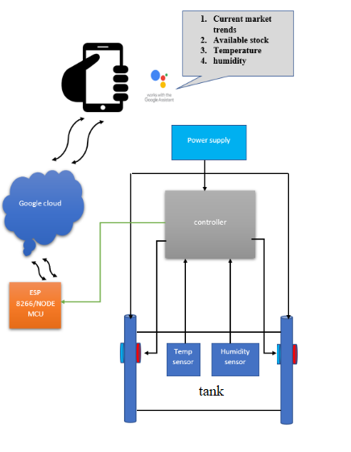
Fig.4.1.1: Block Diagram
4.2 Description

- Power Supply
A power supply is an electronic device that supplies electric energy to a load. The primary function of a power supply is to convert one form of electrical energy into other and as a result power supply are sometimes referred to as electric power converters. Some power supplies are discrete, stand-alone devices, whereas others are built into larger devices along with their loads. The types also include fixed, variable and dual power supply.
- ATmega328
The high-performance Microchip 8-bit AVR RISC-based microcontroller combines 32KB ISP flash memory with read-while-write capabilities, 1KB EEPROM, 2KB SRAM, 23 general purpose I/O lines, 32 general purpose working registers, three flexible timer/counters with compare modes, internal and external interrupts, serial programmable USART, a byte-oriented 2-wire serial interface, SPI serial port, 6-channel 10-bit A/D converter (8-channels in TQFP and QFN/MLF packages), programmable watchdog timer with internal oscillator, and five software selectable power saving modes. The device operates between 1.8-5.5 volts.
- Peltier tile
Peltier modules contain two external ceramic plates separated by semiconductor pellets. One of the plates absorbs heat (becomes cooler) and the other plate dissipates heat (becomes hotter) when a current is passed through the semiconductor pellets.
- ESP8266
The ESP8266 Wi-Fi Module is a self-contained SOC with integrated TCP/IP protocol stack that can give any microcontroller access to your Wi-Fi network. The ESP8266 is capable of either hosting an application or offloading all Wi-Fi networking functions from another application processor. Each ESP8266 module comes pre-programmed with an AT command set firmware, meaning, you can simply hook this up to your Arduino device and get about as much Wi-Fi ability as a Wi-Fi Shield offers (and that's just out of the box)! The ESP8266 module is an extremely cost effective board with a huge, and ever growing, community.
- LM35 Temperature Sensor
The LM35 series are precision integrated-circuit temperature devices with an output voltage linearly-proportional to the Centigrade temperature. The LM35 device has an advantage over linear temperature sensors calibrated in Kelvin, as the user is not required to subtract a large constant voltage from the output to obtain convenient Centigrade scaling. The LM35 device does not require any external calibration or trimming to provide typical accuracies of ±¼°C at room temperature and ±¾°C over a full −55°C to 150°C temperature range.
- Humidity sensor
DHT11 Temperature & Humidity Sensor features a temperature & humidity sensor complex with a calibrated digital signal output. By using the exclusive digital-signal-acquisition technique and temperature & humidity sensing technology, it ensures high reliability and excellent long-term stability. This sensor includes a resistive-type humidity measurement component and an NTC temperature measurement component, and connects to a high performance 8-bit microcontroller, offering excellent quality, fast response, anti-interference ability and cost-effectiveness.
- 3.2.7 Google Assistant
Google Assistant is an artificial intelligence-powered virtual assistant developed by Google that is primarily available on mobile and smart home devices. Unlike the company's previous virtual assistant, Google Now, the Google Assistant can engage in two-way conversations.

5. System Specification
- Input Voltage : 12V 6A
- Output Power : 72W
- Temperature range : -18 to +50 Celcius
- Dimension : 2ft x 2ft

- Tank Capacity : 5Kg

6. FLOWCHART
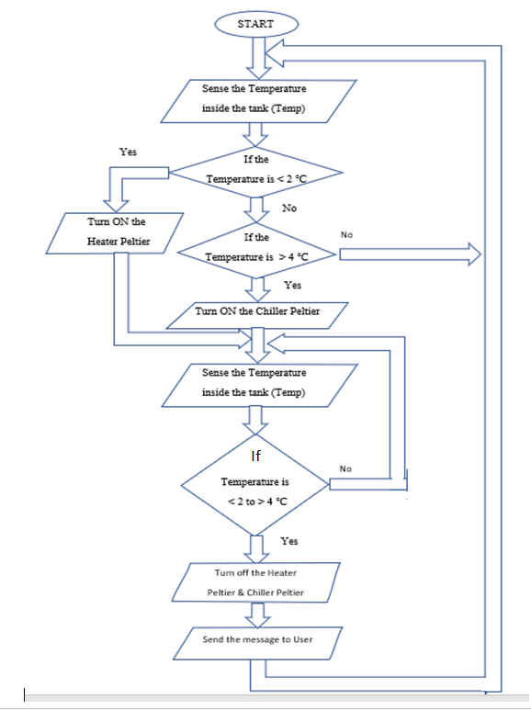
Fig.6.1 : Flowchart
6.1 How system works

- Initially, Temperature sensor will sense the temperature inside the tank And accordingly it will be given as input to the microcontroller.

- If temperature is less than 2℃ then Peltier heater will turn ON else if temperature is greater than 4℃ then Peltier cooler will turn ON.

- Then again sense the temperature inside the tank and compare. If this temperature is in between 2℃ to 4℃ then the heater Peltier and Chiller Peltier will be off else, the process will be repeated.

- If the temperature is exceeds or failure of the system, message will be sent to the user.

- By repeating above all processes, Temperature required for the preservation of onions i.e. temperature range 2-4℃ (32 to 40 ℉) will be maintained.

7. EXPECTED OUTCOME
When inside temperature of the tank breaks the standard preservation temperature range for onion, system turns ON. As per the temperature increases or decreases, Cooling & heating of Peltier starts respectively. At the same time google assistant provides monitoring facilities to the user.

7.1 OUTCOME OF THE PROPOSED RESEARCH
To validate our system, using multiple temp sensors at different locations and integrating their result we monitor and control the temperature of onion tank. As we know Peltier gives heating as well as cooling effect. So no need of external coolant . Here Google assistant plays important role at front end monitoring.

8. CONCLUSION

In this project we have presented the concept and implement of a system for preserving onion based on IoT .This system is able to control the temperature inside the tank required for the onion preservation by monitoring temperature. For the completion of this project we have studied Also we have work on google assistant to intimate user so that system can be monitored.

REFERENCES
[1] An Intelligent IoT-Based Food Quality Monitoring Approach Using Low-Cost Sensors
Alexandru Popa

[2] Mokshi Vyas1, Rutuja Gore “Post harvesting Onion Storage Methodology Using IOT “IJARCCE Vol. 8, Issue 5, May 2019

[3] : S. A. Pawar (M.Phil. Student, Dept. of Electronic Science, K. T. H. M. College, Nashik, Maharashtra, India).” Cost Effective Long-Time Preservation and Reporting of ‘Onion Rotting and Onion Decay’ with Online Feedback” .published in International Journal of Advanced Research in Electrical, Electronics and Instrumentation Engineering Vol. 6, Issue 1, January 2017

[4] \ D. Jude Hemanth (Department of ECE, Karunya Institute of Technology and Sciences, Coimbatore, Tamil Nadu 641014, India “An Intelligent IoT-Based Food Quality Monitoring Approach Using Low-Cost Sensors” Publish in Symmetry

