Starting at 2.30
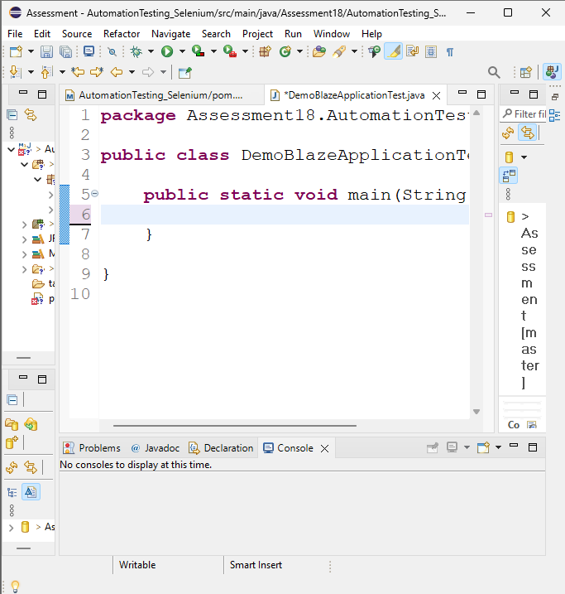
2.40
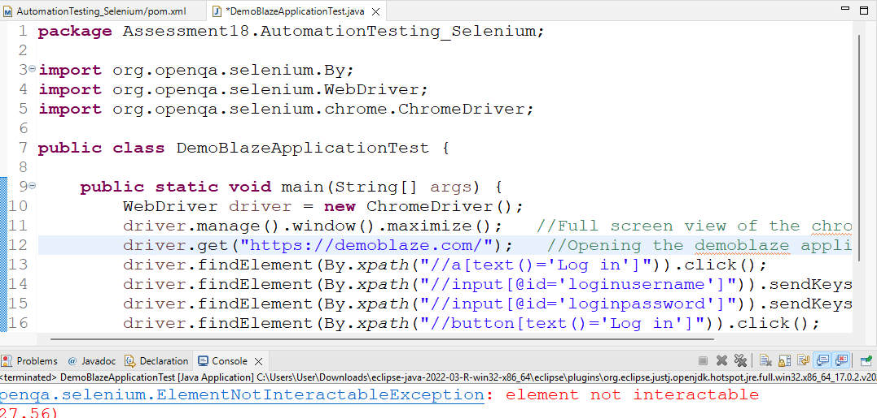
3.00

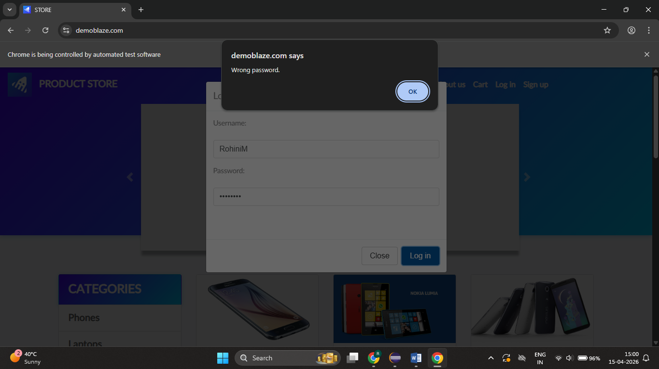
3.10
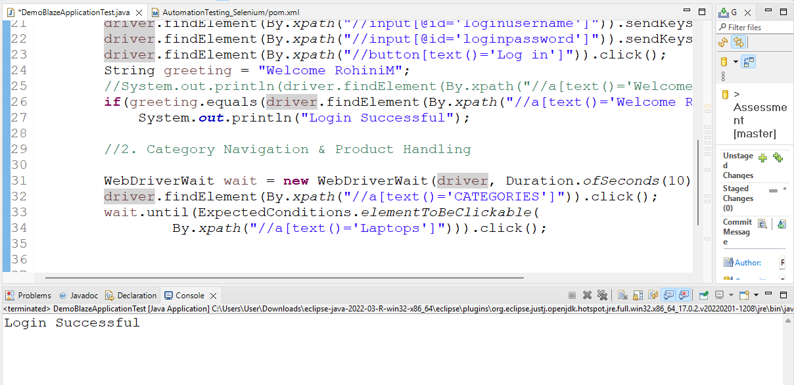

3.30
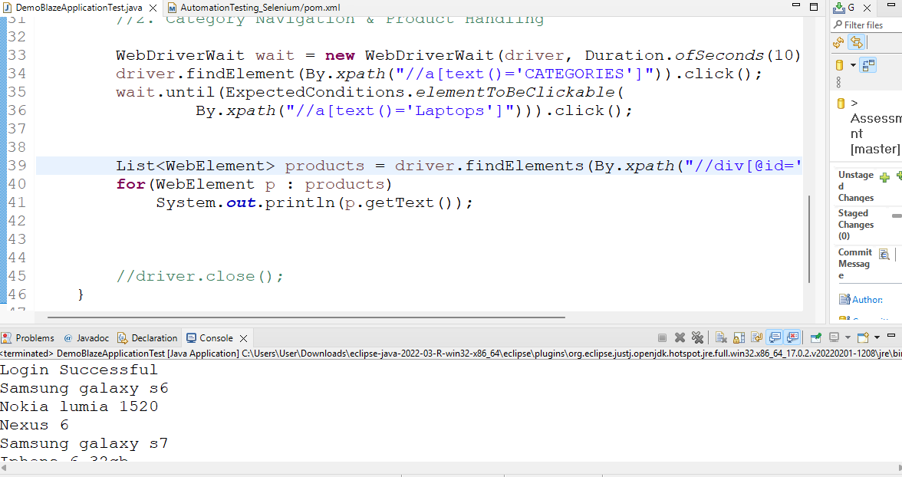

3.40
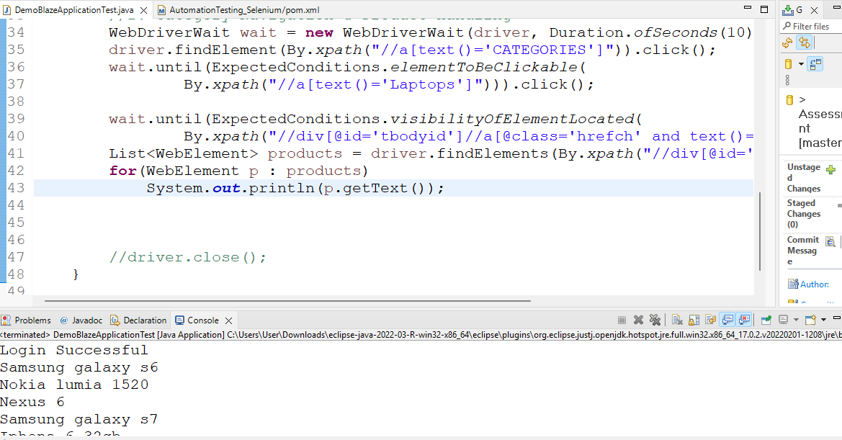
4.00
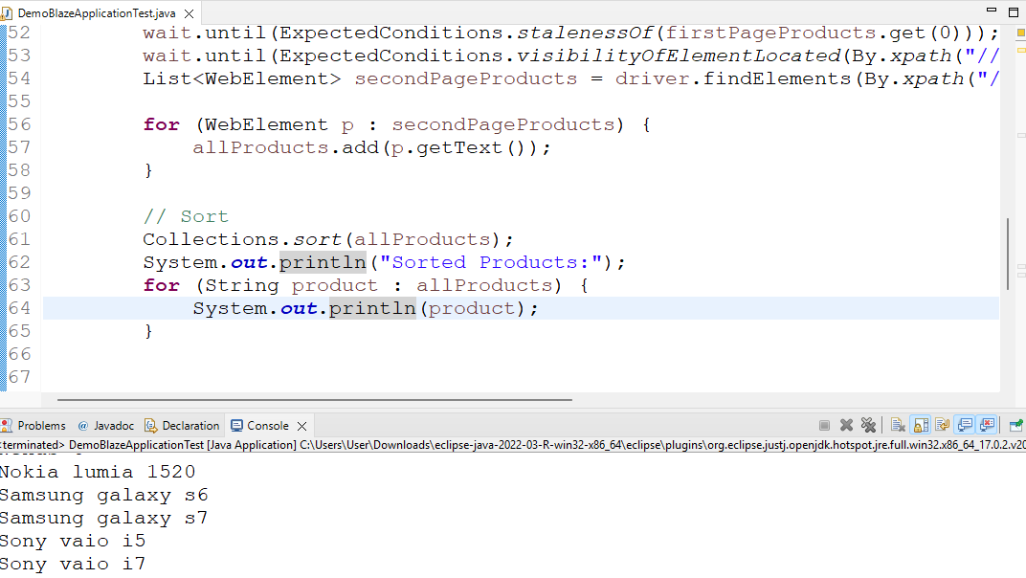
4.20
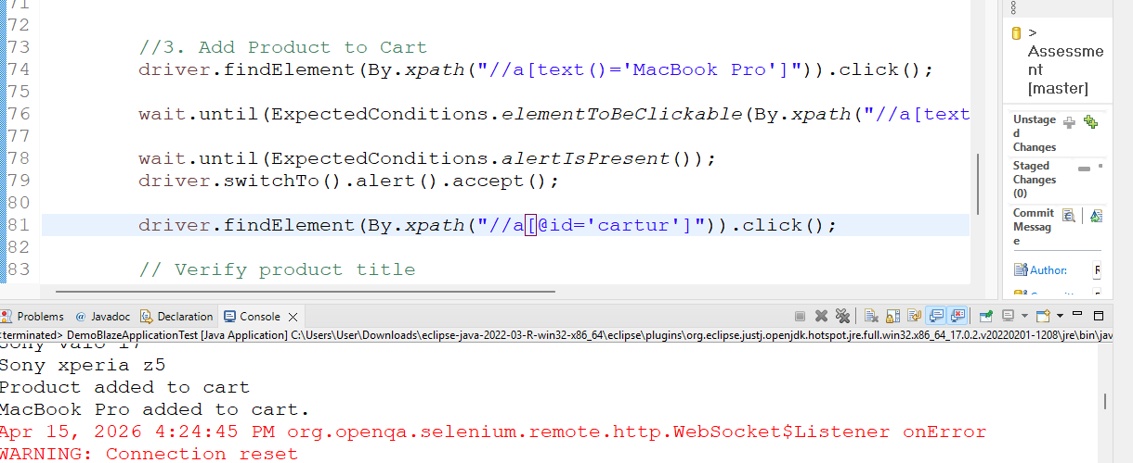

4.30
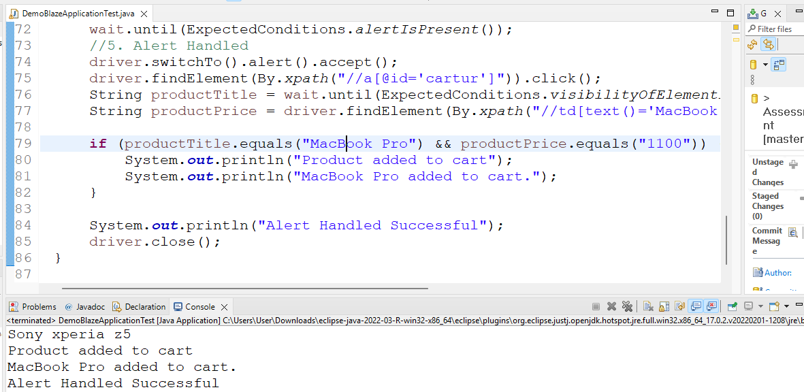

Final Output:
Login Successful
Sorted Products:
2017 Dell 15.6 Inch
ASUS Full HD
Apple monitor 24
Dell i7 8gb
HTC One M9
Iphone 6 32gb
MacBook Pro
MacBook air
Nexus 6
Nokia lumia 1520
Samsung galaxy s6
Samsung galaxy s7
Sony vaio i5
Sony vaio i7
Sony xperia z5
Product added to cart
MacBook Pro added to cart.
Alert Handled Successful

