RESULTS:
Terminal 1: Mininet:

Test Scenario 1 — Connectivity (Allowed vs Blocked)
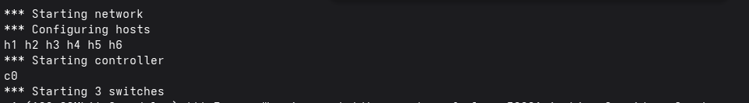
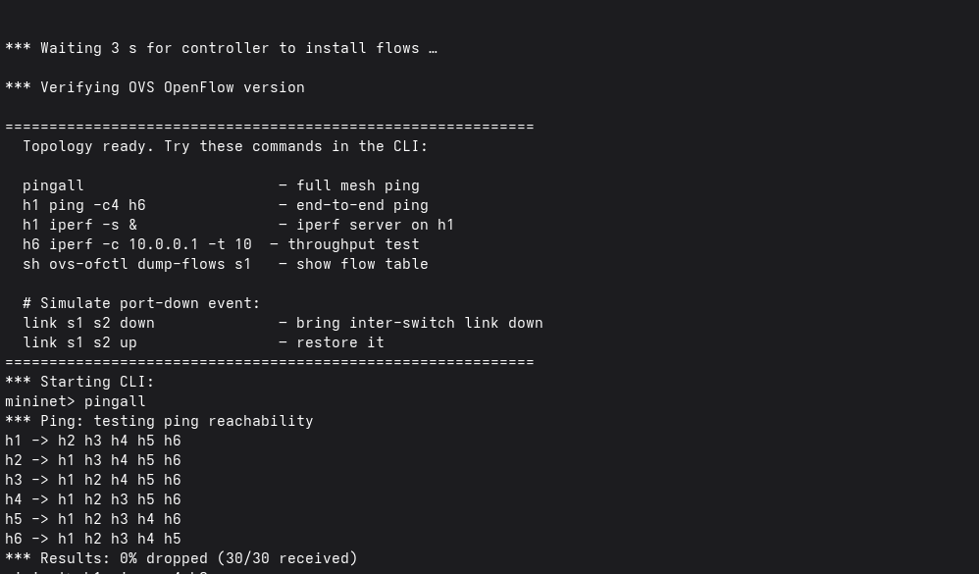
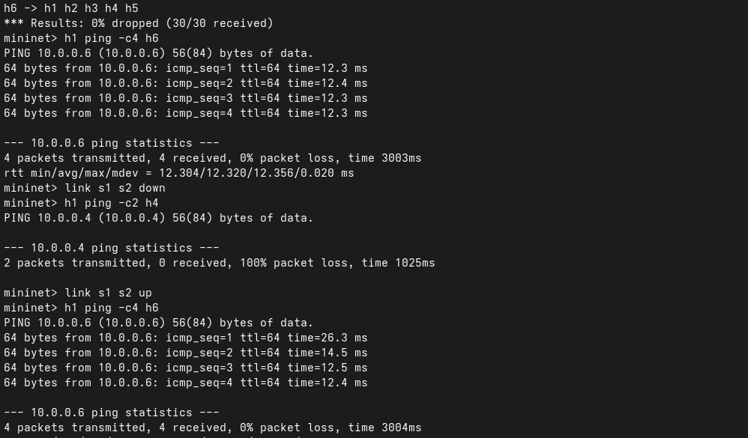
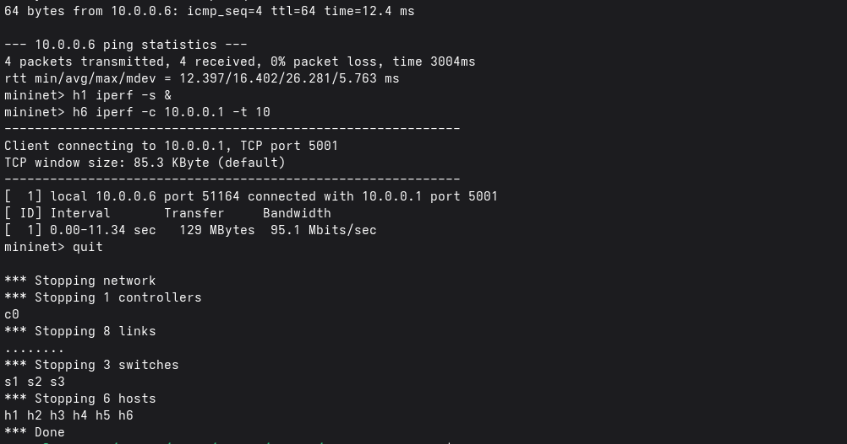

Test Scenario 2 — Port Failure (Normal vs Failure)
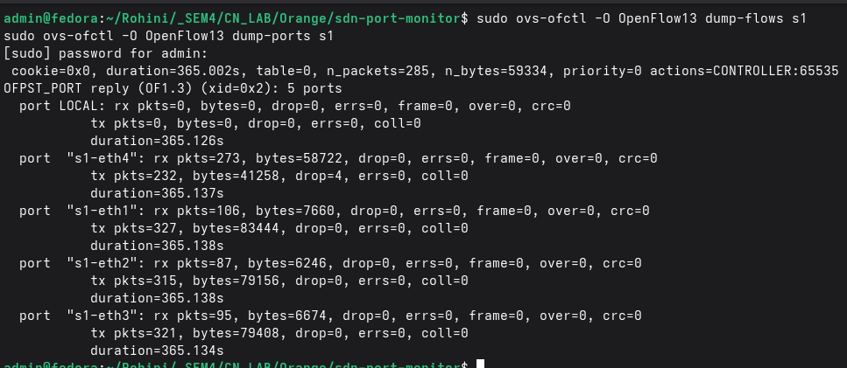

Terminal 2: OSKen Manager
OSKen instead of Ryu (since Ryu is no longer maintained and hence not supported in latest Python versions)
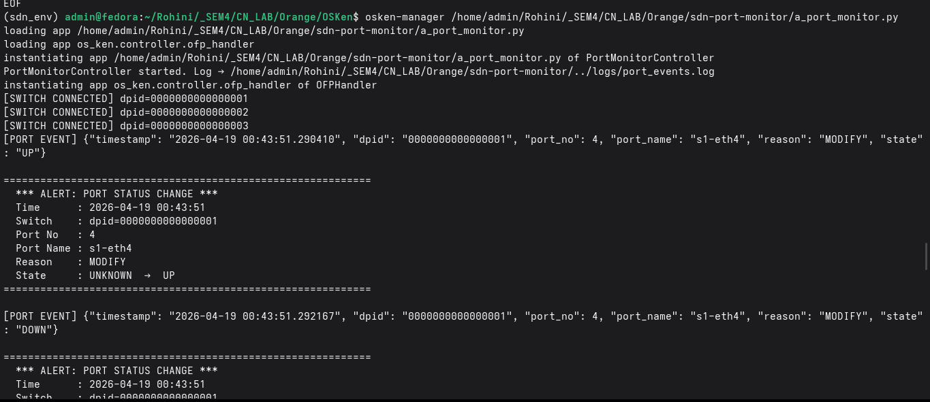

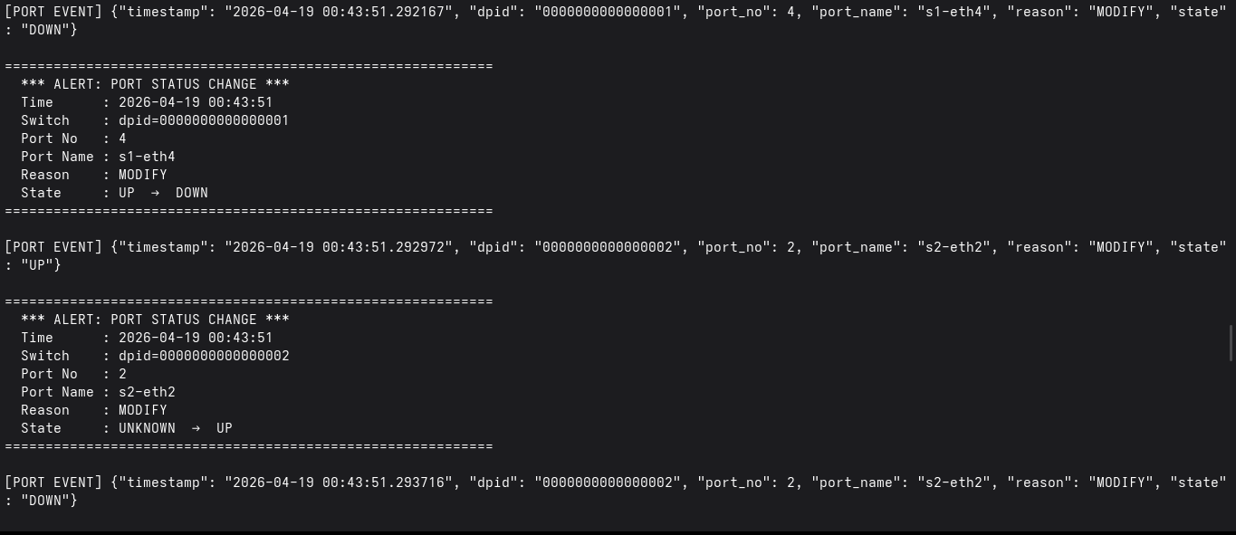
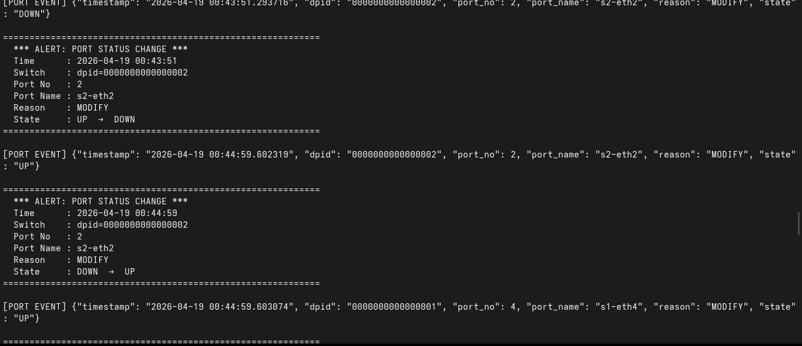
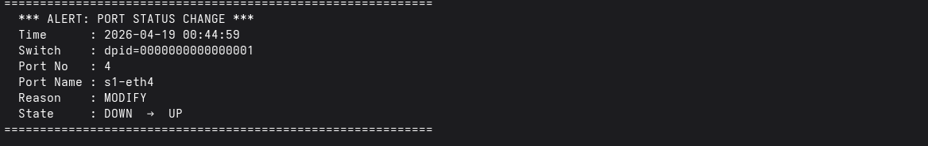

Terminal 3:
GUI
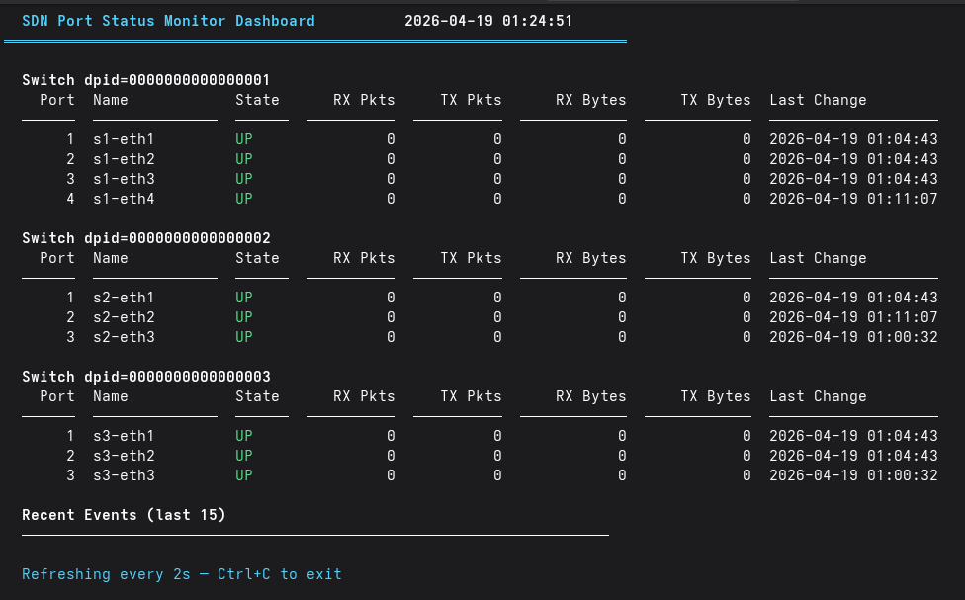

Terminal 4:
iperf:

Test Scenario 3 — Throughput (iperf)
mininet> h1 iperf -s &
mininet> h6 iperf -c 10.0.0.1 -t 10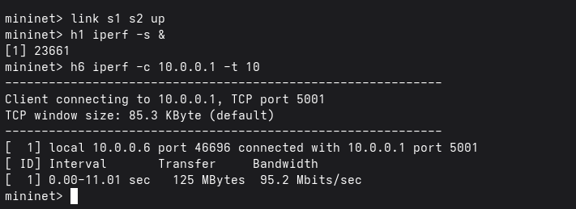

Wireshark:
- Scenario 1: Connectivity (Allowed vs. Blocked)
When it is down:
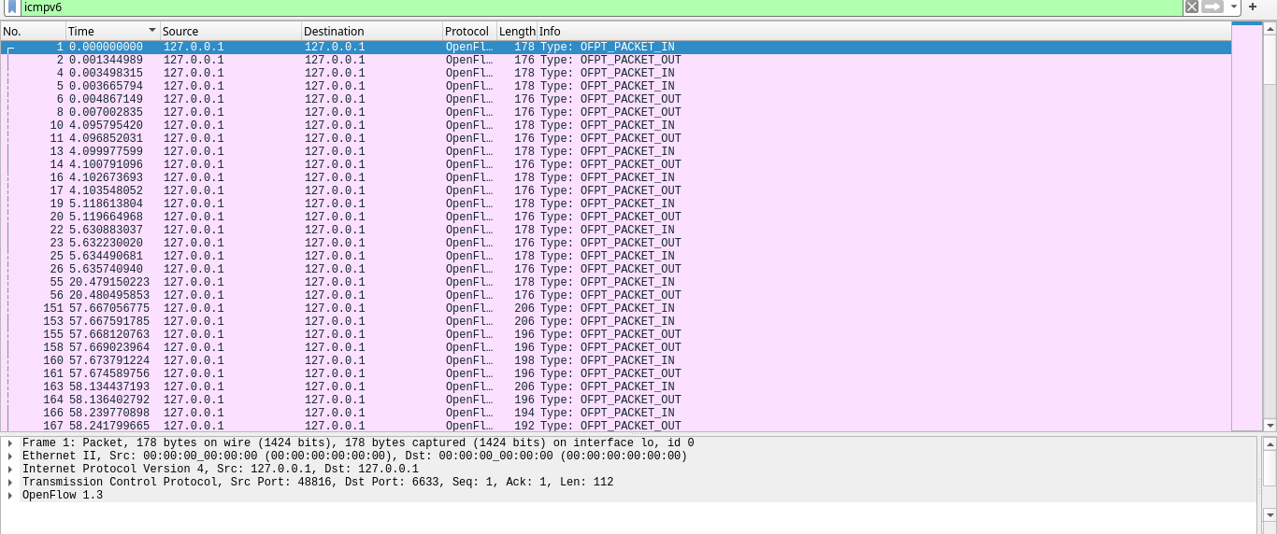
When it is up:
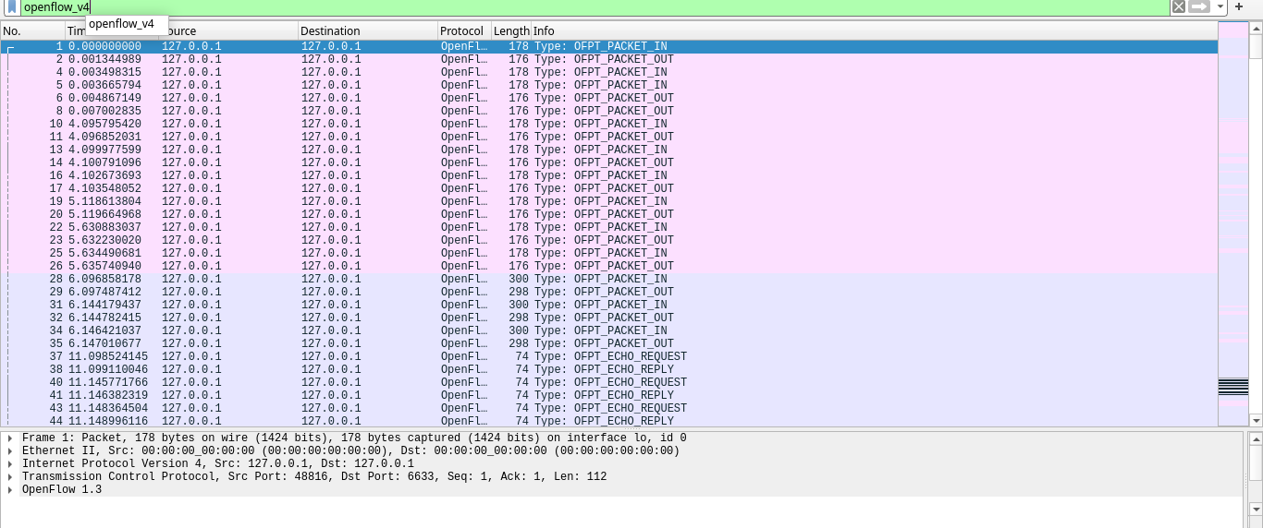
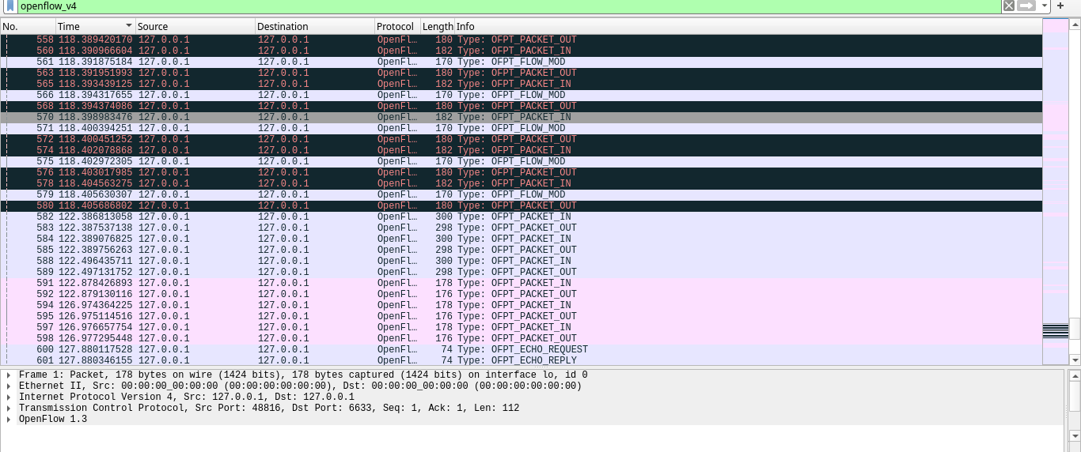
- Scenario 2: Port Failure (OVS Statistics)
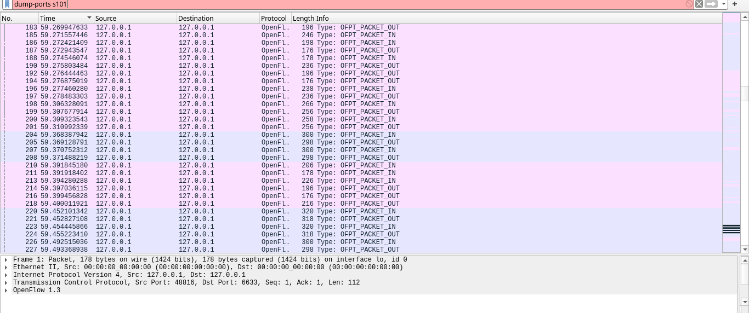
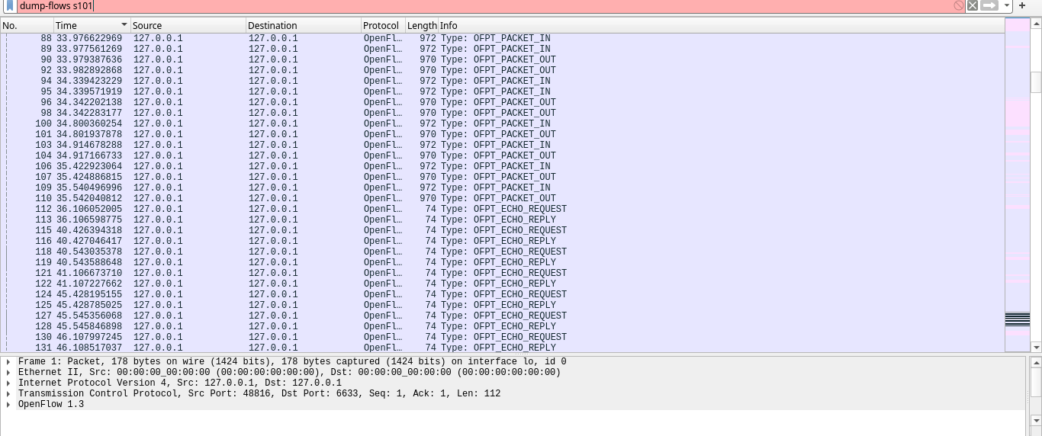
Scenario 3: Throughput
