Title: Sniffing in a Controlled Environment: By Rohinish Sharma

Objective
The goal of this demonstration is to show how unencrypted credentials (like usernames and passwords) can be intercepted using packet sniffing techniques in a controlled lab setup. This helps organizations understand the importance of encrypting network traffic and the risks of insecure protocols like HTTP and FTP.

Key Concepts

What is Packet Sniffing?
Packet sniffing is the process of monitoring and capturing data packets as they travel over a network. Tools like Wireshark or tcpdump can be used to analyze this traffic, making it possible to extract sensitive information — if the data is not encrypted.

What is Network Traffic Analysis?
This refers to examining packets flowing through a network to:
- Identify communication patterns
- Monitor protocol use
- Detect suspicious activity or sensitive data leaks

Risks of Unencrypted Data Transmission
When data (especially credentials) is transmitted without encryption:
- Anyone on the same network can intercept it
- Tools like Wireshark can easily read login forms, FTP credentials, emails, etc.
- Attackers can use this to impersonate users, access systems, or steal data

Step 1: Setting Up the Lab Environment
Objective: Create a safe and isolated network to simulate real-world attacks without any legal or ethical risks.

Actions:
- Launch two Virtual Machines (VMs) in VMware:
  - Kali Linux (Attacker)
  - Windows (Victim)
- Set both VMs to use the Host-Only Network adapter.

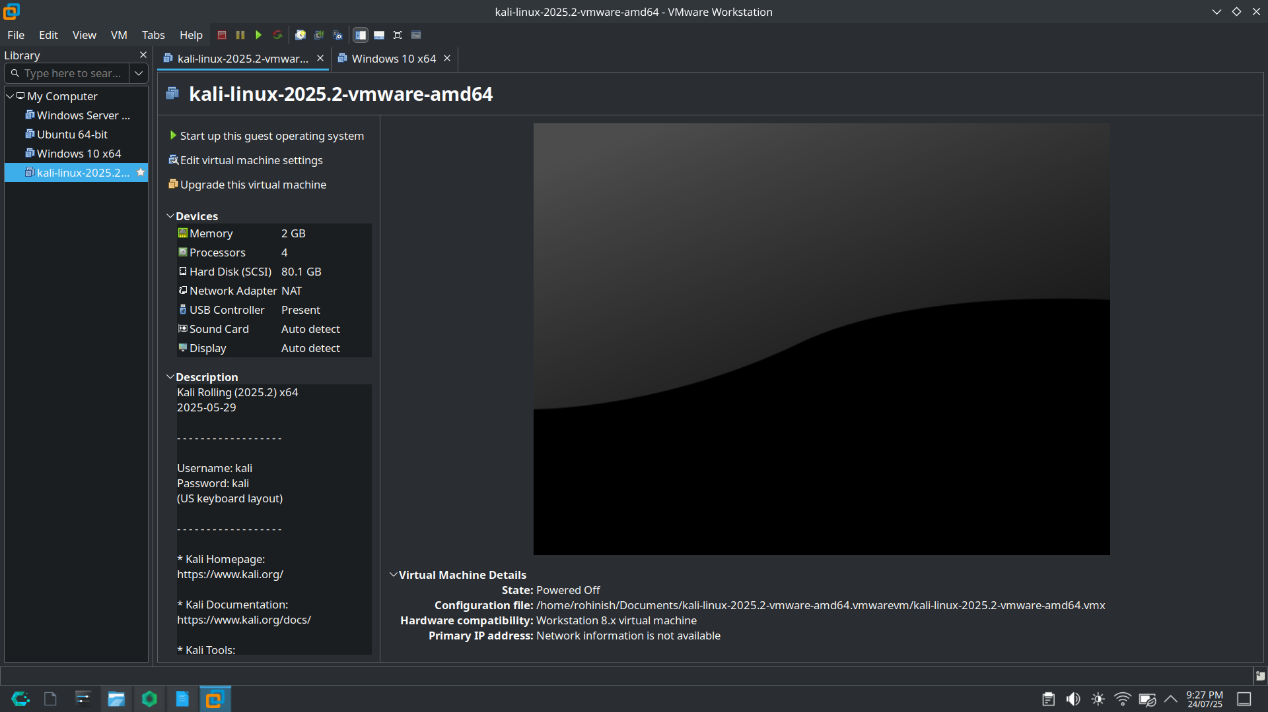

Host-Only networking ensures both machines are on the same private subnet, allowing direct communication while keeping them isolated from the internet. This simulates a local corporate LAN scenario for penetration testing.

Step 2: Identifying IP Addresses & Verifying Connectivity

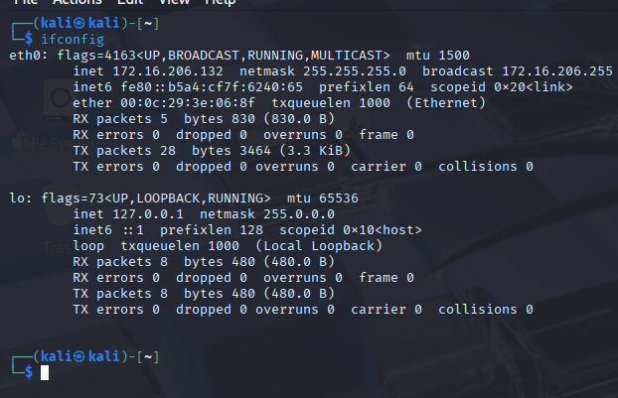

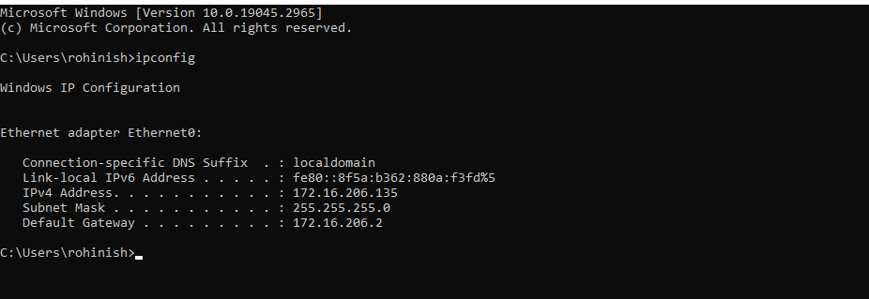
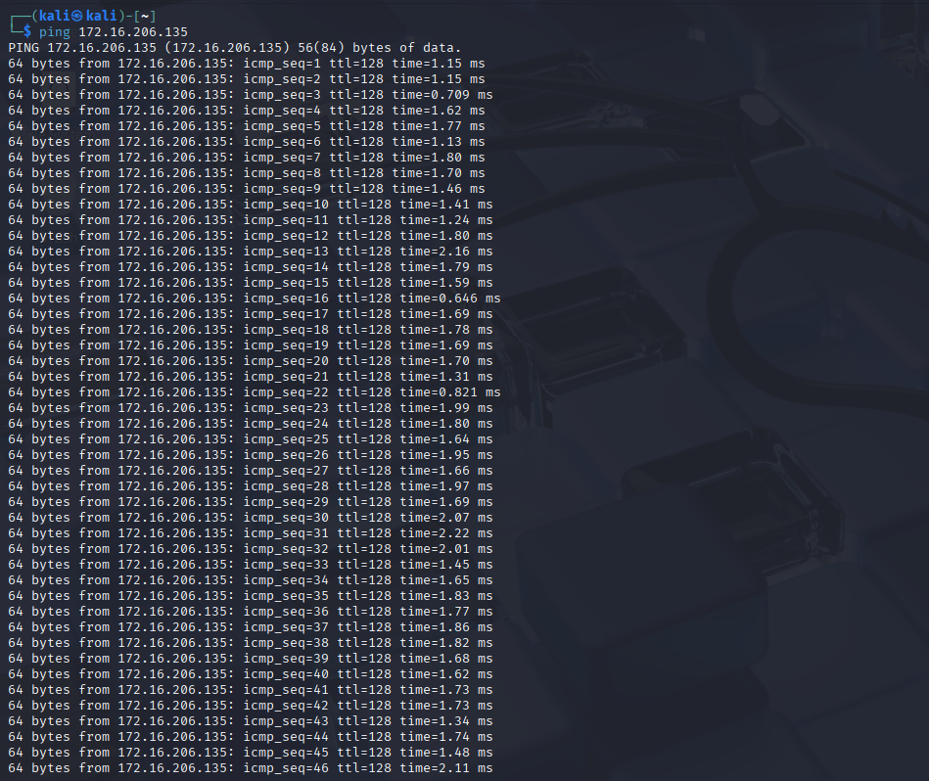

Step 3: Accessing the Site from Windows VM

Actions:
- Open browser in Windows VM.
- Fill the form with credentials (admin / password) and submit.
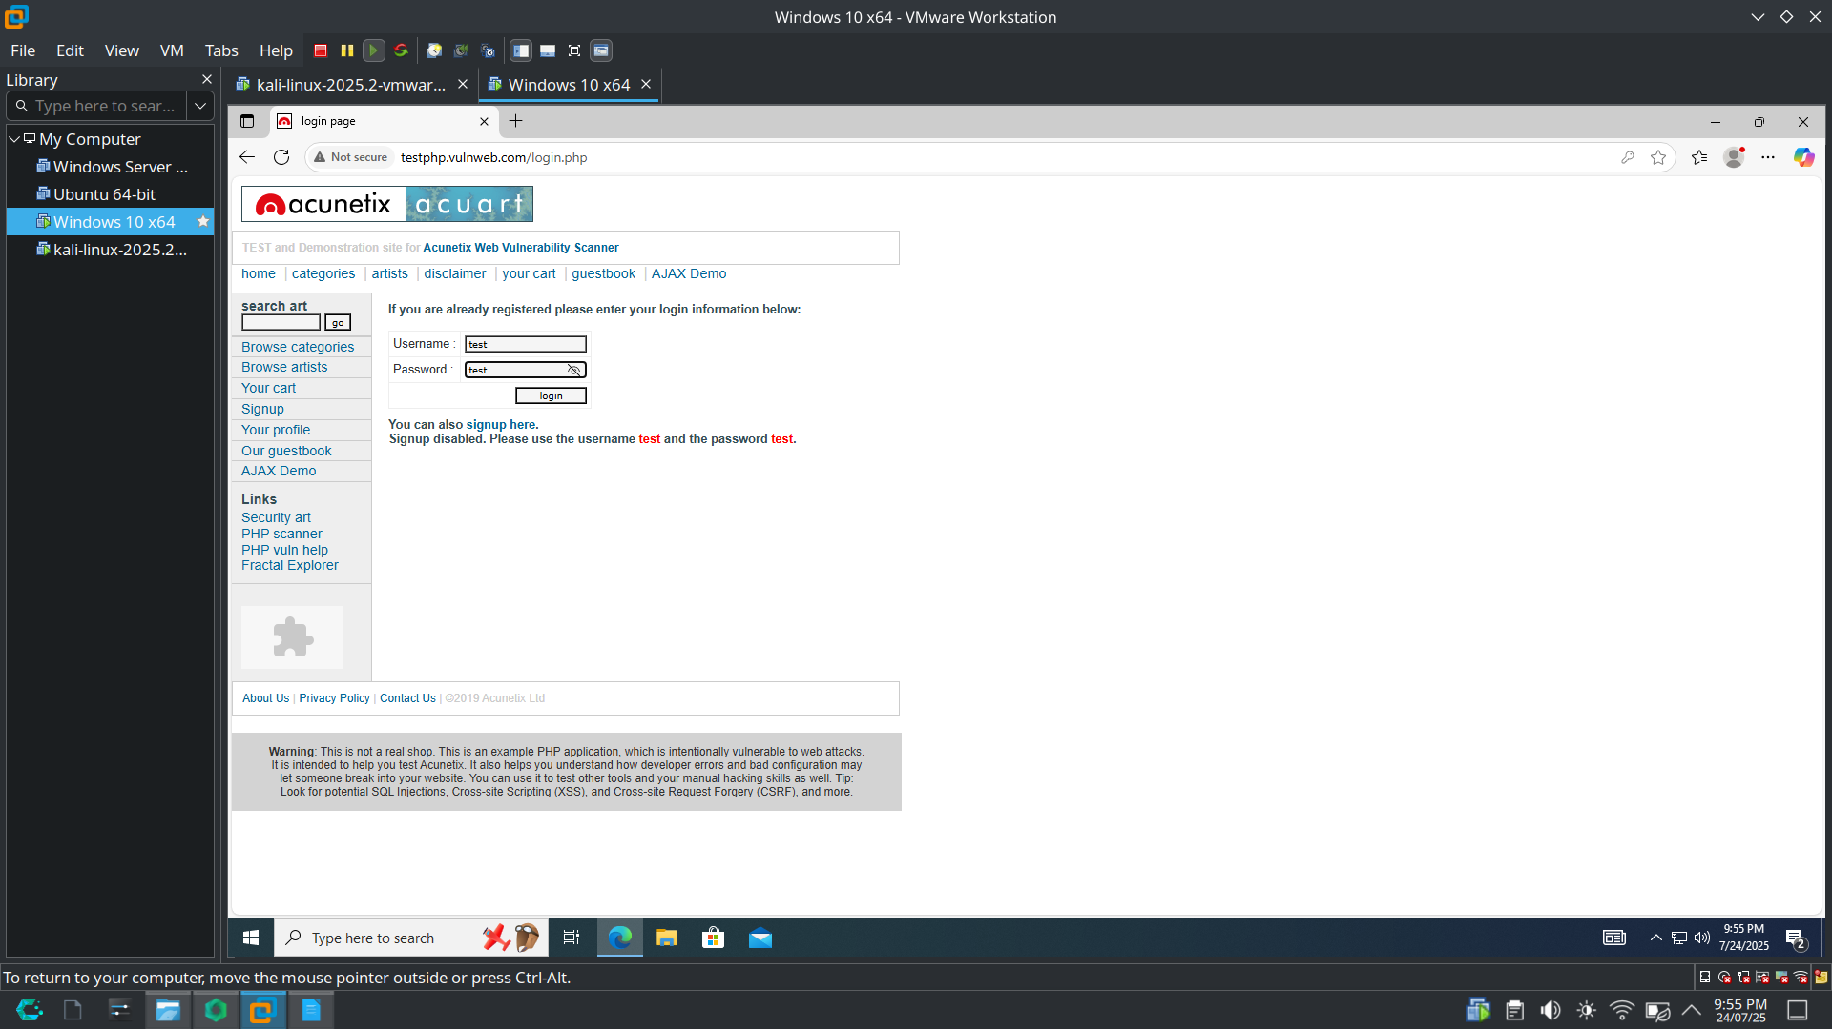
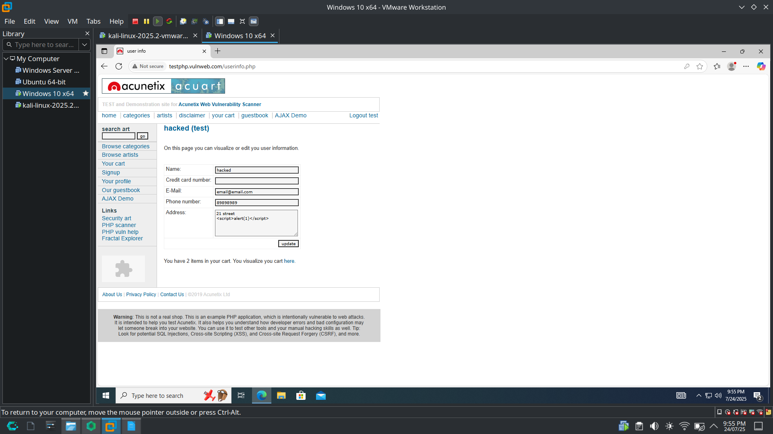

Step 4: Starting Wireshark on Kali Linux

Actions:
- Launch Wireshark:
- Select the active network interface (e.g., eth0, ens33)
- Apply filter:
http
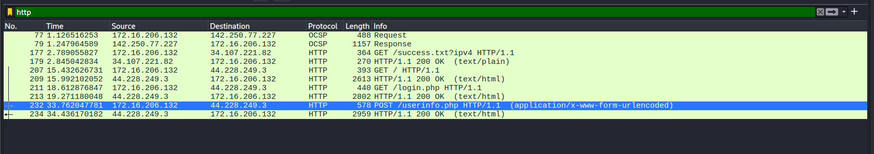

Step 5: Capturing and Analyzing HTTP Credentials

Actions:
- In Wireshark, locate packet with POST /login HTTP/1.1
- Right-click → Follow → HTTP Stream
- Extract:
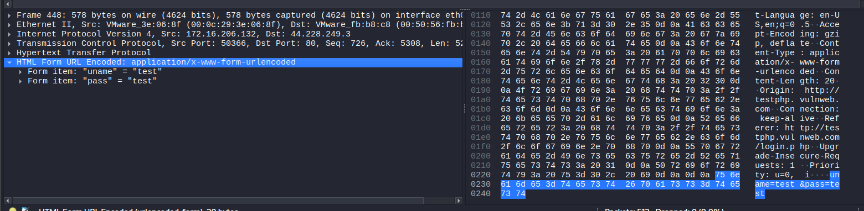

Conclusion
This project shows that:
- Unencrypted traffic is easily intercepted
- Sensitive data must be protected using encryption
- Organizations must move away from insecure legacy protocols

Recommendations
- Enforce use of HTTPS, SFTP, SSH
- Deploy TLS/SSL certificates across all web services
- Monitor and audit network activity regularly
- Educate users about secure communication

