**Lab 2**

1. Create database and two collections:

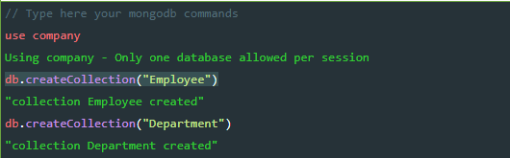

1. Insertion :

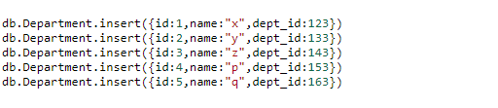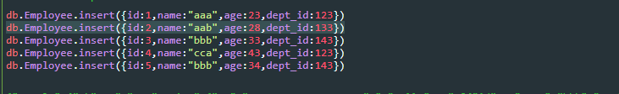

1. Update:

4.png

1. Remove

5.png

1. Select all document

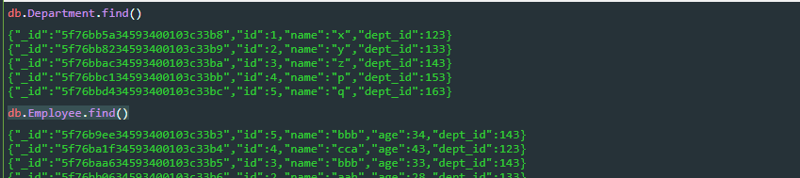

1. Select employee name and department no whose department no falls between 100 and 150

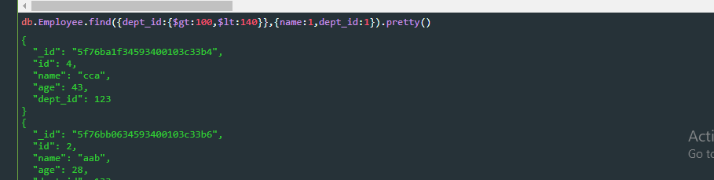

1. Name start with a

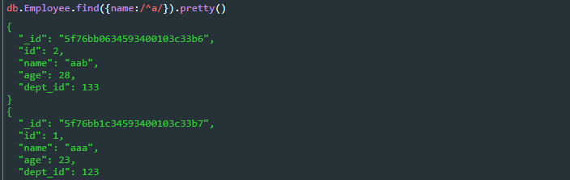

1. Age greater than 30

