**Maven and Automation Tools**

**1. Introduction to Build Automation**

Build automation is the process of automating various steps in the software development lifecycle, such as compiling code, running tests, packaging software, and deploying it. This automation ensures consistency, reduces errors, and speeds up the development process by providing faster feedback to developers.

**2. What is Maven?**

Maven is a powerful build automation tool used mainly for Java projects. It simplifies the build process by managing project dependencies, compiling source code, packaging binaries, running tests, and generating documentation. Maven follows the convention-over-configuration principle, which means it promotes standard practices while allowing customization where needed.

**3. Artifacts**

In the context of build automation, an artifact is any file or set of files produced as a result of the build process. Artifacts are the outputs of the build steps and include:

* **Executable Files:** Programs that can be run by the operating system (e.g., .exe files).
* **Libraries:** Reusable compiled code (e.g., .dll, .jar files).
* **Archives:** Bundled and compressed collections of files (e.g., .zip, .tar.gz).
* **Installers:** Packages for installing software (e.g., .msi, .deb files).
* **Documentation:** Generated files providing information about the project (e.g., HTML, PDF).
* **Configuration Files:** Files needed for application configuration (e.g., .xml, .yaml).
* **Container Images:** Docker images that include the application and its dependencies.
* **Test Reports:** Files detailing the results of automated tests (e.g., XML, HTML).

Artifacts are stored in repositories or package registries, which are centralized locations for managing and sharing build outputs. Popular artifact repositories include JFrog Artifactory, Nexus Repository, and AWS CodeArtifact.

**4. Maven Lifecycle Phases**

Maven uses a well-defined lifecycle consisting of phases that are executed in sequence. Each phase represents a step in the build process:

1. **validate:** Checks if the project structure and dependencies are correct.
2. **compile:** Compiles the source code.
3. **test:** Runs unit tests to verify functionality.
4. **package:** Packages the code into formats like JAR or WAR.
5. **verify:** Ensures the package meets the required standards.
6. **install:** Installs the package into the local Maven repository.
7. **deploy:** Deploys the package to a remote repository for sharing.

**5. Maven Lifecycle Image**

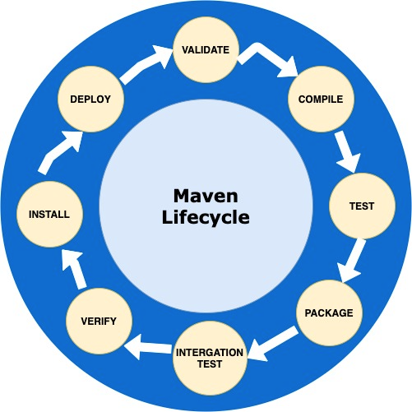**6. Automation Tools for Build Management**

Automation tools help streamline the build, test, and deployment processes. Some popular tools include:

* **Jenkins:** An open-source server for continuous integration and continuous delivery (CI/CD).
* **Gradle:** A flexible build tool supporting multi-language projects.
* **Ant:** A Java-based build tool that automates build processes.
* **Docker:** Automates deploying applications within containers.

**7. Maven Commands**

Here are some basic Maven commands:

* mvn validate: Validates the project setup.
* mvn compile: Compiles the source code.
* mvn test: Runs unit tests.
* mvn package: Packages the project into a JAR or WAR file.
* mvn install: Installs the package into the local repository.
* mvn deploy: Deploys the package to a remote repository.

**8. Maven Built-in Lifecycles**

Maven has three built-in lifecycles:

1. **default:** Handles project deployment, including compiling, testing, and packaging.
2. **clean:** Manages project cleaning, removing files from previous builds.
3. **site:** Generates project site and documentation.

**9. Basic Usage of Maven**

**Installing Maven**

1. Download Maven from the [official Apache Maven website](https://maven.apache.org/download.cgi).
2. Extract the tar file and set up the environment path:

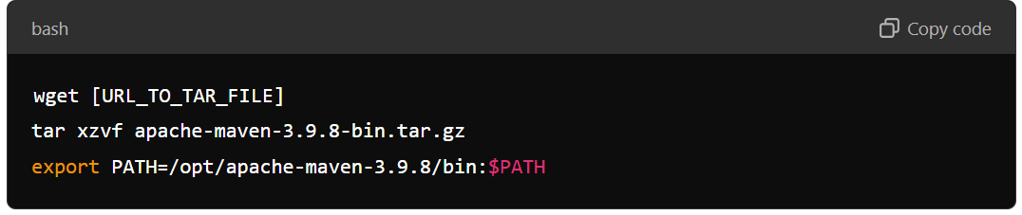

**Adding Dependencies**

Add dependencies in the pom.xml file. Maven will automatically download the required dependencies. Example:

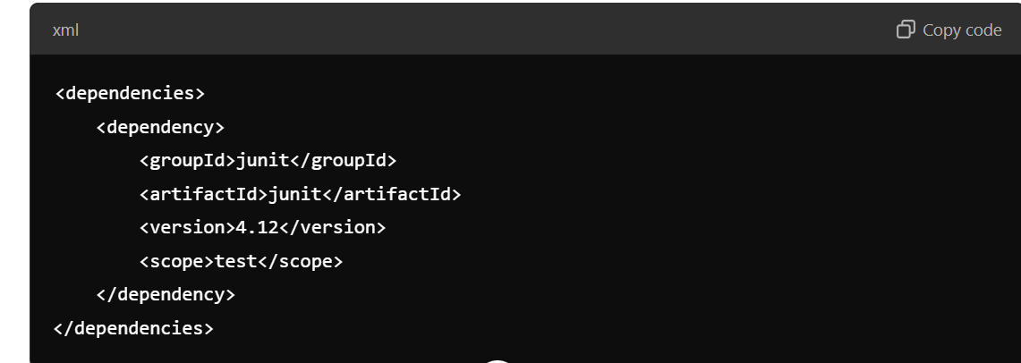

**Example pom.xml File**

Here’s a simple example of a pom.xml file:

