

**AWS DEVELOPMENT**

***A Summer Internship Report submitted in partial fulfillment of the requirements for the award of degree of***

#### BACHELOR OF TECHNOLOGY

**In**

#### CSE (AIML & IOT)

Submitted by:

DULAM ROHIT SAI ANJAN

22MH1A42F7

#### Name of the Department CSE (AIML & IOT)

**ADITYA COLLEGE OF ENGINEERING & TECHNOLOGY (A)**

**Approved by AICTE, permanently affiliated to JNTUK & Accredited by NAAC with ‘A+’ Grade**

**Recognized by UGC under the sections 2(f) and 12(B)of the UGC act 1956**

**Aditya Nagar, ADB Road –Surampalem 533437, E.G. Dist., A.P.,**

**2024-2025.**



#### ADITYA COLLEGE OF ENGINEERING & TECHNOLOGY (A)

**Approved by AICTE, Permanently Affiliated to JNTUK & Accredited by NAAC with ‘A+’ Grade Recognized by UGC under the sections 2(f) and 12(B) of the UGC act 1956**

**Aditya Nagar, ADB Road - Surampalem – 533437, E.G.Dist., A.P.,**

**Department Of CSE (AIML & IOT)**

### CERTIFICATE

This is to certify that the Internship report entitled *“***Hosting a Static website on S3***”* is being submitted by **DULAM ROHIT SAI ANJAN (22MH1A42F7).** In partial fulfillment of the requirements for award of the B.Tech degree in CSE (AIML & IOT) for the academic year 2024-2025.

**Internship Coordinator Head of the Department**

Mr. Yadavalli Suresh Kumar DR.B. Kiran Kumar

Assistant professor Professor

CSE (AIML & IOT) CSE (AIML & IOT)

### DECLARATION

I hereby declare that the Internship entitled **“Hosting a Static website on S3”** is a genuine report. This work has been submitted to the **ADITYA COLLEGE OF ENGINEERING & TECHNOLOGY (A),** Surampalem, permanently affiliated to **JNTUK, KAKINADA** in partial fulfillment of the **B.Tech** degree**.**

I also hereby declare that this internship report not submitted in full or partial any other university for any degree.

**DULAM ROHIT SAI ANJAN**

**22MH1A42F7**

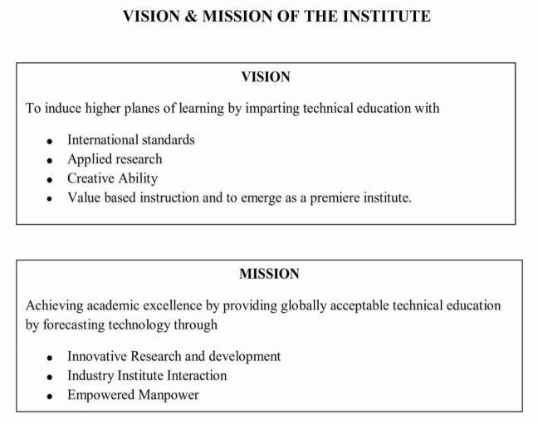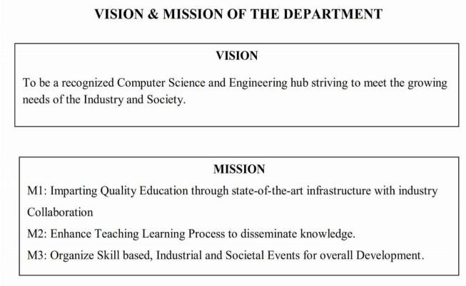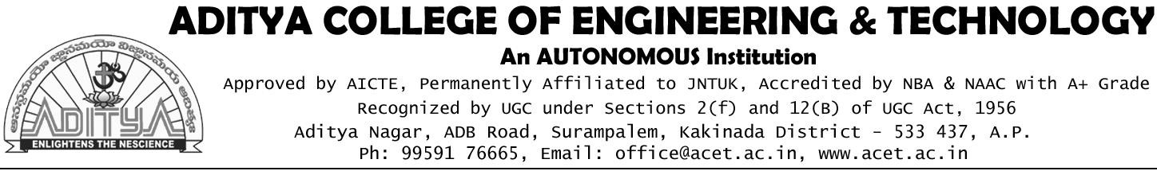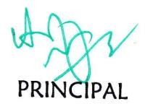

### INTERNSHIP COMPLETION CERTIFICATE

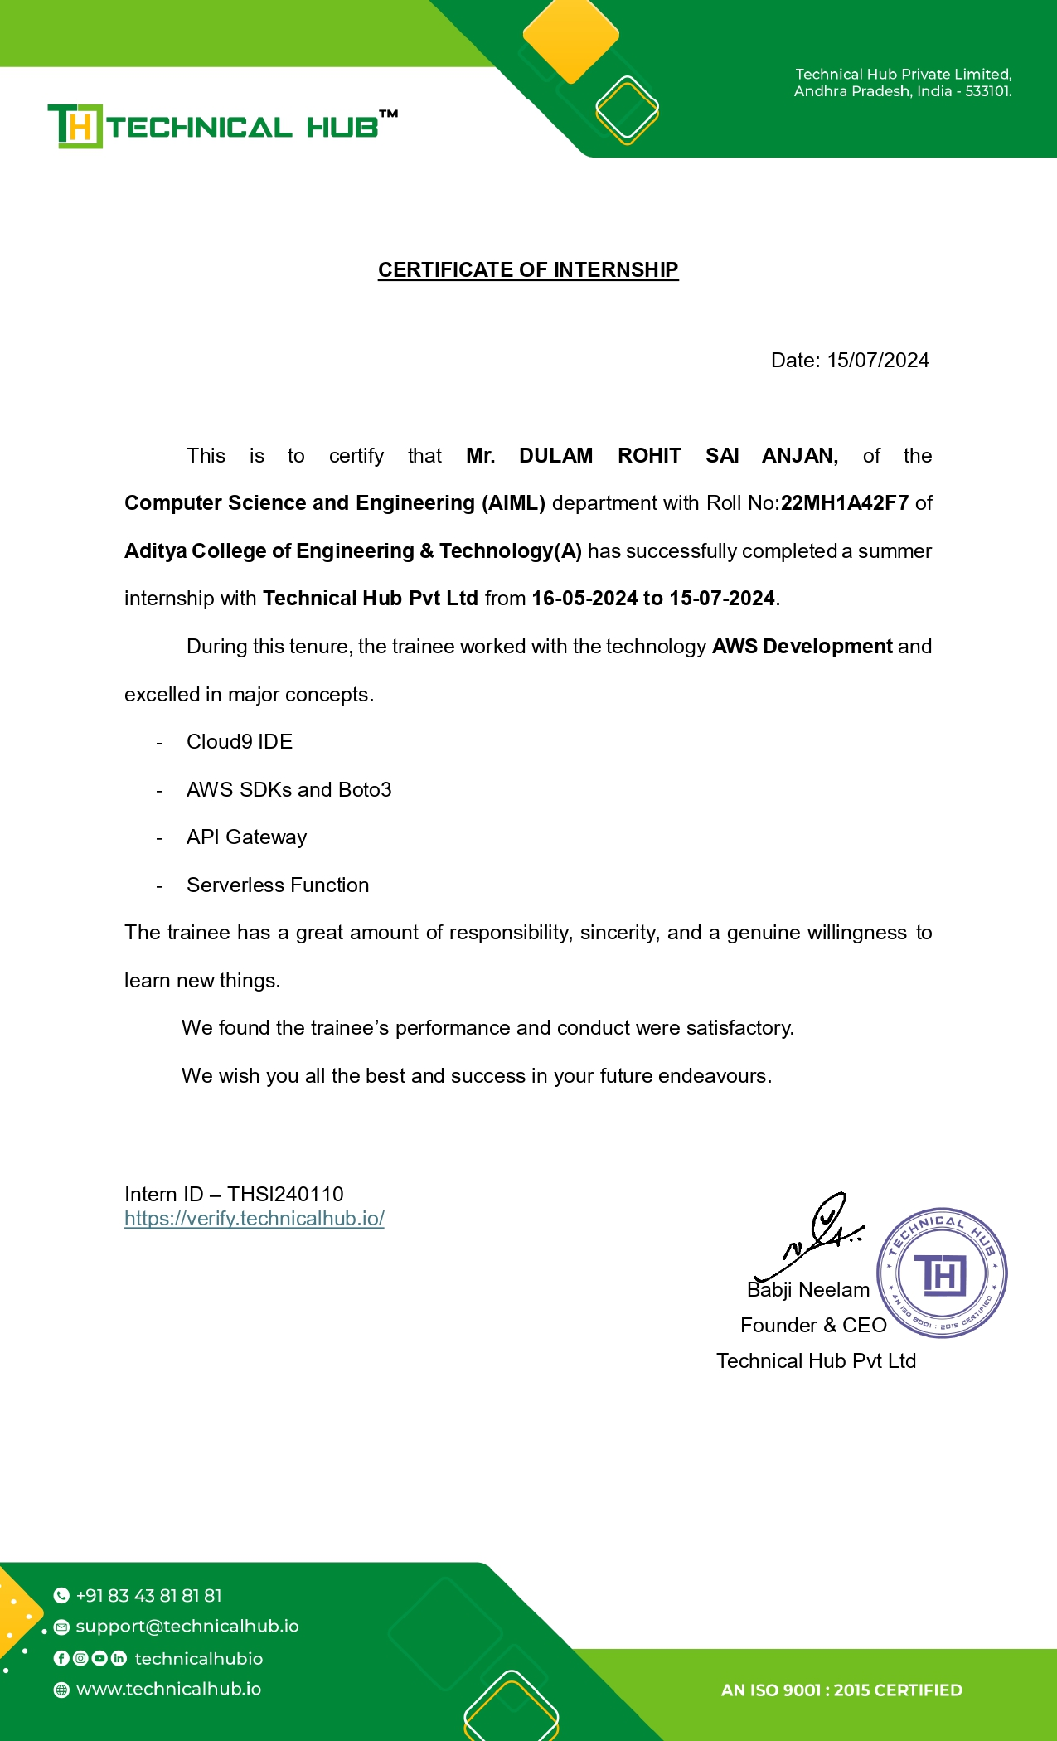

**ACKNOWLEDGEMENT**

I offer my sincere thanks to precious and dynamic Principal, **Dr. A. Ramesh**, **Aditya College of Engineering & Technology (A)** for his co-operation.

My sincere thanks to Dr. B. Kiran Kumar, M.Tech, Ph.D, Head of the department of CSE(AIML & IOT) for his valuable support.

I express my sincere gratitude to my internship guide, Mr. Y.Suresh Kumar, Assistant Professor, Department of CSE (AIML & IOT), for his valuable guidance and encouragement which has been helpful in successful completion of this internship.

With immense pleasure I would like to express my deep sense and heart full thanks to the management of Aditya College of Engineering & Technology (A).

### Learning Objectives/Internship Objectives

1. Internships are generally thought of to be reserved for college students looking to gain experience in a particular field. However, a wide array of people can benefit from Training Internships in order to receive real world experience and develop their skills.
2. An objective for this position should emphasize the skills you already possess in the area and your interest in learning more
3. Internships are utilized in a number of different career fields, including architecture, engineering, healthcare, economics, advertising and many more.
4. Some internships are used to allow individuals to perform scientific research while others are specifically designed to allow people to gain first-hand experience working.
5. Utilizing internships is a great way to build your resume and develop skills that can be emphasized in your resume for future jobs. When you are applying for a Training Internship, make sure to highlight any special skills or talents that can make you stand apart from the rest of the applicants so that you have an improved chance of landing the position.

# ABSTRACT

This report describes my internship at Technical Hub on AWS Development. Technical Hub is a leading IT company that provides internships to many engineering students in various domains such as Web Development, AI, Python, IoT, etc.

The scope of this document is to identify and describe the analysis carried out, projects completed, and experience gained, focusing on the achievements as an **AWS Development** intern. Technical Hub provides a glorious opportunity and flexibility to their interns by offering internships online.

During the internship at Technical Hub, I was introduced to new AWS technologies and services. The most amazing experience was working with the team and completing the cloud-based projects. Overall, I am very satisfied with the results of my internship. I was able to create serverless solutions using AWS Lambda, manage cloud infrastructure using AWS CloudFormation, and develop REST APIs using API Gateway and Boto3.

The usage of tools such as GitHub for version control and following best practices helped me apply my skills to solve real-world problems. I observed notable differences in the functioning of tasks due to my contributions. Despite the short time spent with Technical Hub, I took this experience as an opportunity to provide value using the skills I learned as an **AWS Development** student at Aditya College of Engineering and Technology.

Top of Form

Bottom of Form

# INDEX

|  |  |  |
| --- | --- | --- |
| **Sl.No** | **CONTENTS** | **Page No** |
| CHAPTER 1 | EXECUTIVE SUMMARY | **11** |
| 1.1 | Learning Objectives of Summer Internship |  |
| 1.2 | Learning Outcomes of Summer Internship |  |
| 1.3 | A Brief Description of the Intern Organization |  |
| 1.4 | Summar Internship Summary |  |
| CHAPTER 2 | OVERVIEW OF THE ORGANIZATION | **12** |
| 2.1 | Introduction of the Organization |  |
| 2.2 | Misson of the Organization |  |
| 2.3 | Vision of the Organization |  |
| CHAPTER 3 | INTERNSHIP PART | **13 - 15** |
| 3.1 | Introduction to AWS |  |
| 3.2 | Conclusion |  |
| CHAPTER 4: | WEEKLY REPORTS | **16 - 35** |
| 4.1 | Activity log for the First week |  |
| 4.1.1 | Weekly Report of Week-1 |  |
| 4.2 | Activity log for the Second week |  |
| 4.2.1 | Weekly Report of Week-2 |  |
| 4.3 | Activity log for the Third week |  |
| 4.3.1 | Weekly Report of Week-3 |  |
| 4.4 | Activity log for the Fourth week |  |
| 4.4.1 | Weekly Report of Week-4 |  |
| 4.5 | Activity log for the Fifth week |  |
| 4.5.1 | Weekly Report of Week-5 |  |

|  |  |  |
| --- | --- | --- |
| 4.6 | Activity log for the Sixth week |  |
| 4.6.1 | Weekly Report of Week-6 |  |
| 4.7 | Activity log for the Seventh week |  |
| 4.7.1 | Weekly Report of Week-7 |  |
| 4.8 | Activity log for the Eighth week |  |
| 4.8.1 | Weekly Report of Week-8 |  |
| 4.9 | Activity log for the Ninth week |  |
| 4.9.1 | Weekly Report of Week-9 |  |
| 4.10 | Activity log for the Tenth week |  |
| 4.10.1 | Weekly Report of Week-10 |  |
| CHAPTER 5: | OUTCOMES DESCRIPTION | **36 - 43** |
| 5.1 | Work environment I have experienced |  |
| 5.2 | Real time technical skills I have experienced |  |
| 5.3 | Managerial skills you have acquired |  |
| 5.3.1 | Communication Skills |  |
| 5.3.2 | An appetite for learning |  |
| 5.4 | How I improve my communication skills |  |
| 5.5 | Group Discussion |  |
| 5.6 | Participation in teams |  |
| 5.7 | Photos & videos |  |

**CHAPTER 1: EXECUTIVE SUMMARY**

###### The "AWS DEVELOPMENT" Summer Internship Program Provided By "Technical

###### Hub Pvt. Ltd."

* 1. **Learning Objectives of Summer Internship**
     + Gain Practical Knowledge of AWS Cloud Services
     + Enhance Cloud Infrastructure Management Skills
     + Work on Real-Time Cloud Projects
     + Develop Advanced Skills in Serverless and Cloud Computing

##### Learning Outcomes of Summer Internship

* + - Team Collaboration and Communication in Cloud Projects
    - Continuous Learning and Adaptation to Cloud Technologies
    - Excellent Problem-Solving Skills in Cloud-Based Solutions
    - Extensive Experience in AWS Infrastructure and Services Management

##### A Brief Description of the Intern Organization

Technical Hub Pvt. Ltd., located in Surampalem, Andhra Pradesh, is a software institute that offers a wide range of globally recognized certifications from reputed organizations like Cisco, Red Hat, AWS, Microsoft, and Automation Anywhere. They provide training programs that are certification-aligned and associated with various top industry vendors. The institute also organizes various training and skill enhancement programs.

##### Summer Internship Summary

The summer internship at Technical Hub Pvt. Ltd. in the domain of **AWS Development** was an enriching 7-week program. The internship provided hands-on experience in cloud technologies, allowing the intern to apply theoretical knowledge in real-life situations. The intern had the opportunity to enhance their skills in AWS services such as Lambda, API Gateway, CloudFormation, and deepen their understanding of cloud infrastructure and serverless computing. The program also focused on developing critical thinking abilities as the intern navigated through different cloud architecture designs and deployment best practices.

The intern had the opportunity to work on real projects, such as developing serverless applications and managing cloud infrastructure, providing valuable experience in working on cloud-based systems and understanding their implementation in a professional setting. The internship also provided an excellent opportunity to establish a tech network, connecting with influential people at the company and throughout the tech industry. The experience and skills gained during the internship helped prepare the intern for future success in the tech industry and gave them a better understanding of what type of company or work environment they prefer.

**CHAPTER 2: OVERVIEW OF THE ORGANIZATION**

#### Introduction Of the Organization

Technical Hub Pvt. Ltd., provides the trainings which are certification aligned and associated with various vendors that are top in the industry. Members who are part of this program are given a constant practical example on various topics, thus keeping them abreast of their technological world. It is located in Surampalem, Andhra Pradesh. Founded by Babji Neelam, Technical Hub Pvt.Ltd., quickly grew into one of the largest companies in the Kakinada. Today, Technical Hub Pvt. Ltd is one of the largest technology Educator in Kakinada District.

#### Mission of the Organization

Technical Hub Pvt.Ltd, the Student Success Platform Improving the knowledge base with rapidly evolving technological skills, the skill to communicate across discipline, the ability to lead team-centered projects, contextualized problem formulation and hand-on experience is the present demand of the global industry. To meet this demand, Aditya initiated t-Hub: a perfect launch pad to the job world. T-Hub trains students in various disciplines beyond technological labels.

#### Vision of the Organization

We believe that the business of business is to improve the state of the world, and we work to make sure Technical Hub Pvt. Ltd is a platform for change through serving the interests of all our stakeholders — employees, customers, partners, communities and the environment.

## CHAPTER 3: INTERNSHIP PART

#### 3.1 Introduction to AWS

**AWS Development**, also known as cloud development, involves creating and managing cloud-based applications using Amazon Web Services (AWS). This chapter provides a comprehensive overview of AWS development, covering its importance, key services, and how it impacts scalability, reliability, and efficiency in software development and deployment.

# 3.1.1 Working Conditions:

# Environment: The internship took place in a well-maintained office environment with modern facilities. The workspace was clean, organized, and equipped with essential tools, including computers, projectors, and high-speed internet.

# Ventilation and Space: The office had good ventilation and adequate space, contributing to a comfortable and productive working atmosphere. The environment was conducive to both individual work and team collaboration.

# 3.1.2 Weekly Work Schedule:

# Monday: Typically involved engaging in key tasks such as project implementation, learning new concepts, and hands-on sessions with AWS services.

# Tuesday & Wednesday: Included a mix of regular workdays and holidays. On non-holiday Tuesdays, tasks such as introductions to new AWS services or hands-on sessions were conducted more.

# Thursday & Friday: Focused on practical application of skills, including setting up and configuring AWS services, deploying applications, and preparing documentation. End-of-week activities often involved reviews, documentation, and project deployment.

# Saturday: Usually dedicated to final testing, completing documentation, and conducting project handovers. Holidays were observed on specific days, allowing for rest and reflection.

# 3.1.3 Equipment Used:

# Computers: Used for coding, configuration, and documentation.

# AWS Services: Engaged with AWS tools such as EC2, RDS, S3, and VPC for deployment, database management, and storage solutions.

# Projectors and Other Tools: Used for presentations and team meetings.

# 3.1.4 Tasks Performed:

# Project Implementation: Set up and hosted a static website using Amazon S3. This included configuring S3 buckets, enabling static website hosting, and optimizing settings for performance and security.

# Content Management: Uploaded, organized, and managed website files within S3 buckets, ensuring proper structure and accessibility.

# Integration with CDN: Integrated the static website with Amazon CloudFront to enhance content delivery speed and reliability.

# Access and Security Management: Implemented bucket policies, IAM roles, and HTTPS to secure the website and its content, ensuring secure data transmission and access control.

# Automation and Maintenance: Utilized AWS CLI to automate deployment and update processes, ensuring efficient management and upkeep of the static website.

# Documentation and Reporting: Prepared detailed documentation and final reports summarizing the project work, processes, and outcomes. Conducted final reviews and project handovers.

# 3.1.5 Skills Acquired:

# Technical Skills: Gained hands-on experience with AWS services, including EC2, RDS, S3, and VPC. Developed skills in deploying applications, managing databases, and configuring network setups.

# Project Management: Improved understanding of project implementation, including planning, execution, and final review processes.

# Documentation and Reporting: Enhanced ability to document technical work and prepare comprehensive reports.

# Collaboration and Teamwork: Developed strong collaboration and teamwork skills through regular interactions and support from mentors and colleagues.

# Time Management: Strengthened ability to manage time effectively, prioritize tasks, and meet deadlines in a dynamic work environment

### 3.2 Conclusion

Conclusion in development refers to the final stage of a project, program, or process aimed at achieving growth, progress, or positive change. It serves as the culmination of efforts, analysis, and implementation, offering a summary of the outcomes and insights gained throughout the developmental journey. A well-crafted conclusion typically includes key findings, lessons learned, and recommendations for future actions. It plays a crucial role in assessing the success of the development endeavor, highlighting achievements, and providing a roadmap for further improvements or initiatives. Ultimately, a thoughtful conclusion helps stakeholders and decision- makers make informed choices for ongoing development efforts and ensures that the development process is iterative and adaptive.

### CHAPTER 4: WEEKLY REPORTS

* 1. **Activity Log for the First Week**

|  |  |  |
| --- | --- | --- |
| **Day & Date** | **Brief Description of the Daily Activity** | **Learning Outcome** |
| Thursday, 16/05/2024 | On-boarding and introduction to company | About company, scope of internship and mentor introduction |
| Friday, 17/05/2024 | Introduction to GitHub and Version Control System | Understanding concept of Version Control System using Git and GitHub |
| Saturday, 18/05/2024 | Introduction to Operating Systems | Understanding the concept of Operating Systems in Servers |

### WEEKLY REPORT

###### WEEK – 1 (From Dt: 16/05/2024 to Dt: 18/05/2024)

**Objective of the Activity Done:** Version Control System & Operating Systems.

**Detailed Report:** Since the technology of Cloud Computing requires knowledge of Operating Systems, the activity conducted based on OS concepts understood in Week-1. By doing this activity the I am able to define the benefits of Version Control System and basic and main functionalities of Operating Systems.

### Activity Log for the Second Week

|  |  |  |
| --- | --- | --- |
| **Day & Date** | **Brief Description of the Daily Activity** | **Learning Outcome** |
| Monday, 20/05/2024 | Working with Different Operating Systems | Explore and work with Windows, Linux and Server versions of Operating Systems |
| Tuesday, 21/05/2024 | Introduction to Client-Server Architecture | Understanding the Client and Server Architecture in real-time environments |
| Wednesday, 22/05/2024 | Different types of Servers | Explore the usage and benefits of various servers such as Web, email, FTP, DHCP, FTP, SSH etc |
| Thursday, 23/05/2024 | Introduction to Networking | Understanding role of Networking and Communication in Datacenters and Cloud |
| Friday, 24/05/2024 | Datacenters and Servers | Exploring the Datacenter environment and infrastructure |
| Saturday, 25/05/2024 | Exploring the Datacenter environment and infrastructure | Practical knowledge check on topics covered in the 1st & 2nd Week |

* + 1. **WEEKLY REPORT**

###### WEEK – 2 (From Dt: 20/05/2024 to Dt: 25/05/2024)

**Objective of the Activity Done:** Understanding infrastructure connectivity

**Detailed Report:** In this activity, I was able to define and explore different types of servers and the way they connect to each other using IP Networking concepts. By the end of this activity, it is clearly understood that Client-Server architecture works, how the servers in datacenters placed and infrastructure of the cloud environment that is created by connecting multiple datacenters from different locations of the world

### Activity Log for the Third Week

|  |  |  |
| --- | --- | --- |
| **Day & Date** | **Brief Description of the Daily Activity** | **Learning Outcome** |
| Monday, 27/05/2024 | Introduction to Cloud Infrastructure | Understanding how the data centers connect in real-time |
| Tuesday, 28/05/2024 | Cloud Computing Models | Explore Cloud computing models as per NIST |
| Wednesday, 29/05/2024 | Cloud Services | Understanding Cloud services as per NIST |
| Thursday, 30/05/2024 | Introduction To Virtualization | Exploring how the traditional computing transitioned to Virtualization |
| Friday, 31/05/2024 | Virtual Severs of Linux | Understanding how the servers created in Virtual Environment |
| Saturday, 1/05/2024 | Activity on Cloud and Virtualization | Practical knowledge check on topics covered until Week-3 |

* + 1. **WEEKLY REPORT**

###### WEEK – 3 (From Dt: 27/05/2024 to Dt: 01/06/2024)

**Objective of the Activity Done:** Cloud and Virtualization.

**Detailed Report:** This activity is based on understanding the concepts covered as per Virtualization. By the end of this activity, I was able to explore how the traditional Operating Systems and infrastructure transitioned to virtual environment. It is also understood that virtualization is the pillar of cloud computing concept and how the cloud is built using the various concepts of virtualization.

The infrastructure virtualization is the core concept behind cloud computing that give the customers to manage their resources flexibly considering High Availability, Scalability, Security and Reliability concepts of various server types and cloud services.

### Activity Log for the Fourth Week

|  |  |  |
| --- | --- | --- |
| **Day & Date** | **Brief Description of the Daily Activity** | **Learning Outcome** |
| Monday, 03/06/2024 | Introduction to Linux OS | Understanding why Linux is everywhere |
| Tuesday, 04/06/2024 | Holiday | Holiday (AP Election Results) |
| Wednesday, 05/06/2024 | Linux command syntax and basic commands | Understand the usage of Linux command syntax |
| Thursday, 06/06/2024 | Linux User and Groups | Explore different types of users and groups in Linux |
| Friday, 07/06/2024 | Basic file and directory permission in Linux | Exploring how the permissions work for file, directories, users & Groups |
| Saturday, 08/06/2024 | Activity on Linux Operating System | Practical knowledge check on topics covered until Week-4 |

* + 1. **WEEKLY REPORT**

###### WEEK – 4 (From Dt: 03/06/2024 to Dt: 08/06/2024)

**Objective of the Activity Done:** Working with Linux Operating system

**Detailed Report:** Linux Operating System is considered as a one of the best Open-Source platforms deployed on most the server applications used today. Because of the flexibility of using the applications with integrated security options in Linux, this OS became a widely used platform preferred by major application providers in the world.

By the end of this activity I explore the command syntax of Linux Operating System, OS file system and hierarchy, working with files and directories, applying file and directory level permissions, creating users and working with different types of editors etc.

.

### Activity Log for the Fifth Week

|  |  |  |
| --- | --- | --- |
| **Day & Date** | **Brief Description of the Daily Activity** | **Learning Outcome** |
| Monday, 10/06/2024 | Introduction to AWS Services and Service Categories | Understanding AWS offered services and its categories |
| Tuesday, 11/06/2024 | Understanding AWS Management Console | Explore AWS Management console using sandbox |
| Wednesday, 12/06/2024 | AWS Regions and Availability Zones | Explore and Switch between AWS Regions |
| Thursday, 13/06/2024 | Introduction to AWS Compute Services | Understanding AWS Compute service EC2 and related components |
| Friday, 14/06/2024 | Working with EC2 Service | Exploring various launching options of EC2 |
| Saturday, 15/06/2024 | Activity on AWS Management Console and EC2 Service | Practical knowledge check on topics covered until Week-5 |

* + 1. **WEEKLY REPORT**

###### WEEK – 5 (From Dt: 10/06/2024 to Dt: 15/06/2024)

**Objective of the Activity Done:** AWS Management console and EC2 Service.

**Detailed Report:** Since we understood the cloud infrastructure, Operating Systems, Server-Client and Linux OS concepts, we tried launching the server in AWS Cloud named EC2 instance using AWS Management console. By the end of this activity, I am able to explore and understand how the virtual server can be launched using AWS Cloud and connect to it using various connectivity methods.

It is clear that how the EC2 instances can be connected to on-premises to copy and migrate the data from on-premises servers to cloud instances.

### Activity Log for the Sixth Week

|  |  |  |
| --- | --- | --- |
| **Day & Date** | **Brief Description of the Daily Activity** | **Learning Outcome** |
| Monday, 17/06/2024 | Holiday | Holiday (Bakrid) |
| Tuesday, 18/06/2024 | Web application deployment on Windows Server | Deploying sample web application on Windows EC2 server |
| Wednesday, 19/06/2024 | EC2 Web application deployment on Linux Server | Deploying sample web application on Ubuntu and Amazon EC2 server |
| Thursday, 20/06/2024 | EC2 Managing options for EC2 instance | EC2 managing options such as stop, start, terminate etc. |
| Friday, 21/06/2024 | Ways of connecting to Linux EC2 instances using SSH. Sharing data between local and cloud EC2 instances | Exploring different ways of securely connecting to EC2 instance |
| Saturday, 21/06/2024 | Activity on web application deployment using EC2 compute service | Practical knowledge check on topics covered until Week-6 |

* + 1. **WEEKLY REPORT**

###### WEEK – 6 (From Dt: 17/06/2024 to Dt: 21/06/2024)

**Objective of the Activity Done:** Web application deployment in cloud servers.

**Detailed Report:** Deploying the applications in cloud is an easy and flexible task after understanding the EC2 instance concepts. I obtain practical knowledge on how the applications will be deployed in cloud instances and can be accessed using security groups created.

In this activity, I launched Linux and Windows server instances and deployed various kinds of web applications. Used the security groups to allow and deny access to some of the ports and IP Addresses.

### Activity Log for the Seventh Week

|  |  |  |
| --- | --- | --- |
| **Day & Date** | **Brief Description of the Daily Activity** | **Learning Outcome** |
| Monday, 24/06/2024 | Introduction to Storage technologies | Explore and understand various storage technologies |
| Tuesday, 25/06/2024 | Block vs Object Storage services | Understanding difference between Block and Object storage |
| Wednesday, 26/06/2024 | Working with AWS S3 | Understanding S3 buckets and objects |
| Thursday, 27/06/2024 | Volumes and Snapshots using AWS Elastic Block Storage | Exploring EBS volume and snapshot concepts |
| Friday, 28/06/2024 | Working with EBS Snapshots | Create, Delete and reconnect EBS volume snapshots |
| Saturday, 29/06/2024 | Activity on AWS Object and Block Storage | Practical knowledge check on topics covered until Week-7 |

* + 1. **WEEKLY REPORT**

###### WEEK – 7 (From Dt: 24/06/2024 to Dt: 29/06/2024)

**Objective of the Activity Done:** Working with AWS Object and block storage services

**Detailed Report:** Data backup and recovery is vital process in server management. Backing up the data and volumes of servers in proper scheduling makes the task of Disaster Recovery an easier one. In this activity, explored on AWS Block storage service that allows the customer to take snapshots of volumes easily for backup purposes.

Also, deployed the static website using AWS S3 object storage service that is an unlimited storage service offered.

### 4.8 Activity Log for the Eighth Week

|  |  |  |
| --- | --- | --- |
| **Day & Date** | **Brief Description of the Daily Activity** | **Learning Outcome** |
| Monday, 01/07/2024 | Introduction to AWS Networking Service | Understanding AWS VPC Service |
| Tuesday, 02/07/2024 | AWS Virtual Private Cloud and its components | Explore Subnet and Routing table components of AWS VPC |
| Wednesday, 03/07/2024 | IPv4 Addressing and Subnetting | Understanding IPv4 vs IPv6. Subnetting IPv4 Addressing |
| Thursday, 04/07/2024 | Launching and Connecting resources in AWS VPC | Exploring AWS VPC by launching and connecting resources in it |
| Friday, 05/07/2024 | Web deployment using AWS Elastic Beanstalk | Understanding serverless deployment using AWS Elastic Beanstalk |
| Saturday, 05/07/2024 | Activity on AWS VPC and Elastic Beanstalk | Practical knowledge check on topics covered until Week-8 |

* + 1. **WEEKLY REPORT**

###### WEEK – 7 (From Dt: 01/07/2024 to Dt: 06/07/2024)

**Objective of the Activity Done:** AWS VPC and Elastic Beanstalk.

**Detailed Report:** Deployed the sample web application using serverless technology. Elastic Beanstalk is the serverless service offered by AWS to deploy web applications on the go without focusing much on virtual infrastructure. This service comes under the category of Platform as a Service (PaaS).

Created an isolated network in cloud that is Virtual Private Cloud, as network service offered by AWS to create networks within regions. Launched the ec2 server resources in VPC and used concepts of Subnet, Internet Gateway, Routing Tables etc to connect successfully to these services.

### 4.9 Activity Log for the Ninth Week

|  |  |  |
| --- | --- | --- |
| **Day & Date** | **Brief Description of the Daily Activity** | **Learning Outcome** |
| Monday, 08/07/2024 | Introduction to Development on AWS | Exploring development services in AWS |
| Tuesday, 09/07/2024 | Working with AWS Cloud Shell, AWS CLI & AWS Cloud9 IDE | Understanding CLI access and AWS Cloud9 IDE environments |
| Wednesday, 10/07/2024 | Static website deployment in AWS S3 using Python for AWS SDK (boto3) | Understanding how to deploy the AWS services using boto3 |
| Thursday, 11/07/2024 | Secure access to cloud resources using AWS Identity and Access Management | Understanding how the access to cloud resources can be controlled using AWS IAM |
| Friday, 12/07/2024 | Working with AWS NoSQL services and AWS DynamoDB | Differentiate between SQL and NoSQL databases and explore on NoSQL based AWS DynamoDB service |
| Saturday, 13/07/2024 | Project Deployment | Hand-on project with use case applying knowledge of all topics covered until Week-9 |

* + 1. **WEEKLY REPORT**

###### WEEK – 7 (From Dt: 08/07/2024 to Dt: 13/07/2024)

**Objective of the Activity Done:** Working with AWS Development Services.

**Detailed Report:** After going through the development services available in AWS, able to work with then by deploying and creating web applications and databases in cloud.

Worked with AWS SDK, AWS Cloud9, AWS CLI and AWS Code Whisperer to deploy the applications and database services. Used AWS SDK for Python that is also known as boto3 in AWS to deploy the static website in s3.

Configured the users and groups to access resources securely using IAM service. Used the NoSQL based AWS DynamoDB service to create tables and items related to web applications.

### 4.9 Activity Log for the Tenth Week

|  |  |  |
| --- | --- | --- |
| **Day & Date** | **Brief Description of the Daily Activity** | **Learning Outcome** |
| Monday, 15/07/2024 | Project Deployment | Hand-on project with use case applying knowledge of all topics covered until Week-9 |

* + 1. **WEEKLY REPORT**

###### WEEK – 7 (From Dt: 13/07/2024 to Dt: 15/07/2024)

**Objective of the Activity Done:** Project Deployment

**Detailed Report:**

**Project Implementation**

**Title:** Creating a Static Website Hosted on S3

**Prerequisite:** For this project, I utilized a variety of technologies and websites, which include:

* Static website templates
* AWS service
* S3 technologies
* **Static website templates**

Static website templates are pre-designed HTML/CSS layouts that provide a foundation for building websites without server-side processing. They offer ready-to-use components such as headers, footers, and navigation bars, allowing users to quickly create visually appealing web pages. Static templates are ideal for portfolios, landing pages, and informational sites where content changes infrequently.

* **AWS service**

AWS services encompass a wide range of cloud computing solutions provided by Amazon Web Services, including computing power, storage, databases, networking, machine learning, and more. These services are designed to be highly scalable, secure, and cost-effective, enabling businesses to build and manage applications in the cloud with ease. With its global infrastructure, AWS provides reliable performance and flexible pricing models to meet diverse business needs.

* **AWS S3**

S3 (Simple Storage Service) technologies provide scalable object storage in the cloud, offering high durability and availability for storing and retrieving data. With features like versioning, lifecycle policies, and cross-region replication, S3 ensures data integrity and cost-effective storage management. It's commonly used for backup and archiving, static website hosting, and storing large datasets for analytics and machine learning.

### CHAPTER 5: OUTCOMES DESCRIPTION

#### WORK ENVIRONMENT I HAVE RXPERIENCED

My summer internship at Technical Hub Pvt Ltd in Surampalem was a transformative experience. Immersed in a vibrant work environment, I honed my problem-solving skills and deepened my understanding of Java. The guidance from mentors and the collaborative spirit of fellow interns were invaluable. This enriching journey not only covered all topics in Java and Data Structures and Algorithms, but also competitive mathematics, paving the way for my future endeavors in the tech industry.

#### Real time technical skills I have experienced

During my summer internship at Technical Hub Pvt Ltd in Surampalem, I had the opportunity to apply and enhance my technical skills in a real-world setting. The focus on problem-solving and Java programming allowed me to delve deeper into these areas. The comprehensive coverage of topics in Java, Data Structures and Algorithms, and competitive mathematics equipped me with a robust skill set that is applicable in various technical domains.

#### Managerial skills you have acquired

* + 1. **Communication skills:**

This is big one. I improved my communication skills a lot than before While speaking to my mentor or to the Salesforce Org I have been through speaking in English made my communication skill practice and better than before.

#### An appetite for learning:

Curiosity motivated me to investigate and study the platform. It made me more engaged in real time work experience.

#### How I improve my communication skills

I am a communicative person who established an outstanding rapport with others. I am able to listen deeply to people, to help them, to share my experience with them. Many of them tell me I am a good listener and when I talk, they usually listen to me. I understand how people interpret my communicative style and I am able to avoid misunderstanding. I sometimes handle children's hassles effectively.

People usually understand my thoughts and I can understand theirs. The tone of my voice sometimes communicates how I feel about my partner. Determining a communication problem is not very hard for me and I am often able to resolve it. I usually speak in a gentle manner, to give an impression of kindness. I often stay calm in tense situations. I can express my feelings and tell people close to me how much I care about them. My relationship with my

family is full of emotion and devotion. Many people think I am a friendly and expansive person. I often know how to cooperate with them and they usually do what I want them to do.

However, I have not always been so successful. I was shy when I was younger and did not speak with assertion. It was hard for me to express my thoughts; it was hard for others to know how I felt about something. Later, I improved my communication skills. During my experience, I began to speak louder and people could understand me. I listened to others more carefully. I learned that it is important to avoid passive style of communication. I also learned to speak with more assertion because my own opinion is as important as the opinion of other people.

#### Group Discussion:

In group discussion I have interacted with my friends who are doing the same internship. I actively participate in the discussion and we went through different question in the discussion I have actively discuss about learning objectives I had a great time with group discussion.

#### Participation in teams:

In participate in group will make us so supportive and also, we can have the team support to know about the problems we don’t know so I also active in team participation and also knowing about unknow things and tell them the known things.

**Student Name:** DULAM ROHIT SAI ANJAN

**Term of Internship: Date of Evaluation:**

**Registration No**: 22MH1A42F7

**From:**16-05-2024

**To:**15-07-2024

**Name of Organization &Address:** Technical Hub Pvt Ltd

***Student Self Evaluation of the Short-Term Internship***

**Please rate your performance in the following areas:**

**Rating Scale: Letter grade of CGPA calculation to be provided**

|  |  |  |  |  |  |  |
| --- | --- | --- | --- | --- | --- | --- |
| 1 | Oral communication | 1 | 2 | 3 | 4 | 5 |
| 2 | Written communication | 1 | 2 | 3 | 4 | 5 |
| 3 | Proactiveness | 1 | 2 | 3 | 4 | 5 |
| 4 | Interaction ability with community | 1 | 2 | 3 | 4 | 5 |
| 5 | Positive Attitude | 1 | 2 | 3 | 4 | 5 |
| 6 | Self-confidence | 1 | 2 | 3 | 4 | 5 |
| 7 | Ability to learn | 1 | 2 | 3 | 4 | 5 |
| 8 | Work Plan and organization | 1 | 2 | 3 | 4 | 5 |
| 9 | Professionalism | 1 | 2 | 3 | 4 | 5 |
| 10 | Creativity | 1 | 2 | 3 | 4 | 5 |
| 11 | Quality of work done | 1 | 2 | 3 | 4 | 5 |
| 12 | Time Management | 1 | 2 | 3 | 4 | 5 |
| 13 | Understanding the Community | 1 | 2 | 3 | 4 | 5 |
| 14 | Achievement of Desired Outcomes | 1 | 2 | 3 | 4 | 5 |
| **15** | **OVERALL PERFORMANCE** | **1** | **2** | **3** | **4** | **5** |

**Date: Signature of the Student**

**Student Name:** DULAM ROHIT SAI ANJAN **Registration No**:22MH1A42F7

**Term of Internship:**

**Date of Evaluation:**

**From:**16-05-2024 **To:**15-07-2024

**Name of Organization &Address:** Technical Hub Pvt Ltd

**Name & Address of the Supervisor with Mobile Number:**

#### Evaluation by the Supervisor of the Intern Organization

**Student Name:** CHAGANTI SURYA PHANEEDRA **Registration No**:21P31A0577 **Term of Internship: From:** 15-05-2023 **To:**08-07-2023 **Date of Evaluation:**

**Name of Organization &Address:** Technical Hub Pvt Ltd

Please rate the student’s performance in the following areas:

Please note that your evaluation shall be done independent of the Student’s self-evaluation Rating Scale: 1 is lowest and 5 is highest rank

|  |  |  |  |  |  |  |
| --- | --- | --- | --- | --- | --- | --- |
| 1 | Oral communication | 1 | 2 | 3 | 4 | 5 |
| 2 | Written communication | 1 | 2 | 3 | 4 | 5 |
| 3 | Proactiveness | 1 | 2 | 3 | 4 | 5 |
| 4 | Interaction ability with community | 1 | 2 | 3 | 4 | 5 |
| 5 | Positive Attitude | 1 | 2 | 3 | 4 | 5 |
| 6 | Self-confidence | 1 | 2 | 3 | 4 | 5 |
| 7 | Ability to learn | 1 | 2 | 3 | 4 | 5 |
| 8 | Work Plan and organization | 1 | 2 | 3 | 4 | 5 |
| 9 | Professionalism | 1 | 2 | 3 | 4 | 5 |
| 10 | Creativity | 1 | 2 | 3 | 4 | 5 |
| 11 | Quality of work done | 1 | 2 | 3 | 4 | 5 |
| 12 | Time Management | 1 | 2 | 3 | 4 | 5 |
| 13 | Understanding the Community | 1 | 2 | 3 | 4 | 5 |
| 14 | Achievement of Desired Outcomes | 1 | 2 | 3 | 4 | 5 |
| **15** | **OVERALL PERFORMANCE** | **1** | **2** | **3** | **4** | **5** |

**Date: Signature of the Supervisor**

#### EVALUATION

**Internal Evaluation for Short Term Internship (On-site/Virtual)**

###### Objectives:

* To integrate theory and practice.
* To learn to appreciate work and its function towards the future.
* To develop work habits and attitudes necessary for job success.
* To develop communication, interpersonal and other critical skills in the future job.
* To acquire additional skills required for the world of work.

###### Assessment Model:

* There shall only be internal evaluation.
* The Faculty Guide assigned is in-charge of the learning activities of the students and for the comprehensive and continuous assessment of the students.
* The assessment is to be conducted for 100 marks.
* The number of credits assigned is 4. Later the marks shall be converted into grades and grade points to include finally in the SGPA and CGPA.
* The weightings shall be:
  + Activity Log 25 marks
  + Internship Evaluation 50marks
  + Oral Presentation 25 marks
* Activity Log is the record of the day-to-day activities. The Activity Log is assessed on an individual basis, thus allowing for individual members within groups to be assessed this way. The assessment will take into consideration the individual student’s involvement in the assigned work.
* While evaluating the student’s Activity Log, the following shall be considered

1. The individual student’s effort and commitment.
2. The originality and quality of the work produced by the individual student.
3. The student’s integration and co-operation with the work assigned.
4. The completeness of the Activity Log.

* The Internship Evaluation shall include the following components and based on Weekly Reports and Outcomes Description

1. Description of the Work Environment.
2. Real Time Technical Skills acquired.
3. Managerial Skills acquired.
4. Improvement of Communication Skills.

#### INTERNAL ASSIGNMENT STATEMENT

**Name of the Student:** CHAGANTI SURYA PHANEENDRA

**Programme of Study:** Bachelor Of Technology

**Year Of Study:** 3rd

**Group:** Computer

**Name of the Student: DULAM ROHIT SAI ANJAN**

**Program of Study:** Bachelor of Technology

**Year Of Study:** 3rd

**Group:** CSE (AIML & IOT)

**Register No/H.T.NO: 22MH1A42F7**

**Name of the college:** Aditya College of Engineering and Technology

|  |  |  |  |
| --- | --- | --- | --- |
| ***SI.No*** | ***Evaluation Criterion*** | ***Maximum Marks*** | ***Marks Awarded*** |
| 1. | Activity Log | 25 |  |
| 2. | Internship Evaluation | 50 |  |
| 3. | Oral Presentation | 25 |  |
|  | GRAND TOTAL | 100 |  |

Date: **Signature of the Faculty Guide**

### Certified by

###### Date: Signature of the Head of the Department/Principal

Seal:

**5.7 (PHOTOS & VIDEOS)**

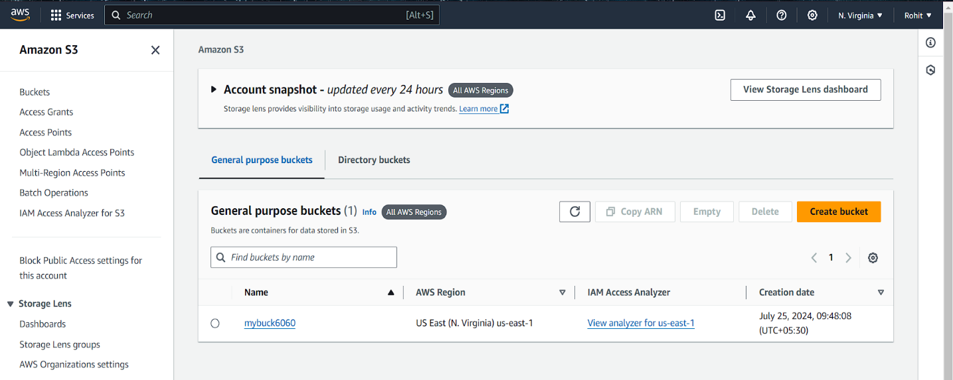

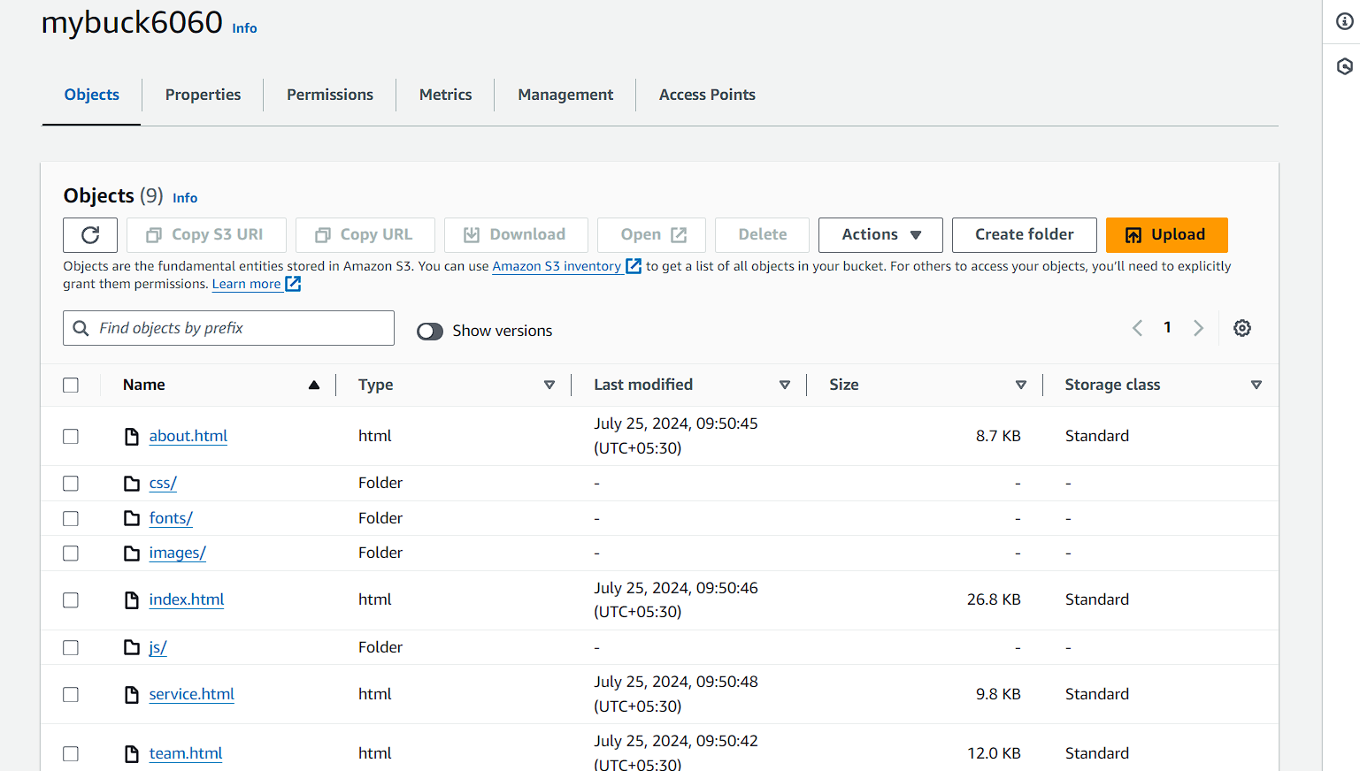

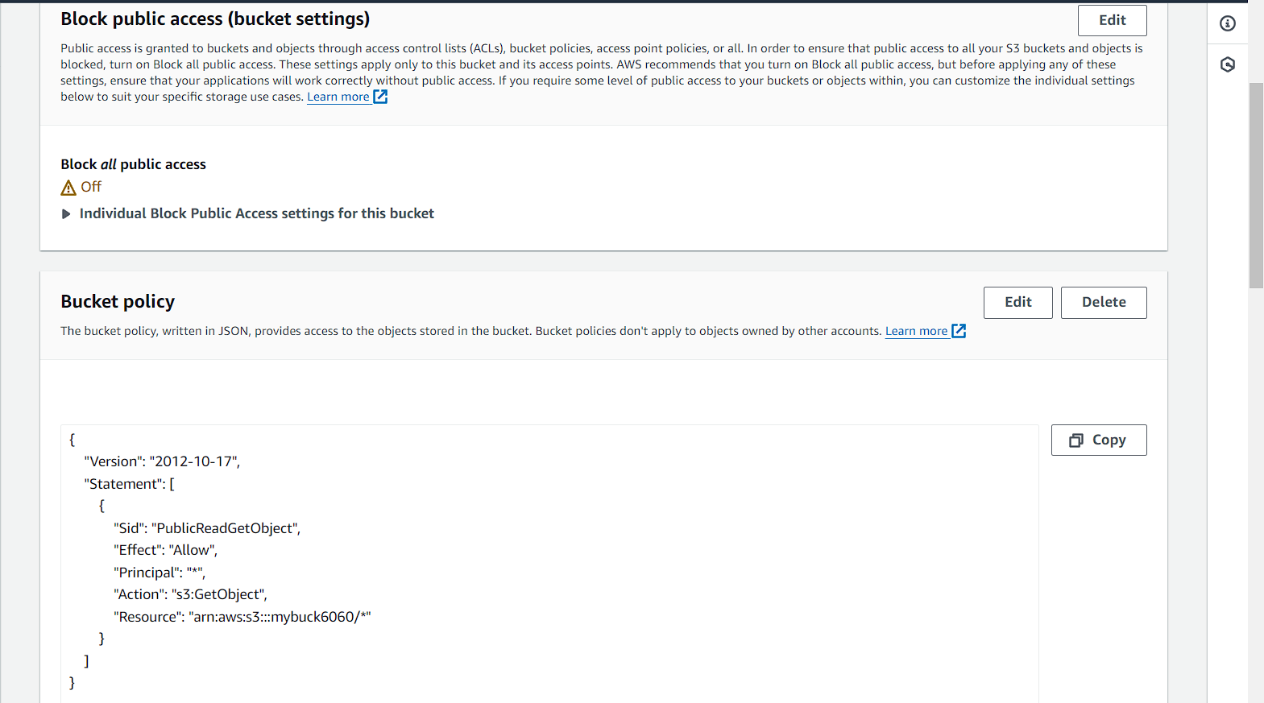

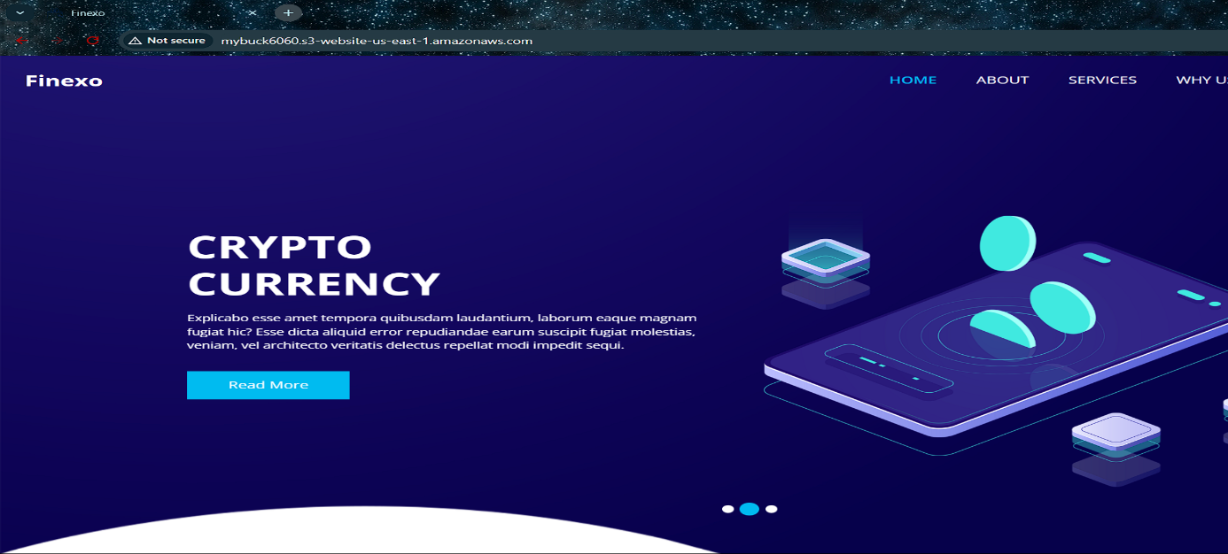

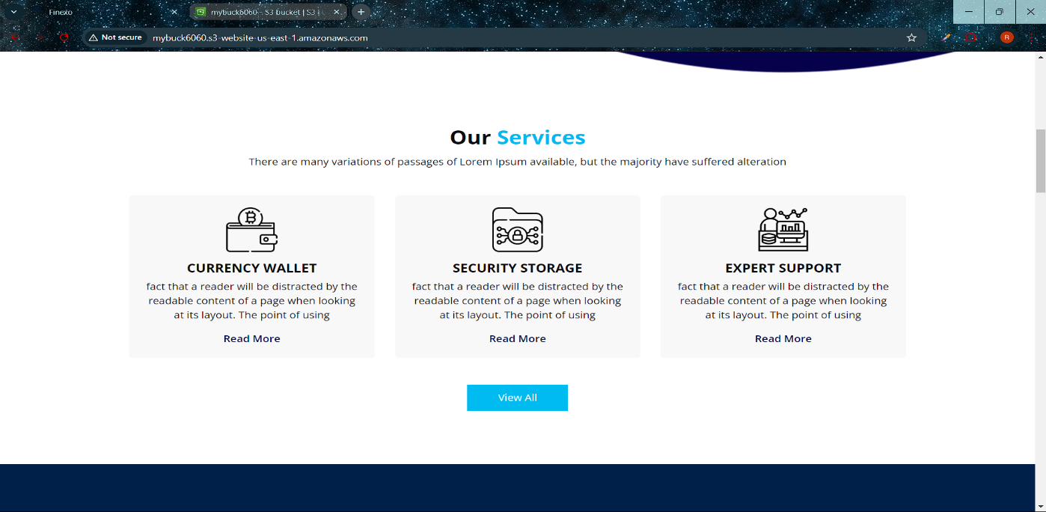

**VIDEO LINK: (CLICK HERE)**