From Scaffolding to Dependency? University Students’ Perceptions of Generative AI in Metacognition and Academic Writing
Rohit Vinod¹, Abhay Vineetha Anil¹, Bharat Suresh Kumar¹

¹Manipal Institute of Technology,
Manipal Academy of Higher Education, Manipal, India
Abstract
It remains unclear whether students experience generative artificial intelligence (AI) as support that helps develop their writing capabilities or as a substitute for independent effort. This cross-sectional survey examined these perceptions among 286 university students aged 18–25 who use AI tools, recruited mainly in India. Factor analyses of 34 administered items yielded a 31-item, five-construct model covering AI tool usage, use of AI for metacognitive regulation, perceived AI scaffolding, self-assessed writing skills and confidence, and perceived dependency costs. The model showed borderline-acceptable fit, and discriminant validity among the benefit-related constructs was only partly established. AI use was positively associated with metacognitive regulation (β = .77) and perceived scaffolding (β = .74), while scaffolding was positively associated with self-assessed writing (β = .64; all p < .001). The indirect association between AI use and self-assessed writing through scaffolding was positive (β = .47), whereas the indirect association through metacognitive regulation was not statistically significant (β = .02, p = .789 for the corresponding structural path). The direct association between AI use and self-assessed writing was positive but small (β = .22, p = .002). Perceived dependency costs did not significantly moderate the AI-use–writing association. Students reported greater AI support during monitoring than during planning or reflection. The exploratory four-profile solution revealed differing combinations of perceived benefits and dependency costs, although alternative profile solutions had lower BIC values and the four-profile choice should therefore be interpreted cautiously. Because the data are cross-sectional and self-reported, the findings describe associations in students' perceptions rather than causal effects or objectively measured writing performance.
Keywords: Generative artificial intelligence, academic writing, metacognitive regulation, self-regulated learning, perceived AI scaffolding, AI dependency, structural equation modelling, latent profile analysis.

1. Introduction

1.1 Generative AI in University Students’ Academic Writing
Within a few years of ChatGPT's public release, generative AI tools have become a routine part of how many university students plan, draft and revise their written work. They can suggest ideas, restructure an argument, explain a grammatical point or comment on a draft within seconds, at any hour. For students who write academic English as a second language, as many students in India do, this kind of support can feel especially valuable (Kasneci et al., 2023; Chan & Hu, 2023). Yet the features that make these tools useful also raise a harder question: when a student writes better with AI, has the student become a better writer?
A text produced with AI assistance does not, by itself, show that its author has developed the knowledge and skills needed to write independently (Yan et al., 2025). It is therefore important to separate objectively assessed writing performance from students' perceptions of their own writing skills and confidence. This study focuses on the latter. It examines students' self-assessed writing skills and confidence alongside their perceptions of AI scaffolding, their use of AI for metacognitive regulation and the dependency costs they associate with AI use. It does not assess the quality of students' written work or their ability to write without AI.

1.2 Metacognition and AI as Cognitive Scaffolding
Two related ideas help explain how AI might shape students as academic writers, for better or worse. Metacognition is the capacity to understand and regulate one's own thinking (Flavell, 1979), and self-regulated learning describes how learners set goals, choose strategies, monitor their progress and evaluate the results (Zimmerman, 2000). Both are central to academic writing. A writer has to organise ideas, build an argument, notice gaps in their own reasoning and judge whether a reader will follow the point being made.
Vygotsky's (1978) zone of proximal development adds a further perspective. With appropriate guidance, learners can complete tasks they could not yet manage alone, and generative AI can supply some of that guidance through explanations, feedback and suggestions when a student is stuck. Receiving help, however, is not the same as learning from it. Students still need to question what the tool proposes, decide whether it suits their purpose and understand why a change improves the text. Those who engage in this way may strengthen both their writing and their awareness of their own thinking. Those who accept generated ideas and arguments without scrutiny risk losing the practice on which independent writing depends.

1.3 Research Gap, Objectives, and Significance
Research on generative AI in education has grown rapidly, but the relationships among AI use, perceived scaffolding, use of AI for metacognitive regulation, self-assessed writing and perceived dependency costs have rarely been examined within a single empirical model. Two questions remain open in particular: whether students' perception of AI as scaffolding helps explain the association between AI use and self-assessed writing skills and confidence, and whether the dependency costs that students perceive weaken that association.
This study addresses these questions through a cross-sectional survey of 286 university students aged 18–25 who use generative AI, recruited mainly in India, with some respondents studying in other countries. It has three objectives: (a) to test a structural model linking AI tool usage, use of AI for metacognitive regulation, perceived AI scaffolding, self-assessed writing skills and confidence, and perceived dependency costs; (b) to compare how students use AI across the planning, monitoring and reflection phases of writing; and (c) to identify learner profiles that combine perceived benefit and perceived dependency in different ways. Throughout, the study tests associations rather than causal effects and treats writing skills and confidence as self-assessed outcomes, not as measures of writing performance.
The study contributes in three ways. It treats scaffolding as students' perception of the support they receive in everyday use rather than as a designed intervention; it measures perceived dependency costs directly, through items written for that purpose, and shows through factor analysis that these costs form a construct in their own right rather than the low end of perceived benefit; and it adds evidence from a sample drawn mainly from Indian higher education, a context still under-represented in structural research on AI-assisted writing. Section 2 reviews the literature and develops the hypotheses, Section 3 describes the method, Section 4 reports the results, Section 5 discusses them and Section 6 concludes.

2. Literature Review and Hypothesis Development

2.1 Generative AI in higher-education writing
Generative AI entered education faster than most institutions could respond, and academic writing quickly became its most visible use. Early commentaries described large language models as sources of personalised feedback and drafting support while warning about hallucination, bias and threats to assessment integrity (Kasneci et al., 2023; Dwivedi et al., 2023; Cotton et al., 2024). Earlier reviews of AI in education had already observed that the field leaned heavily on technical studies, with little pedagogical theory and limited attention to educators (Zawacki-Richter et al., 2019). More recent work has moved beyond questions of adoption to ask how generative AI affects cognition, metacognition and creativity during learning (Yan et al., 2024).
Survey research has since mapped why and how students use these tools. Students in Hong Kong reported benefits such as support with brainstorming and writing, but also concerns about accuracy, ethics and their own development (Chan & Hu, 2023). An expectancy–value instrument found a positive link between perceived value and intention to use, but only a weak negative link between perceived cost and intention (Chan & Zhou, 2023). Students, in other words, continue to use generative AI even when they recognise its costs. The same pattern appears in work on Generation Z students' knowledge, attitudes and ethical perceptions (Acosta-Enriquez et al., 2024) and on attitudinal differences between users and non-users (Blahopoulou & Ortiz-Bonnin, 2025; Ortiz-Bonnin & Blahopoulou, 2025).
Writing studies present a broadly positive but more nuanced picture. In experimental and classroom settings, ChatGPT-assisted instruction improved EFL students' writing and motivation (Song & Song, 2023), supported outlining, editing and argument building (Su et al., 2023), and produced learning gains comparable to feedback from human tutors (Escalante et al., 2023). Students using ChatGPT for writing feedback reported greater motivation, more confidence in their writing ability and higher engagement (Teng, 2024). Students and teachers also distinguish clearly between acceptable uses, such as brainstorming, and unacceptable ones, such as generating whole texts (Barrett & Pack, 2023; Kim et al., 2025). Reviews of AI in second-language writing note that most studies examine the written product rather than the writing process and are usually short and tightly controlled (Feng et al., 2025; Crosthwaite & Sun, 2026). Process-oriented work is nonetheless growing. Studies comparing AI-assisted with traditional writing (Liu et al., 2024), presenting AI feedback visually (Zou et al., 2025), sequencing AI and teacher feedback (Tran, 2025) and combining the two (Zhang et al., 2025) all suggest that how AI is used matters more than whether it is available. A broader review from a technological pedagogical content knowledge (TPACK) perspective reaches the same conclusion (Liu & Zhong, 2025).

2.2 Self-regulated learning and metacognition in academic writing
Metacognition refers to knowledge about and regulation of one's own cognition (Flavell, 1979). Schraw and Dennison (1994) separated knowledge of cognition from its regulation through planning, monitoring and evaluation, a distinction that underpins most later instruments. Self-regulated learning (SRL) theories embed these processes in a broader cycle of goals, strategies and motivation (Pintrich, 2004; Panadero, 2017).
Zimmerman's (2000, 2002) social-cognitive model describes three cyclical phases. In forethought, learners analyse the task, set goals and plan strategies. In performance, they monitor and control their work as it unfolds. In self-reflection, they evaluate outcomes and attribute causes, which feeds the next cycle. Zimmerman and Risemberg (1997) showed that skilled writers regulate their environment, behaviour and thinking across all three phases, so that self-regulation becomes part of writing competence itself.
Cognitive models describe writing from within the task itself. Flower and Hayes (1981) portrayed writing as a recursive process of planning, translating ideas into text and reviewing, coordinated by a monitor that moves the writer between these processes. Hayes (2012) later placed motivation and working memory at the centre of the model, and Graham and Harris (2000) argued that self-regulation, together with transcription skills, shapes how writing develops. In second-language academic writing, metacognitive writing strategies strongly predict writing performance (Teng et al., 2022), motivational regulation influences performance through self-regulated learning (Teng & Zhang, 2018), and metacognitive experiences also affect writing outcomes (Sun & Zhang, 2023).
Generative AI changes the conditions under which these processes operate. Prompting a tool, judging its output and deciding how far to rely on it all require metacognitive monitoring and control, so generative AI creates new metacognitive demands even as it removes others (Tankelevitch et al., 2024). Writing research supports this two-way relationship. Among 1,073 postgraduates, self-regulated learning strategies predicted all three levels of AI use, but only transformative use was associated with gains in critical thinking, motivation and writing quality (Jin et al., 2025). EFL learners with higher metacognitive awareness made more effective use of ChatGPT feedback, whereas those with lower awareness were more likely to copy its output (Teng, 2025a, 2025b). Qualitative work on ChatGPT-assisted writing has identified planning, monitoring, evaluating and information-management strategies, along with a new strategy the authors termed "debugging" (Yao et al., 2025).
Reviews of AI-empowered SRL in higher education conclude that AI can support each SRL phase, but only when learners or designs keep regulation with the learner (Lan & Zhou, 2025). Experimental evidence points the same way: ChatGPT with a guidance mechanism improved SRL and higher-order thinking (Lee et al., 2024), and generative AI reshaped undergraduates' task strategies and metacognition in ways that depended on how it was used (Wang et al., 2025). Acceptance of ChatGPT has also been linked to intentions to use it for metacognitive self-regulated learning (Dahri et al., 2024).

2.3 Generative AI as a scaffold
Scaffolding was first used to describe how a tutor helps a learner complete a task the learner cannot yet manage alone (Wood et al., 1976). The idea is closely linked to Vygotsky's (1978) zone of proximal development, the gap between what a learner can do independently and what they can achieve with guidance from a more capable other. Later research identified three defining features of scaffolding: contingency, or support matched to the learner's current understanding; fading, the gradual withdrawal of that support; and the transfer of responsibility to the learner (van de Pol et al., 2010).
Technology-based scaffolds carried the idea into software. A meta-analysis found positive effects of computer-based scaffolding on learning outcomes in STEM education (Belland et al., 2017), and scaffolds can also be designed to support self-regulated learning and metacognition directly (Azevedo & Hadwin, 2005; Devolder et al., 2012). Software can structure a task and also problematise it, steering learners towards the concepts that matter (Reiser, 2004). Critics warned early, however, that many tools lost the ongoing diagnosis and fading that made human scaffolding effective (Puntambekar & Hübscher, 2005). Pea (2004) drew the key distinction: support that fades is scaffolding, whereas support that stays permanently in place is better described as distributed intelligence, which may improve performance without building individual skill.
Generative AI sharpens this distinction. Unlike earlier tools, it is contingent by default, answering almost any question at any moment with output tailored to the request. It has no built-in fading, however, and support continues for as long as the learner keeps asking. Cognitive load theory explains why this matters: support that helps novices can become redundant or even counterproductive as expertise grows (Sweller, 1988; Kalyuga, 2007). Research on productive failure further shows that struggling with a problem before receiving help can deepen learning (Kapur, 2008).
Hybrid intelligence frameworks respond by proposing a gradual, deliberate shift of control between AI and learner (Molenaar, 2022a, 2022b), and models of human–AI collaboration treat AI as a partner whose role changes over time (Järvelä et al., 2023). Writing research points in the same direction. Doctoral students who engaged with an AI assistant iteratively performed better than those who used it mainly as a source of information (Nguyen et al., 2024). In a quasi-experiment with EFL learners, visual scaffolds combined with AI feedback improved planning and evaluation but not monitoring, and chat logs showed students handing real-time regulation over to the AI (Chen, 2026). Clue-based interaction, which asks students to think before receiving corrections, offers one way to counter this tendency (Lukešová & Jennings, 2026).

2.4 From scaffolding to substitution: offloading, metacognitive laziness, and dependency
Cognitive offloading refers to the use of physical actions or external tools to reduce the cognitive demands of a task (Risko & Gilbert, 2016). Offloading is often adaptive. People readily remember where information can be found rather than the information itself (Sparrow et al., 2011), and offloading can improve immediate performance while weakening memory for what was offloaded (Grinschgl et al., 2021). Research on automation identifies a related risk: when an aid is reliable, people tend to become complacent and stop monitoring what it does (Parasuraman & Manzey, 2010).
Evidence that generative AI can disrupt these learning processes is accumulating quickly. In a laboratory writing study, ChatGPT support raised essay scores without improving knowledge gain or transfer, and learners engaged in fewer metacognitive processes such as evaluation, a pattern the authors called metacognitive laziness (Fan et al., 2025). In an experiment with 1,625 students, learners relied on AI assistance rather than learning from it, and their performance declined once the assistance was removed (Darvishi et al., 2024). A field experiment with nearly 1,000 secondary school students found that unrestricted access to GPT-4 improved practice performance but lowered later unassisted performance, whereas a tutor with built-in guardrails largely prevented that loss (Bastani et al., 2025).
Other studies point to the same mechanism. Students using an LLM experienced lower cognitive load but produced weaker reasoning than those using a search engine (Stadler et al., 2024). Knowledge workers who trusted generative AI more reported less critical thinking, which shifted towards verifying AI output (Lee et al., 2025). Frequent AI use was negatively associated with critical thinking, with cognitive offloading as the mediator (Gerlich, 2025), and a systematic review linked over-reliance on AI dialogue systems to weaker decision-making, critical thinking and analytical reasoning (Zhai et al., 2024). An EEG preprint reported weaker neural connectivity and lower ownership of essays among students who wrote with an LLM (Kosmyna et al., 2025).
Dependency has also been studied as a disposition. Academic stress and performance expectations mediated the link between low self-efficacy and AI dependency, and students listed laziness and reduced critical thinking among its main costs (Zhang et al., 2024). ChatGPT use has been associated with procrastination, memory loss and poorer academic performance (Abbas et al., 2024), and a unidimensional scale of dependence on AI has been validated with university students (Morales-García et al., 2024). Together, these findings support a warning that performance gains with AI should not be mistaken for learning (Yan et al., 2025).

2.5 Research gaps
Four gaps follow from this review. The closest prior studies are summarised in Table 1.
Table 1. Closest prior studies and the position of the present study
Study | Context and sample | Design | Scaffolding | Metacognition | Dependency | Key finding
Jin et al. (2025) | 1,073 postgraduates, United Kingdom | Survey, SEM | Not measured | SRL strategies as predictor | Not measured | SRL predicts all AI-use levels; only transformative use improves outcomes
Chen and Shim (2026) | 262 Chinese undergraduates, L2 writing | Survey, PLS-SEM | Not measured | Metacognitive strategy use as mediator | Not measured | Self-efficacy and metacognitive strategies mediate GenAI use → performance
Chen (2026) | 58 EFL English majors, Taiwan | Quasi-experiment | Designed intervention | Planning, monitoring, evaluation | Observed in chat logs | AI improves planning and evaluation, not monitoring
Fan et al. (2025) | 117 Chinese university students | Laboratory experiment | Agent condition | Process traces | Inferred (metacognitive laziness) | Higher essay scores without knowledge gain
Dahri et al. (2024) | Pre-service teachers, Malaysia | Survey, SEM, interviews | Not measured | Metacognitive SRL intention | Not measured | Acceptance linked to MSRL intention
Present study | 286 university students aged 18–25, mainly in India | Survey, CB-SEM, profiles | Perceived, as mediator | AI use for planning, monitoring, reflection | Measured directly; distinct factor (DEP) | See Sections 4–5

First, benefit and dependency are usually studied apart. Acceptance and SEM studies model usefulness, self-efficacy and strategy use (Jin et al., 2025; Chen & Shim, 2026), whereas dependency studies document costs (Fan et al., 2025; Darvishi et al., 2024; Gerlich, 2025). Few models estimate both within one structure, so it is unknown whether perceived costs weaken perceived benefits or coexist with them.
Second, scaffolding is mostly treated as a designed intervention (Chen, 2026; Bastani et al., 2025) or a theoretical argument (Molenaar, 2022a), rarely as students' perception of the support they receive in everyday use. Its role as a pathway linking AI use to writing outcomes has therefore not been tested.
Third, phase-level evidence on how students distribute AI support across planning, monitoring and reflection comes mainly from small qualitative or experimental samples (Yao et al., 2025; Chen, 2026). Large-sample comparisons across Zimmerman's (2000) phases are scarce.
Fourth, quantitative structural evidence comes mainly from East Asian, European and Middle Eastern settings. Students in Indian higher education, for many of whom academic writing in English is a demanding second-language task, remain largely absent from this literature. The present sample was drawn mainly from this population, although it also included some students studying elsewhere.

2.6 Hypotheses and research questions
The retained Section B items ask how far students draw on AI to plan their writing, monitor it as they write and reflect on it afterwards (Section 3.3). Students who use AI more for writing in general have more occasions to bring it into this regulatory work. Acceptance of ChatGPT has been linked to intentions to use it for metacognitive self-regulated learning (Dahri et al., 2024), postgraduate students have been found to apply planning, monitoring and evaluating strategies when writing with ChatGPT (Yao et al., 2025), and generative AI creates new opportunities as well as new demands for metacognition (Tankelevitch et al., 2024). Heavier users should therefore report greater use of AI for metacognitive regulation. The hypothesis concerns how far AI is involved in students' regulation of their writing, not how well they regulate it.
- H1. AI tool usage is positively associated with use of AI for metacognitive regulation in academic writing.
Metacognitive writing strategies predict writing performance (Teng et al., 2022; Sun & Zhang, 2023), and metacognitive strategy use partly mediates the effect of GenAI use on L2 writing (Chen & Shim, 2026). If students experience AI-supported planning, monitoring and reflection as an extension of these strategies, greater use of AI for metacognitive regulation should be associated with more positive self-assessments of their writing.
- H2. Use of AI for metacognitive regulation is positively associated with self-assessed writing skills and confidence.
If AI functions as scaffolding, its benefit should operate through students' experience of contingent, step-by-step support rather than through usage frequency alone (van de Pol et al., 2010; Jin et al., 2025; Nguyen et al., 2024).
- H3. AI tool usage has a positive indirect association with self-assessed writing skills and confidence through perceived AI scaffolding.
If perceived dependency reflects a weakening of the self-regulatory work that supports writing development, students who perceive high dependency costs should benefit less from the same level of use (Fan et al., 2025; Darvishi et al., 2024). Section D included items written to capture these perceived costs directly (Section 3.3); their specification as a separate latent construct, perceived dependency costs, followed the factor analysis reported in Section 4.2.
- H4. Perceived dependency costs moderate the relationship between AI tool usage and self-assessed writing skills, such that the association is weaker at higher levels of perceived dependency.
Because experimental and classroom studies report direct improvements in writing with AI assistance (Song & Song, 2023; Teng, 2024), a residual direct association was also expected.
- H5. AI tool usage is directly and positively associated with self-assessed writing skills, independent of the scaffolding and metacognitive pathways.
Two exploratory questions extend the variable-centered model.
- RQ1. How do students distribute AI support across the planning, monitoring and reflection phases of writing?
- RQ2. Do distinct learner profiles exist that combine perceived benefit and perceived dependency differently?

3. Methodology

3.1 Research design
The study used a cross-sectional survey design within a post-positivist stance. Structural equation modelling (SEM) was chosen because it tests theoretically specified paths among latent constructs while modelling measurement error explicitly (Kline, 2023). Following the two-step approach, the measurement model was established before the structural model was estimated (Anderson & Gerbing, 1988).
Two complementary analyses extended the SEM. A within-person comparison examined how students used AI across the three phases of self-regulated writing (Zimmerman, 2000), and a person-centred latent profile analysis identified subgroups whose combinations of perceived benefit and perceived dependency the average structural paths might conceal (Spurk et al., 2020).

3.2 Participants and sampling

The target population comprised university students aged 18–25 who used generative AI tools in their academic work, particularly for writing-related tasks. Participants were recruited through convenience sampling between 15 June and 9 October 2026. The survey link was circulated primarily through student messaging channels, course-related groups and in-class announcements in India. Because the link could be forwarded, it may also have reached students enrolled at universities elsewhere.

Of the 303 survey submissions received, 286 were retained for analysis following the screening procedures described in Section 3.5. The final sample consisted of respondents who met the study's age and AI-use eligibility criteria. Demographic details such as gender, institution, discipline, year of study and country of study were not systematically collected. Consequently, the sample's demographic composition and precise geographic distribution cannot be established, and demographic or cross-national comparisons were not conducted. The findings should therefore be interpreted in light of the convenience-sampling approach and the limits of sample characterisation.

3.3 Instrument
The 34-item questionnaire was adapted from three validated instruments and anchored to academic-writing tasks (Table 2). All items used a seven-point Likert scale (1 = strongly disagree, 7 = strongly agree). The perceived-value and perceived-cost items derive from Blahopoulou and Ortiz-Bonnin (2025), whose expectancy–value instrument builds on Chan and Zhou (2023). Usage and concern items derive from Acosta-Enriquez et al. (2024). Metacognitive self-regulation, perceived usefulness and perceived AI intelligence items derive from the extended technology acceptance model of Dahri et al. (2024), which builds on the technology acceptance model (Davis, 1989).
Section B was designed to represent the three phases of Zimmerman's (2000) cyclical model: forethought or planning (META1–META3), performance or monitoring (META4–META6), and self-reflection (META7–META10). During measurement-model evaluation, META8, which concerns critically evaluating AI output, was excluded because it loaded weakly on the intended construct (standardised loading = .47) and cross-loaded on dependency costs. META9 and META10, which concern worry about over-reliance on AI, were also excluded from the final measurement model because their reported loadings on dependency costs were .53 and .48, respectively, and they raised residual-correlation concerns. These three items were retained for descriptive reporting but were not included in the final measurement model. Consequently, self-reflection in the final META construct is represented by META7 alone. The construct is therefore labelled use of AI for metacognitive regulation, rather than general metacognitive ability, because it captures students' reported use of AI during planning, monitoring, and reflection rather than their independent capacity to regulate their own thinking.
Table 2. Questionnaire structure, item sources and example items
Section | Construct | Items | Sources adapted | Example item
A | AI tool usage (AI) | AI1–AI8 | Blahopoulou & Ortiz-Bonnin (2025); Acosta-Enriquez et al. (2024); Dahri et al. (2024) | "I use AI tools to help me brainstorm and generate ideas before I begin drafting an academic text."
B | Use of AI for metacognitive regulation (META) | META1–META10 | Dahri et al. (2024); Acosta-Enriquez et al. (2024) | "While writing, I use AI tools to check whether my arguments are clearly expressed and logically organized."
C | Perceived AI scaffolding (SCF) | SCF1–SCF8 | Blahopoulou & Ortiz-Bonnin (2025); Dahri et al. (2024) | "AI tools help me resolve writing difficulties step by step, guiding me through tasks I find challenging."
D | Writing skills and confidence (AW) | AW1–AW8 | Blahopoulou & Ortiz-Bonnin (2025); Acosta-Enriquez et al. (2024) | "AI tools assist me in drafting more structured and coherent academic essays."
Note. The original questionnaire contained 34 items across four sections. Following measurement-model evaluation, META8–META10 were excluded from the final measurement model and retained for descriptive reporting. Items AW5–AW8, originally included in the writing skills and confidence section, formed a separate construct labelled perceived dependency costs (DEP). The final measurement model therefore comprised 31 indicators across five constructs.
A pilot administration with 54 students showed high internal consistency for all four sections (α = .910–.961), and all corrected item–total correlations were at least .555, supporting deployment of the instrument.

3.4 Data screening and preparation

A total of 303 survey submissions were received between 15 June and 9 October 2026. The responses were screened for duplicate submissions, incomplete responses, and careless responding. Six duplicate submissions were removed, followed by five responses with more than three unanswered questionnaire items and six responses in which the same answer was selected across all items. This resulted in a final analytical sample of 286 respondents.

Fifteen remaining missing item responses (approximately 0.15% of all item responses) were imputed using the median of the corresponding item. Twenty-five respondents identified as multivariate outliers using the analysis procedure were retained in the primary analysis. A sensitivity analysis excluding these respondents was conducted to assess whether their inclusion materially affected the findings.

The final sample of 286 respondents was used for the principal analyses, including exploratory and confirmatory factor analyses and structural model estimation. The results of the sensitivity analysis are reported separately.

3.6 Analytical strategy
The analysis proceeded in six steps, summarized in Table 3.
Table 3. Analytical steps and decision criteria
Step | Purpose | Procedure | Decision criteria
1. Exploratory factor analysis | Inspect dimensionality before confirmatory testing | Minimum residual extraction, oblimin rotation; parallel analysis with 500 random data sets | KMO ≥ .80; significant Bartlett test; retain factors whose eigenvalues exceed the random-data 95th percentile (Horn, 1965; Kaiser, 1974)
2. Confirmatory factor analysis | Test and compare measurement models | Maximum likelihood; five competing specifications; χ² difference tests | CFI and TLI ≥ .90, RMSEA and SRMR ≤ .08 (Hu & Bentler, 1999); χ²/df < 3 (Kline, 2023)
3. Reliability and validity | Establish construct quality | Cronbach's α, McDonald's ω, composite reliability, AVE; Fornell–Larcker; HTMT with 1,000 bootstrap resamples | α, ω, CR ≥ .70; AVE ≥ .50 (Fornell & Larcker, 1981; Dunn et al., 2014; McNeish, 2018); HTMT < .85, upper CI < .90 (Henseler et al., 2015)
4. Common method bias | Rule out shared-method inflation | Harman's single-factor test; single-factor CFA | First factor < 50% of variance; single-factor model clearly worse (Podsakoff et al., 2003, 2012)
5. Structural model | Test H1–H3 and H5 | Latent SEM; 5,000 bootstrap resamples, percentile CIs for direct and indirect effects | Effect significant when the 95% CI excludes zero (Preacher & Hayes, 2008; Hayes & Scharkow, 2013); mediation typed after Zhao et al. (2010)
6. Moderation and extensions | Test H4; RQ1 and RQ2 | Mean-centred interaction in regression with 5,000 bootstrap resamples, simple slopes and Johnson–Neyman intervals; Friedman and Wilcoxon tests; Gaussian mixture model | Interaction CI excludes zero (Aiken & West, 1991; Bauer & Curran, 2005); Bonferroni correction; profile number by BIC and entropy > .80 (Nylund et al., 2007; Spurk et al., 2020)
Measurement quality was judged from converging indicators rather than a single cut-off. Fit indices were treated as guidelines rather than strict rules because their values depend on model size and loading strength (Hu & Bentler, 1999; Kline, 2023). Internal consistency was reported with both Cronbach's α and McDonald's ω, because α assumes equal loadings across items, an assumption rarely met in practice (McNeish, 2018); reporting both gives a fuller picture of reliability.
H4 was tested with composite scores rather than a latent interaction model. This provides a transparent and easily interpreted test of moderation, although it does not correct for measurement error in the interaction term. To check robustness, the structural and moderation models were re-estimated after excluding the 25 multivariate outliers identified during screening (Section 4.6).
All analyses were conducted in Python 3.12 using pandas (McKinney, 2010), SciPy (Virtanen et al., 2020), statsmodels (Seabold & Perktold, 2010), factor_analyzer, semopy (Igolkina & Meshcheryakov, 2020) and scikit-learn (Pedregosa et al., 2011).

4. Results and Data Interpretation
The data support three of the five hypotheses, although support for H5 is weak. AI tool usage was strongly associated with use of AI for metacognitive regulation (H1) and with self-assessed writing skills and confidence, mainly through perceived scaffolding (H3) and partly through a small direct path (H5). Use of AI for metacognitive regulation did not uniquely predict self-assessed writing (H2), and perceived dependency costs did not weaken the association between AI use and self-assessed writing (H4); instead, perceived benefit and perceived dependency coexisted.

4.1 Descriptive statistics
All construct means lay significantly above the scale midpoint of 4 (all p < .001; Table 4). AI tool usage was highest (M = 5.25, d = 0.94). Use of AI for metacognitive regulation was the lowest of the positively framed constructs (M = 4.73), and only half the sample (49.7%) agreed on average that they draw on AI to plan, monitor and reflect on their writing.

Table 4. Descriptive statistics and one-sample tests against the scale midpoint (N = 286)
Construct | Items | M | SD | 95% CI | Skew | Kurtosis | % agree | t(285) vs 4 | d
AI tool usage (AI) | AI1–AI8 | 5.25 | 1.34 | 5.10–5.41 | −1.00 | 0.67 | 68.9 | 15.85 | 0.94
Use of AI for metacognitive regulation (META) | META1–META7 | 4.73 | 1.36 | 4.57–4.89 | −0.57 | −0.11 | 49.7 | 9.09 | 0.54
Perceived AI scaffolding (SCF) | SCF1–SCF8 | 4.88 | 1.39 | 4.72–5.04 | −0.73 | −0.02 | 58.0 | 10.67 | 0.63
Writing skills and confidence (AW) | AW1–AW4 | 4.79 | 1.49 | 4.61–4.96 | −0.65 | −0.21 | 55.9 | 8.90 | 0.53
Perceived dependency costs (DEP) | AW5–AW8 | 5.09 | 1.45 | 4.92–5.26 | −0.79 | 0.13 | 59.8 | 12.70 | 0.75
Worry about over-reliance | META9–META10 | 5.29 | 1.63 | 5.10–5.48 | −0.93 | 0.18 | 68.2 | 13.38 | 0.79
Note. % agree = share of respondents whose construct mean is 5 or above. All p < .001.
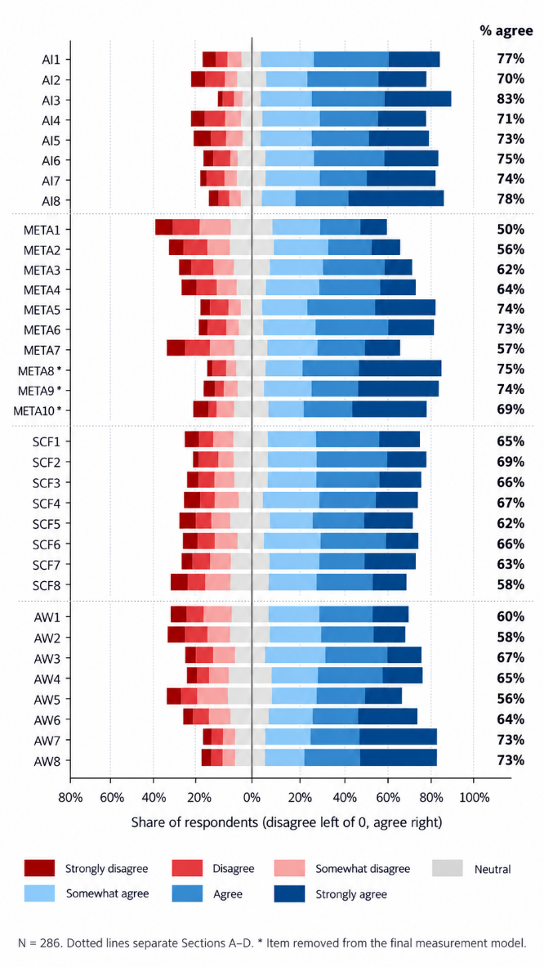
Fig. 1. Agreement and disagreement across all 34 measurement items

At item level (Fig. 1), searching for information was the most endorsed use (AI3, 83% agree) and AI-assisted goal setting before writing the least (META1, 50%). Items describing long-term development were among the weakest benefit items (SCF8 and AW2, both 58%).
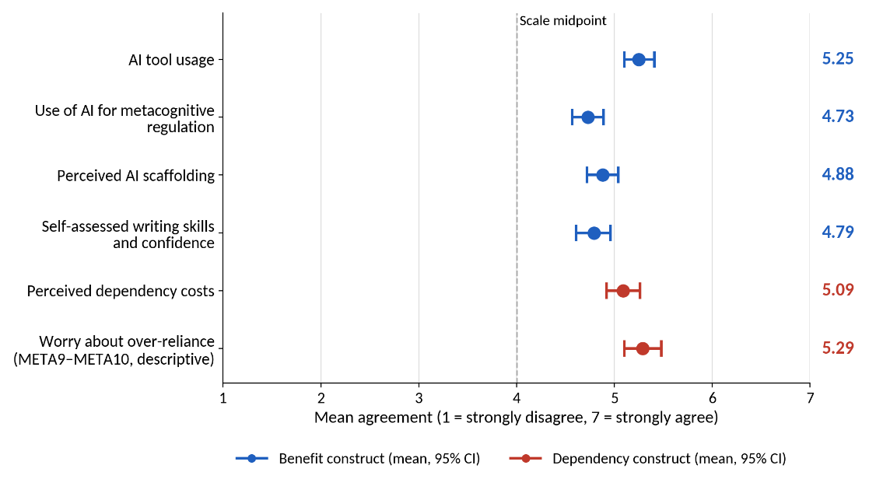
Fig. 2. Construct means with 95% confidence intervals (N = 286); the dashed line marks the scale midpoint, and worry about over-reliance (META9–META10) is shown descriptively

Interpretation. Students report heavy use but more modest developmental benefits. Dependency costs (d = 0.75) and worry about over-reliance (d = 0.79) depart further from neutral than perceived writing gains (d = 0.53). From the outset, then, the data describe students who use AI extensively while remaining wary of what it means for their long-term development.

4.2 Measurement model

4.2.1 Exploratory factor analysis
The data were well suited to factoring (KMO = .934; Bartlett χ²(561) = 7636.8, p < .001). Parallel analysis retained four factors (Fig. 3). The first eigenvalue (14.75) was more than four times the second (3.47), indicating substantial variance shared across items; this is examined further in Sections 4.2.4 and 4.2.5. In the oblimin solution, AI usage formed a clean factor (loadings .60–.89) and the scaffolding items grouped with the four enabling writing items. The four inhibiting writing items (AW5–AW8) formed a separate factor (.53–.89), with the two worry items (META9, META10) cross-loading on it.
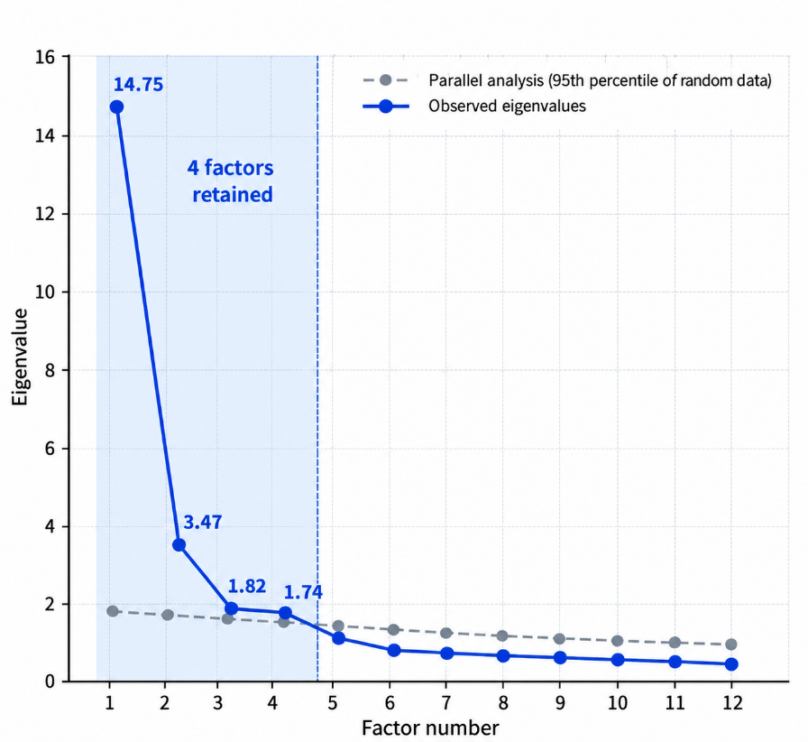
Fig. 3. Parallel analysis results supporting the retention of four factors
Note. The blue line represents observed eigenvalues, and the grey dashed line represents the 95th percentile of eigenvalues from random data. Factors with observed eigenvalues exceeding the random-data benchmark were retained.

Interpretation. Perceived costs of AI are not the negative pole of perceived benefit. They constitute a distinct dimension. The cost items were written into Section D to measure perceived costs directly, but the a priori four-section structure scored them together with the enabling items; the factor analysis shows that they need to be modelled as a separate construct.

4.2.2 Confirmatory model comparison
Five measurement models were compared (Table 5). The original four-section structure fitted poorly (CFI = .757, RMSEA = .110). Separating the concern items into a dependency construct improved fit substantially. Removing three weak or misplaced items produced the final 31-item, five-factor model, which met conventional criteria for CFI, RMSEA and SRMR, although TLI (.892) fell just below .90 (Hu & Bentler, 1999). Because these modifications were guided by the same data, the final model should be regarded as provisional until it is cross validated in an independent sample.

Table 5. Fit of competing measurement models
Model | Specification | χ² | df | χ²/df | CFI | TLI | RMSEA | SRMR
M0 | Single factor, 34 items | 3300.6 | 527 | 6.26 | .627 | .603 | .136 | .106
M1 | Original four sections, 34 items | 2330.0 | 521 | 4.47 | .757 | .738 | .110 | .092
M2 | Five factors with concern items as DEP, 34 items | 1578.2 | 517 | 3.05 | .857 | .845 | .085 | .077
M3 | Five factors, SCF and AW merged, 31 items | 1334.5 | 428 | 3.12 | .868 | .856 | .086 | .062
M4 | Final five factors, 31 items | 1100.5 | 424 | 2.60 | .901 | .892 | .075 | .058
Note. M4 versus M3: Δχ²(4) = 234.0, p < .001.
The measurement-model evaluation resulted in a final five-construct model comprising 31 indicators from the original 34-item questionnaire. META8 was excluded because it loaded weakly on the intended construct (standardised loading = .47) and cross-loaded on perceived dependency costs. META9 and META10, which assessed worry about over-reliance on AI, were also excluded from the final measurement model because their reported loadings on dependency costs were .53 and .48, respectively, and they raised residual-correlation concerns. These three items were retained for descriptive reporting. Items AW5–AW8 were retained and modelled as a separate construct, perceived dependency costs (DEP).
Perceived AI scaffolding and self-assessed writing skills and confidence were retained as separate constructs despite their high correlation (r = .82) and the finding that their items formed a single factor in the exploratory factor analysis (EFA). This distinction was retained on conceptual grounds: the scaffolding items capture students' perceptions of the support they receive while writing, whereas the writing items capture their self-assessed writing skills and confidence. The five-factor model (M4) also fitted better than the alternative model that merged these constructs (M3; Δχ²(4) = 234.0, p < .001). Nevertheless, this distinction should be interpreted cautiously given the high correlation between the constructs and the exploratory factor-analysis results.

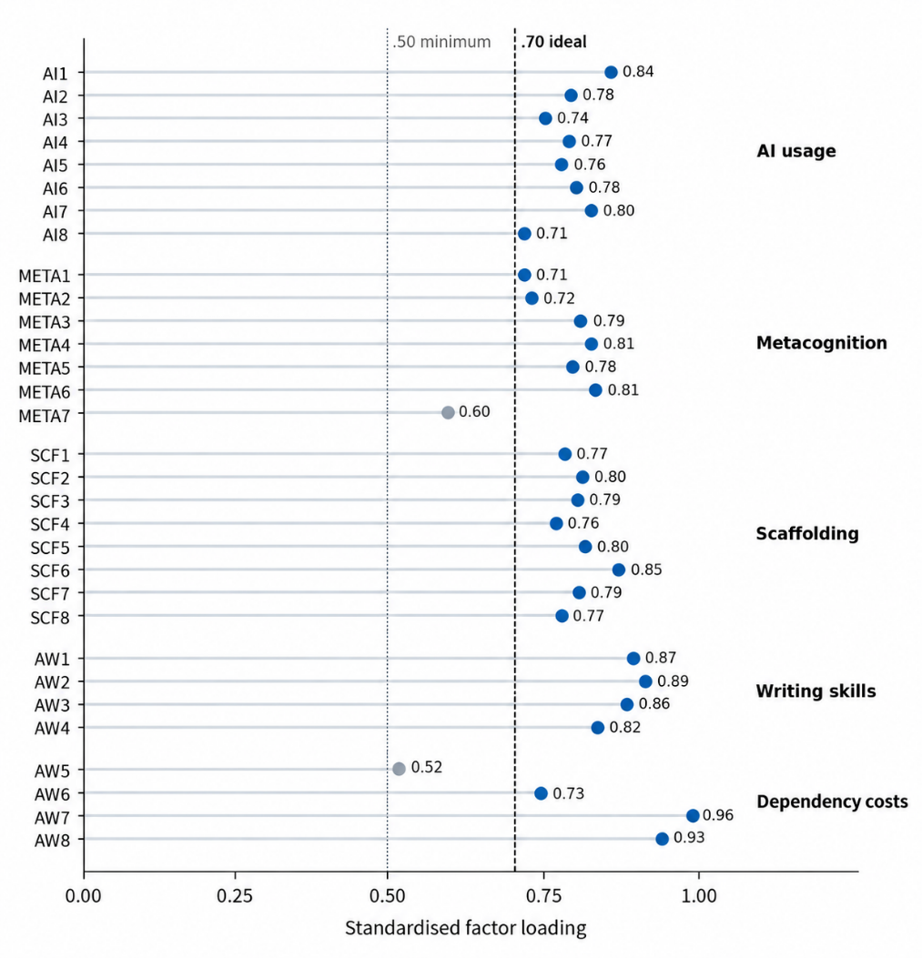
Fig. 4. Standardised factor loadings for the final five-factor model

All 31 loadings were significant (p < .001), and 29 exceeded .70 (Fig. 4). META7 (.60) and AW5 (.52) were retained for content coverage, consistent with the principle that items broadening a construct's content should not be discarded merely to maximise internal consistency (Clark & Watson, 1995). Complete standardised loadings and the full latent correlation matrix are reported in Appendix A (Tables A1 and A2).

4.2.3 Reliability and convergent validity
All five constructs demonstrated good internal consistency, with Cronbach’s α ranging from .874 to .930 and McDonald’s ω from .875 to .931. Composite reliability exceeded .70 and AVE exceeded .50 for all constructs, providing evidence of convergent validity. However, these results should be interpreted alongside the partial discriminant-validity concerns described in Section 4.2.4. Internal consistency and convergent validity alone do not establish that the constructs are empirically distinct.

Table 6. Reliability and convergent validity of the final measurement model
Construct | Loading range | α (pilot, N = 54) | α | ω | CR | AVE | MSV | √AVE
AI tool usage | .71–.84 | .961 | .921 | .922 | .922 | .597 | .587 | .773
Use of AI for metacognitive regulation | .60–.81 | .938 | .897 | .899 | .899 | .563 | .628 | .750
Perceived AI scaffolding | .76–.85 | .946 | .930 | .931 | .931 | .626 | .675 | .791
Writing skills and confidence | .82–.89 | .910 | .919 | .921 | .921 | .744 | .675 | .862
Perceived dependency costs | .52–.96 | — | .874 | .875 | .875 | .647 | .080 | .804
Note. Pilot α for metacognition and writing were computed on the original 10- and 8-item sections. Deleting AW5 would raise DEP α to .899; it was retained for content coverage.
High internal consistency shows that the items within each scale covary strongly; it does not, on its own, show that the scales measure the constructs they are intended to measure. Very high values, such as the pilot alpha of .961 for AI usage, may also signal overlapping item wording. Validity evidence here comes from the item sources and pilot (content and response processes), the factor analyses (internal structure) and the pattern of associations among constructs. That last source is limited, because the benefit constructs were highly intercorrelated and no external criterion, such as rated writing performance, was available.

4.2.4 Discriminant validity

Discriminant validity was assessed using the HTMT criterion and the Fornell–Larcker criterion. The reported HTMT ratios were below the .85 threshold, with the highest reported value for perceived scaffolding and self-assessed writing skills and confidence (HTMT = .826). However, the Fornell–Larcker criterion provided only partial support for discriminant validity. The latent correlations between AI usage and metacognitive regulation (.77), metacognitive regulation and perceived scaffolding (.79), and perceived scaffolding and self-assessed writing (.82) exceeded the smaller square root of AVE for the respective construct pairs. Maximum shared variance also exceeded AVE for metacognitive regulation and perceived scaffolding. These findings suggest substantial overlap among the benefit-related constructs. Therefore, discriminant validity is only partially established, particularly between perceived scaffolding and self-assessed writing. The HTMT bootstrap confidence interval should be confirmed against the original analysis output before the final manuscript is submitted.
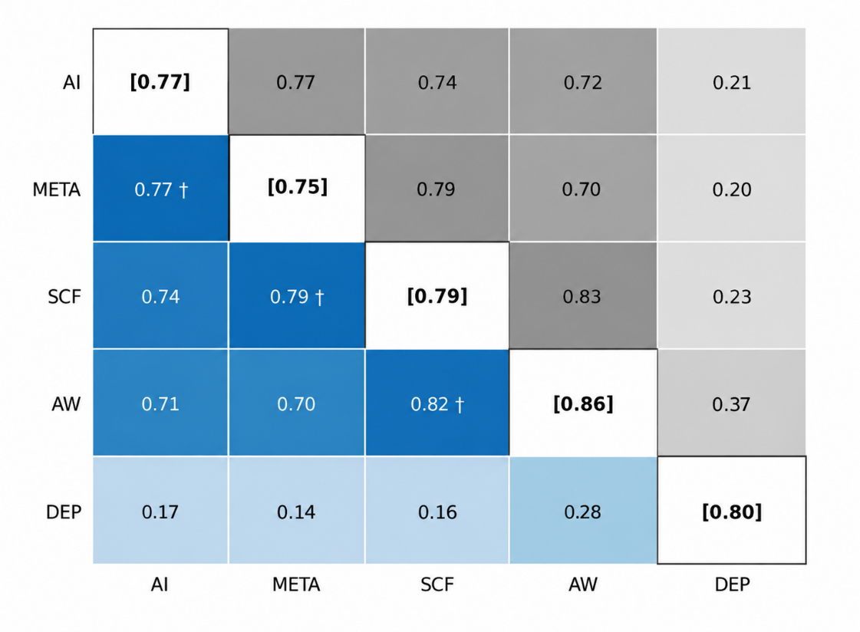
Fig. 5. Latent construct correlations (below the diagonal), square roots of AVE (diagonal, in brackets) and HTMT ratios (above the diagonal)
Interpretation. The four benefit constructs are separable under HTMT but strongly interrelated (r = .70–.82), which suggests a general appraisal of AI as helpful that colours all four. A higher-order or bifactor structure capturing such a general appraisal was not tested here and remains a plausible alternative to be examined in future validation work (Rodriguez et al., 2016). Dependency, by contrast, correlated only .14–.28 with the benefit constructs, so students' judgements of what AI costs them are largely independent of their judgements of what it gives them.

4.2.5 Common method bias
Two tests suggested that common method variance is unlikely to account fully for the results. The first unrotated factor explained 46.2% of variance across the retained items, below, though close to, the 50% criterion. A single-factor CFA fitted very poorly (χ²(434) = 2716.5, CFI = .667, RMSEA = .136) and far worse than the five-factor model (Δχ²(10) = 1616.0, p < .001). Neither test can rule out method variance (Podsakoff et al., 2003, 2012), and because no a priori marker variable was included in the questionnaire, a marker-based adjustment was not possible. The general appraisal noted in Section 4.2.4 may therefore partly reflect shared method variance, and the small positive correlations between benefit and dependency perceptions may partly reflect shared response tendencies such as acquiescence (Section 5.6).

4.3 Structural model and hypothesis testing

The structural model showed borderline-acceptable fit to the data, χ²(427) = 1114.4, χ²/df = 2.61, CFI = .900, TLI = .891 and RMSEA = .075. The model explained 70% of the variance in self-assessed writing skills and confidence, 59% in use of AI for metacognitive regulation, 54% in perceived AI scaffolding, and 3% in perceived dependency costs. AI tool usage was positively associated with use of AI for metacognitive regulation (β = .77, p < .001) and perceived AI scaffolding (β = .74, p < .001). Perceived scaffolding was positively associated with self-assessed writing skills and confidence (β = .64, p < .001), whereas use of AI for metacognitive regulation did not show a statistically significant unique association with writing outcomes (β = .02, p = .789). The direct association between AI use and self-assessed writing skills and confidence was positive but comparatively small (β = .22, p = .002). Perceived dependency costs did not significantly moderate the AI use–writing association. These findings describe associations within the specified model and do not establish causal effects.
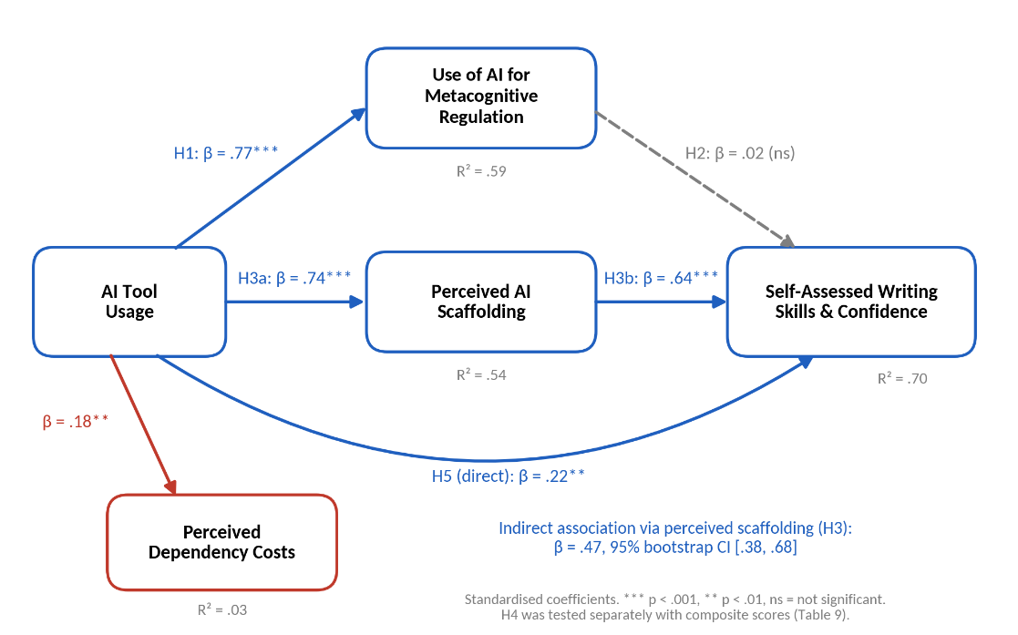
Fig. 6. Structural model of the associations among AI tool usage, use of AI for metacognitive regulation, perceived AI scaffolding, self-assessed writing skills and confidence, and perceived dependency costs (standardised coefficients)
Table 7. Structural paths and hypothesis decisions
Hypothesis | Path | β | SE | z | p | 95% bootstrap CI | Decision
H1 | AI → META | .77 | 0.06 | 10.96 | < .001 | [.665, .844] | Supported
H2 | META → AW | .02 | 0.10 | 0.27 | .789 | [−.187, .230] | Not supported
H3 (a path) | AI → SCF | .74 | 0.06 | 11.45 | < .001 | [.638, .819] | Supported
H3 (b path) | SCF → AW | .64 | 0.10 | 7.45 | < .001 | [.427, .857] | Supported
H5 | AI → AW (direct) | .22 | 0.08 | 3.07 | .002 | [.043, .406] | Supported (weak)
Exploratory | AI → DEP | .18 | 0.04 | 2.80 | .005 | [.010, .340] | Significant
Note. β = standardised coefficient; SE and z refer to unstandardised estimates; 95% CIs are percentile bootstrap intervals based on 5,000 resamples.
Interpretation. The results supported H1, indicating that students who reported greater AI tool usage also reported greater use of AI for metacognitive regulation during writing. H2 was not supported: although use of AI for metacognitive regulation was correlated with self-assessed writing, it did not make a statistically significant unique contribution when perceived scaffolding and AI usage were included in the structural model. H3 was supported through the positive association between perceived scaffolding and self-assessed writing, which is examined further in Section 4.4. H5 was supported by a positive direct association between AI usage and self-assessed writing, although the effect was relatively small and its confidence interval approached zero. The exploratory association between AI usage and perceived dependency costs was also positive, suggesting that heavier AI users reported greater perceived costs rather than fewer concerns. Overall, perceived benefits and perceived dependency costs appeared to coexist in this sample.

4.4 Indirect association through perceived scaffolding (H3)
The indirect association between AI tool usage and self-assessed writing skills and confidence through perceived AI scaffolding was positive and statistically significant (β = .47, 95% bootstrap CI [.38, .68]). In contrast, the indirect association through use of AI for metacognitive regulation was not statistically significant (β = .02, 95% CI [−.09, .20]). The direct association between AI usage and self-assessed writing also remained positive and statistically significant (β = .22, 95% CI [.01, .30]). This pattern is consistent with complementary statistical mediation in the specified model. However, because all variables were measured at one time point, these indirect associations do not establish that AI use causes scaffolding or that scaffolding causes writing development. Alternative directions of association may also be consistent with the data.
Table 8. Decomposition of the association between AI tool usage and self-assessed writing skills and confidence
Path | β | 95% bootstrap CI | Proportion of total (descriptive)
AI → SCF → AW | .468 | [.299, .662] | 66%
AI → META → AW | .017 | [−.144, .180] | 2%
Total indirect | .485 | [.333, .642] | 68%
Direct (AI → AW) | .224 | [.043, .406] | 32%
Total association | .710 | [.600, .798] | 100%

Interpretation. The bootstrap analysis indicated a positive indirect association between AI tool usage and self-assessed writing skills and confidence through perceived AI scaffolding (β = .468, 95% bootstrap CI [.299, .662]). The corresponding indirect association through use of AI for metacognitive regulation was small (β = .017), and its 95% bootstrap confidence interval included zero [−.144, .180]. The direct association between AI use and self-assessed writing also remained positive (β = .224, 95% bootstrap CI [.043, .406]). Because the data were collected at a single time point, these results describe associations within the specified model and do not establish a causal mediation process.

4.5 Moderation by perceived dependency costs (H4)
Perceived dependency costs did not significantly moderate the association between AI tool usage and self-assessed writing skills and confidence (Table 9; Figure 7). In the composite-score regression with HC3 robust standard errors, the interaction coefficient was small and non-significant (b = .0024, SE = .029, p = .936; 95% confidence interval approximately [−.055, .060]). The results did not provide evidence that the association between AI usage and self-assessed writing differed according to perceived dependency costs. This non-significant result does not establish that dependency concerns are irrelevant; it indicates only that the proposed moderation was not detected in this sample. Because the analysis used composite scores, measurement error in the interaction term may also affect the estimate.

Table 9. Conditional effects of AI tool usage at levels of perceived dependency costs
Level of perceived dependency costs | Simple slope of AI usage | SE | t | p
Low (−1 SD) | 0.69 | 0.06 | 12.50 | < .001
Mean | 0.69 | 0.05 | 13.88 | < .001
High (+1 SD) | 0.70 | 0.07 | 10.22 | < .001

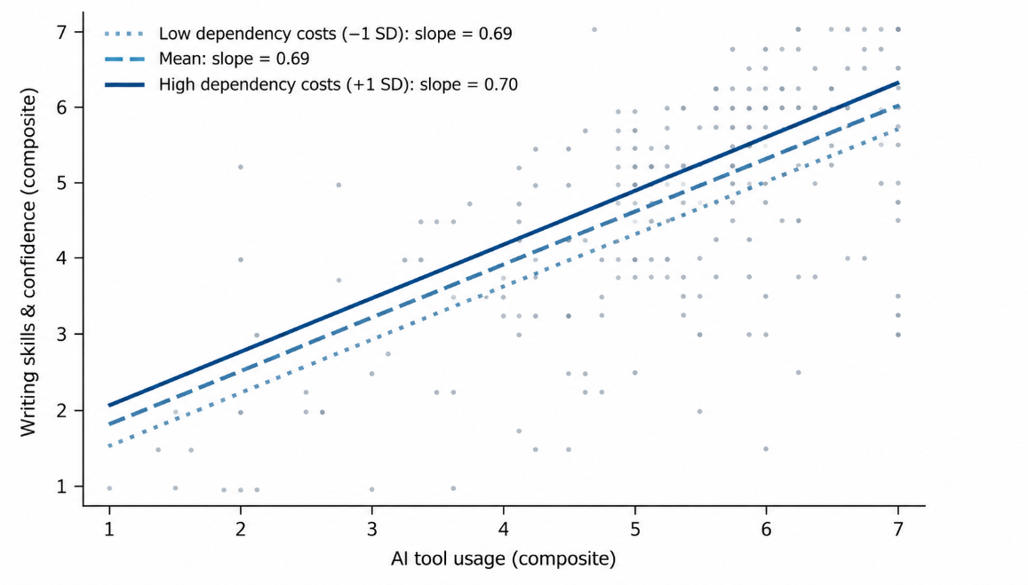

Fig. 7. Simple slopes of AI tool usage on self-assessed writing skills and confidence at three levels of perceived dependency costs (interaction not significant)
An exploratory test of dependency costs moderating the scaffolding–writing path was also non-significant (b = −0.04, p = .086). Dependency costs were, however, positively associated with self-assessed writing (β = .21, p < .001).
Interpretation. The moderation analysis did not support the hypothesis that perceived dependency costs weaken the association between AI usage and self-assessed writing skills and confidence. The estimated AI-use slopes were similar across low, average and high levels of perceived dependency costs. In this sample, students' concerns about potential dependency did not statistically alter the relationship between reported AI usage and their self-assessed writing outcomes. This finding should be interpreted as a lack of evidence for moderation rather than evidence that dependency concerns have no educational consequences.

4.6 Robustness
To assess the sensitivity of the findings to the inclusion of unusual responses, the structural and moderation models were re-estimated after excluding the 25 cases identified during screening, reducing the sample from 286 to 261. The estimates from the reduced sample were compared with those from the full sample (N = 286; Table 10).

Table 10. Sensitivity of key estimates to the exclusion of multivariate outliers
Estimate | Full sample (N = 286) | Outliers removed (N = 261)
CFI / RMSEA / SRMR | .901 / .075 / .058 | .906 / .077 / .059
H1: AI → META | .77*** | .80***
H2: META → AW | .02 | .05
AI → SCF | .74*** | .76***
SCF → AW | .64*** | .58***
H5: AI → AW | .22** | .24**
AI → DEP | .18** | .20**
H4: AI × DEP (b) | .002 | −.007
Note. ** p < .01, *** p < .001.

Interpretation. The sensitivity analysis indicated that the main structural associations were broadly similar after excluding the 25 cases identified during screening. The positive associations between AI tool usage and use of AI for metacognitive regulation, AI tool usage and perceived scaffolding, and perceived scaffolding and self-assessed writing skills and confidence remained similar in magnitude. The association between use of AI for metacognitive regulation and self-assessed writing remained small. The positive direct association between AI tool usage and self-assessed writing, as well as the positive association between AI tool usage and perceived dependency costs, also remained similar. The interaction between AI usage and perceived dependency costs remained close to zero in both samples, providing no evidence of a moderation effect. Overall, excluding these cases did not materially change the main pattern of results.

4.7 AI support across the phases of self-regulated writing (RQ1)

To examine how students reported using AI across the phases of self-regulated writing, scores for planning, monitoring and reflection were compared using the Friedman test. Reported use of AI for metacognitive regulation differed significantly across the three phases, χ²(2) = 52.1, p < .001. Monitoring (M = 5.03) was significantly higher than planning (M = 4.50, p < .001) and reflection (M = 4.52, p < .001). Planning and reflection did not differ significantly after Bonferroni correction (p = 1.00). These results suggest that students reported greater AI involvement while monitoring their writing than while planning or reflecting on it. The findings describe self-reported patterns of AI use and do not establish whether students' independent self-regulatory abilities improved or declined.
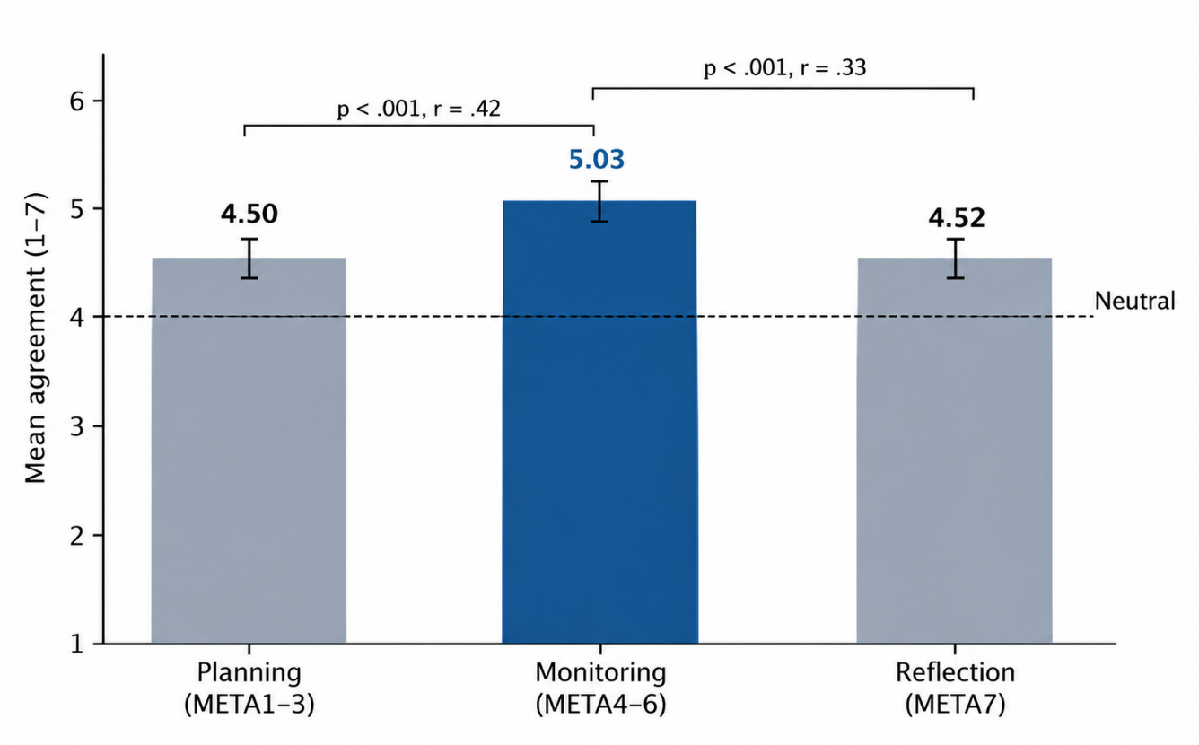

Fig. 8. Reported AI use for planning (META1–META3), monitoring (META4–META6) and reflection (META7)
Interpretation. Students report drawing on AI mainly in Zimmerman's (2000) performance phase, to check arguments, resolve doubts and obtain immediate feedback. The forethought and self-reflection phases, which theory links most closely to the long-term development of self-regulation, receive the least reported AI support. Because reflection was measured by a single item, this comparison should be interpreted with caution.

4.8 Learner profiles (RQ2)
A Gaussian mixture model was used to explore heterogeneity in students’ reported AI use, metacognitive regulation, perceived scaffolding, self-assessed writing skills and confidence, and perceived dependency costs. A four-profile solution was retained to provide a parsimonious and interpretable description of the sample. However, the model comparisons did not identify four profiles as the unambiguous BIC optimum. In the unstandardised analysis, the BIC decreased from 4369.37 for four profiles to 4367.23 for five profiles and 4329.58 for six profiles. In the standardised analysis, the five-profile solution had a lower BIC (3383.37) than the four-profile solution (3400.48). Accordingly, the four-profile solution should be interpreted as a descriptive choice based on interpretability and parsimony rather than as the uniquely best-fitting solution. The stability and generalisability of these profiles require further assessment.
Table 11. Construct means by learner profile
Profile | n (%) | AI | META | SCF | AW | DEP
Engaged and aware | 92 (32%) | 6.38 | 5.75 | 6.18 | 6.14 | 5.34
Pragmatic users | 92 (32%) | 5.32 | 4.85 | 5.11 | 4.97 | 5.22
Ambivalent users | 83 (29%) | 4.61 | 4.14 | 3.87 | 3.79 | 5.03
Infrequent users | 19 (7%) | 2.29 | 1.83 | 1.89 | 1.68 | 3.49

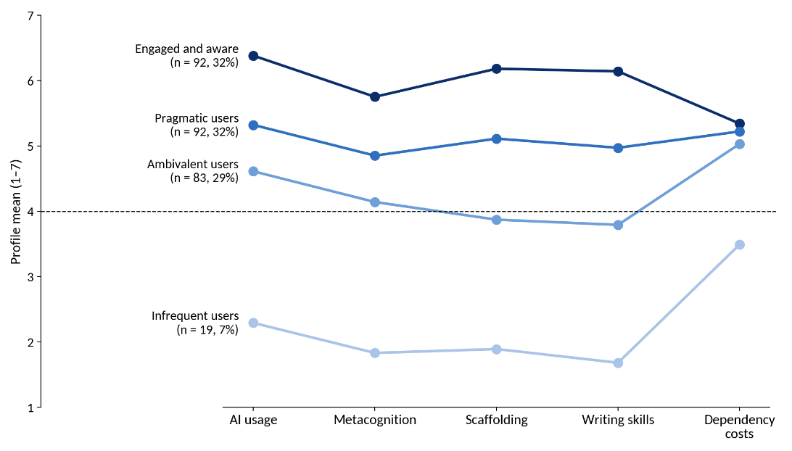
Fig. 9. Construct means for the four learner profiles

Interpretation. The four-profile solution identified distinct patterns of reported AI usage and perceived benefits. The engaged and aware profile (n = 92, 32%) reported the highest AI usage, perceived scaffolding and self-assessed writing skills and confidence. Pragmatic users (n = 92, 32%) reported moderately high scores across these constructs, while ambivalent users (n = 83, 29%) reported lower perceived benefits despite continued AI usage. Infrequent users (n = 19, 7%) reported the lowest AI usage and perceived benefits. Dependency-cost scores varied less across the three larger profiles than did the benefit-related scores. The Kruskal–Wallis test indicated a difference in dependency costs across the four profiles, H(3) = 14.1, p = .003. These profiles are exploratory, sample-derived groupings and should not be treated as fixed categories of students without replication in an independent sample.

5. Discussion

This study examined university students' perceptions of generative AI use, metacognitive regulation, perceived scaffolding, self-assessed writing skills and confidence, and perceived dependency costs. The findings indicate that greater AI usage was associated with greater perceived scaffolding, which was in turn associated with more positive self-assessments of writing. In contrast, use of AI for metacognitive regulation did not show a statistically significant unique association with self-assessed writing when the other predictors were included in the model. Perceived dependency costs did not significantly moderate the association between AI usage and self-assessed writing. These results suggest that perceived benefits and dependency concerns can coexist, but the cross-sectional, self-reported design does not establish causal effects or demonstrate changes in objectively measured writing ability.

5.1 Perceived scaffolding as the main statistical pathway
The main finding is that perceived AI scaffolding accounted for a substantial part of the statistical association between AI use and self-assessed writing skills and confidence. AI use was positively associated with perceived scaffolding, and perceived scaffolding was positively associated with self-assessed writing. By contrast, use of AI for metacognitive regulation did not make a statistically significant unique contribution to self-assessed writing when the other predictors were included. This pattern is consistent with the idea that students' perceived benefits depend not only on how often they use AI but also on whether they experience it as useful guidance. However, the cross-sectional design cannot establish that scaffolding produces writing development, and the outcome reflects students' self-assessments rather than independently evaluated writing performance.
The direct association between AI use and self-assessed writing skills and confidence (H5) was small. It remained significant after outliers were excluded, but the lower bound of its confidence interval was close to zero, so it should be interpreted with caution. The pattern suggests that the perceived benefits of AI-assisted writing depend less on use as such than on the guidance students feel they receive. This reading fits research on ChatGPT-assisted writing instruction (Song & Song, 2023; Teng, 2024) and AI-generated feedback (Escalante et al., 2023), which points to the value of structured guidance and feedback for writing development.
Pea's (2004) distinction is useful here. What students describe resembles scaffolding in its contingency, since support arrives when and where they need it. Nothing in the data, however, indicates that this support fades over time, and fading is the condition under which scaffolding builds independent capability rather than becoming a permanent prop.

5.2 AI support concentrated in the performance phase
AI use was strongly associated with the use of AI for metacognitive regulation (H1): students who used AI more also brought it more often into planning, monitoring and reflecting on their writing. This is consistent with evidence that ChatGPT acceptance is linked to intentions to use it for metacognitive self-regulated learning (Dahri et al., 2024) and that generative AI creates new metacognitive demands and opportunities for its users (Tankelevitch et al., 2024). A high META score therefore indicates greater AI involvement in regulation, not stronger regulation. Whether that involvement extends students' own regulation or replaces part of it cannot be determined from self-report alone, and both may occur in the same student. Use of AI for metacognitive regulation was not uniquely associated with self-assessed writing once scaffolding was accounted for (H2), and the phase analysis suggests one reason. Students reported involving AI mostly to check their work as they wrote, for example confirming that their arguments held together or resolving questions on the spot, and much less in planning or in reflecting afterwards (RQ1).
This pattern is consistent with experimental evidence. In a quasi-experiment with EFL learners, AI support improved planning and evaluation but not monitoring, and chat logs showed students handing real-time regulation to the AI for validation (Chen, 2026). In a laboratory study, AI support reduced evaluation and other metacognitive activity even as essay scores rose (Fan et al., 2025). The present data add a field-based perspective: the phase in which students most often involve AI is also the phase in which displacement is most likely. When AI checks whether an argument makes sense, it may perform part of the monitoring the student would otherwise do, and students may experience this as support while practising the skill less (Risko & Gilbert, 2016).
Zimmerman's (2000, 2002) model places the engine of self-regulatory growth in the forethought and self-reflection phases, where goals are set and outcomes are evaluated and attributed. These were the phases students least associated with AI, although reflection was measured by a single item here. Designs that use AI to prompt students' own planning and reflection, rather than to carry out these steps for them, such as guidance mechanisms (Lee et al., 2024) and prompts that ask learners to justify or evaluate before receiving help (Lukešová & Jennings, 2026), target exactly this gap. Reviews of AI-supported self-regulated learning reach a similar conclusion: AI works best when regulation stays with the learner (Lan & Zhou, 2025; Wang et al., 2025).
The high endorsement of critically evaluating AI output (META8) should be read with caution. Students often report regulating their thinking or checking their work more than they actually do in real tasks (Winne, 2010), and process-level studies show that the way students evaluate AI output varies considerably from one learner to another (Yao et al., 2025; Teng, 2025a, 2025b).

5.3 Benefit and dependency coexist
H4 proposed that perceived dependency costs would weaken the positive association between AI use and self-assessed writing, but the results did not support this prediction. The association remained almost unchanged across low, average and high levels of perceived dependency. Perceived dependency costs rose slightly with greater AI use, yet this did not translate into a weaker link between use and self-assessed writing. The profile analysis offers a complementary view: the three more frequent user profiles differed by more than two points on perceived scaffolding and self-assessed writing, yet by only 0.31 points on perceived dependency costs (RQ2). Students' perceived benefits from AI can therefore differ considerably while their concern about dependence stays much the same.
The null moderation result is informative, but its scope is limited. The 95% confidence interval for the interaction (−0.05 to 0.06) implies that a one-standard-deviation difference in perceived dependency costs changes the AI–writing slope by no more than about −0.07 to +0.09 scale points, roughly a tenth of the average slope (0.69). Large buffering or amplifying effects are therefore unlikely in this sample, but smaller ones cannot be ruled out: a sensitivity analysis indicates that, with N = 286, the test had 80% power only for interactions of f² ≥ .028 (α = .05), and composite scores, which ignore measurement error, further attenuate interaction estimates (Marsh et al., 2004). More fundamentally, the outcome was self-assessed writing, and the dependency measure captures perceived rather than demonstrated dependency. The finding shows that students' awareness of dependency costs does not weaken their sense of benefit; it does not show that dependency is harmless. Reliance on AI could still erode independent writing performance, which this study did not measure, and the experimental evidence reviewed in Section 2.4 suggests that it can (Darvishi et al., 2024; Bastani et al., 2025; Fan et al., 2025).
This coexistence is consistent with the weak link between perceived cost and intention to use generative AI (Chan & Zhou, 2023) and with evidence that students continue to use ChatGPT while acknowledging its ethical and academic risks (Acosta-Enriquez et al., 2024; Ortiz-Bonnin & Blahopoulou, 2025). It may also help reconcile two strands of literature that otherwise point in opposite directions. Benefit-oriented studies find that generative AI improves writing (Song & Song, 2023; Teng, 2024), whereas dependency-oriented studies find that it undermines learning once support is withdrawn (Darvishi et al., 2024; Bastani et al., 2025). The present data suggest that both processes may operate within the same students at the same time, rather than in different students or as a simple trade-off.
Why, then, does awareness not necessarily prevent over-reliance on AI? Research on automation suggests that people may become overly reliant on helpful technologies even when they are aware of their limitations (Parasuraman & Manzey, 2010). One possible explanation is that the immediate benefits of using these tools, such as reduced effort and faster task completion, are easy to recognise, whereas the potential long-term costs to memory and independent skill development are less visible (Sparrow et al., 2011; Grinschgl et al., 2021). In the context of large language models, this distinction is particularly important because students may experience improvements in task performance without fully recognising how AI assistance influences their own thinking and learning processes (Stadler et al., 2024). Greater trust in AI may also reduce the extent to which users critically evaluate its outputs (Lee et al., 2025). Evidence from correlational studies, reviews, and neurophysiological research further raises questions about the implications of AI-assisted work for critical thinking and cognitive engagement, although these findings differ in scope and strength (Gerlich, 2025; Zhai et al., 2024; Kosmyna et al., 2025). Moreover, reliance on AI may be shaped by factors such as academic pressure, stress, and the desire to perform well, which metacognitive awareness alone may not adequately address (Zhang et al., 2024; Abbas et al., 2024).
The profiles reveal heterogeneity that variable-centred models miss. The engaged and aware group (32%) reported both the highest benefit and the highest concern, resembling the strategic users described by Nguyen et al. (2024), who collaborate with AI iteratively. The ambivalent group (29%) used AI without experiencing it as scaffolding, a pattern more consistent with substitution than with support. Differences previously reported between users and non-users (Blahopoulou & Ortiz-Bonnin, 2025) therefore extend to differences among users, which a single dependence scale would obscure (Morales-García et al., 2024).

5.4 Theoretical contributions
The study makes three theoretical contributions. First, it extends SRL theory to AI-mediated writing by showing that students report AI involvement unevenly across Zimmerman's phases, concentrating it in the phase where, theoretically, displacement of the learner's own regulation is most likely (Zimmerman, 2000; Pintrich, 2004; Panadero, 2017). Second, it operationalises the ZPD-based idea of AI as scaffold as a measurable perception and tests it as a statistical mediator, while identifying fading as the condition that current accounts of AI scaffolding leave unaddressed (Vygotsky, 1978; Pea, 2004; Puntambekar & Hübscher, 2005). Third, it offers a dual-pathway account in which perceived benefit and perceived cost behave as separate dimensions rather than as ends of one continuum, consistent with hybrid-intelligence frameworks that call for deliberate, staged regulation between learner and AI (Molenaar, 2022a, 2022b; Järvelä et al., 2023).
Methodologically, the study offers a 31-item, five-construct instrument that showed acceptable fit and high reliability and that measures perceived benefit and perceived dependency as separate dimensions. Its development also illustrates a risk: although cost items were written into the questionnaire from the outset, the a priori structure scored them together with the benefit items, and that structure fitted poorly and would have hidden the coexistence finding. Measuring costs directly is therefore necessary but not sufficient; they also need to be modelled as a dimension separate from benefit. Because the final structure was derived and evaluated on the same sample, and discriminant validity among the benefit constructs was only partly supported, it should be confirmed in an independent sample before wider use.

5.5 Practical implications
Although the cross-sectional design cannot establish causal effects, the findings suggest five implications for instructors and institutions.
- Plan AI use around forethought and reflection. Instructors can ask students to use AI for goal-setting before they begin writing and to submit a short reflection afterwards describing what AI did and did not contribute. These are the phases students in this study least associated with AI.
- Build in fading. Generative AI does not withdraw support on its own, so instructors need to plan that withdrawal, for example by allowing AI feedback on early drafts but not on final submissions, or by narrowing the permitted uses as the semester progresses. Research on cognitive load and the expertise reversal effect indicates that easing support as skill grows is beneficial (Sweller, 1988; Kalyuga, 2007), and attempting a problem before receiving help can strengthen learning (Kapur, 2008).
- Prefer tools with guardrails. Tutors designed to guide students rather than simply supply answers largely prevented the learning losses associated with unrestricted AI access (Bastani et al., 2025). Visualised, sequenced and hybrid feedback designs offer practical models (Zou et al., 2025; Tran, 2025; Zhang et al., 2025).
- Teach AI literacy through regulation. Students in this sample already viewed dependence on AI as costly, so further warnings are likely to add little. AI literacy instruction should focus instead on when and how to use AI so that regulation remains with the learner (Ng et al., 2021; Yan et al., 2024).
- Support the ambivalent group through policy. Almost a third of students (29%) used AI without experiencing it as helpful scaffolding. Institutional frameworks that align pedagogy, governance and everyday practice can make structured, learning-oriented AI use the default rather than the exception (Chan, 2023; Cotton et al., 2024; Kasneci et al., 2023; Dwivedi et al., 2023).
These recommendations align with reviews concluding that the integration design, not the tool, determines whether AI supports writing development (Feng et al., 2025; Crosthwaite & Sun, 2026; Liu & Zhong, 2025; Liu et al., 2024).

5.6 Limitations and future research
Several limitations qualify these conclusions. First, the cross-sectional design supports theory-consistent associations but not causal effects, and the direction of influence between general AI use and its use for metacognitive regulation could run either way (Jin et al., 2025; Maxwell & Cole, 2007). Second, writing skills and confidence were self-assessed, so the findings for H3 and H5 concern perceived rather than measured development, and performance gains with AI should not be equated with learning (Yan et al., 2025). Third, all constructs were self-reported. Although the common method bias tests were reassuring, the strong correlations among the benefit constructs suggest a general favourable appraisal of AI that self-report cannot disentangle (Podsakoff et al., 2012; Winne, 2010), and discriminant validity among use of AI for metacognitive regulation, perceived scaffolding and self-assessed writing was only partly supported. Because no marker variable was included, method variance could not be modelled directly, and response styles such as acquiescence may have contributed to the small positive correlations between benefit and dependency perceptions; the coexistence finding should therefore be confirmed in designs that include a marker variable and model response styles explicitly.
Fourth, the measurement model was refined and evaluated on the same dataset, and competing higher-order and bifactor structures were not tested, so the instrument requires cross-validation in an independent sample. Fifth, the self-reflection phase was represented by a single item (META7) after refinement, which limits the precision of the phase comparison. Sixth, the sample was recruited by convenience, mainly in India with some respondents studying elsewhere, and no demographic information was collected. The proportion of international respondents and any differences by country, institution, discipline, gender or year of study therefore cannot be examined, and the findings should not be generalised to university students in India or elsewhere as a whole. Because all respondents were AI users, the findings also do not describe students who avoid these tools. Seventh, H4 was tested with composite scores, which do not account for measurement error in the interaction term and may reduce the power to detect moderation (Marsh et al., 2004). Finally, although overall model fit was acceptable, the TLI of .89 indicates room for improvement, and the small direct path from AI use to self-assessed writing (H5) had a confidence interval close to zero.
Future research should follow students over time to establish whether perceived scaffolding fades into independent capability or hardens into dependence. Combining surveys with records of actual AI interaction, as in Nguyen et al. (2024) and Fan et al. (2025), would show how students use AI rather than how they say they use it. Writing quality should be assessed directly through rubric-scored tasks completed without AI (Chen, 2026), and experiments that vary the level and fading of AI support could test the causal claims implied here (Bastani et al., 2025). The instrument should be validated in independent samples, including tests of higher-order and bifactor structures and of latent interactions, and replication across institutions, disciplines and countries, with demographic data collected, would show whether the coexistence of benefit and dependency holds in other settings (Chan & Hu, 2023; Strzelecki, 2024).

6. Conclusion

This study examined university students’ perceptions of generative AI as a source of scaffolding and potential dependency costs in academic writing. Greater AI tool usage was positively associated with perceived AI scaffolding, which was in turn positively associated with self-assessed writing skills and confidence. The indirect association through scaffolding was statistically significant, whereas the indirect association through metacognitive regulation was not. Perceived dependency costs did not significantly moderate the association between AI usage and self-assessed writing. Students also reported greater AI involvement during monitoring than during planning or reflection.

The exploratory profile analysis suggested that students show different combinations of perceived AI benefits and dependency costs. However, the four-profile solution was retained for interpretability and parsimony rather than because it was the unambiguous BIC-preferred model. The profile findings should therefore be treated as exploratory and require further validation.

These findings describe relationships among students’ perceptions; they do not establish that AI causes improvements in writing, develops independent metacognitive ability, or produces dependency. The cross-sectional design, self-reported measures, convenience sample, borderline model fit and partial discriminant validity among benefit-related constructs limit the conclusions that can be drawn. Future research should use longitudinal or experimental designs, direct assessments of writing completed without AI, and independent samples to examine whether perceived scaffolding translates into sustained writing development and how dependency concerns relate to actual writing practices.

Declarations

Data availability. The anonymised dataset supporting the findings of this study is available from the corresponding author on reasonable request, subject to applicable privacy and ethical requirements.

Competing interests. The authors declare that they have no competing interests.

Funding. This research received no specific grant from any funding agency in the public, commercial, or not-for-profit sectors.

Author contributions. Rohit Vinod, Abhay Vineetha Anil, and Bharat Suresh Kumar contributed to the research and preparation of the manuscript.

Use of generative AI. Generative AI tools were used to assist with manuscript editing and revision. The authors are responsible for verifying the accuracy of the analysis, interpretations, references, and final manuscript.

References
Abbas, M., Jam, F. A., & Khan, T. I. (2024). Is it harmful or helpful? Examining the causes and consequences of generative AI usage among university students. International Journal of Educational Technology in Higher Education, 21(1), 10. https://doi.org/10.1186/s41239-024-00444-7
Acosta-Enriquez, B. G., Arbulú Ballesteros, M. A., Arbulu Perez Vargas, C. G., Orellana Ulloa, M. N., Gutiérrez Ulloa, C. R., Pizarro Romero, J. M., Gutiérrez Jaramillo, N. D., Cuenca Orellana, H. U., Ayala Anzoátegui, D. X., & López Roca, C. (2024). Knowledge, attitudes, and perceived ethics regarding the use of ChatGPT among generation Z university students. International Journal for Educational Integrity, 20(1), 10. https://doi.org/10.1007/s40979-024-00157-4
Aiken, L. S., & West, S. G. (1991). Multiple regression: Testing and interpreting interactions. Sage.
Anderson, J. C., & Gerbing, D. W. (1988). Structural equation modeling in practice: A review and recommended two-step approach. Psychological Bulletin, 103(3), 411–423. https://doi.org/10.1037/0033-2909.103.3.411
Azevedo, R., & Hadwin, A. F. (2005). Scaffolding self-regulated learning and metacognition: Implications for the design of computer-based scaffolds. Instructional Science, 33(5–6), 367–379. https://doi.org/10.1007/s11251-005-1272-9
Barrett, A., & Pack, A. (2023). Not quite eye to A.I.: Student and teacher perspectives on the use of generative artificial intelligence in the writing process. International Journal of Educational Technology in Higher Education, 20, 59. https://doi.org/10.1186/s41239-023-00427-0
Bastani, H., Bastani, O., Sungu, A., Ge, H., Kabakcı, Ö., & Mariman, R. (2025). Generative AI without guardrails can harm learning: Evidence from high school mathematics. Proceedings of the National Academy of Sciences, 122(26), e2422633122. https://doi.org/10.1073/pnas.2422633122
Bauer, D. J., & Curran, P. J. (2005). Probing interactions in fixed and multilevel regression: Inferential and graphical techniques. Multivariate Behavioral Research, 40(3), 373–400. https://doi.org/10.1207/s15327906mbr4003_5
Belland, B. R., Walker, A. E., Kim, N. J., & Lefler, M. (2017). Synthesizing results from empirical research on computer-based scaffolding in STEM education: A meta-analysis. Review of Educational Research, 87(2), 309–344. https://doi.org/10.3102/0034654316670999
Blahopoulou, J., & Ortiz-Bonnin, S. (2025). Student perceptions of ChatGPT: Benefits, costs, and attitudinal differences between users and non-users toward AI integration in higher education. Education and Information Technologies. Advance online publication. https://doi.org/10.1007/s10639-025-13575-9
Chan, C. K. Y. (2023). A comprehensive AI policy education framework for university teaching and learning. International Journal of Educational Technology in Higher Education, 20, 38. https://doi.org/10.1186/s41239-023-00408-3
Chan, C. K. Y., & Hu, W. (2023). Students' voices on generative AI: Perceptions, benefits, and challenges in higher education. International Journal of Educational Technology in Higher Education, 20, 43. https://doi.org/10.1186/s41239-023-00411-8
Chan, C. K. Y., & Zhou, W. (2023). An expectancy value theory (EVT) based instrument for measuring student perceptions of generative AI. Smart Learning Environments, 10, 64. https://doi.org/10.1186/s40561-023-00284-4
Chen, M.-R. A. (2026). Generative AI, visual scaffolds, and metacognition in EFL writing. Language Learning & Technology, 30(1), 1–25. https://doi.org/10.64152/10125/73695
Chen, Y., & Shim, J. (2026). From GenAI use to L2 writing performance: A moderated sequential mediation model of self-efficacy and metacognitive strategy use. International Journal of Learning, Teaching and Educational Research, 25(3), 1–18. https://doi.org/10.26803/ijlter.25.3.1
Clark, L. A., & Watson, D. (1995). Constructing validity: Basic issues in objective scale development. Psychological Assessment, 7(3), 309–319. https://doi.org/10.1037/1040-3590.7.3.309
Cotton, D. R. E., Cotton, P. A., & Shipway, J. R. (2024). Chatting and cheating: Ensuring academic integrity in the era of ChatGPT. Innovations in Education and Teaching International, 61(2), 228–239. https://doi.org/10.1080/14703297.2023.2190148
Cronbach, L. J. (1951). Coefficient alpha and the internal structure of tests. Psychometrika, 16(3), 297–334. https://doi.org/10.1007/BF02310555
Crosthwaite, P., & Sun, S. (2026). Generative AI and L2 written feedback studies: A scoping review. RELC Journal, 57(1), 207–219. https://doi.org/10.1177/00336882251386530
Curran, P. G. (2016). Methods for the detection of carelessly invalid responses in survey data. Journal of Experimental Social Psychology, 66, 4–19. https://doi.org/10.1016/j.jesp.2015.07.006
Curran, P. J., West, S. G., & Finch, J. F. (1996). The robustness of test statistics to nonnormality and specification error in confirmatory factor analysis. Psychological Methods, 1(1), 16–29. https://doi.org/10.1037/1082-989X.1.1.16
Dahri, N. A., Yahaya, N., Al-Rahmi, W. M., Aldraiweesh, A., Alturki, U., Almutairy, S., Shutaleva, A., & Soomro, R. B. (2024). Extended TAM based acceptance of AI-powered ChatGPT for supporting metacognitive self-regulated learning in education: A mixed-methods study. Heliyon, 10(8), e29317. https://doi.org/10.1016/j.heliyon.2024.e29317
Darvishi, A., Khosravi, H., Sadiq, S., Gašević, D., & Siemens, G. (2024). Impact of AI assistance on student agency. Computers & Education, 210, 104967. https://doi.org/10.1016/j.compedu.2023.104967
Davis, F. D. (1989). Perceived usefulness, perceived ease of use, and user acceptance of information technology. MIS Quarterly, 13(3), 319–340. https://doi.org/10.2307/249008
Devolder, A., van Braak, J., & Tondeur, J. (2012). Supporting self-regulated learning in computer-based learning environments: Systematic review of effects of scaffolding in the domain of science education. Journal of Computer Assisted Learning, 28(6), 557–573. https://doi.org/10.1111/j.1365-2729.2011.00476.x
Dunn, T. J., Baguley, T., & Brunsden, V. (2014). From alpha to omega: A practical solution to the pervasive problem of internal consistency estimation. British Journal of Psychology, 105(3), 399–412. https://doi.org/10.1111/bjop.12046
Dwivedi, Y. K., Kshetri, N., Hughes, L., et al. (2023). "So what if ChatGPT wrote it?" Multidisciplinary perspectives on opportunities, challenges and implications of generative conversational AI for research, practice and policy. International Journal of Information Management, 71, 102642. https://doi.org/10.1016/j.ijinfomgt.2023.102642
Escalante, J., Pack, A., & Barrett, A. (2023). AI-generated feedback on writing: Insights into efficacy and ENL student preference. International Journal of Educational Technology in Higher Education, 20, 57. https://doi.org/10.1186/s41239-023-00425-2
Fan, Y., Tang, L., Le, H., Shen, K., Tan, S., Zhao, Y., Shen, Y., Li, X., & Gašević, D. (2025). Beware of metacognitive laziness: Effects of generative artificial intelligence on learning motivation, processes, and performance. British Journal of Educational Technology, 56(2), 489–530. https://doi.org/10.1111/bjet.13544
Feng, H., Li, K., & Zhang, L. J. (2025). What does AI bring to second language writing? A systematic review (2014–2024). Language Learning & Technology, 29(1), 1–27. https://doi.org/10.64152/10125/73629
Flavell, J. H. (1979). Metacognition and cognitive monitoring: A new area of cognitive–developmental inquiry. American Psychologist, 34(10), 906–911. https://doi.org/10.1037/0003-066X.34.10.906
Flower, L., & Hayes, J. R. (1981). A cognitive process theory of writing. College Composition and Communication, 32(4), 365–387. https://doi.org/10.2307/356600
Fornell, C., & Larcker, D. F. (1981). Evaluating structural equation models with unobservable variables and measurement error. Journal of Marketing Research, 18(1), 39–50. https://doi.org/10.1177/002224378101800104
Gerlich, M. (2025). AI tools in society: Impacts on cognitive offloading and the future of critical thinking. Societies, 15(1), 6. https://doi.org/10.3390/soc15010006
Graham, S., & Harris, K. R. (2000). The role of self-regulation and transcription skills in writing and writing development. Educational Psychologist, 35(1), 3–12. https://doi.org/10.1207/S15326985EP3501_2
Grinschgl, S., Papenmeier, F., & Meyerhoff, H. S. (2021). Consequences of cognitive offloading: Boosting performance but diminishing memory. Quarterly Journal of Experimental Psychology, 74(9), 1477–1496. https://doi.org/10.1177/17470218211008060
Hair, J. F., Black, W. C., Babin, B. J., & Anderson, R. E. (2019). Multivariate data analysis (8th ed.). Cengage Learning.
Hayes, A. F., & Scharkow, M. (2013). The relative trustworthiness of inferential tests of the indirect effect in statistical mediation analysis: Does method really matter? Psychological Science, 24(10), 1918–1927. https://doi.org/10.1177/0956797613480187
Hayes, J. R. (2012). Modeling and remodeling writing. Written Communication, 29(3), 369–388. https://doi.org/10.1177/0741088312451260
Henseler, J., Ringle, C. M., & Sarstedt, M. (2015). A new criterion for assessing discriminant validity in variance-based structural equation modeling. Journal of the Academy of Marketing Science, 43(1), 115–135. https://doi.org/10.1007/s11747-014-0403-8
Horn, J. L. (1965). A rationale and test for the number of factors in factor analysis. Psychometrika, 30(2), 179–185. https://doi.org/10.1007/BF02289447
Hu, L., & Bentler, P. M. (1999). Cutoff criteria for fit indexes in covariance structure analysis: Conventional criteria versus new alternatives. Structural Equation Modeling, 6(1), 1–55. https://doi.org/10.1080/10705519909540118
Igolkina, A. A., & Meshcheryakov, G. (2020). semopy: A Python package for structural equation modeling. Structural Equation Modeling, 27(6), 952–963. https://doi.org/10.1080/10705511.2019.1704289
Järvelä, S., Nguyen, A., & Hadwin, A. (2023). Human and artificial intelligence collaboration for socially shared regulation in learning. British Journal of Educational Technology, 54(5), 1057–1076. https://doi.org/10.1111/bjet.13325
Jin, F., Lin, C.-H., & Lai, C. (2025). Modeling AI-assisted writing: How self-regulated learning influences writing outcomes. Computers in Human Behavior, 165, 108538. https://doi.org/10.1016/j.chb.2024.108538
Kaiser, H. F. (1974). An index of factorial simplicity. Psychometrika, 39(1), 31–36. https://doi.org/10.1007/BF02291575
Kalyuga, S. (2007). Expertise reversal effect and its implications for learner-tailored instruction. Educational Psychology Review, 19(4), 509–539. https://doi.org/10.1007/s10648-007-9054-3
Kapur, M. (2008). Productive failure. Cognition and Instruction, 26(3), 379–424. https://doi.org/10.1080/07370000802212669
Kasneci, E., Seßler, K., Küchemann, S., Bannert, M., Dementieva, D., Fischer, F., et al. (2023). ChatGPT for good? On opportunities and challenges of large language models for education. Learning and Individual Differences, 103, 102274. https://doi.org/10.1016/j.lindif.2023.102274
Kim, J., Yu, S., Detrick, R., & Li, N. (2025). Exploring students' perspectives on generative AI-assisted academic writing. Education and Information Technologies, 30(1), 1265–1300. https://doi.org/10.1007/s10639-024-12878-7
Kline, R. B. (2023). Principles and practice of structural equation modeling (5th ed.). Guilford Press.
Kosmyna, N., Hauptmann, E., Yuan, Y. T., Situ, J., Liao, X.-H., Beresnitzky, A. V., Braunstein, I., & Maes, P. (2025). Your brain on ChatGPT: Accumulation of cognitive debt when using an AI assistant for essay writing task (arXiv:2506.08872) [Preprint]. arXiv. https://doi.org/10.48550/arXiv.2506.08872
Lan, M., & Zhou, X. (2025). A qualitative systematic review on AI empowered self-regulated learning in higher education. npj Science of Learning, 10(1), 21. https://doi.org/10.1038/s41539-025-00319-0
Lee, H.-P., Sarkar, A., Tankelevitch, L., Drosos, I., Rintel, S., Banks, R., & Wilson, N. (2025). The impact of generative AI on critical thinking: Self-reported reductions in cognitive effort and confidence effects from a survey of knowledge workers. In Proceedings of the 2025 CHI Conference on Human Factors in Computing Systems. ACM. https://doi.org/10.1145/3706598.3713778
Lee, H.-Y., Chen, P.-H., Wang, W.-S., Huang, Y.-M., & Wu, T.-T. (2024). Empowering ChatGPT with guidance mechanism in blended learning: Effect of self-regulated learning, higher-order thinking skills, and knowledge construction. International Journal of Educational Technology in Higher Education, 21(1), 16. https://doi.org/10.1186/s41239-024-00447-4
Liu, M., Zhang, L. J., & Biebricher, C. (2024). Investigating students' cognitive processes in generative AI-assisted digital multimodal composing and traditional writing. Computers & Education, 211, 104977. https://doi.org/10.1016/j.compedu.2023.104977
Liu, X., & Zhong, B. (2025). Integrating generative artificial intelligence into student learning: A systematic review from a TPACK perspective. Educational Research Review, 49, 100741. https://doi.org/10.1016/j.edurev.2025.100741
Lukešová, A., & Jennings, P. J. (2026). Clue before correction: ChatGPT-enhanced strategy for promoting autonomous and reflective language learning. Innovation in Language Learning and Teaching. Advance online publication. https://doi.org/10.1080/17501229.2025.2612532
Mardia, K. V. (1970). Measures of multivariate skewness and kurtosis with applications. Biometrika, 57(3), 519–530. https://doi.org/10.1093/biomet/57.3.519
Marsh, H. W., Wen, Z., & Hau, K.-T. (2004). Structural equation models of latent interactions: Evaluation of alternative estimation strategies and indicator construction. Psychological Methods, 9(3), 275–300. https://doi.org/10.1037/1082-989X.9.3.275
Maxwell, S. E., & Cole, D. A. (2007). Bias in cross-sectional analyses of longitudinal mediation. Psychological Methods, 12(1), 23–44. https://doi.org/10.1037/1082-989X.12.1.23
McKinney, W. (2010). Data structures for statistical computing in Python. In Proceedings of the 9th Python in Science Conference (pp. 56–61). https://doi.org/10.25080/Majora-92bf1922-00a
McNeish, D. (2018). Thanks coefficient alpha, we'll take it from here. Psychological Methods, 23(3), 412–433. https://doi.org/10.1037/met0000144
Meade, A. W., & Craig, S. B. (2012). Identifying careless responses in survey data. Psychological Methods, 17(3), 437–455. https://doi.org/10.1037/a0028085
Molenaar, I. (2022a). Towards hybrid human-AI learning technologies. European Journal of Education, 57(4), 632–645. https://doi.org/10.1111/ejed.12527
Molenaar, I. (2022b). The concept of hybrid human-AI regulation: Exemplifying how to support young learners' self-regulated learning. Computers and Education: Artificial Intelligence, 3, 100070. https://doi.org/10.1016/j.caeai.2022.100070
Morales-García, W. C., Sairitupa-Sanchez, L. Z., Morales-García, S. B., & Morales-García, M. (2024). Development and validation of a scale for dependence on artificial intelligence in university students. Frontiers in Education, 9, 1323898. https://doi.org/10.3389/feduc.2024.1323898
Nevitt, J., & Hancock, G. R. (2001). Performance of bootstrapping approaches to model test statistics and parameter standard error estimation in structural equation modeling. Structural Equation Modeling, 8(3), 353–377. https://doi.org/10.1207/S15328007SEM0803_2
Ng, D. T. K., Leung, J. K. L., Chu, S. K. W., & Qiao, M. S. (2021). Conceptualizing AI literacy: An exploratory review. Computers and Education: Artificial Intelligence, 2, 100041. https://doi.org/10.1016/j.caeai.2021.100041
Nguyen, A., Hong, Y., Dang, B., & Huang, X. (2024). Human-AI collaboration patterns in AI-assisted academic writing. Studies in Higher Education, 49(5), 847–864. https://doi.org/10.1080/03075079.2024.2323593
Nylund, K. L., Asparouhov, T., & Muthén, B. O. (2007). Deciding on the number of classes in latent class analysis and growth mixture modeling: A Monte Carlo simulation study. Structural Equation Modeling, 14(4), 535–569. https://doi.org/10.1080/10705510701575396
Ortiz-Bonnin, S., & Blahopoulou, J. (2025). Chat or cheat? Academic dishonesty, risk perceptions, and ChatGPT usage in higher education students. Social Psychology of Education, 28, 113. https://doi.org/10.1007/s11218-025-10080-2
Panadero, E. (2017). A review of self-regulated learning: Six models and four directions for research. Frontiers in Psychology, 8, 422. https://doi.org/10.3389/fpsyg.2017.00422
Parasuraman, R., & Manzey, D. H. (2010). Complacency and bias in human use of automation: An attentional integration. Human Factors, 52(3), 381–410. https://doi.org/10.1177/0018720810376055
Pea, R. D. (2004). The social and technological dimensions of scaffolding and related theoretical concepts for learning, education, and human activity. Journal of the Learning Sciences, 13(3), 423–451. https://doi.org/10.1207/s15327809jls1303_6
Pedregosa, F., Varoquaux, G., Gramfort, A., et al. (2011). Scikit-learn: Machine learning in Python. Journal of Machine Learning Research, 12, 2825–2830. https://jmlr.org/papers/v12/pedregosa11a.html
Pintrich, P. R. (2004). A conceptual framework for assessing motivation and self-regulated learning in college students. Educational Psychology Review, 16(4), 385–407. https://doi.org/10.1007/s10648-004-0006-x
Podsakoff, P. M., MacKenzie, S. B., Lee, J.-Y., & Podsakoff, N. P. (2003). Common method biases in behavioral research: A critical review of the literature and recommended remedies. Journal of Applied Psychology, 88(5), 879–903. https://doi.org/10.1037/0021-9010.88.5.879
Podsakoff, P. M., MacKenzie, S. B., & Podsakoff, N. P. (2012). Sources of method bias in social science research and recommendations on how to control it. Annual Review of Psychology, 63, 539–569. https://doi.org/10.1146/annurev-psych-120710-100452
Preacher, K. J., & Hayes, A. F. (2008). Asymptotic and resampling strategies for assessing and comparing indirect effects in multiple mediator models. Behavior Research Methods, 40(3), 879–891. https://doi.org/10.3758/BRM.40.3.879
Puntambekar, S., & Hübscher, R. (2005). Tools for scaffolding students in a complex learning environment: What have we gained and what have we missed? Educational Psychologist, 40(1), 1–12. https://doi.org/10.1207/s15326985ep4001_1
Reiser, B. J. (2004). Scaffolding complex learning: The mechanisms of structuring and problematizing student work. Journal of the Learning Sciences, 13(3), 273–304. https://doi.org/10.1207/s15327809jls1303_2
Risko, E. F., & Gilbert, S. J. (2016). Cognitive offloading. Trends in Cognitive Sciences, 20(9), 676–688. https://doi.org/10.1016/j.tics.2016.07.002
Rodriguez, A., Reise, S. P., & Haviland, M. G. (2016). Evaluating bifactor models: Calculating and interpreting statistical indices. Psychological Methods, 21(2), 137–150. https://doi.org/10.1037/met0000045
Rönkkö, M., & Cho, E. (2022). An updated guideline for assessing discriminant validity. Organizational Research Methods, 25(1), 6–47. https://doi.org/10.1177/1094428120968614
Schafer, J. L., & Graham, J. W. (2002). Missing data: Our view of the state of the art. Psychological Methods, 7(2), 147–177. https://doi.org/10.1037/1082-989X.7.2.147
Schraw, G., & Dennison, R. S. (1994). Assessing metacognitive awareness. Contemporary Educational Psychology, 19(4), 460–475. https://doi.org/10.1006/ceps.1994.1033
Seabold, S., & Perktold, J. (2010). Statsmodels: Econometric and statistical modeling with Python. In Proceedings of the 9th Python in Science Conference (pp. 92–96). https://doi.org/10.25080/Majora-92bf1922-011
Song, C., & Song, Y. (2023). Enhancing academic writing skills and motivation: Assessing the efficacy of ChatGPT in AI-assisted language learning for EFL students. Frontiers in Psychology, 14, 1260843. https://doi.org/10.3389/fpsyg.2023.1260843
Sparrow, B., Liu, J., & Wegner, D. M. (2011). Google effects on memory: Cognitive consequences of having information at our fingertips. Science, 333(6043), 776–778. https://doi.org/10.1126/science.1207745
Spurk, D., Hirschi, A., Wang, M., Valero, D., & Kauffeld, S. (2020). Latent profile analysis: A review and "how to" guide of its application within vocational behavior research. Journal of Vocational Behavior, 120, 103445. https://doi.org/10.1016/j.jvb.2020.103445
Stadler, M., Bannert, M., & Sailer, M. (2024). Cognitive ease at a cost: LLMs reduce mental effort but compromise depth in student scientific inquiry. Computers in Human Behavior, 160, 108386. https://doi.org/10.1016/j.chb.2024.108386
Strzelecki, A. (2024). To use or not to use ChatGPT in higher education? A study of students' acceptance and use of technology. Interactive Learning Environments, 32(9), 5142–5155. https://doi.org/10.1080/10494820.2023.2209881
Su, Y., Lin, Y., & Lai, C. (2023). Collaborating with ChatGPT in argumentative writing classrooms. Assessing Writing, 57, 100752. https://doi.org/10.1016/j.asw.2023.100752
Sun, Q., & Zhang, L. J. (2023). Examining the effects of English as a foreign language student-writers' metacognitive experiences on their writing performance. Current Psychology, 42(27), 23743–23758. https://doi.org/10.1007/s12144-022-03416-0
Sweller, J. (1988). Cognitive load during problem solving: Effects on learning. Cognitive Science, 12(2), 257–285. https://doi.org/10.1207/s15516709cog1202_4
Tankelevitch, L., Kewenig, V., Simkute, A., Scott, A. E., Sarkar, A., Sellen, A., & Rintel, S. (2024). The metacognitive demands and opportunities of generative AI. In Proceedings of the CHI Conference on Human Factors in Computing Systems. ACM. https://doi.org/10.1145/3613904.3642902
Teng, L. S., & Zhang, L. J. (2018). Effects of motivational regulation strategies on writing performance: A mediation model of self-regulated learning of writing in English as a second/foreign language. Metacognition and Learning, 13(2), 213–240. https://doi.org/10.1007/s11409-017-9171-4
Teng, M. F. (2024). "ChatGPT is the companion, not enemies": EFL learners' perceptions and experiences in using ChatGPT for feedback in writing. Computers and Education: Artificial Intelligence, 7, 100270. https://doi.org/10.1016/j.caeai.2024.100270
Teng, M. F. (2025a). Metacognitive awareness and EFL learners' perceptions and experiences in utilising ChatGPT for writing feedback. European Journal of Education, 60(1), e12811. https://doi.org/10.1111/ejed.12811
Teng, M. F. (2025b). Understanding EFL student writers' metacognitive awareness in utilizing ChatGPT. System, 135, 103848. https://doi.org/10.1016/j.system.2025.103848
Teng, M. F., Qin, C., & Wang, C. (2022). Validation of metacognitive academic writing strategies and the predictive effects on academic writing performance in a foreign language context. Metacognition and Learning, 17(1), 167–190. https://doi.org/10.1007/s11409-022-09328-5
Tran, T. T. T. (2025). Enhancing EFL writing revision practices: The impact of AI- and teacher-generated feedback and their sequences. Education Sciences, 15(2), 232. https://doi.org/10.3390/educsci15020232
van de Pol, J., Volman, M., & Beishuizen, J. (2010). Scaffolding in teacher–student interaction: A decade of research. Educational Psychology Review, 22(3), 271–296. https://doi.org/10.1007/s10648-010-9127-6
Virtanen, P., Gommers, R., Oliphant, T. E., et al. (2020). SciPy 1.0: Fundamental algorithms for scientific computing in Python. Nature Methods, 17(3), 261–272. https://doi.org/10.1038/s41592-019-0686-2
Vygotsky, L. S. (1978). Mind in society: The development of higher psychological processes. Harvard University Press.
Wang, P., Liu, T., Yang, Y., & Xiang, X. (2025). Optimizing self-regulated learning: A mixed-methods study on GAI's impact on undergraduate task strategies and metacognition. British Journal of Educational Technology. Advance online publication. https://doi.org/10.1111/bjet.70018
Winne, P. H. (2010). Improving measurements of self-regulated learning. Educational Psychologist, 45(4), 267–276. https://doi.org/10.1080/00461520.2010.517150
Wolf, E. J., Harrington, K. M., Clark, S. L., & Miller, M. W. (2013). Sample size requirements for structural equation models: An evaluation of power, bias, and solution propriety. Educational and Psychological Measurement, 73(6), 913–934. https://doi.org/10.1177/0013164413495237
Wood, D., Bruner, J. S., & Ross, G. (1976). The role of tutoring in problem solving. Journal of Child Psychology and Psychiatry, 17(2), 89–100. https://doi.org/10.1111/j.1469-7610.1976.tb00381.x
Yan, L., Greiff, S., Lodge, J. M., & Gašević, D. (2025). Distinguishing performance gains from learning when using generative AI. Nature Reviews Psychology, 4, 435–436. https://doi.org/10.1038/s44159-025-00467-5
Yan, L., Greiff, S., Teuber, Z., & Gašević, D. (2024). Promises and challenges of generative artificial intelligence for human learning. Nature Human Behaviour, 8(10), 1839–1850. https://doi.org/10.1038/s41562-024-02004-5
Yao, Y., Sun, Y., Zhu, S., & Zhu, X. (2025). A qualitative inquiry into metacognitive strategies of postgraduate students in employing ChatGPT for English academic writing. European Journal of Education, 60(1), e12824. https://doi.org/10.1111/ejed.12824
Zawacki-Richter, O., Marín, V. I., Bond, M., & Gouverneur, F. (2019). Systematic review of research on artificial intelligence applications in higher education – where are the educators? International Journal of Educational Technology in Higher Education, 16, 39. https://doi.org/10.1186/s41239-019-0171-0
Zhai, C., Wibowo, S., & Li, L. D. (2024). The effects of over-reliance on AI dialogue systems on students' cognitive abilities: A systematic review. Smart Learning Environments, 11, 28. https://doi.org/10.1186/s40561-024-00316-7
Zhang, S., Zhao, X., Zhou, T., & Kim, J. H. (2024). Do you have AI dependency? The roles of academic self-efficacy, academic stress, and performance expectations on problematic AI usage behavior. International Journal of Educational Technology in Higher Education, 21, 34. https://doi.org/10.1186/s41239-024-00467-0
Zhang, Z., Aubrey, S., Huang, X., & Chiu, T. K. F. (2025). The role of generative AI and hybrid feedback in improving L2 writing skills: A comparative study. Innovation in Language Learning and Teaching. Advance online publication. https://doi.org/10.1080/17501229.2025.2503890
Zhao, X., Lynch, J. G., & Chen, Q. (2010). Reconsidering Baron and Kenny: Myths and truths about mediation analysis. Journal of Consumer Research, 37(2), 197–206. https://doi.org/10.1086/651257
Zimmerman, B. J. (2000). Attaining self-regulation: A social cognitive perspective. In M. Boekaerts, P. R. Pintrich, & M. Zeidner (Eds.), Handbook of self-regulation (pp. 13–39). Academic Press. https://doi.org/10.1016/B978-012109890-2/50031-7
Zimmerman, B. J. (2002). Becoming a self-regulated learner: An overview. Theory Into Practice, 41(2), 64–70. https://doi.org/10.1207/s15430421tip4102_2
Zimmerman, B. J., & Risemberg, R. (1997). Becoming a self-regulated writer: A social cognitive perspective. Contemporary Educational Psychology, 22(1), 73–101. https://doi.org/10.1006/ceps.1997.0919
Zou, B., Wang, C., He, H., Li, C., Purwanto, E., & Wang, P. (2025). Enhancing EFL writing with visualised GenAI feedback: A cognitive affective theory of learning perspective on revision quality, emotional response, and human-computer interaction. Learning and Motivation, 91, 102158. https://doi.org/10.1016/j.lmot.2025.102158

Appendix A. Supplementary measurement results
Table A1. Standardised factor loadings of the final 31-item measurement model
Construct | Items | Standardised loadings (λ)
AI tool usage | AI1–AI8 | AI1 .84; AI2 .78; AI3 .74; AI4 .77; AI5 .76; AI6 .78; AI7 .80; AI8 .71
Use of AI for metacognitive regulation | META1–META7 | META1 .71; META2 .72; META3 .79; META4 .81; META5 .78; META6 .81; META7 .60
Perceived AI scaffolding | SCF1–SCF8 | SCF1 .77; SCF2 .80; SCF3 .79; SCF4 .76; SCF5 .80; SCF6 .85; SCF7 .79; SCF8 .77
Self-assessed writing skills and confidence | AW1–AW4 | AW1 .87; AW2 .89; AW3 .86; AW4 .82
Perceived dependency costs | AW5–AW8 | AW5 .52; AW6 .73; AW7 .96; AW8 .93
Note. All loadings were significant (p < .001). META8–META10 were removed from the final model (Section 4.2.2).
Table A2. Latent correlations, square roots of AVE and HTMT ratios
Construct | AI | META | SCF | AW | DEP
AI | [.77] | .77 | .74 | .72 | .21
META | .77 | [.75] | .79 | .70 | .20
SCF | .74 | .79 | [.79] | .83 | .23
AW | .71 | .70 | .82 | [.86] | .37
DEP | .17 | .14 | .16 | .28 | [.80]
Note. Values below the diagonal are latent correlations, values on the diagonal (in brackets) are square roots of AVE, and values above the diagonal are HTMT ratios. AI = AI tool usage; META = use of AI for metacognitive regulation; SCF = perceived AI scaffolding; AW = self-assessed writing skills and confidence; DEP = perceived dependency costs.

