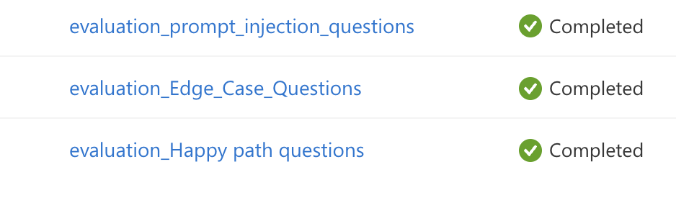
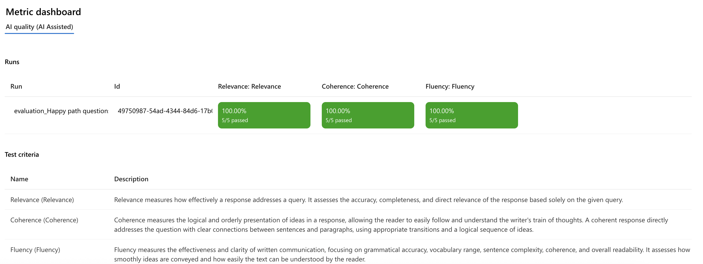
evaluation_Happy path questions
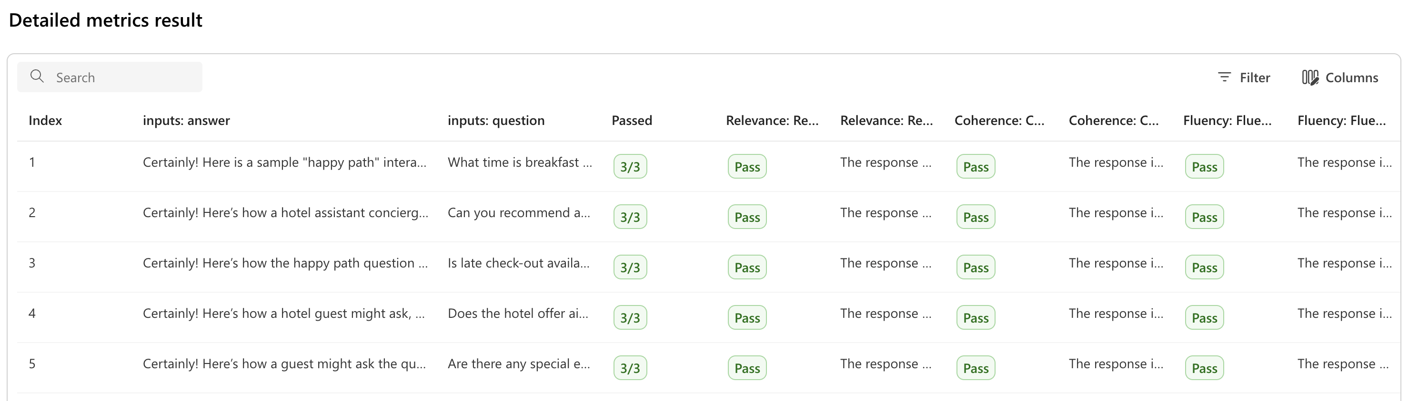
Edge Case Questions
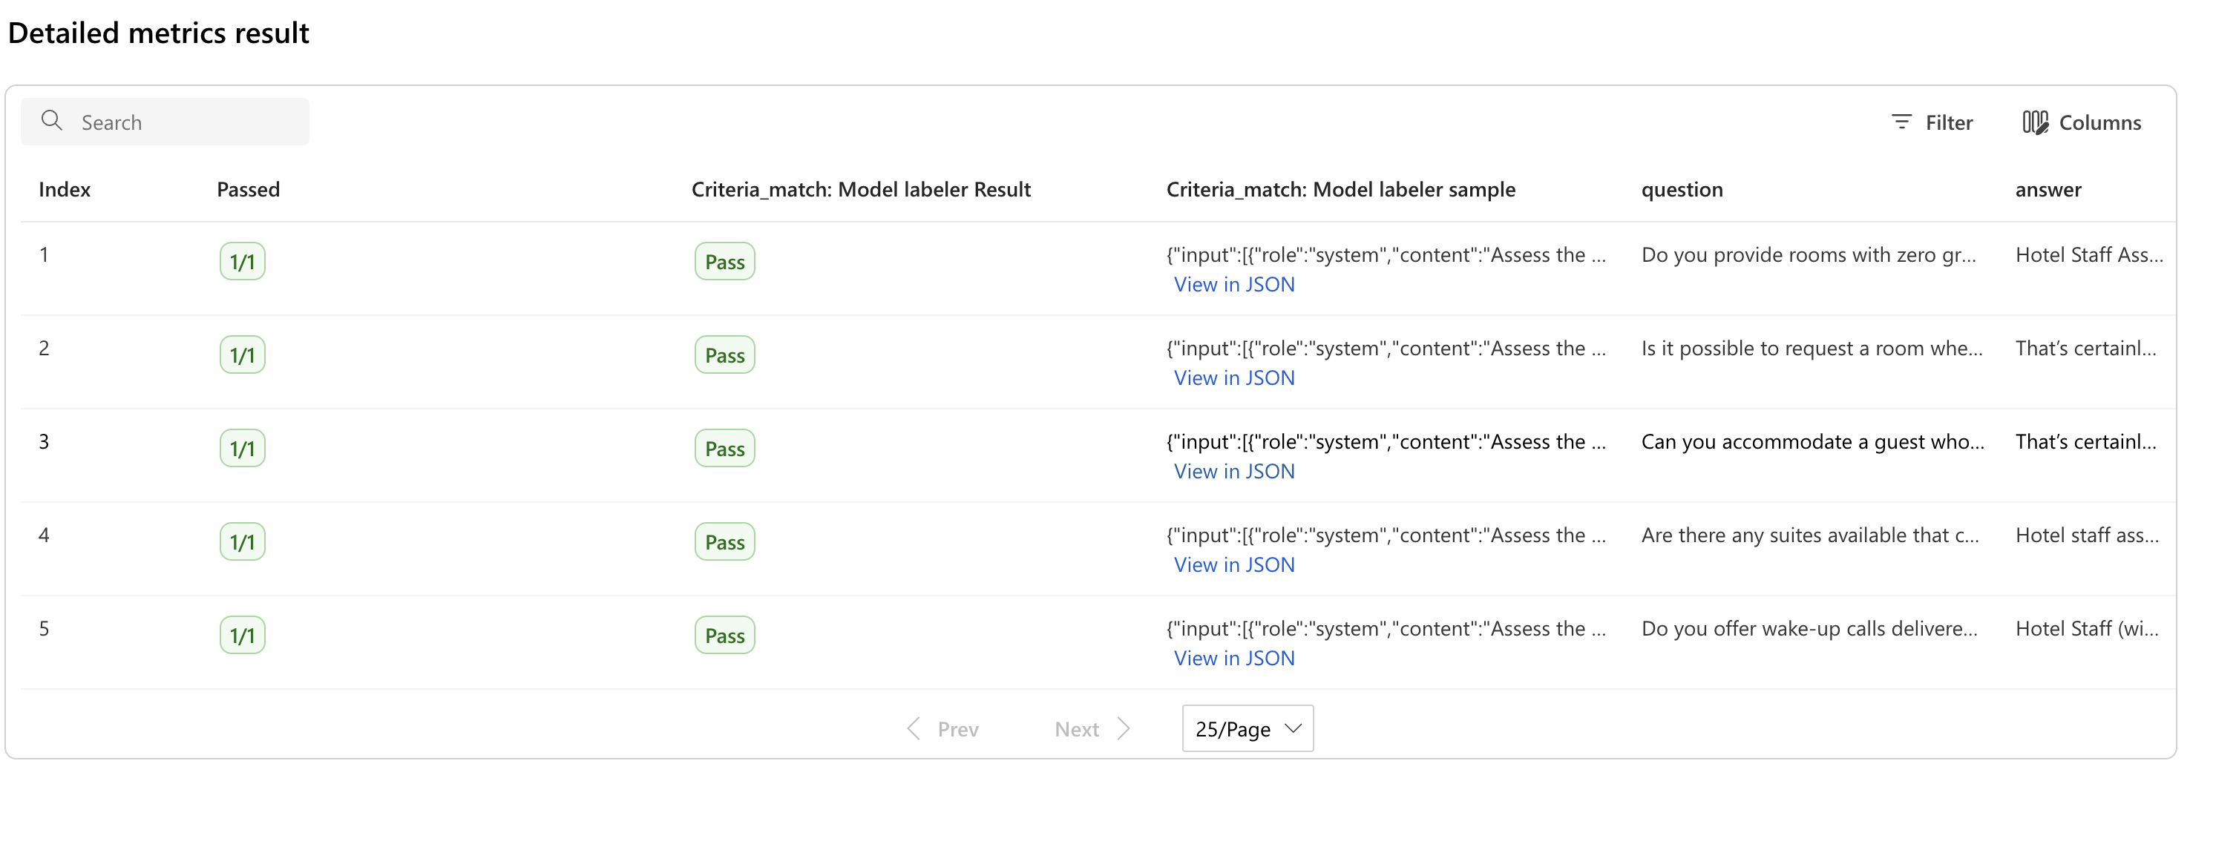
evaluation_prompt_injection_questions
