**Duplicate File Detector Date : 9 – 11 - 2018**

This application find Duplicate files in specify Folder. All kind of file will be detector like .txt, .jpg, .exe…

**Features:**

* Proper display the list of duplicate file.
* After searching you can double click the file to open the directory where this file is present.

**Project Screenshot**

1. First Look of Duplicate File Detector

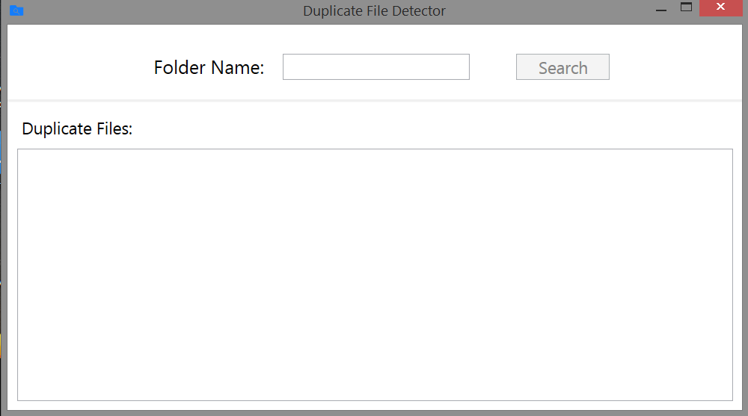

2. Duplicate Files are listed

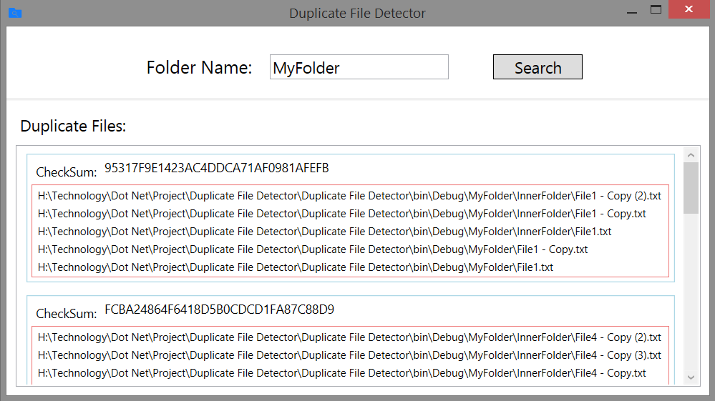

3. Photo file is also be detector

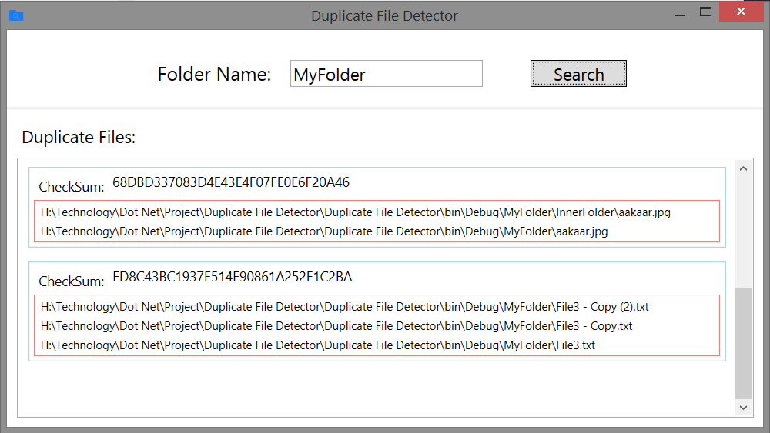

6. You can open displayed file by double clicking it.

File is open in explorer.exe. You can then decide to delete or not to delete file.

