**EMI Calculator Date : 10 – 11 - 2018**

This project is demonstration of Client-Server Application.

This Application is use to calculate EMI. ROI value is fetch from the server.

**Features:**

* Socket Programming.
* Server fetch ROI value from XML. So if we change the value in XML Then change will reflect to client.

**Project Screenshot**

1. First Look of EMI Calculator.

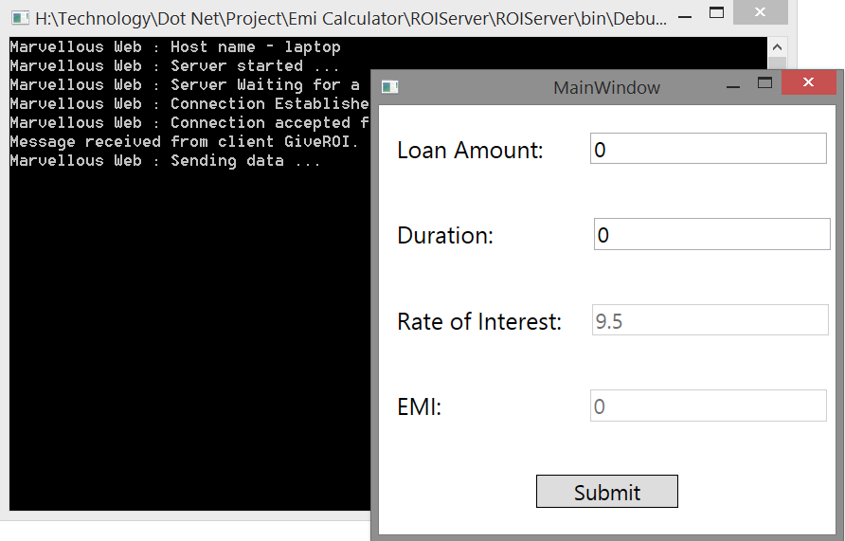

2. EMI Calculation

