**Marvellous Calculator**

It is programmer calculator developed in C# and WPF (Windows Presentation Foundation) using DOT NET framework. Calculator can do all basic operation (+ - * /) as well as all bitwise operation (& | ^ >> <<).

* **Framework:** Dot Net.
* **Front End:** Windows Presentation Foundation (WPF)
* **Back End:** C#.
* **Platform:** Windows.

**Features:**

* Providing all function to programmer.
* Use concept of Explicit Dynamic Linked Library (DLL).
* Function can be add or modify without re-Compiling whole project.
* Operation is done according Precedence Level of operator.
* Providing conversion value into {Binary, Octal, Decimal, Hex}.
* Provided operation on bit.
* All calculation history is save in file when user say 'yes' at time of closing application.
* Flexible GUI.
* Addition Function like (Prime, Factor, …more). And more function can be add in DLL which can be directly added in calculator.

**Project Screenshot**

1. First Look of Calculator.

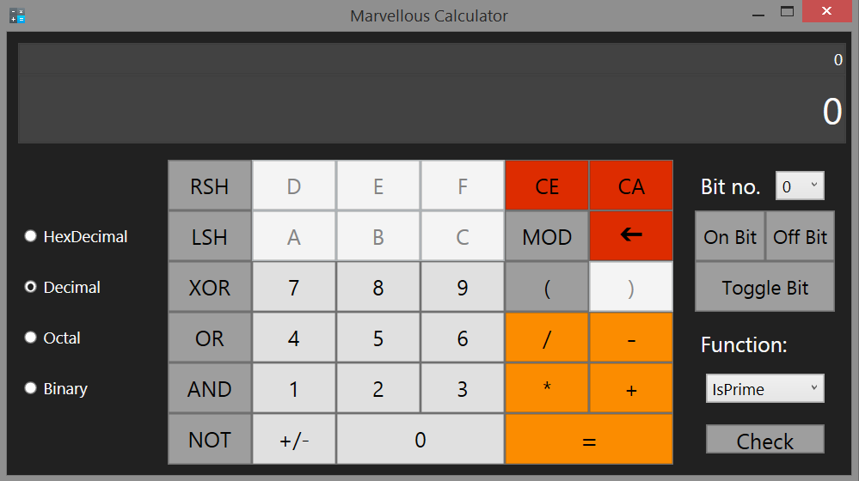

2. Follows Precedence levels

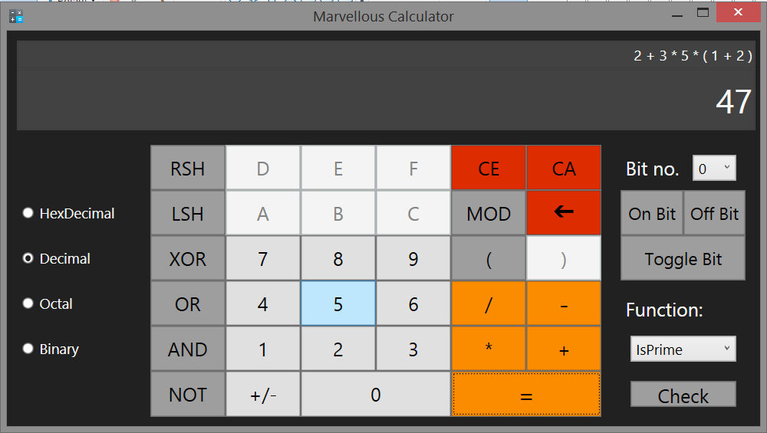

3. Bitwise operator operation

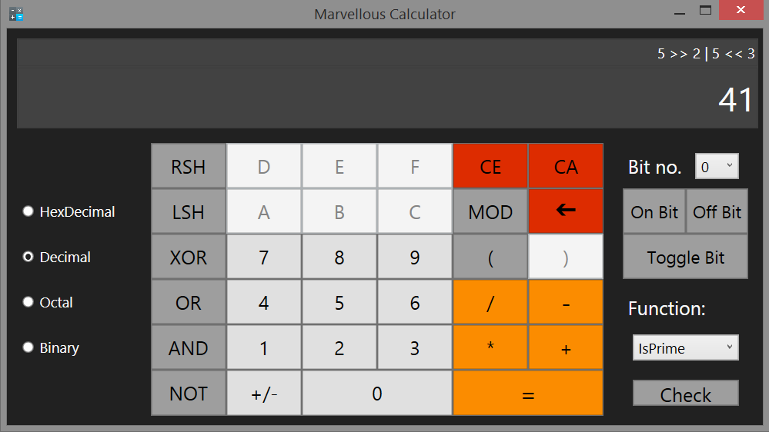

4. Conversion into hex

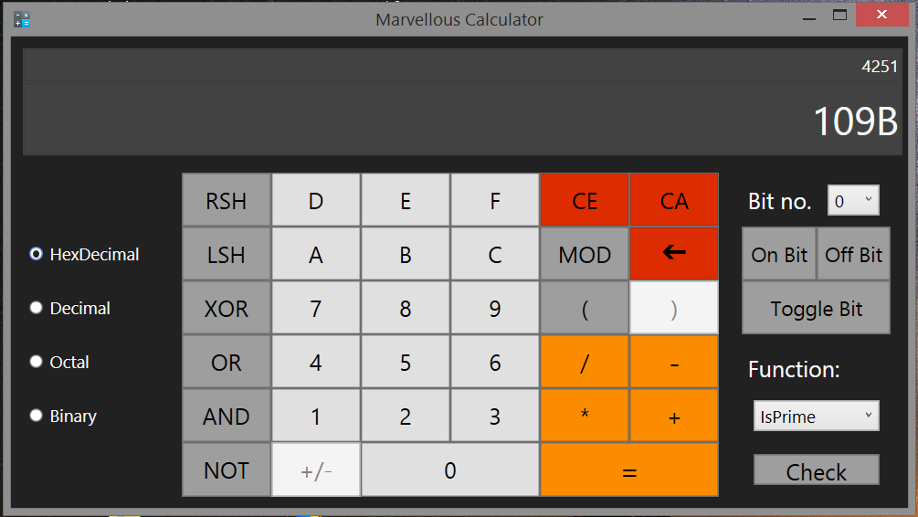

5. Bit operation

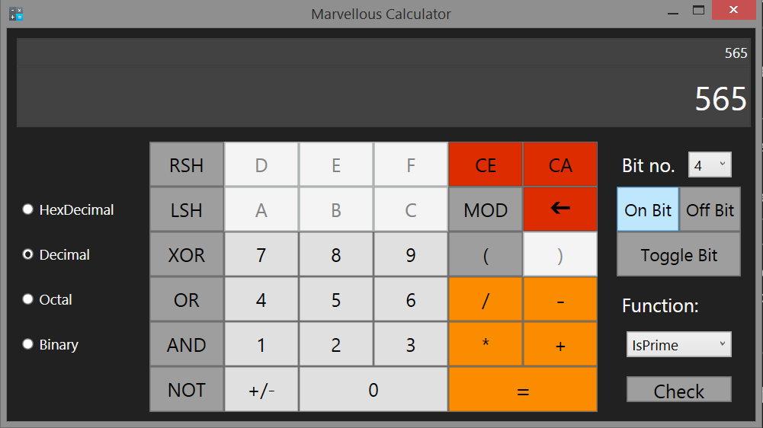

6. Checking if number is prime or not

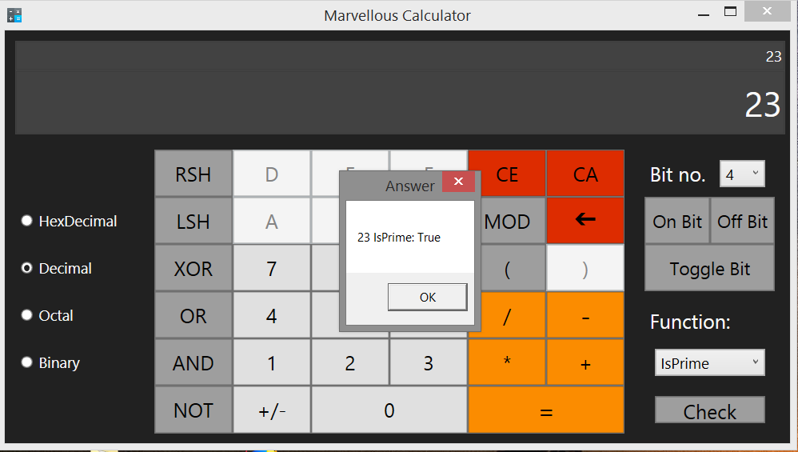

7. Get All factor of given number.

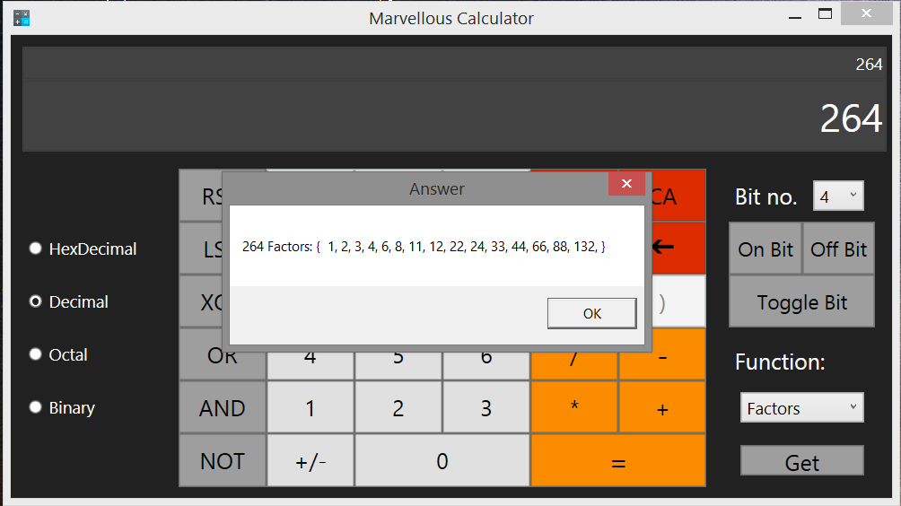

8. Click 'yes' to save the calculation history.

