**Shotlight Date : 9 – 11 - 2018**

This application use to search the file fastly.

**Features:**

* Use Multithreading for searching different drive simultaneously.
* You can also specify which drive you want to search.
* After searching you can double click the file to open the directory where this file is present

**Project Screenshot**

1. First Look of ShotLight.

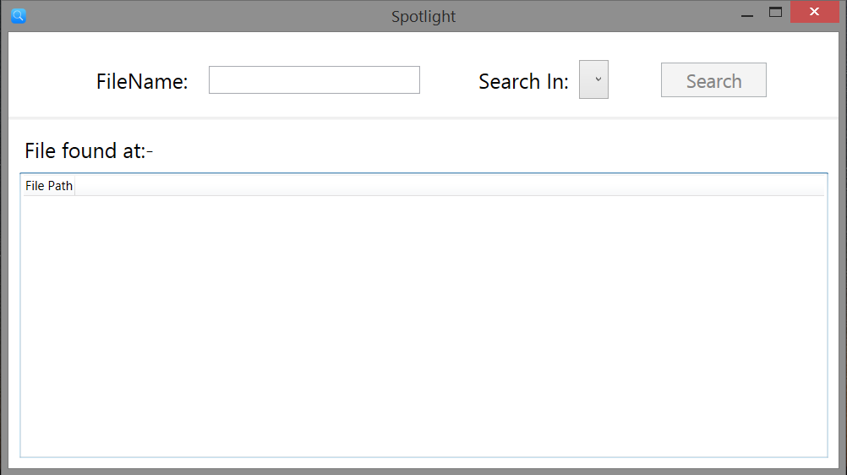

2. You can specify in which drive you want to search file

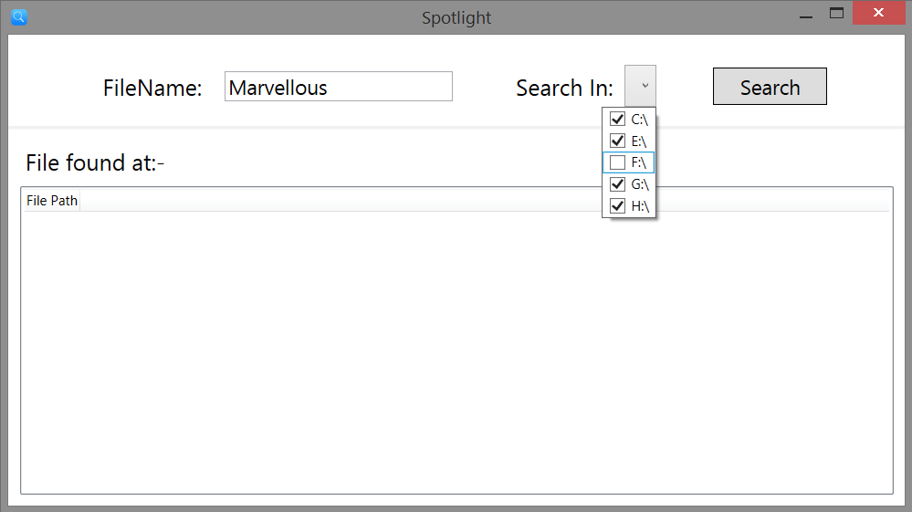

3. When you click search button.

Searching is started

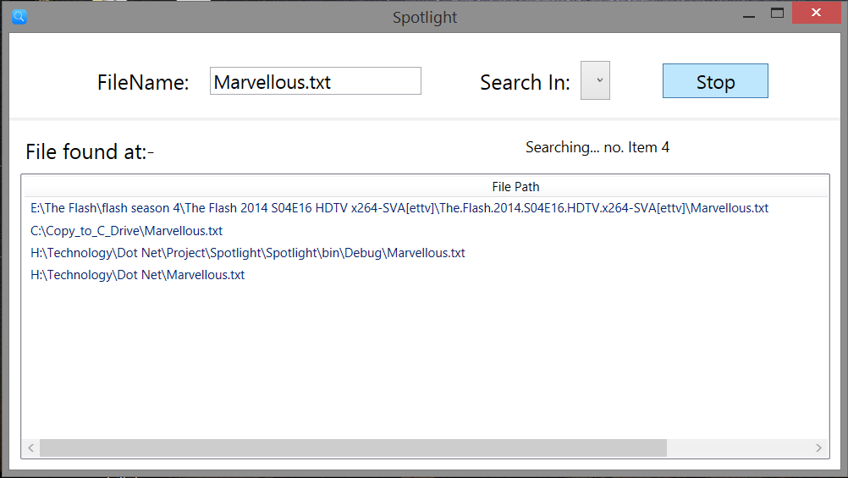

4. Completing Searching

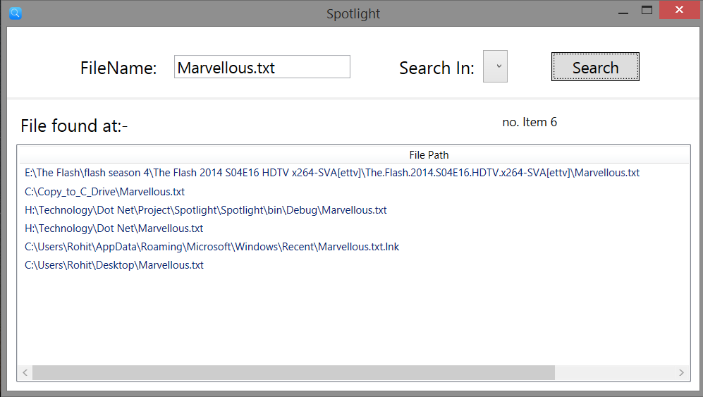

6. You can open displayed file by double clicking it.

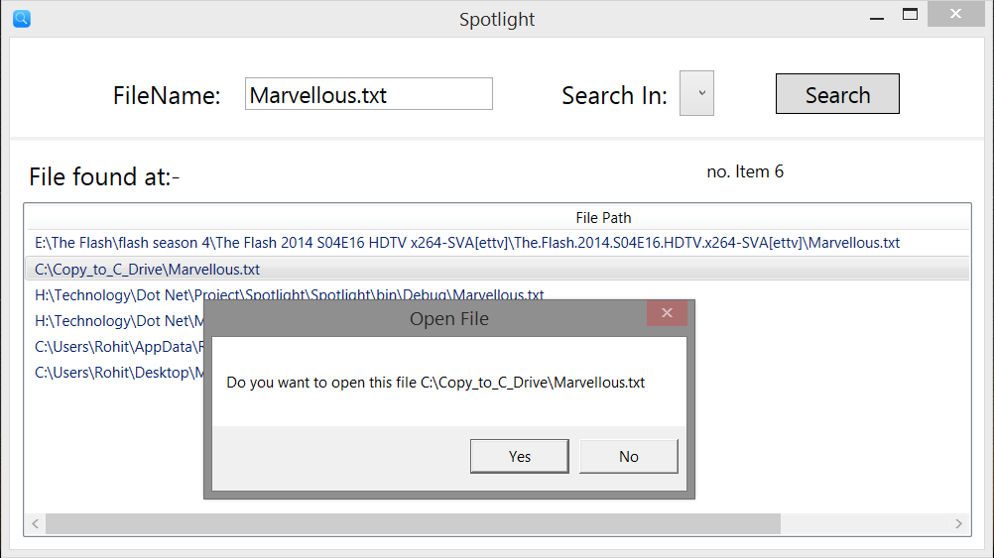

7. File is open in explorer.exe

