**File Transfer Protocol Date : 10 – 11 - 2018**

This project is demonstration of synchronous Client-Server Application.

Purpose of this Project is to access the folder and file from remote computer.

Eg If I want some file from computer which is at home. So I can tell someone to start there server application and from laptop I can start client application and search the required file and download it.

**Socket Programming**:

* Socket programs are used to communicate between various processes usually running on different systems.
* Is base of all the network programming.

**File Transfer Protocol:**

* FTP is used to transfer files between computers on a network.

This Application is use to search, list all and download the file from server and it can also upload the file to server.

**Features:**

* Socket Programming.
* Download and Upload file.
* Server synchronous connect the client.
* If the server is off then client application will get popup message and application close.
* Authentication.
* Duplicated file is also detected.

**Future Improvement:**

* Providing Multiuser.
* Asynchronous server and client.

**Project Screenshot**

1. Login Screen

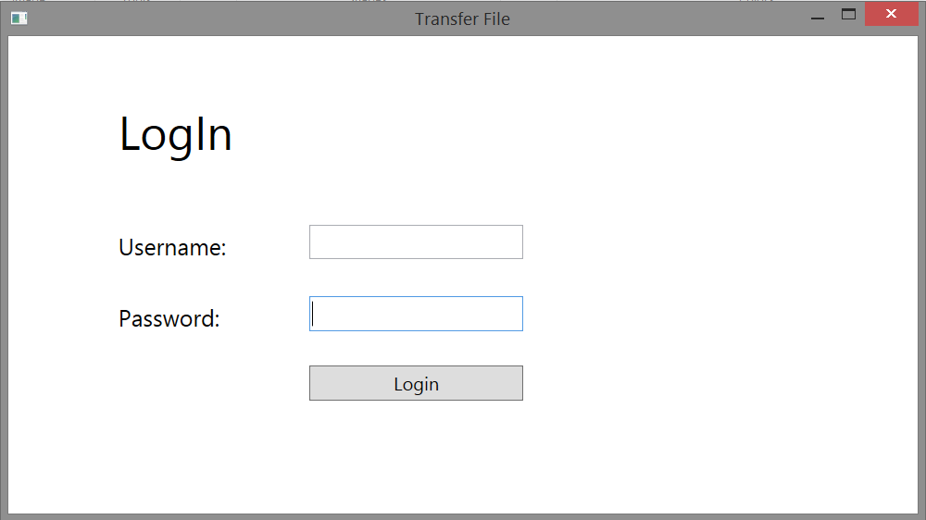

2. Main Window

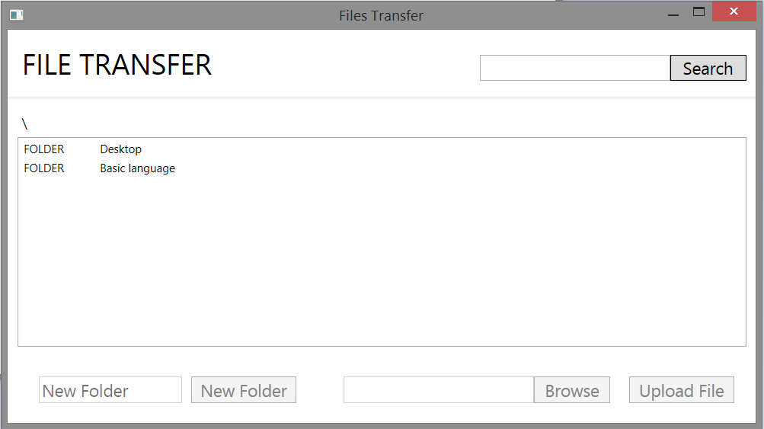

3. Navigation (Seeing the contain of folder)

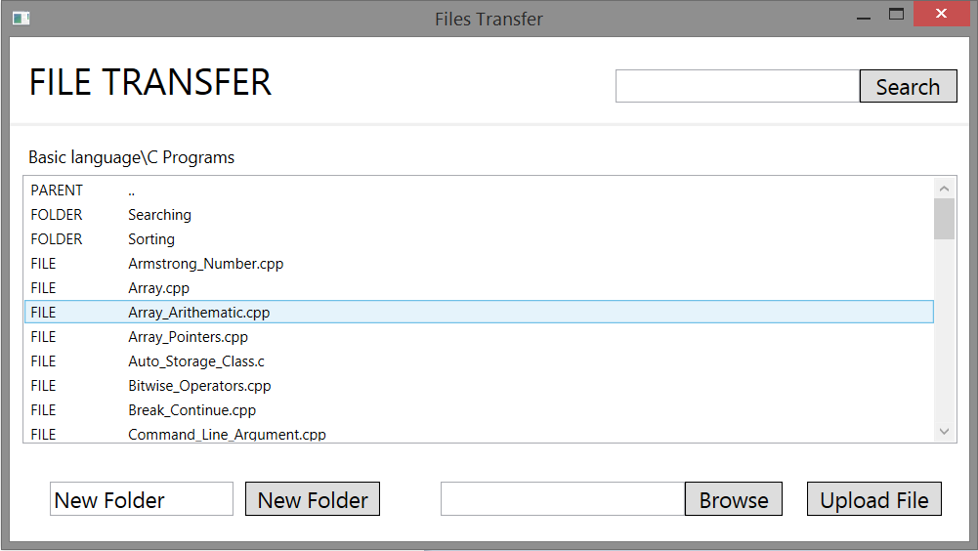

4. Go to back to parent Folder

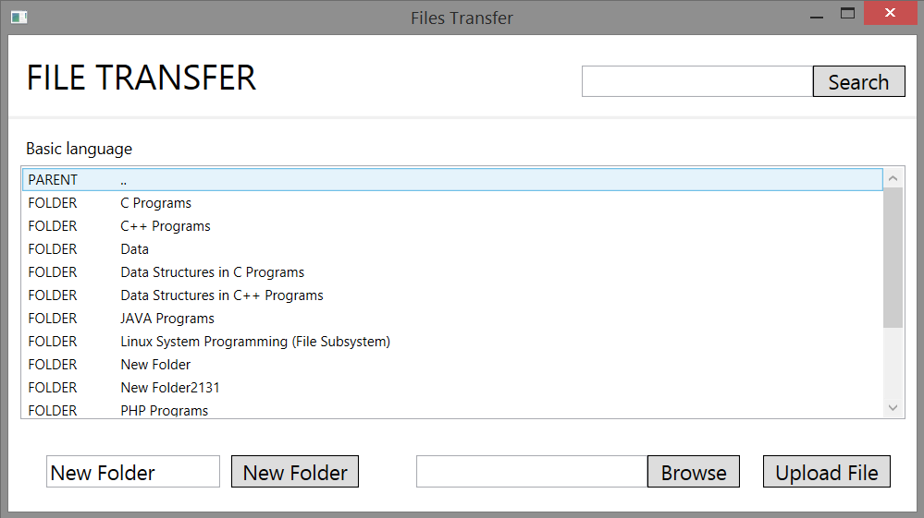

5. Searching file

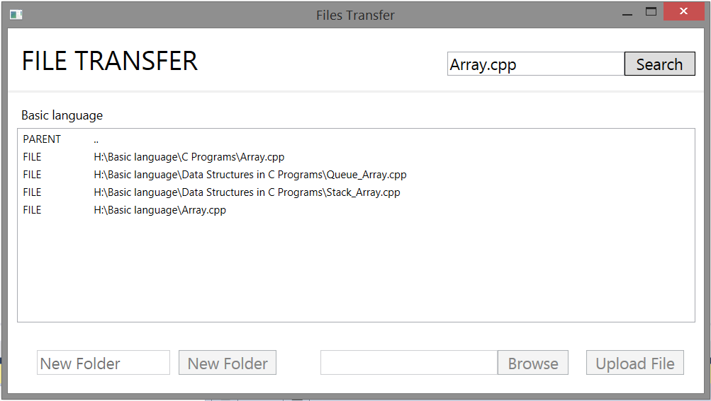

6. Creating new Folder

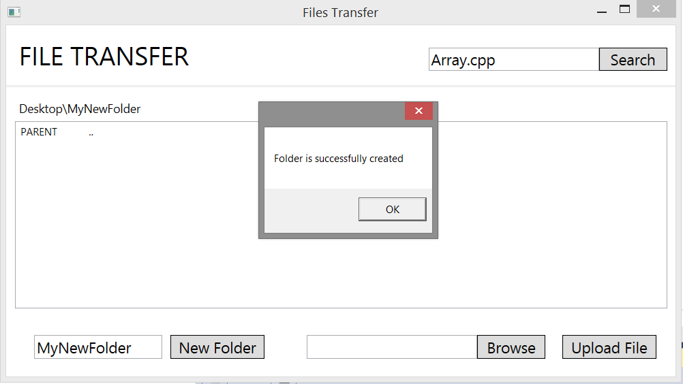

7. Uploading File

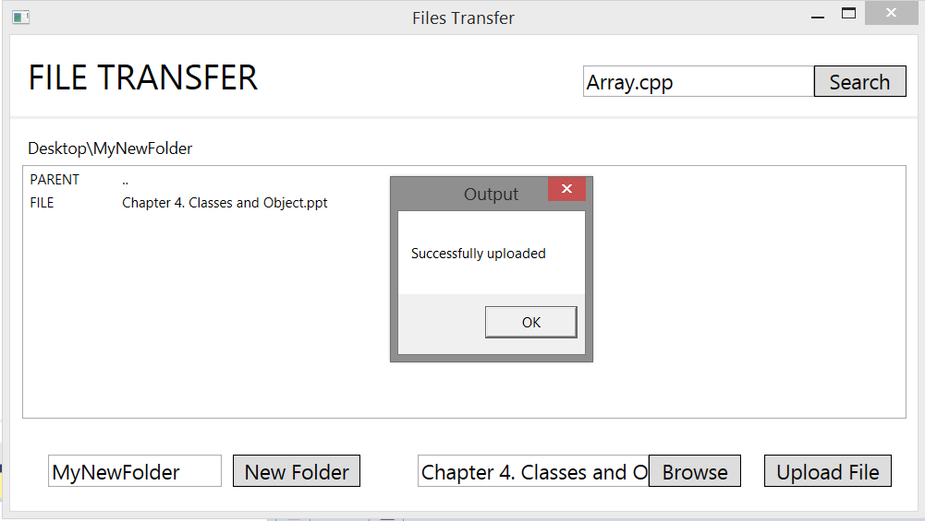

8. Checking If there is duplicate file present.

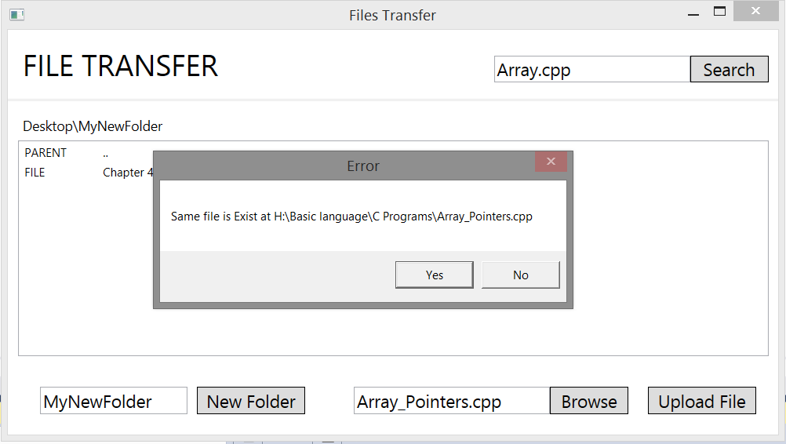

9. Downloading file