**Name: Mihika Saraf**

**Roll No.: 35063**

**Class: TE IT A**

**Subject: Web Application Development**

**Lab Assignment No. 2 A**

**Title: Create version control account on GitHub and using Git commands to create**

**repository and push your code to GitHub.**

1) Download and install git bash

2) Configure Github user





3) Initialize project

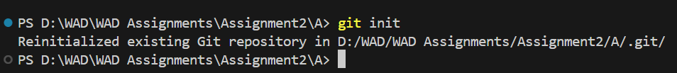

4) Check status

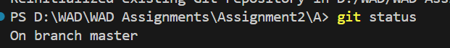

5) Add new file

PS D:\WAD\Assignment2A> git add index.html

6) Add all files to the staging area



7) Commit the changes with a message



8) Git log command

PS D:\WAD\Assignment2A> git log

commit 4e8590387a4d366b48b7a7bc5843a77624cccec9 (HEAD -> master)

Author: Mihika Saraf <mihikaps003@gmail.com>

Date: Mon Mar 4 12:49:45 2024 +0530

Updates index.html with a new line

commit 709346d28bf65fa3a8ed21b20fbcc093baf86370

Author: Mihika Saraf <mihikaps003@gmail.com>

Date: Mon Mar 4 12:48:19 2024 +0530

First git demo

9) Switch to the main branch



10) Add remote origin for local git project



11) Push the local code to GitHub on the main branch



12) Switch to other branches

