Global Semiconductor Industry and India’s OSAT Opportunity

A Comprehensive Beginner-to-Expert Guide — Visual Edition
An institutional-quality industry primer on semiconductor manufacturing, packaging, testing, industry economics, and the OSAT business model — with India as the core investment theme.
Prepared: November 2026 · Style: industry primer / book chapter · Audience: investment banking, private equity, strategy consulting, debt syndication, project finance and corporate finance professionals, written so that a complete beginner can follow it end to end.
About this report. All market sizes, market shares, capacities and incentive figures are drawn from public sources — WSTS, SIA, TrendForce, IDC, company filings, Government of India (MeitY/PIB) releases and reputable trade press — as of November 2026, and are identified in Appendix C. Where sources disagree, the range is shown and the disagreement is flagged. This visual edition renders all figures as charts and diagrams. This is an educational and analytical document, not investment advice.

Table of Contents
- Executive Summary
- Introduction to Semiconductors — physics, doping, transistors, chip types
- The Complete Semiconductor Value Chain — raw materials → wafers → design → EDA → fabrication → equipment
- Deep Dive: The OSAT Industry — process flow, packaging technologies, global players, facility economics
- Global Semiconductor Market Structure — sellers, buyers and concentration at every stage
- Global Industry Status (2025–26) — the AI boom, packaging shortages, geopolitics
- The Indian Semiconductor Industry — ecosystem, country comparison, approved projects
- India Semiconductor Mission (ISM 1.0 and 2.0) — incentives and global policy comparison
- Special Study: Suchi Semicon and the Future of OSAT in India
- SWOT Analysis — global industry, Indian industry, Indian OSAT
- Investment and Financial Analysis — margins, ROCE, capex intensity and cash flows by segment
- The Future of Semiconductors (2030–2040)
- Conclusion
Appendix A: Glossary (200+ terms) · Appendix B: Acronym list · Appendix C: References and sources

SECTION 1: EXECUTIVE SUMMARY

1.1 The industry in one page
Semiconductors — “chips” — are the physical substrate of the digital economy. Every smartphone, car, data centre, missile, MRI machine, washing machine and power grid controller depends on them. The industry that makes them is simultaneously one of the largest, most concentrated, most capital-intensive and most geopolitically contested industries on earth.
The numbers have become extraordinary. Global semiconductor sales were $630.5 billion in 2024 and jumped 25.6% to $791.7 billion in 2025 (SIA; WSTS counts $795.6 billion on slightly different coverage). The long-standing industry consensus — “a trillion-dollar industry by 2030” — is arriving roughly four years early: SIA projected 2026 sales of roughly $1 trillion, and the WSTS Spring 2026 forecast, swollen by an unprecedented AI-driven memory price supercycle, projects ~$1.5 trillion for 2026 and ~$1.9 trillion for 2027. Those spring-2026 numbers deserve caution — they are driven primarily by memory price inflation (memory revenue is forecast to more than triple), and price-driven booms reverse — but even the conservative reading (WSTS’s autumn-2025 forecast of $975 billion for 2026) implies the fastest sustained expansion in the industry’s history.
Table 1 — Global semiconductor industry snapshot (November 2026)
Indicator | Value | Source / note
2024 global sales | $630.5 bn | SIA/WSTS actual
2025 global sales | $791.7 bn (+25.6%) | SIA actual; WSTS $795.6 bn
2026 forecast | ~$975 bn (WSTS autumn-25) to ~$1.51 tn (WSTS spring-26) | Memory supercycle drives the gap
2030 consensus (pre-boom) | $1.0–1.3 tn | SIA / McKinsey, now likely conservative
Global foundry leader | TSMC, ~70% of pure-play foundry revenue | TrendForce
EUV lithography | ASML — 100% share (monopoly) | Company filings
OSAT market, 2025 | ~$45–47 bn (IDC $45.3 bn; Mordor $47.1 bn) | Top-10 OSATs ≈ $41.6 bn revenue in 2024
Advanced packaging market | ~$40 bn (2024) → $80 bn+ by 2030E | Yole and industry estimates
India semiconductor consumption | ~$50 bn (2024–25) → $100–110 bn by 2030E | IESA/industry estimates
India ISM 1.0 + 2.0 incentive outlay | ₹76,000 cr + ₹1,28,000 cr (~US$23 bn combined) | MeitY / Cabinet (ISM 2.0 approved July 2026)
India approved projects (ISM 1.0) | 12 units, ~₹1.64 lakh crore (~$19–20 bn) investment | PIB/IBEF, mid-2026
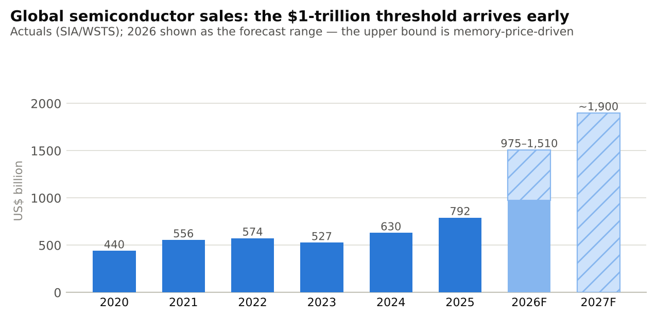
Figure 1 — Global semiconductor sales, 2020–2027F

1.2 Why semiconductors are strategically important
Three structural facts explain why governments now treat chips the way they treated oil in the twentieth century:
- Universality of demand. Semiconductor content is rising in every end market. A modern car carries 1,500–3,000 chips and $600–$1,200 of semiconductor content (EVs: $1,500–$3,000). An AI data-centre rack carries hundreds of thousands of dollars of silicon. There is no modern economy — civilian or military — without chips.
- Extreme concentration of supply. Advanced logic manufacturing (below 7 nm) is ~90% concentrated in Taiwan, one EU company (ASML) monopolises the EUV lithography machines without which advanced chips cannot be printed, and three firms control the memory market. A single earthquake, blockade or export-control decision can ripple through a $100-trillion world economy — the 2021–22 chip shortage alone cost the global automotive industry an estimated $200+ billion of lost revenue.
- Chokepoint economics. Because each layer of the value chain is an oligopoly (or monopoly), chips became the first theatre of US–China technology competition: US export controls (2022, tightened repeatedly since), China’s retaliatory curbs on gallium and germanium, and a global subsidy race exceeding $400 billion of announced public money (US CHIPS Act, EU Chips Act, China’s Big Fund, Japan, Korea, India’s ISM).

1.3 Key technological trends
- The AI supercycle. Generative AI converted the data centre into the industry’s largest end market. Nvidia — a fabless design company — became the world’s most valuable firm; its data-centre GPUs and their HBM memory stacks dominate incremental industry growth.
- Packaging is the new bottleneck. AI chips are assembled from multiple dies on silicon interposers (TSMC’s CoWoS and similar 2.5D/3D platforms). CoWoS capacity — ~35–40k wafers/month in 2024 — is being pushed toward 120,000–140,000 wafers/month by end-2026, with OSAT partners adding another 50,000–60,000; demand still exceeds supply. Value is migrating from “shrinking transistors” to “stacking and connecting dies” — which is precisely the OSAT industry’s territory.
- Chiplets replace monolithic chips. Instead of one giant die, leading products (AMD EPYC, Nvidia Blackwell/Rubin, Intel Foveros-based CPUs) combine multiple specialised dies. This multiplies the testing and assembly content per device.
- The 2 nm transition. TSMC, Samsung and Intel moved to gate-all-around transistors in 2025–26; the leading edge now costs >$20 billion per fab.
- Compound semiconductors (SiC, GaN) are displacing silicon in EV powertrains, chargers and power infrastructure — a segment where India has made its first fab bets.

1.4 Outlook over the next 10 years
The consensus path: $1 trillion± in 2026 → $1.5–2 trillion by the early-to-mid 2030s, with cyclicality overlaid (memory-led booms correct; 2027–28 carries real inventory-cycle risk). The compute stack (AI logic + HBM + advanced packaging) compounds fastest; automotive and power semiconductors compound steadily on electrification; analog and mature nodes grow with GDP-plus. Manufacturing geography diversifies modestly — Arizona, Kumamoto, Dresden, Dholera — but Taiwan and Korea remain dominant at the leading edge through 2030.
Table 2 — Winners and losers in the current cycle
 | Who | Why
Winners | Nvidia, Broadcom and AI-ASIC designers | Own the scarcest IP in computing
 | TSMC | ~70% foundry share; monopoly economics at the leading edge
 | SK Hynix, Samsung, Micron (memory) | HBM supercycle; 2026 memory revenue forecast to roughly triple
 | ASML, AMAT, Lam, TEL, KLA (equipment) | Sell the “picks and shovels” to a $400 bn subsidy race
 | OSATs with advanced packaging (ASE, Amkor) | Packaging is the binding constraint on AI supply
 | India (policy winner) | Captured 12 approved projects + two national incentive rounds
Losers / pressured | Intel | Lost process leadership; restructured; US government took ~10% equity stake (2025)
 | Lagging-edge-only players without China cost structure | Squeezed by subsidised Chinese legacy capacity
 | China’s leading-edge ambitions | Export controls cap EUV access; stuck near 7 nm-class logic at scale
 | Pure consumer-exposed chipmakers | AI crowds out fab/packaging/substrate capacity and bids up memory input costs

1.5 Why India is entering the race — and why OSAT is the spearhead
India consumes ~$50 billion of semiconductors a year (heading to $100–110 billion by 2030) but until 2024 manufactured essentially none of them. It has the world’s second-largest pool of chip-design engineers (roughly a fifth of the global design workforce works in India for Qualcomm, Nvidia, AMD, Intel, TI and others), a $150 billion+ electronics manufacturing base growing >15% a year, and — since 2021 — serious money on the table: ISM 1.0 (₹76,000 crore, 2021) and ISM 2.0 (₹1.28 lakh crore ≈ $13.25 billion, approved July 2026).
The strategic logic of starting with OSAT/ATMP (assembly, testing, marking and packaging) rather than leading-edge fabs is the central theme of this report:
- OSAT plants cost $100 million–$3 billion versus $10–20 billion+ for an advanced fab — an order of magnitude less capital at risk;
- they are labour-intensive, playing to India’s cost advantage (a packaging operator in India costs a fraction of one in Taiwan or Malaysia);
- they can reach commercial output in 18–30 months (Micron Sanand: approved June 2023, inaugurated February 2026; Kaynes Sanand: approved September 2024, inaugurated March 2026; Suchi Semicon shipped commercially from Surat within ~18 months of breaking ground);
- and they plug into supply chains immediately, because packaging is where the industry’s capacity shortage is most acute.
Ten of India’s twelve approved ISM 1.0 projects are packaging/ATMP/OSAT or specialty units, not leading-edge fabs. That is not a weakness; it is the same sequencing Taiwan, Malaysia, Singapore and China used — enter at assembly and test, build operational credibility, move up the value curve. Sections 7–9 examine whether India — and bellwether first movers such as Tata, Micron, Kaynes, CG Power and Suchi Semicon — can repeat that playbook.

SECTION 2: INTRODUCTION TO SEMICONDUCTORS
This section assumes no engineering background. Each concept is explained simply first, then given a more advanced treatment.

2.1 What is a semiconductor?
Every material responds to electricity in one of three ways:
- Conductors (copper, aluminium, gold) let electric current flow freely — their atoms have loosely bound electrons that wander easily.
- Insulators (glass, rubber, dry wood) block current — their electrons are locked tightly to their atoms.
- Semiconductors (silicon, germanium, gallium arsenide) sit in between: in their pure state they barely conduct, but their conductivity can be switched and tuned — by adding impurities, applying a voltage, light or heat.
That controllability is the entire trick. A material that can be electrically switched between “conducting” and “not conducting” can represent 1 and 0 — and computing is nothing but the manipulation of 1s and 0s, billions of times per second.
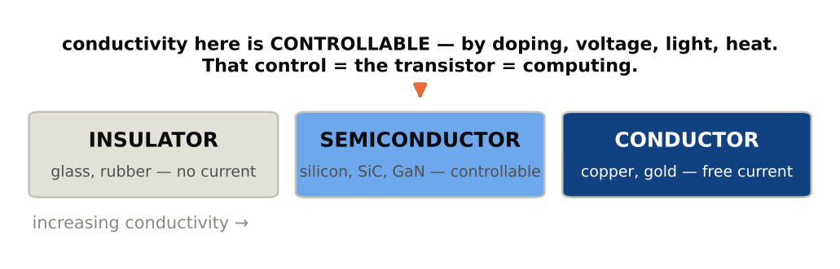
Figure 2 — The conductivity spectrum
Table 3 — Conductors vs insulators vs semiconductors
Property | Conductor | Semiconductor | Insulator
Resistivity (Ω·cm) | ~10⁻⁶ | 10⁻³–10⁸ (tunable) | >10¹⁰
Band gap | None (bands overlap) | Small (Si: 1.1 eV; SiC: 3.3 eV; GaN: 3.4 eV) | Large (>5 eV)
Current control | No | Yes — the key property | No
Example use | Wiring | Transistors, diodes, chips | Isolation layers
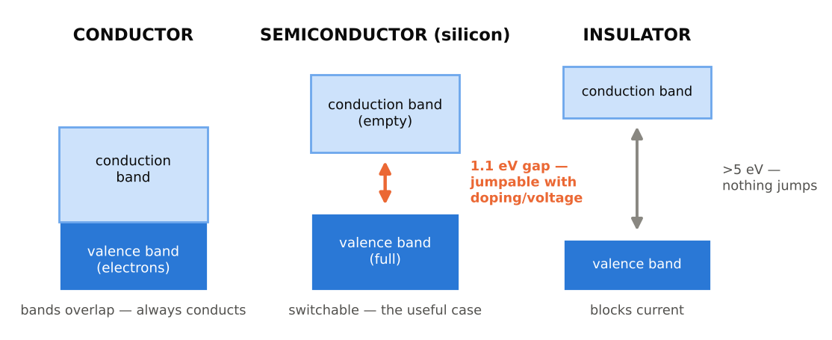
Figure 3 — Energy bands: the advanced view
Advanced view. In quantum terms, electrons in a solid occupy energy “bands.” In conductors the valence band (where electrons live) and the conduction band (where they can move) overlap. In insulators a huge energy gap separates them. In semiconductors the gap is small — ~1.1 electron-volts for silicon — small enough that engineering tricks (doping, electric fields) can lift electrons across it on demand. Wide-band-gap materials such as SiC and GaN need more energy to switch but tolerate far higher voltages and temperatures, which is why they rule power electronics (Section 12).

2.2 Why silicon?
Silicon won for four reasons: (1) abundance — it is the second most common element in the earth’s crust (ordinary sand is silicon dioxide), so the raw material is effectively free; (2) a near-perfect native oxide — heat silicon in oxygen and it grows glass (SiO₂) on its own surface, a flawless built-in insulator that made the MOS transistor manufacturable; (3) thermal and mechanical robustness at processing temperatures above 1,000 °C; and (4) seventy years of accumulated manufacturing learning — trillions of dollars of process knowledge that any alternative material must overcome. Compound semiconductors (GaAs, GaN, SiC, InP) beat silicon on specific physics (speed, light emission, power handling) and so own niches — RF, lasers, EV power — but silicon carries ~95% of industry volume.

2.3 Doping: engineering conductivity atom by atom
Pure (“intrinsic”) silicon is a poor conductor: each silicon atom has 4 outer electrons, all locked into bonds with 4 neighbours in a perfect crystal lattice. Doping means deliberately adding ~1 impurity atom per million silicon atoms to change its electrical personality:
- Add phosphorus or arsenic (5 outer electrons): four bond with neighbours, the fifth is left over and free to move → extra negative carriers → N-type silicon.
- Add boron or gallium (3 outer electrons): one bond is left incomplete, creating a “hole” — a missing electron that behaves like a mobile positive charge → P-type silicon.
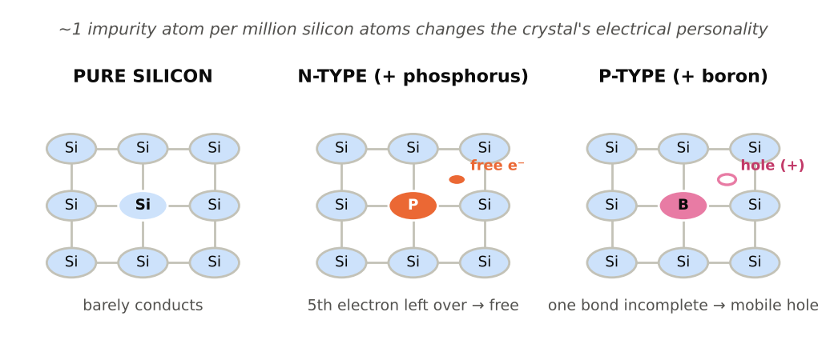
Figure 4 — Doping
Put a P-region against an N-region and you get a P-N junction — a one-way valve for current (a diode). Every solar cell, LED and rectifier is a P-N junction. Every transistor is a clever arrangement of them.

2.4 The transistor: the switch that built the modern world
A transistor is an electrically controlled switch with no moving parts. The dominant type, the MOSFET (metal-oxide-semiconductor field-effect transistor), has three terminals: current wants to flow from source to drain, but can only cross a P-type channel in between; a voltage on the gate (separated from the channel by an ultra-thin insulator) attracts electrons into the channel and turns it conductive. Gate voltage on → switch closed → “1”. Gate voltage off → switch open → “0”.
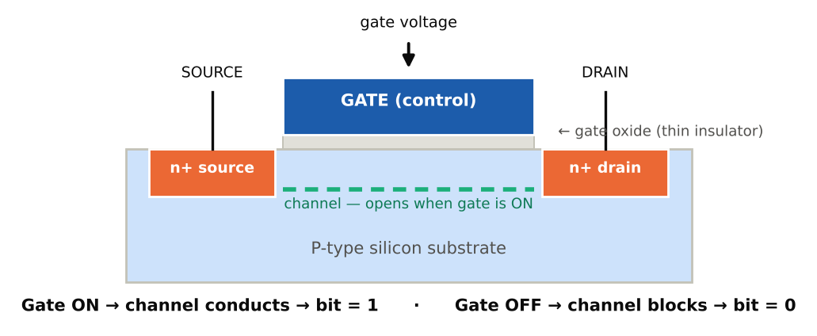
Figure 5 — A MOSFET as a switch
Wire two transistors together and you get a logic gate (NAND, NOR); wire a few billion together and you get a CPU. Moore’s Law — the observation that transistor counts double roughly every two years — took the industry from 2,300 transistors (Intel 4004, 1971) to ~200 billion+ (Nvidia’s Blackwell-generation AI packages). Advanced transistor geometry evolved from planar to FinFET (3D fins, from ~22 nm) to gate-all-around nanosheets (2 nm class, 2025–26) — each step wrapping the gate more completely around the channel for better control at atomic dimensions. Note that node names (“3 nm”, “2 nm”) are now marketing labels for density generations, not literal dimensions.

2.5 The four big chip families
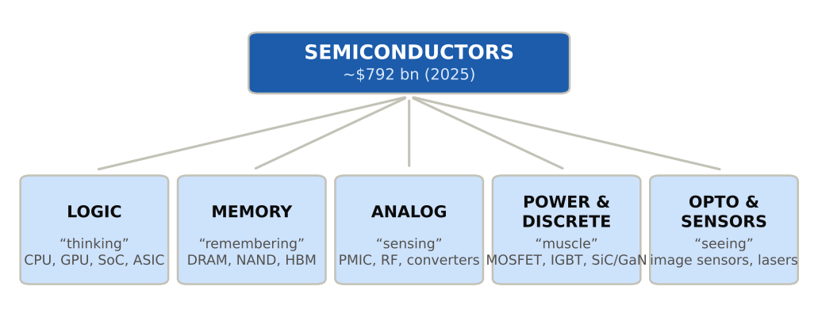
Figure 6 — The semiconductor family tree
Table 4 — Chip types, functions, leaders and market size
Family | What it does | Example products | Leading companies | 2024–25 market (approx.)
Logic | Computes; runs instructions | CPUs, GPUs, smartphone SoCs, AI ASICs, FPGAs | Nvidia, Apple, AMD, Qualcomm, Broadcom, MediaTek, Intel | ~$215–270 bn; the largest and fastest-growing family
Memory | Stores data | DRAM (working memory), NAND flash (storage), HBM (stacked DRAM for AI) | Samsung, SK Hynix, Micron, Kioxia, SanDisk | ~$165 bn (2024) → forecast to roughly triple in 2026 on the AI price cycle
Analog / mixed-signal | Bridges the physical world (sound, radio, power levels) and digital logic | Power-management ICs, RF front-ends, data converters | TI, Analog Devices, Infineon, NXP, ST, Renesas | ~$80–90 bn
Power & discretes | Switches and converts electrical energy | MOSFETs, IGBTs, SiC/GaN devices, rectifiers, diodes | Infineon, onsemi, ST, Mitsubishi, Fuji, Rohm, Wolfspeed | ~$55–65 bn incl. discretes
Opto & sensors | Light and physical sensing | CMOS image sensors, lasers, LEDs, MEMS | Sony (CIS), ams-Osram, Bosch, STMicro | ~$60 bn
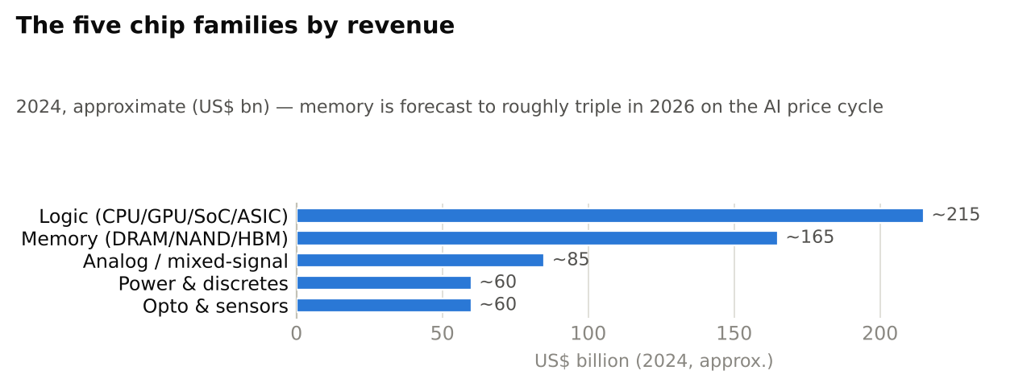
Figure 7 — The five chip families by revenue (2024, approximate)
Two practical observations matter for the rest of this report. First, different chip families need different manufacturing: leading-edge logic needs EUV lithography and $20 billion fabs; analog, power and many automotive chips are built profitably on mature nodes (28 nm–180 nm+) in far cheaper fabs — which is exactly the tier India’s first fab (Tata–PSMC, 28–110 nm) targets. Second, every one of these chips, whatever its family, must be packaged and tested — the universal downstream step that is the OSAT industry’s business, and India’s entry point.

SECTION 3: THE COMPLETE SEMICONDUCTOR VALUE CHAIN
No industry on earth has a longer or more specialised value chain. A single chip crosses 70+ international borders before reaching a consumer. The chain can be read as six industrial layers plus the downstream electronics system layer.
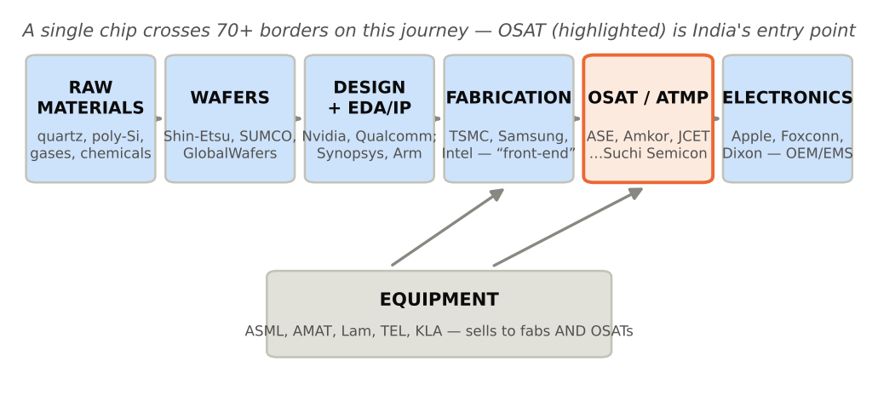
Figure 8 — End-to-end ecosystem map
Table 5 — Master value-chain map (figures approximate, 2024–25)
Industry touch point | Function | Major players | Market size | Typical margins | Capital requirement
Raw materials (poly-Si, gases, chemicals) | Ultra-pure inputs | Hemlock, Wacker, Tokuyama, Linde, Air Liquide, Shin-Etsu Chemical, JSR, TOK | $60–70 bn across categories | EBITDA 20–35% | Moderate ($0.5–2 bn/plant)
Silicon wafers | Polished/epitaxial 200/300 mm substrates | Shin-Etsu, SUMCO, GlobalWafers, Siltronic, SK Siltron | ~$12–15 bn | EBITDA 25–40% (cyclical) | High ($2–5 bn/300 mm plant)
Chip design (fabless) | Product definition, logic design | Nvidia, Qualcomm, Broadcom, AMD, MediaTek, Apple (captive) | >$250 bn fabless revenue | Gross 50–75%, EBITDA 25–60% | Low fixed assets; R&D $0.1–16 bn/yr
EDA & IP | Design software and reusable blocks | Synopsys, Cadence, Siemens EDA; Arm (IP) | ~$18–22 bn | EBITDA 35–45% | Very low; pure R&D
Foundry / fabrication | Wafer manufacturing (“front-end”) | TSMC, Samsung Foundry, SMIC, UMC, GlobalFoundries, Intel Foundry | ~$160–190 bn foundry revenue | TSMC gross ~55–60%; others far lower | Extreme: $10–28 bn per leading-edge fab
Equipment | The machines in fabs and OSATs | ASML, Applied Materials, Lam Research, Tokyo Electron, KLA; (back-end: ASMPT, Kulicke & Soffa, Advantest, Teradyne, BESI, Disco) | ~$110–120 bn WFE + ~$15–20 bn back-end | Gross 40–50%, EBITDA 25–35% | Moderate
OSAT / ATMP (“back-end”) | Assembly, packaging, testing | ASE, Amkor, JCET, TFME, PTI, ChipMOS; India: Micron, Tata TSAT, Kaynes, CG Semi, Suchi Semicon | ~$45–47 bn | Gross 15–25%, EBITDA 18–30% | $0.1–3 bn per facility
Electronics manufacturing (EMS/OEM) | Boards and final devices | Foxconn, Pegatron, Luxshare; India: Dixon, Kaynes, Syrma, Tata Electronics (EMS) | >$500 bn EMS | EBITDA 3–8% | Moderate, labour-heavy
The economic shape of this table is the single most important thing a finance professional should internalise: margins and capital intensity are wildly uneven across the chain. Design and EDA earn software-like margins on little capital; foundries earn high margins only at monopoly scale; OSAT earns industrial margins (mid-teens to high-twenties EBITDA) on moderate capital — the profile of a quality industrial processor, not a tech monopoly. Section 11 quantifies this.

3.1 Raw materials
A fab consumes staggering quantities of ultra-pure inputs — “eleven nines” (99.999999999%) pure polysilicon, dozens of specialty gases, acids and photoresists:
- Silica sand / quartz — the starting point. High-purity quartz for crucibles comes overwhelmingly from Spruce Pine, North Carolina (The Quartz Corp, Sibelco) — one of the industry’s least-known chokepoints.
- Polysilicon — semiconductor-grade suppliers: Hemlock (US), Wacker (Germany), Tokuyama and Mitsubishi Materials (Japan), OCI (Korea/Malaysia). (China’s GCL/Daqo dominate cheaper solar-grade poly.)
- Specialty gases — neon, helium, silane, nitrogen trifluoride, WF₆: Linde, Air Liquide, Air Products, Taiyo Nippon Sanso, SK Materials. (The 2022 Ukraine war spiked neon prices ~10x — Odesa supplied ~half the world’s semiconductor neon.)
- Chemicals and photoresists — Shin-Etsu Chemical, JSR, Tokyo Ohka Kogyo, Sumitomo Chemical, Fujifilm (Japan controls ~90% of advanced photoresist), DuPont, Merck KGaA, Entegris (handling/filtration), Cabot/CMC (CMP slurries).
- Rare earths and critical minerals — gallium, germanium (China ~60–90% of refined supply; export-controlled by Beijing since 2023), tantalum, palladium, high-purity copper and gold (bonding wire — relevant to OSATs).
Table 6 — Key material chokepoints
Material | Use | Dominant suppliers | Concentration risk
High-purity quartz | Crucibles for ingot growth | Spruce Pine, NC (2 firms) | Extreme — single geography
Semiconductor polysilicon | Wafers | Hemlock, Wacker, Tokuyama, OCI | High — 4 firms ~80%+
Advanced photoresist | Lithography | JSR, TOK, Shin-Etsu, Sumitomo, Fujifilm | Extreme — Japan ~90%
Neon | Excimer lasers | Ukraine/China recovery post-2022 | High
Gallium / germanium | GaN, GaAs, SiC devices | China (~60–90% refined) | Extreme — weaponised 2023
EMC mould compound, substrates, leadframes | Packaging (OSAT inputs) | Japan/Taiwan/Korea (Ibiden, Shinko, Unimicron, ASE Material, Mitsui High-tec) | High — a key gap India must localise

3.2 Wafer manufacturing: from sand to mirror
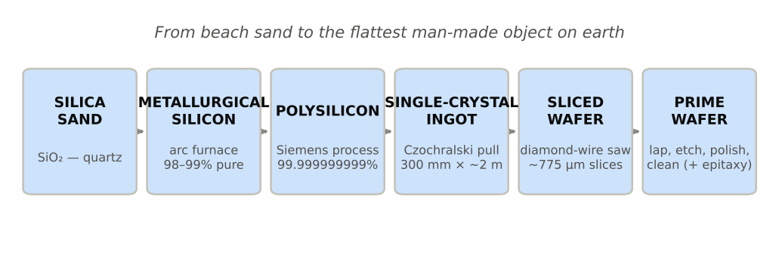
Figure 9 — Sand to wafer
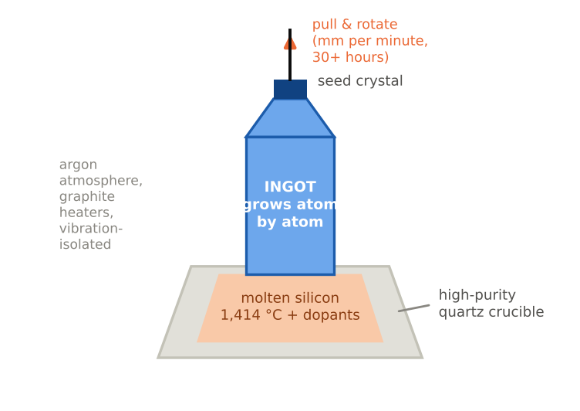
Figure 10 — Inside a Czochralski puller
Step by step: (1) Siemens process — metallurgical silicon is reacted with HCl to form trichlorosilane gas, which is fractionally distilled to remove every impurity, then thermally decomposed onto heated silicon filaments, growing rods of 99.999999999% polysilicon. (2) Czochralski (CZ) crystal growth — chunks are melted at 1,414 °C in a quartz crucible; a thumb-sized seed crystal touches the melt and is withdrawn while rotating over ~30+ hours; the liquid freezes onto the seed atom-by-atom in a single unbroken crystal lattice; dopants are added to the melt to set wafer type. (3) Slicing with diamond wire saws (losing ~a third of the ingot as kerf), then edge grinding, lapping, chemical etching, chemo-mechanical polishing to sub-nanometre flatness — the flattest man-made objects — then cleaning and, for many logic/power wafers, growth of a defect-free epitaxial surface layer.
Table 7 — Silicon wafer market (~$12–15 bn; 300 mm shares approximate)
Company | HQ | Share | Notes
Shin-Etsu Handotai | Japan | ~27–30% | Technology and profitability leader
SUMCO | Japan | ~22–25% | Pure-play wafers
GlobalWafers | Taiwan | ~15–17% | Acquisitive (incl. US Texas 300 mm plant)
Siltronic | Germany | ~11–12% | New Singapore 300 mm fab
SK Siltron | Korea | ~10–11% | Captive-plus-merchant; SiC wafers too
Top 5 combined |  | ~90%+ | A near-oligopoly; no Indian producer yet
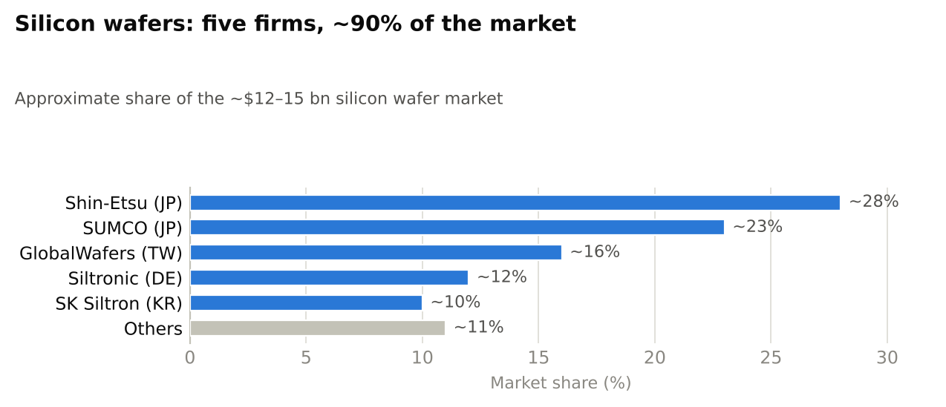
Figure 11 — Silicon wafer market: top-5 share ~90%

3.3 The chip design industry
Three business models coexist — understanding them is prerequisite to everything else in semiconductor finance:
Table 8 — The three business models
Model | Owns fabs? | Owns product/IP? | Examples | Economics
IDM (integrated device manufacturer) | Yes | Yes | Intel, Samsung, Micron, TI, Infineon, STMicro | Full margin capture, full capex burden; being unbundled at the leading edge
Fabless | No | Yes | Nvidia, AMD, Qualcomm, Broadcom, MediaTek, Apple (captive) | Asset-light; gross margins 50–75%; all manufacturing outsourced to foundries + OSATs
Foundry | Yes | No (manufactures others’ designs) | TSMC, UMC, GlobalFoundries, SMIC; Samsung/Intel (hybrid) | Pure manufacturing service; scale and yield decide everything
The fabless–foundry split (pioneered by Morris Chang’s TSMC, 1987) is the single most important structural innovation in the industry’s history: it collapsed the capital barrier to designing chips and created today’s giants. Nvidia (FY2025 revenue ~$130 bn, overwhelmingly data-centre AI) owns no fab; TSMC fabricates, and TSMC/ASE/Amkor/SPIL package and test, everything it sells. Other majors: Qualcomm (~$39 bn FY24; smartphone SoCs/modems), Broadcom (~$30 bn+ semiconductor revenue; networking and custom AI ASICs for hyperscalers), AMD (~$26 bn 2024; CPUs/GPUs via chiplets), MediaTek (~$16.5 bn; volume smartphone SoCs), Apple (world’s largest “captive fabless” — designs its own A/M-series chips, buys ~a quarter of TSMC’s leading-edge output). India note: every one of these firms runs major design centres in India — the design layer is where India already participates at scale.
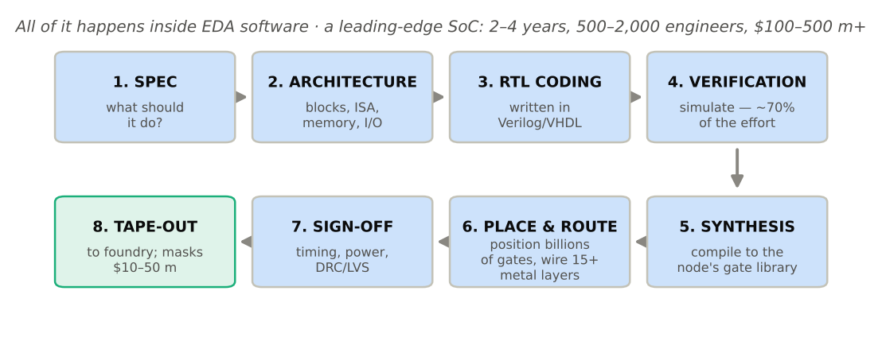
Figure 12 — From idea to tape-out: the chip design flow

3.4 The EDA industry: the software that designs the hardware
A modern chip has tens of billions of transistors; no human can place them. EDA (electronic design automation) software performs synthesis (converting logic descriptions in Verilog/VHDL into gate netlists), place-and-route, timing/power analysis, physical verification (DRC/LVS) and increasingly AI-driven design optimisation. The sector is a ~$18–22 bn triopoly with near-software margins and extraordinary strategic leverage (US export controls apply to EDA): Synopsys (~$6.1 bn FY24, plus the ~$35 bn Ansys acquisition completed 2025 — adding simulation), Cadence (~$4.6–5.1 bn), Siemens EDA (ex-Mentor, ~$1.7 bn+). Top three ≈ 70–75% share. Alongside sits the semiconductor IP industry — pre-designed, licensable blocks — dominated by Arm (CPU architecture in ~99% of smartphones), plus Synopsys/Cadence interface IP and the open-source RISC-V movement (strategically important to both China and India’s sovereign-design ambitions).

3.5 The foundry / fabrication industry (“front-end”)
A fab turns blank wafers into wafers full of chips through 400–1,000+ process steps over ~3 months, looping repeatedly through the same core operations, layer by layer (modern chips have 60–100+ layers):
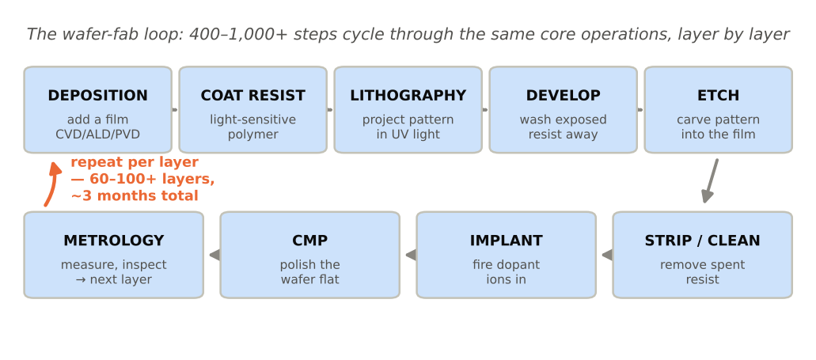
Figure 13 — The wafer-fab process loop
- Photolithography — the defining step: a scanner projects the circuit image from a mask onto the wafer. Leading-edge layers use EUV (13.5 nm wavelength light made by vaporising tin droplets with a laser, 50,000 times a second, inside an ASML machine costing $180–400 m); older layers use DUV (193 nm, often immersion). 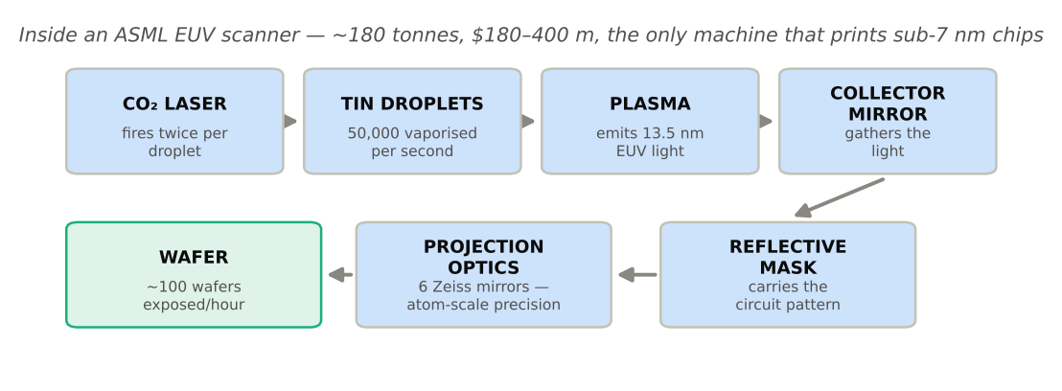
- Deposition (CVD/ALD/PVD) adds conducting, insulating or semiconducting films, some one atom thick; etch (plasma/RIE) removes material with atomic precision; ion implantation fires dopants into exact locations; CMP re-flattens the wafer after every few layers; metrology/inspection (KLA’s domain) hunts defects measured in billionths of a metre, because yield — the % of good dies per wafer — is the whole economics of a fab. A mature leading-edge process yields 80–95%; a new node can start below 50%.
Table 9 — Foundry market share (pure-play + foundry arms, TrendForce-basis, 2025)
Foundry | Share | 2024–25 revenue | Node leadership | Notes
TSMC (Taiwan) | ~67–71% | ~$90 bn (2024) → ~$115–120 bn (2025) | N3 in volume; N2 (GAA) ramping 2025–26; A16 2026–27 | >90% of world’s sub-7 nm output; 2025 capex ~$40 bn+, rising in 2026
Samsung Foundry (Korea) | ~7–8% | ~$20 bn | SF2 GAA | Yield challenges vs TSMC; Taylor, TX fab
SMIC (China) | ~5–6% | ~$8 bn | 7 nm-class (DUV multi-patterning) | Export-control constrained; China’s champion
UMC (Taiwan) | ~4–5% | ~$7.5 bn | 22/28 nm specialty | Mature-node specialist
GlobalFoundries (US) | ~4% | ~$6.8 bn | 12 nm FDX/FinFET | US/EU trusted supply; RF, auto
Intel Foundry (US) | ~1% external | (~$17 bn internal) | 18A (2 nm-class) ramping 2025–26 | Turnaround bet; US government took ~10% equity 2025
HuaHong, Vanguard, Tower, PSMC, Rapidus (2027) | ~6–8% combined | — | Mature/specialty | PSMC is Tata’s Dholera technology partner
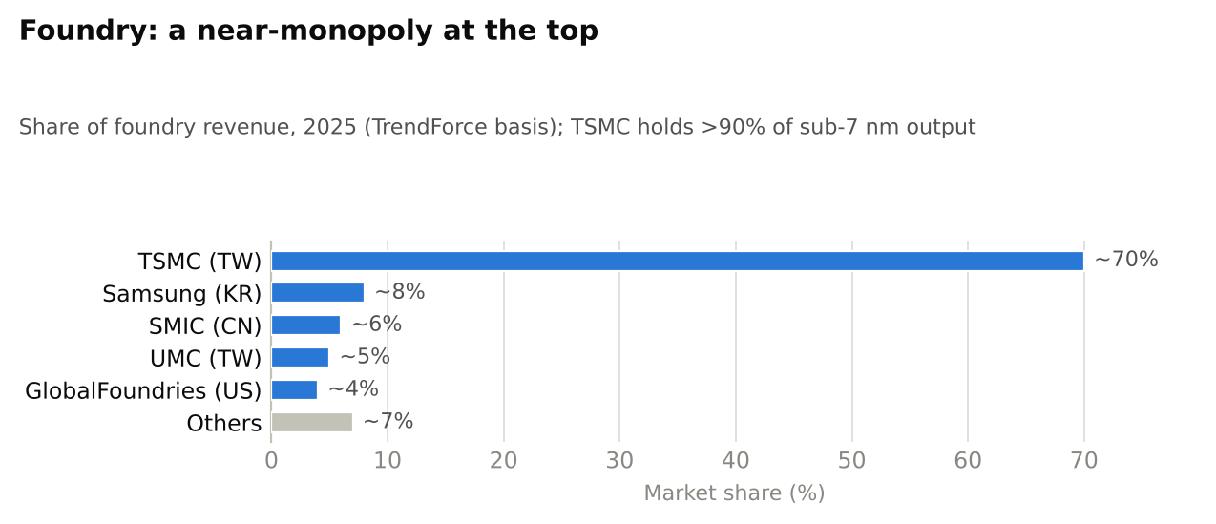
Figure 15 — Foundry market share, 2025
Capex intensity defines this tier: a leading-edge gigafab costs $20–28 bn (one EUV high-NA scanner: ~$380 m; a fab needs dozens of scanners among ~1,200 tools); even a mature 28–40 nm fab like Dholera costs ~$10–11 bn with infrastructure. Depreciation is 5–7 years, so a foundry must run near full utilisation or margins collapse — the root of the industry’s brutal cyclicality.

3.6 The semiconductor equipment industry
Five firms sell ~70% of the world’s wafer-fab equipment (WFE market ~$110–120 bn, 2025):
Table 10 — Equipment leaders (FY2024–25 revenue, approximate)
Company | Domain | Revenue | Position
ASML (NL) | Lithography (EUV monopoly, DUV leader) | €28.3 bn (2024) → ~€32–33 bn (2025E) | The industry’s most absolute chokepoint; High-NA EUV shipping
Applied Materials (US) | Deposition, etch, implant, CMP — broadest portfolio | ~$27 bn | #1 overall by revenue
Lam Research (US) | Etch and deposition (memory-heavy) | ~$15–18 bn | Critical for 3D NAND/HBM stacking
Tokyo Electron (JP) | Coat/develop (~90% share), etch, deposition | ~¥2.4 tn (~$16 bn) | Japan’s champion
KLA (US) | Metrology & inspection (~55% share) | ~$11–12 bn | The “yield police”; highest margins in the group
Back-end (OSAT-relevant): ASMPT, Kulicke & Soffa, BESI (hybrid bonding), Disco (dicing/grinding ~80–90% share), Advantest & Teradyne (testers ~90% combined) |  | ~$15–20 bn | These are the machines an Indian OSAT buys — note they are also oligopolies
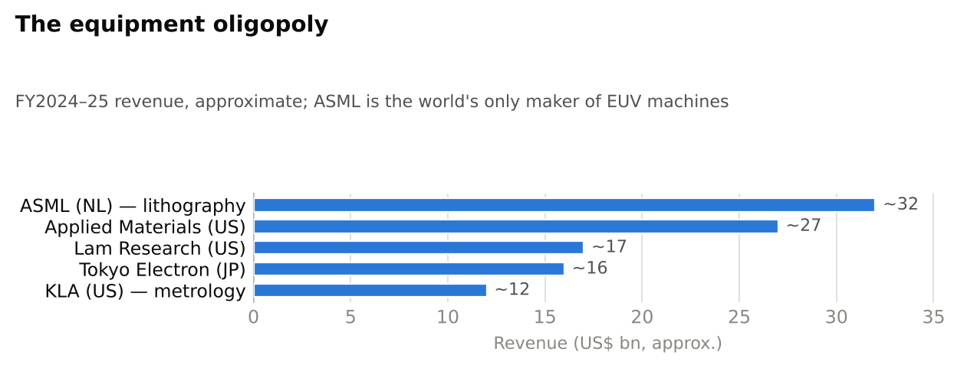
Figure 16 — The equipment oligopoly (FY2024–25 revenue)
Equipment is the tollbooth on the global subsidy race: whoever builds fabs — America, Japan, India or China — pays this handful of firms. US, Japanese and Dutch export controls on this layer are the primary instrument capping China’s leading-edge progress; China responded by stockpiling DUV tools (ASML’s China revenue share spiked ~40%+ in 2023–24) and pouring Big Fund III money into domestic toolmakers (Naura, AMEC, SMEE).

SECTION 4: DEEP DIVE — THE OSAT INDUSTRY
This is the report’s core section. OSAT is where chips become usable products, where the AI boom’s binding constraint now sits, and where India’s semiconductor strategy concentrates.

4.1 What is OSAT, and why does it exist?
OSAT — Outsourced Semiconductor Assembly and Test — companies take finished wafers from foundries/IDMs and perform the “back-end”: they cut the wafer into individual dies, connect each die electrically to the outside world, encase it in a protective package, and test it exhaustively. The Indian policy vocabulary is ATMP — Assembly, Testing, Marking and Packaging — the same activity set.
Why does a separate industry exist for this? For the same reason the foundry exists: specialisation economics. Packaging and test are operationally different businesses from wafer fabrication — more labour-intensive, more SKU-diverse (thousands of package variants), lower capex per unit, shorter asset lives, thinner margins. Chip companies realised decades ago that outsourcing the back-end freed capital for design and front-end; foundries (except for the most advanced packages) preferred not to run it. Roughly 50–55% of global packaging/test is outsourced to OSATs; the rest stays in-house at IDMs (Intel, Samsung, Micron, TI) and, for cutting-edge AI packages, increasingly at TSMC itself.
Table 11 — Foundry vs OSAT: two different businesses
Dimension | Foundry (“front-end”) | OSAT (“back-end”)
Transforms | Blank wafer → patterned wafer of dies | Patterned wafer → packaged, tested chips
Precision domain | Nanometres (atoms) | Micrometres (fine mechanics)
Capex per plant | $10–28 bn (leading edge) | $0.1–3 bn
Cleanroom class | ISO 1–5 (ultra) | ISO 6–8 (moderate)
Labour intensity | Low (highly automated) | High — thousands of operators/technicians
Gross margins | TSMC ~55–60%; others 20–40% | 14–25%
Cycle time | ~3 months per wafer | Days to weeks
Share of chip cost | ~70–85% historically | ~15–30% historically — rising fast with advanced packaging (AI packages: 30–50%+)
Barrier to entry | Near-impossible at leading edge | Achievable — hence India’s entry point

4.2 The OSAT process flow, step by step
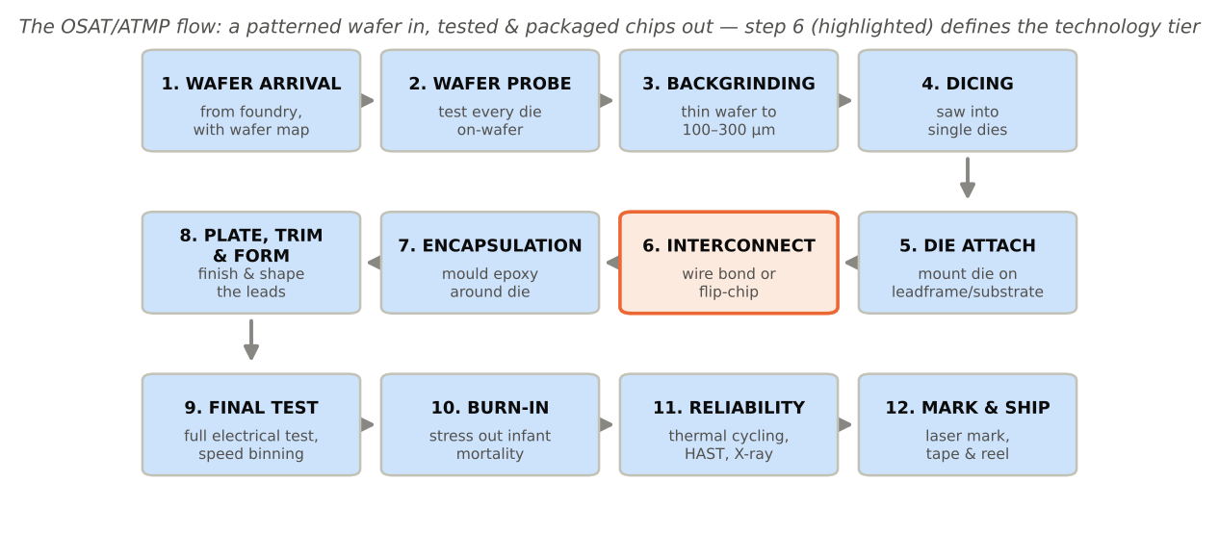
Figure 17 — The OSAT/ATMP process flow
- Wafer arrival & incoming QA — wafers arrive from the foundry with a wafer map (electronic file of known-good-die locations).
- Wafer probe / circuit probe (CP) — a probe card touches microscopic pads on every die and runs electrical tests while still on the wafer; failing dies are logged so no packaging money is wasted on them. (Probe is often done by dedicated test houses — e.g., KYEC in Taiwan.)
- Backgrinding — the wafer is ground from ~775 µm down to 100–300 µm (as thin as 25–50 µm for stacked memory), because thin packages are what phones and HBM stacks demand.
- Wafer saw / dicing (die separation) — diamond blades or lasers cut along “scribe lines” to singulate thousands of individual dies.
- Die attach — each good die is picked and placed (thousands per hour) onto its carrier: a stamped copper leadframe (cheap, high-volume packages) or a laminated organic substrate (BGA-class packages), fixed with epoxy or solder.
- Interconnection — the defining step. Two main technologies:
  - Wire bonding — a machine welds hair-thin (15–50 µm) gold or copper wires, one by one, between die pads and leadframe fingers, at 10–20 wires/second. Mature, cheap, still used in the majority of the world’s chips by unit volume.
  - Flip-chip — solder “bumps” are formed on the die face; the die is flipped and soldered face-down onto the substrate. Hundreds-to-thousands of connections form simultaneously; shorter paths mean better speed and power. All high-performance chips use flip-chip or finer successors (micro-bumps, copper-pillar, and bumpless hybrid bonding at <10 µm pitch). 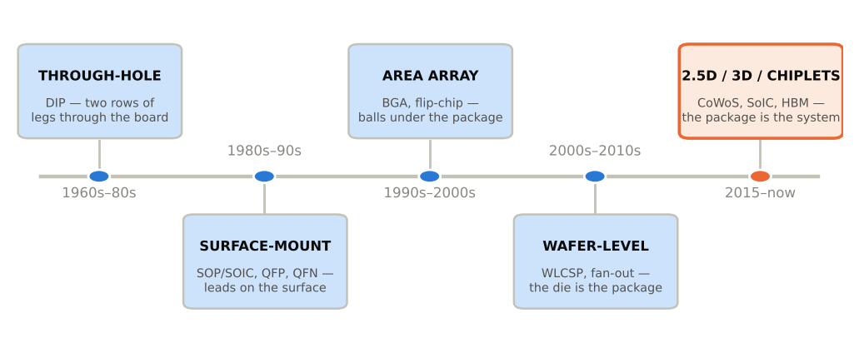
- Encapsulation / moulding — the die and wires are over-moulded in black epoxy moulding compound (EMC), protecting against moisture, light and handling.
- Plating, trim & form (leadframe packages) — leads are solder-plated, cut from the frame and bent to final shape; BGA packages instead get solder balls attached.
- Package testing (final test, FT) — automated test equipment (ATE from Advantest/Teradyne) with custom “load boards” and handlers runs every device through full electrical test; devices are binned by speed/power grade (the same silicon becomes different-priced SKUs).
- Burn-in testing — devices are operated at elevated temperature and voltage for hours to precipitate “infant mortality” failures — mandatory for automotive, server and defence parts.
- Reliability / qualification testing (sampled, and at product qualification): temperature cycling (−55 °C↔150 °C, 1,000 cycles), highly accelerated stress test (HAST), drop/vibration, X-ray and scanning acoustic microscopy for voids and delamination.
- Marking and shipping — laser marking (part number, lot, date code), lead scan, tape-and-reel or tray packing, and despatch into the customer’s supply chain.
A typical OSAT runs this flow for hundreds of different package types simultaneously — operationally closer to a precision high-mix manufacturing business (think contract pharma or precision auto components) than to a fab.

4.3 Packaging technologies: from DIP to CoWoS
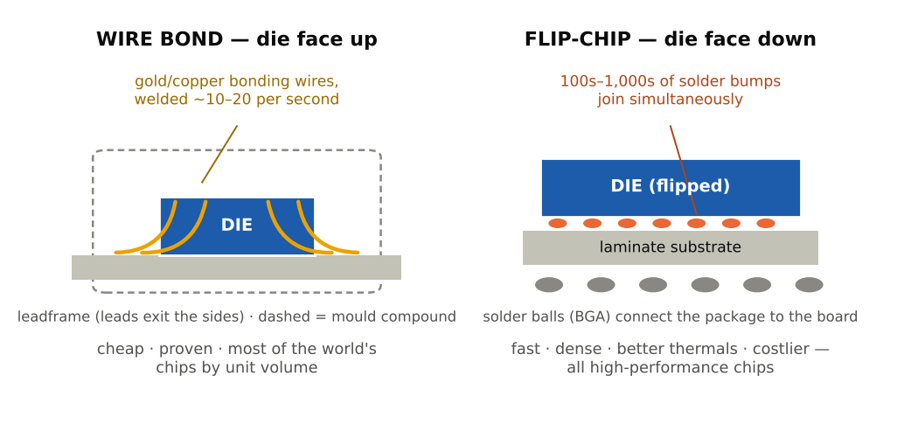
Figure 19 — Sixty years of package evolution
Traditional (leadframe + wirebond) packages — the volume workhorses, and where every new OSAT (including India’s) starts:
- DIP (dual in-line package): the 1970s classic with two rows of through-hole legs; survives in hobbyist/industrial niches.
- SOP/SOIC (small-outline): the surface-mount successor — gull-wing leads, vastly smaller; billions made monthly for analog/power/logic.
- QFP (quad flat package): leads on all four sides, up to ~300+ pins — microcontrollers everywhere.
- QFN (quad flat no-lead): pads underneath instead of leads; tiny, cheap, thermally strong; today’s default for power-management and RF chips. (SOIC/QFN/TO are precisely the packages Suchi Semicon, CDIL and India’s first wave produce.)
Advanced packaging:
- BGA (ball grid array): solder balls across the package underside — hundreds-to-thousands of connections; the standard for processors and ASICs. Variants: fine-pitch, flip-chip BGA (FCBGA).
- WLCSP (wafer-level chip-scale package): the package is built directly on the wafer — redistribution layers (RDL) and balls applied before dicing; the chip IS the package. Dominant in smartphones.
- Fan-out (FO-WLP/FOPLP): dies are embedded in a moulded reconstituted wafer/panel, letting the RDL “fan out” beyond the die edge for more I/O without a substrate. TSMC’s InFO (which won Apple’s A-series business from 2016) is the landmark; panel-level fan-out is the current cost frontier.
- 2.5D packaging: multiple dies sit side-by-side on a silicon interposer with microscopic wiring (µ-bumps at 40–55 µm pitch, TSVs through the interposer). This is CoWoS (Chip-on-Wafer-on-Substrate, TSMC) — the package of essentially every Nvidia/AMD data-centre GPU: logic die(s) + 4–12 HBM memory stacks on one interposer.
- 3D packaging: dies stacked vertically, connected by through-silicon vias (TSVs) and increasingly hybrid bonding (direct copper-to-copper, bumpless, <10 µm pitch): TSMC SoIC (used in AMD’s 3D V-Cache), Intel Foveros (logic-on-logic stacking), HBM itself (8–16 DRAM dies stacked on a logic base die).
- Chiplets: the architectural shift all of the above enables — building a “virtual monolithic” system from many smaller dies (compute tiles, I/O dies, memory) mixed across process nodes, linked by standards like UCIe. Economics: small dies yield far better than giant ones, and each function can use its cheapest adequate node.
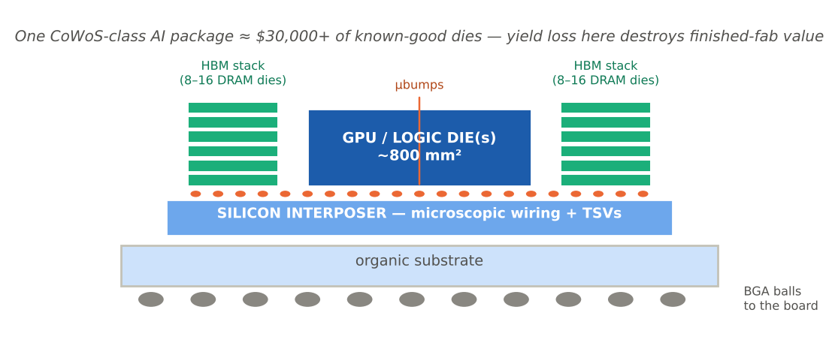
Figure 20 — Anatomy of an AI package (CoWoS-class 2.5D, text graphic)
Table 12 — Packaging technology generations
Generation | Interconnect | I/O count | Typical cost/package | Who runs it | Example products
Leadframe (DIP/SOP/QFP/QFN/TO) | Wire bond | 2–300 | $0.01–0.5 | All OSATs incl. new Indian entrants | PMICs, MCUs, discretes
Laminate BGA / FCBGA | Wire bond / flip-chip | 100–2,000+ | $0.5–10 | Tier-1/2 OSATs, IDMs | CPUs, modems, consoles
WLCSP / fan-out | RDL / µbump | 50–1,500 | $0.3–5 | TSMC InFO, ASE, Amkor, JCET | Smartphone SoCs, RF
2.5D (CoWoS/EMIB class) | µbumps + interposer + TSV | 10,000s | $100s–$1,000s | TSMC, ASE/SPIL, Amkor, Samsung | AI GPUs/accelerators
3D (SoIC/Foveros/HBM) | Hybrid bond / TSV | 100,000s | $100s–$1,000s | TSMC, Intel, memory makers | V-Cache CPUs, HBM4
How AI is rewriting packaging economics. Until ~2020, packaging was ~15–20% of chip cost and strategically boring. Generative AI inverted this: an H100/Blackwell-class accelerator is defined by its package — the interposer, the HBM stacks, the yield of assembling $30,000+ of known-good dies without destroying them. Consequences: (1) packaging capex at TSMC/ASE/Amkor/Samsung exploded — CoWoS-class capacity from ~35–40k wafers/month (2024) toward 120–140k/month by end-2026, with OSAT partners adding 50–60k more and total industry capacity trending toward ~200k; (2) the CoWoS supply–demand gap, ~20% in mid-2026, is expected to narrow only to ~10% by end-2026 — Nvidia alone books over half of TSMC’s capacity, with Broadcom second and AMD third; (3) back-end value share of an AI system’s silicon cost has risen to 30–50%+; (4) OSATs are being pulled up the value curve as TSMC offloads the mid-complexity tiers (on-substrate assembly, test) to ASE/SPIL, Amkor and KYEC. For India the lesson is double-edged: the opportunity is bigger than ever, but the frontier is sprinting away — a new entrant must master the wirebond/QFN tier while building toward flip-chip and fan-out, not leap straight to CoWoS.
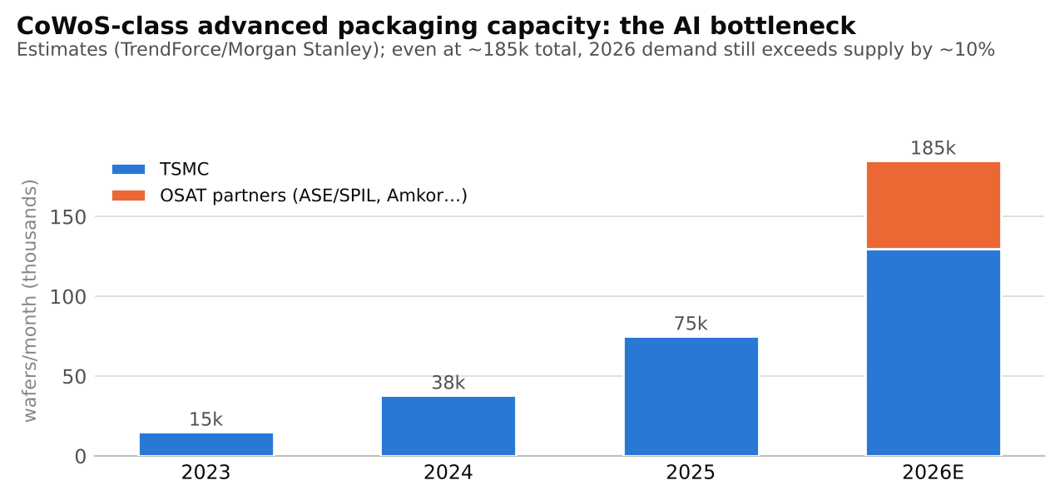
Figure 21 — CoWoS-class advanced packaging capacity ramp, 2023–2026E

4.4 The global OSAT industry: structure and profiles
The top-10 OSATs earned ~$41.6 bn in 2024 (TrendForce); the total market is ~$45–47 bn (2025: IDC $45.3 bn, +9.2%; Mordor $47.1 bn), headed for ~$61 bn by 2030 (GIA). Geographic DNA: Taiwan (~50%+ of revenue), China (~25% and climbing on policy-driven onshoring), US (Amkor, operating mostly in Asia), Korea, Singapore/Malaysia — and now India.
Table 13 — Top-10 OSAT ranking (2024 revenue, TrendForce basis)
# | Company | HQ | 2024 revenue | YoY | ~Share of top-10
1 | ASE Technology Holding (incl. SPIL) | Taiwan | $18.54 bn | +2% | ~45%
2 | Amkor Technology | USA | $6.32 bn (FY25: $6.71 bn) | −3% / +6% | ~15%
3 | JCET Group | China | $5.00 bn | +19% | ~10%
4 | Tongfu Microelectronics (TFME) | China | ~$3.3 bn | +double-digit | ~8%
5 | Powertech Technology (PTI) | Taiwan | ~$2.7 bn | +5% | ~6%
6 | Tianshui Huatian | China | ~$2.1 bn | +double-digit | ~5%
7 | KYEC (test specialist) | Taiwan | ~$1.2 bn | +AI-driven | ~3%
8 | UTAC | Singapore | ~$1.0 bn | flat | ~2%
9 | ChipMOS | Taiwan | ~$0.7 bn | flat | ~2%
10 | Hana Micron | Korea | ~$0.7 bn | +memory | ~2%
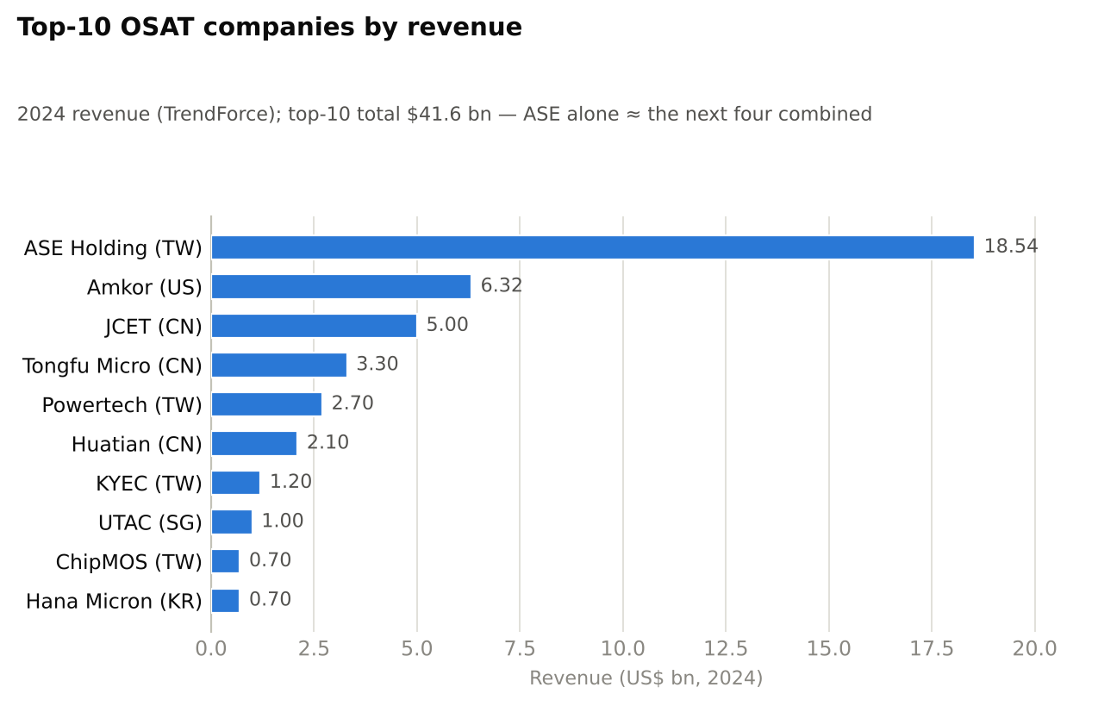
Figure 22 — Top-10 OSAT companies by 2024 revenue
Company profiles:
- ASE Technology Holding (Taiwan; ~$18.5 bn, ~28–30% of global OSAT). The industry’s colossus, formed by ASE’s acquisition of rival SPIL (2018); also owns EMS arm USI. 90+ plants across Taiwan (Kaohsiung HQ), China, Korea, Japan, Malaysia, Singapore, Vietnam, Mexico. Customers: effectively every major fabless firm and IDM; deeply embedded with TSMC as the overflow partner for advanced packaging (“CoWoS-ready” interposer assembly, test). Full technology stack — wirebond to fan-out (FOCoS) to 2.5D to co-packaged optics. Advantage: scale (≈ next four competitors combined), Taiwan cluster adjacency, and R&D depth no rival matches.
- Amkor Technology (US HQ, Arizona; $6.3–6.7 bn). Founded 1968 — the original OSAT. Factories in Korea, Philippines, Taiwan, Japan, Malaysia, Vietnam, Portugal; building a $2 bn advanced-packaging plant in Peoria, Arizona (CHIPS-funded) to package TSMC-Arizona wafers — the “trusted Western OSAT.” Strength in automotive (largest auto-packaging share), RF/SiP for Apple, and advanced SWIFT/S-Connect fan-out. Customer concentration: Apple is ~a quarter of revenue.
- JCET Group (China; $5.0 bn). China’s champion, transformed by the 2015 acquisition of Singapore’s STATS ChipPAC (with Big Fund backing). Plants in Jiangyin, Chuzhou, Shaoxing, Singapore, Korea. Full portfolio including 2.5D (XDFOI chiplet platform), SiP, memory packaging. Rides China’s chip-self-sufficiency drive — domestic designers (HiSilicon ecosystem, SMIC output) must package onshore. Risk: US export-control spillover.
- Tongfu Microelectronics (China; ~$3.3 bn). Jiangsu-based; the standout structural winner of AMD’s chiplet era — acquired 85% of AMD’s Penang and Suzhou back-end plants (2016) and still handles a large share of AMD’s CPU/GPU assembly. Growing in fan-out and 2.5D for domestic AI chips.
- Powertech Technology (Taiwan; ~$2.7 bn). The memory-packaging specialist (DRAM/NAND for Micron, Kioxia and others) plus logic test; now a meaningful player in HBM-adjacent test and advanced memory stacking. Cyclical with memory, which in 2025–26 is a tailwind.
- ChipMOS (Taiwan; ~$0.7 bn). Mid-size specialist in display-driver ICs (gold bump, COF/COG) and mixed-signal/memory test — an instructive model for Indian aspirants of a profitable niche OSAT that never chased the leading edge.
Strategic reading: the tier-1s (ASE, Amkor) are pulling away via advanced packaging capex that mid-tiers cannot fund; China’s players grow on a protected home market; the mid-tier (PTI, ChipMOS, UTAC, Hana) survives on niches. A new entrant’s viable strategies are: (a) a protected/subsidised home market — India’s case; (b) a niche; or (c) an anchor customer/technology partner — which is why every Indian project is structured around one (Micron captive; CG-Renesas; Kaynes anchor orders; Suchi-ROHM; Tata-Tesla/PSMC relationships).

4.5 Economics of an OSAT facility
What does it actually cost to build and run one? Synthesising disclosed Indian projects (Kaynes ₹3,307 cr; CG Semi ₹7,600 cr; Suchi ~₹840 cr phase plan; Micron $2.75 bn) and global benchmarks:
Table 14 — Indicative capex for a mid-size wirebond/QFN OSAT (~1.5–2 m units/day, leadframe-class)
Item | Share | Indicative cost (₹ cr) | Notes
Land & building (incl. ISO 6–8 cleanrooms ~15–25k m²) | 20–25% | 250–400 | Vibration-controlled floors, ESD flooring
Assembly equipment | 30–35% | 400–550 | Grinders/saws (Disco), die bonders (ASMPT/BESI, $0.15–0.5 m each), wire bonders (K&S/ASMPT, $60–150k each — a line needs 50–200+), mould presses (Towa/Yamada), plating lines
Test equipment | 20–25% | 300–450 | ATE testers (Advantest/Teradyne, $0.5–3 m each), handlers, probe stations, burn-in chambers
Utilities & facilities | 10–15% | 150–250 | N₂ plant, DI water, HVAC, compressed dry air, 10–30 MW power, backup
Reliability lab, IT/MES, spares, working capital seed | ~10% | 100–200 | X-ray, SAM, thermal-cycling chambers
Total | 100% | ₹1,200–1,800 cr ($150–220 m) | Advanced flip-chip/FO line: 2–4×; memory/HBM test: higher again
Operating profile. Utilities: OSATs are power- and water-hungry (though an order of magnitude less than fabs) — 24×7 operation, ~8–15 MWh and hundreds of kL water per day for a mid-size plant; a 1-second power dip scraps work-in-progress, so dual-grid + diesel/UPS is standard. Labour: 1,500–4,000 operators/technicians plus 200–400 engineers per mid-size plant — labour is 8–15% of cost in Taiwan/Malaysia and ~4–7% in India, the core of India’s cost case. Materials (leadframes, substrates, gold/copper wire, EMC) are 45–60% of revenue and almost entirely imported into India today — the single biggest localisation gap. Quality certifications are non-negotiable gate-passes: ISO 9001, IATF 16949 (automotive), AEC-Q100/Q101 qualification flows, ISO 14001/45001, ANSI/ESD S20.20, plus each customer’s own 6–12-month qualification audits — the hidden barrier that takes longer than building the plant.
Table 15 — Sample project model: Indian greenfield OSAT (illustrative, steady state in year 4–5)
Line item | Value | Basis
Capex (phase 1) | ₹1,500 cr | Table 14 midpoint
Government incentive (ISM 50% + state ~20–25%) | ₹(900–1,100) cr | Effective promoter/debt-funded capex: ₹400–600 cr
Capacity | ~1.5 m units/day (~500 m units/yr @ 90% utilisation × ~75% of days) | leadframe mix
Realisation (blended QFN/SOIC/TO) | ~₹4–7/unit ($0.05–0.08) | volume analog/power mix
Revenue | ₹2,200–3,000 cr/yr
Materials | 50–55% | imported leadframes/wire/EMC
Labour | 5–7% | India advantage
Power & utilities | 6–8%
Other opex (maintenance, logistics, SG&A) | 10–12%
EBITDA margin | 20–26% (₹450–750 cr) | vs. global OSAT 18–30%
Depreciation (7–8 yr equipment) | 9–12% of revenue
EBIT margin | 10–15%
Table 16 — Return metrics (same illustrative project)
Metric | Without incentives | With ISM + state incentives
Project IRR | 8–12% | 16–22%
ROCE (steady state) | 9–13% | 18–25% (on net invested capital)
Payback | 8–10 years | 4–6 years
Debt capacity | ~1:1 D:E | Lenders can size debt against post-incentive capex; DSCR comfort from take-or-pay/anchor contracts
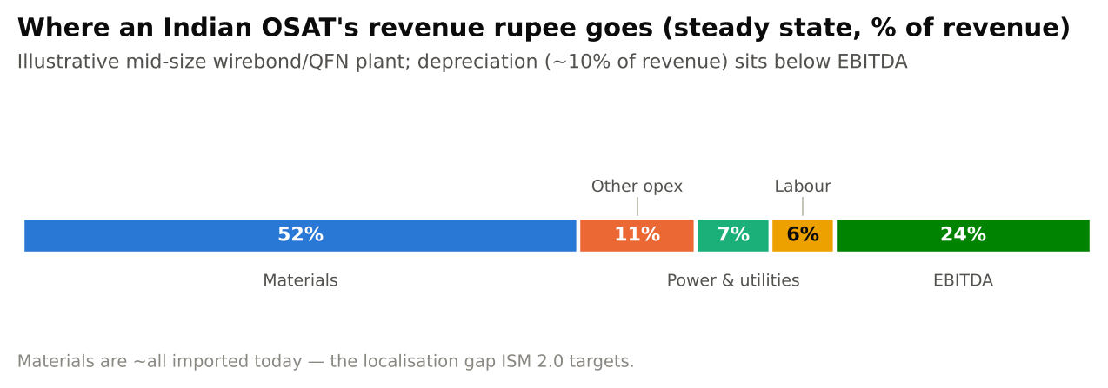
Figure 23 — OSAT cost structure
The financial character of OSAT, stated plainly for a credit committee: a volume-driven industrial converter with 20–25% EBITDA, high operating leverage (utilisation is everything), 7–8-year asset lives requiring perpetual reinvestment, negative-to-neutral working capital possible on consignment-material models, and returns that clear hurdle rates in India only because incentives absorb half or more of the capex. The bull case is not the first plant’s spreadsheet; it is what the first plant buys — customer qualifications, a trained workforce, and the option on each next rung of the packaging ladder (Section 9).

SECTION 5: GLOBAL SEMICONDUCTOR MARKET STRUCTURE — SELLERS AND BUYERS AT EVERY STAGE
A finance professional’s map of the industry is a map of who sells to whom, and how concentrated each node is. The Herfindahl–Hirschman Index (HHI — the sum of squared market shares; >2,500 = highly concentrated) is rarely published for these niches, so the tables below give computed/estimated HHI bands from the share data cited in Section 3. The pattern is unmistakable: almost every stage of this chain is a concentrated oligopoly or monopoly — which is why chokepoints, pricing power and geopolitics define the industry.
Table 17 — Upstream: silicon, wafers and materials
Segment | Market size | Top sellers (share order) | Top buyers | Concentration (est. HHI)
Semiconductor polysilicon | ~$5–7 bn | Hemlock, Wacker, Tokuyama, OCI, Mitsubishi, REC | Wafer makers (Shin-Etsu, SUMCO, GlobalWafers, Siltronic, SK Siltron) | High (~2,000–2,500)
Silicon wafers | ~$12–15 bn | Shin-Etsu ~28%, SUMCO ~23%, GlobalWafers ~16%, Siltronic ~12%, SK Siltron ~10%; tail: Okmetic, Wafer Works, SAS | TSMC, Samsung, Intel, Micron, SK Hynix, Kioxia, SMIC, UMC, GF, Infineon, TI, ST + all other fabs | Highly concentrated (~1,900–2,200); top-5 >90%
Photoresists & litho chemicals | ~$5 bn | JSR, TOK, Shin-Etsu Chem, Sumitomo, Fujifilm, DuPont, Merck | Same fab buyer set | Extreme in ArF/EUV resist (Japan ~90%)
Specialty gases | ~$10–12 bn | Linde, Air Liquide, Air Products, TNSC/Matheson, SK Materials, Kanto Denka | Fabs + OSATs (N₂ for both) | Moderate-high
Packaging materials (substrates, leadframes, EMC, bonding wire) | ~$25–30 bn | Ibiden, Shinko, Unimicron, Nan Ya PCB, AT&S, Kinsus (substrates); Mitsui High-tec, Shinko, Chang Wah, SDI (leadframes); Resonac, Sumitomo Bakelite, Kyocera (EMC); Heraeus, Tanaka, MK Electron (wire) | OSATs and IDM back-ends — ASE, Amkor, JCET, Intel, Samsung …and India’s new plants | High per sub-segment; ABF substrates were the 2021–22 shortage chokepoint
Table 18 — Design layer: EDA, IP and chip design
Segment | Market size | Top sellers | Top buyers | Concentration
EDA | ~$18–22 bn (incl. IP tools) | Synopsys(+Ansys), Cadence, Siemens EDA ≈ 70–75%; Keysight, Ansys-legacy, Empyrean (CN) | Every design team on earth: Nvidia, Apple, Qualcomm, Broadcom, AMD, Intel, Samsung, hyperscalers (Google/Amazon/Microsoft/Meta ASIC teams), and India’s 100+ design centres | Triopoly; HHI >2,000; US-controlled → export-control lever
Semiconductor IP | ~$8–9 bn | Arm (~40%+), Synopsys, Cadence, Imagination, Ceva, SiFive/Andes (RISC-V) | Same buyer set | Arm near-monopoly in mobile CPU ISA
Chip design (fabless sales) | >$250 bn | Nvidia, Broadcom, Qualcomm, AMD, MediaTek, Marvell, Realtek, Novatek, Will/Omni, MPS…; captive: Apple, Google TPU, Amazon Annapurna, Microsoft, Tesla | OEMs/hyperscalers: Apple, Samsung, Dell/HPE/Lenovo/Supermicro, AWS/Azure/GCP/Meta, auto Tier-1s (Bosch, Denso, Continental, Aptiv), phone OEMs (Xiaomi, Oppo/vivo) | Top-10 fabless ≈ 80% of fabless revenue; Nvidia alone >35%
Table 19 — Manufacturing layer: foundry and equipment
Segment | Market size | Top sellers | Top buyers | Concentration
Foundry | ~$160–190 bn | TSMC ~70%, Samsung ~8%, SMIC ~6%, UMC ~5%, GF ~4%, HuaHong, Vanguard, Tower, PSMC, Nexchip; +Intel Foundry external ramp | Fabless + IDM-outsourcers: Nvidia, Apple (~25% of TSMC), Qualcomm, AMD, Broadcom, MediaTek, Intel (external), auto/industrial IDMs | HHI ~5,000 — effective monopoly at leading edge
Wafer-fab equipment | ~$110–120 bn | ASML (litho 100% EUV), AMAT, Lam, TEL, KLA ≈ 65–70%; ASMI (ALD), SCREEN, Advantest, Hitachi High-Tech, Naura/AMEC (CN) | TSMC, Samsung, Intel, Micron, SK Hynix, Kioxia, SMIC (where permitted), new fabs incl. Tata–PSMC Dholera | Oligopoly per tool class; EUV HHI = 10,000 (monopoly)
Back-end equipment | ~$15–20 bn | ASMPT, K&S, BESI, Towa, Disco (saw/grind ~80%+), Shinkawa; testers: Advantest, Teradyne (~90% duopoly); Cohu, FormFactor (probe) | OSATs (ASE, Amkor, JCET…), IDM back-ends, India’s new OSATs — all its equipment is imported today | Duopolies/monopolies per niche
Table 20 — Back-end and end-product layer
Segment | Market size | Top sellers | Top buyers | Concentration
OSAT | ~$45–47 bn | ASE ~28–30%, Amkor ~14%, JCET ~10%, TFME, PTI, Huatian, KYEC, UTAC, ChipMOS, Hana; India entrants: Micron-captive, Tata TSAT, Kaynes, CG Semi, Suchi, ASIP | Fabless/IDM chip firms (the same design-layer names), foundries subcontracting overflow | Moderate-high (HHI ~1,300–1,500); top-3 >50%
Memory (chips) | ~$165 bn (2024) → supercycle 2026 | Samsung, SK Hynix, Micron ≈ 95%+ of DRAM; +Kioxia, SanDisk in NAND; CXMT/YMTC (CN) rising at trailing edge | Hyperscalers (AI servers), phone/PC OEMs, Nvidia (HBM via SK Hynix/Micron/Samsung) | DRAM HHI ~3,300 — triopoly; HBM: SK Hynix-led
Logic/processors | ~$215–270 bn | Nvidia, Intel, AMD, Apple(captive), Qualcomm, MediaTek, Broadcom | Data centres ~40%+, phones ~25%, PCs, auto, industrial | High and rising (AI)
Analog/power/auto | ~$135–150 bn combined | TI, ADI, Infineon, ST, NXP, Renesas, onsemi, Microchip, Rohm, Toshiba, Fuji, Mitsubishi, Vishay, Nexperia, Wolfspeed | Auto Tier-1s/OEMs (Bosch, Denso, ZF, Tesla, BYD, Hyundai, VW, Toyota), industrial, appliances, grid | Fragmented by product (HHI <1,000 overall) — the natural first customer base for Indian OSATs: mature nodes, leadframe packages, long product lives
Reading these four tables together: the most fragmented, highest-volume, least technologically forbidding node of the whole chain is exactly where India has entered — leadframe-class packaging of analog/power/auto chips, sold into a diversified buyer base that is actively de-risking from China/Taiwan concentration (“China+1”). Conversely, every input an Indian OSAT buys (equipment duopolies, substrate/leadframe oligopolies) carries pricing power against it — the margin squeeze is structural, and scale + incentives are the only antidotes.

SECTION 6: GLOBAL SEMICONDUCTOR INDUSTRY STATUS (2025–26)

6.1 The AI boom and the “Nvidia effect”
Data-centre AI is now the industry’s demand engine. Nvidia’s rise from ~$27 bn revenue (FY2023) to ~$130 bn (FY2025) and beyond — briefly making it the world’s most valuable company — pulled the entire chain with it: TSMC’s 2025 revenue grew ~35%+ to ~$115–120 bn; HBM memory sold out through multi-year contracts; and hyperscaler capex (Microsoft, Google, Amazon, Meta — each $60–100 bn+/yr) became the industry’s true end-demand variable. Three second-order effects matter most:
- The memory supercycle. AI servers consume 5–8× the DRAM of ordinary servers, plus HBM stacks that eat ~3× the wafer capacity per bit. By mid-2026 contract prices for DRAM/NAND had inflated so sharply that WSTS’s spring-2026 forecast has memory revenue roughly tripling in 2026 to >$800 bn — the main driver of the headline $1.5 tn industry forecast. Veterans note that every price-driven memory boom in history has ended in a glut; 2027–28 is the consensus risk window.
- The packaging shortage (Section 4.3): CoWoS-class capacity sold out years forward; Nvidia holding >half of TSMC’s allocation; OSATs promoted from commodity suppliers to strategic partners.
- Design fragmentation: every hyperscaler now designs custom silicon (Google TPU, Amazon Trainium, Meta MTIA, Microsoft Maia, OpenAI-Broadcom), multiplying the number of large customers for foundries, OSATs — and EDA.

6.2 Geopolitics: the chip war
- US export controls (October 2022, tightened 2023–25) deny China EUV and advanced DUV lithography, leading-edge AI GPUs, and US-origin EDA/tooling above thresholds; entity-listing of SMIC, YMTC, Huawei ecosystem. 2025 added country-tier AI-diffusion rules and episodic licence regimes for mid-range AI chips; policy has oscillated with US-China trade negotiations (H20-class sales permitted, then re-restricted).
- China’s response: Big Fund III (¥344 bn ≈ $47.5 bn, 2024) focused on equipment/materials self-sufficiency; retaliatory export controls on gallium/germanium (2023) and rare-earth processing leverage (2025 flare-ups); massive legacy-node capacity build (China is adding more 28 nm+ capacity than the rest of the world combined — a looming source of mature-node price pressure that directly affects the customers Indian OSATs serve).
- Taiwan concentration risk: ~90% of sub-7 nm logic, plus the headquarters of the foundry and OSAT industries, sit on one island 180 km from China. This single fact underwrites every Western, Japanese and Indian subsidy programme. Diversification is real but partial: TSMC Arizona (3 fabs committed, first producing N4 since 2025, total US commitment raised to $165 bn), TSMC Kumamoto (JASM, 2 fabs), TSMC Dresden (ESMC), Samsung Taylor TX, Rapidus Hokkaido (2 nm pilot 2025, production 2027).
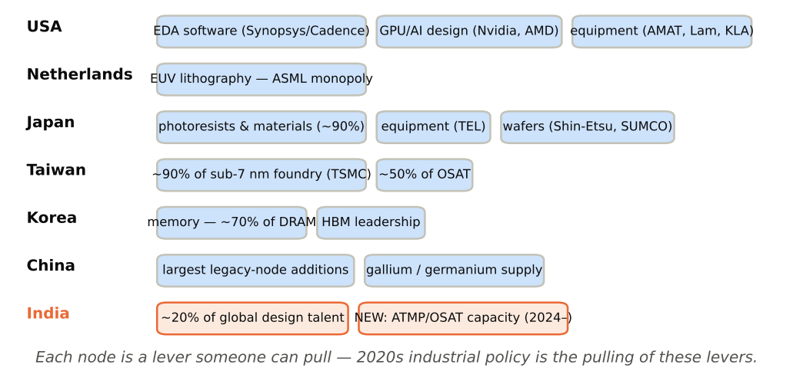
Figure 24 — The chokepoint map

6.3 Capacity and investment scoreboard
Table 21 — Market size and segment outlook (2024 → 2026F)
Segment | 2024 | 2025 | 2026F | Driver
Total semiconductors | $630.5 bn | $791.7 bn | ~$975 bn (WSTS autumn-25) – $1.51 tn (WSTS spring-26) | AI + memory prices
Memory | ~$165 bn | ~$250 bn± | forecast to ~triple (price-led) | HBM/DDR5 scarcity
Logic (incl. GPUs/ASICs) | ~$215 bn | ~$270 bn+ | strong double-digit growth | AI accelerators
Foundry revenue | ~$155 bn | ~$190 bn | +15–20% | TSMC N3/N2
WFE (equipment) | ~$100 bn | ~$110–120 bn | ~flat-to-up | subsidy-funded fabs
OSAT | ~$42–44 bn | ~$45–47 bn | ~$50 bn+ | advanced packaging overflow
Table 22 — Headline capacity projects announced/underway (status, late 2026)
Project | Location | Investment | Status
TSMC Arizona (3+ fabs, packaging) | USA | $65 bn → $165 bn committed | Fab 1 producing N4; Fab 2–3 construction
Samsung Taylor | Texas | $17 bn → $37 bn+ | Ramp delayed to ~2026–27 (2 nm pivot)
Intel Ohio/Arizona + 18A | USA | $100 bn programme (stretched) | 18A ramping; US govt ~10% equity (2025)
TSMC JASM Kumamoto 1 & 2 | Japan | ~$20 bn, ~¥1.2 tn subsidy | Fab 1 producing; Fab 2 building
Rapidus 2 nm | Hokkaido | ~¥5 tn plan, ~¥1.7 tn+ state support | Pilot line live (2025); mass production target 2027
SK Hynix Yongin cluster + M15X | Korea | $90 bn+ multi-fab HBM/DRAM | Under construction
China (SMIC, CXMT, YMTC, Huahong et al.) | China | >$100 bn across programmes | Fastest capacity additions globally, mature nodes
India — 12 ISM projects (Tata fab + 11 ATMP/OSAT/specialty) | India | ~₹1.64 lakh cr (~$19–20 bn) | 4 units inaugurated/shipping by mid-2026; Dholera fab targeting first wafers late-2026/2027
The structural summary of 2025–26: demand has gone vertical (AI), supply of the scarcest things (HBM, CoWoS, leading-edge wafers) is rationed, governments are co-investors everywhere, and the back-end — packaging and test — has moved from the industry’s periphery to its centre. That is the global backdrop against which India’s OSAT bet must be judged — and it is, on balance, the most favourable backdrop a new packaging ecosystem could have asked for.

SECTION 7: THE INDIAN SEMICONDUCTOR INDUSTRY

7.1 The ecosystem India already has
India’s semiconductor story did not start with fabs. Three mature layers existed before the first ISM plant was approved:
- Design. India is the world’s second-largest concentration of chip-design talent: roughly 20% of the global semiconductor design workforce (~125,000+ engineers) works in India, in the design centres of virtually every major firm — Qualcomm, Intel, Nvidia, AMD, TI, Samsung, MediaTek, Broadcom, Marvell, NXP, Micron, Arm, Synopsys, Cadence (Bengaluru, Hyderabad, Noida, Pune, Ahmedabad). Nearly every flagship global SoC has substantial Indian design content. What India historically lacked was ownership: the IP, and the P&L, sat abroad.
- Home-grown fabless and IP — small but real: Tejas Networks (telecom silicon), Mindgrove and InCore (RISC-V SoCs from the IIT-Madras Shakti/Moushik lineage), Saankhya Labs (broadcast SDR, acquired by Tejas), Signalchip (4G/5G), Vervesemi, Aura/Netrasemi (edge-AI), plus 100+ startups supported by the Design-Linked Incentive (DLI) scheme and the C-DAC/ISRO/DRDO strategic-chip programmes. The government’s SCL Mohali (180 nm, being modernised) remains the only operating silicon fab of the pre-ISM era.
- Electronics manufacturing (EMS). The demand pull: India’s electronics production crossed $115–130 bn/yr (FY25–26), with mobile phones >$60 bn (Apple now assembles a mid-teens share of global iPhones in India via Foxconn/Tata Electronics). Dixon, Kaynes, Syrma SGS, Amber, Tata Electronics anchor a fast-compounding EMS tier; PLI schemes for electronics, telecom, auto and solar all raise domestic chip consumption — currently ~$50 bn/yr, projected to reach $100–110 bn by 2030 (IESA). Every packaged chip an Indian OSAT ships can, increasingly, find its board-level customer within India.

7.2 India’s position versus the incumbents
Table 23 — Country comparison for semiconductor manufacturing (qualitative scoring: ●●● strong / ●● moderate / ● weak)
Factor | Taiwan | S. Korea | Japan | USA | China | Malaysia | Vietnam | India
Fab manufacturing base | ●●● | ●●● | ●● | ●● | ●●● (mature) | ● | ● | ● (building)
OSAT/packaging base | ●●● | ●● | ●● | ● | ●●● | ●●● (13% of global ATP) | ●● (Intel, Amkor) | ● → ●● (12 projects)
Design talent pool | ●● | ●● | ●● | ●●● | ●●● | ● | ● | ●●● (scale)
Engineering cost | High | High | High | Very high | Medium | Medium | Low | Low (30–50% of Taiwan/US)
Infrastructure (power, water, logistics) | ●●● | ●●● | ●●● | ●●● | ●●● | ●● | ●● | ● → ●● (improving; reliability still the gap)
Policy support (current) | ●● | ●●● | ●●● | ●●● | ●●● | ●● | ●● | ●●● (ISM 1.0+2.0 ≈ $23 bn)
Supply-chain depth (materials, substrates, gases) | ●●● | ●●● | ●●● | ●● | ●●● | ●● | ● | ● (the critical weakness)
Domestic demand | ● | ●● | ●● | ●●● | ●●● | ● | ● | ●●● (growing fastest)
Geopolitical alignment with Western supply chains | ●●● (but concentration risk) | ●●● | ●●● | — | ✗ | ●● | ●● | ●●● (“trusted partner” premium)
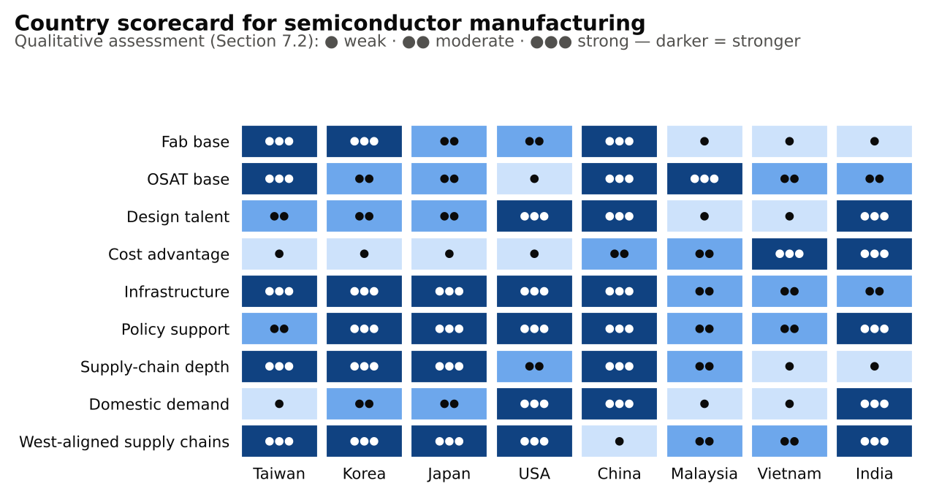
Figure 25 — Country scorecard for semiconductor manufacturing
The honest synthesis: India’s winning cards are talent, labour cost, domestic demand, political trust and subsidy depth; its losing cards are supply-chain depth (every leadframe, substrate, chemical and machine is imported), infrastructure reliability, and zero accumulated manufacturing learning. That hand is poorly suited to leading-edge fabs — and well suited to OSAT/ATMP, which is precisely how the approved project slate is weighted.

7.3 Major semiconductor investments in India (the ISM 1.0 dozen)
Table 24 — All 12 approved ISM 1.0 projects (status: November 2026)
# | Project / promoters | Location | Type | Investment | Capacity | Status / jobs
1 | Micron Technology | Sanand, Gujarat | ATMP (memory assembly & test) | ₹22,516 cr ($2.75 bn; ~70% subsidised centre+state) | DRAM/NAND modules | Inaugurated Feb 2026; ~5,000 direct jobs planned
2 | Tata Electronics + PSMC | Dholera, Gujarat | Fab — 28/40/55/90/110 nm | ₹91,000 cr | 50,000 wafers/month | Construction advanced; 200+ engineers trained at PSMC Taiwan; first wafers targeted late-2026/2027; 20,000+ direct/indirect jobs
3 | Tata Semiconductor Assembly & Test (TSAT) | Morigaon (Jagiroad), Assam | ATMP — wirebond, flip-chip, ISIP | ₹27,000 cr | 48 million chips/day | Phase-1 nearing production; ~27,000 direct+indirect jobs
4 | CG Power + Renesas + Stars Microelectronics | Sanand, Gujarat | OSAT | ₹7,600 cr | 15 million chips/day | Pilot line operating; ramping
5 | Kaynes Semicon | Sanand, Gujarat | OSAT | ₹3,307 cr | 6.3 million chips/day | Inaugurated Mar 2026; power/analog packages; anchor-customer agreements (incl. US power-semi designers)
6 | HCL + Foxconn JV | Jewar (near Noida airport), UP | Display-driver chip unit | ₹3,706 cr | 20,000 wafers/month; 36 m driver ICs/month | Approved May 2025; under construction
7 | SiCSem + RIR Power (with Clas-SiC, UK) | Bhubaneswar, Odisha | India’s first commercial SiC compound fab + integrated OSAT | ₹2,066 cr | 60,000 SiC wafers/yr class | Approved Aug 2025
8 | 3D Glass Solutions (3DGS) | Odisha | Glass-substrate advanced packaging | ₹1,943 cr | Glass interposers/packages | Approved Aug 2025
9 | ASIP Technologies (with APACT, Korea) | Andhra Pradesh | OSAT | ₹468 cr | Consumer/industrial packages | Approved Aug 2025
10 | CDIL (Continental Device India) | Mohali, Punjab | Brownfield discrete/power expansion | ₹117 cr | +158 m devices/yr | Approved Aug 2025; India’s legacy packager since 1964
11 | Suchi Semicon | Surat, Gujarat | OSAT | ₹868 cr | 1,033.2 m chips/yr | Approved May 2026 (already shipping commercially since Dec 2024 — see Section 9)
12 | Crystal Matrix | Dholera, Gujarat | Compound-semi fab + ATMP for Mini/Micro-LED display modules | ₹3,068 cr | LED display modules | Approved May 2026
 | Total | 6 states | 1 fab + 11 ATMP/OSAT/specialty | ~₹1.64 lakh crore (~$19–20 bn) |  | ~85,000+ direct/indirect jobs projected
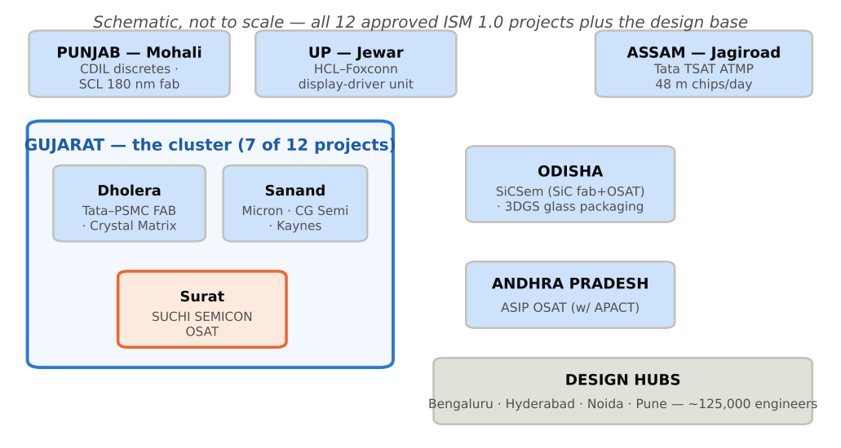
Figure 26 — India’s semiconductor map
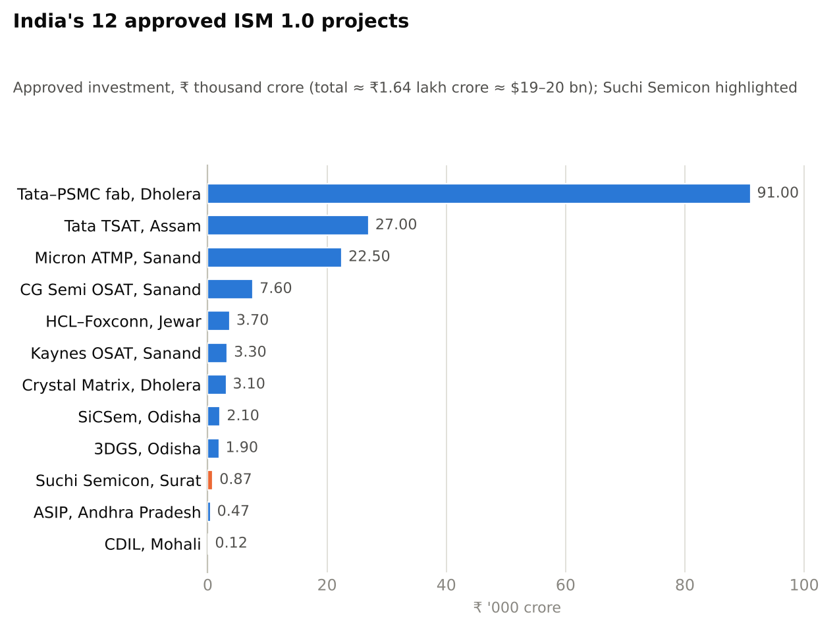
Figure 27 — Approved investment across India’s 12 ISM 1.0 projects
Pattern recognition for investors: Gujarat has become India’s semiconductor cluster (7 of 12 projects — mirroring how Hsinchu, Penang and Suzhou formed); 11 of 12 projects are packaging/specialty rather than leading-edge fabs (deliberate capability sequencing); every project has a technology partner or anchor customer (PSMC, Renesas, ROHM, APACT, Clas-SiC — nobody is attempting autarky); and the first wave has moved from approval to inauguration in 18–30 months, fast by global standards. The failed-bid history (Vedanta-Foxconn’s $19.5 bn fab collapse, 2023; ISMC/Tower’s stalled proposal) taught the ecosystem to favour credible, partner-backed, right-sized projects.

SECTION 8: THE INDIA SEMICONDUCTOR MISSION (ISM)

8.1 ISM 1.0 (2021–2026): origin, design, results
Origin. Approved December 2021 with a ₹76,000 crore (~$10 bn) outlay, ISM was India’s response to the pandemic chip shortage, the China+1 realignment and two decades of failed fab attempts. It sits inside MeitY as a specialised division of Digital India Corporation, acting as the single-window agency for appraisal, disbursement and ecosystem development.
Table 25 — ISM 1.0 scheme architecture
Scheme | Support | For
Silicon fab scheme | 50% of project cost (pari-passu fiscal support) | Wafer fabs of any node (originally tiered 30–50% by node; flattened to 50% for all)
Display fab scheme | 50% of project cost | AMOLED/LCD fabs (no takers yet)
Compound semi / sensors / ATMP / OSAT scheme | 50% of capital expenditure | SiC/GaN fabs, MEMS, packaging & test units — the scheme Micron, Kaynes, CG, Suchi et al. used
Design-Linked Incentive (DLI) | Up to 50% of eligible design cost (cap ₹15 cr) + 4–6% of net sales (cap ₹30 cr) | Domestic fabless startups (100+ supported)
Chips-to-Startup (C2S) | Talent programme | 85,000 engineers across ~100+ institutions
+ State stacking | Gujarat/UP/Assam/Odisha add 20–25% of capex, land, power and water subsidies | Effective total support reaches ~70–75% of project cost in Gujarat
Progress achieved: 12 approved projects, ~₹1.64 lakh crore committed investment, four units inaugurated or in commercial shipment by mid-2026 (Micron, Kaynes, CG pilot, Suchi), the Dholera fab in advanced construction, the ₹76,000 crore nearly fully committed — and, equally important, the institutional learning: appraisal discipline after the Vedanta-Foxconn failure, a functioning centre-state incentive stack, and SEMICON India as a credible annual industry fixture.

8.2 ISM 2.0 (approved July 2026): the second tranche
The Union Cabinet approved ISM 2.0 in July 2026 with an outlay of ₹1,28,000 crore (~US$13.25 bn) (EFC-cleared at ~₹1.25 tn; initial FY27 budget provision ₹1,000 cr). Design changes reflect the lessons of round one:
Table 26 — ISM 1.0 vs ISM 2.0
 | ISM 1.0 (2021) | ISM 2.0 (2026)
Outlay | ₹76,000 cr | ₹1,28,000 cr
Centre of gravity | Getting any fab + first ATMP units built | Deepening the ecosystem
Fiscal support | 50% capex | Up to 50%, extended across more categories
New focus areas | — | Compound semiconductors; advanced packaging; materials & inputs (gases, ingots, substrates, leadframes); equipment; design IP retained in India; R&D and talent
Design policy | DLI (startup-scale) | Larger design incentives tied to IP ownership residing in India
Strategic intent | Prove India can build | Make what was built self-sustaining — localise the imported 50–60% bill of materials that currently caps OSAT margins
For the OSAT theme specifically, ISM 2.0’s materials-and-equipment focus is the decisive piece: an Indian OSAT today imports essentially 100% of its leadframes, substrates, mould compound, bonding wire and machines. Every percentage point of that bill localised is a direct, recurring margin and forex gain — and a far larger prize than any single additional plant.

8.3 How India’s incentives compare globally
Table 27 — National semiconductor incentive programmes
Programme | Headline public money | Instruments | Distinctive feature
USA — CHIPS & Science Act (2022) | $52.7 bn appropriated ($39 bn mfg grants) + 25% investment tax credit (worth >$75 bn) | Grants, loans, ITC | 2025 shift under the new administration: several grants converted into government equity (≈10% of Intel); scale per project largest anywhere
China — “Big Fund” I/II/III (2014–2024) | ¥138.7 bn + ¥204 bn + ¥344 bn ($47.5 bn), plus provincial funds (total state support est. >$150 bn) | Equity injections | Big Fund III targets equipment & materials self-sufficiency under export controls
Taiwan (2023 “Chips Act”) | 25% tax credit on R&D, 5% on advanced equipment | Tax credits (plus decades of ITRI/Hsinchu infrastructure) | The model: state incubation (ITRI→TSMC 1987) then light-touch support of a private champion
South Korea — K-Chips Act (2023, enhanced 2025) | Facility-investment tax credits raised to ~20% (large firms)/~30% (SMEs); ~₩26 tn support package; Yongin mega-cluster (~$470 bn private, state-enabled) | Tax credits + infrastructure | State builds the grid/water; chaebols build the fabs
Japan (2021–) | ~¥3.9 tn committed (TSMC Kumamoto ~¥1.2 tn; Rapidus ~¥1.7 tn+), inside a ~¥10 tn AI/semiconductor frame to 2030 | Direct subsidies up to ~50% | Fastest disbursement in the world; Kumamoto fab built in ~22 months
EU Chips Act (2023) | €43 bn mobilised | Grants via member states | ESMC Dresden (TSMC JV); Intel Magdeburg shelved
India — ISM 1.0 + 2.0 | ₹76,000 cr + ₹1,28,000 cr ≈ $23 bn, plus state stacking of 20–25% | Upfront capex sharing (50%+) | Highest proportional de-risking of project capex anywhere; weighted to ATMP/OSAT and now materials — i.e., to India’s realistic rungs of the ladder
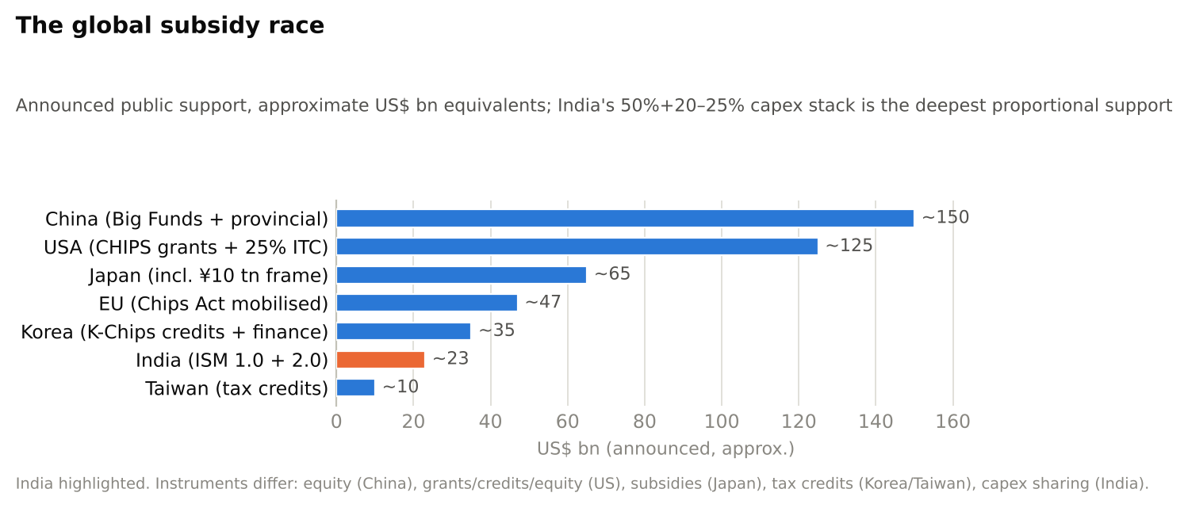
Figure 28 — The global subsidy race (announced public support, text graphic)
Two comparative judgements: (1) In absolute money India’s ~$23 bn is a fraction of US/China programmes — but measured as share of project capex covered, India’s 50% + state stack is the most generous regime in the world, which is exactly what a zero-base ecosystem needs. (2) The unresolved comparison is speed and depth of disbursement: Japan built Kumamoto in 22 months; India’s test is whether Dholera’s fab and the ATMP dozen convert approvals into shipped volume on comparable timelines. The early OSAT evidence (Micron, Kaynes, Suchi) is encouraging.

SECTION 9: SPECIAL STUDY — SUCHI SEMICON AND THE FUTURE OF OSAT IN INDIA
A consulting-style growth study of India’s first private home-grown OSAT. Public information is limited for a young private company; figures below combine company statements, the Cabinet approval release and trade press, and the forward path is explicitly scenario analysis, not guidance.

9.1 Business model and what Suchi Semicon does
Suchi Semicon (Surat, Gujarat) is the semiconductor venture of the Suchi Industries textile group — a diversification from yarn to chips that is itself emblematic of India’s industrial moment. The company built its OSAT plant at Surat on its own balance sheet before winning government approval: trial production began December 2024, commercial production and export shipments followed in 2025, and in May 2026 the Union Cabinet approved it under ISM with a project cost of ₹868 crore and sanctioned capacity of 1,033.2 million chips per annum — one of the final two ISM 1.0 approvals.
The operating model today:
- Packages: SOIC, QFN/DFN and TO families — the leadframe/wirebond tier (Section 4.3) serving power-management ICs, discretes and consumer/industrial analog — exactly the segment this report identified as the rational Indian entry point.
- Scale: rated capacity ~300,000 chips/day, with the company reporting ~150,000/day of running production (mid-2026) and a stated target of 3 million chips/day within three years (~1 billion/yr, matching the sanctioned capacity).
- Customers and partners: an anchor US customer (reported order volume ~150,000 chips/day); 20+ identified customers across the US, Japan, Korea and Taiwan; and — strategically the most important fact on record — a partnership with ROHM (Japan), under which ROHM supplies wafers to Suchi for packaging. A tier-1 Japanese IDM routing wafers through a Surat startup is the industry’s standard seal of qualification.
- Funding model: phased promoter capital (~₹840–870 cr programme) now levered by the ISM 50% + Gujarat ~25% incentive stack — i.e., the Section 4.5 economics with the de-risked capex case applying.
Table 28 — Suchi Semicon snapshot (November 2026)
Dimension | Position
Founded / plant | Suchi group venture; Surat, Gujarat OSAT
Status | Commercial production & exports; ISM-approved May 2026
Project cost (sanctioned) | ₹868 crore
Capacity | ~300k chips/day running→rated; sanctioned 1,033.2 m chips/yr
Packages | SOIC, QFN/DFN, TO (wirebond/leadframe tier)
Key relationships | ROHM wafer-supply partnership; US anchor customer; 20+ pipeline accounts (US/JP/KR/TW)
Peer set in India | Kaynes Semicon, CG Semi (both Sanand, larger, listed/conglomerate-backed), CDIL (legacy discretes), ASIP
Differentiation | First private, home-grown, self-started Indian OSAT — proved demand before subsidy

9.2 Growth opportunities by end market
Table 29 — Addressable demand for an Indian leadframe-tier OSAT
End market | Why it fits | Indicative opportunity
Mobile & consumer electronics | India assembles >$60 bn of phones/yr; every charger, PMIC, audio amp uses QFN/SOIC parts | Largest unit volumes; price-competitive vs China
Automotive & EV | India is the #3 car market; EV content = 2–3× ICE chips; AEC-Q qualification = sticky, premium business | The margin ladder: burn-in + reliability revenue
Industrial & appliances | PLI-driven appliance/inverter manufacturing localising boards | Steady baseload volume
Power electronics / solar / grid | India’s solar + storage build-out consumes discretes, IGBTs, SiC (SiCSem upstream in Odisha) | Natural adjacency to TO/power packages
Defence & space | Sovereign packaging demand (DRDO/ISRO) requires onshore trusted ATMP | Small volume, strategic pricing, certification halo
AI/data centre (indirect) | Not CoWoS-class work — but AI crowds incumbent OSAT capacity, pushing legacy overflow to new entrants | The 2025–27 window-opener

9.3 The five-stage expansion path
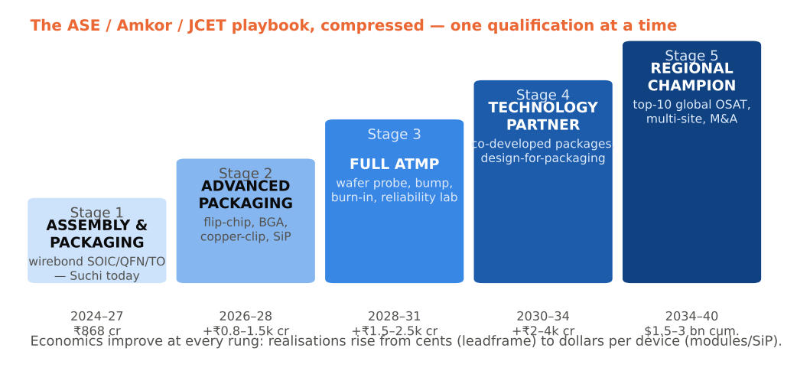
Figure 29 — The OSAT capability ladder
Table 30 — Stage gates, timelines and capital (illustrative)
Stage | Capabilities added | Indicative timeline | Incremental capex | Gate to pass
1. Assembly & packaging (now) | Wirebond leadframe packages + final test at 1 m+/day scale | 2024–27 | ₹868 cr (sanctioned) | Yield >99%, 3–5 qualified volume customers, IATF 16949
2. Advanced packaging | Flip-chip on leadframe/laminate, power modules, copper-clip, SiP | 2026–28 | ₹800–1,500 cr | One anchor (e.g., ROHM-class) migrating a flip-chip line
3. Full ATMP | Wafer probe/CP, bumping, burn-in, full reliability lab, automotive grade at scale | 2028–31 | ₹1,500–2,500 cr | AEC-Q volume programmes; memory or MCU test wins
4. Technology partner | Co-developed packages, design-for-packaging services, fan-out pilot | 2030–34 | ₹2,000–4,000 cr | R&D org >300 engineers; IP filings; ISM 2.0 R&D support
5. Regional champion | Top-10 global OSAT scale (~$1 bn+ revenue), multi-site, M&A | 2034–40 | Cumulative $1.5–3 bn | Access to capital markets; ecosystem (substrates/leadframes) localised around it
This is, deliberately, the ASE/Amkor/JCET historical playbook compressed: every tier-1 OSAT began exactly where Suchi is — wirebonding simple packages for a sponsor customer — and climbed one qualification at a time. The ladder’s economics improve at each rung: realisations rise from ~$0.03–0.08 (leadframe) to $0.5–10 (laminate/flip-chip) to dollars-per-device (modules/SiP), while customer stickiness and switching costs deepen.

9.4 Risks
Table 31 — Risk matrix (Suchi-specific and India-OSAT generic)
Risk | Severity | Mitigant
Technology obsolescence — wirebond tier commoditises while frontier races ahead (hybrid bonding, panel FO) | Medium-high, slow-burning | Leadframe packages have decades of residual life (auto/power/analog); climb Stage 2–3 on schedule
Customer concentration — one US anchor + ROHM dominate early volumes | High in 2025–28 | 20+ account pipeline; ISM-driven domestic demand (Tata fab output from 2027 needs onshore packaging)
China competition — subsidised legacy-node + packaging overcapacity dumping prices | The structural risk for every leadframe OSAT | India tariff/trusted-supply-chain positioning; “China+1” procurement mandates of US/JP customers
Pricing pressure from tier-1 scale (ASE’s unit costs) | Medium | Labour arbitrage + 70% subsidised capex = viable cost floor; niche focus
Talent shortage — India has designers, not yet packaging process engineers | Medium | Taiwan/Malaysia hiring, ISM talent schemes, Tata/Micron alumni flywheel forming
Materials import dependence (leadframes, EMC, wire) | Medium, margin-capping | ISM 2.0 materials localisation; cluster effects in Gujarat
Execution/financial — a mid-size private group running a 24×7 precision plant | Medium | ROHM partnership discipline; phased capex; incentive milestones enforce audits

9.5 Outlook 2025–2040 (scenario projections, illustrative)
Table 32 — Suchi Semicon scenarios (revenue, rounded)
 | 2026 (run-rate) | 2030 | 2035 | 2040
Bear (stays Stage 1; price pressure) | ~₹100–150 cr | ₹400 cr | ₹600 cr | consolidation target
Base (executes Stages 1–3) | ~₹100–150 cr | ₹1,200–1,800 cr | ₹4,000–6,000 cr | ₹8,000–12,000 cr; top-15 global OSAT
Bull (Stage 5; India OSAT market compounds >20%) | ~₹150 cr | ₹2,500 cr | ₹8,000–10,000 cr | $2–3 bn revenue; top-10 global
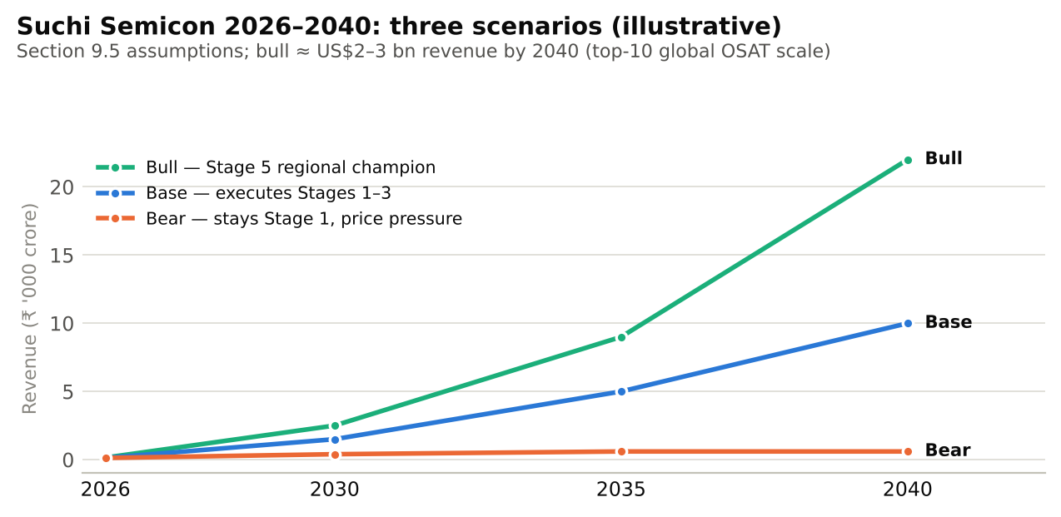
Figure 30 — Suchi Semicon revenue scenarios, 2026–2040 (illustrative)
The base case assumes what the evidence so far supports: the plant fills (ROHM-class partners migrate volume), ISM 2.0 materials localisation lifts margins 300–500 bps, and India’s domestic chip consumption doubles by 2030. The decisive variable is not demand — it is execution of the Stage 2–3 climb before the leadframe tier’s pricing erodes, and that in turn depends on talent and on anchoring one more tier-1 technology partner.

SECTION 10: SWOT ANALYSIS
Table 33 — SWOT: Global semiconductor industry
Strengths | Weaknesses
Irreplaceable, universal demand; secular AI/electrification growth; extraordinary margins at chokepoints (TSMC, ASML, Nvidia); deepest R&D flywheel of any industry | Extreme cyclicality (memory supercycle 2025–26 → glut risk 2027–28); capex escalation ($20 bn+/fab); geographic concentration (Taiwan/Korea); 70+-border supply chains fragile to shocks

Opportunities | Threats
AI/data-centre decade; advanced packaging value pool; automotive/power electrification; $400 bn of global subsidies; chiplets opening design space | US–China escalation severing the chain; Taiwan contingency; subsidised global overcapacity at mature nodes; talent shortfall (est. 1 m+ workers needed by 2030); energy constraints on fabs and data centres
Table 34 — SWOT: Indian semiconductor industry
Strengths | Weaknesses
20% of global design talent; $50 bn and fastest-growing domestic demand; deepest proportional incentives anywhere (ISM 1+2 ≈ $23 bn + state stack); political consensus & geopolitical trust; proven speed in first ATMP wave (approval→inauguration in ~2 yrs) | Zero legacy manufacturing learning; near-total import dependence for equipment, materials, chemicals; infrastructure reliability (power quality, water, logistics); no leading-edge roadmap; past failed-bid credibility overhang (Vedanta-Foxconn); bureaucratic disbursement risk

Opportunities | Threats
China+1/Taiwan-derisking procurement shifts; ISM 2.0 materials & equipment localisation; mature-node fab (Dholera) + OSATs = full mini-ecosystem by 2028; compound semis (SiC for EV/solar) where no incumbent lead is unassailable; services-to-product IP flip in design | Chinese mature-node price war; incentive dependence (projects may not clear hurdles unsubsidised); global downcycle hitting just as plants ramp (2027–28 memory risk); talent poaching wars; technology partners withholding leading tech
Table 35 — SWOT: Indian OSAT industry specifically
Strengths | Weaknesses
Right rung of the ladder (low capex, labour-intensive, fast to revenue); labour cost 30–50% below Taiwan/Malaysia; 70%+ capex subsidised; five credible first movers already shipping/qualifying; anchor partnerships (ROHM, Renesas, PSMC, APACT) | Materials 50–60% of revenue, ~all imported; thin domestic engineering bench in package process; no advanced packaging capability yet; subscale vs ASE (whose single-company revenue ≈ 10× India’s entire 12-project investment)

Opportunities | Threats
Global packaging shortage & AI overflow; Dholera fab output (2027+) requiring onshore ATMP; auto/EV/solar localisation mandates; ISM 2.0 funding the missing substrate/leadframe ecosystem; defence/space sovereign demand | Commoditisation of wirebond tier by Chinese overcapacity; tier-1 OSATs opening India plants and outcompeting locals (ASE/Amkor have optionality); customer qualification timelines (12–24 months) outlasting startup balance sheets; currency/duty shocks on imported inputs

SECTION 11: INVESTMENT AND FINANCIAL ANALYSIS

11.1 Where the value sits
Global market ~$792 bn (2025) heading through $1 tn; but revenue ≠ value. The industry’s economic profit pools follow a “smile curve”: deepest at design/IP and at the chokepoint tools, thinner in the middle of manufacturing, and thinnest — but steadiest — in back-end processing.
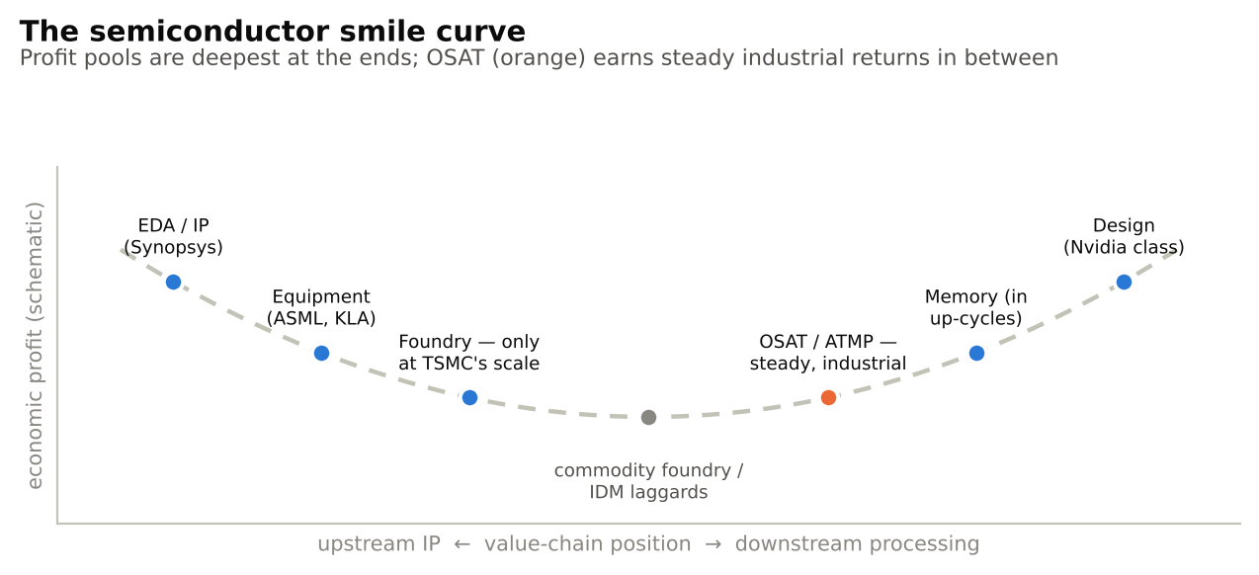
Figure 31 — The semiconductor smile curve
Table 36 — Financial profile by segment (typical through-cycle ranges, large listed players)
Metric | Design (fabless) | Foundry | IDM | Equipment | OSAT | ATMP captive (e.g., Micron India-class)
Gross margin | 50–75% | TSMC 55–60%; others 20–40% | 30–60% (memory swings −ve to 60%+) | 40–50% | 14–25% | internal transfer pricing
EBITDA margin | 25–60% | TSMC ~65–70%; tier-2 25–40% | 25–50% | 25–35% | 18–30% | 20–30% equivalent
ROCE / ROIC | 20–100%+ (Nvidia extreme) | TSMC 25–30%; tier-2 <10% | 5–25%, cyclical | 25–40% | 8–15% unsubsidised; 15–25% with India incentive stack | parent-dependent
Capex / revenue | 2–5% | 30–50% | 15–35% | 5–10% | 10–18% sustaining; >50% in build-out | heavy upfront
R&D / revenue | 15–30% | 7–9% | 10–20% | 10–15% | 3–5% | low
Working-capital cycle | +30–60 days (inventory-light) | ~neutral (prepayments from customers at leading edge) | +60–120 days (inventory-heavy; memory worst) | +60–90 days (long build cycles) | short: 30–50 days; consignment-material models can run near zero | short
Cash-flow character | FCF machines; buybacks | FCF strong only at scale leader | boom-bust | strong, cyclical orders | steady converter; FCF after sustaining capex is modest — the model is volume + reinvestment | strategic, not FCF-driven
Cyclicality | product-cycle driven | utilisation-driven | highest (memory) | order-book whiplash | dampened — diversified packages/customers smooth the cycle | memory-linked
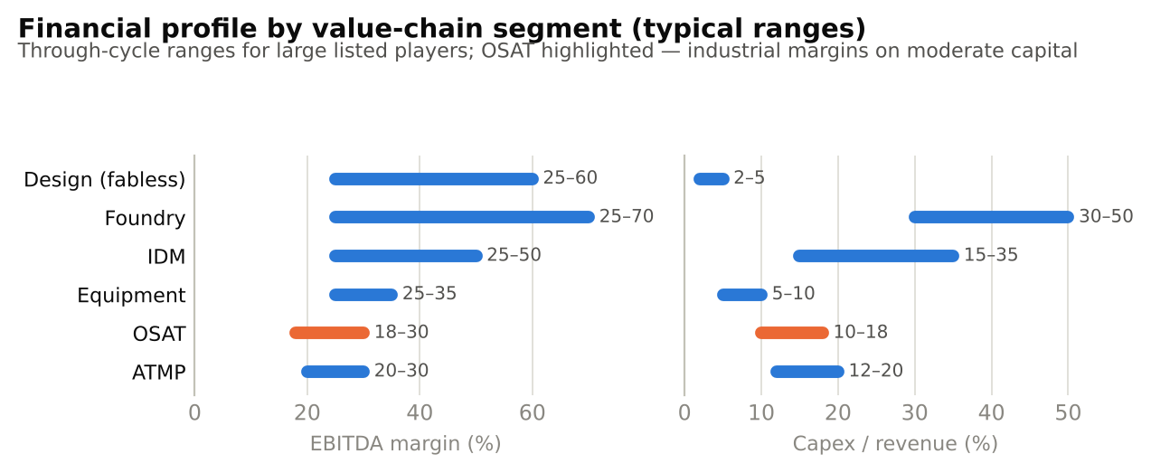
Figure 32 — EBITDA margins and capex intensity by value-chain segment

11.2 Implications for different capital providers
- Equity investors: the compounding machines are at the curve’s ends (design, EDA, equipment, TSMC). OSAT equity is an industrial story: value creation comes from utilisation, mix migration up the packaging ladder, and — in India uniquely — subsidy-boosted ROCE. Listed pure-play comparables: ASE (TW), Amkor (US), JCET (CN), PTI (TW); in India the exposure today is via Kaynes Technology (listed parent), CG Power, Tata (unlisted), and eventually IPO candidates like Suchi.
- Lenders / project finance: OSAT is the most bankable node of India’s semiconductor push: 4–6-year paybacks post-incentive, hard-currency export revenue, collateralisable equipment (though specialised), and milestone-linked government disbursements. Key credit covenants in practice: anchor-customer volume contracts, incentive-receipt assignment, utilisation floors, and technology-partner lock-ins. Primary credit risks: qualification slippage (revenue starts 12–24 months after mechanical completion), materials import margin squeeze, and single-customer dependence in early years.
- Policy-makers: every $1 of ISM money mobilises ~$1–1.3 of private capital today; the multiplier rises steeply once materials/equipment localisation (ISM 2.0) cuts the imported bill-of-materials — the difference between an assembly colony and an ecosystem.
Table 37 — Value generation per $100 of final chip value (indicative, logic chip)
Stage | Share of value | Captured today by | India’s capture today → 2030 potential
Design & IP | ~50–60% | US, UK (Arm) | salaries only (~$10–15 bn design services) → design IP via ISM 2.0
Fabrication | ~25–35% | Taiwan, Korea, US, (China mature) | ~0% → Dholera mature-node share
Equipment & materials (embedded) | ~15–20% | US, NL, JP | ~0% → ISM 2.0 target
Assembly, test & packaging | ~8–15% (30–50% for AI-class packages) | Taiwan, China, Malaysia, Korea | first plants live → credible 5–8% of global OSAT by 2032–35

SECTION 12: THE FUTURE OF SEMICONDUCTORS (2030–2040)
Table 38 — Ten technology vectors and what they mean for India/OSAT
Vector | What happens by 2030–2040 | Implication for India & OSAT
AI chips | Accelerators dominate incremental industry value; inference silicon proliferates to every device tier | India’s data-centre build-out creates sovereign-AI silicon demand; OSATs capture test/assembly of inference edge parts long before CoWoS-class work
Chiplets / heterogeneous integration | UCIe-standard die-to-die links make “mix-and-match silicon” the default; packaging = system design | The structural OSAT prize: value share of back-end rises to 20–30% of chip cost; Stage 3–4 Indian players can sell co-design services on Indian engineering cost
Advanced packaging | Panel-level fan-out, glass substrates (3DGS is already in Odisha), co-packaged optics, hybrid bonding everywhere | India can leapfrog into new platforms (glass, panel) where no incumbent has decades of lead
Silicon photonics | Optical I/O replaces copper between racks, then between chips | Test/assembly of optical engines is precision OSAT work — a niche India can target by 2030
Quantum computing | Niche but strategic; cryo-control silicon matures | R&D/sovereign demand; not a volume OSAT market by 2035
Compound semis — SiC | EV traction inverters, fast charging, grid; SiC device market to ~$10–15 bn+ by 2030 | SiCSem fab + India’s EV/solar demand = credible full-stack Indian niche; TO/module packaging is leadframe-tier work Indian OSATs already do
GaN | Chargers, data-centre power (800 V), RF/defence | Same logic; GaN-on-Si rides mature-node fabs like Dholera’s class
Automotive | Software-defined vehicles: $1,500–3,000 silicon/car; zonal computers; chip content CAGR ~10%+ | AEC-qualified Indian ATMP for the world’s #3 auto market is the single most defensible demand pool
Edge computing / IoT | Tens of billions of devices; cheap MCUs + sensors + connectivity | Massive leadframe/QFN unit volumes — the Indian OSAT sweet spot through 2035
Memory evolution | HBM4/5, processing-in-memory, CXL pooling | Memory ATMP (Micron Sanand) scales with it; HBM-class stacking is the 2030s stretch goal for Tata TSAT-class plants
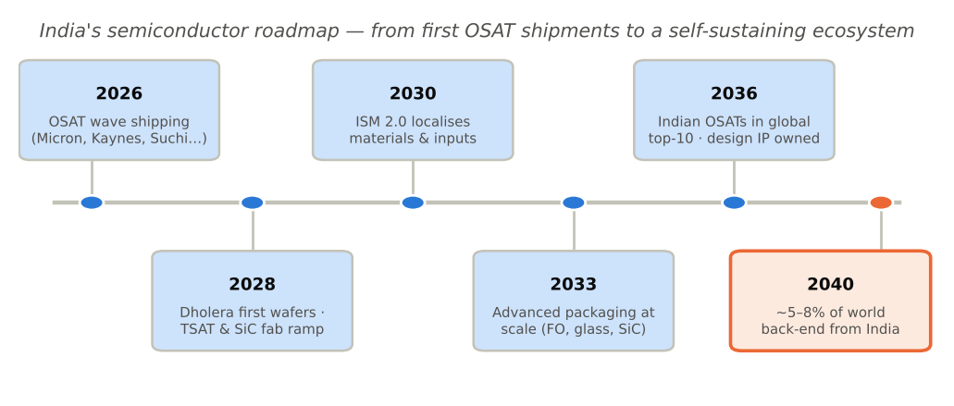
Figure 33 — 2026→2040 India roadmap
The honest 2040 question is not whether India will matter in semiconductors — its design workforce already guarantees that — but which rungs it will own. The realistic prize by 2040: 5–8% of global OSAT/ATMP, a self-sustaining mature-node and compound-semi fab cluster, a localised materials base, and one or two OSAT champions of JCET-class scale. That outcome alone would be a $30–50 bn annual manufacturing industry employing several hundred thousand people — and it runs almost entirely through the OSAT door.

SECTION 13: CONCLUSION
Key takeaways:
- Semiconductors are the strategic industry of the century — a ~$792 bn (2025) market crossing $1 trillion in 2026 on the AI supercycle, structured as a chain of oligopolies where packaging has become the binding constraint.
- The value chain is long, concentrated and uneven: design and chokepoint tools earn software margins; fabs cost $10–28 bn and reward only monopoly scale; OSAT earns steady industrial returns on an order of magnitude less capital — the only node a new national entrant can realistically storm.
- OSAT is India’s rational beachhead, and the beachhead is already taken: 12 approved ISM projects (~₹1.64 lakh crore), four units shipping or inaugurated within ~30 months of approval, a 28–110 nm fab under construction at Dholera, and ISM 2.0’s ₹1.28 lakh crore now aimed at the real gap — materials, equipment and design IP.
- The playbook is proven, not novel: Taiwan, Malaysia, Singapore, China and Korea all entered through assembly and test and climbed. Suchi Semicon — a textile group’s self-funded Surat plant, now ROHM-partnered and ISM-backed — is the cleanest live test of whether Indian private capital can run the same ladder: wirebond today, flip-chip by 2028, full ATMP by 2031, technology partner by the mid-2030s.
- The risks are specific and watchable: Chinese mature-node overcapacity compressing leadframe-tier pricing; qualification timelines outlasting balance sheets; the 2027–28 memory-cycle correction; materials import dependence capping margins until ISM 2.0 delivers; and the perennial Indian risks of infrastructure reliability and disbursement speed.
What each constituency should watch (2027–2030): Investors — utilisation and customer-qualification milestones at Micron/Kaynes/CG/Suchi, Tata TSAT’s ramp, and the first Indian OSAT IPO. Lenders — incentive disbursement cadence, anchor-contract coverage ratios, and equipment-import duty policy. Policy-makers — substrate/leadframe/EMC localisation under ISM 2.0 (the single highest-leverage variable), packaging-engineer talent pipelines, and Dholera’s first-wafer date. Entrepreneurs — the opening is no longer the OSAT plant itself but everything around it: materials, tooling services, test engineering, design-for-packaging — the ecosystem layer where the next decade’s Indian semiconductor fortunes will actually be made.
Semiconductors took Taiwan from assembly lines to the centre of the world economy in one generation. India has, for the first time, assembled all four preconditions of that journey — talent, demand, capital and policy. The back-end is the front door, and India has stepped through it.

APPENDIX A: GLOSSARY (200+ SEMICONDUCTOR TERMS)
A–B
- Advanced packaging — Packaging beyond single-die wirebond: flip-chip, WLCSP, fan-out, 2.5D, 3D.
- AEC-Q100 / Q101 — Automotive qualification stress-test standards for ICs / discretes.
- ALD (atomic layer deposition) — Deposits films one atomic layer at a time.
- Analog IC — Chip processing continuous real-world signals (voltage, sound, radio).
- Annealing — Heat treatment repairing crystal damage and activating dopants after implantation.
- AOI (automated optical inspection) — Camera-based defect inspection.
- ASIC — Application-specific IC; custom chip for one task (e.g., Google TPU).
- ASP — Average selling price.
- Assembly — Mounting, connecting and encapsulating a die into a package.
- ATE (automated test equipment) — Machines (Advantest, Teradyne) that electrically test chips.
- ATMP — Assembly, Testing, Marking and Packaging — India’s term for back-end operations.
- Backgrinding — Thinning a finished wafer from ~775 µm to 100–300 µm before dicing.
- Back-end — Industry shorthand for assembly, packaging and test (vs “front-end” fab).
- Backside power delivery — Routing power through the wafer’s back (Intel PowerVia) to free routing space.
- Ball grid array (BGA) — Package with solder balls in a grid underneath.
- Band gap — Energy needed to free an electron; defines conductor/semiconductor/insulator.
- Bare die — An unpackaged chip.
- BEOL (back end of line) — Fab stage forming the metal interconnect layers (not to be confused with back-end packaging).
- Binning — Sorting tested chips into speed/power grades sold as different SKUs.
- BOM (bill of materials) — All inputs to a product; OSAT BOM = leadframe, wire, EMC, substrate.
- Bonding wire — Gold/copper/silver wire (15–50 µm) connecting die pads to the package.
- Bump / bumping — Forming solder or copper bumps on die pads for flip-chip connection.
- Burn-in — Operating chips at elevated temperature/voltage to screen out early-life failures.
C
- Capex intensity — Capital expenditure as % of revenue; foundries 30–50%, OSATs 10–18%.
- Chiplet — A small functional die designed to be combined with others in one package.
- Cleanroom — Particle-controlled space; ISO Class 1–5 for fabs, 6–8 for OSATs.
- CMOS — Complementary MOS; the dominant logic technology pairing N- and P-type transistors.
- CMP (chemo-mechanical planarisation) — Polishing a wafer flat between layers.
- COF/COG — Chip-on-film / chip-on-glass; display-driver mounting formats.
- Compound semiconductor — Non-silicon semiconductor (GaAs, GaN, SiC, InP).
- Consignment inventory — Customer-owned materials held at the OSAT; shrinks its working capital.
- Co-packaged optics — Optical transceivers integrated into the chip package.
- Copper pillar — Fine-pitch successor to solder bumps for flip-chip.
- CoWoS — TSMC’s Chip-on-Wafer-on-Substrate 2.5D platform; the AI-GPU package.
- CP (circuit probe) — See wafer probe.
- Crystal growth — Forming a single-crystal silicon ingot from molten silicon.
- CSP (chip-scale package) — Package no larger than ~1.2× the die.
- CVD (chemical vapour deposition) — Depositing films from reactive gases.
- Cycle time — Elapsed time through a process; ~3 months for a fab, days–weeks for OSAT.
- Czochralski (CZ) method — Pulling a rotating seed crystal from molten silicon to grow an ingot.
D
- Defect density — Defects per unit wafer area; the key driver of yield.
- Design house — Firm providing chip-design services without own products.
- Design rule — Minimum geometries a process allows; encoded in the PDK.
- DFT (design for test) — Circuitry built into chips to make testing feasible.
- Die (plural dies/dice) — One individual chip cut from a wafer.
- Die attach — Fixing a die to leadframe/substrate with epoxy or solder.
- Die shrink — Porting a design to a smaller node to cut cost.
- Dielectric — Insulating layer between conductors.
- Dicing / die separation — Sawing the wafer into individual dies.
- Diode — Two-terminal one-way valve for current; a P-N junction.
- DIP (dual in-line package) — Classic two-row through-hole package.
- Discrete — Single-function device (transistor, diode) rather than an IC.
- Display driver IC (DDIC) — Chip driving rows/columns of a display panel.
- DLI — India’s Design-Linked Incentive scheme for fabless startups.
- Dopant — Impurity atom (B, P, As) added to set silicon’s electrical type.
- Doping — Introducing dopants to create N-type or P-type regions.
- DRAM — Dynamic RAM; volatile working memory.
- DRC (design rule check) — EDA verification that a layout obeys process rules.
- Dry etch — Plasma-based material removal (vs wet chemical etch).
- DUV (deep ultraviolet) — 193/248 nm lithography; workhorse below EUV layers.
E–F
- EDA — Electronic design automation; software used to design chips.
- Edge computing — Processing data on/near the device rather than in the cloud.
- Electromigration — Metal atoms displaced by current flow; a reliability failure mode.
- EMC (epoxy moulding compound) — Black epoxy encapsulating packaged chips.
- EMS — Electronics manufacturing services; board/device assembly (Foxconn, Dixon).
- Encapsulation — Moulding protective compound around die and interconnects.
- Entity List — US export-control blacklist restricting technology sales.
- Epitaxy — Growing a perfect crystalline silicon layer on a wafer surface.
- ESD (electrostatic discharge) — Static electricity that destroys chips; controlled per ANSI/ESD S20.20.
- Etch — Removing material to carve patterns into films.
- EUV (extreme ultraviolet) — 13.5 nm lithography; ASML monopoly; required below ~7 nm.
- Fab — A wafer-fabrication plant.
- Fabless — Chip company that designs but does not manufacture (Nvidia, Qualcomm).
- Failure analysis (FA) — Forensic engineering on failed devices.
- Fan-in WLP — Wafer-level package with connections within the die footprint.
- Fan-out (FO-WLP/PLP) — Package extending connections beyond the die edge via RDL in mould compound.
- FCBGA — Flip-chip ball grid array; standard high-performance package.
- Final test (FT) — Full electrical test of the packaged device.
- FinFET — 3D transistor with a fin-shaped channel (~22 nm to ~3 nm era).
- Flip-chip — Mounting a die face-down via solder bumps instead of wires.
- FOUP — Front-opening unified pod; sealed 25-wafer carrier used in fabs.
- Foundry — Contract wafer manufacturer (TSMC, UMC).
- Foveros — Intel’s 3D die-stacking technology.
- FPGA — Field-programmable gate array; reconfigurable logic chip.
- Front-end — Wafer fabrication (vs back-end assembly/test).
G–I
- GaAs — Gallium arsenide; RF and optoelectronic semiconductor.
- GAA (gate-all-around) — Transistor whose gate wraps the channel on all sides; the 2 nm-era architecture.
- GaN — Gallium nitride; wide-band-gap material for fast chargers, RF, data-centre power.
- Gate — The transistor terminal that switches it on/off.
- Gate oxide — Ultra-thin insulator between gate and channel.
- Glass substrate — Emerging package substrate material offering flatness/density gains.
- Gross margin — (Revenue − cost of goods)/revenue; TSMC ~55–60%, OSAT 14–25%.
- Handler — Robot that feeds packaged devices to a tester across temperature.
- HAST — Highly accelerated stress test (temperature + humidity + bias).
- HBM (high-bandwidth memory) — Vertically stacked DRAM dies on a logic base, co-packaged with processors.
- Heterogeneous integration — Combining different dies/technologies in one package.
- HHI — Herfindahl–Hirschman Index; market-concentration measure.
- High-k metal gate — Gate stack materials replacing SiO₂ at advanced nodes.
- Hybrid bonding — Direct copper-to-copper die bonding without bumps; <10 µm pitch.
- IC (integrated circuit) — Many transistors fabricated as one chip.
- IDM — Integrated device manufacturer; designs and fabs its own chips (Intel, Samsung).
- IGBT — Insulated-gate bipolar transistor; workhorse power switch (traction, grid).
- Infant mortality — Early-life failures screened by burn-in.
- InFO — TSMC’s integrated fan-out package (Apple A-series).
- Ingot — The grown single-crystal silicon cylinder sliced into wafers.
- Interposer — Silicon/organic/glass wiring layer connecting dies in 2.5D packages.
- I/O — Input/output connections of a chip or package.
- Ion implantation — Firing dopant ions into silicon with electrostatic accelerators.
- IP (semiconductor) — Licensable pre-designed circuit blocks (e.g., Arm cores).
- ISM — India Semiconductor Mission.
- ISO cleanroom class — Particle-count standard (ISO 1 cleanest).
J–L
- JEDEC — Standards body for semiconductor packages, memory and reliability tests.
- Junction — Boundary between P-type and N-type regions.
- Kerf — Material lost to the saw cut in slicing/dicing.
- KGD (known good die) — Die verified functional before use in multi-die packages.
- K-Chips Act — Korea’s semiconductor tax-credit legislation.
- Laminate substrate — Multi-layer organic PCB-like base of BGA packages.
- Lapping — Mechanical flattening of sliced wafers before polish.
- Laser marking — Engraving part/lot codes on packages.
- Leadframe — Stamped metal frame forming the leads of low-cost packages.
- Leading edge — The most advanced process nodes in production (~2–3 nm in 2026).
- Legacy / mature node — Older processes (28 nm and above); most auto/analog chips.
- Lithography — Printing circuit patterns with light; the defining fab step.
- Load board — Custom interface PCB between tester and device.
- Logic chip — Chip that computes (CPU, GPU, SoC).
- LVS (layout vs schematic) — Verification that layout matches the circuit design.
M–O
- Mask / reticle — Quartz plate carrying one layer’s circuit pattern for lithography.
- MCU (microcontroller) — Small self-contained computer-on-a-chip; billions used in cars/appliances.
- MEMS — Micro-electro-mechanical systems (accelerometers, microphones).
- MES — Manufacturing execution system; factory-floor software.
- Metallurgical silicon — 98–99% pure silicon from smelting quartz; polysilicon feedstock.
- Metrology — In-line measurement of dimensions/films in nanometres.
- Microbump — 10–50 µm solder interconnects used in 2.5D/3D stacking.
- Mixed-signal — Chip combining analog and digital circuits.
- Moore’s Law — Transistor counts double ~every two years at constant cost.
- MOSFET — Metal-oxide-semiconductor field-effect transistor; the basic switch.
- Moulding — See encapsulation.
- Multi-patterning — Splitting one layer into multiple DUV exposures to beat resolution limits.
- NAND flash — Non-volatile storage memory.
- Nanosheet — Stacked horizontal channel sheets in GAA transistors.
- Node — A process generation (“3 nm”); now a marketing label, not a dimension.
- NRE (non-recurring engineering) — One-time design/tooling cost of a chip (masks alone: $10–50 m at leading edge).
- N-type — Silicon doped for electron (negative) conduction.
- OEE — Overall equipment effectiveness; utilisation × performance × quality.
- OEM — Original equipment manufacturer (Apple, Toyota).
- OSAT — Outsourced semiconductor assembly and test company.
- Optoelectronics — Light-emitting/sensing semiconductors (LEDs, lasers, image sensors).
P–R
- Package — The protective, connectable housing of a die.
- Panel-level packaging (PLP) — Fan-out processing on large rectangular panels for cost.
- Passivation — Final protective dielectric layer on a die.
- PDK (process design kit) — Foundry’s rulebook/models enabling design for its process.
- Photolithography — See lithography.
- Photoresist — Light-sensitive polymer that captures the projected pattern.
- Pick-and-place — High-speed robotic die/component placement.
- Pitch — Centre-to-centre spacing of features/bumps/leads.
- Plasma etch — See dry etch.
- Plating — Electro-depositing solderable finishes on leads.
- PLI — India’s production-linked incentive schemes.
- PMIC — Power-management IC; regulates voltages in every device.
- P-N junction — The diode-forming interface of P- and N-regions.
- Polishing — Final mirror-finish CMP of bare wafers.
- Polysilicon — 99.999999999% pure silicon feedstock for ingots.
- Power semiconductor — Device switching/converting electrical power (MOSFET, IGBT, SiC).
- Probe card — Needle array contacting die pads during wafer test.
- Process node — See node.
- P-type — Silicon doped for hole (positive) conduction.
- Pure-play — Company doing only one chain role (pure-play foundry: TSMC).
- PVD / sputtering — Physical vapour deposition of metal films.
- QFN — Quad flat no-lead package; pads underneath; today’s analog/RF workhorse.
- QFP — Quad flat package; gull-wing leads on four sides.
- Qualification (qual) — Formal reliability test campaign certifying a part/process/plant.
- RCA clean — Standard wet-chemical wafer-cleaning sequence.
- RDL (redistribution layer) — Thin-film wiring re-routing die pads in WLP/fan-out.
- Reliability testing — Stress regimes (thermal cycling, HAST, drop) proving lifetime.
- RF chip — Radio-frequency device (power amps, transceivers).
- RISC-V — Open-source instruction-set architecture; strategic for India/China sovereignty.
- ROCE — Return on capital employed.
S–T
- SAM (scanning acoustic microscopy) — Ultrasound imaging of package voids/delamination.
- Scribe line — Sacrificial lanes between dies where the saw cuts.
- Seed crystal — Small perfect crystal that templates CZ ingot growth.
- SiC (silicon carbide) — Wide-band-gap material for EV/grid power devices.
- Siemens process — Converting metallurgical silicon to ultra-pure polysilicon via trichlorosilane.
- Singulation — Separating individual units (dies or packages) from an array.
- SiP (system-in-package) — Multiple dies/passives integrated in one package.
- SoC (system-on-chip) — CPU + GPU + modem + more on one die (smartphone chips).
- SoIC — TSMC’s 3D hybrid-bonded die-stacking platform.
- SOIC/SOP — Small-outline IC package; surface-mount successor to DIP.
- Solder ball — Sphere forming a BGA connection.
- Sort (wafer sort) — See wafer probe.
- SPC (statistical process control) — Statistical monitoring of process stability.
- Stepper / scanner — The lithography exposure machine.
- Substrate — The base a die is mounted on (laminate, leadframe, interposer); also the wafer itself.
- Surface-mount technology (SMT) — Soldering packages onto board surfaces (vs through-hole).
- System-level test (SLT) — Testing a chip in near-real system conditions.
- Tape-and-reel — Packing chips in carrier tape for automated board assembly.
- Tape-out — Releasing a finished design to mask-making.
- Test escape — Defective part that passes test; measured in DPPM (defects per million).
- Thermal cycling — Repeated hot/cold cycling to fatigue-test packages.
- Through-hole — Legacy mounting with leads through board holes.
- TIM (thermal interface material) — Heat-conducting layer between die and lid/heatsink.
- TO package — Transistor-outline package for discretes/power (TO-220 etc.).
- Transistor — The electrically controlled switch; basic unit of all chips.
- Trim and form — Cutting packages from the leadframe and bending leads.
- TSV (through-silicon via) — Vertical copper connection drilled through a die/interposer.
- Turnkey OSAT — One vendor handling probe→assembly→test→drop-ship.
U–Z
- UCIe — Universal Chiplet Interconnect Express; the open die-to-die standard.
- Underfill — Epoxy flowed under flip-chips to absorb thermal stress.
- UPH (units per hour) — Machine throughput metric.
- Utilisation — % of capacity in use; the single biggest OSAT profit driver.
- Verilog/VHDL — Hardware-description languages chips are written in.
- Via — Vertical connection between metal layers.
- Wafer — The thin polished silicon disc (200/300 mm) chips are built on.
- Wafer-level packaging (WLP) — Building the package on the wafer before dicing.
- Wafer map — Electronic record of good/bad die locations.
- Wafer probe — Testing every die on-wafer before assembly.
- Wet etch — Chemical-bath material removal.
- WFE (wafer-fab equipment) — The front-end equipment market.
- WIP — Work in progress.
- Wire bonding — Welding micro-wires between die and leadframe; the workhorse interconnect.
- WLCSP — Wafer-level chip-scale package; the chip is its own package.
- WSTS — World Semiconductor Trade Statistics; the industry’s data authority.
- X-ray inspection — Seeing voids/wire sweep inside opaque packages.
- Yield — % of good units; the central economic variable of the industry.
- Yield learning — The experience-curve process of driving yield up on a new line.
- Zero-defect — Automotive quality philosophy (<1 DPPM targets).

APPENDIX B: ACRONYM LIST
Acronym | Expansion |  | Acronym | Expansion
AI | Artificial intelligence |  | ISM | India Semiconductor Mission
ALD | Atomic layer deposition |  | ITC | Investment tax credit
AMHS | Automated material handling system |  | JV | Joint venture
ASIC | Application-specific integrated circuit |  | KGD | Known good die
ASP | Average selling price |  | MCU | Microcontroller unit
ATE | Automated test equipment |  | MEMS | Micro-electro-mechanical systems
ATMP | Assembly, testing, marking & packaging |  | MES | Manufacturing execution system
BEOL | Back end of line |  | MeitY | Ministry of Electronics & IT (India)
BGA | Ball grid array |  | MNC | Multinational corporation
BOM | Bill of materials |  | MOSFET | Metal-oxide-semiconductor FET
CAGR | Compound annual growth rate |  | NRE | Non-recurring engineering
CapEx | Capital expenditure |  | OEM | Original equipment manufacturer
CIS | CMOS image sensor |  | OSAT | Outsourced semiconductor assembly & test
CMP | Chemo-mechanical planarisation |  | PCB | Printed circuit board
CMOS | Complementary metal-oxide-semiconductor |  | PDK | Process design kit
CoWoS | Chip-on-wafer-on-substrate |  | PLI | Production-linked incentive
CP | Circuit probe |  | PLP | Panel-level packaging
CVD | Chemical vapour deposition |  | PMIC | Power-management IC
CZ | Czochralski |  | PVD | Physical vapour deposition
DDIC | Display driver IC |  | QFN | Quad flat no-lead
DIP | Dual in-line package |  | QFP | Quad flat package
DLI | Design-linked incentive |  | R&D | Research & development
DPPM | Defects per million |  | RDL | Redistribution layer
DRAM | Dynamic random-access memory |  | RF | Radio frequency
DRC | Design rule check |  | ROCE | Return on capital employed
DSCR | Debt-service coverage ratio |  | SiC | Silicon carbide
DUV | Deep ultraviolet |  | SiP | System-in-package
EDA | Electronic design automation |  | SLT | System-level test
EMC | Epoxy moulding compound |  | SMT | Surface-mount technology
EMS | Electronics manufacturing services |  | SoC | System-on-chip
ESD | Electrostatic discharge |  | SOIC | Small-outline IC
EUV | Extreme ultraviolet (lithography) |  | SPC | Statistical process control
FCBGA | Flip-chip ball grid array |  | TIM | Thermal interface material
FEOL | Front end of line |  | TO | Transistor outline (package)
FO-WLP | Fan-out wafer-level packaging |  | TSV | Through-silicon via
FOUP | Front-opening unified pod |  | UCIe | Universal Chiplet Interconnect Express
FPGA | Field-programmable gate array |  | UPH | Units per hour
FT | Final test |  | WFE | Wafer-fab equipment
GAA | Gate-all-around |  | WIP | Work in progress
GaN | Gallium nitride |  | WLCSP | Wafer-level chip-scale package
HAST | Highly accelerated stress test |  | WLP | Wafer-level packaging
HBM | High-bandwidth memory |  | WSTS | World Semiconductor Trade Statistics
HHI | Herfindahl–Hirschman Index |  | YoY | Year over year
IC | Integrated circuit |  | 2.5D/3D | Interposer-based / stacked-die packaging
IDM | Integrated device manufacturer |  | 3DGS | 3D Glass Solutions
IGBT | Insulated-gate bipolar transistor |  | ATE | Automated test equipment
IP | Intellectual property |  | EFC | Expenditure Finance Committee (India)
ISA | Instruction-set architecture |  | PIB | Press Information Bureau (India)

APPENDIX C: REFERENCES AND SOURCES
Market data and forecasts
- SIA, 2026 State of the Industry Report — 2025 sales $791.7 bn (+25.6%).
- SIA via iConnect007, Global Annual Semiconductor Sales Increase 25.6% to $791.7 Billion in 2025.
- WSTS, Global Semiconductor Market Approaches $1T in 2026 and Spring 2026 forecast release — 2026F ~$1.51 tn (memory-led).
- Tom’s Hardware, Semiconductor industry on track to hit $1 trillion in sales in 2026, SIA predicts.
OSAT industry
- TrendForce via iConnect007, Top 10 OSAT Companies of 2024 Revealed; Evertiq, Chinese firms gain ground in 2024 top 10 OSAT ranking.
- IDC, Worldwide Semiconductor Manufacturing Services (OSAT) study — 2025 market $45.3 bn (+9.2%).
- Mordor Intelligence / Global Industry Analysts, OSAT market to $61.2 bn by 2030.
Advanced packaging / AI
- TrendForce, TSMC CoWoS supply-demand gap seen narrowing from 20% to 10% by end-2026 as capacity expands.
- Morgan Stanley via iTiger, TSMC CoWoS capacity forecast raised to 120–130k wafers/month by late 2026.
India / ISM
- PM India / PIB, Cabinet approves two more semiconductor units with cumulative investment of more than ₹3,900 crore (Suchi Semicon ₹868 cr / 1,033.2 m chips p.a.; Crystal Matrix ₹3,068 cr; May 2026).
- IBEF, Cabinet approves India Semiconductor Mission 2.0 with outlay of US$13.25 billion (July 2026).
- Business Standard, Govt approves ₹1.25 trillion outlay for India Semiconductor Mission 2.0; Evertiq, $13 billion outlay for ISM 2.0 cleared.
- Business Today, Suchi Semicon targets 3 million packaged chips daily after ISM approval; Inc42, Can Suchi Semicon Build India’s First Homegrown OSAT Giant?.
- S&P Global Mobility, ROHM and Suchi Semicon partner to boost semiconductor manufacturing in India.
- Outlook Business, Tata Electronics sends 200+ personnel to Taiwan for PSMC training as ₹91,000 cr Dholera fab advances; Free Press Journal, Tata Group to start chip production from Gujarat, Assam plants by 2026.
- AnantamIAS, India Semiconductor Plants: Locations and Companies in 2026 (Micron Sanand inaugurated Feb 2026; Kaynes Mar 2026).
- Wikipedia, Electronics and semiconductor manufacturing industry in India.
Company and policy filings (background)
- Annual reports/filings: TSMC, ASML, Applied Materials, Lam Research, Tokyo Electron, KLA, ASE Technology Holding, Amkor Technology, JCET Group, Powertech, ChipMOS, Nvidia, Synopsys, Cadence, Shin-Etsu, SUMCO (FY2024–25).
- US CHIPS & Science Act (2022) and 2025 programme restructuring; China National IC Fund I–III disclosures; Korea K-Chips Act amendments (2023–25); Japan METI semiconductor budgets (2021–25); EU Chips Act (2023); MeitY ISM scheme documents (2021, guidelines as amended).
- Industry research consulted conceptually: McKinsey semiconductor practice, Yole Group advanced-packaging series, Bernstein and Deloitte semiconductor outlooks, SEMI equipment and materials statistics.
All figures are as reported by the cited sources as of November 2026; market estimates differ across research houses, and ranges are shown where material. Nothing herein is investment advice.

