------------------------------------------------------------------------------------------

**Practical No:** 10

**Title:** Develop a program to implement login window using above UI controls.

class: TYCO Roll No: 12

<?xml version = "1.0" encoding = "utf-8"?>

<RelativeLayout xmlns:android = "http://schemas.android.com/apk/res/android"

xmlns:tools = "http://schemas.android.com/tools" android:layout_width="match_parent"

android:layout_height = "match_parent" android:paddingLeft= "@dimen/activity_horizontal_margin"

android:paddingRight = "@dimen/activity_horizontal_margin"

android:paddingTop = "@dimen/activity_vertical_margin"

android:paddingBottom = "@dimen/activity_vertical_margin" tools:context = ".MainActivity">

<TextView android:text = "Login" android:layout_width="wrap_content"

android:layout_height = "wrap_content"

android:id = "@+id/textview"

android:textSize = "35dp"

android:layout_alignParentTop = "true"

android:layout_centerHorizontal = "true" />

<TextView

android:layout_width = "wrap_content"

android:layout_height = "wrap_content"

android:text = "Tutorials point"

android:id = "@+id/textView"

android:layout_below = "@+id/textview"

android:layout_centerHorizontal = "true"

android:textColor = "#ff7aff24"

android:textSize = "35dp" />

<EditText

android:layout_width = "wrap_content"

android:layout_height = "wrap_content"

android:id = "@+id/editText"

android:hint = "Enter Name"

android:focusable = "true"

android:textColorHighlight = "#ff7eff15"

android:textColorHint = "#ffff25e6"

android:layout_marginTop = "46dp"

android:layout_below = "@+id/imageView"

android:layout_alignParentLeft = "true"

android:layout_alignParentStart = "true"

android:layout_alignParentRight = "true"

android:layout_alignParentEnd = "true" />

<ImageView

android:layout_width="wrap_content"

android:layout_height="wrap_content"

android:id="@+id/imageView"

android:src="@drawable/abc"

android:layout_below="@+id/textView"

android:layout_centerHorizontal="true" />

<EditText

android:layout_width="wrap_content"

android:layout_height="wrap_content"

android:inputType="textPassword"

android:ems="10"

android:id="@+id/editText2"

android:layout_below="@+id/editText"

android:layout_alignParentLeft="true"

android:layout_alignParentStart="true"

android:layout_alignRight="@+id/editText"

android:layout_alignEnd="@+id/editText"

android:textColorHint="#ffff299f"

android:hint="Password" />

<TextView

android:layout_width="wrap_content"

android:layout_height="wrap_content"

android:text="Attempts Left:"

android:id="@+id/textView2"

android:layout_below="@+id/editText2"

android:layout_alignParentLeft="true"

android:layout_alignParentStart="true"

android:textSize="25dp" />

<TextView

android:layout_width="wrap_content"

android:layout_height="wrap_content"

android:text="New Text"

android:id="@+id/textView3"

android:layout_alignTop="@+id/textView2"

android:layout_alignParentRight="true"

android:layout_alignParentEnd="true"

android:layout_alignBottom="@+id/textView2"

android:layout_toEndOf="@+id/textview"

android:textSize="25dp"

android:layout_toRightOf="@+id/textview" />

<Button

android:layout_width="wrap_content"

android:layout_height="wrap_content"

android:text="login"

android:id="@+id/button"

android:layout_alignParentBottom="true"

android:layout_toLeftOf="@+id/textview"

android:layout_toStartOf="@+id/textview" />

<Button

android:layout_width="wrap_content"

android:layout_height="wrap_content"

android:text="Cancel"

android:id="@+id/button2"

android:layout_alignParentBottom="true"

android:layout_toRightOf="@+id/textview"

android:layout_toEndOf="@+id/textview" />

</RelativeLayout>

**Main Activity**

package com.example.sairamkrishna.myapplication;

import android.app.Activity;

import android.graphics.Color;

import android.os.Bundle;

import android.view.View;

import android.widget.Button;

import android.widget.EditText;

import android.widget.TextView;

import android.widget.Toast;

public class MainActivity extends Activity {

Button b1,b2;

EditText ed1,ed2;

TextView tx1;

int counter = 3;

@Override

protected void onCreate(Bundle savedInstanceState) {

super.onCreate(savedInstanceState);

setContentView(R.layout.activity_main);

b1 = (Button)findViewById(R.id.button);

ed1 = (EditText)findViewById(R.id.editText);

ed2 = (EditText)findViewById(R.id.editText2);

b2 = (Button)findViewById(R.id.button2);

tx1 = (TextView)findViewById(R.id.textView3);

tx1.setVisibility(View.GONE);

b1.setOnClickListener(new View.OnClickListener() {

@Override

public void onClick(View v) {

if(ed1.getText().toString().equals("admin") &&

ed2.getText().toString().equals("admin")) {

Toast.makeText(getApplicationContext(),

"Redirecting...",Toast.LENGTH_SHORT).show();

}else{

Toast.makeText(getApplicationContext(), "Wrong

Credentials",Toast.LENGTH_SHORT).show();

tx1.setVisibility(View.VISIBLE);

tx1.setBackgroundColor(Color.RED);

counter--;

tx1.setText(Integer.toString(counter));

if (counter == 0) {

b1.setEnabled(false);

}

}

}

});

b2.setOnClickListener(new View.OnClickListener() {

@Override

public void onClick(View v) {

finish();

}

});

}

}

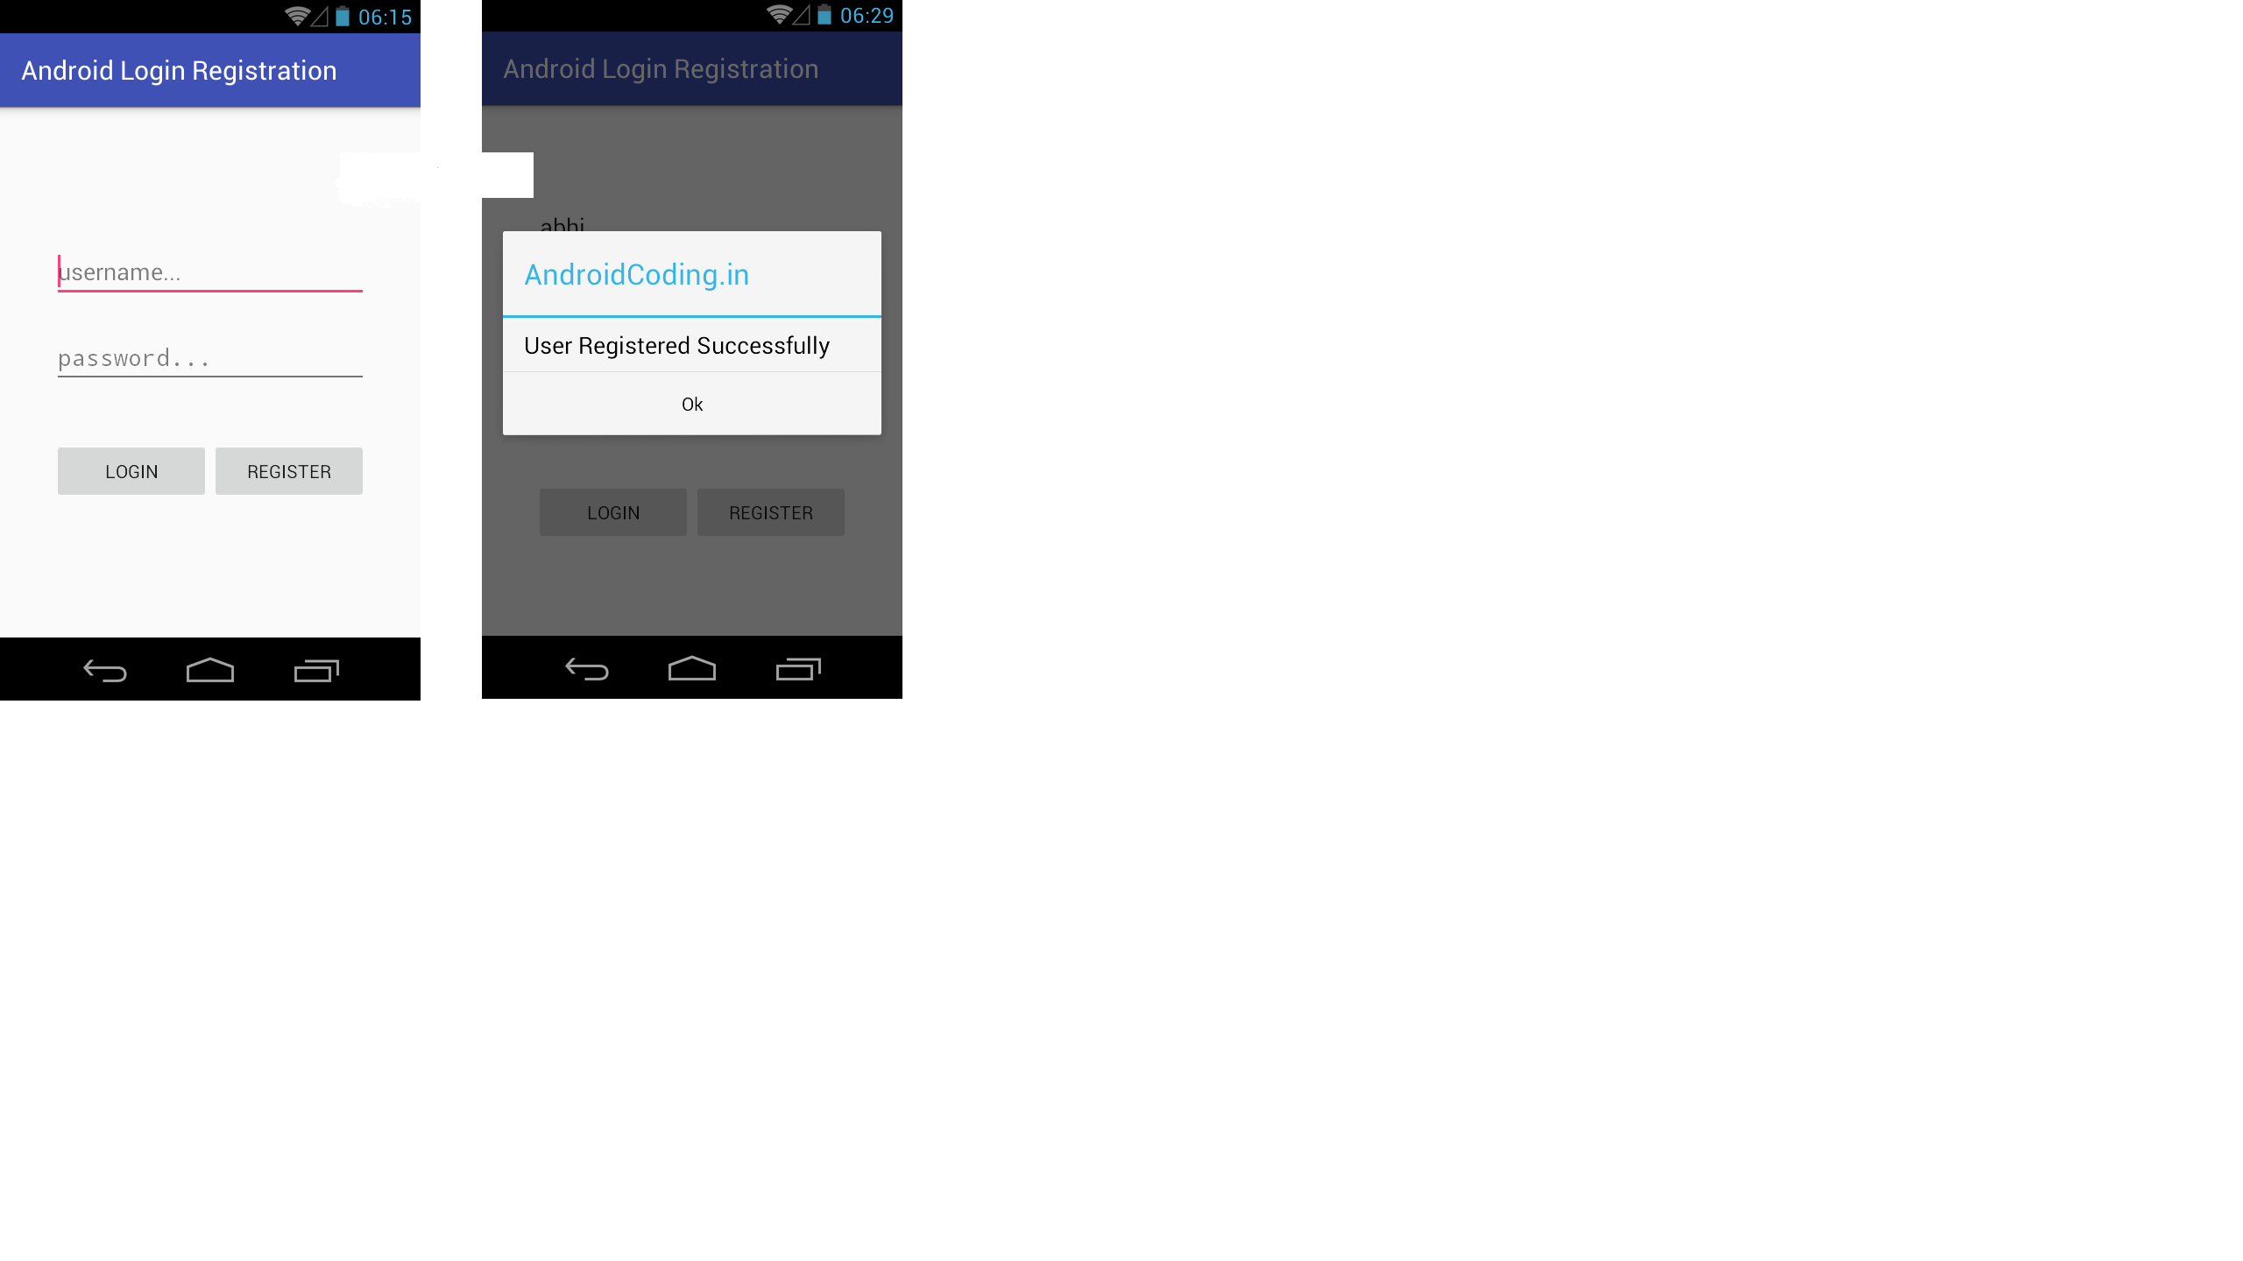

Fig. Login Pag