------------------------------------------------------------------------------------------

**Practical No:** 11

**Title:** Develop a program to implement Checkbox.

class: TYCO Roll No: 12

//XML CODE checkbox

*<?***xml version="1.0" encoding="utf-8"***?>*<**LinearLayout xmlns:android="http://schemas.android.com/apk/res/android"  
 xmlns:app="http://schemas.android.com/apk/res-auto"  
 xmlns:tools="http://schemas.android.com/tools"  
 android:layout_width="match_parent"  
 android:layout_height="match_parent"  
 android:orientation="vertical"  
 tools:context=".MainActivity"**>  
  
  
 <**TextView  
 android:layout_width="match_parent"  
 android:layout_height="wrap_content"  
 android:background="#90EE00"  
 android:text="Select Course"  
 android:textAlignment="center"  
 android:textSize="30dp"**></**TextView**>  
  
 <**CheckBox  
 android:layout_width="wrap_content"  
 android:layout_height="wrap_content"  
 android:text="Android"  
 android:id="@+id/and"  
 android:textSize="20dp"** ></**CheckBox**>  
  
 <**CheckBox  
 android:layout_width="wrap_content"  
 android:layout_height="wrap_content"  
 android:id="@+id/php"  
 android:text="PHP"  
 android:textSize="20dp"** ></**CheckBox**>  
  
 <**CheckBox  
 android:layout_width="wrap_content"  
 android:layout_height="wrap_content"  
 android:id="@+id/java"  
 android:text="JAVA"  
 android:textSize="20dp"** ></**CheckBox**>  
  
  
 <**Button  
 android:layout_width="wrap_content"  
 android:layout_height="wrap_content"  
 android:text="submit"  
 android:id="@+id/btn"**>  
  
 </**Button**>  
  
 <**TextView  
 android:layout_width="wrap_content"  
 android:layout_height="wrap_content"  
 android:id="@+id/tv"**></**TextView**>  
</**LinearLayout**>

**//// Color.xml**

*<?***xml version="1.0" encoding="utf-8"***?>*<**resources**>  
 <**color name="colorPrimary"**>#008577</**color**>  
 <**color name="colorPrimaryDark"**>#00574B</**color**>  
 <**color name="colorAccent"**>#D50000</**color**>  
 <**color name="colorBlack"**>#000</**color**>  
</**resources**>

**/*** Java Code**** /**

**package** com.example.checkbox_demo;  
**import** androidx.appcompat.app.AppCompatActivity;  
**import** android.os.Bundle;  
**import** android.view.View;  
**import** android.widget.Button;  
**import** android.widget.CheckBox;  
**import** android.widget.TextView;  
  
**public class** MainActivity **extends** AppCompatActivity {  
 CheckBox **a**,**p**,**j**;  
 Button **b**;  
 TextView **tx**;  
  
 @Override  
 **protected void** onCreate(Bundle savedInstanceState) {  
 **super**.onCreate(savedInstanceState);  
 setContentView(R.layout.***activity_main***);  
 **a**=(CheckBox)findViewById(R.id.***and***);  
 **p**=(CheckBox)findViewById(R.id.***php***);  
 **j**=(CheckBox)findViewById(R.id.***java***);  
 **b**=(Button)findViewById(R.id.***btn***);  
  
 **tx**=(TextView)findViewById(R.id.***tv***);  
  
 **a**.setOnClickListener(**new** View.OnClickListener() {  
 @Override  
 **public void** onClick(View v) {  
  
 **if**(**a**.isChecked())  
 {  
 **a**.setTextColor(getResources().getColor(R.color.***colorAccent***));  
 }  
 **else** {  
 **a**.setTextColor(getResources().getColor(R.color.***colorBlack***));  
 }  
  
 }  
 });  
  
 **p**.setOnClickListener(**new** View.OnClickListener() {  
 @Override  
 **public void** onClick(View v) {  
  
 **if**(**p**.isChecked())  
 {  
 **p**.setTextColor(getResources().getColor(R.color.***colorAccent***));  
 }  
 **else** {  
 **p**.setTextColor(getResources().getColor(R.color.***colorBlack***));  
 }  
  
 }

});  
  
  
 **j**.setOnClickListener(**new** View.OnClickListener() {  
 @Override  
 **public void** onClick(View v) {  
  
 **if**(**j**.isChecked())  
 {  
 **j**.setTextColor(getResources().getColor(R.color.***colorAccent***));  
 }  
 **else** {  
 **j**.setTextColor(getResources().getColor(R.color.***colorBlack***));  
 }  
  
 }  
 });  
  
  
 **b**.setOnClickListener(**new** View.OnClickListener() {  
 @Override  
 **public void** onClick(View v) {  
 String val=**""**;  
 **if**(**a**.isChecked())  
 {  
  
 val+=**"\n Android"**;  
 }  
 **if**(**p**.isChecked())  
 {  
 val+=**"\n PHP"**;  
 }  
  
 **if**(**j**.isChecked())  
 {  
 val+=**"\n JAVA"**;  
 }  
 **tx**.setText(val);  
 }  
 });  
  
  
 }  
}

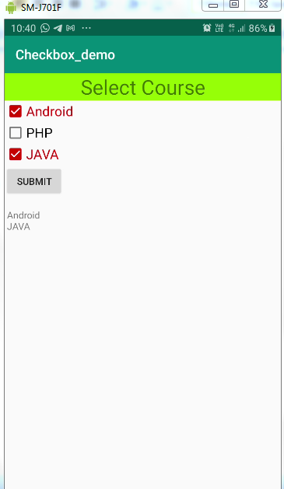

Fig. CheckBox