------------------------------------------------------------------------------------------

**Practical No:** 12

**Title:** Develop a program to implement Radio Button and Radio Group

class: TYCO Roll No: 12

*<?***xml version="1.0" encoding="utf-8"***?>*<**LinearLayout xmlns:android="http://schemas.android.com/apk/res/android"  
 xmlns:app="http://schemas.android.com/apk/res-auto"  
 xmlns:tools="http://schemas.android.com/tools"  
 android:layout_width="match_parent"  
 android:layout_height="match_parent"  
 android:orientation="vertical"  
 tools:context=".MainActivity"**>  
  
 <**TextView  
 android:layout_width="match_parent"  
 android:layout_height="wrap_content"  
 android:text="Select Course"  
 android:textAlignment="center"  
 android:textSize="20dp"  
 android:textColor="#DD2C00"  
 android:fontFamily="casual"** ></**TextView**>  
  
 <**RadioGroup  
 android:layout_width="match_parent"  
 android:layout_height="wrap_content"  
 android:layout_marginTop="20dp"** >  
 <**RadioButton  
 android:layout_width="match_parent"  
 android:layout_height="wrap_content"  
 android:id="@+id/co"  
 android:text="Compute"  
 android:textColor="#6200EA"  
 android:textSize="15dp"** ></**RadioButton**>  
  
 <**RadioButton  
 android:layout_width="match_parent"  
 android:layout_height="wrap_content"  
 android:id="@+id/IT"  
 android:text="Information Technology "  
 android:textColor="#FFAB00"  
 android:textSize="15dp"  
 android:checked="true"** ></**RadioButton**>  
  
 <**RadioButton  
 android:layout_width="match_parent"  
 android:layout_height="wrap_content"  
 android:id="@+id/CE"  
 android:text="Civil "  
 android:textColor="#C51162"  
 android:textSize="15dp"** ></**RadioButton**>  
 <**RadioButton**

**android:layout_width="match_parent"  
 android:layout_height="wrap_content"  
 android:id="@+id/ME"  
 android:text="Mechanical "  
 android:textColor="#00C853"  
 android:textSize="15dp"** ></**RadioButton**>  
  
 </**RadioGroup**>  
  
  
 <**Button  
 android:layout_width="wrap_content"  
 android:layout_height="wrap_content"  
 android:id="@+id/btn"  
 android:text="SUBMIT"  
 android:layout_marginLeft="150dp"** ></**Button**>  
  
  
</**LinearLayout**>

//Java Code

**package** com.example.radio_button_demo;  
  
**import** androidx.appcompat.app.AppCompatActivity;  
  
**import** android.os.Bundle;  
**import** android.view.View;  
**import** android.widget.Button;  
**import** android.widget.RadioButton;  
**import** android.widget.Toast;  
  
**public class** MainActivity **extends** AppCompatActivity {  
  
 RadioButton **co**,**it**,**ce**,**me**;  
 Button **bt**;  
 String **val**;  
  
  
 @Override  
 **protected void** onCreate(Bundle savedInstanceState) {  
 **super**.onCreate(savedInstanceState);  
 setContentView(R.layout.***activity_main***);  
  
 **co**=(RadioButton)findViewById(R.id.***co***);  
 **it**=(RadioButton)findViewById(R.id.***IT***);  
 **ce**=(RadioButton)findViewById(R.id.***CE***);  
 **me**=(RadioButton)findViewById(R.id.***ME***);  
  
 **bt**=(Button)findViewById(R.id.***btn***);  
  
  
 **bt**.setOnClickListener(**new** View.OnClickListener() {  
 @Override  
 **public void** onClick(View v) {  
  
 **if**(**co**.isChecked())  
 {  
 **val**=**co**.getText().toString();  
 }**else if**(**it**.isChecked())  
 {  
 **val**=**it**.getText().toString();  
 }**else if**(**ce**.isChecked())  
 {  
 **val**=**ce**.getText().toString();  
 }**else if**(**me**.isChecked())  
 {  
 **val**=**me**.getText().toString();  
 }  
  
 Toast.*makeText*(getApplicationContext(),**"You selected "**+**val**,Toast.***LENGTH_SHORT***).show();  
  
 }  
 });  
  
  
  
 }  
}

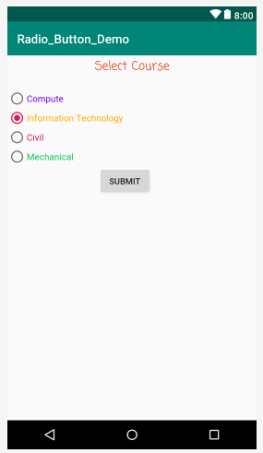

Fig. Radio Button