------------------------------------------------------------------------------------------

**Practical No:** 13

**Title:** Develop a program to implement progress Bar

class: TYCO Roll No: 12

***// Main_activity.xml***

*<?***xml version="1.0" encoding="utf-8"***?>*<**RelativeLayout xmlns:android="http://schemas.android.com/apk/res/android"  
 xmlns:app="http://schemas.android.com/apk/res-auto"  
 xmlns:tools="http://schemas.android.com/tools"  
 android:layout_width="match_parent"  
 android:layout_height="match_parent"  
 tools:context=".MainActivity"**>  
 <**Button  
 android:layout_width="wrap_content"  
 android:layout_height="wrap_content"  
 android:id="@+id/down"  
 android:text="Download"  
 android:layout_centerHorizontal="true"** ></**Button**>  
</**RelativeLayout**>

//Java Code

**package** com.example.progress_bar_demo;  
**import** androidx.appcompat.app.AppCompatActivity;  
**import** android.app.ProgressDialog;  
**import** android.os.Bundle;  
**import** android.view.View;  
**import** android.widget.Button;  
  
**public class** MainActivity **extends** AppCompatActivity {  
  
 Button **bt**;  
 ProgressDialog **progressDialog**;  
  
 @Override  
 **protected void** onCreate(Bundle savedInstanceState) {  
 **super**.onCreate(savedInstanceState);  
 setContentView(R.layout.***activity_main***);  
 **bt**=(Button)findViewById(R.id.***down***);  
  
 **bt**.setOnClickListener(**new** View.OnClickListener() {  
 @Override  
 **public void** onClick(View v) {  
 **progressDialog**=**new** ProgressDialog(MainActivity.**this**);  
 **progressDialog**.show();

**progressDialog**.setContentView(R.layout.***pro_dailog***);  
 }  
 });  
 }  
  
 @Override  
 **public void** onBackPressed() {  
 **super**.onBackPressed();  
 **progressDialog**.dismiss();  
  
 }  
}

***//pro_dailog.xml***

*<?***xml version="1.0" encoding="utf-8"***?>*<**RelativeLayout xmlns:android="http://schemas.android.com/apk/res/android"  
 android:orientation="vertical" android:layout_width="match_parent"  
 android:layout_height="match_parent"**>  
 <**LinearLayout  
 android:layout_width="match_parent"  
 android:layout_height="wrap_content"  
 android:orientation="vertical"  
 android:padding="25dp"  
 android:background="@drawable/rg_round"** >  
  
 <**ProgressBar  
 android:layout_width="wrap_content"  
 android:layout_height="wrap_content"**></**ProgressBar**>  
  
 <**TextView  
 android:layout_width="wrap_content"  
 android:layout_height="wrap_content"  
 android:layout_marginTop="60dp"  
 android:textSize="20dp"  
 android:text="Loading......"** ></**TextView**>  
 </**LinearLayout**>  
  
  
</**RelativeLayout**>

// **rg_round.xml -> Drawable**

*<?***xml version="1.0" encoding="utf-8"***?>*<**shape xmlns:android="http://schemas.android.com/apk/res/android"**>  
 <**solid android:color="@android:color/holo_blue_bright"**></**solid**>  
 <**corners android:radius="25dp"**></**corners**>  
</**shape**>

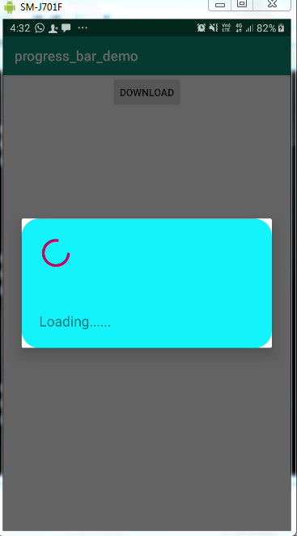

Fig. Progress Bar