------------------------------------------------------------------------------------------

**Practical No:** 14

**Title:** Develop a program to implement List View, Grid View, Image View and Scroll View

class: TYCO Roll No: 12

1. List View

package com.example.ListDisplay;

import android.os.Bundle;

import android.app.Activity;

import android.view.Menu;

import android.widget.ArrayAdapter;

import android.widget.ListView;

public class ListDisplay extends Activity {

// Array of strings...

String[] mobileArray = {"Android","IPhone","WindowsMobile","Blackberry",

"WebOS","Ubuntu","Windows7","Max OS X"};

@Override

protected void onCreate(Bundle savedInstanceState) {

super.onCreate(savedInstanceState);

setContentView(R.layout.activity_main);

ArrayAdapter adapter = new ArrayAdapter<String>(this,

R.layout.activity_listview, mobileArray);

ListView listView = (ListView) findViewById(R.id.mobile_list);

listView.setAdapter(adapter);

}

}

/// XML CODE

<LinearLayout xmlns:android="http://schemas.android.com/apk/res/android"

xmlns:tools="http://schemas.android.com/tools"

android:layout_width="match_parent"

android:layout_height="match_parent"

android:orientation="vertical"

tools:context=".ListActivity" >

<ListView

android:id="@+id/mobile_list"

android:layout_width="match_parent"

android:layout_height="wrap_content" >

</ListView>

</LinearLayout>

**/// activity_listview.xml**

<?xml version="1.0" encoding="utf-8"?>

<!-- Single List Item Design -->

<TextView xmlns:android="http://schemas.android.com/apk/res/android"

android:id="@+id/label"

android:layout_width="fill_parent"

android:layout_height="fill_parent"

android:padding="10dip"

android:textSize="16dip"

android:textStyle="bold" >

</TextView>

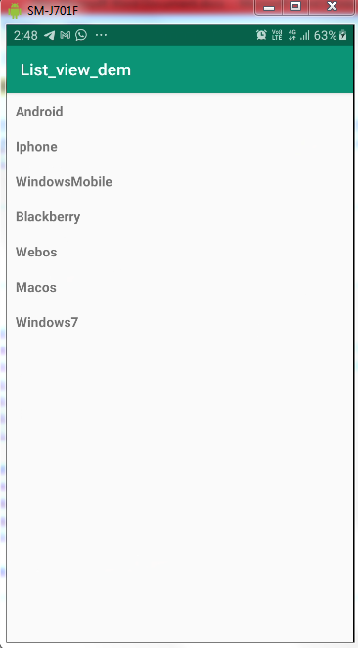

Fig. List View

1. Grid View

*<?***xml version="1.0" encoding="utf-8"***?>*<**GridView xmlns:android="http://schemas.android.com/apk/res/android"  
 xmlns:app="http://schemas.android.com/apk/res-auto"  
 xmlns:tools="http://schemas.android.com/tools"  
 android:layout_width="match_parent"  
 android:layout_height="match_parent"  
 tools:context=".MainActivity"  
 android:id="@+id/gridview"  
 android:columnWidth="90dp"  
 android:numColumns="2"  
 android:verticalSpacing="40dp"  
 android:horizontalSpacing="10dp"  
 android:listSelector="#0f0"  
 android:gravity="center"** >  
</**GridView**>

**package** com.example.grid_demo_image;  
**import** androidx.appcompat.app.AppCompatActivity;  
**import** android.os.Bundle;  
**import** android.widget.GridView;  
  
**public class** MainActivity **extends** AppCompatActivity {  
  
 @Override  
 **protected void** onCreate(Bundle savedInstanceState) {  
 **super**.onCreate(savedInstanceState);  
 setContentView(R.layout.***activity_main***);  
  
 GridView gridview = (GridView) findViewById(R.id.***gridview***);  
  
 gridview.setAdapter(**new** ImageAdapter(**this**));  
  
 }  
}

**package** com.example.grid_demo_image;  
**import** android.content.Context;  
**import** android.view.View;  
**import** android.view.ViewGroup;  
**import** android.widget.BaseAdapter;  
**import** android.widget.GridView;  
**import** android.widget.ImageView;  
  
**public class** ImageAdapter **extends** BaseAdapter {  
  
 **private** Context **mContext**;  
 *// Constructor* **public** Integer[] **mThumbIds** ={R.drawable.***zero***,R.drawable.***one***,R.drawable.***two***,R.drawable.***three***,R.drawable.***four***,R.drawable.***five***,R.drawable.***six***,R.drawable.***seven***,R.drawable.***eight***

,R.drawable.***nine***};  
  
  
 **public** ImageAdapter(Context c) {  
 **mContext** = c;  
 }  
  
 @Override  
  
  
 **public int** getCount() {  
 **return mThumbIds**.**length**;  
 }  
  
  
 @Override  
 **public** Object getItem(**int** position) {  
 **return null**;  
 }  
  
 @Override  
 **public long** getItemId(**int** position) {  
 **return** 0;  
 }

@Override  
 **public** View getView(**int** position, View convertView, ViewGroup parent) {  
  
 ImageView imageView;  
  
 **if** (convertView == **null**) {  
 imageView = **new** ImageView(**mContext**);  
 imageView.setLayoutParams(**new** GridView.LayoutParams(85, 85));  
 imageView.setScaleType(ImageView.ScaleType.***CENTER_CROP***);  
 imageView.setPadding(8, 8, 8, 8);  
 }  
 **else** {  
 imageView = (ImageView) convertView;  
 }  
 imageView.setImageResource(**mThumbIds**[position]);  
 **return** imageView;  
 }  
  
}

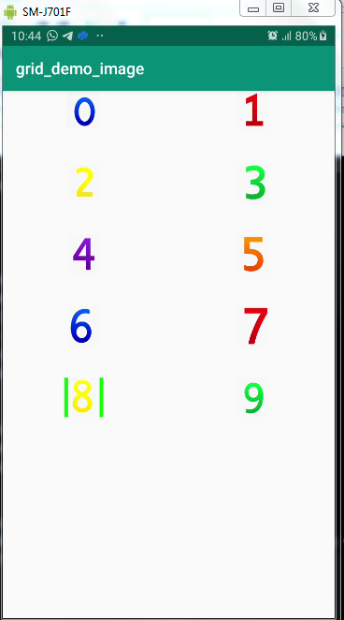

Fig. Grid View

1. Image View

*<?***xml version="1.0" encoding="utf-8"***?>*<**LinearLayout xmlns:android="http://schemas.android.com/apk/res/android"  
 xmlns:app="http://schemas.android.com/apk/res-auto"  
 xmlns:tools="http://schemas.android.com/tools"  
 android:layout_width="match_parent"  
 android:layout_height="match_parent"  
 android:orientation="vertical"  
 tools:context=".MainActivity"**>  
<**ImageView  
 android:layout_width="match_parent"  
 android:layout_height="200dp"  
 android:id="@+id/lion"  
 android:src="@drawable/lion"  
 android:scaleType="centerInside"** ></**ImageView**>  
  
 <**ImageView  
 android:layout_width="match_parent"  
 android:layout_height="250dp"  
 android:id="@+id/mokey"  
 android:src="@drawable/moneky"  
 android:scaleType="centerInside"** ></**ImageView**>  
  
</**LinearLayout**>

**// Java Code**

**package** com.example.imagedemo;  
**import** androidx.appcompat.app.AppCompatActivity;  
**import** android.os.Bundle;  
**import** android.view.View;  
**import** android.widget.ImageView;  
**import** android.widget.Toast;  
**public class** MainActivity **extends** AppCompatActivity {  
  
  
 ImageView **li**,**mo**;  
  
 @Override  
 **protected void** onCreate(Bundle savedInstanceState) {  
 **super**.onCreate(savedInstanceState);  
 setContentView(R.layout.***activity_main***);  
 **li**=(ImageView)findViewById(R.id.***lion***);  
 **mo**=(ImageView)findViewById(R.id.***mokey***);  
  
  
 **li**.setOnClickListener(**new** View.OnClickListener() {  
 @Override  
 **public void** onClick(View v) {  
 Toast.*makeText*(getApplicationContext(),**"Lion"**,Toast.***LENGTH_LONG***).show();  
  
 }  
 });  
  
  
 **mo**.setOnClickListener(**new** View.OnClickListener() {  
 @Override  
 **public void** onClick(View v) {  
 Toast.*makeText*(getApplicationContext(),**"Moneky"**,Toast.***LENGTH_LONG***).show();  
  
 }  
 });  
  
  
 }  
}

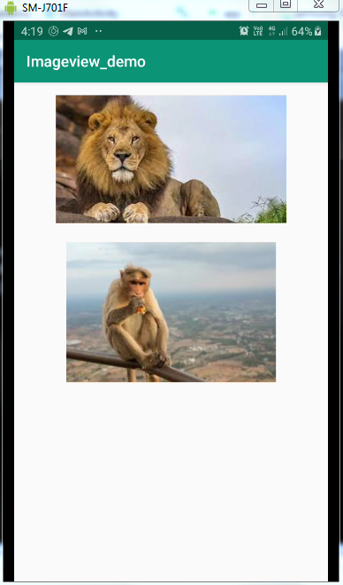

Fig. Image View

1. Scroll View

*<?***xml version="1.0" encoding="utf-8"***?>*<**RelativeLayout xmlns:android="http://schemas.android.com/apk/res/android"  
 xmlns:app="http://schemas.android.com/apk/res-auto"  
 xmlns:tools="http://schemas.android.com/tools"  
 android:layout_width="match_parent"  
 android:layout_height="match_parent"  
 tools:context=".MainActivity"**>  
  
 <**TextView  
 android:layout_width="wrap_content"  
 android:layout_height="wrap_content"  
 android:text="Vertical ScrollView example"  
 android:id="@+id/textView"  
 android:layout_gravity="center_horizontal"  
 android:layout_centerHorizontal="true"  
 android:layout_alignParentTop="true"** />

<**ScrollView android:layout_marginTop="30dp"  
 android:layout_width="fill_parent"  
 android:layout_height="wrap_content"  
 android:scrollbars="vertical"  
 android:id="@+id/scrollView"**>  
  
 <**LinearLayout  
 android:layout_width="fill_parent"  
 android:layout_height="fill_parent"  
 android:orientation="vertical"** >  
  
 <**Button  
 android:layout_width="fill_parent"  
 android:layout_height="wrap_content"  
 android:text="Button 1"** />  
 <**Button  
 android:layout_width="fill_parent"  
 android:layout_height="wrap_content"  
 android:text="Button 2"** />  
 <**Button  
 android:layout_width="fill_parent"  
 android:layout_height="wrap_content"  
 android:text="Button 3"** />  
 <**Button  
 android:layout_width="fill_parent"  
 android:layout_height="wrap_content"  
 android:text="Button 4"** />  
 <**Button  
 android:layout_width="fill_parent"  
 android:layout_height="wrap_content"  
 android:text="Button 5"** />  
 <**Button  
 android:layout_width="fill_parent"  
 android:layout_height="wrap_content"  
 android:text="Button 6"** />  
 <**Button  
 android:layout_width="fill_parent"  
 android:layout_height="wrap_content"  
 android:text="Button 7"** />  
 <**Button  
 android:layout_width="fill_parent"  
 android:layout_height="wrap_content"  
 android:text="Button 8"** />  
 <**Button  
 android:layout_width="fill_parent"  
 android:layout_height="wrap_content"  
 android:text="Button 9"** />  
 <**Button  
 android:layout_width="fill_parent"  
 android:layout_height="wrap_content"  
 android:text="Button 10"** />  
 <**Button  
 android:layout_width="fill_parent"  
 android:layout_height="wrap_content"  
 android:text="Button 11"** />  
 <**Button  
 android:layout_width="fill_parent"  
 android:layout_height="wrap_content"  
 android:text="Button 12"** />  
 <**Button  
 android:layout_width="fill_parent"  
 android:layout_height="wrap_content"  
 android:text="Button 13"** />  
 <**Button  
 android:layout_width="fill_parent"  
 android:layout_height="wrap_content"  
android:text="Button 14"** />  
 <**Button  
 android:layout_width="fill_parent"  
 android:layout_height="wrap_content"  
 android:text="Button 15"** />  
 <**Button  
 android:layout_width="fill_parent"  
 android:layout_height="wrap_content"  
 android:text="Button 16"** />  
 <**Button  
 android:layout_width="fill_parent"  
 android:layout_height="wrap_content"  
 android:text="Button 17"** />  
 <**Button  
 android:layout_width="fill_parent"  
 android:layout_height="wrap_content"  
 android:text="Button 18"** />  
  
 <**Button  
 android:layout_width="fill_parent"  
 android:layout_height="wrap_content"  
 android:text="Button 19"** />  
 <**Button  
 android:layout_width="fill_parent"  
 android:layout_height="wrap_content"  
 android:text="Button 20"** />

</**LinearLayout**>

</**ScrollView**>

</**RelativeLayout**>

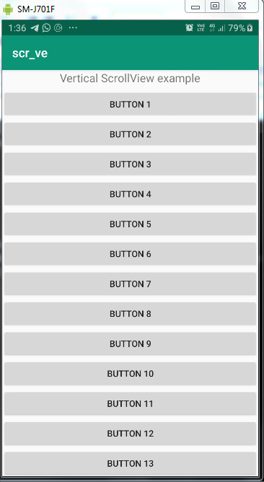

Fig. Scroll View