------------------------------------------------------------------------------------------

**Practical No:** 15

**Title:** Develop a program to implement Custom Toast Alert

class: TYCO Roll No: 12

#### // activity_main.xml

*<?***xml version="1.0" encoding="utf-8"***?>*<**RelativeLayout xmlns:android="http://schemas.android.com/apk/res/android"  
 xmlns:app="http://schemas.android.com/apk/res-auto"  
 xmlns:tools="http://schemas.android.com/tools"  
 android:layout_width="match_parent"  
 android:layout_height="match_parent"  
 tools:context=".MainActivity"**>  
  
 <**Button  
 android:layout_width="wrap_content"  
 android:layout_height="wrap_content"  
 android:id="@+id/btn"  
 android:text="Click"  
 android:layout_centerHorizontal="true"** ></**Button**>  
  
  
</**RelativeLayout**>

#### cust_alter_msg.xml

**Create another xml file inside the layout directory.**

**Here we are having ImageView and TextView in this xml file.**

*<?***xml version="1.0" encoding="utf-8"***?>*<**LinearLayout xmlns:android="http://schemas.android.com/apk/res/android"  
 android:orientation="vertical"  
 android:id="@+id/cust_alter_layout"  
 android:layout_width="match_parent"  
 android:layout_height="match_parent"**>  
  
 <**ImageView  
 android:layout_width="wrap_content"  
 android:layout_height="wrap_content"  
 android:src="@drawable/download"  
 android:scaleType="fitCenter"** ></**ImageView**>  
  
 <**TextView  
 android:layout_width="wrap_content"  
 android:layout_height="wrap_content"  
 android:text="Custom Toast "  
 android:layout_gravity="center"** ></**TextView**>  
  
</**LinearLayout**>

**//** MainActivity.java

**package** com.example.cust_alert;  
**import** androidx.appcompat.app.AppCompatActivity;  
**import** android.os.Bundle;  
**import** android.widget.Button;  
**import** android.view.LayoutInflater;  
**import** android.view.View;  
**import** android.view.ViewGroup;  
**import** android.widget.Toast;  
**import** android.view.Gravity;  
  
**public class** MainActivity **extends** AppCompatActivity {  
 Button **bt**;  
 @Override  
 **protected void** onCreate(Bundle savedInstanceState) {  
 **super**.onCreate(savedInstanceState);  
 setContentView(R.layout.***activity_main***);  
 **bt**=(Button)findViewById(R.id.***btn***);  
  
 LayoutInflater li= getLayoutInflater();  
   
 View layout =li.inflate(R.layout.***cust_alter_msg***,(ViewGroup)findViewById(R.id.***cust_alter_layout***));  
   
 **final** Toast toast=**new** Toast(getApplicationContext());  
 toast.setDuration(Toast.***LENGTH_LONG***);  
 toast.setGravity(Gravity.***CENTER_HORIZONTAL***,0,0);  
 toast.setView(layout);  
 **bt**.setOnClickListener(**new** View.OnClickListener() {  
 @Override  
 **public void** onClick(View v) {  
 toast.show();  
  
 }  
 });  
 }  
}

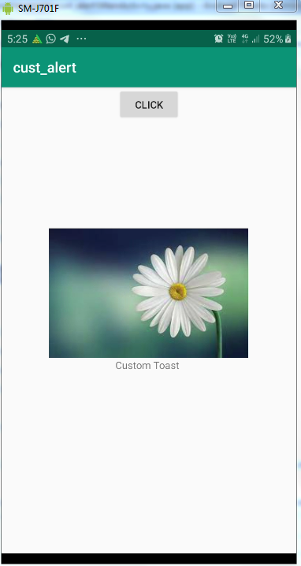

Fig. Custom Toast Alert