------------------------------------------------------------------------------------------

**Practical No:** 16

**Title:** Develop a program to implement Date and Time Picker

class: TYCO Roll No: 12

**// Date Picker Mode**

**package** com.example.date_picker;  
**import** androidx.appcompat.app.AppCompatActivity;  
**import** android.os.Bundle;  
**import** android.view.View;  
**import** android.widget.Button;  
**import** android.widget.DatePicker;  
**import** android.widget.Toast;  
  
**public class** MainActivity **extends** AppCompatActivity {  
  
 Button **btn**;  
 DatePicker **dp**;  
  
 @Override  
 **protected void** onCreate(Bundle savedInstanceState) {  
  
 **super**.onCreate(savedInstanceState);  
 setContentView(R.layout.***activity_main***);  
 **btn**=(Button)findViewById(R.id.***bt***);  
 **dp**=(DatePicker)findViewById(R.id.***dp***);  
  
 **btn**.setOnClickListener(**new** View.OnClickListener() {  
 @Override  
 **public void** onClick(View v) {  
  
  
 *// get the values for day of month , month and year from a date picker* String day = **"Day = "** + **dp**.getDayOfMonth();  
 String month = **"Month = "** + (**dp**.getMonth()+1);  
 String year = **"Year = "** + **dp**.getYear();  
 *// display the values by using a toast* Toast.*makeText*(getApplicationContext(), day + **"\n"** + month + **"\n"** + year, Toast.***LENGTH_LONG***).show();  
 }  
 });  
  
 }  
}

*<?***xml version="1.0" encoding="utf-8"***?>*<**RelativeLayout xmlns:android="http://schemas.android.com/apk/res/android"  
 xmlns:app="http://schemas.android.com/apk/res-auto"  
 xmlns:tools="http://schemas.android.com/tools"  
 android:layout_width="match_parent"  
 android:layout_height="match_parent"  
 tools:context=".MainActivity"**>  
  
<**DatePicker  
 android:layout_width="wrap_content"  
 android:layout_height="wrap_content"  
 android:id="@+id/dp"  
 android:layout_centerHorizontal="true"  
 android:padding="20dp"  
 android:datePickerMode="calendar"** ></**DatePicker**>  
  
  
 <**Button  
 android:layout_width="wrap_content"  
 android:layout_height="wrap_content"  
 android:id="@+id/bt"  
 android:text="Submit"  
 android:textColor="#fff"  
 android:background="#150"  
 android:layout_marginTop="500dp"  
 android:layout_marginLeft="180dp"  
 android:textSize="20sp"  
 android:textStyle="bold"** ></**Button**>  
  
  
</**RelativeLayout**>

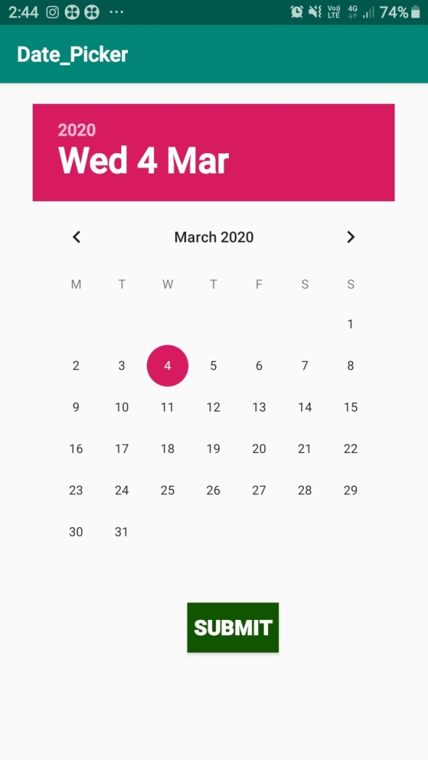

Fig. Date Picker