------------------------------------------------------------------------------------------

**Practical No:** 18

**Title:** Develop a program to implement new activity using Explicit intent and implicit intent

class: TYCO Roll No: 12

*// INTENT - Implicit and Explicit Demo*

*// Activity_main.xml*

*<?***xml version="1.0" encoding="utf-8"***?>*<**RelativeLayout xmlns:android="http://schemas.android.com/apk/res/android"  
 xmlns:app="http://schemas.android.com/apk/res-auto"  
 xmlns:tools="http://schemas.android.com/tools"  
 android:layout_width="match_parent"  
 android:layout_height="match_parent"  
 tools:context=".MainActivity"**>  
  
  
 <**Button  
 android:layout_width="wrap_content"  
 android:layout_height="wrap_content"  
 android:id="@+id/b1"  
 android:text="Explict Exmaple"  
 android:layout_marginTop="100dp"  
 android:layout_marginLeft="150dp"** ></**Button**>  
  
 <**Button  
 android:layout_width="wrap_content"  
 android:layout_height="wrap_content"  
 android:id="@+id/b2"  
 android:text="Implicit Exmaple"  
 android:layout_marginTop="200dp"  
 android:layout_marginLeft="150dp"** ></**Button**>  
  
  
  
  
</**RelativeLayout**>

**//** MainActivity.java

**package** com.example.implicit_explicit;  
**import** androidx.appcompat.app.AppCompatActivity;  
**import** android.content.Intent;  
**import** android.net.Uri;  
**import** android.os.Bundle;  
**import** android.view.View;  
**import** android.widget.Button;  
  
**public class** MainActivity **extends** AppCompatActivity {  
  
 Button **btn1**,**btn2**;  
  
  
 @Override  
 **protected void** onCreate(Bundle savedInstanceState) {  
 **super**.onCreate(savedInstanceState);  
 setContentView(R.layout.***activity_main***);  
  
 **btn1**=(Button)findViewById(R.id.***b1***);  
 **btn2**=(Button)findViewById(R.id.***b2***);  
  
  
 **btn1**.setOnClickListener(**new** View.OnClickListener() {  
 @Override  
 **public void** onClick(View v) {  
 *// Explicit Intent* Intent intent=**new** Intent(getApplicationContext(),second.**class**);  
 startActivity(intent);  
  
 }  
 });  
  
  
 **btn2**.setOnClickListener(**new** View.OnClickListener() {  
 @Override  
 **public void** onClick(View v) {  
 *//Implicit Intent* Intent intobj =**new** Intent(Intent.***ACTION_VIEW***);  
 intobj.setData(Uri.*parse*(**"https://www.google.com/"**));  
 startActivity(intobj);  
  
 }  
 });  
  
  
 }  
}

*//SecondActivity.xml*

*<?***xml version="1.0" encoding="utf-8"***?>*<**RelativeLayout xmlns:android="http://schemas.android.com/apk/res/android"  
 xmlns:app="http://schemas.android.com/apk/res-auto"  
 xmlns:tools="http://schemas.android.com/tools"  
 android:layout_width="match_parent"  
 android:layout_height="match_parent"  
 tools:context=".second"**>  
  
 <**TextView  
 android:layout_width="match_parent"  
 android:layout_height="wrap_content"  
 android:id="@+id/tv1"  
 android:text="We are In Second Actiity"  
 android:textSize="20dp"  
 android:gravity="center"  
 android:textColor="#f00"  
 android:textStyle="bold|italic"** ></**TextView**>  
  
</**RelativeLayout**>

// second.java

**package** com.example.implicit_explicit;  
**import** androidx.appcompat.app.AppCompatActivity;  
**import** android.os.Bundle;  
**import** android.widget.Toast;  
  
*// This is the Second Activity***public class** second **extends** AppCompatActivity {  
  
 @Override  
 **protected void** onCreate(Bundle savedInstanceState) {  
 **super**.onCreate(savedInstanceState);  
 setContentView(R.layout.***activity_second***);  
 Toast.*makeText*(getApplicationContext(),**"We are on Second Activity "**,Toast.***LENGTH_LONG***).show();  
  
 }  
}

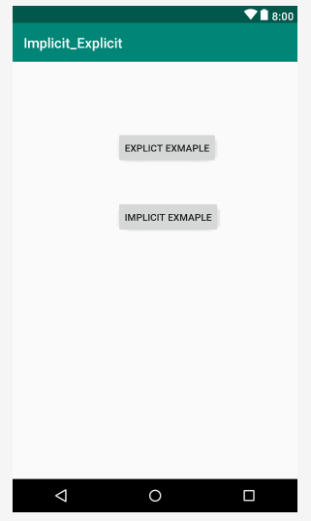

Fig. Implicit_Explicit Intent